Classification

As the name suggests, Classification is the task of “classifying things” into sub-categories. But, by a machine! If that doesn’t sound like much, imagine your computer being able to differentiate between you and a stranger. Between a potato and a tomato. Between an A grade and an F. Now, it sounds interesting now. In Machine Learning and Statistics, Classification is the problem of identifying to which of a set of categories (subpopulations), a new observation belongs, on the basis of a training set of data containing observations and whose categories membership is known.
Classification is a machine learning task that involves assigning a class label to a given input based on a set of training data. The goal of classification is to build a model that can accurately predict the class label for new, unseen data.

Here are some steps to get started with classification:
- Understanding the problem: Before getting started with classification, it is important to understand the problem you are trying to solve. What are the class labels you are trying to predict? What is the relationship between the input data and the class labels?
- Data preparation: Once you have a good understanding of the problem, the next step is to prepare your data. This includes collecting and preprocessing the data, and splitting it into training, validation, and test sets.
- Selecting a model: There are many different models that can be used for classification, including decision trees, random forests, k-nearest neighbors, and support vector machines. It is important to select a model that is appropriate for your problem, taking into account the size and complexity of your data, and the computational resources you have available.
- Training the model: Once you have selected a model, the next step is to train it on your training data. This involves adjusting the parameters of the model to minimize the error between the predicted class labels and the actual class labels for the training data.
- Evaluating the model: After training the model, it is important to evaluate its performance on a validation set. This will give you a good idea of how well the model is likely to perform on new, unseen data.
- Fine-tuning the model: If the model’s performance is not satisfactory, you can fine-tune it by adjusting the parameters, or trying a different model.
- Deploying the model: Finally, once you are satisfied with the performance of the model, you can deploy it to make predictions on new data.
- These are the basic steps to get started with classification. As you gain more experience, you may want to explore more advanced techniques, such as ensemble methods, deep learning, and transfer learning.

Classification Definition
Given a collection of records, build a model that can be used to predict a designated class variable. For the collection or a subset of the collection called the training set:
Each record of the collection (training set) is by characterized by a tuple (x,y), where x is the attribute set and y is the class label.
Other paired terms used for x and y:
- x: attribute, predictor, independent variable, input
- y: class, response, dependent variable, output
Task of classification:
Learn/build a model that maps each attribute set x into one of the predefined class labels y
Task | Attribute set, x | Class label, y
Categorizing email messages | Features extracted from email message header and content | spam or non-spam
Identifying tumor cells | Features extracted from MRI scans | malignant or benign cells
Cataloging galaxies | Features extracted from telescope images | Elliptical, spiral, or irregular-shaped galaxies

Types of Classification
Classification is of two types:
- Binary Classification: When we have to categorize given data into 2 distinct classes. Example – On the basis of given health conditions of a person, we have to determine whether the person has a certain disease or not.
- Multiclass Classification: The number of classes is more than 2. For Example – On the basis of data about different species of flowers, we have to determine which specie our observation belongs.
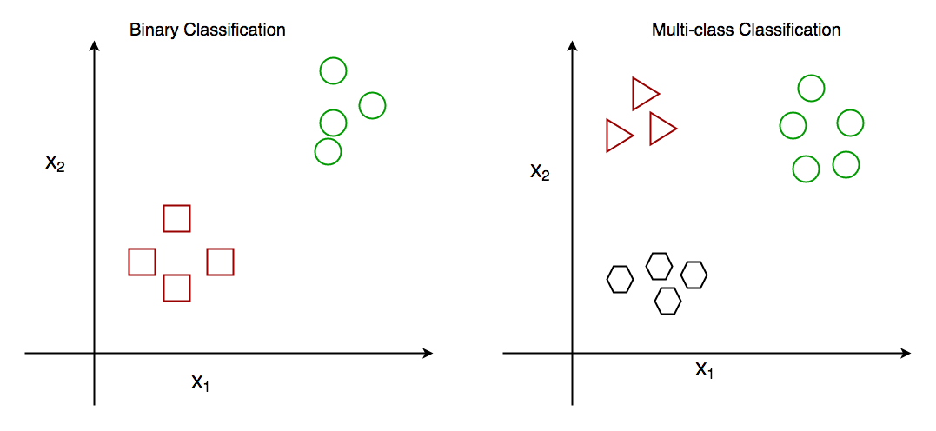
Fig: Binary and Multiclass Classification. Here x1 and x2 are the variables upon which the class is predicted.

How does classification works?
Suppose we have to predict whether a given patient has a certain disease or not, on the basis of 3 variables, called features.
This means there are two possible outcomes:
- The patient has the said disease. Basically, a result labelled “Yes” or “True”.
- The patient is disease-free. A result labelled “No” or “False”.
This is a binary classification problem.
We have a set of observations called the training data set, which comprises sample data with actual classification results. We train a model, called Classifier on this data set, and use that model to predict whether a certain patient will have the disease or not.
The outcome, thus now depends upon :
- How well these features are able to “map” to the outcome.
- The quality of our data set. By quality, I refer to statistical and Mathematical qualities.
- How well our Classifier generalizes this relationship between the features and the outcome.
- The values of the x1 and x2.

General process for classification model building
An induction process builds the model (learn) and a deduction process tests the model for accuracy/quality.

Following is the generalized block diagram of the classification task.
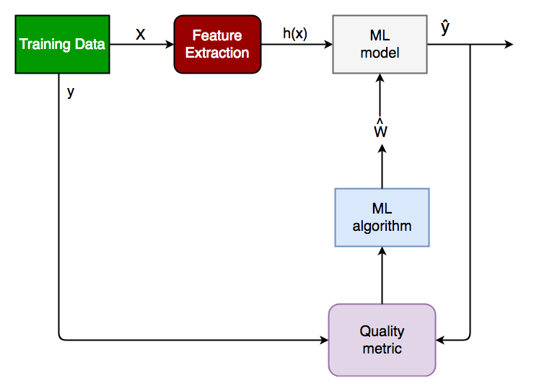
Generalized Classification Block Diagram.
- X: pre-classified data, in the form of an N*M matrix. N is the no. of observations and M is the number of features
- y: An N-d vector corresponding to predicted classes for each of the N observations.
- Feature Extraction: Extracting valuable information from input X using a series of transforms.
- ML Model: The “Classifier” we’ll train.
- y’: Labels predicted by the Classifier.
- Quality Metric: Metric used for measuring the performance of the model.
- ML Algorithm: The algorithm that is used to update weights w’, which updates the model and “learns” iteratively.

Apply the model to test data

Decision Tree Classification Task
Types of Classifiers (algorithms)
Base Classifiers
Input training set used in classification model to predict an output
Linear Classifiers: Logistic Regression
Tree-Based Classifiers: Decision Tree Classifier
Rule-based Methods
Nearest-neighbor
Neural Networks
Deep Learning
Naïve Bayes and Bayesian Belief Networks
Support Vector Machines

Ensemble Classifiers
Use a combination of different classifiers or variations of the same classifier
Boosting, Bagging, Random Forests
Classifiers tend to have biases in the modeling process that ensemble classifiers may be able to work around

Design Issues of Decision Tree Induction
How should training records be split?
- Method for specifying test condition
  - depending on attribute types
- Measure for evaluating the goodness of a test condition
How should the splitting procedure stop?
- Stop splitting if all the records belong to the same class or have identical attribute values
- Early termination
Methods for Expressing Test Conditions
- Attribute types to consider: binary, nominal, ordinal, continuous
- Splitting options: binary, multi-way
Binary type
Simple splitting binary

Nominal
Multi-way: use as many partitions as values in nominal/binary cases
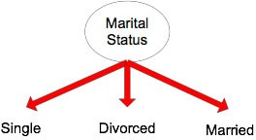
Versus binary: can have variations on different combinations of groups, for example
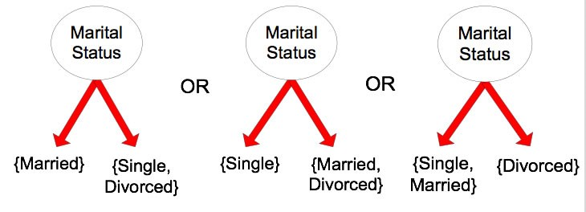

Ordinal
Multi-way: use as many partitions as distinct values
- choice in number of partitions
- choice in how to split the partitions, similar to choices in binning
Binary split: Divides values into two subsets
- Preserve order property among attribute values
- Choose median or mean as split
See bad choice on grouping on right

Continuous
Have to choose a splitting value.
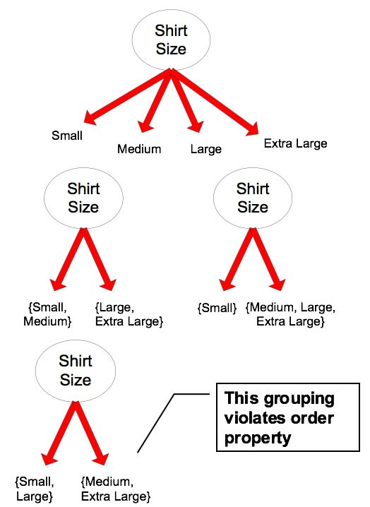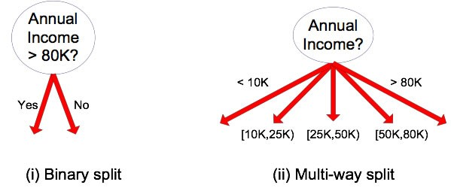
Different ways of handling discretization to form an ordinal
categorical attribute
Ranges can be found by equal interval bucketing, equal
frequency bucketing (percentiles), or clustering.
Static – discretize once at the beginning
Dynamic – repeat at each node
Binary Decision: (A < v) or (A != v )
consider all possible splits and finds the best cut
can be more computing intensive
Determining the best split
That is, what attribute provides the best split? And what is "best"?
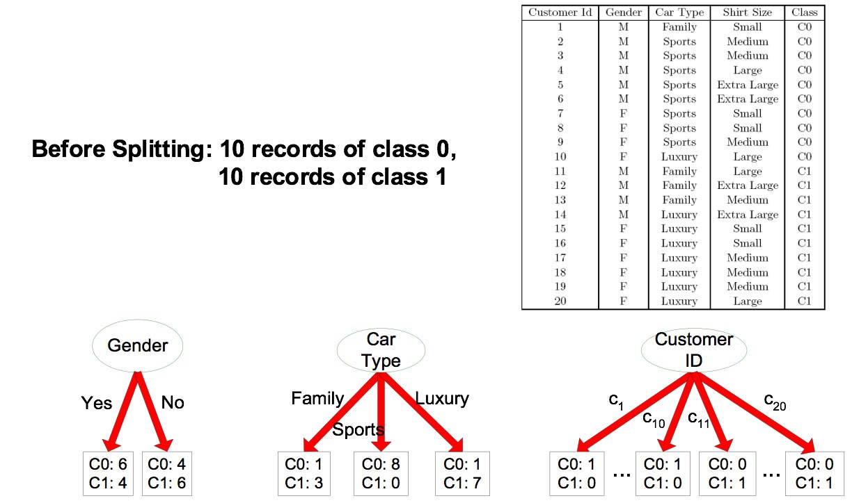
So which would the be the best split?
The leftmost binary split has no solid or definitive determination.
The middle one seems to have a fairly predictable outcomes based on car type
The rightmost, using ID is entirely useless for prediction, albeit perfect on the training data, real future id's will be out of range.

Greedy Approach
Nodes with a purer class distribution are preferred. So we need a meausure of node impurity.
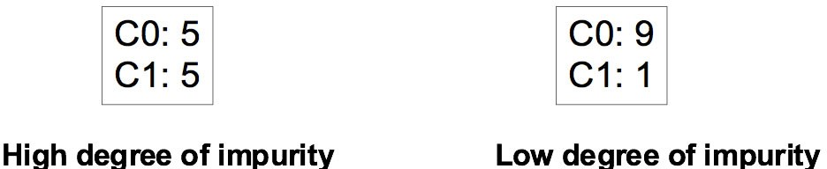

Example measures of impurity
Gini index: 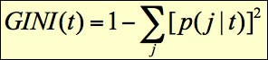
GINI(C0=5,C1=5) = 1 - (0.5)² - (0.5)² = 0.5
GINI(C0=9,C1=1) = 1 - (0.9)²- (0.1)² = 0.18 Entropy index: 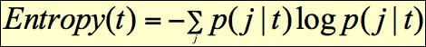
Entropy(C0=5,C1=5) = -(0.5)log(0.5) + -(0.5)log(0.5) = -0.5*(-1) + -0.5*(-1) = 1
Entropy(C0=9,C1=1) = -(0.9)log(0.9) + -(0.1)log(0.1) = -0.9(-0.152) + -0.1(-3.322) = 0.469
Misclassification error index: 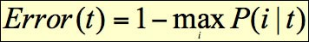
Error(C0=5) = 1 - max(0.5,0.5) = 1 - 0.5 = 0.5
Error(C0=9,C1=1) = 1 - max(0.9,0.1) = 1 - 0.9 = 0.1
These approaches are discussed further below

Algorithm for determining best split
- Compute impurity measure (P) before splitting
- Compute impurity measure (M) after splitting
Compute impurity measure of each child node
M is the weighted impurity of children
- Choose the attribute test condition that produces the highest gain: Gain = P - M or equivalently, find the lowest impurity measure after splitting (M)
Generically, the process comparing gain between two (or more) attributes:
Do we choose attribute A or B for the decision?
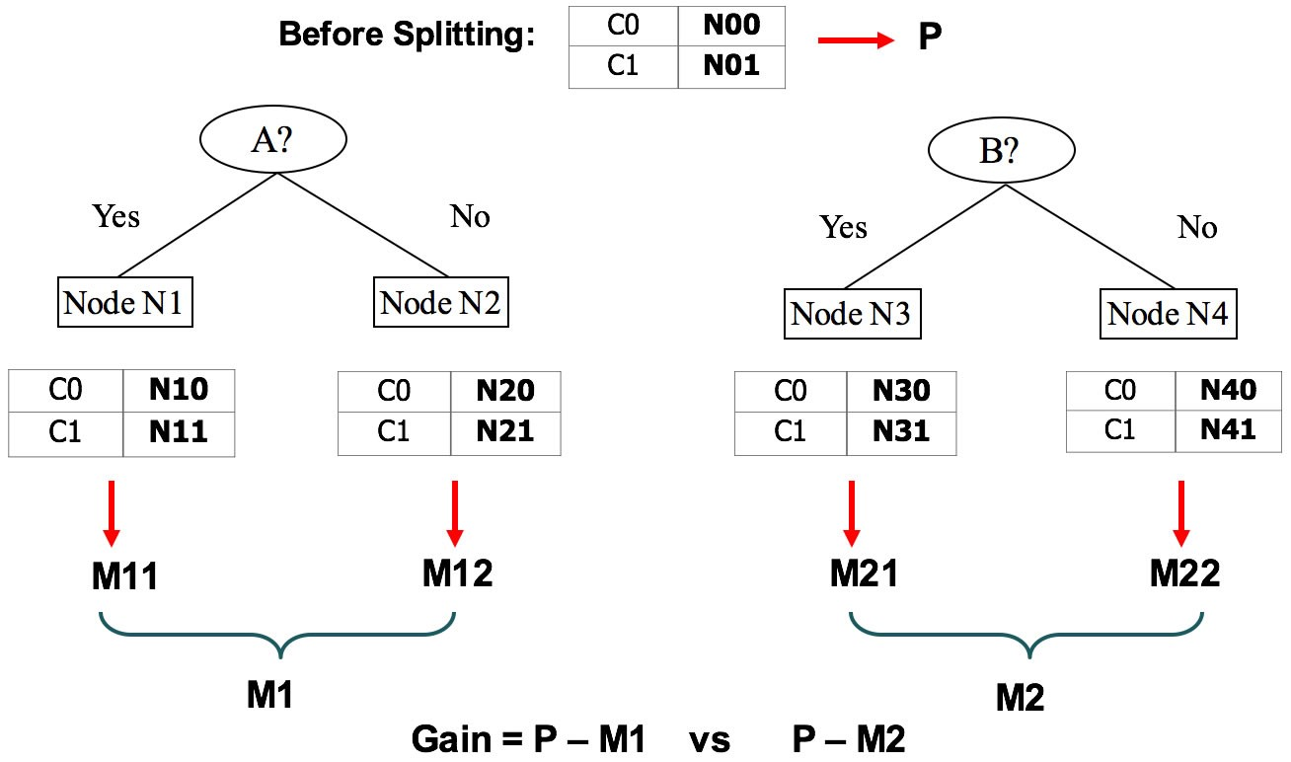
Choose attribute with highest Gain.

Practical Applications of Classification
- Google’s self-driving car uses deep learning-enabled classification techniques which enables it to detect and classify obstacles.
- Spam E-mail filtering is one of the most widespread and well-recognized uses of Classification techniques.
- Detecting Health Problems, Facial Recognition, Speech Recognition, Object Detection, and Sentiment Analysis all use Classification at their core.

Implementation:

Let’s get a hands-on experience with how Classification works. We are going to study various Classifiers and see a rather simple analytical comparison of their performance on a well-known, standard data set, the Iris data set.
Requirements for running the given script:
- Python 3.8.10
- Scipy and Numpy
- Pandas for data i/o
- Scikit-learn Provides all the classifiers
Example
- Python
# Python program to perform classification on Iris dataset
# Run this program on your local Python interpreter
# provided you have installed the required libraries

# Importing the required libraries
import numpy as np
import pandas as pd
from sklearn.model_selection import train_test_split
from sklearn.metrics import accuracy_score
from sklearn import datasets
from sklearn import svm
from sklearn.tree import DecisionTreeClassifier
from sklearn.naive_bayes import GaussianNB

# import the iris dataset
iris = datasets.load_iris()
X = iris.data
y = iris.target

# splitting X and y into training and testing sets
X_train, X_test, y_train, y_test = train_test_split(
X, y, test_size=0.3, random_state=1)

# GAUSSIAN NAIVE BAYES
gnb = GaussianNB()
# train the model
gnb.fit(X_train, y_train)
# make predictions
gnb_pred = gnb.predict(X_test)
# print the accuracy
print("Accuracy of Gaussian Naive Bayes: ", accuracy_score(y_test, gnb_pred))

# DECISION TREE CLASSIFIER
dt = DecisionTreeClassifier(random_state=0)
# train the model
dt.fit(X_train, y_train)
# make predictions
dt_pred = dt.predict(X_test)
# print the accuracy
print("Accuracy of Decision Tree Classifier: ", accuracy_score(y_test, dt_pred))

# SUPPORT VECTOR MACHINE
svm_clf = svm.SVC(kernel='linear') # Linear Kernel
# train the model
svm_clf.fit(X_train, y_train)
# make predictions
svm_clf_pred = svm_clf.predict(X_test)
# print the accuracy
print("Accuracy of Support Vector Machine: ",
accuracy_score(y_test, svm_clf_pred))

