**EEG Notebooks: Mac installation instructions**

**STEP 1: download the Miniconda installer for Mac**

* Click the Python 3.6 file link on this website: <https://conda.io/miniconda.html>

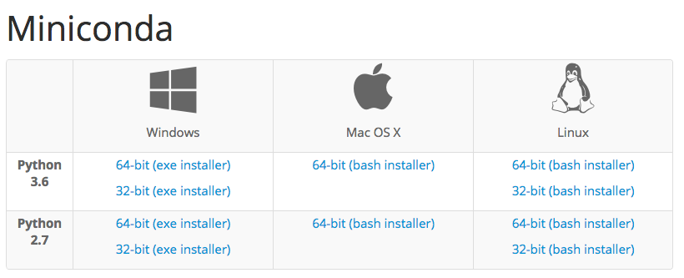

* Press “command” and “spacebar” at the same time → type “Terminal” into the search bar → press the Terminal icon to open a new Terminal
* Enter the following commands in the Terminal:

cd ~/Downloads/

sh ./Miniconda3-latest-MacOSX-x86_64.sh

* You will be asked to type “yes” in the Terminal a couple times

**STEP 2: install required packages**

* Run the following commands in the Terminal:

mv ~/eeg-notebooks ~/old-eeg-notebooks (if old version installed)

source ~/.bash_profile

cd ~

conda create -n nbmac python=3

source activate nbmac

conda install python=3.6

conda install git

git clone https://www.github.com/kylemath/eeg-notebooks

cd ~/eeg-notebooks

pip install -r requirements_mac.txt

* For the “conda create” command, you will be asked to type “y” to confirm that yes, you wish to install the required packages
* The above packages may take ~5-10 minutes to install
* Ignore the warning that muselsl is not compatible with pygatt version 3.2.0
* Run the following commands in the Terminal:

mkdir ~/.jupyter/

jupyter notebook password

* You will then be asked to enter a password. Note that the password will not show up in the Terminal! After pressing <enter>, you will be asked to confirm your password
* Run the following commands in the Terminal:

python

import matplotlib

exit()

echo "backend: TkAgg" > ~/.matplotlib/matplotlibrc

**STEP 3: Working with eeg-notebooks**

* Turn on your MUSE device
* Connect the Bluetooth dongle to the USB port of your Mac
* Run the following commands in the Terminal (in the nbmac environment)

source activate nbmac

cd ~/eeg-notebooks/notebooks

jupyter notebook

* Open **cueing.ipynb** in the browser
* The rest of the instructions for running experiments and analyzing data are in the cueing.ipynb notebook

**STEP 4: Shutting down eeg-notebooks**

* Close the tab for the experiment notebook (e.g. mac_n170.ipynb) in your browser
* In the jupyter notebook “Home” tab:
  + Click the checkbox beside the notebook(s) that is/are running (they will be green)
  + Click the orange “Shutdown” button that will appear after you click the checkbox
* In your terminal, press Ctrl + C, then press “y” and Enter when prompted to finish shutting down the jupyter notebook kernel

