**RRPathGen**

**Author**: Dennis O’Brien  
(dco6453@me.com)

**Team**: FTC-7462 (Not to Scale), Mentor

Table of Contents

1 Disclaimer 3

2 Introduction 3

3 Installation 4

4 Configure 4

5 Tool Usage 5

# Disclaimer

Most of the text in this document was copied from the [RRPathGen](https://learnroadrunner.com/tool/rrpathgen.html#rrpathgen) web site.

# Introduction

RRPathGen is a program that allows teams to quickly generate trajectories through a GUI.

Current features:

* Viewing of paths by importing them
* Modification of paths through either the GUI or changing the values in the text fields
* Export of paths in the form of Java code
* Customization of length and width of the robot
* Support for different sized screens and resolutions
* Paths can be flipped to account for the robot starting in different sides of the field
* Uses same field coordinates as MeepMeep

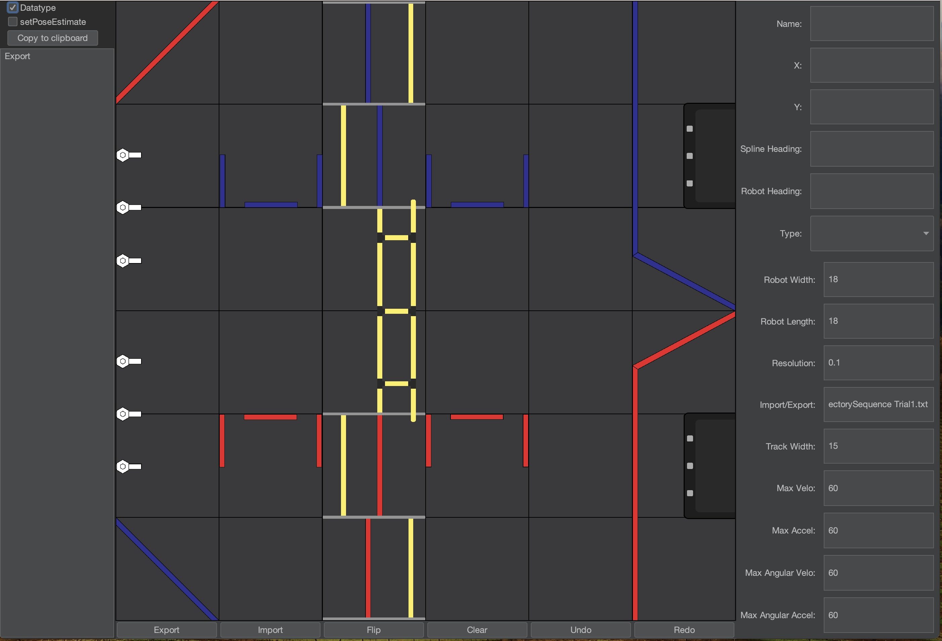

# Installation

|  |  |
| --- | --- |
| 1. | Download the jar from the [releases page](https://github.com/Jarhead20/RRPathGen/releases) |
| 2. | Check that you have at least java 8 installed using the following command,  java --version (Mac/Unix)  java -version (PC) |
| 3. | To simplify its execution, make a batch (i.e. “bat”) file. Open a text editor and add the following line,  java -jar RRPathGen-X.X.X.jar  where, X.X.X matches the values in the downloaded jar file. |
| 4. | When you close the file it will probably have an extension of “.bat.txt”. In a command/terminal window, rename the file to remove the “.txt” extension. |
| 5. | Run the jar either by double clicking on the batch file. |

# Configure

RRPathGen maintains a variety of values in the right-hand side of the window. As of this writing, it does not appear as though these values can be saved from one session to another. These values are stored, and can be changed, by editing the config.propoerties file found in the following locations,

|  |  |
| --- | --- |
| PC | C:/Users/Admin/AppData/Roaming/RRPathGen |
| Mac/Linux | ~/Library/”Application Support”/RRPathGen **Note:** Be aware of the space between “Application”   and “Support” will result in having to navigate to  the folder using 2 commands. |

# Tool Usage

Generate your paths using the key binds below and once you are done export the path with the export button and copy paste it into your autonomous program.

|  |  |
| --- | --- |
| **Key Bind** | **Action** |
| Left Click | Add New Point |
| Left Drag (Point) | Drags Selected Point |
| Alt + Left Click | Change Heading |
| Left Arrow | Next Path |
| Right Arrow | Previous Path |
| R | Reverse Robot Direction |
| Delete | Delete Selected Node |
| Ctrl + Z | Undo Previous Action |