Báo cáo bài tập tuần 1
Bế Quốc Thành – 20235830

- HelloWorld
- Code
import javax.swing.*;

public class HelloWorld {
public static void main(String[] args) {
String name = JOptionPane.showInputDialog("Nhập tên của bạn:");
JOptionPane.showMessageDialog(null, "Hello " + name + "!");
}
}
- Kết quả
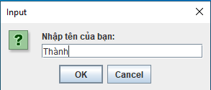
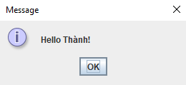
- Calculator sử dụng Swing
- Code
Calculator Controller
import java.awt.event.ActionEvent;
import java.awt.event.ActionListener;

public class CalculatorController {
private CalculatorView theView;
private CalculatorModel theModel;

public CalculatorController(CalculatorView theView, CalculatorModel theModel) {
this.theView = theView;
this.theModel = theModel;

this.theView.addCalculateListener(new CalculateListener());
}

class CalculateListener implements ActionListener{
public void actionPerformed(ActionEvent e) {
int firstNumber, secondNumber = 0;

try{
firstNumber = theView.getFirstNumber();
secondNumber = theView.getSecondNumber();

theModel.addTwoNumbers(firstNumber, secondNumber);

theView.setCalcSolution(theModel.getCalculationValue());
}
catch(NumberFormatException ex){
System.out.println(ex);
theView.displayErrorMessage("Bruh nhập 2 số nguyên đi");
}
}
}
}

Calculator Model
public class CalculatorModel {
private int calculationValue;

public void addTwoNumbers(int firstNumber, int secondNumber){
calculationValue = firstNumber + secondNumber;
}

public int getCalculationValue(){
return calculationValue;
}
}

Calculator View
import java.awt.event.ActionListener;
import javax.swing.*;

public class CalculatorView extends JFrame{
private JTextField firstNumber = new JTextField(10);
private JLabel additionLabel = new JLabel("+");
private JTextField secondNumber = new JTextField(10);
private JButton calculateButton = new JButton("Tính toán");
private JTextField calcSolution = new JTextField(10);

CalculatorView(){
JPanel calcPanel = new JPanel();

this.setDefaultCloseOperation(JFrame.EXIT_ON_CLOSE);
this.setSize(600, 200);

calcPanel.add(firstNumber);
calcPanel.add(additionLabel);
calcPanel.add(secondNumber);
calcPanel.add(calculateButton);
calcPanel.add(calcSolution);

this.add(calcPanel);
}

public int getFirstNumber(){
return Integer.parseInt(firstNumber.getText());
}

public int getSecondNumber(){
return Integer.parseInt(secondNumber.getText());
}

public int getCalcSolution(){
return Integer.parseInt(calcSolution.getText());
}

public void setCalcSolution(int solution){
calcSolution.setText(Integer.toString(solution));
}

void addCalculateListener(ActionListener listenForCalcButton){
calculateButton.addActionListener(listenForCalcButton);
}

void displayErrorMessage(String errorMessage){
JOptionPane.showMessageDialog(this, errorMessage);
}
}

MVCSwing
public class MVCSwing {
public static void main(String[] args) {
CalculatorView theView = new CalculatorView();
CalculatorModel theModel = new CalculatorModel();
CalculatorController theController = new CalculatorController(theView, theModel);
theView.setVisible(true);
}
}

- Kết quả
Trường hợp 1:
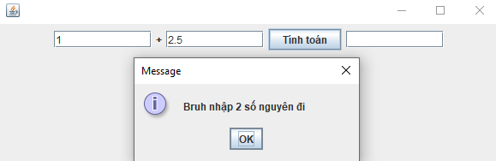
Trường hợp 2:
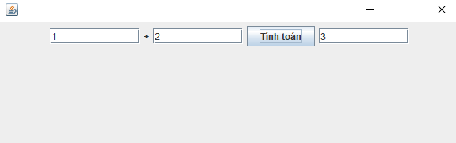
- Calculator sử dụng Fx
- Code
Calculator Controller
public class CalculatorControllerFx {
private CalculatorViewFx theView;
private CalculatorModelFx theModel;

public CalculatorControllerFx(CalculatorViewFx theView, CalculatorModelFx theModel) {
this.theView = theView;
this.theModel = theModel;

this.theView.getCalculateButton().setOnAction(e -> {
try{
int firstNumber = theView.getFirstNumber();
int secondNumber = theView.getSecondNumber();

theModel.addTwoNumbers(firstNumber, secondNumber);
theView.setCalcSolution(theModel.getCalculationValue());
}
catch(NumberFormatException ex){
System.out.println(ex);
theView.displayErrorMessage("Điền 2 số nguyên vào bruh");
}
});
}
}

Calculator Model
public class CalculatorModelFx {
private int calculationValue;

public void addTwoNumbers(int firstNumber, int secondNumber){
calculationValue = firstNumber + secondNumber;
}

public int getCalculationValue(){
return calculationValue;
}
}

Calculator View
import javafx.scene.control.Button;
import javafx.scene.control.Label;
import javafx.scene.control.TextField;
import javafx.scene.layout.HBox;

public class CalculatorViewFx {
private TextField firstNumber = new TextField();
private TextField secondNumber = new TextField();
private TextField calcSolution = new TextField();
private Button calculateButton = new Button("Tính toán");

public HBox getView() {
firstNumber.setPromptText("Số đầu tiên");
secondNumber.setPromptText("Số thứ hai");
calcSolution.setPromptText("Kết quả");
calcSolution.setEditable(false);

HBox hbox = new HBox(10);
hbox.getChildren().addAll(firstNumber, new Label("+"), secondNumber, calculateButton, calcSolution);
hbox.setStyle("-fx-padding: 20; -fx-alignment: center;");

return hbox;
}

public int getFirstNumber(){
return Integer.parseInt(firstNumber.getText());
}

public int getSecondNumber(){
return Integer.parseInt(secondNumber.getText());
}

public void setCalcSolution(int solution){
calcSolution.setText(Integer.toString(solution));
}

public Button getCalculateButton(){
return calculateButton;
}

public void displayErrorMessage(String errorMessage){
System.out.println("Lỗi: " + errorMessage);
}
}

MVCJavaFX
import javafx.application.Application;
import javafx.scene.Scene;
import javafx.scene.layout.VBox;
import javafx.stage.Stage;

public class MVCJavaFX extends Application {

@Override
public void start(Stage primaryStage) {
CalculatorViewFx theView = new CalculatorViewFx();
CalculatorModelFx theModel = new CalculatorModelFx();
CalculatorControllerFx theController = new CalculatorControllerFx(theView, theModel);

VBox root = new VBox(20);
root.getChildren().add(theView.getView());
root.setStyle("-fx-padding: 20;");

Scene scene = new Scene(root, 900, 150);
primaryStage.setTitle("Calculator JavaFX");
primaryStage.setScene(scene);
primaryStage.show();
}

public static void main(String[] args) {
launch(args);
}
}
- Kết quả
Trường hợp 1:
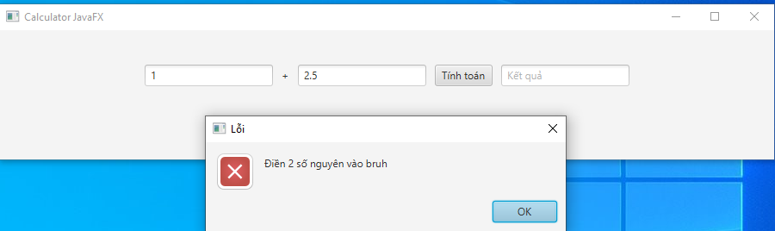
Trường hợp 2:
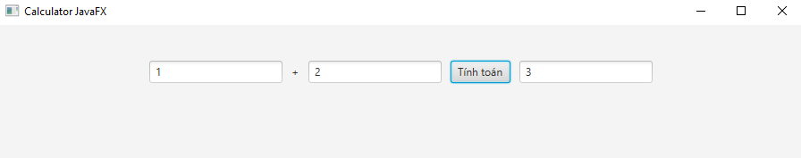
- GIT
- Add
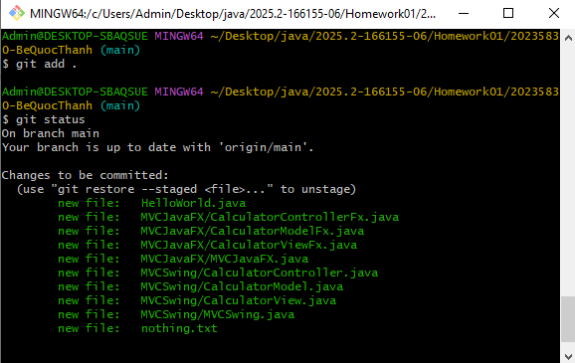
- Remove
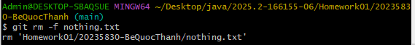
- Modify
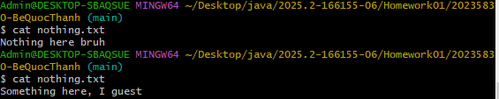
- Commit
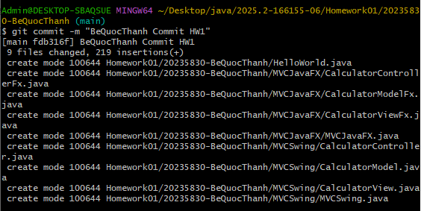
- Push
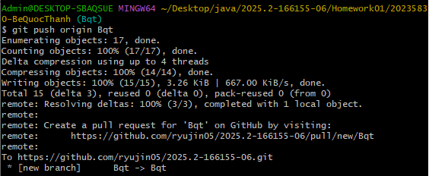
- Pull
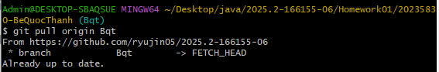
- Merge
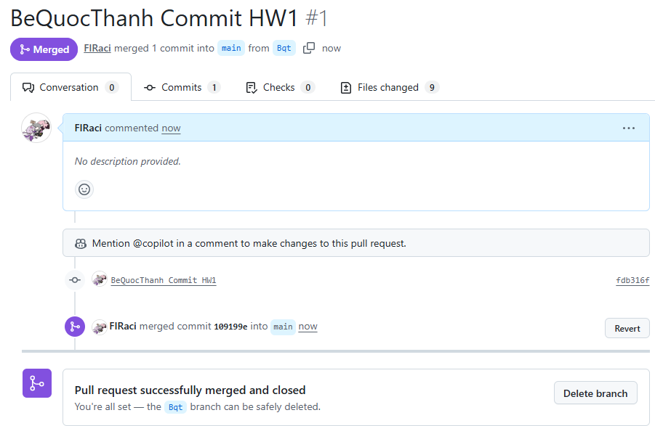
- Brach
