

**FPT-aptech computer education**

eProject Document

Airlines Reservation System

|  |
| --- |
|  |
| |  |  | | --- | --- | | **Group** | | | **Group Member** | |  |  | | --- | --- | | **Student** | **Student Code** | | Nguyễn Duy Đức | Student706828 | | Nguyễn Đức Hải | Student706859 | | Nguyễn Hoàng Giáp | Student706847 | | | **Instructor** | Nguyễn Tuân | | **Batch** | GC0804 | | **Semester** | 4 | |

-Hanoi, 11/2014

# **Introduction**

KSC Technology and Sciences is the educational university which runs the classes for the categories like Engineering, Pharmaceutical sciences, Literature, etc. It is one of the famous universities in the country. They generally conduct Paper Presentations at state level and national level. They also conduct seminars, Techno-Feat, etc. so as to entertain the students in the technical back grounds.

Each time when they conduct seminars, symposiums, or paper presentation, etc. they used to send the invitations for the participation of the students of other colleges, etc. so that the knowledge of the student can be enhanced and at the same time, the students who does not belong to this university can also have the opportunity in participating in these activities.

While sending the invitations to the other colleges, universities, they quote some registration fees for the gate pass and also they will provide the details like the topics for which seminars or paper presentations or symposiums or techno-feats are conducted. For the seminars and the Techno-feats they also provide the names of the speakers who are conducting or providing this. Along with the invitation they also send the format of application, which is to be filled and sent back to the address as mentioned in the invitation for participating in the activities.

In general to participate in these activities, the students who do not belong to this university send their requests by filling in the application form as per the format sent and send it along with the payment through courier or directly dropping it at the address in personal. In case of the Paper presentations, along with the courier, they also used to submit both the soft copy and the hard copy, so that they can reach the mentioned address before the end date of the participation. After sending these copies, they used to verify and then finalize which students are to be participated in this paper presentation. The selection is purely based on the technology (like mostly they prefer the new implementations in the technology, etc.).

# **Problem Definition**

After reading the project specifications, the developer states the scope of the project very briefly. This is referred to as the problem definition. Modules related to the applications can be or more the following:

* Restricted handle event and business when we work in JSP/Servlet.
* Make automatic events active and deactive.
* No unit test when we code so its hard to control.

# **Customer Requirement Specification and System infomation**

Now they want to provide a facility where the participants can register themselves online and as well the invitation can be displayed directly online itself in the specific portal. Once they are registered online they can send the details of the payment along with the print out of the application along with the signature of the participant and for the paper presentation, the hard copy of the paper presentation will be sent along with it. So they have approached us in order to help them.

They want that the following steps to be incorporated in the website.

1. There should be a logo indicating the brand of the institute on all the web pages. (Note: the logo can be of any institution or it can be designed by your own as well)
2. On the home page of the website the details of the upcoming activities, and the winners of the recent activity conducted is to be displayed. Also the details of the participants like how many are registered for the recent or for the latest activity conducted can be displayed on the home page.
3. The user can also create the account with the website, with his/her personal mail id. So that if any activity is going to be launched a mail will be marked to the mail id that is mentioned during the time of registration with the site.
4. When a user tries to access the link of the activity like symposium, seminar, techno-feat, etc. he/she should be able to view the details like
   * Date and time of conducting
   * The procedure for applying for the participation
   * The fees details
   * Payment options
   * Eligibility criteria
   * Speakers name or guest’s name
   * Topics on which the activity is performed
   * Prize details if any
   * Address for sending the applications for the participation
   * Terms and conditions, etc.
5. The navigation bar should include the following

* Home Page
* Login Page
* Application or enroll Page
* Update/Edit Page
* Subscribe Page (through this one can create the account) and unsubscribe
* Page (through this one can deactivate the account created)
* About Us Page
* Contact Information Page

1. Through Login page, users and admin can login.
2. Through the Enroll page one can enroll or apply for symposiums, seminars, Techno-Feat, etc.
3. Through Un-Enroll for an event (symposiums/seminars/Techno-Feat)
4. Through Subscribe Page one can subscribe for the mailing lists and create the account with the site.
5. Through Unsubscribe Page one can subscribe for the mailing lists.
6. Through Update page that is available after login one can Manage Personal Information
7. It should also include the About Us and Contact information.
8. The payment options to be included are

* Payment through Demand Draft
* Payment through Cheque
* Payment by cash

1. The application can be done in both the ways

* Online application

Note: The payment can be sent through the courier or dropped at the address. Once the payment is cleared, then only the enrollment will be activated.

* Taking the print out of the application and filling it up and sending it through courier to the address mentioned.

*** System information

* We created 3 projects. They are KSC client, KSCClubBand and WS(web service project for payment if event has prices).
* KSCClubBand is admin project. The admin or subadminh can manage events when thry created.
* KSC Client project is client project. The user use it for seeing, choosing and paying event.

# **4. Architecture & Design**

## **4.1. Data Flow Diagram**

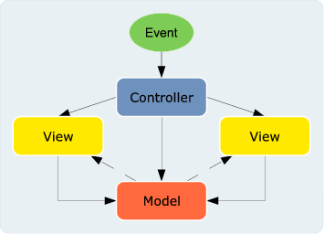

**MVC Architecture of the Project**

## **4.2. Entity Relationship Diagram**

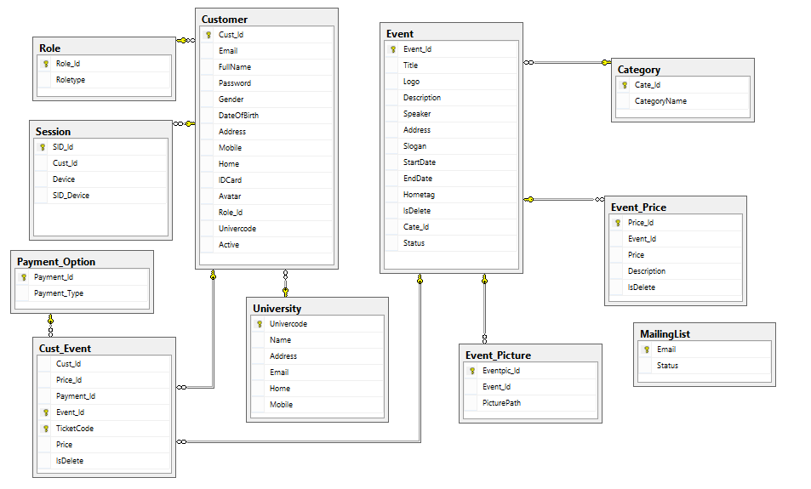

## **4.3. Database Design**

|  |  |  |  |  |
| --- | --- | --- | --- | --- |
| Table : **Role** | | | | |
| **Field Name** | **Data Type** | **Null** | **Key** | **Description** |
| Role_Id | int |  | PK |  |
| Role | nvarchar(max) |  |  |  |

|  |  |  |  |  |
| --- | --- | --- | --- | --- |
| Table : **University** | | | | |
| **Field Name** | **Data Type** | **Null** | **Key** | **Description** |
| univercode | int |  | PK |  |
| name | nvarchar(max) |  |  |  |
| address | nvarchar(max) |  |  |  |
| email | nvarchar(max) |  |  |  |
| home | Nvarchar(max) |  |  |  |
| moblie | nvarchar(max) |  |  |  |

|  |  |  |  |  |
| --- | --- | --- | --- | --- |
| Table : **Customer** | | | | |
| **Field Name** | **Data Type** | **Null** | **Key** | **Description** |
| Cust_Id | int |  | PK |  |
| Email | Unique nvarchar(200) | No |  |  |
| password | Nvarchar(100) |  |  |  |
| Gender | bit | No |  |  |
| DateOfBirth | date |  |  |  |
| Address | Nvarchar(max) |  |  |  |
| Mobile | Nvarchar(max) |  |  |  |
| Home | Nvarchar(max) |  |  |  |
| IDcard | Varchar(14) |  |  |  |
| Avatar | Nvarchar(max) |  |  |  |
| Role_Id | int |  |  |  |
| Univercode | int |  |  |  |
| Active | bit |  |  |  |

|  |  |  |  |  |
| --- | --- | --- | --- | --- |
| Table : **category** | | | | |
| **Field Name** | **Data Type** | **Null** | **Key** | **Description** |
| Cate_Id | int |  | PK |  |
| CategoryName | nvarchar(max) |  |  |  |

|  |  |  |  |  |
| --- | --- | --- | --- | --- |
| Table : **Payment_Option** | | | | |
| **Field Name** | **Data Type** | **Null** | **Key** | **Description** |
| Payment_Id | Int |  | PK |  |
| Payment_Type | Nvarchar(max) |  |  |  |

|  |  |  |  |  |
| --- | --- | --- | --- | --- |
| Table : **Event_Picture** | | | | |
| **Field Name** | **Data Type** | **Null** | **Key** | **Description** |
| Eventpic_Id | Int |  | PK |  |
| Event_Id | Int |  |  |  |
| PicturePath | nvarchar |  |  |  |

|  |  |  |  |  |
| --- | --- | --- | --- | --- |
| Table : **Event** | | | | |
| **Field Name** | **Data Type** | **Null** | **Key** | **Description** |
| Event id | Int |  | Pk |  |
| Title | Nvarchar(max) |  |  |  |
| Logo | Datetime |  |  |  |
| Description | Varchar(10) |  |  |  |
| Speaker | Nvarchar(max) |  |  |  |
| Address | Nvarchar(max) |  |  |  |
| Slogan | Nvarchar(max) |  |  |  |
| Startdate | Datetime |  |  |  |
| Enddate | Datetime |  |  |  |
| Hometag | Bit |  |  |  |
| Is delete | Bit |  |  |  |
| Cate id | Int |  |  |  |
| status | Bit default |  |  |  |

|  |  |  |  |  |
| --- | --- | --- | --- | --- |
| Table : **Event picture** | | | | |
| **Field Name** | **Data Type** | **Null** | **Key** | **Description** |
| Eventpic_Id | Int |  | Pk |  |
| EventId | int |  |  |  |
| PicturePath | Nvarchar(max) |  |  |  |

|  |  |  |  |  |
| --- | --- | --- | --- | --- |
| Table : **session** | | | | |
| **Field Name** | **Data Type** | **Null** | **Key** | **Description** |
| sid | Int |  | Pk |  |
| custid | int |  |  |  |
| device | Nvarchar(max) |  |  |  |
| Sid_Device | nvarchar(max) |  |  |  |

|  |  |  |  |  |
| --- | --- | --- | --- | --- |
| Table : **Event price** | | | | |
| **Field Name** | **Data Type** | **Null** | **Key** | **Description** |
| price id | Int |  | Pk |  |
| eventID | int |  |  |  |
| price | float |  |  |  |
| Description | check |  |  |  |
| isdelete | bit |  |  |  |

|  |  |  |  |  |
| --- | --- | --- | --- | --- |
| Table : **cust Event** | | | | |
| **Field Name** | **Data Type** | **Null** | **Key** | **Description** |
| cust id | Int |  |  |  |
| Price id | int |  |  |  |
| Payment id | int |  |  |  |
| Event id | int |  | pk |  |
| Ticket code | varchar(20) |  |  |
| price | float |  |  |  |
| Is delete | bit |  |  |  |

|  |  |  |  |  |
| --- | --- | --- | --- | --- |
| Table : **mailing list** | | | | |
| **Field Name** | **Data Type** | **Null** | **Key** | **Description** |
| Email | Varchar(200) |  | Pk |  |
| Status | bit |  |  |  |

# **5. Task Sheet**

|  |  |  |  |  |  |
| --- | --- | --- | --- | --- | --- |
| **Project Ref. No.:**  **eP/FURNITURESYSTEM/** | | **Date of Preparation of Activity Plan:** | | | |
| **Sr.No.** | **Task** | **Actual Start Date** | **Actual Days** | **Team Member Names** | **Status** |
| 1 | Create event | 21/10/2014 | 6 | Giáp, Hải | Completed |
| 2 | Select events | 27/10/2014 | 10 | Hải | Completed |
| 3 | Show event price  And create price | 27/10/2014 | 2 | Hải , Giáp | Completed |
| 4 | Event payment with webservice | 29/10/2014 to  2/11/2014 | 10 | Đức | Completed |
| 5 | Email active new account | 3/11/2014 | 5 | Đức | Completed |
| 6 | Show event, event detail | 8/11/2014 | 5 | Đức, Giáp | Completed |
| 6 | Registration account | 18to20/11/2014 | 10 | Đức, Giáp | Completed |
| 7 | Login admin and user | 18to 19/11/2014 |  | Hải, Đức , Giáp | Completed |
| 8 | Statistic | 15to21/11/2014 |  | Hải | Completed |

# **6. Checklist of Validations**

|  |  |
| --- | --- |
| **Option** | **Validated** |
| Can only admin can manage all information in Event management system? | Yes |
| Can only registered users choose event and event payment? | Yes |
| Can anonymous users only search and see the event infomation or cannot pay? | Yes |

# **7. Submission Checklist**

|  |  |  |  |  |  |
| --- | --- | --- | --- | --- | --- |
| **Sr.No.** | **Particulars** | **Yes** | **No** | **NA** | **Comments** |
| 1 | Is the Admin able to enter the Admin pages? | Yes |  |  |  |
| 2 | Are the customer able login in web? | Yes |  |  |  |
| 3 | System allow only administrator can manage all information belong to the system? | Yes |  |  |  |
| 4 | Can only registered users select event and event payment? | Yes |  |  |  |
| 5 | Can anonymous users only search and see the event or cannot pay? | Yes |  |  |  |
| 6. | Is the web site friendly? | Yes |  |  | Tested on IE, Chrome, Fire Fox |