

|  |
| --- |
| **FPT-aptech computer education** |
| User Manual  Furniture System |

|  |  |
| --- | --- |
| **Group** | |
| **Group Member** | |  |  | | --- | --- | | **Student** | **Student Code** | | Nguyễn Duy Đức | Student706828 | | Nguyễn Đức Hải | Student706859 | | Nguyễn Hoàng Giáp | Student706847 | |
| **Instructor** | Nguyễn Tuân |
| **Batch** | GC0804 |
| **Semester** | 4 |

-Hanoi,11/2014-

Admin

1. Login

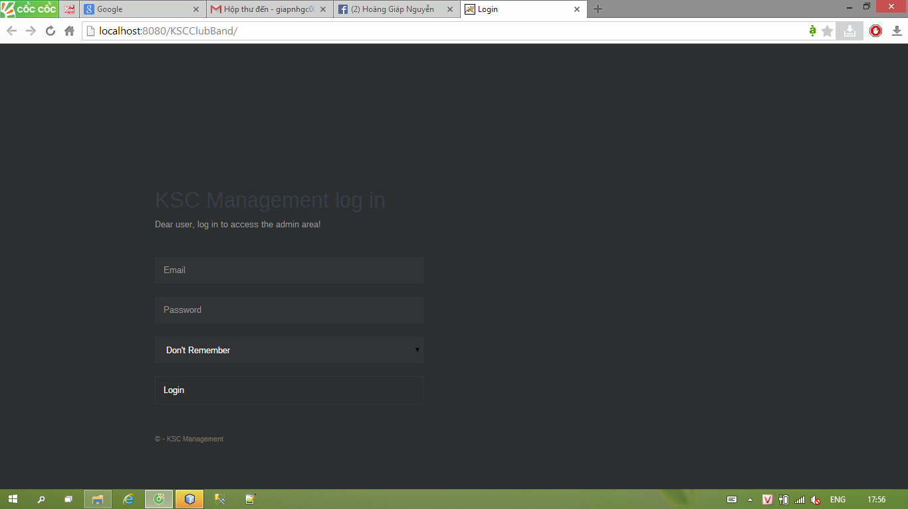

1. Filter

* Admin can see and edit event, show event profile

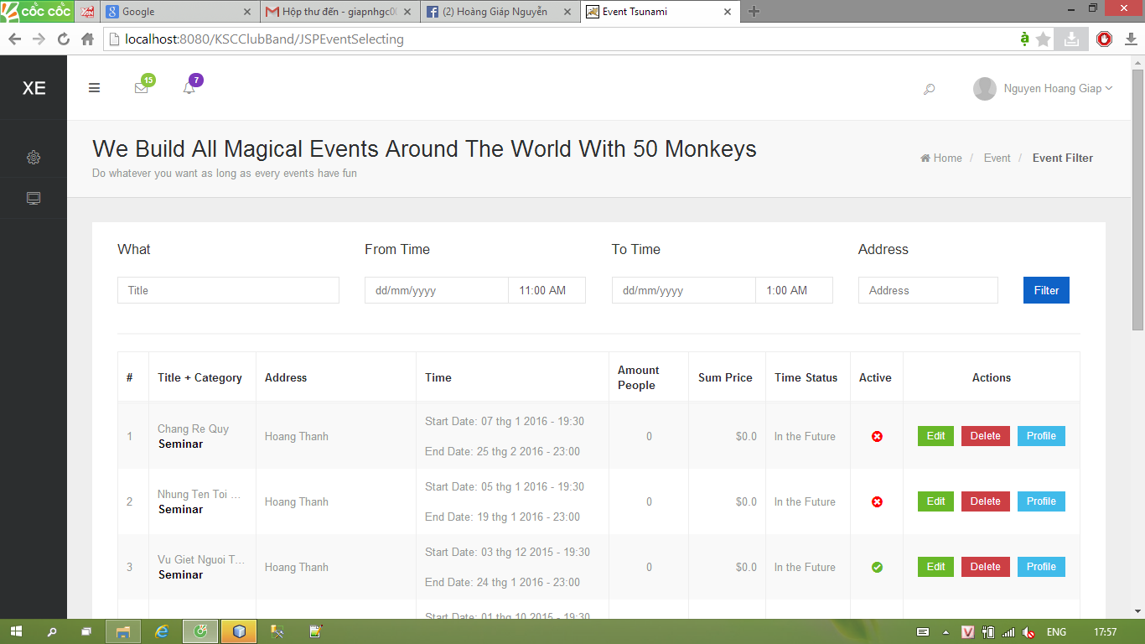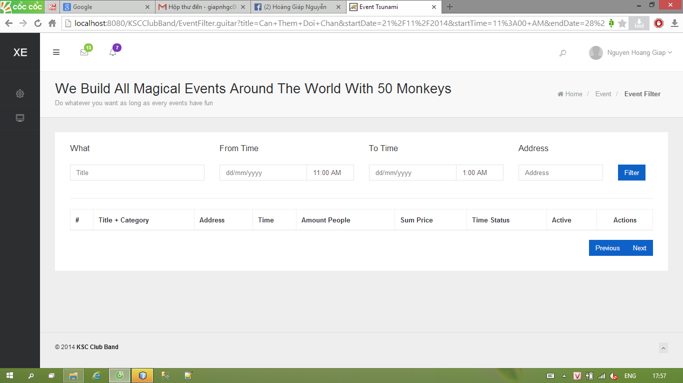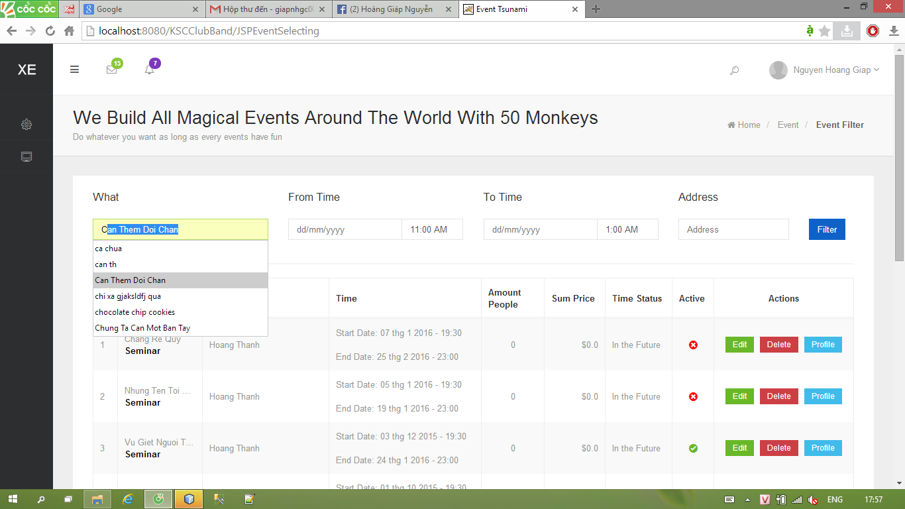

1. Event Information

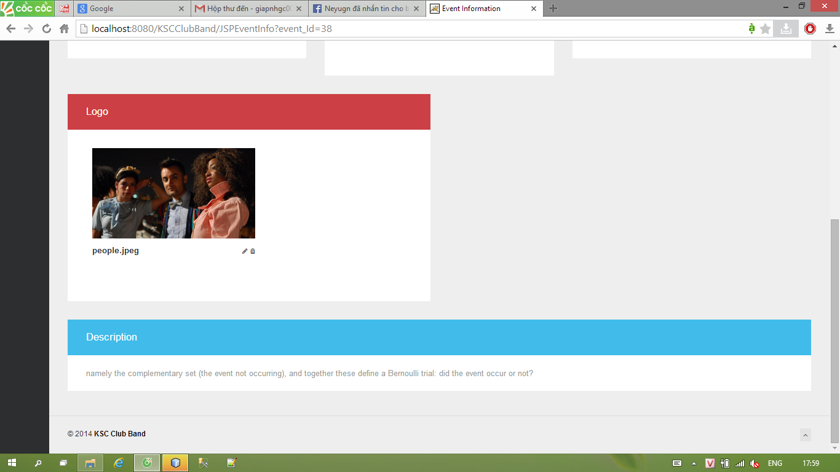

Admin can active, edit event profile, active or deactive them

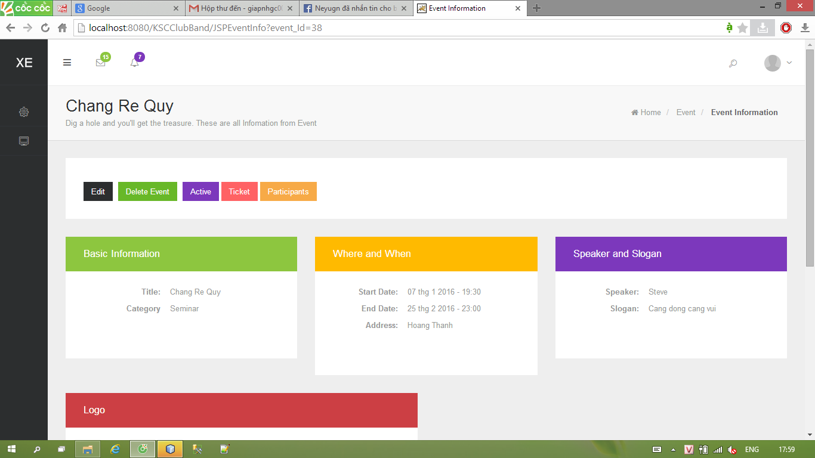

1. Event creating

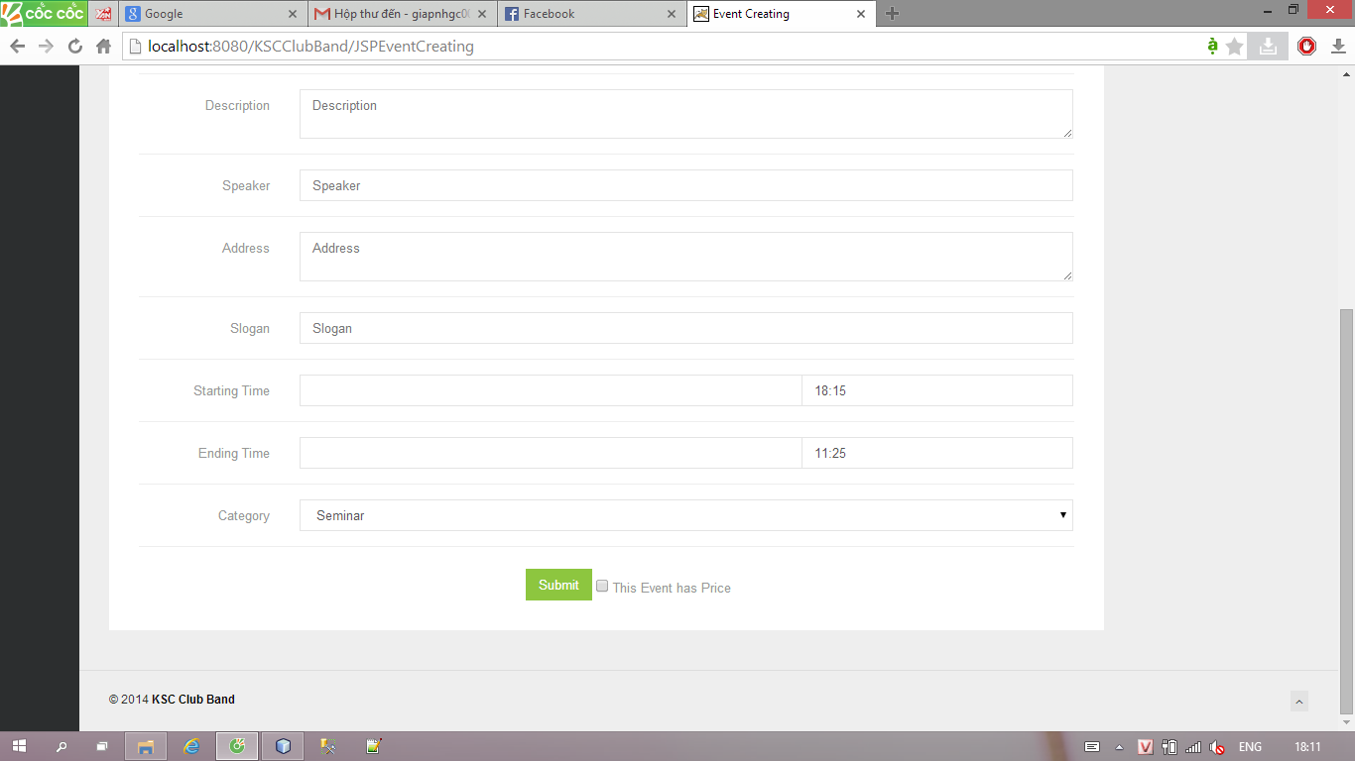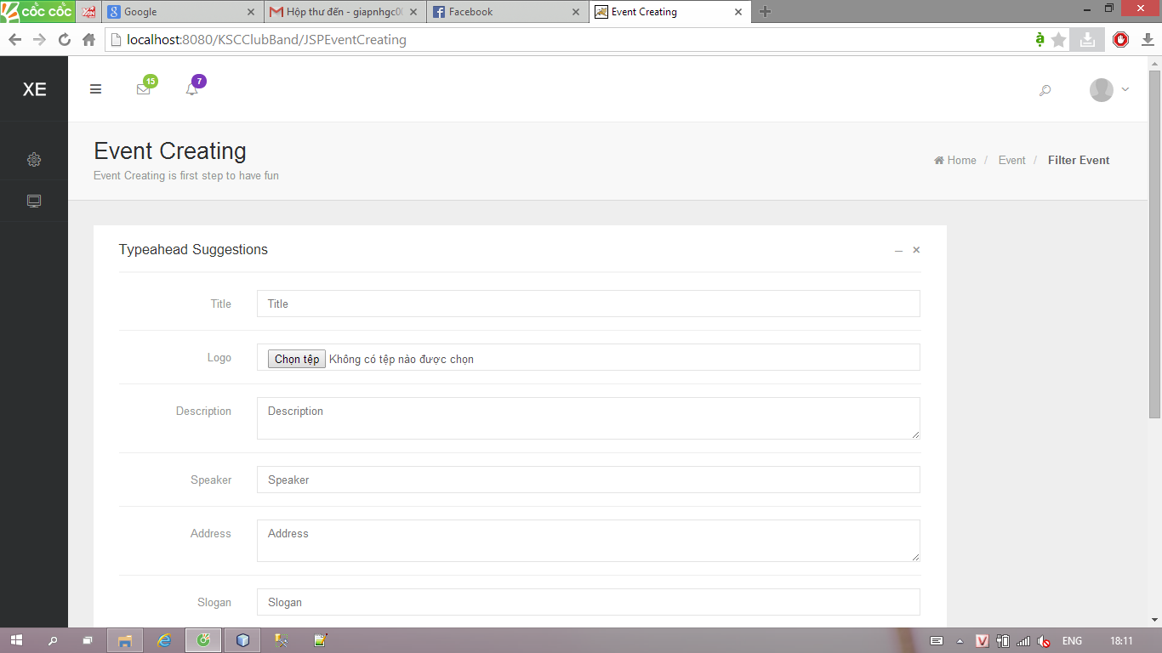

1. Create/Edit event price

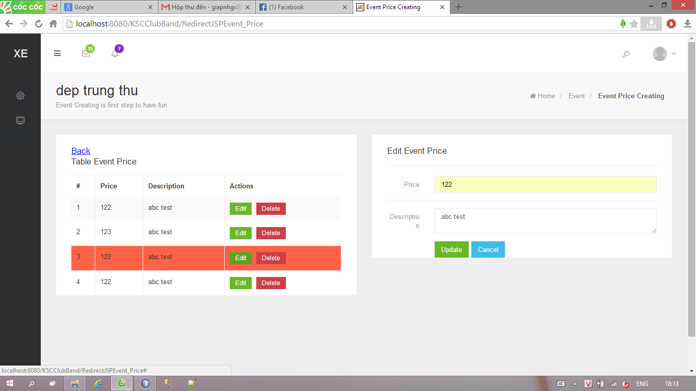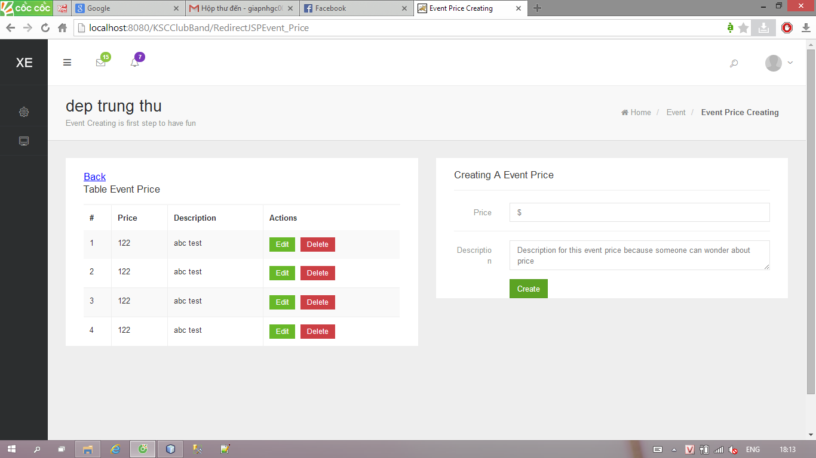

1. Statitic

