Predatory Stress Response of Hemigrapsus oregonensis to Carcinus maenas in Warming Environments
William Menapace
Abstract
Hemigrapsus orogenesis are a species of native shore crabs to the west coast of the United States. These populations are currently threatened by the presence of Carcinus maenas, an invasive species along the west coast characterized by diverse diets and tolerable environmental conditions. Current studies indicate that temperature is an important determining factor in distribution of these crab species. Carcinus maenas individuals are known to prey on and take over habitat space from Hemigrapsus orogenesis individuals. As the effects of global warming worsen, identifying how this competitive relationship shifts with changing temperatures is important for spatially honing conservation efforts. Here we show that increased temperature conditions likely increase the physiological stress of Hemigrapsus orogenesis with and without a predatory encounter with Carcinus maenas. This underscores the importance of temperature in determining the fitness of shore crabs. These results suggest that areas most susceptible to warming are where Carcinus maenas populations pose the highest threat to native shore crab species. More research is needed to determine the exact effects of predation of the stress of shore crabs.
Introduction
The Hairy Shore Crab (Hemigrapsus oregonensis) inhabits most intertidal areas along the mainland western United States and Canada. These crabs are known to be environmentally resilient, inhabiting a wide range of temperature and salinity conditions, as well as being able to survive out of water for long periods at a time. Hemigrapsus oregonensis are abundant in many intertidal habitats, providing a food source to larger local predatory species including larger crustaceans and marine birds. Currently, populations of the Hair Shore Crab (HSC) are being threatened by the continued invasion of the European Green Crab (Carcinus maenas). The European Green Crab (EGC) was first introduced to North American intertidal ecosystems along the eastern coast of the United States and was later transported to the west coast where populations quickly spiked (Turner et al., 2025). The EGC is now listed among the top 100 invasive species globally. The success of the EGC populations in North America can be attributed to the organisms’ wide range of tolerable environmental conditions as well as a diverse diet. EGC are known to be omnivorous, with one major food source being larval or juvenile HSC. Due to similarity in occupied habitat distribution, and viable temperature and salinity ranges between both crab species, competition between populations of HSC and EGC is becoming more prevalent (Fisher et al., 2024).
Most recently, EGC populations have begun to arise along the Washington coast and within the intertidal ecosystems around Puget Sound. HSC are known to be abundant and thrive in these ecosystems. Abundance assessments and conservation efforts are ongoing to quantify the presence of EGC within this region, and to assess the effects of their presence on native crab populations. It is known that EGC pose a threat to HSC populations through predation and possible habitat limitation; however, minimal research has been done characterizing the physiological effect of predation by EGC on the fitness of HSC individuals. In addition to mortality through predation, physiological stress response to EGC individuals may result in fitness loss for the HSC populations, decreasing available energy for growth, reproduction, and foraging.
As global warming increases, the habitats of EGC and HSC alike are expected to experience major thermal shifts, specifically increasing temperatures year-round (Walker et al. 2022). While both crab species exhibit a wide thermal tolerance range, previous studies have shown changes in EGC population distribution correlating with temperature and plateauing of abundance with high temperatures (Nielsen et al. 2025). To focus conservation efforts and identify areas of high ecological threat, it is important to quantify the response of HSC to EGC predation under rising temperature conditions. This project evaluates the changing physiological stress response of HSC using respirometry and behavioral measurements to EGC exposure under differing thermal conditions.
Methods
HSC and EGC individuals were gathered from Puget Sound in May 2026 and brought to the University of Washington Fisheries Teaching and Research building where they were housed separately in a lobster tank at ambient temperature and salinity conditions. 12 HSC individuals (6 male, 6 female) were divided among two treatment groups: ambient and elevated. The ambient group was housed in 10C, 35 ppt water and the ‘elevated’ group in 25C, 35 ppt water. To quantify stress response, three major metrics were used: respirometry, righting time, and distance travelled. Experimentation occurred over three weeks in lab, with measurements taken once a week and groups kept in respective conditions between trials. EGC individuals were housed together in ambient conditions throughout the entire 3-week period and only removed during experimentation times. HSC individuals were tagged and numbered to keep track of physiological metrics over the experimentation period.
Respirometry measurements were taken using a Resazurin assay. This method has most recently been developed at UW, and we followed the protocol outlined in Huffmyer et al. 2025.
Preliminary data for each HSC individual was collected during the first week. Individuals were weighed, measured for carapace width, tagged prior to being divided into treatment groups. Groups were split up evenly across sex with 3 males and 3 females in each. Carapace width varied by no more than 4 mm across all individuals and weight by 1.67 grams. Crabs were selected to be as similar in size and weight as possible. Initial righting times and respirometry measurements were also taken prior to moving crabs into treatment tanks. Righting time was measured by placing individual crabs on their back out of the water and timing (in seconds) how long it took for them to flip onto their ventral side. No predatory encounters occurred during week one to allow for treatment groups to acclimate to their respective conditions.
Experimentation during week 2 involved acquiring baseline respirometry and righting time for crabs after the first week acclimation period in the treatment tanks. Baselines in weeks 1 and 2 allow us to account for any response brought on by the thermal shifts and separate those from response due to predatory exposure. After these measurements, the first predator exposure trials took place. To simulate a predatory encounter in the field between an EGC and HSC, we constructed a test tank in which a HSC individual was introduced to an GC behind a see-through oyster net in water equivalent to the individual’s treatment condition. We then recorded the encounter and measured the distance traveled by the HSC within the tank. We measured this by constructing a small hallway for the HSC to move within, with distance measurements marked along the wall (Fig 1). Measurements were recorded using video footage post-experimentation. We then recorded righting time immediately after the predatory encounter. We finally performed hemolymph extractions for all crabs to contribute to the larger UW FISH 460 group dataset.
Results
The Resazurin assays show little variation in respiration level across both ambient and elevated groups from pre to post predator encounter. There is, however, a significant change in Respiration level from week 1 baseline assays to week 2. Across all weeks, there is no significant difference between elevated and ambient groups along all timepoints. Greatest individual variation in respiration level occurred during week 1 (Fig 2).
For righting time, the ambient group of HSC showed variation across all four measurements. Baseline measurements from week 1 indicate an average righting time of 0.75 seconds. This increased in week 2 baseline measurements where individuals had an average righting time of approximately 1.25 seconds. After predator exposure in week 2, righting time dropped overall, decreasing to an average of approximately 0.8 seconds. This trend continued in week 3 where righting time was approximately 0.95 seconds for the ambient group. The elevated group showed even greater variation between trials and individuals. Baseline measurements for week 1 were around 0.9 seconds, which continued into week 2 baseline measurements (also approximately 0.9 seconds). Post-predator encounters righting times for week 2 did not significantly change from baseline (Fig 3).
Distance travelled by HSC within the predator encounter tanks was variable in all scenarios with minimal trends between treatment group. The range in movement observed was greater post-predator encounter for both groups with preliminary data showing a maximum of 30 cm travelled and predator-encounter data showing a maximum of approximately 65 cm. Elevated crabs did exhibit faster response times than the ambient crabs post-acclimation in week 2. Greater distance travelled was also more common among elevated crabs during the predator encounter than it was for ambient crabs. It should also be noted that 3 of the 6 shore crabs in the elevated group died in the third week of experimentation.
Discussion
The results of this experiment indicate that elevated temperatures effect physiological stress of HSC. Due to greater variation in righting times, increased reaction time to the EGC predator, heightened behavioral activity, and ultimate mortality, we can conclude that elevated temperatures likely influence heightened exercise or behavioral responses to an HSC individual’s environment. Based on the results of the Resazurin assays, we cannot determine the effects of elevated temperature or predatory encounter on respiration levels within HSC individuals. Our results indicate that there is no change between ambient and elevated treatment groups, possibly indicating little to no effect of temperature on respiration of HSC. However, our results are supported by those from a previous study showing a decrease in respiration levels after acclimation to changing temperature conditions (Griffen et al., 2024).
In accordance with previous studies, elevated temperature was shown to increase activity of the HSC individuals, exhibited by decreased righting time post-acclimation and more erratic behavior. The mortality of the HSC individuals at high temperature may be explained by this increased stress. This is further supported by known plateauing of crab populations at high temperatures (Nielsen et al., 2025).
Conclusions
Elevated temperatures result in higher physiological stress for HSC and heighten behavioral response. Shifting predatory response under changing temperature conditions in still unknown based on these results. This study underscores the need for continued investigation into the dynamics between EGC and HSC. The predatory encounter outlined in this project did not produce the hypothesized results, with HSC individuals moving towards or even hiding next to EGC individuals. To improve the metrics recorded here, more trials and robust setups are required to achieve reliable results. Ultimately, more work is needed to determine the exact effects of predator encounters on physiological stress of HSC.
Figures
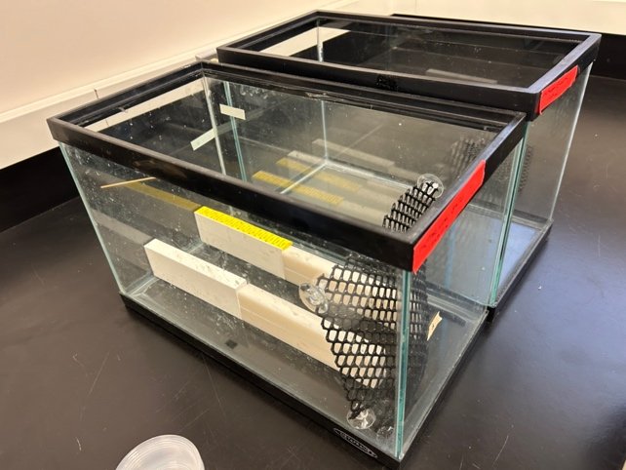
Fig 1. Predatory encounter tank set up. Two tanks set up for each treatment group. White plaster walls formed hallway in which HSC was placed. Black oyster net attached to bottom and sides of tank to separate the EGC from the HSC and allow for olfactory response to occur.
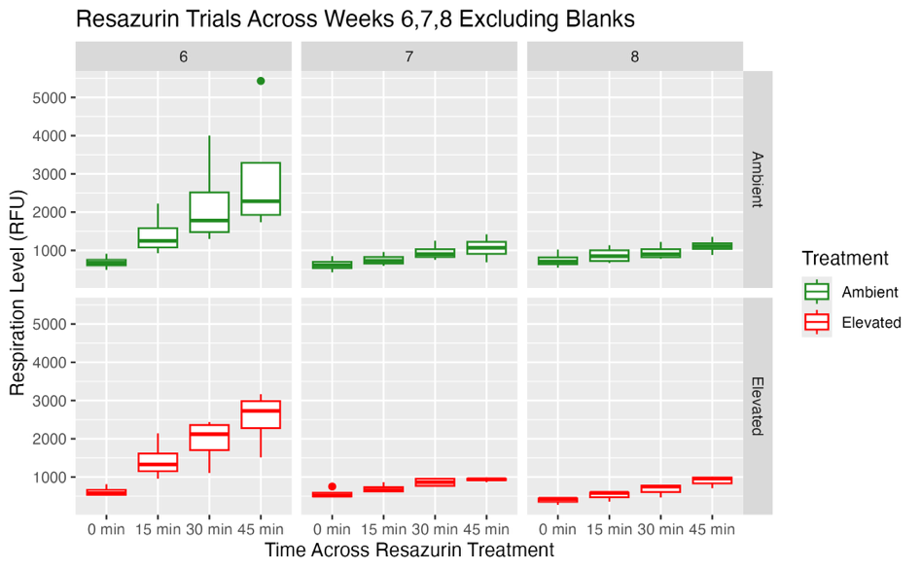
Fig 2. Resazurin trials across all weeks, numbers 6, 7, and 8 correspond to weeks 1, 2, and 3 of experimentation, respectively
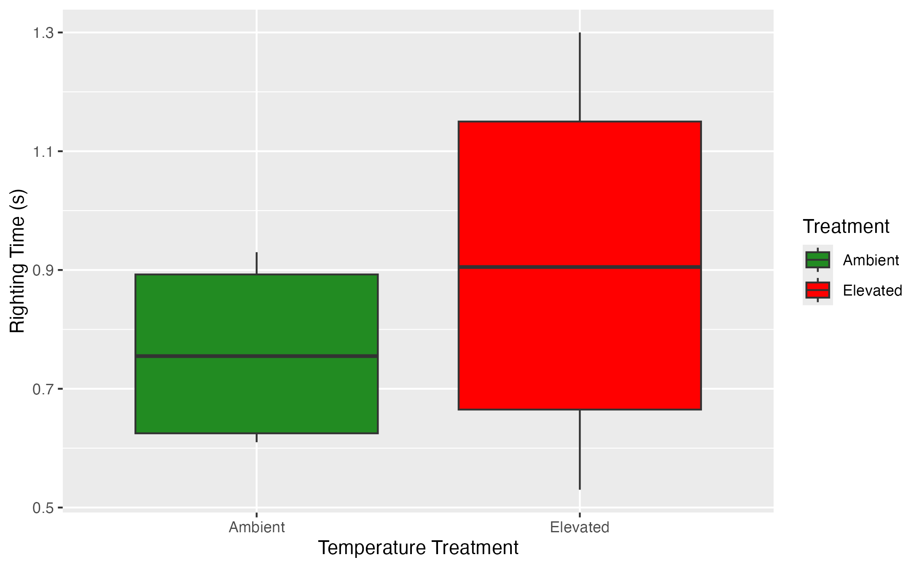
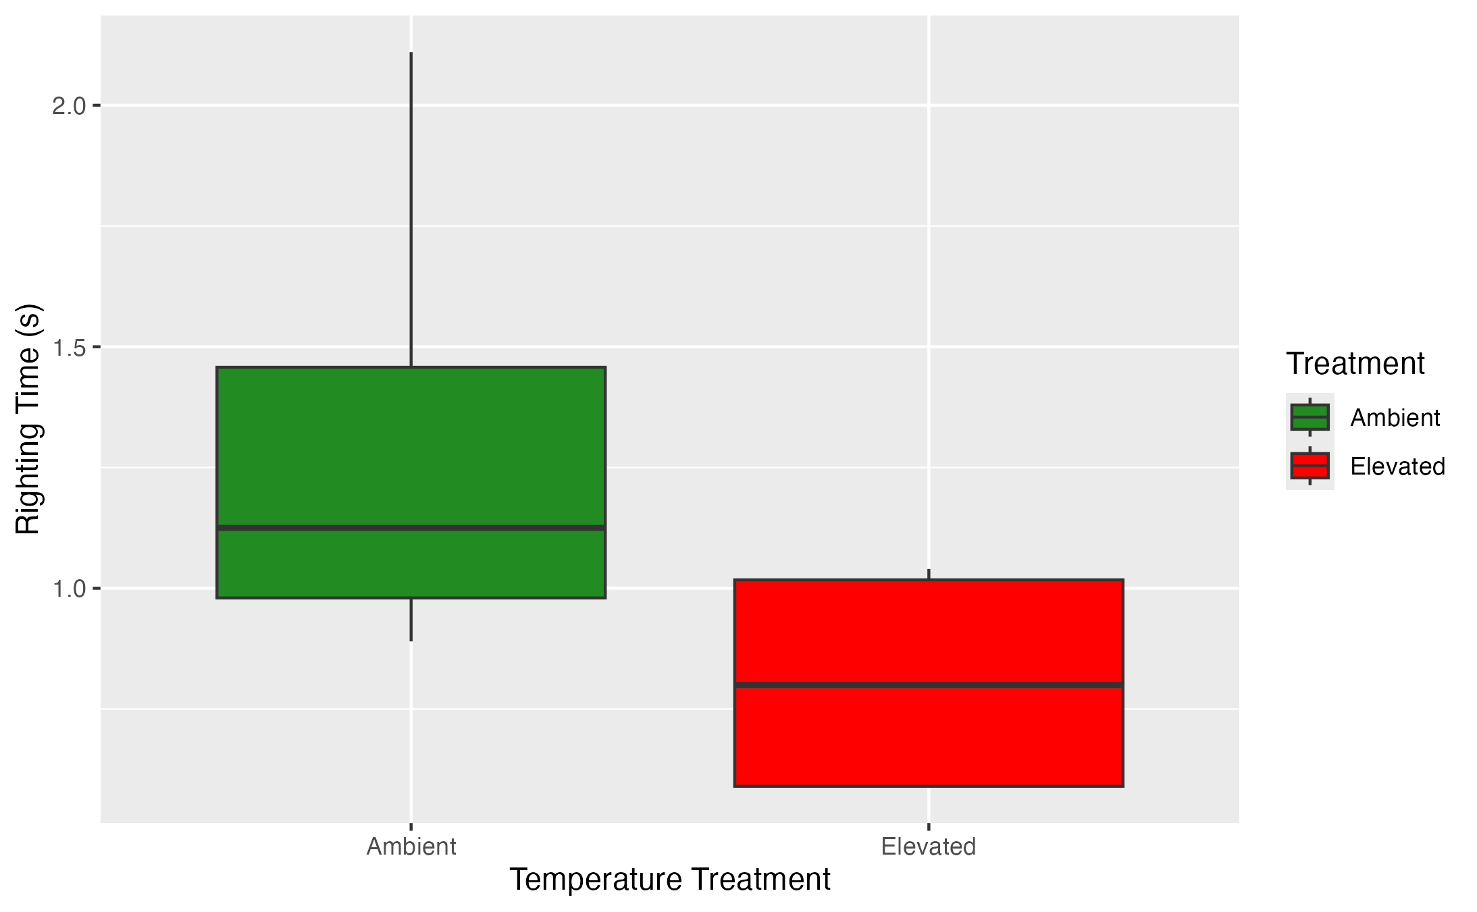
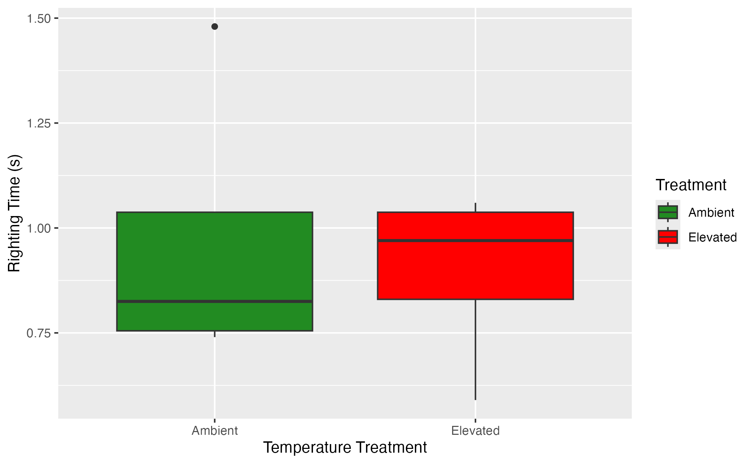
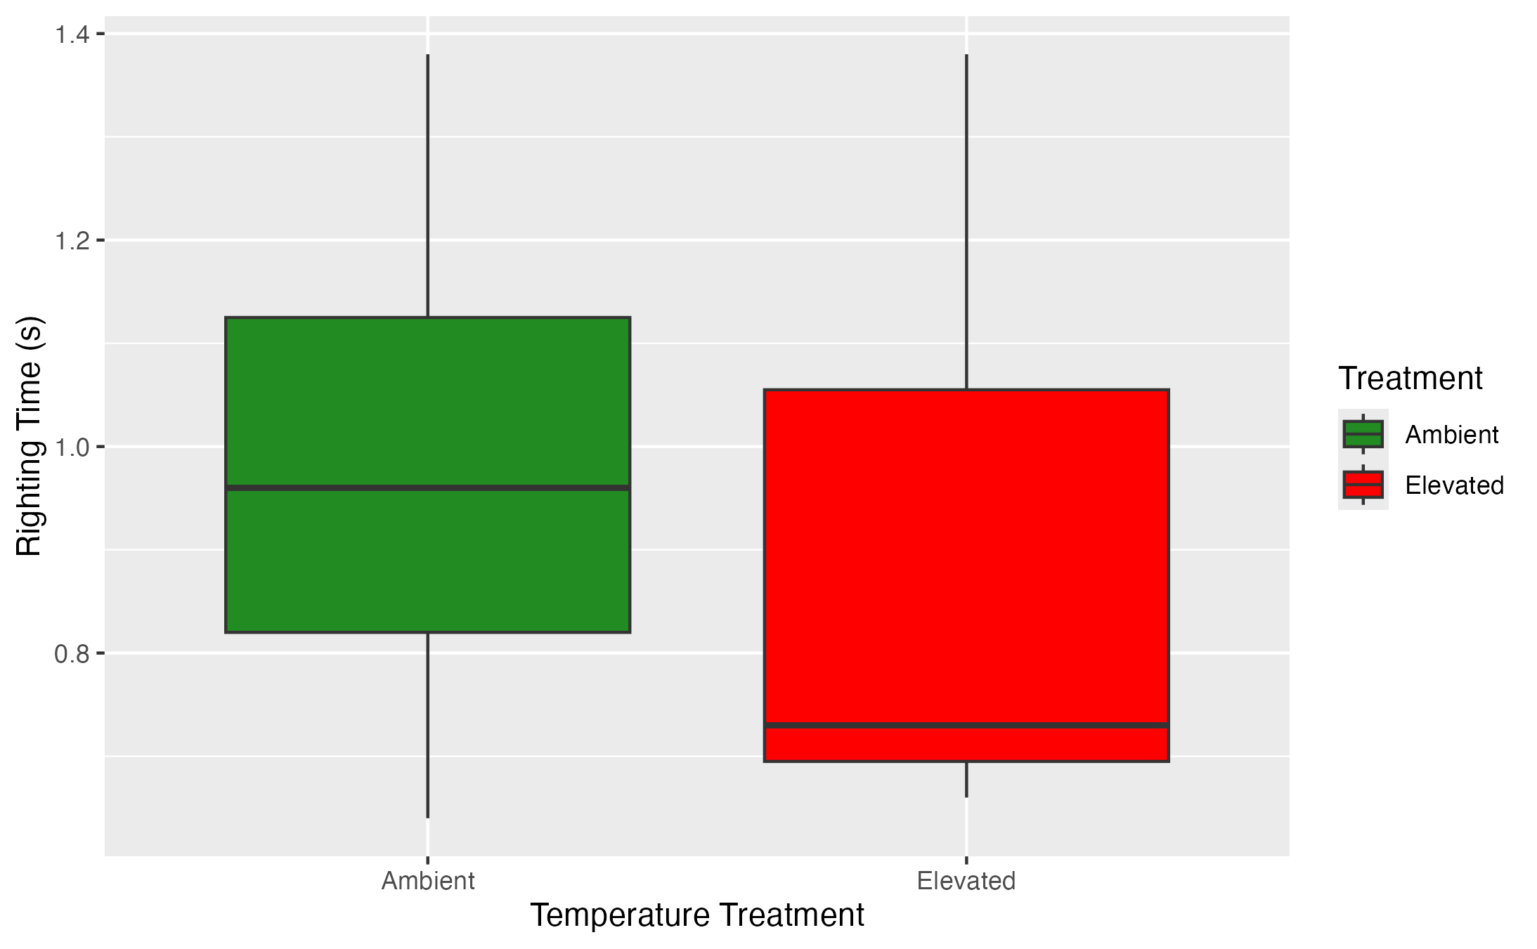
Fig 3. Righting time averaged across treatment groups. Top left is week 1 baseline data, top right is week 2 post-acclimation data, bottom left is week 2 post-predatory encounter, and bottom right is week 3
Fig 4. Distance Travelled by HSC. Top Left is week 1 preliminary data. Top right is week 2 baseline data post-acclimation to treatment. Bottom is week 2 post predator encounter.
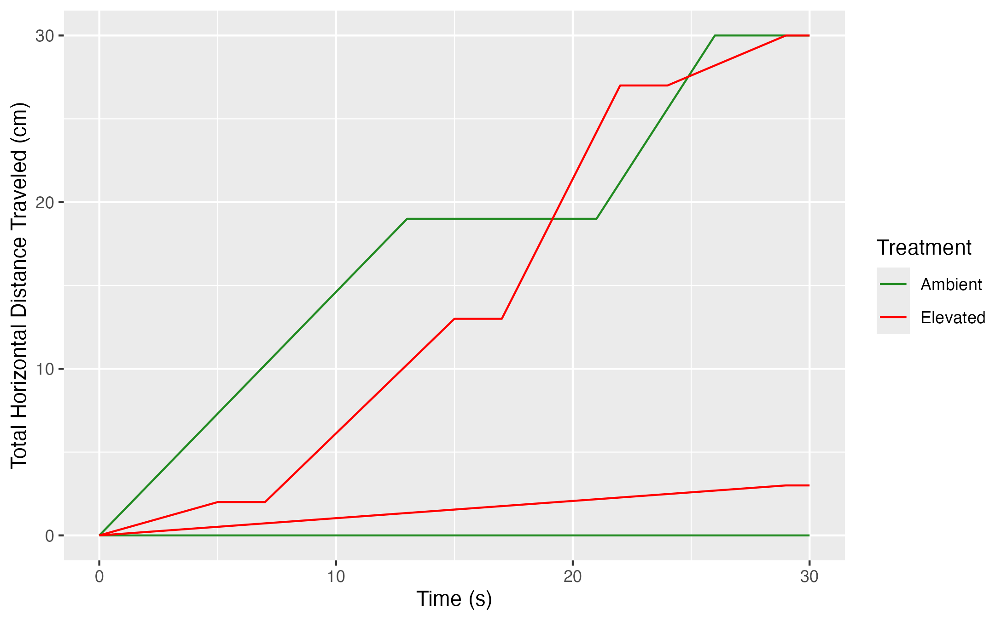
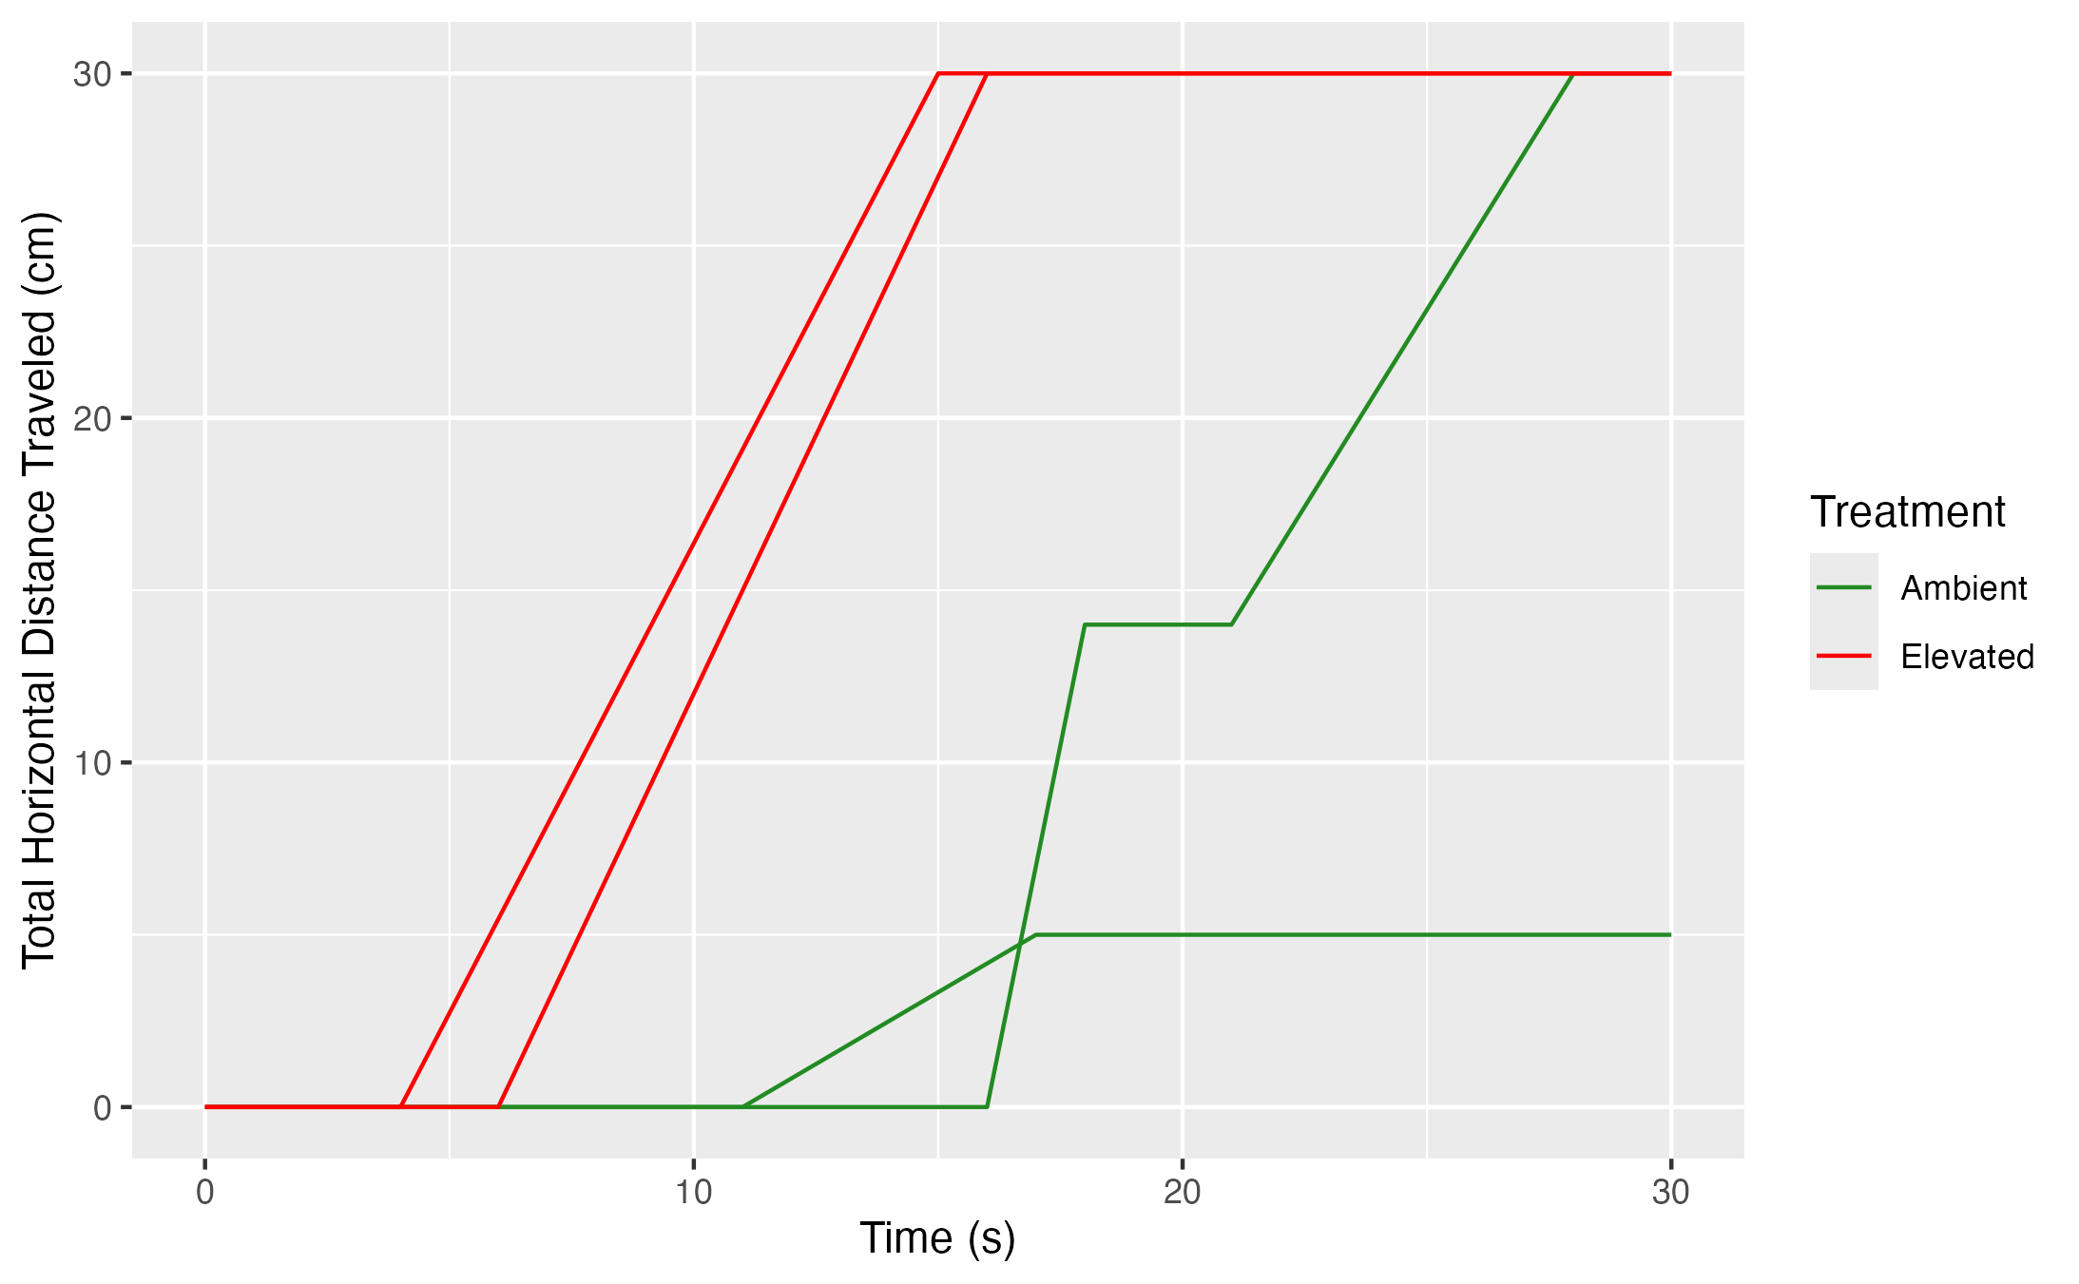
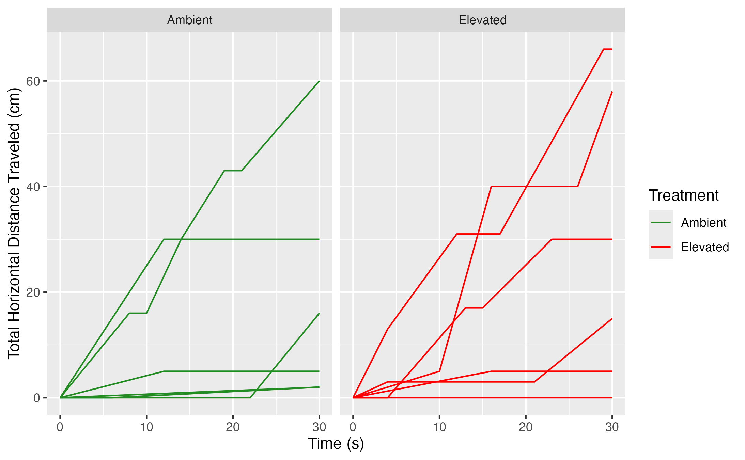
References
Fisher, M. C., Grason, E. W., Stote, A., Kelly, R. P., & Litle, K., McDonald, P. S. (2024). Invasive European green crab (Carcinus maenas) predation in a Washington State estuary revealed with DNA metabarcoding. PLoS ONE, 19(5): e0302518. doi:10.1371/journal.pone.0302518.
Griffen, B. D., Ashton, I. B., Dominguez-Villalobos, A., Fletcher, L. S., Marlow, B. N., Raj, V., Reese, L. A., Reese, T. C. & Richardson, H. C. (2024). Variation in metabolic rate during low tide aerial exposure in the Asian shore crab Hemigrapsus sanguineus. Marine Biology, 171(129). doi:10.1007/s00227-024-04449-8
Huffmyer, A. S., & Ozguner, N. (2025). From blue to pink: Resazurin as a high-throughput proxy for metabolic rate in oysters [Preprint].bioRxiv. https://doi.org/10.1101/2025.11.06.686367
Nielsen, M. S., Svendsen, J. C., Wilms, T., Bertelsen, J. L., Kruse, B. M., & Lindegren, M. (2025). Factors influencing the abundance of European green crab (Carcinus maenas): Combined effects of temperature, habitat and predator release. Estuarine, Coastal and Shelf Science, 322, 109374. doi:10.1016/j.ecss.2025.109374.
Turner, B. C. (2025). European Green Crab Joint Quarterly and Annual Progress Report – April 1 to June 30, 2025, and Fiscal Year 2025 (July 1, 2024, to June 30, 2025). Olympia, WA. Washington Department of Fish and Wildlife.
Walker, S., Mozaria-Luna, H. N., Kaplan, I., & Petatán-Ramírez, D. (2022). Future temperature and salinity in Puget Sound, Washington State, under CMIP6 climate change scenarios. Journal of Water and Climate Change. 13 (12): 4255–4272. doi: 10.2166/wcc.2022.282.

