Glucose Assay Protocol

Sample Prep:
- Collect blood using hemolymph extraction
- Centrifuge at 700-1000 x g for 10 min at 4C.
  - Pipette the top yellow layer off being careful not disrupt white layer
  - Store plasma on ice while not using
- Dilute plasma 1:5 with diluted Assay buffer before assaying

Standard Perp:
- Mix 50 microliters of the 1000 mg/dl Glucose Standard with 450 microliters of diluted Assay Buffer (100mg/dl stock)
- Label 8 clean glass test tubes/polystyrene tubes (A-H), and add the amt of glucose in Table 1.
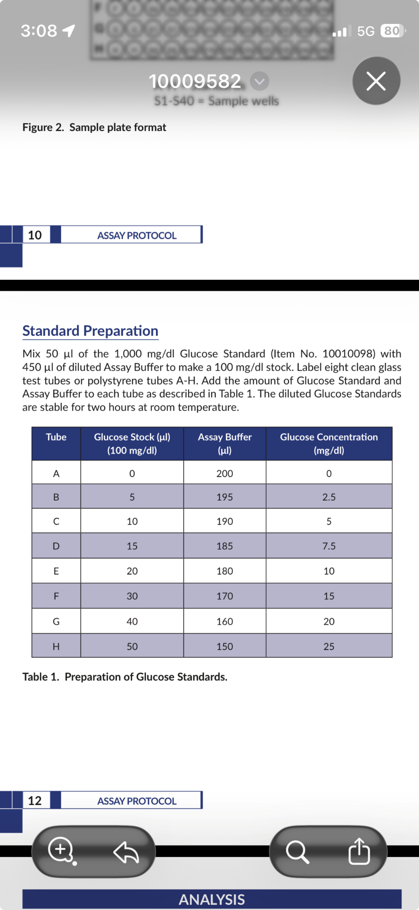

Performing Assay:
- Glucose standard wells – add 85 microliters of diluted Assay buffer and 15 miccroliters of each standard tube (A-H) to two wells (Figure 1.)
- Sample wells – add 85 microliters of diluted Assay Buffer and 15 microliters of sample to two wells
- Initiate the reaction by adding 100 microliters of the enzyme mixture to all the standard and sample well
- Cover the places with the plate cover and incubate for 10 min at 37 C
- Remove plate cover and read the absorbance at 500-520 nm using a plate reader

Calculations:
Glusoce (mg/dL) = [ ((corrected absorbance)-(y-intercept)) / Slope)] * dilution

