The Effects of Elevated Temperature and Desiccation on Two Intertidal Crab Species: Carcinus maenas and Hemigrapsus oregonensis
Chloe Rusk
Abstract
Global warming is increasing ocean temperatures around the globe. In the Puget Sound, we could see a significant increase in temperature which can have negative impacts on local organisms, especially those that can’t self-regulate their temperature such as crabs. These impacts are exacerbated when crabs spend time out of water and experience desiccation, which increases felt temperature. However, there is variation in thermal tolerance between crab species. The invasive European green crab Carcinus maenas can withstand a wider range of temperatures than the native Hemigrapsus oregonensis, which poses a threat to native species as temperatures rise. It is important to understand how increasing temperature will affect invasive vs native crab species. Here we used metabolism as a proxy for stress to study how these two crab species respond to desiccation in control vs elevated water temperatures. We found that both crab species in elevated temperatures experienced less change in metabolism after desiccation than those in control temperatures. This indicates that by acclimating to warm temperatures in water, desiccation is less of a temperature shock and causes less of an increase in metabolism. However we also saw that H. oregonensis had significantly higher metabolism in elevated temperature water, indicating that they will experience more stress as temperatures increase. These results show that native crab species in the Puget Sound will experience more stress as water temperatures increase than the invasive green crab.

Introduction
Temperatures have been increasing due to climate change and global warming. In the Puget Sound, seasonal water temperature already varies from 8-13°C, and is expected to increase up to 19.6°C by 2050 (Walker et al, 2022). This warming has detrimental effects on marine organisms, especially for those which spend time out of water (Griffen et al, 2024). Temperature is experienced differently when exposed to air compared to in water due to the lower specific heat capacity of air. Therefore marine organisms that experience desiccation are more at risk from temperature increase due to global warming.
This is especially true for ectotherms. Ectotherms are marine organisms that do not regulate their body temperature, and instead internal metabolic processes are directly affected by environmental temperature (Dehnel, 1960). Intertidal crabs are ectotherms that regularly experience desiccation so global warming will likely have a significant impact on their metabolism and therefore their fitness.
However, within ectotherms, and even within intertidal crab species, there is great variability in temperature tolerance. Some crabs, like the European green crab (Carcinus maenas), have a wide range of temperatures they can withstand (Tepolt et al, 2020), while other species like the hairy shore crab (Hemigrapsus oregonensis) have a narrower heat tolerance range (Todd et al, 1960). These differences can lead to dominance of one species, especially when temperatures become extreme such as during desiccation.
C. maenas is an invasive species in the Puget Sound and threatens native crab species such as H. oregonensis. It is important to understand how both these crabs will tolerate future climate change conditions. This information can help inform removal efforts for the invasive green crab by determining how warming waters will affect their distribution. It can also offer insight into whether native species like H. oregonensis will be able to compete as temperatures rise.
Our study aims to understand how increases in water temperature will affect two competing intertidal crab species (H. oregonensis and C. maenas) during desiccation. We will first find the base metabolic rate of each species to compare them pre-experiment. Then we will measure their metabolism before and after desiccation in either control or elevated water temperature to compare how desiccation, species, and water temperature affects their metabolic rate.

Methods
Our experiment involved ten hemigrapsus oregonensis crabs and two carcinus maenas crabs. All crabs underwent an initial resazurin trial to obtain control metabolic rates. Two shallow trays were filled with our control temperature water at 14℃. In these trays, two six-well plates and four small plastic cups were placed. Each well of the six-well plates were filled with 8mL of the resazurin solution, and each cup was filled with 40mL. 200uL of resazurin was pulled from each plate before the trial at t=0 and each sample was added to a 96-well plate. Each H. oregonensis was placed in its own well, and each C. maenas was placed in one of the cups. The unused wells and cups were used as controls. After the crabs were placed, 200uL resazurin samples were taken every 10 minutes for an hour. The 96-well plate then went through a fluorometer to measure the fluorescence of the solution, which is a proxy for oxygen consumption.
After the initial resazurin trial, each crab was rinsed and tagged. Basic measurements were taken for each crab (sex, weight, and carapace length). Sex and length were used to determine the similarity of each crab, while weight was used to normalize metabolism between crabs. Each crab was returned to the control water temperature.
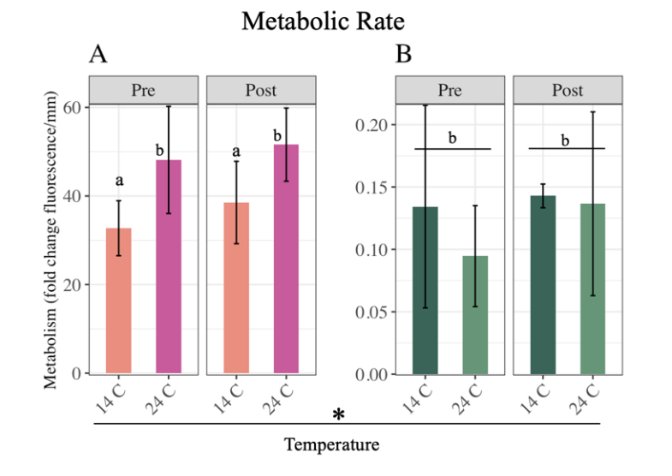
To test the effects of elevated water temperature and desiccation on both crab species, each species group was randomly split in half. Five H. oregonensis and one C. maenas went to the experimental group while the others were in the control group. Another resazurin trial was conducted to obtain pre-desiccation metabolism. For this trial, the experimental group was held in a tray of 24℃ water while the control group remained in the 14℃ temperature. The trial was conducted the same as above. After the trial, each crab was rinsed and then placed in a corral of medium-grain sand underneath a heat lamp. The sand temperature was held at 30℃. The crabs remained in this corral for 30 minutes to simulate desiccation. Afterwards, a post-desiccation resazurin trial was conducted. This trial followed the same protocol as the pre-desiccation trial. The entire experiment was repeated a second time in order to obtain more replicates.

Results
Metabolism was calculated as the change in fluorescence over the hour of the resazurin trial. Metabolism was normalized by crab weight. Percentage change in metabolism before vs after desiccation was calculated.
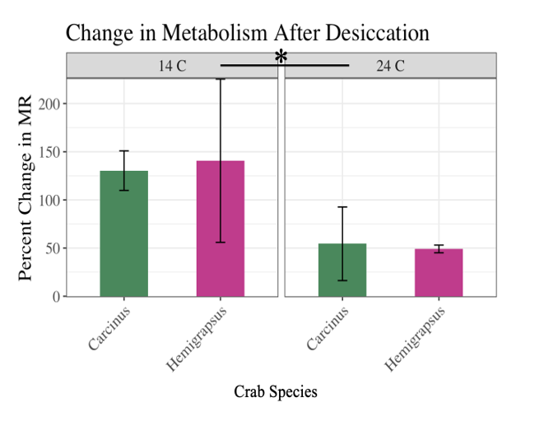
We saw a significant difference in metabolism between the control and experimental temperature H. oregonensis groups (Fig 1). C. maenas saw no difference in metabolism between water temperatures (Fig 1).
Figure 1. Metabolism as a fold change in resazurin fluorescence/mm for Hemigrapsus oregonensis (A) and Carcinus maenas (B) pre and post desiccation at a control (14C) and elevated (24C) temperatures. ‘a’ is significantly different (p-val < 0.05) than ‘b’. Standard deviation represented as error bars.
There was also a difference in metabolism before and after desiccation (Fig 2). This change was significantly higher in the control temperature group, reaching around 130% change, than in the elevated temperature group which was around a 50% change (Fig 2). Between species, there was no significant difference in the percent change of metabolism pre vs post desiccation.
Figure 2. Percent change in metabolism after desiccation for Hemigrapsus oregonensis and Carcinus maenas in control (14C) and elevated (24C) temperatures. Control temperature percentage change is significantly different from elevated temperature percent change (p-val < 0.05). Standard deviation represented as error bars.

Discussion
Our results showed that H. oregonensis are more susceptible to changes in water temperature than C. maenas are. We can see this in figure 1 where H. oregonensis in the 24℃ water had higher metabolism than in the 14℃ water. This indicates higher stress and less ability to tolerate warmer water because their metabolism is increasing significantly with an increase in temperature. An increase in metabolism can be bad for crabs since it increases demand for energy.
We also found that crabs in elevated temperatures did better post-desiccation than crabs in control temperatures. This is likely due to a smaller difference in temperature between the warm water and the sand temperature (24°C to 30°C) than the control water and sand temperature (14°C to 30°C). This implies that even as water temperatures increase, the consequential increase in air temperature won’t have as significant an impact on crabs during desiccation.
We did not see any difference in change in metabolism after desiccation between species. This means that both species had a similar percent change in metabolism after desiccation, so neither species was more tolerant of desiccation as a whole.
Future studies should continue to study how native vs invasive species respond to stressors. This study was very limited in the number of green crabs, so future studies could replicate this one with more green crabs to get more rigorous results. Also further studies using resazurin as a proxy for metabolism would continue to refine this method of studying metabolism in marine organisms.

References
Dehnel, P. A. (1960). Effect of Temperature and Salinity on the Oxygen Consumption of Two Intertidal Crabs. Biological Bulletin 118(2) 215-249.
Griffen, Blaine D, et al. (2024). Variation in Metabolic Rate during Low Tide Aerial Exposure in the Asian Shore Crab Hemigrapsus Sanguineus. Marine Biology 171(6).
Todd, M. & Dehnel, P. (1960). Effect of Temperature and Salinity on Heat Tolerance in Two Grapsoid Crabs, Hemigrapsus nudus and Hemigrapsus oregonensis. Biological Bulletin 118(1) 150-172.
Tepolt, C. K. & Somero, G. N. (2014). Master of All Trades: Thermal Acclimation and Adaptation of Cardiac Function in a Broadly Distributed Marine Invasive Species, the European Green Crab Carinus maenas. Journal of Experimental Biology 217(7) 1129-1138.
Walker, S., Mozaria-Luna, H. N., Kaplan, I., & Petatan-Ramirez, D. (2022). Future temperature and salinity in the Puget Sound, Washington State, under CMIP6 climate change scenarios. Journal of Water and Climate Change 13(12), 4255-4272.

