Internal temperature response to external temperature

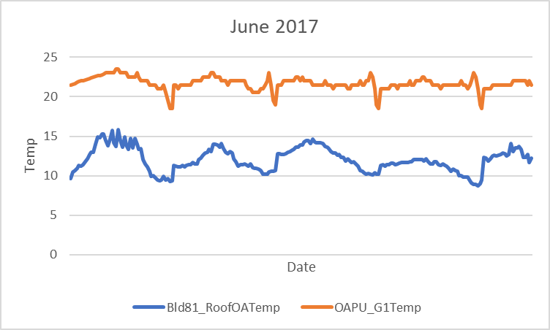

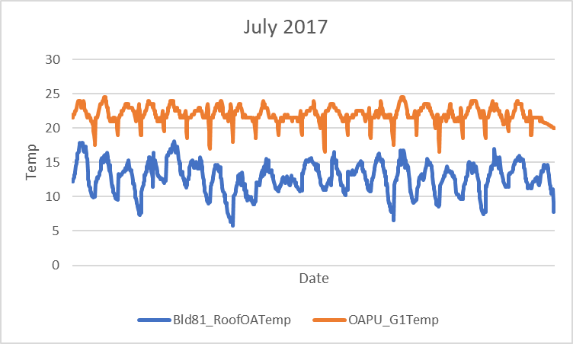

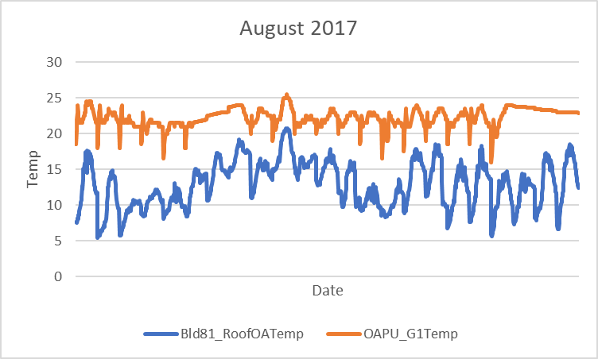

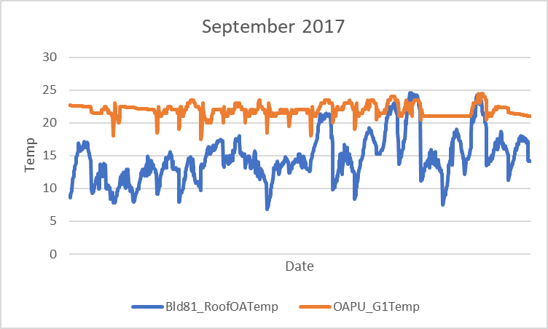

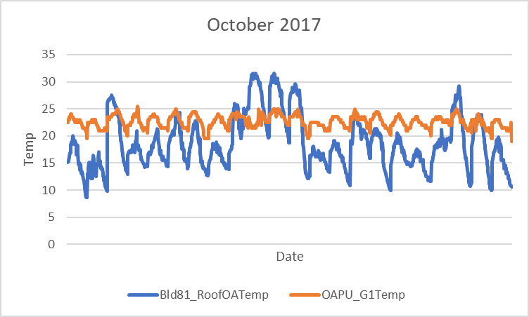

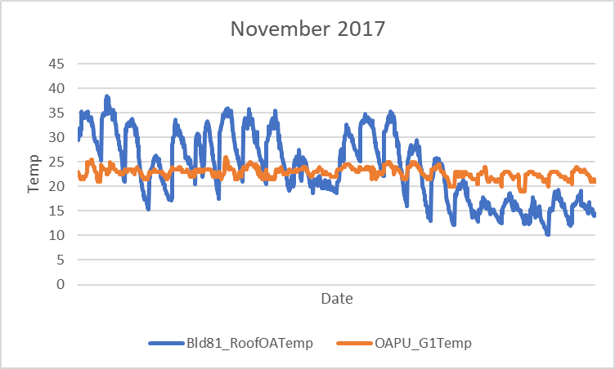

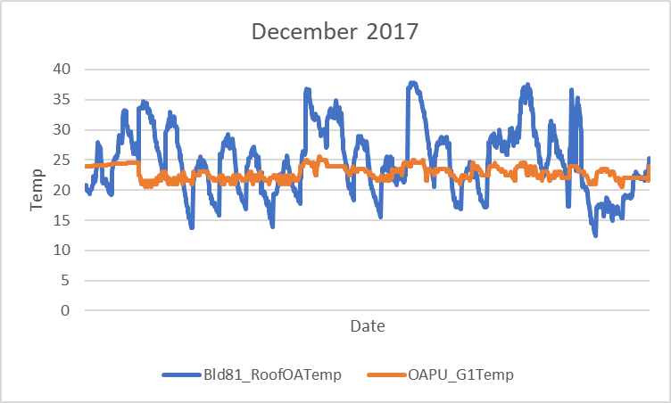

Relationship between external temperature and internal temperature

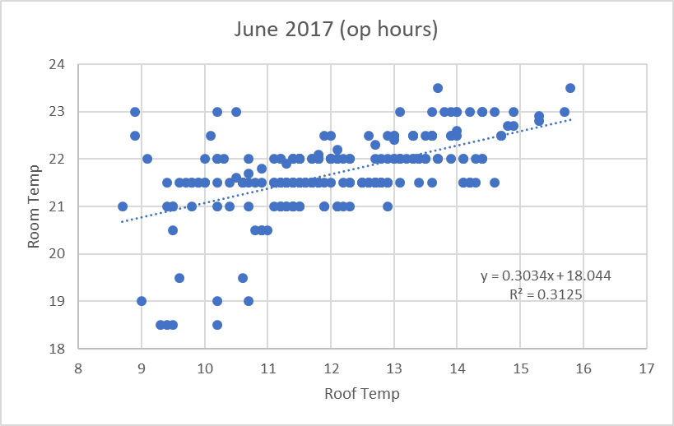

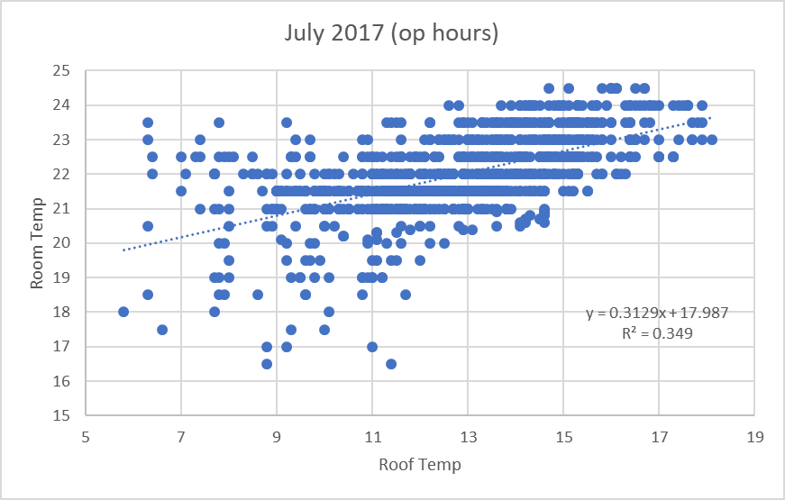

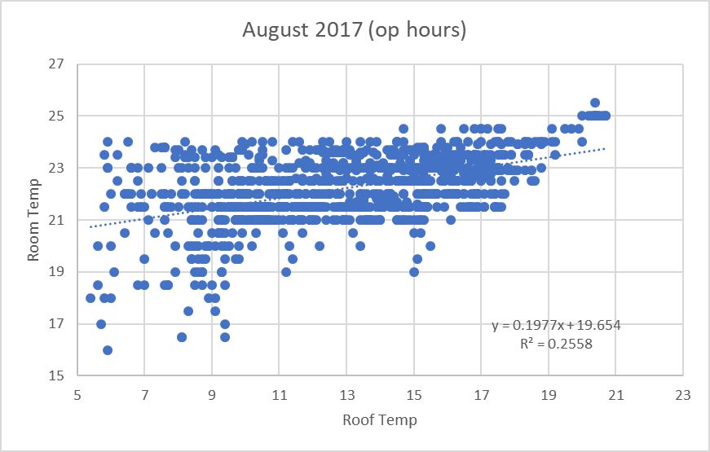

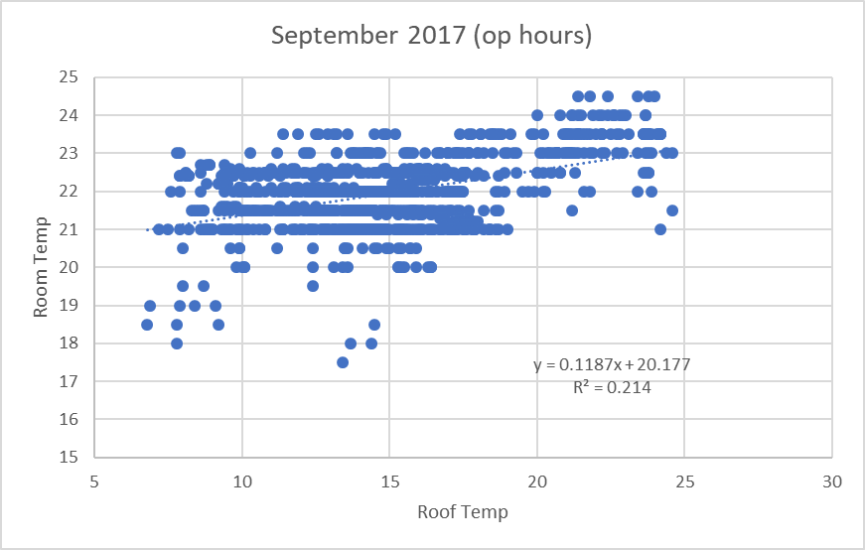

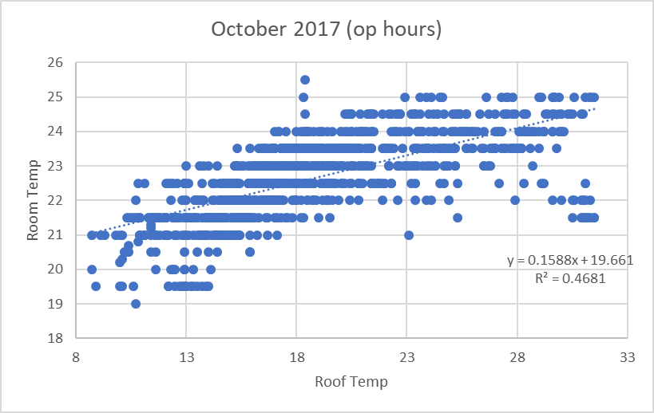

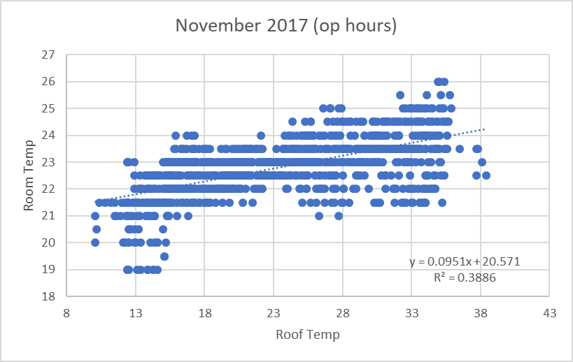

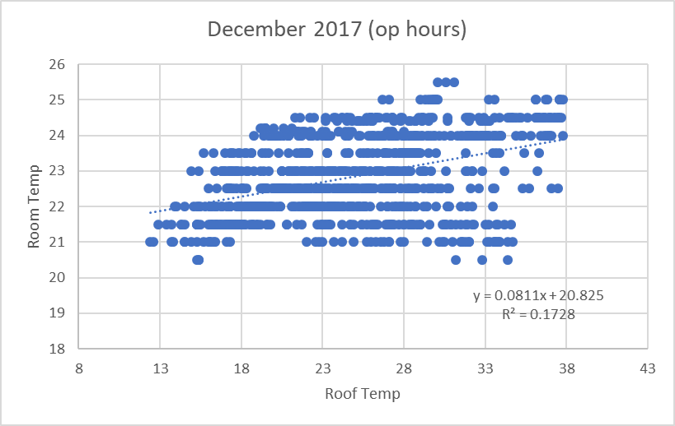

Correlation between room temperature and roof temperature

|  |  |
| --- | --- |
| **Month** | **R2 value** |
| June 2017 | 0.313 |
| July 2017 | 0.349 |
| August 2017 | 0.256 |
| September 2017 | 0.214 |
| October 2017 | 0.468 |
| November 2017 | 0.389 |
| December 2017 | 0.173 |

Temperature difference (internal – external temperature)

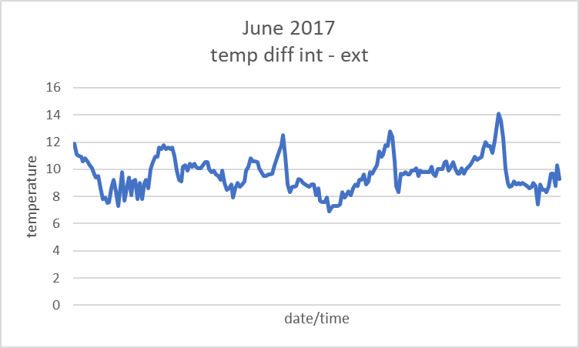

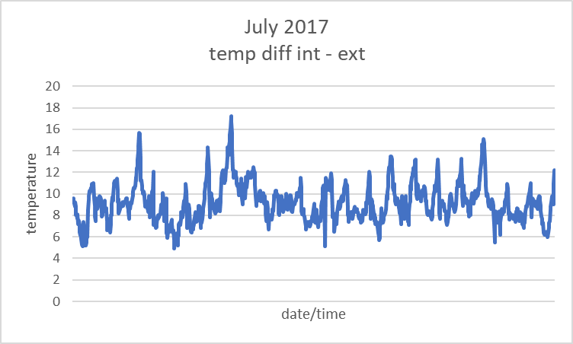

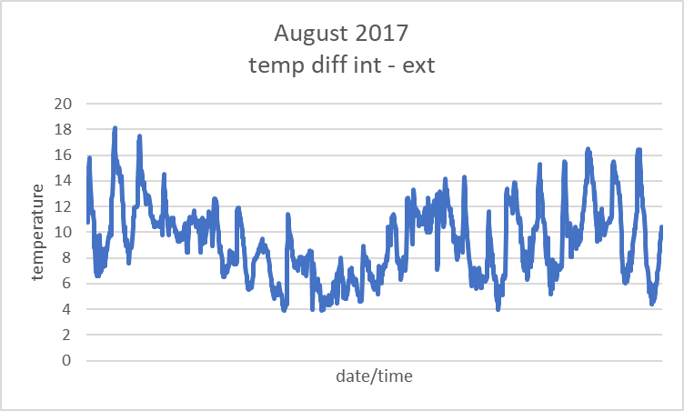

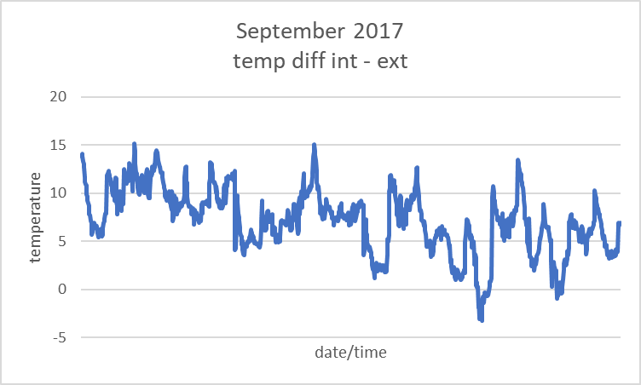

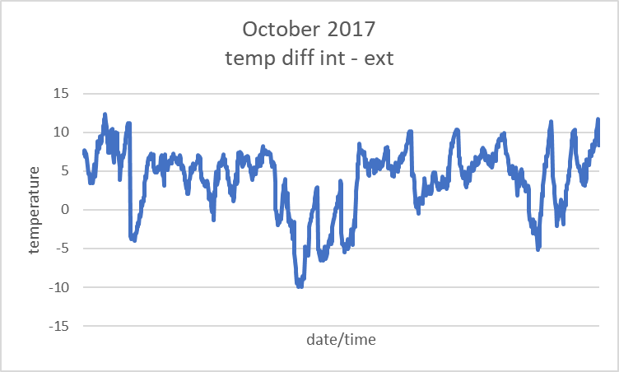

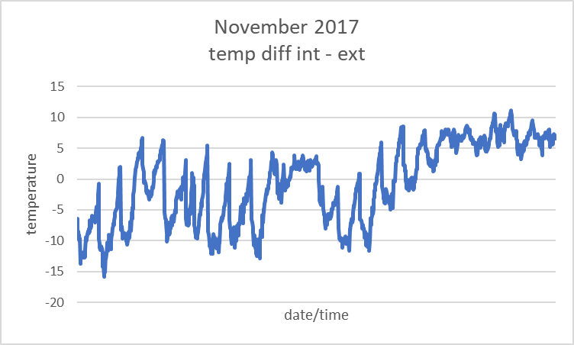

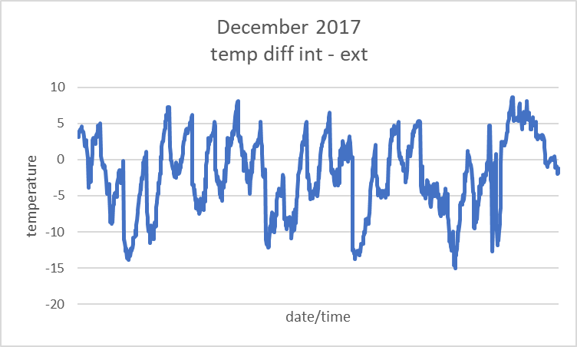

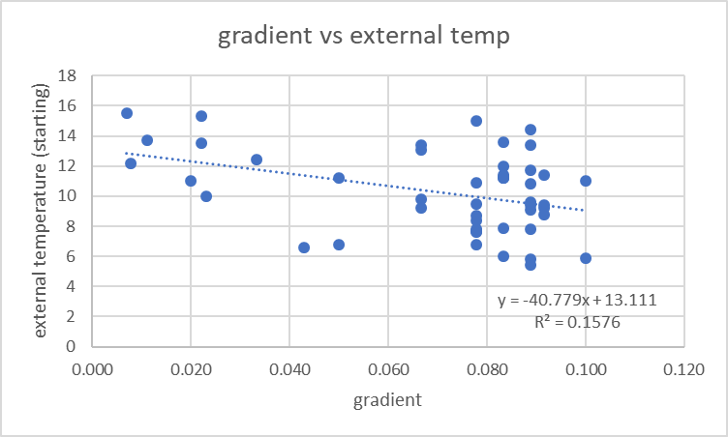



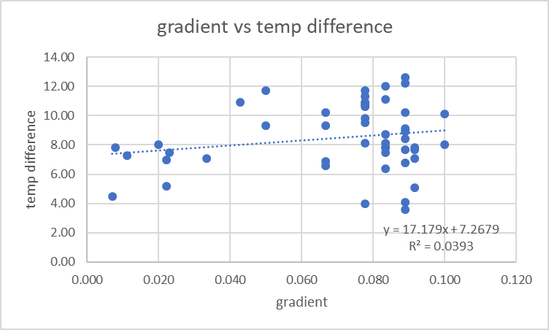



From last week’s meeting:

* Contrary to our assumptions, the AC is not the main source of heating/cooling
  + OAPU is the main heating/cooling unit, and the AC supplements it
  + Hence why AC isn’t on a lot of the time
  + AC is switched on manually in the rooms
* OAPU is on between 6.45am – 7pm
* Unit_occ refers to the occupancy of the room
  + Whether or not there are people inside the room
* Temp sensors in the room are higher up
  + Unit blows air downwards, hence people may feel hotter/cooler than the room temp itself could indicate
  + Is this significant for us?
* Other variables to keep in mind
  + G04/G05 – has big open windows (sunlight could be a factor) + there is a partition that can be removed between the rooms
  + Body heat generated by humans could affect room temp by a fairly significant amount
    - Wifi signals/CO2 levels?
    - Too difficult to try and measure/take into account

Graphs

* General
  + Only taking into account operational hours (6.45am-7pm)
    - Other times wouldn’t reflect the rate at which the OAPU heats/cools the room
  + Monthly basis
    - Different in different seasons
* Internal temp vs external temp and Temp difference graphs
  + Initial visualisation indicates that there may be some relationship between the internal temp and external temp
  + Working out the temp diff and plotting it 🡪 is there a regular pattern?
* Hypothesis testing
  + Null Hypothesis 1: There is no relationship between the gradient and the external temperature
  + Null Hypothesis 2: There is no relationship between the gradient and the temperature difference (between the external and internal temperature)
  + Very low p level
  + Reject null hypothesis
  + There is a relationship
  + What is the relationship?
  + The way the data is clustered seems vaguely linear 🡪 linear regression?
* Relationship between external & internal temp
  + Scatter plot to try and investigate the relationship between external temperature (roof temp) and internal temperature (room temp)
  + R2 value of the graphs not particularly high – weak to moderate positive correlation between outside & inside temp of the room

Questions

* What does OAPU stand for? (something auxiliary power unit? -> if so, why is it the main heating/cooling unit? Is there anything else that is responsible for maintaining temperature?)
* Wouldn’t the rate at which the OAPU is operating be determined by the set temp? Most of the data has the set temp at 22 (not much variation in set temp)
  + Theoretically, the rate at which the room heats/cools should be the same regardless of other factors (given that the set temp is the same)
    - And if they aren’t the same, may be due to other factors (not related to the rate at which the unit is working)
  + How are we to assess if a change in the set temp affects the rate at which the OAPU operates?
  + Only thing that would change the rate at which the room heats/cools is if the AC is on to supplement it too (would speed it up)

WHOLE TIME

