* Model Details

MODEL CARD

**Hand Gesture Game**

這模型的參數量約1.5M，透過YOLOv5訓練出來的手勢偵測模型，類別包含了手掌(Palm)以及比讚(Like)。可以即時地擷取Webcam的影像並進行推論，在VA8801上的推論時間約160ms，也就是6.25FPS且準確率高於90%。

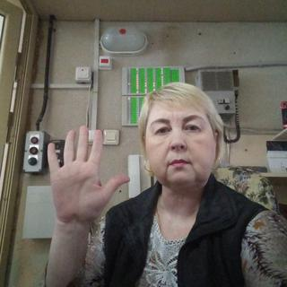

紅框分別偵測了手掌以及比讚兩個手勢

* Model Specifications

Model Type : Convolutional Neural Network

Model Architecture : Yolov5n with customized backbone for VA8801

Input : 3*320*320

Output : [class,x0,y0,x1,y1]

Class :

1. 手掌(手指併攏或張開)，正負90度
2. 比讚(正反面)，正負90度

* Application

手勢控制的產品: 拍貼機、互動遊戲

應用範例 : 可以透過Output的座標計算出BoundingBox的中心點，並檢查中心點是否在觸發或感應區。

* Limitation
  1. 距離四公尺以外不易被偵測
  2. 光線小於30 lux不支援
  3. 俯仰角度不超過30度，平視效果較佳
* Training Data

Hagrid – Hand Gesture Recognition Image

Subsets : stop, palm, like

Total : about 1000 images

You can use it for image classification or image detection tasks, it can be used in video conferencing services (Zoom, Skype etc.)

There are some images have no_gesture class if there is a second free hand in the frame, so we trained the model without no_gesture class. The people here are from 18 to 65 years old, which was collected mainly indoors with considerable variation in lighting, including artificial and natural light. The dataset includes images taken in extreme conditions such as facing and backing to a window. Also, the subjects had to show gestures at a distance of 0.5 to 4 meters from the camera.

* Reference

<https://github.com/hukenovs/hagrid>