Florida International University

School of Computing and Information Sciences

CIS 4911 U01

Pinecrest People Mover

Required Document(RD)

Members:

Ricardo Martinez

Maurice Pruna

September 6, 2014

Mentor:

Gabriela Wilson

Instructor:

Masoud Sadjadi

© 2014 by Senior Project – People Mover.

All rights reserved. No part of this document may be reproduced or transmitted in any form or by any means, electronic, mechanical, photocopying, recording, or otherwise, without prior written permission of Senior Project – People Mover.

Abstract

This document is divided into four sections: Introduction, Feasibility Study, Project Plan, and the Appendix and References. The introduction provides information in regards to the project. This information consists of explaining the problem definition, which includes the desire, expectation, and goal provided by the client, gives a description of the project background, and provides a list of definitions and acronyms used in the document.

The feasibility study sections provides a description of any current system similar to our project, a proposition of the new system, the user requirements provided by the client, and any solutions that will aid in the development process. The project plan section provides an outline to the team personnel, the hardware and software resources needed for the project, and the work breakdown consisting of identifying tasks, milestones, and deliverables. Lastly, the document will have the appendix section, which consists of the project schedule in the form of a Gantt chart, the feasibility matrix, cost matrix, and the diary of the team meetings.

Table OF CONTENT

1. Introduction 5

1.1 Problem definition 5

1.2 Scope of the System 5

1.3 Definitions, Acronyms, and Abbreviations 5

1.4 Overview of Document 5

2. Description of Current System (Limitations and Constraints) 6

3. Project Plan 7

3.1 Project Organization 7

3.1.1 Project Personnel Organization 7

3.1.2 Hardware and Software Resources 8

3.2 Identification of Tasks, Milestones and Deliverables (work breakdown) 8

4. Proposed System Requirements 10

4.1 Functional Requirements 10

4.2 Analysis of System Requirements 13

4.2.1 Scenarios 13

4.2.2 Use case model 15

4.2.3 Static model e.g., object diagrams, class diagram 16

4.2.4 Dynamic model e.g., sequence diagrams or state machines 17

5. Glossary 18

6. Appendix 19

6.1 Appendix A - Complete use cases 19

6.2 Appendix B - Use case diagram using UML 26

6.3 Appendix C - Static UML diagram 27

6.4 Appendix D - Dynamic UML diagrams 28

6.5 Appendix E - User Interface designs. 30

6.6 Appendix F - Diary of meeting and tasks. 31

7. References 36

# 1. Introduction

This section gives a brief idea about what is the problem presented by the community of Pinecrest using their trolley system called People Mover (PPM)

## Problem definition

Pinecrest government would like to design a Web tracker and a Mobile tracker to show residents routes, hours of operation, real-time trolley location (as a list and as an interactive map) and allow for automatic notifications for arrival at user’s favorite stops. The mobile tracker should work well on iPhone and android devices.

## Scope of the System

The Pinecrest People Mover is a free transit bus service operated by the Village of Pinecrest connecting their neighborhoods and schools. Middle and high school students who do not qualify for bus service from the school district mostly use it.

## Definitions, Acronyms, and Abbreviations

PPM: Pinecrest People Mover

SRS: Software Requirements Specification

UML: Unified Modeling Language

## Overview of Document

* Chapter 2: Describes the status of the current system.
* Chapter 3: Definition of the project plan, which consists of the project organization which assigns roles to the team members and the project schedule.
* Chapter 4: This chapter contains the proposed system requirements (definition of the scenarios, use case models, Static model, and Dynamic model).
* Chapter 5: Glossary with definitions of specific terms.
* Chapter 6: Appendix
* Chapter 7: References to other works.

# 2. Description of Current System (Limitations and Constraints)

The village of Pinecrest has two mover routes that are currently operating as a free service (Palmetto Middle School and Palmetto Senior High School). Each one has a north and a south path. Pinecrest citizens mainly use the movers as alternative to get to the local schools. They have no way to know with precision the wait time for next mover while are waiting on a stop, or the nearest stop to their actual position. For that reason Pinecrest government is currently involved on the installation of GPS devices in the movers. A new system will be created to serve the clients desired purposes.

# 3. Project Plan

This chapter will explain the schedule for the development plan. The roles of each team member are outlined in this section including their assigned roles. The hardware and software resources needed for the development of this project are also provided. Tasks, milestones, and deliverables are also outlined.

## 3.1 Project Organization

The team implementing this project consists of two students. Being the fact that the team is small, each team member will require having multiple roles, which include project manager, developer, tester, etc. The team members will have to use the resources allocated to them and must be approved by the client in order for the development of project to be a success

### 3.1.1 Project Personnel Organization

The structure of the project organization can be considered hierarchal. Each student will be in constant communication with each other during the development process. The students will be presenting their progress to Masoud Sadjadi, the professor, and Gabriela Wilson, the client. Masoud Sadjadi will be providing feedback to Ricardo Martinez and Maurice Pruna in how to improve project.

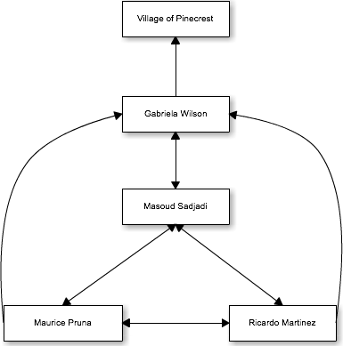

|  |  |  |
| --- | --- | --- |
| Name | Roles | Contact |
| Gabriela Wilson | Client/Mentor | gwilson@pinecrest-fl.gov |
| Masoud Sadjadi | Professor | sadjadi@cs.fiu.edu |
| Ricardo Martinez | Front-End Developer, Tester | rmart071@fiu.edu |
| Maurice Pruna | Back-End Developer, Tester | mprun003@fiu.edu |

### 3.1.2 Hardware and Software Resources

**Required Hardware**

* iOS device
* Android device
* Server

**Required Software**

* Microsoft Word
* Cacoo
* Mockup Builder
* Microsoft Project
* GitHub
* Trello
* SourceTree
* FIU Moodle

## 3.2 Identification of Tasks, Milestones and Deliverables (work breakdown)

|  |  |  |  |  |
| --- | --- | --- | --- | --- |
| ID | Task Name | Duration | Start | Finish |
| 1 | Meet with Partner |  |  |  |
| 2 | Meet with mentor |  |  |  |
| 3 | Create high level requirements |  |  |  |
| 4 | UI Mockup Designs |  |  |  |
| 5 | Create Use Cases |  |  |  |
| 6 | Create Schedule |  |  |  |
| 7 | Use Case Diagrams |  |  |  |
| 8 | Requirements Document |  |  |  |
| 9 | Project Plan Document |  |  |  |
| 10 | Feasibility Study |  |  |  |
| 11 | Hardware & Software Specifications |  |  |  |
| 12 | Retrieval of client server and database information |  |  |  |
| 13 | Begin Implementations |  |  |  |
| 14 | Design Test Cases based on use case criteria |  |  |  |
| 15 | Present to client product |  |  |  |
| 16 | Present project to class |  |  |  |
|  |  |  |  |  |

|  |  |
| --- | --- |
| Milestones | Projected Date |
| Finalized Requirements Document | 10/5/14 |
| Finalized Design Document | 10/13 |
| Completion of Implementation | 11/28/14 |
| Testing Phase Completed | 12/4/14 |
| Final Deliverable | 12/11/14 |
| Provide finished product to client | 12/12/14 |

# 4. Proposed System Requirements

This chapter will contain the detailed requirements for the application. Also there will be information about the different scenarios, uses cases model, class diagram, and sequential diagram.

## 4.1 Functional Requirements

1. **PPM_01: Display Hours of Operation**

The system shall provide the user with the information in regards to the hours of operation.

* Usability: The user will access this function in 1 click from home.
* Reliability: Low mean time to failure since this function would be one of the main buttons on the menu
* Performance: Data will load in less than 2 seconds.
* Supportability: This functionality should be supported by any internet browser, iOS and Android Devices

1. **PPM_02: Trolley Alerts**

The system shall provide the user with any updates in regards to the trolleys. This can be a malfunction to a trolley, delayed departure, and not-in-service for that day

* Usability: This data doesn’t require any action of the user to get activated.
* Reliability: Low mean time to failure as this functionality would be very beneficial to the users
* Performance: Notifications should be sent as soon as information is entered by admin
* Supportability: This functionality should be supported by any internet browser, iOS and Android Devices

1. **PPM_03: Final Destination Alert**

The system shall send an email notification when the mover listed as final destination arrives to the selected stop.

* Usability: This feature is automatically generated.
* Reliability: Depends on the email server.
* Performance: Email will be generated in less than 2 seconds and it will be sent in less than 2 seconds.
* Supportability: This functionality should be supported by any internet browser, iOS and Android Devices

1. **PPM_04: Remove Final Destination**

The system shall allow the user remove the final destinations entered.

* Usability: The user will access this function in 23 clicks from home view.
* Reliability: Low mean time to failure, as this functionality will be beneficial to the users.
* Performance: Information would be deleted within 2 seconds.
* Supportability: This functionality should be supported by any internet browser, iOS and Android Devices

1. **PPM_05: Estimated Time for a Favorite Stop**

The system shall provide the estimated time for a selected stop marked as favorite.

* Usability: The user will access this function in 1 click from home.
* Reliability: Low mean time to failure since this is a main functionality of the app
* Performance: Data will load in less than 2 seconds.
* Supportability: This functionality should be supported by any internet browser, iOS and Android Devices

1. **PPM_06: Set Favorite Stop**

The system shall allow the user set a stop as a favorite stop.

* Usability: The user will access this function in the list stop view.
* Reliability: Low mean time to failure as user should be able to see estimated time for arrivla
* Performance: Information would be available within 2 seconds.
* Supportability: This functionality should be supported by any internet browser, iOS and Android Devices

1. **PPM_07: Remove Favorite Stop**

The system shall allow the user remove the favorite stops entered.

* Usability: Easy as using pressing a button. No training required
* Reliability: Low mean time to failure since user should be able to set and remove favorite stops.
* Performance: Information would be deleted within 2 seconds.
* Supportability: This functionality should be supported by any internet browser, iOS and Android Devices

1. **PPM_08: List Stops**

The system shall provide the user a list of all the stops given a route and direction.

* Usability: No training required. Can be seen in two clicks from the home screen.
* Reliability: Low mean time to failure since this information is retrieved from the database.
* Performance: Data will load in less than 2 seconds.
* Supportability: This functionality should be supported by any internet browser, iOS and Android Devices

1. **PPM_09: Map Routes**

The system shall provide the user a map given a route and direction.

* Usability: No training required. App opens up to map view.
* Reliability: Low mean time to failure since this is one of the main functionalities of the app
* Performance: Data will load in less than 2 seconds.
* Supportability: This functionality should be supported by any internet browser, iOS and Android Devices

1. **PPM_10: Estimated Arrival Time given Stop**

The system shall provide the estimated time for a selected stop.

* Usability: The user will access this function in 1 click from home.
* Reliability: Low mean time to failure as this is a main functionality of the app.
* Performance: Data will load in less than 2 seconds.
* Supportability: This functionality should be supported by any internet browser, iOS and Android Devices

1. **PPM_11: Find Nearest Stop**

The system shall provide the nearest stop to the user’s geolocation.

* Usability: The user will access this function in 1 click from home.
* Reliability: Low mean time to failure since this depends on the information tracked by the GPS
* Performance: Data will load in less than 2 seconds.
* Supportability: This functionality should be supported by any internet browser, iOS and Android Devices

1. **PPM_12: Arrived to Location Alert**

The system shall send a SMS notification or email notification to user once trolley has arrived to selected location

* Usability: No training required.
* Reliability: Low mean time to failure since this depends on the information tracked by the GPS
* Performance: Notification should be sent no more than 1 minute.
* Supportability: This functionality should be supported by any internet browser, iOS and Android Devices

1. **PPM_13: Login**

The system shall check if the username and password of a user are correct and show favorite stops.

* Usability: No training required. Login will contain input boxes.
* Reliability: Low mean time to failure as this functionality will allow user many functionalities.
* Performance: Login should take no longer than 10 seconds.
* Supportability: This functionality should be supported by any internet browser, iOS and Android Devices

1. **PPM_14: Register**

The system shall save the username and password of a user.

* Usability: No training required. Registration view will contain input boxes.
* Reliability: Low mean time to failure as this functionality allows system to have users.
* Performance: Registration should take no longer than 20 seconds.
* Supportability: This functionality should be supported by any internet browser, iOS and Android Devices

1. **PPM_15: Request Stop**

The system shall provide the user with a form view allowing the user to request a stop. They system should save the information in the database and show an alert box saying ‘Thank you for your request. The Village of Pinecrest reviews routes twice a year (Aug and Jan) based on suggestions from interested residents. Please review route information regularly to see if we were able to accommodate your request’

* Usability: No Training required. The view will contain input boxes where the user can type in information.
* Reliability: Low mean time to failure as this functionality allows interaction from the user.
* Performance: Request should take no longer than 20 seconds.
* Supportability: This functionality should be supported by any internet browser, iOS and Android Devices

## 4.2 Analysis of System Requirements

Analysis models – contains the complete functional specification and is mainly for the designers and programmers. This section describes the diagrams in the Appendices B - D and validates the models against the use cases.

### 4.2.1 Scenarios

1. **Scenario - PPM_01: Display Hours of Operation**
   1. The user has downloaded the app and wants to check what time the Pinecrest People Mover is operating. The user clicks on the Service Time button located in a tab panel on the Main Menu. The system retrieves the information from the database and displays information on the interface. The user will not be able to see at what time the trolley is working.
2. **Scenario – PPM_02: Trolley Alerts**
   1. The user has the app downloaded on the phone device and wants to verify that the trolleys are operating on schedule. The user clicks on the ‘More’ button and when system has redirected to another view, he/she presses the Trolley Alerts button. The system retrieves any information saved in the database and displays on the interface that the trolley for Palmetto High Route is not functioning.
   2. The system will send notifications to all users in the app indicating that the movers are out-of-service. When the user opens the app a message will appear indicating that there has been a problem with the movers. If the user has provided an email or cell phone, a notification will be sent to them ahead of time
3. **Scenario – PPM_03: Final Destination Alert**
   1. The user knows of someone using the north route for the Palmetto Senior High mover. Once the mover, has arrived to the Palmetto Senior High stop, the system will send a notification to the user indicating that the mover has arrived safely to the location. This will require email and cell phone information so the notifications can be sent.
4. **Scenario – PPM_04: Remove Final Destination**
   1. The user receives alerts when the trolley has arrived at the final destination. However, the user no longer wants notifications when the trolley has made the last stop, they just want the alert when they have arrived at their favorite spot. They click on the ‘More’ button on the bottom of the panel and click the options button. Once they have clicked the options button, they will receive a final stop notification, there they can choose to remove the notification.
5. **Scenario – PPM_05: Estimated Time for Favorite Stop**
   1. The user has selected a certain stop. The system should provide the user with information about the closets bus with that stop in its route. Such information should include the ID number, route information, the mover’s next stop, and estimated time of arrival to the user’s selected stop. The estimated time of arrival should be in minute format.
6. **Scenario – PPM_06: Set Favorite Stop**
   1. The user knows of someone using the north route for the Palmetto Senior High mover. Once the mover, has arrived to the Palmetto Senior High stop, the system will send a notification to the user indicating that the mover has arrived safely to the location. This will require email and cell phone information so the notifications can be sent.
7. **Scenario – PPM_07: Remove Favorite Stop**
   1. The user wants to remove their current favorite stop from the list. They have realized that they no longer us that stop, so they decided to click on the favorites button on the home page. They click on their favorite stop and a view is showing, where an option appears and displays ‘Remove from Favorites’. The user selects the option and the stop no longer appears on the list.
8. **Scenario –PPM_08: List Stops**
   1. The user is using the application and wants to see all the stops a mover will make in a certain route. In the menu there will be a ‘List route’ button which will direct the user to another page indicating to choose which destination, Palmetto Middle School or Palmetto High School. He/she then chooses the route. Once the route has been selected, a list of all the stops is now being shown to the user
9. **Scenario – PPM_09: Map Routes**
   1. The user is using the application and clicks on the view map button. The system will direct the user to a site with a Google map implemented. This map will have four different colors, which will be used to identify the different routes, and a People Mover icon, which will represent the actual location of the bus. The map will be considered real-time by showing the current location of the mover, so if the mover is driving to the next stop, the icon will be moving as well.
10. **Scenario – PPM_10: Estimated Arrival Time Given Stop**
    1. The user is currently looking at the stop list for a given route. The list will also display the estimated arrival time for each stop. The user now knows the status of the trolley and around what location the trolley is currently located.
11. **Scenario – PPM_11: Find the Nearest Stop**
    1. The user is on the Pinecrest People Mover application and clicks on the ‘Near Me’ button. The system should use the GPS feature to determine the user’s location and direct the user to a pin indicating the closest stop to their current location. They system will provide the user with the address of the stop and its route information.
12. **Scenario – PPM_12: Arrived to Location Alert**
    1. The user has selected their favorite stop and the menu for time of alert appears. This menu give you options to either get instant notification when the trolley has arrived and ranges to up to 15 minutes before trolley arrives. The user selects the instant notification. Once the trolley has arrived at the favorite spot, they receive a SMS text notification and email notification indicating the trolley has arrived.
13. **Scenario – PPM_13: Login**
    1. The user has already registered for the app. They want the app to retrieve all of their information and allow alert functionalities for their favorite spots. They click on the ‘More’ button and select the Sign in button. They enter their username and password and now the system will allow the alerts functionalities and their selected favorite spots will now appear.
14. **Scenario – PPM_14: Register**
    1. The user wants to have the alert functionalities and keep the list of the favorite spots. They click on the ‘More’ button and select the Register button. They will enter their username, password, email, and phone number. Once they have selected the register button they will receive an email confirmation and can now use that information to sign in.
15. **Scenario – PPM_15: Request a Stop**
    1. The user has moved location but there is no stop for the trolley near by. He/she wants to send a request so when they click on the ‘More’ button, they then click on the request a stop button. They will fill out the needed fields and submit the request. They will then see a confirmation message.

### 4.2.2 Use case model

### 4.2.3 Static model e.g., object diagrams, class diagram

### 4.2.4 Dynamic model e.g., sequence diagrams or state machines

# 5. Glossary

# 6. Appendix

## 6.1 Appendix A - Complete use cases

|  |  |
| --- | --- |
| Use Case ID | PPM-01 Search Stop Near Me |
| **Description** | Allow user to get a list view of the stops located near him. |
| **Actor** | User |
| **Pre-conditions** | 1. Requires The GPS setting enabled on the user’s device or accept localization when using a desktop web browser. |
| **Main success scenario** | 1. The system receives the localization coordinates. 2. The system validates that the location correspond to the area of Pinecrest. 3. The system detects the stops that are immediate close to the user location within a defined radius. 4. The system prints out the all the stops near user on a list view order by distance. |
| **Post-conditions** | 1. The system printed out the all the stops near user localization |
| **Exceptions** | If the localization detected is out of Pinecrest Village the following message will be posted: “You a currently located out of the Village of Pinecrest” |

|  |  |
| --- | --- |
| Use Case ID | PPM-02 Trolley Alerts |
| **Description** | Allow user to receive alerts about any issues in regards to the trolleys |
| **Actor** | User |
| **Pre-conditions** | 1. The user has opened the app |
| **Main success scenario** | 1. The system checks in database if any current issue is present 2. System shows alert box with alert message |
| **Post-conditions** | 1. The user can no make changes to plans |
| **Exceptions** |  |

|  |  |
| --- | --- |
| Use Case ID | PPM-03 Manage System Settings |
| **Description** | Allows user to enable/disable alerts, replace email address, change password |
| **Actor** | User |
| **Pre-conditions** | 1. User is logged on the system |
| **Main success scenario** | 1. The system start/stop sending status alerts to user. 2. The system updates user email address if it has been replaced. 3. The system updates the current password. |
| **Post-conditions** | The system enabled/disabled access to favorites stops, parental stop.  The system started/stopped sending status alerts |
| **Exceptions** | The user is not logged on the system. |

|  |  |
| --- | --- |
| Use Case ID | PPM-04 Login |
| **Description** | Allows user to Login on the system |
| **Actor** | User |
| **Pre-conditions** | 1. User is registered on the system |
| **Main success scenario** | 1. The system authenticates the user. 2. The system enables the following options on the menu: Manage System, Manage Favorite Stops, Manage Parental Stop |
| **Post-conditions** | The system enabled options related to the management use cases |
| **Exceptions** | The user is not registered on the system. |

|  |  |
| --- | --- |
| Use Case ID | PPM-05 Register User |
| **Description** | Allows user to Register on the system |
| **Actor** | User |
| **Pre-conditions** |  |
| **Main success scenario** | 1. The system validates that the filed username is populated with an email. 2. The system validates that the password and confirm password entered are equal. 3. If validations is correct the system save the email address and password introduced. |
| **Post-conditions** | The system enabled options related to the management use cases |
| **Exceptions** |  |

|  |  |
| --- | --- |
| Use Case ID | PPM-06 Manage Forgot Password |
| **Description** | Allows user to redefine password |
| **Actor** | User |
| **Pre-conditions** | 2. User is registered on the system |
| **Main success scenario** | 1. The system validates that the password and confirm password entered are equal. 2. If validation is correct the system saves password introduced. |
| **Post-conditions** | The system allows user to be log in |
| **Exceptions** | The user is not registered on the system. |

|  |  |
| --- | --- |
| Use Case ID | PPM-07 Manage Favorite Stop |
| **Description** | Allows user to add/remove favorite stops |
| **Actor** | User |
| **Pre-conditions** | 2. User is logged on the system |
| **Main success scenario** | 1. The system add/remove a favorite stop previously selected on the list of stops. 2. The system provides/interrupts information about a favorite stop like:  * Route name * Stop Address * Estimated arrival time |
| **Post-conditions** | The system provided/interrupted information about a favorite stop |
| **Exceptions** | The user is not logged on the system. |

|  |  |
| --- | --- |
| Use Case ID | PPM-08 Manage Parental Stop |
| **Description** | Allows user to define and alert for a defined stop |
| **Actor** | User |
| **Pre-conditions** | 1. User is logged on the system 2. User defined a stop as favorite 3. User defined amount of time to receive a message alert that could be:  * Parental Message or 0 time in order to receive instant message. * From 5 min to 30 min in order to receive a message at the expected time before the arrival of the mover |
| **Main success scenario** | 1. The system add/remove a message alert for a favorite stop previously selected on the list of stops 2. The system sends a message alert as soon as the mover arrives to given stop   Or   1. The system sends a message alert at the defined amount of time |
| **Post-conditions** |  |
| **Exceptions** | The user is not logged on the system. |

|  |  |
| --- | --- |
| Use Case ID | PPM-09 View Route Information |
| **Description** | Allows user to view the list of routes |
| **Actor** | User |
| **Pre-conditions** | User selected a Routes button on the menu |
| **Main success scenario** | 1. The system shows a list of routes and direction |
| **Post-conditions** |  |
| **Exceptions** |  |

|  |  |
| --- | --- |
| Use Case ID | PPM-10 View Stops |
| **Description** | Allows user to view the list of stops for a given route |
| **Actor** | User |
| **Pre-conditions** | User selected a route and direction |
| **Main success scenario** | 1. The system shows a list of stops for the given route |
| **Post-conditions** |  |
| **Exceptions** |  |

|  |  |
| --- | --- |
| Use Case ID | PPM-11 View Tracking Map |
| **Description** | Allows user to view the updated position of a mover for a given route |
| **Actor** | User |
| **Pre-conditions** | User selected a route and direction or user selected a stop |
| **Main success scenario** | 1. The system shows a map with updated information about the position of a mover from a specific route |
| **Post-conditions** |  |
| **Exceptions** |  |

|  |  |
| --- | --- |
| Use Case ID | PPM-12 Search Estimated Arrival Time |
| **Description** | Allows user to know the Estimated Arrival Time of a mover to a stop |
| **Actor** | User |
| **Pre-conditions** | User selected a route, direction, and selected a stop |
| **Main success scenario** | 1. The system shows the Estimated Arrival Time for a given mover. |
| **Post-conditions** |  |
| **Exceptions** |  |

|  |  |
| --- | --- |
| Use Case ID | PPM-15 Send Message to System |
| **Description** | Allow user to send messages to the system. It could be reporting a problem, a feedback or requesting a new stop |
| **Actor** | User |
| **Pre-conditions** | User is logged on the system to automatically capture sender email  or  User enter email to the system. |
| **Main success scenario** | 1. The system creates a message with a formatted subject with one of the stated topics 2. Send an email to the corresponding authority. |
| **Post-conditions** | 1. The email is sent to the corresponding authority |
| **Exceptions** |  |

## 6.2 Appendix B - Use case diagram using UML

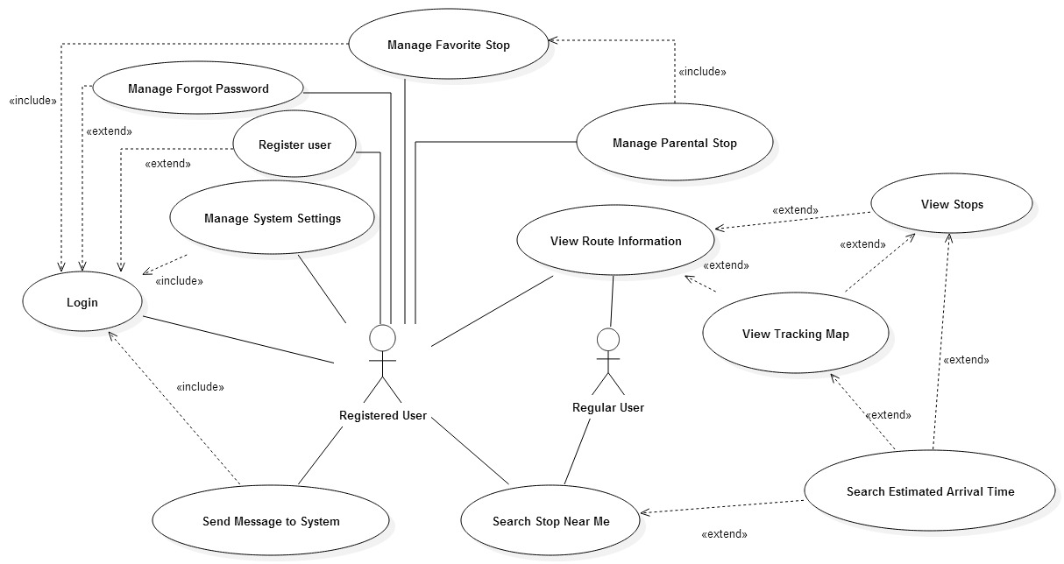

## 6.3 Appendix C - Static UML diagram

## 6.4 Appendix D - Dynamic UML diagrams

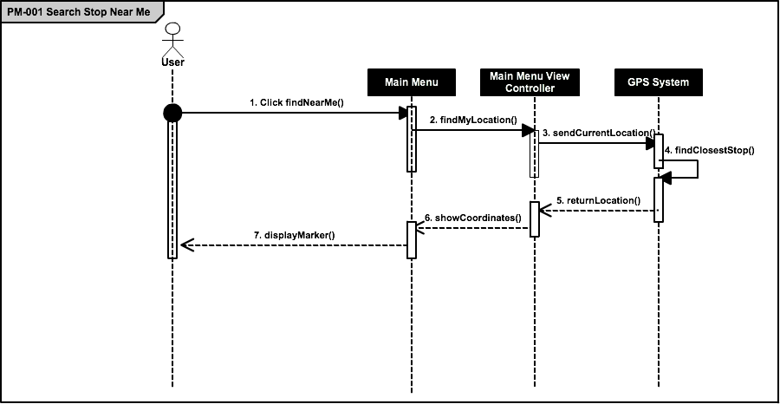

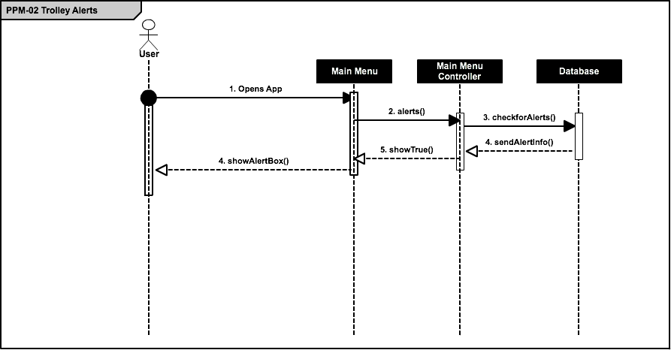

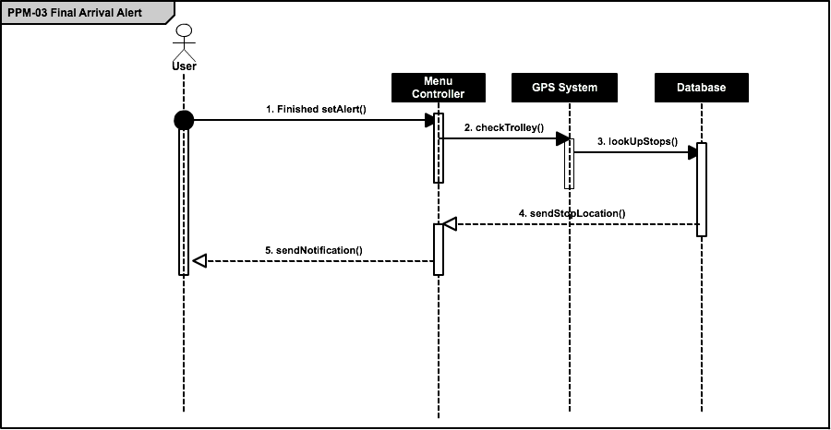

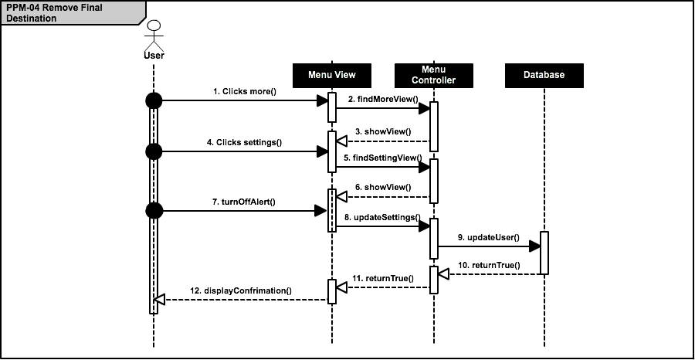

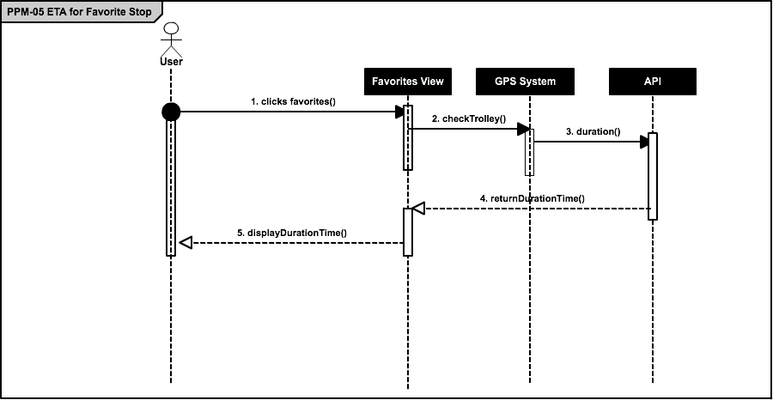

## 6.5 Appendix E - User Interface designs.

Figure E-1 : Loading Image



Figure E-2: Main Menu

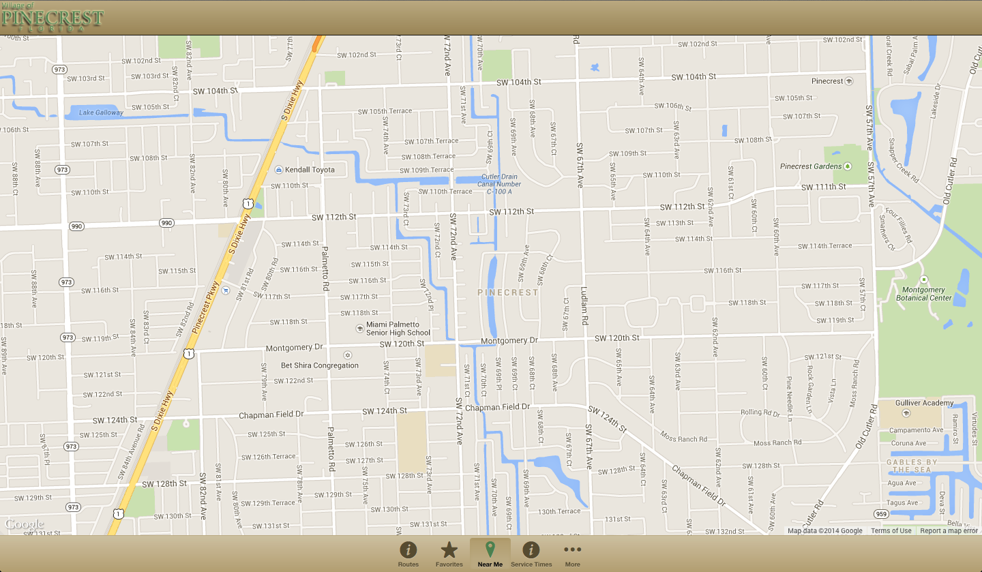

Figure E-3: Routes List

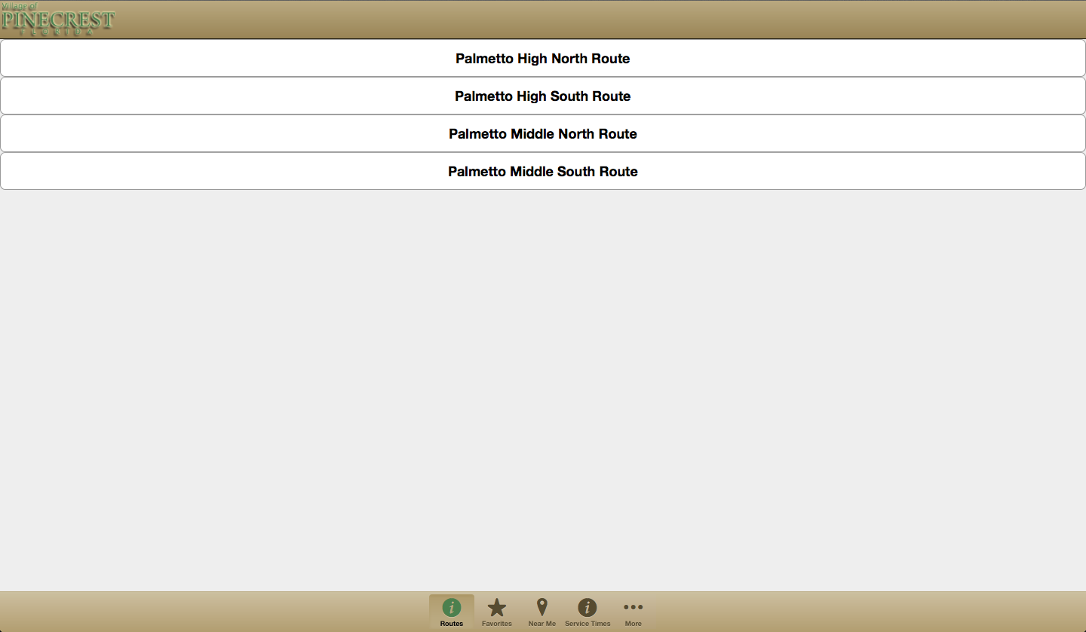

Figure E-4: More View

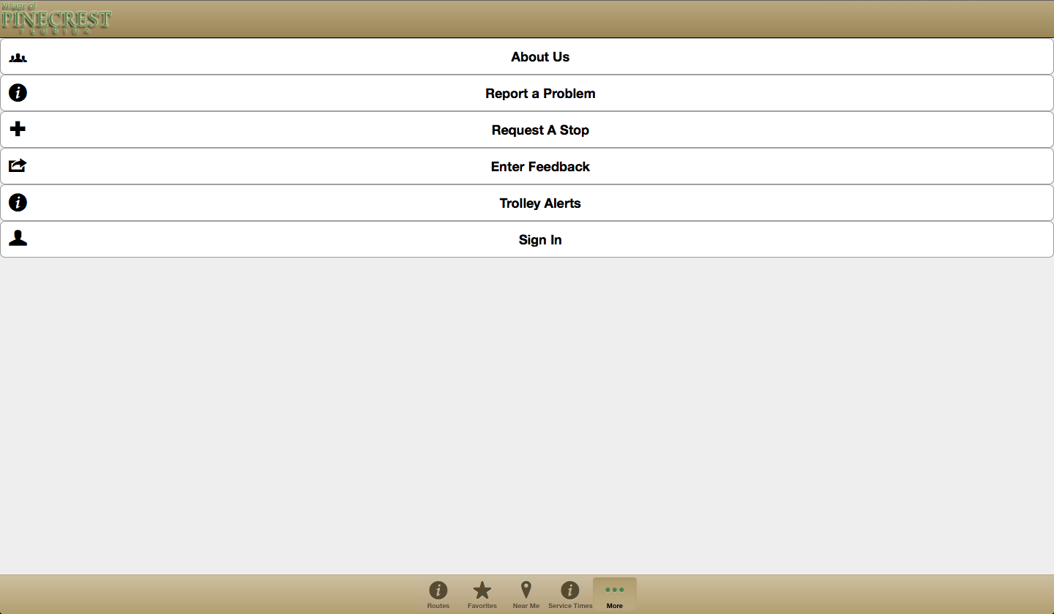

Figure E-5: Login View

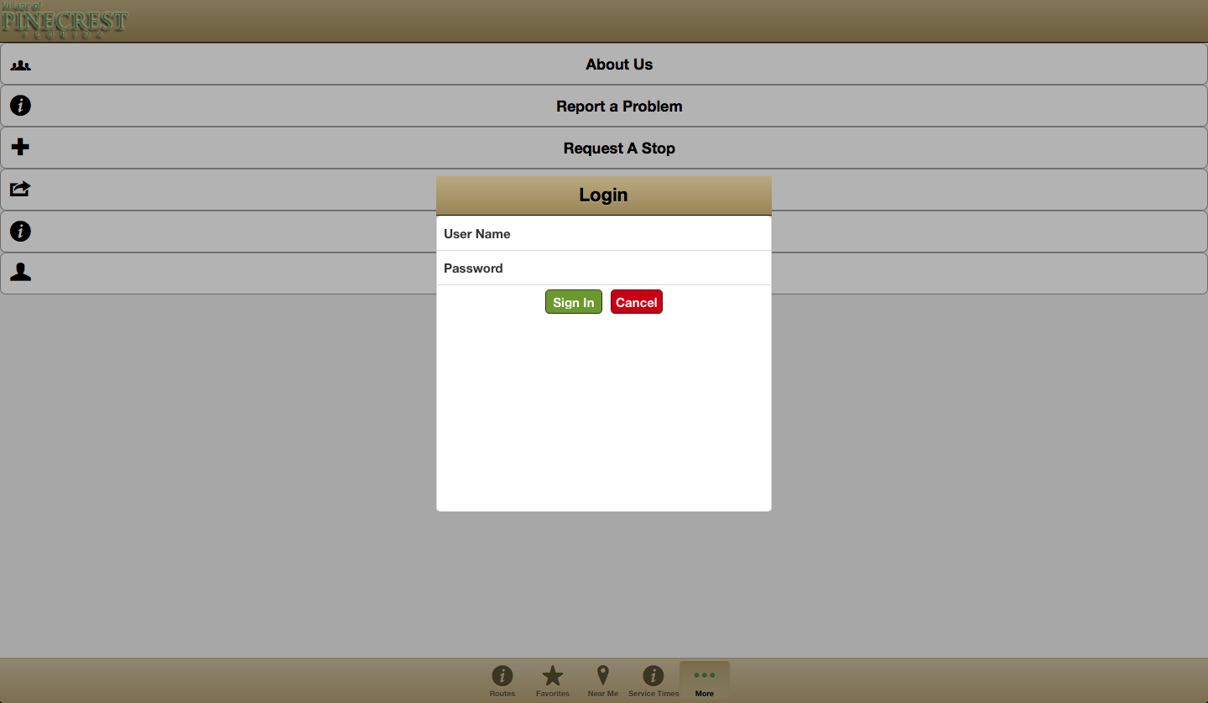

## 6.6 Appendix F - Diary of meeting and tasks.

Meeting 1

|  |  |
| --- | --- |
| Date: | Wednesday, September 3, 2014 |
| Location: | Google Hangouts |
| Start time: | 8:00 pm |
| End time: | 8:30 pm |
| In Attendance: | Ricardo Martinez, Maurice Pruna |
| Agenda: | 1. Introduction to Teammates |
|  | 2. Discuss ideas and gather information of what may be needed for the project. (use Miami-dade transit website as reference) |
|  | 3. Go over information in regards to PineCrest Mover |
| Assigned Tasks: |  |
|  | 1. Meet September 4, 2014 at FIU |
|  |  |

Meeting 2

|  |  |
| --- | --- |
| Date: | Wednesday, September 4, 2014 |
| Location: | FIU, JCCL Lab |
| Start time: | 8:15 pm |
| End time: | 9:00 pm |
| In Attendance: | Ricardo Martinez, Maurice Pruna |
| Agenda: | 1. Gather questions for tomorrow’s conference call with mentor |
|  | 2.Share bootstrap and Google maps API resources |
|  | 3. Go over what is needed in document and feasibility matrix |
| Assigned Tasks: |  |
|  | 1. Meet September 5, 2014 for conference call 12:30pm – 1:30 pm |
| Duration: | 45 minutes |

Meeting 3

|  |  |
| --- | --- |
| Date: | Friday, September 5, 2014 |
| Location: | Conference Call |
| Start time: | 12:30 am |
| End time: | 1:30 pm |
| In Attendance: | Gabriela Wilson, Ricardo Martinez, Maurice Pruna |
| Agenda: | 1. Problem discussion and identification of possible users   * Agreed to start a Web/Mobil app * Defined guest user for general interaction * Defined registered user for “favorite bus stop” * Extra tool requested to manage routes and buses. |
|  | 2. Defined status of the GPS devices on the movers.   * Identified Trolley Company as the source of GPS data. |
|  | 3. Identified similar applications from other local governments. |
|  |  |
| Assigned Tasks: | 1. Create mock ups design 2. Define use cases 3. Contact the trolley company to define the data retrieval |
| Duration: | 60 minutes |

Meeting 4

|  |  |
| --- | --- |
| Date: | Saturday, September 6, 2014 |
| Location: | FIU, JCCL Lab |
| Start time: | 10:30 pm |
| End time: | 4:30 pm |
| In Attendance: | Ricardo Martinez, Maurice Pruna |
| Agenda: | 1. Begin Feasibility Study document |
|  | 2.Begin Project Plant document |
|  | 3.Discuss best approach for implementation of project |
| Assigned Tasks: |  |
|  | 1. Meet September 7, 2014 10:30 AM at FIU |
| Duration: | 6 hours |

Meeting 5

|  |  |
| --- | --- |
| Date: | Sunday, September 7, 2014 |
| Location: | FIU, JCCL Lab |
| Start time: | 11:00 pm |
| End time: | 4:45 pm |
| In Attendance: | Ricardo Martinez, Maurice Pruna |
| Agenda: | 1. Think of specifications |
|  | 2.Begin Specifications doc |
|  | 3.Discuss best approach for implementation of project |
| Assigned Tasks: |  |
|  | Submit first revision documents |
| Duration: | 5 hours 45 minutes |

Meeting 6

|  |  |
| --- | --- |
| Date: | Tuesday, September 9, 2014 |
| Location: | FIU, JCCL Lab |
| Start time: | 6:30 pm |
| End time: | 8:00 pm |
| In Attendance: | Ricardo Martinez, Maurice Pruna |
| Agenda: | 1. Check Requirements Feedback |
|  | 2. Work on the mockups design |
|  |  |
| Assigned Tasks: | Continue working on the mockups |
|  | Improve use cases model |
| Duration: | 90 min |

Meeting 7

|  |  |
| --- | --- |
| Date: | Wednesday, September 10, 2014 |
| Location: | Conference Call |
| Start time: | 12:00 am |
| End time: | 12:30 am |
| In Attendance: | Ricardo Martinez, Maurice Pruna, Gabriela Wilson |
| Agenda: | 1. Check Requirements |
|  | 2. Check mockups design updates |
|  | 3. Check business workflow |
|  | 4. Status of the TSO api and GPS devices |
| Assigned Tasks: | Continue working on the mockups |
|  | Improve use cases model |
| Duration: | 30 min |

Meeting 8

|  |  |
| --- | --- |
| Date: | Thursday, September 11, 2014 |
| Location: | Starbucks |
| Start time: | 7:30 pm |
| End time: | 9:30 pm |
| In Attendance: | Ricardo Martinez, Maurice Pruna |
| Agenda: | 1. Read documentation for Sencha |
|  | 2. Did some research for MVC architecture |
|  |  |
| Assigned Tasks: | Continue working on the mockups |
|  | Begin with interfaces |
| Duration: | 2 hours (120 minu) |
|  |  |

Meeting 9

|  |  |
| --- | --- |
| Date: | Sunday, September 14, 2014 |
| Location: | FIU JCCL Labs |
| Start time: | 3:30 pm |
| End time: | 7:00 pm |
| In Attendance: | Ricardo Martinez, Maurice Pruna |
| Agenda: | 1. Continue with Interface implementation |
|  | 2. Provide feedback and assign roles |
| Assigned Tasks: | Continue with Interface Implementation |
|  | Improve use cases model |
| Duration: | 3hours 30 min |
|  |  |
|  |  |

Meeting 10

|  |  |
| --- | --- |
| Date: | Wednesday, September 17, 2014 |
| Location: | Conference Call |
| Start time: | 12:00 pm |
| End time: | 1:00 pm |
| In Attendance: | Ricardo Martinez, Maurice Pruna, Gabriela Wilson, David Gonzalez (TSO) |
| Agenda: | 1. Ask questions in regards to usage of API |
|  | 2. Database integration |
| Assigned Tasks: | Look over API Documenation |
|  |  |
| Duration: | 60 min |
|  |  |
|  |  |

Meeting 11

|  |  |
| --- | --- |
| Date: | Sunday, September 21, 2014 |
| Location: | FIU JCCL Lab |
| Start time: | 3:30 pm |
| End time: | 7:00 pm |
| In Attendance: | Ricardo Martinez, Maurice Pruna |
| Agenda: | 1. Go over API Documentation |
|  | 2. Continue with interface implementation |
| Assigned Tasks: |  |
|  |  |
| Duration: | 3hour 30 min |
|  |  |
|  |  |

Meeting 13

|  |  |
| --- | --- |
| Date: | Thursday, September 25, 2014 |
| Location: | FIU JCCL Lab |
| Start time: | 7:30 pm |
| End time: | 9:00 pm |
| In Attendance: | Ricardo Martinez, Maurice Pruna |
| Agenda: | 1. API Connection |
|  | 2. Continue with interface implementation |
| Assigned Tasks: |  |
|  |  |
| Duration: | 1hour 30 min |
|  |  |
|  |  |

Meeting 14

|  |  |
| --- | --- |
| Date: | Saturday, September 27, 2014 |
| Location: | Starbucks |
| Start time: | 3:00 pm |
| End time: | 6:00 pm |
| In Attendance: | Ricardo Martinez, Maurice Pruna |
| Agenda: | 1. API Connection |
|  | 2. Continue with interface implementation |
| Assigned Tasks: |  |
|  |  |
| Duration: | 3 hours |
|  |  |
|  |  |

Meeting 15

|  |  |
| --- | --- |
| Date: | Sunday, September 28, 2014 |
| Location: | Starbucks |
| Start time: | 3:00 pm |
| End time: | 7:00 pm |
| In Attendance: | Ricardo Martinez, Maurice Pruna |
| Agenda: | 1. Prepare Documentations |
|  |  |
| Assigned Tasks: | Ready to present for tomorrow’s class presentation |
|  |  |
| Duration: | 4 hours |
|  |  |
|  |  |

# 7. References

Please email me the UML diagram in one file before the presentation.