|  |  |
| --- | --- |
|  | 2014 |
|  | Pinecrest People Mover  Maurice Pruna  Ricardo Martinez  Florida International University |



|  |
| --- |
| **[User’s GUide]** |
|  |

© 2014 by Senior Project – People Mover.

All rights reserved. No part of this document may be reproduced or transmitted in any form or by any means, electronic, mechanical, photocopying, recording, or otherwise, without prior written permission of Senior Project – People Mover.

# Introduction

Pinecrest government would like to design a Web tracker and a Mobile tracker to show residents routes, hours of operation, real-time trolley location (as a list and as an interactive map) and allow for automatic notifications for arrival at user’s favorite stops. The mobile tracker should work well on iPhone and android devices.

# Hardware and Software Requirements

**Required Hardware**

* iOS device
* Android device
* Server

**Required Software**

* Apache Tomcat
* MySQL
* Sencha Touch
* Apache
* GitHub/SourceTree

# Installation and setup

The necessary components for this application to run successfully on the server side are:

* Apache
* Tomcat Server
* MySQL server

Download the repository for People Mover on GitHub from:

<https://github.com/FIU-SCIS-Senior-Project-2014-Fall/People-Mover>

and import the file PPM.sql located in inside the Code/ExecLibFIles to set up MySQL database, preferably you can do this by using MySQL workbench or phpMyAdmin. Deploy the ppmws.war file, stored in the same location as ppmDB.sql, on the Tomcat server using the server URL:

<http://yourserver.com:8080>

Insert admin credentials on the manager webapp. Before uploading the WAR file, open the ppmws.war with any compressor software. Then go to WEB-INF\classes\ppmWS.properties and change the emailusername, emailpassword, which are the credentials for the gmail SMTP server, and emailreceiver, which will be the Pinecrest email information is being sent to. After go to the WAR file to deploy section and upload the ppmWS.war file located in the ExecLibFiles. Wait until load has reached 100% completion before continuing.

Download Sencha Touch, which can be found at <http://www.sencha.com/products/touch/> , and place in the HTML folder inside Apache. You can then move the files located in Code/SourceFiles/peoplemover into the Sencha Touch folder.

**You are now ready to use the Pinecrest People Mover.**

# Getting Started

* To see the Map with all of the routes and stops click on the Map tab in the panel.
* 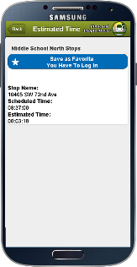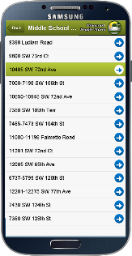To be able to see all the stops for a particular route, press the Routes tab and select the route name. You can click on the stop and a new view will open providing the name of the stop and other information, such as estimated time and define favorite stops.
* To see the favorites, you must be signed in
  + Go to More tab and click the Login or if needed, the Register button
  + Type in username and password
  + Go back and click on the favorites tab, there you will be able to see all of your favorite stops
* 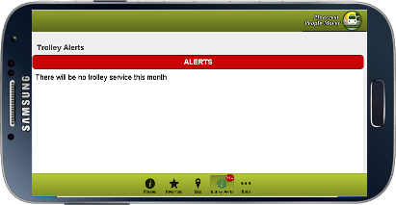To see all of the alerts for the Pinecrest People Mover, click on the Trolley Alerts tab and you can see all the alerts provided by the admin.
* 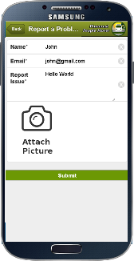On the more tab, you can request a stop, provide feedback, as well as report a problem. Also the service times and the about us will be provided.

# References

Maurice Pruna

* Email: [mauricepruna@gmail.com](mailto:mauricepruna@gmail.com)
* Phone: 786-445-3488

Ricardo Martinez

* Email: [rjmartinez23@gmail.com](mailto:rjmartinez23@gmail.com)
* Phone: 305-282-1544