**Feasibility Study and Project Plan**

|  |  |
| --- | --- |
| Course | CIS 4911 |
| System | (IBM) Track and keep score of and compute a group's sustainability efforts |
| Team | Jorge McGarry  Monica Del Prado |
| Date | 9-8-2014 |
| Instructor | Masoud Sadjadi |
| Mentor | Juan Caraballo |

**Version: 2.00**

Table of Contents

Overview 3

1. Introduction 3

1.1 Problem Definition 3

1.2 Background 4

1.3 Definitions, Acronyms, and Abbreviations 4

1.4 Overview of document 4

2. Feasibility Study 4

2.1 Description of Current System 4

2.2 Purpose of New System 5

2.3 High-level Definition of User Requirements 5

2.4 Alternative Solutions 6

2.4.1 Description of Alternatives 6

2.4.2 Selection Criteria 7

2.4.3 Analysis of Alternatives 7

2.4.4 Recommendations 7

3. Project Plan 7

3.1 Project Organization 7

3.1.1 Project Personnel Organization 7

3.1.2 Hardware and Software Resources 7

3.2 Identification of Tasks, Milestones and Deliverables 7

4. Appendix 8

4.1 Appendix A - Project schedule 8

4.2 Appendix B – Feasibility Matrix 8

4.3 Appendix C – Cost Matrix 8

4.4 Appendix D - Diary of Meetings 8

5. References 9

**Overview**

The main goal of the project is to develop a software application that entices people to recycle and keeps track of their efforts. The application will also have a “competitive spirit” built in, which means that recycling efforts will be compared against other registered users and groups. Users who excel in recycling will be provided some sort of reward in order to entice them in continuing the recycling behavior.

# Introduction

## Problem Definition

Currently, there is no software application that tracks and compares people’s recycling efforts. We want to build an application that tracks recycling efforts and encourages people to use it by providing a competitive approach.

Since recycling and keeping track are completely voluntary we also want to build in some sort of reward aspect into the application, to entice people to keep track of their efforts.

## Background

Our clients, FPL and IBM, want to increase recycling efforts and awareness. They want to build a platform that validates, tracks and rewards recycling initiatives. They not only want to do this at the individual level, but also at the corporate, college and community levels.

## Definitions, Acronyms, and Abbreviations

|  |  |
| --- | --- |
| **Term** | **Definition** |
| Group | A group of users that compete between each other. |
| Guest User | A user that has not created an account in the system |
| Registered User | A user that has created an account in the system |
| Group Owner | A user that created a group is automatically that group’s owner |
| Group Member | A registered user that joined a group. |

Table 1‑1. Definitions

## Overview of document

Section 1 includes the introduction to this project and describes the existing problem and the solution we plan to build. It also provides the background information that motivated our customers to need this system. This section ends with a brief overview of what this document contains in the next sections.

Section 2 will describe the feasibility study, which describes the current system and the purpose of the new system that will be built. It will discuss high-level definitions in terms of the user requirements for the system. Finally, it will provide an analysis of the similar existing systems.

Section 3 presents the project plan, and the hardware and software requirements. This section also covers how the project itself is organized, along with the personnel organization and the identification of tasks, milestones, and deliverables for this project.

Section 4 provides appendices with the project schedule and diary of meetings.

Section 5 includes the references.

# Feasibility Study

## Description of Current System

There are not previous versions of this system. This project will be the initial code base of the system.

## Purpose of New System

* Track recycling efforts.
* Compare recycling efforts between users and groups.
* Reward users who excel at recycling.

## High-level Definition of User Requirements

The system will provide the following general features:

* Should provide a redemption value based on the user’s recycling efforts.
* Should create a game environment by which users are rewarded by being singled out publicly for their efforts, and/or they gain extra access to the application based on their points.
* Should provide users the ability to compete between registered users.
* Should provide users the ability to compete under groups.
* The system should validate the recycling efforts.

Security:

* Users must log in to the system, so their efforts will be accounted for.
* Users must be part of a group, to compete within that group.
* Users must request permission to be part of a group.
* Users must pass the validation requirement to log items into the system.

Privacy:

* Group administrators will have access to full profile information of group members
* Application will be password protected.

The system will provide the following functionalities depending on the type of user:

Registered User:

* Should be able to log his recycling efforts as part of a group and also individually.
* Should be able to locate recycling locations depending on GPS location.
* Should be able to create a group.
* Should be able to join groups.
* Should be able to edit the profile information.
* Should be able to review the recycling history.

Group Member:

* Should be able to see details of joined groups such as overall activity and members of that group.
* Should be able to abandon groups.
* Should be able to see recycling locations related to the joined groups.
* Should be able to search for groups.

Group Administrator:

* Should be able to edit group details.
* Should be able to manage requests to join the group.
* Should be able to view the overall activity of the group.
* Should be able to search group members.

## Alternative Solutions

### Description of Alternatives

There are two types of applications related to recycling. One group provides useful tips and nearby recycling location centers, and the other is a single application called Green Bean Recycle and it is being used in nine colleges in the US. The main purpose of Green Bean Recycle application is to encourage recycling by rewarding the users who recycle the most. The limitation of this application is that it works together with recycling machines where users enter their phone number and the application logs the item that the user recycled into the application and increments the current dollar value that the user has collected so far.

### Selection Criteria

Game component on application:

1. Keep point-based application where groups can keep track of their efforts. track of their recycling efforts.
2. Keep an additional level-based system where the user can advance among levels
3. Challenge other users or teams.

Validation of recycling action:

1. Taking pictures while recycling an item.
2. Scanning items’ barcode.
3. Using geo-tag location to assign recycling efforts to a specific group.

### Analysis of Alternatives

Game component on application:

Alternative 1: Extra features could be added without affecting the ability to add alternative 2 and 3.

Alternative 2 and 3: Given the time constraint on this project, these alternatives could be added on future releases if needed.

Validation of recycling action:

Alternative 1: It would still require manual input from the user and verification from the group administrator to approve the scanned item.

Alternative 2: The barcode will provide a validation step on the process of recycling an item. The limitation will be that only items with barcodes will be accounted for.

Alternative 3: The geo-tag location approach could be effective since it will allow to log items into the appropriate group, so individual actions will not count towards their group contribution.

### Recommendations

Game component on application:

Start with a point-based system.

Validation of recycling action:

Even though bar code approach has some limitation, it will be a suitable way of validating user’s recycling actions. Geo-tag location will provide a way of assigning items to appropriate groups.

# Project Plan

## Project Organization

### Project Personnel Organization

Monica Del Prado will be working on all the front-end website aspects of the application.

Jorge McGarry will be working on all the front-end mobile aspects of the application.

Monica Del Prado and Jorge McGarry will work jointly between the backend aspects of the application, for both the website and mobile platforms.

Monica Del Prado and Jorge McGarry will work jointly on the documentation of the application.

### Hardware and Software Resources

Hardware:

* Windows, Mac, or Linux desktop or laptop computers

Software:

* Eclipse JEE (Kepler, Juno or Luna)
* Worklight plugin for Eclipse
* MySQL
* Apache
* PHP

## Identification of Tasks, Milestones and Deliverables

|  |
| --- |
| **Tasks** |
| Requirement Elicitation |
| Requirement Analysis |
| Feasibility Document (Deliverable 1) |
| Use cases, minimal class diagrams and sequence diagrams |
| Requirement Document (Deliverable 2) |
| System Architecture |
| Database Design and Setup |
| System Design |
| Implementation of General Use Features |
| Implementation of Individual Features (Website and Mobile application) |
| Design Document (Deliverable 3) |
| Test Cases Design |
| Test Implementation |
| Final Document (Deliverable 4) |

Table 3‑1. Project tasks

|  |  |
| --- | --- |
| **Milestone** | **Date** |
| Requirements Specification | 09/19/14 |
| System Design | 10/03/14 |
| Implementation | 11/15/14 |
| Testing | 12/08/14 |
| Project Completed | 12/11/14 |

Table 3‑2. Project Milestones

# Appendix

## Appendix A - Project schedule

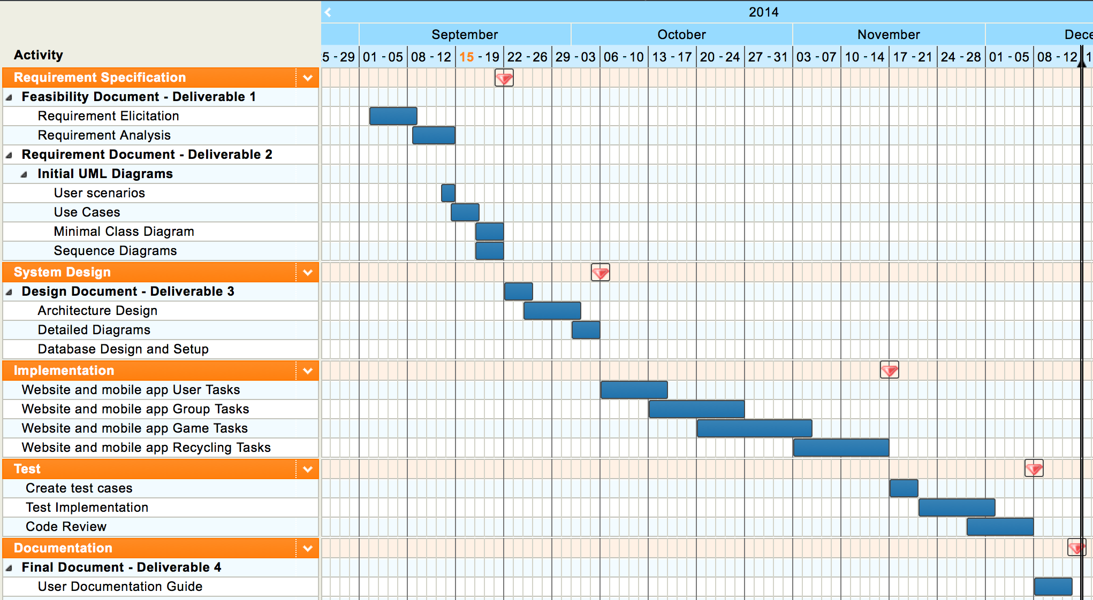

## Appendix B – Feasibility Matrix

## Appendix C – Cost Matrix

No costs will be associated to this project.

## Appendix D - Diary of Meetings

|  |  |  |
| --- | --- | --- |
| Date | Attendants | Agenda |
| 09/03/14 | Monica del Prado  Jorge McGarry  Manuel Bascuas  Nancy Mulshine  Juan Caraballo | General idea of system requirements was explained.  Monica and Jorge will submit a system proposal. |
| 09/08/14 | Monica del Prado  Jorge McGarry | Create initial website mockup and find major system functionalities. |

# References