Design Document
Course | CIS 4911
System | (IBM) Track and keep score of and compute a group's sustainability efforts
Team | Jorge McGarry  Monica Del Prado
Due Date | 12-10-2014
Instructor | Masoud Sadjadi
Mentor | Juan Caraballo

Contents
Abstract 3
1. Introduction 4
1.1 Problem Definition. 4
1.2 Design Methodology 4
1.3 Terminology - Definitions, acronyms, and abbreviations. 5
1.4 Overview of document 5
2. System Design 6
2.1 Overview 6
2.2 Subsystem Decomposition 7
2.3 Hardware and Software Mapping 7
2.4 Persistent Data Management 8
2.5 Security/Privacy 9
3. Detailed Design 10
3.1 Overview 11
3.2 Static model 12
3.3 Dynamic model 13
3.4 Code Specification 18
4. Glossary 19
5. Appendix 20
5.1 Appendix A – Use Case Diagram 20
5.2 Appendix B - Use Cases 21
5.3 Appendix C – Class Interfaces 33
5.4 Appendix D - Diary of meeting and tasks 39
6. References 46

Abstract
This document begins with an introduction to the ECO Sustainability Efforts system.. Following, is the description of the current system that is being implemented. The next section is all about system design and the methodology used. Furthermore, the requirements of the system are outlined. Additionally, the overall system design, including the primary and secondary architectural patterns, is discussed in detail. The detailed design follows with visual diagrams for better understanding. The end of the document includes a glossary, references, and an appendix.

Introduction
The Introduction provides a description about the system that will be built and the need of building such system. It will also provide a description of the expectations about the main system functionalities. Finally, it will provide a brief description of the rest of the document.

Problem Definition.
Currently, there is no software application that tracks and compares people’s recycling efforts. We want to build an application that tracks recycling efforts and encourages people to use it by providing a competitive approach.
Since recycling and keeping track are completely voluntary we also want to build in some sort of reward aspect into the application, to entice people to keep track of their efforts.

Design Methodology
Waterfall is the design model used to develop our project. This sequential model fits our needs for the purpose of developing the application given the time constraints. Based on the use cases, sequence diagrams were created to show how processes operate with one another and in which order.

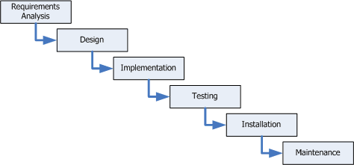

Terminology - Definitions, acronyms, and abbreviations.

Term | Definition
Guest User | A user that has not created an account in the system
Registered User | A user that has created an account in the system
Group Owner | A user that created a group is automatically that group’s owner
Group Member | A registered user that joined a group.
UML | Unified Modeling Language
Class diagram | Describes the system in terms of classes, attributes, and their relationships.
Server-side architecture | An architectural pattern that consist of a server handling requests from clients .

Overview of document
The remainder of this document contains four more sections where the last is the appendix. A brief description is provided below:
- Section 2 details the proposed software architecture of the whole project. This included the subsystem decomposition, hardware and software mapping, data management and Security and Privacy.
- Section 3 elaborates on the detailed design of the system. This chapter includes an overview of the process as well as object interactions and class design. This chapter also includes class diagrams for the subsystems being implemented as well as sequence diagrams for object interactions to be implemented.
- Section 4 is the glossary of terms used in the document, with an emphasis on domain specific terms.
- Section 5 is the appendix. This chapter contains the use case diagrams (both for functional and non-functional requirements). Detailed class diagrams are shown for each class. The document ends with a diary of meeting and tasks.
- Section 6 will list the references used.

System Design
In this chapter, the system design is explained in detail. Package diagrams are used to represent the major subsystems, which will be described in the next section along with the corresponding use cases, and then provide an overview of these subsystems. A deployment diagram will help to visualize the mapping between hardware and software.
The next two sections are related to stored data and security aspects of the system. The persistent data management and security requirements applicable to the storage of this data are described. Finally, security and privacy concerns and how they are managed on this system are explained.

Overview
The primary system architecture for this system will be the Server-Client Architecture and the secondary system architecture will be the MVC used on the client side. Both are used in the creation of the system due to the use of IBM Worklight Server. Both architectures are discussed in greater details throughout this section.

Server-Client Architecture
The Server-side of the system is provided by IBM Worklight Adapter framework. The Adapter is in charge of communication with the database and in charge of business logic of the application.

MVC Architecture
The MVC architecture was used on the Client side to ensure separation of concerns and maintainable code. A simplified diagram is provided below to visualize the decomposition and system architecture or the application

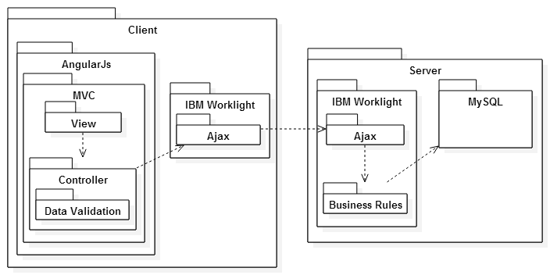
Figure 2.1.1 Server-Client Package Diagram. MVC Architecture on client-side

Subsystem Decomposition
The application is split into group administration subsystem, contest subsystem, recycling subsystem, dashboard subsystem.

The user administration is in charge of user-required functionalities such as log in, authentication verification and basic functionalities such as edit user profile.

The group administration subsystem is in charge of allowing users to perform group related functions, such as creating groups, editing groups information. The information related to this subsystem is stored in the database and functions such as edit group profile and setting user roles is based on permission, which is stored in the database and assigned to each user.

The recycling subsystem is related to recycling actions, items and materials administration. It allows registered users and administrators to recycle items in the system with consistent information. The data related to item and material is verified on the database to provide a reliable system.

The contest subsystem allows group owners and authorized users to launch contests and keep track of contest activities. The information of the contest is stored in the database and verified is consistent with user expectation.

The dashboard subsystem allows the user to access the information about site usage providing an intuitive interface that connects different components of the system. Groups, users, items information is accessed through the dashboard subsystem and customized according to user’s needs.

Hardware and Software Mapping
The system was implemented using AngularJS on the client side implementation for the MVC pattern. Javascript libraries using AngularJS directives were used to ensure consistency and supportability code. The IBM Worklight Adapter provides a layer of security allowing to implement server side security requirements on that component and allowing communication with the MySQL database.

Figure 2.1.2 System Architecture and Implementation

Persistent Data Management

Data is being stored in a MySQL database. It is necessary to store all persistent data in tables to hold information such as: user profiles, groups, items, recycling actions, contests, forms static information, etc.

The design of the database can be visualized in the ER diagram below:
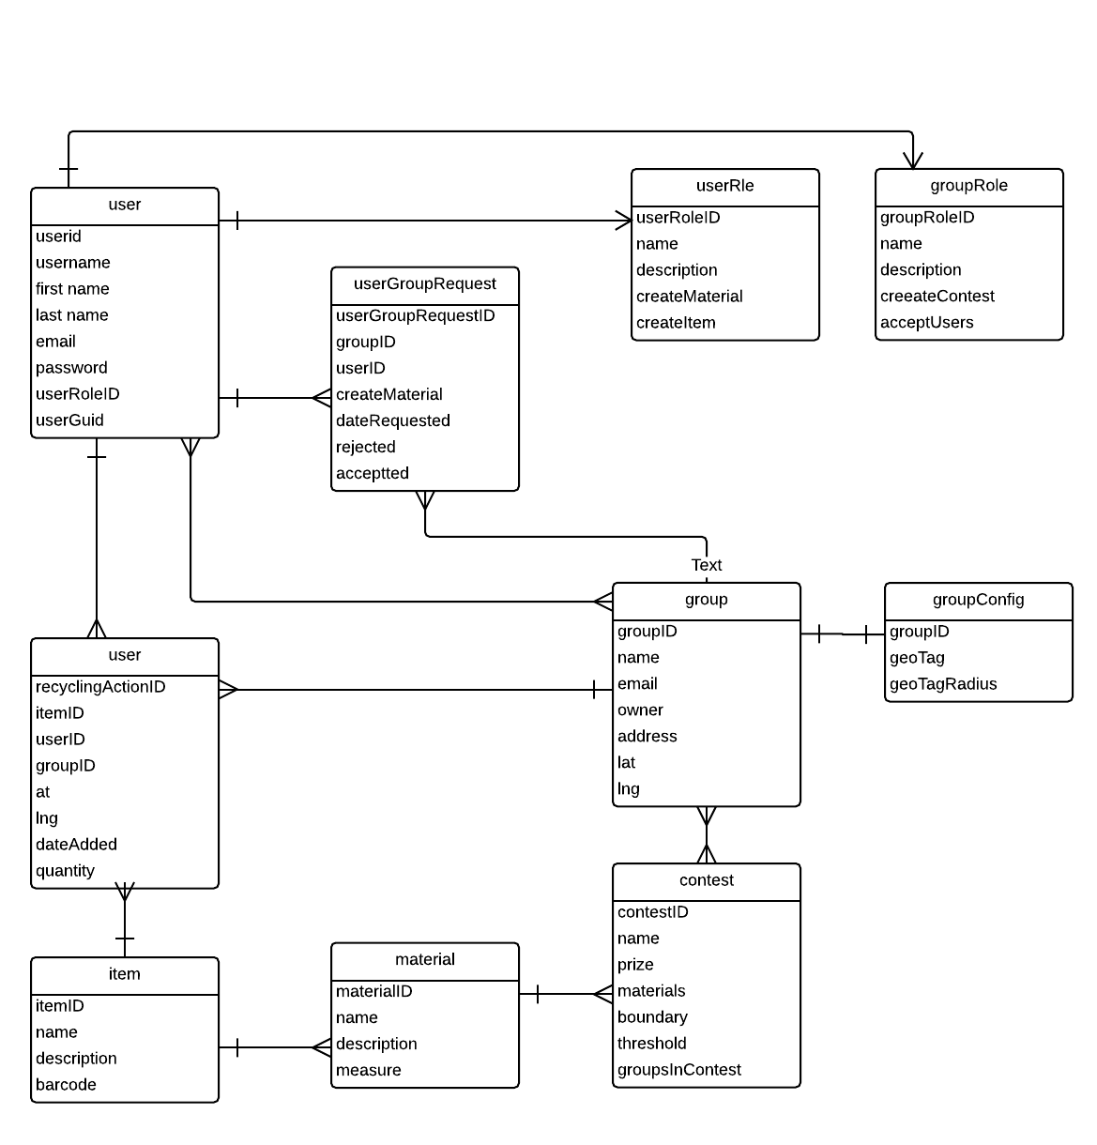

Security/Privacy
Security Features
- User password will be required to log in.

Upon registration, the passwords will be stored in the database. At this point the password will not be encrypted. .
- IBM Worklight Adapter access control rules
The Adapter framework provides access control with respect to controllers used. This access control will make sure that not logged users performing certain actions. For example, users that are not logged in will not have access to edit profile page.
Privacy
The only private information is the profile information respective to each user. To modify this information, the user needs to be authenticated in the system. However, This information is available to the users on the site taking in some pages.

Detailed Design
This chapter will explain in depth the object design of the system. This chapter will provide class diagrams, along with a description and the purpose of each subsystem used for the subsystems described on the previous chapter. Sequence diagrams will be used to show object interactions for the corresponding use cases presented on this document.

Overview

The base structure of our application applies to all subsystems. On the client side application, AngularJS is used to ensure proper MVC implementation. Views are updated from the Model and controller retrieves information from the services which communicates with the IBM Worklight Adapter. The IBM Worklight Adapter ensures the required services are allowed by the system and retrieve, update or add information in the database and returns success or failure messages to the services. The IBM Worklight Adapter uses Javascript as base language.

The group subsystem allows functions such as creating groups, edit group profile, setting group permissions, material and item creation. Any user could create groups, but membership to groups must be requested and approved or rejected by group owners.

The user subsystem allows basic functions such as logging in, logging out and editing group profile.

The recycling subsystem is related to recycling actions and recyclable items. It also allows to search recycling locations which is controlled by the GeoMap IBM Worklight Adapter.

The contest subsystem requires special permission from group owners and is in charge of displaying and updating information related to contests to the users.

The dashboard subsystem displayed relevant information related to site groups, users and items. It allows users to filter information by group and user. It provides search functionalities to the users, so they can visualize information in the system.

Static model
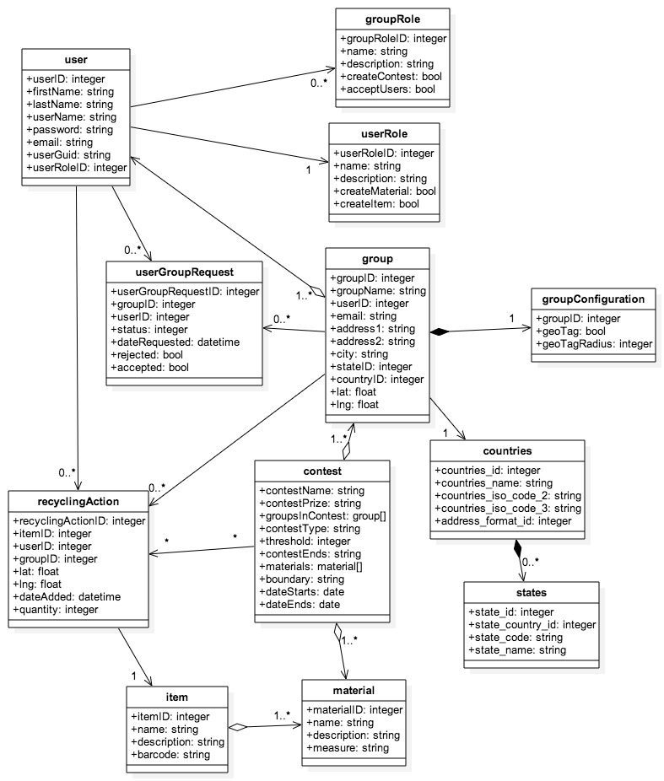
Figure 3.2.1- Class Diagram

Dynamic model
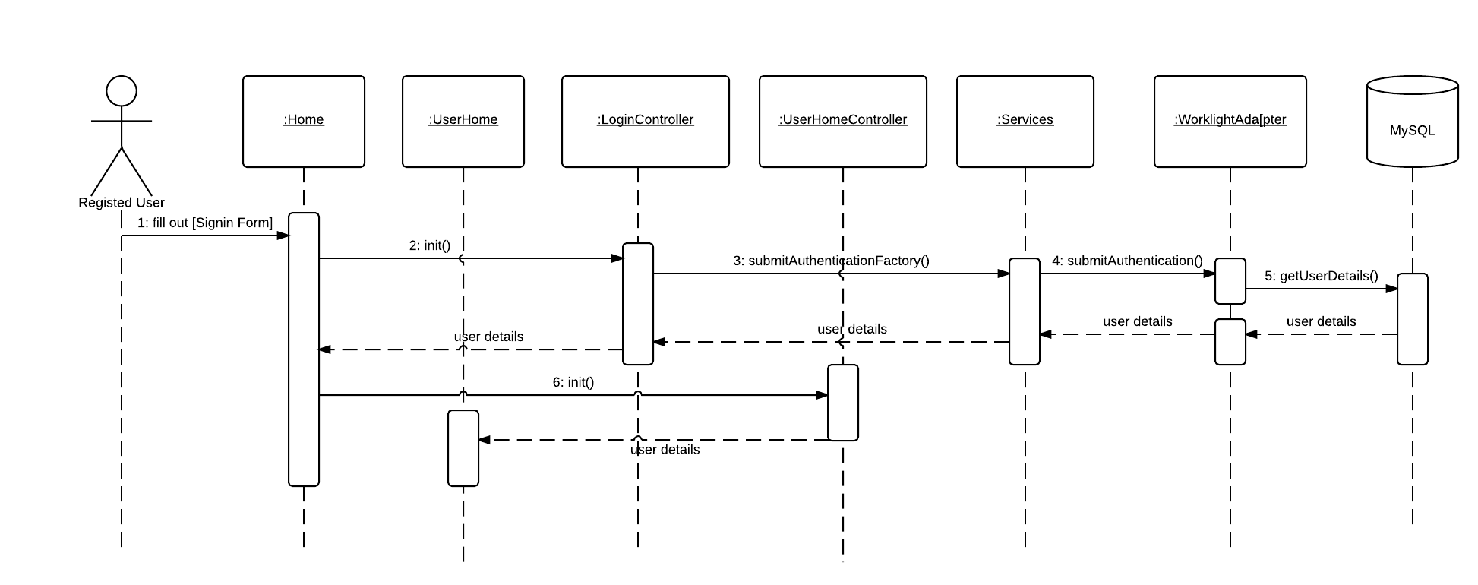
Figure 3.3.1- Log In
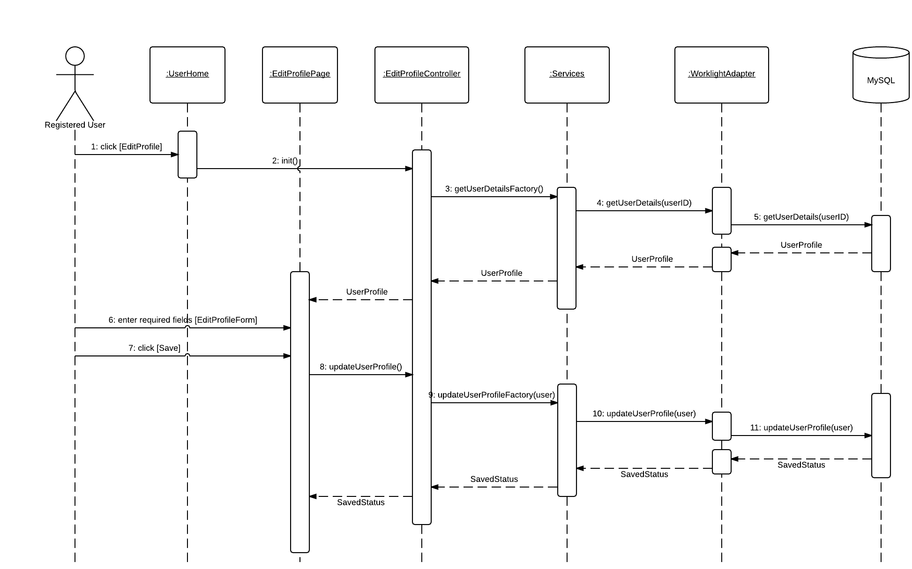
Figure 3.3.2- Edit Profile

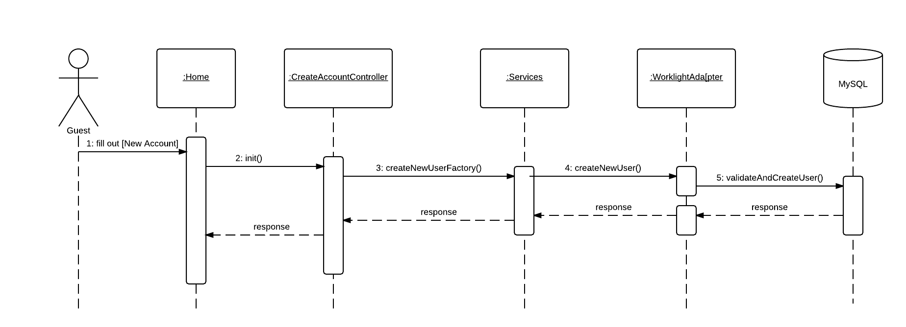
Figure 3.3.3 Create Account
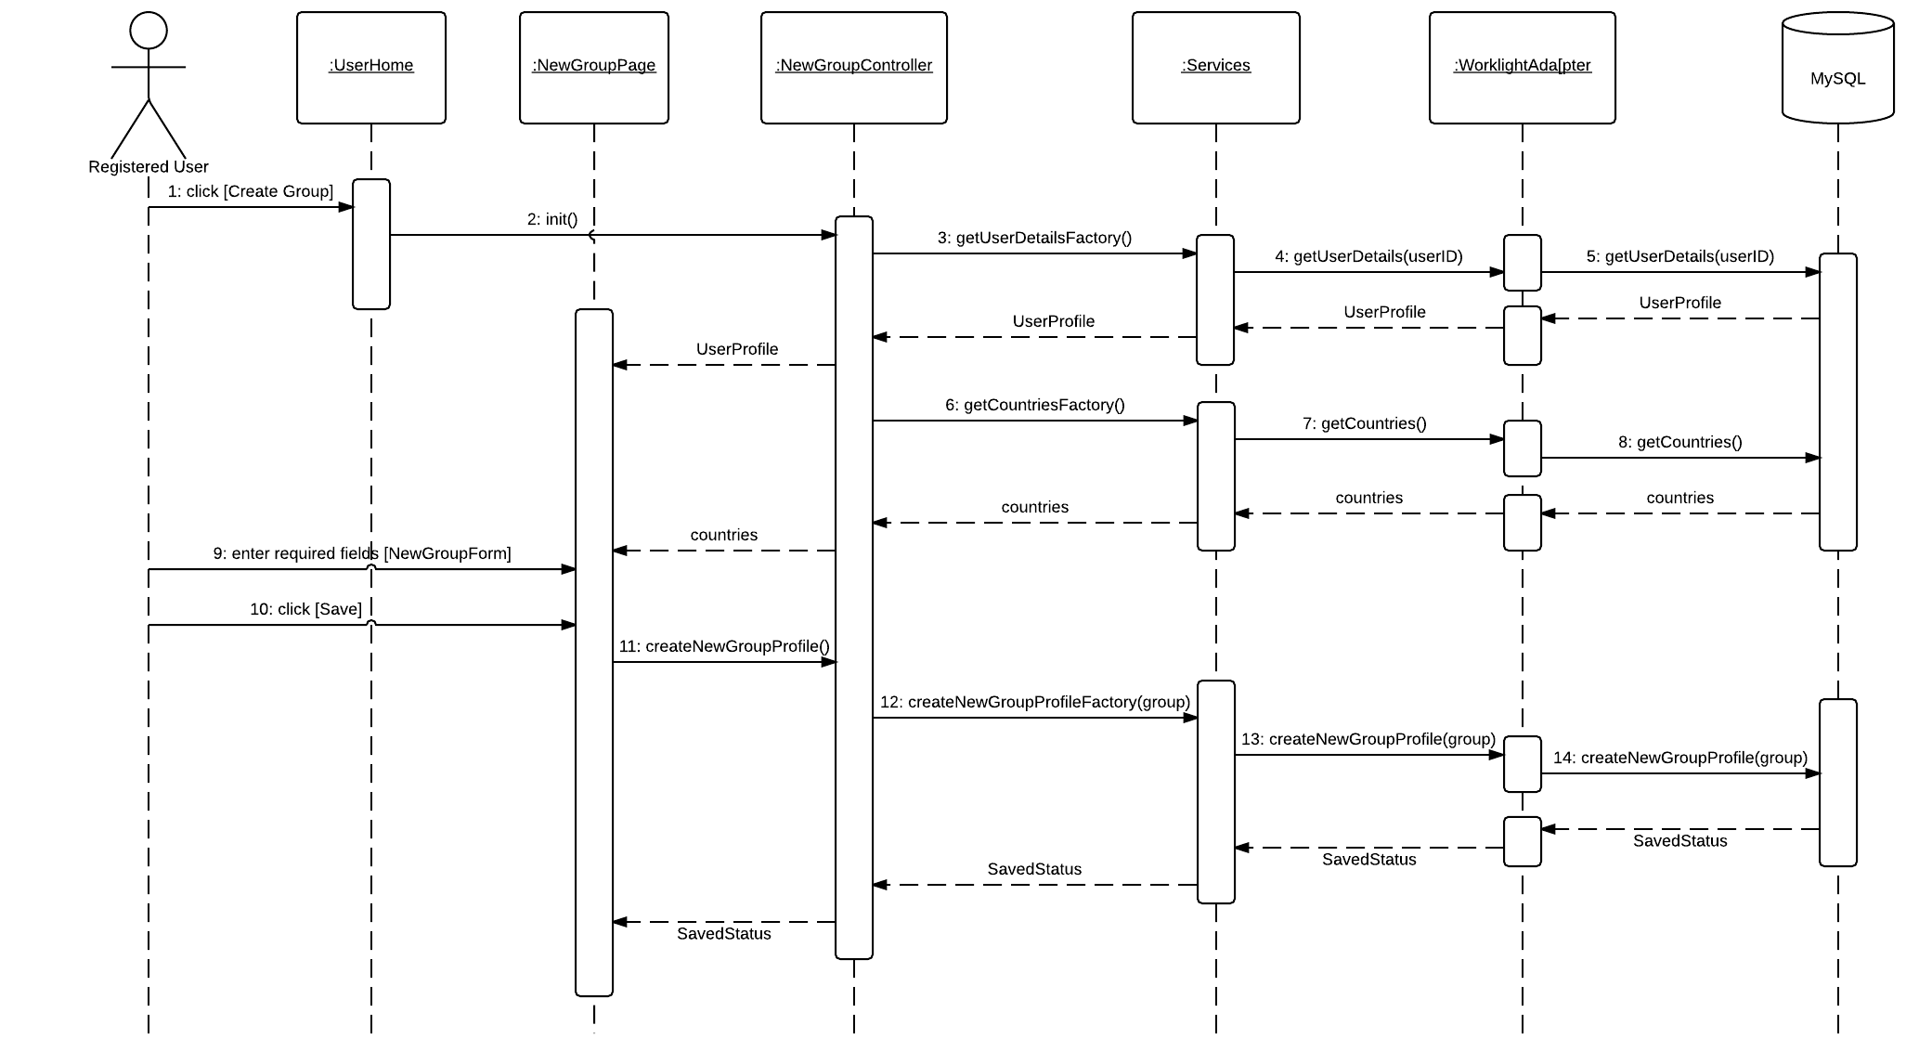
Figure 3.3.4- Create Group
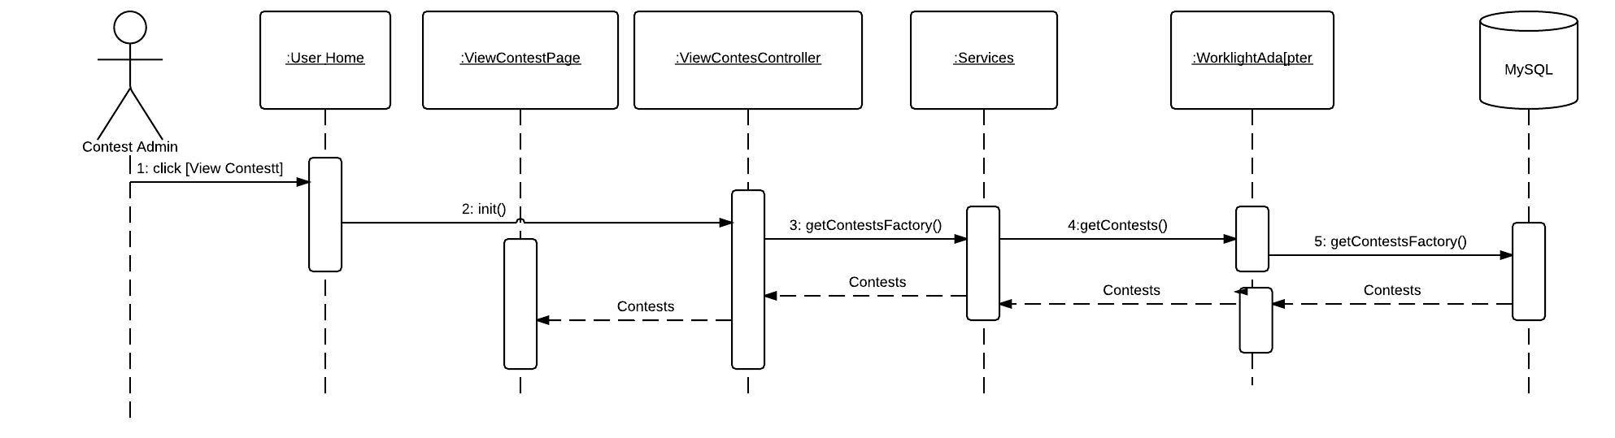
Figure 3.3.5 Create Contest

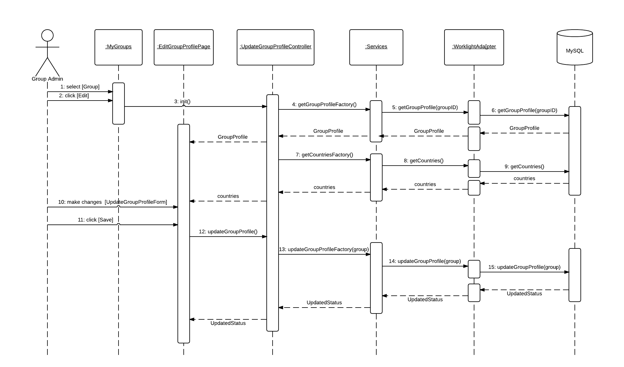
Figure 3.3.6 – Edit Group Profile
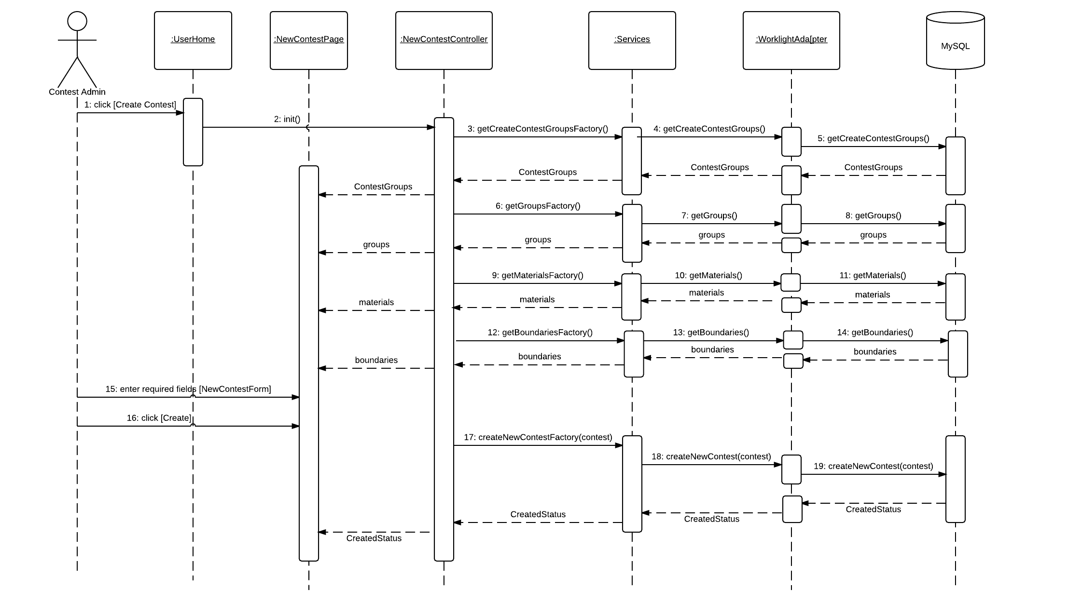
Figure 3.3.7 View Contest

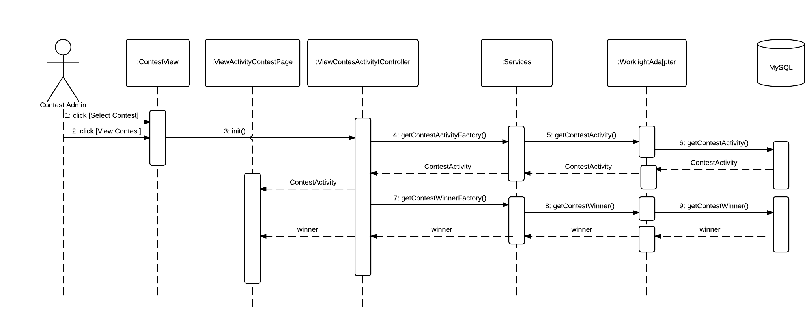
Figure 3.3.8- View Contest Activity

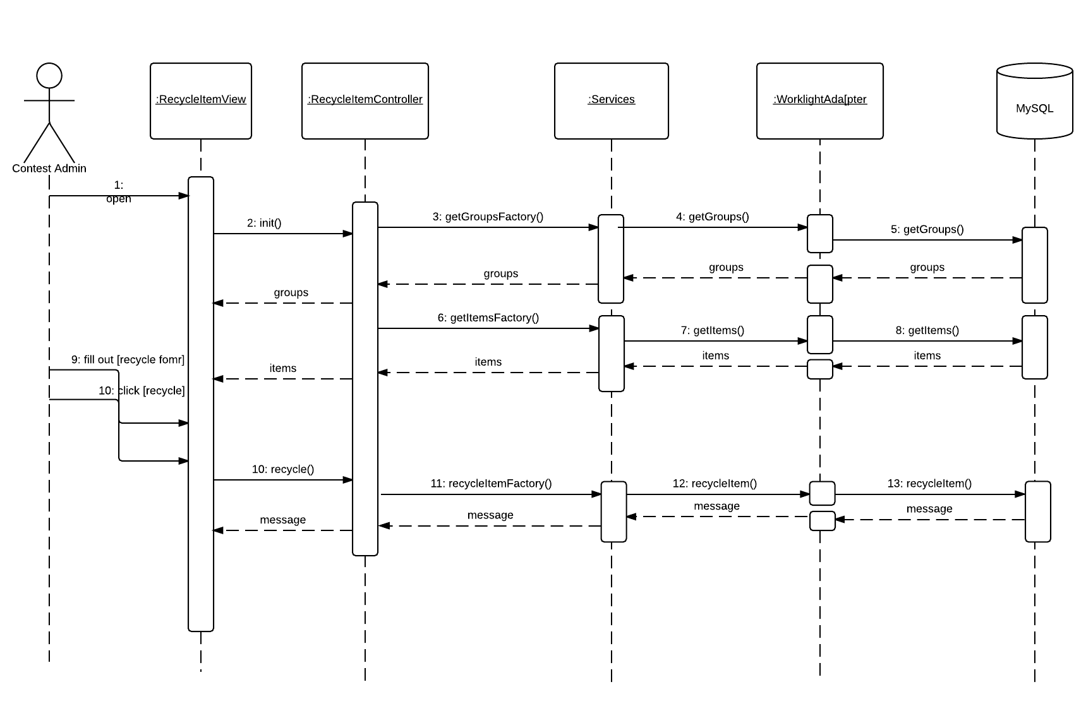
Figure 3.3.9- Recycle Item

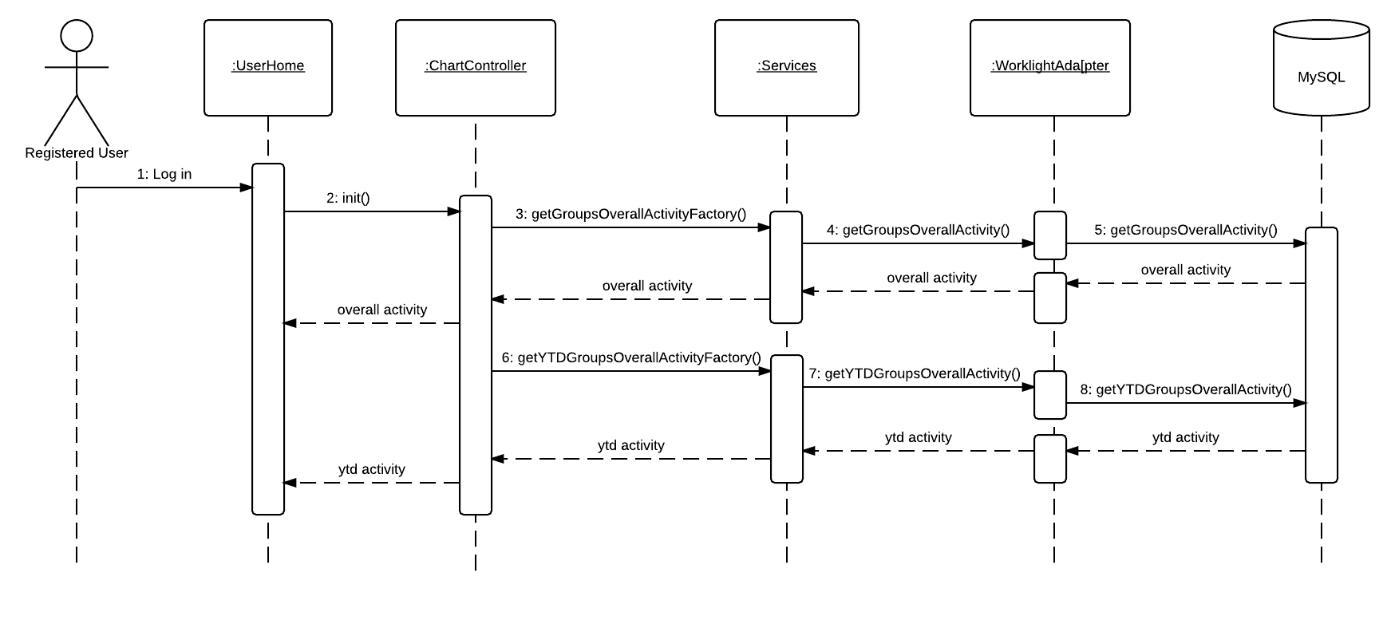
Figure 3.3.10 – Dashboard Charts
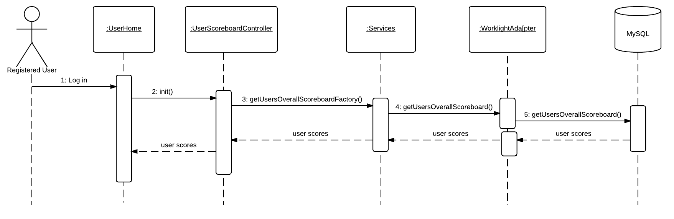
Figure 3.3.11- User Scoreboard
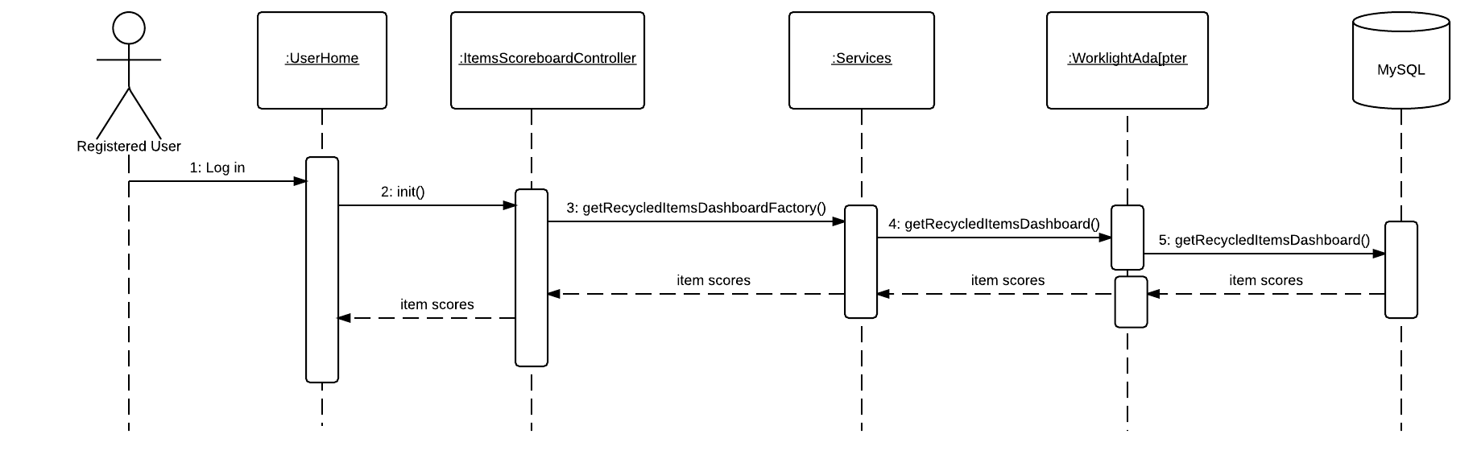
Figure 3.3.12- Item Scoreboard
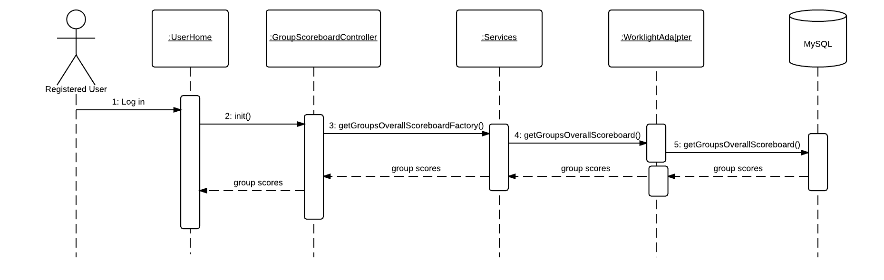
Figure 3.3.13- Group Scoreboard
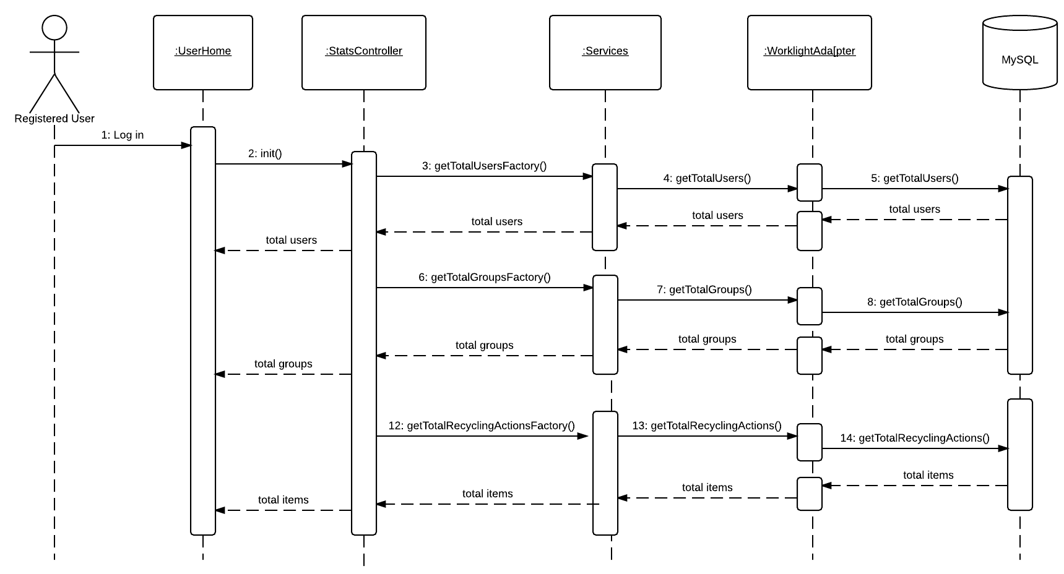
Figure 3.3.14- Site Usage widgets
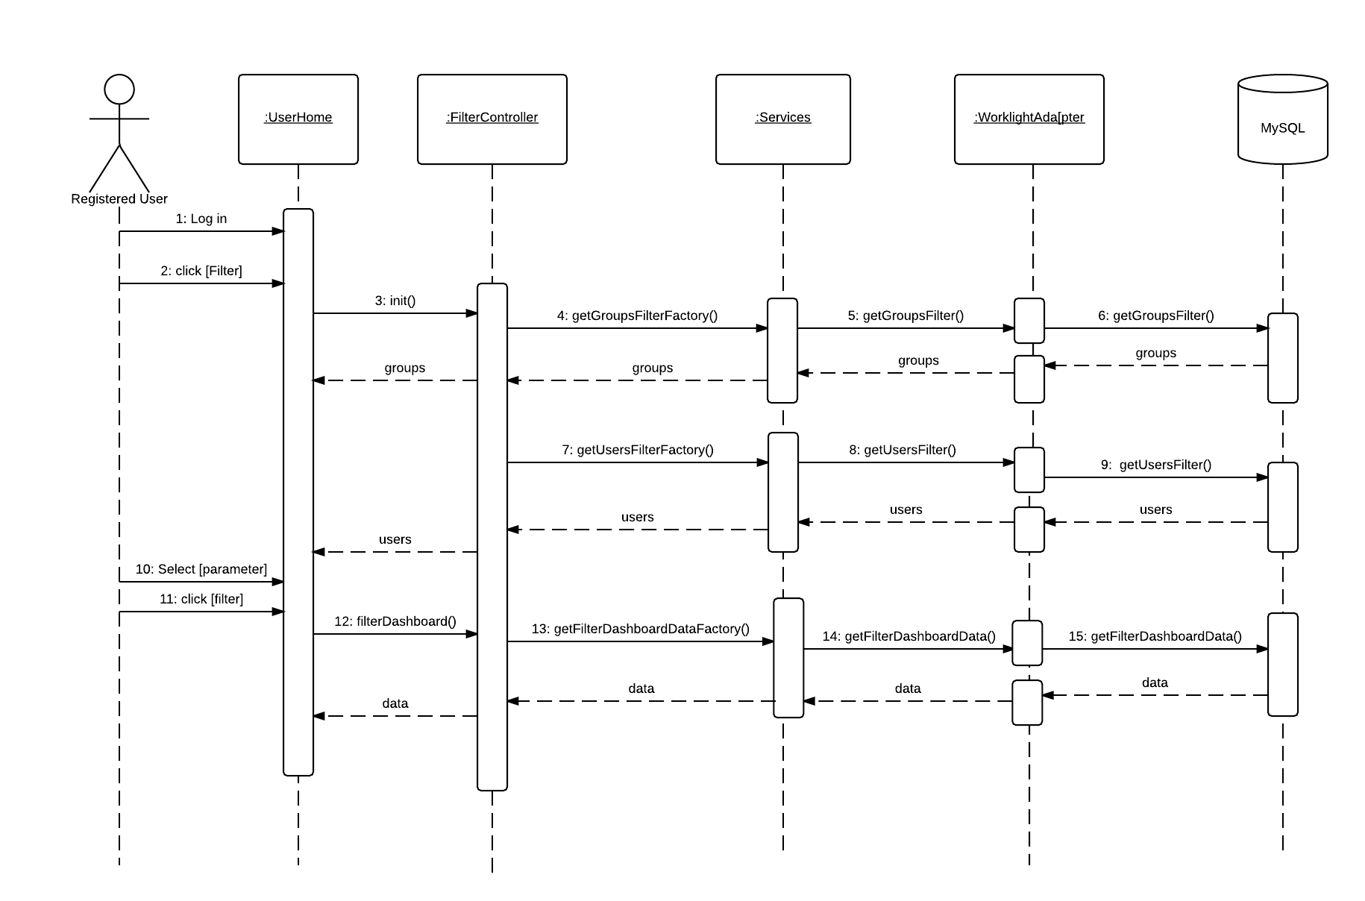
Figure 3.3.15- Filter Dashboard

Code Specification

The application functions are implemented using AngularJS scope model and accessed by the controllers that serve specific purposes. The controllers retrieve and update information to the database using service calls that communicate with the IBM Worklight Adapter. The information handled by the application is basically group information, user information and recycling activity information.

Glossary
Term | Definition
Guest User | A user that has not created an account in the system
Registered User | A user that has created an account in the system
Group Owner | A user that created a group is automatically that group’s owner
Group Member | A registered user that joined a group.
UML | Unified Modeling Language
MVC | Model View Controller
IBM Worklight | Server-side framework used to develop the application

Appendix

Appendix A – Use Case Diagram
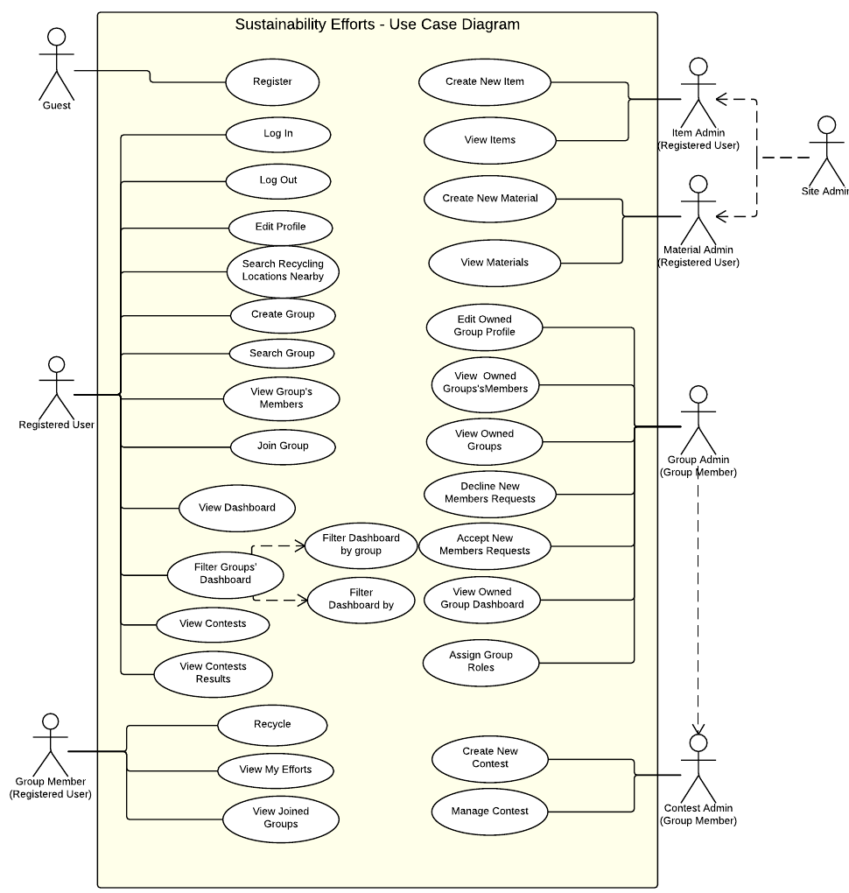

Figure 5.1.1- Use Case Diagram

Appendix B - Use Cases
Use Case ID | US1001
Description | Allows a Guest to create an account and become a registered user.
Actor | Guest
Pre-conditions | - The Guest accesses the home page of the application.
Steps | - The Guest fills out the required user account information.  - The Guest clicks on “Create Account” button.  - The user account information is validated by the System.  - The user account information is created by the System.  - The Guest is notified that the account has been created.
Post-Conditions | 1. The Guest is now a registered user in the system.
Exceptions | Exception: User account information is invalid  Raised when any of the user information fields contains invalid information.

Use Case ID | US1002
Description | A Registered User should be able to login into the system.
Actor | Registered User
Pre-conditions | - The Registered User access the home page of the application.
Steps | - The Registered User fills out his credentials.  - The Register User clicks on “Sign in”.  - The system validates the credentials.  - The system logs in the Registered User.  - The system redirects the user to the User Home page.
Post-Conditions | 1. The user has access to site data
Exceptions | Exception: User/Password incorrect  Raised when the entered credentials do not match anything in the system.

Use Case ID | US1003
Description | A Registered User should be able to edit their user profile in the system to keep it up to date.
Actor | Registered User
Pre-conditions | - The Registered User accesses the home page of the application.  - The Registered User logs into the application.  - The Registered User clicks the “User” menu item.
Steps | - The Registered User clicks the “Edit Profile” menu item.  - The Registered User changes the user account information as need be.  - The Registered User clicks on “Save” button.  - The System validates the user account information.  - The System updates the user account information.  - The Registered User receives notification the user account information was updated.
Post-Conditions | 1. The new information is stored in the database
Exceptions | Exception: User account information is invalid  Raised when any of the user account information fields contains invalid information.

Use Case ID | US1004
Description | A Registered User should be able to view the overall group’s activity of the site.
Actor | Registered User
Pre-conditions | - The Registered User logs into the application.  - The Registered User accesses the user home page of the application.
Steps | - The System shall retrieve groups, recycled and users activity  - The system shall display the information on the dashboard
Post-Conditions | 1. The user can see the group, users and items activity
Exceptions | Exception: System is not able to retrieve data

Use Case ID | US1005
Description | A Registered User should be able to send a request to a group they are not a member of, to join the group.
Actor | Registered User
Pre-conditions | - The Registered User accesses the home page of the application.  - The Registered User logs into the application.  - The Registered User clicks the “Groups” menu item.  - The Registered User clicks the “Search Group” menu item.
Steps | - The Registered User searches and clicks on the Group they wish to join.  - The Registered User clicks on “Join” button.  - The Registered User receives notification the request was sent.
Post-Conditions | 8. The notification is added to the queue of that group’s administrator
Exceptions

Use Case ID | US1008
Description | A Registered User should be able to create a new group.
Actor | Registered User
Pre-conditions | - The Registered User accesses the home page of the application.  - The Registered User logs into the application.  - The Registered User clicks the “Groups” menu item.
Steps | - The Registered User clicks the “Create Group” menu item.  - The Registered User fills out the group account information.  - The Registered User clicks on the “Save” button.  - The System validates the group account information.  - The System group account information is created by the system.  - The Registered User receives notification the group has been created.
Post-Conditions | The Registered User is assigned as the Group Owner of the created group.
Exceptions

Use Case ID | US1009
Description | A Registered User can log recycling actions.
Actor | Registered User
Pre-conditions | - The Registered User accesses the home page of the application.  - The Registered User logs into the application.
Steps | - The Registered User clicks the “Recycle” menu item.  - The Registered User selects the appropriate information for the recycling action.  - The Registered User clicks on the “Create Recycling Action” button.  - The system will add the new recycling action.  - The system shall verify if the recycled item is part of a contest.  - The Registered User receives notification that the recycling action has been created.
Post-Conditions | The system displays success/failure message
Exceptions

Use Case ID | US1011
Description | A Registered User can see recycling locations near by.
Actor | Registered User
Pre-conditions | - The Registered User accesses the home page of the application.  - The Registered User logs into the application.
Steps | - The Registered User clicks the “Recycle Locations” menu item.
Post-Conditions
Exceptions | The system is not able to retrieve location.

Use Case ID | US1012
Description | A Registered User can review all materials created in the system.
Actor | Registered Users
Pre-conditions | - The Registered User accesses the home page of the application.  - The Registered User logs into the application.
Steps | - The Registered User clicks the “Materials” menu item.  - The system shall retrieve the materials information from the database.
Post-Conditions | The system displays the list of materials
Exceptions

Use Case ID | US1013
Description | A Material Administrator wants to create a new Material.
Actor | Material Administrator
Pre-conditions | - The Material Administrator accesses the home page of the application.  - The Material Administrator logs into the application.
Steps | - The Material Administrator clicks the “Item” menu item.  - The Material Administrator clicks the “New Material” menu item.  - The Material Administrator fills out the new material information.  - The Material Administrator clicks on “Create Material” button.  - The System validates the new material information.  - The System creates the new material.  - The Material Administrator is notified that the material was created.
Post-Conditions
Exceptions | Exception: New material information is invalid  Raised when any of the new material information fields contains invalid information.

Use Case ID | US1014
Description | A Registered User should be able to review Items in the System.
Actor | Registered User
Pre-conditions | - The Registered User accesses the home page of the application.  - The Registered User logs into the application.
Steps | - The Registered User clicks the “Item” menu item.  - The Registered User clicks the “Items” menu item.
Post-Conditions
Exceptions

Use Case ID | US1015
Description | An Item Administrator wants to create a new Item.
Actor | Item Administrator
Pre-conditions | - The Item Administrator accesses the home page of the application.  2. The Item Administrator logs into the application.
Steps | - The Item Administrator clicks the “Item” menu item.  - The Item Administrator clicks the “New Item” menu item.  - The Item Administrator types in some information on the new item and clicks on “Next” button.  - The Item Administrator confirms this item is not already in the System.  - The Item Administrator enters the new item information.  - The Item Administrator clicks on “Create Item” button.  - The System validates the new item information.  - The System creates the new item.
Post-Conditions | The Item Administrator is notified that the material was created.
Exceptions | Exception: New item information is invalid  Raised when any of the new item information fields contains invalid information.

Use Case ID | US1016
Description | A Registered User can view groups they are members of.
Actor | Registered User
Pre-conditions | - The Registered User accesses the home page of the application.  - The Registered User logs into the application.
Steps | - The Registered User clicks the “Groups” menu item.  - The Registered User clicks the “Joined Groups” menu item.  - The system shall list the groups the user has joined
Post-Conditions
Exceptions

Use Case ID | US1018
Description | A Registered User can view the members of a group they have joined.
Actor | Registered User
Pre-conditions
Steps | - The Registered User accesses the home page of the application.  - The Registered User logs into the application.  - The Registered User clicks the “Groups” menu item.  - The Registered User clicks the “Joined Groups” menu item.  - The Registered User clicks on a Group.  - The Registered User clicks the “members” button.  - The Registered User is shown all members of that Group.
Post-Conditions
Exceptions

Use Case ID | US1020
Description | A registered user can log out
Actor | Registered User
Pre-conditions | - The Registered User accesses the home page of the application.  - The Registered User logs into the application.
Steps | - The Registered User accesses User drop down menu  - The registered user click log out  - The system shall log out the user from the application
Post-Conditions | 6. The user cannot access any functionality of the application without logging in again
Exceptions

Use Case ID | US1021
Description | A Group Administrator can edit the information of the group they administrate.
Actor | Group Administrator
Pre-conditions | - The Group Administrator accesses the home page of the application.  - The Group Administrator logs into the application.  - The Group Administrator clicks the “Groups” menu item.  - The Group Administrator clicks the “My Groups” menu item.
Steps | - The Group Administrator clicks on a Group.  - The Group Administrator clicks the “edit” button.  - The Group Administrator updates the Group information that needs update.  - The Group Administrator clicks on the “save” button.  - The System validates the information.  - The System updates the new information for the group.
Post-Conditions
Exceptions | Exception: Group information is invalid  Raised when any of the group information fields contains invalid information.

Use Case ID | US1022
Description | A Group Administrator can accept or decline users from joining the groups they own.
Actor | Group Administrator
Pre-conditions | - The Group Administrator accesses the home page of the application.  - The Group Administrator logs into the application.
Steps | - The Group Administrator clicks the “Groups” menu item.  - The Group Administrator clicks the “Accept Users” menu item.  - The Group Administrator clicks on a Group.  - The Group Administrator clicks the “Requests” button.  - The Group Administrator clicks on a user and clicks “Accept” or “Reject”.
Post-Conditions | The user is deleted from the group owner’s request queue
Exceptions

Use Case ID | US1023
Description | A Group Administrator or authorized user can create a contest
Actor | Group Administrator/Authorized user
Pre-conditions | - The actor accesses the home page of the application.  - The actor logs into the application.
Steps | - The Actor clicks on Contest menu item.  - The Actor clicks the “New Contest” menu item.  - The Actor fills out the required information  - The actor clicks create contest
Post-Conditions | The contest is stored in the database and available
Exceptions | The actor entered incorrect contest information and the system cannot create the contest

Use Case ID | US1024
Description | A User should be able to view contests
Actor | Registered User
Pre-conditions | - The Actor accesses the home page of the application.  - The Actor logs into the application.
Steps | - The Actor clicks the “Contest” menu item.  - The Actor clicks the “View Contest” menu item.  - The System shall get contest information from the database.  - The system displays the list of groups
Post-Conditions | The user is able to select a contest and perform actions on them
Exceptions

Use Case ID | US1025
Description | A user should be able to view contest activity
Actor | Registered User
Pre-conditions | - The Actor accesses the home page of the application.  2. The Actor logs into the application.
Steps | - The Actor clicks the “Contest” menu item.  - The Actor clicks the “View Contest” menu item.  - The actor selects a contest  - The actor clicks view activity  - The System shall get contest activity from the database.
Post-Conditions | The shall display the status of the contest
Exceptions

Use Case ID | US1026
Description | A user should be able to see to search overall activity of a group.
Actor | Registered User
Pre-conditions | - The Actor accesses the home page of the application.  2. The Actor logs into the application.
Steps | - The system shall display groups activity in the dashboard  - The user types a name on the group search box  - The system shall retrieve the data associated with that group
Post-Conditions | The user gets information filtered by group name
Exceptions | The group name that the user entered does not exist

Use Case ID | US1027
Description | A user should be able to see to search overall activity of a user.
Actor | Registered User
Pre-conditions | - The Actor accesses the home page of the application.  2. The Actor logs into the application.
Steps | - The system shall display users activity in the dashboard  - The user types a name on the user search box  - The system shall retrieve the data associated with that user
Post-Conditions | The user gets information filtered by user name
Exceptions | The user name that the user entered does not exist

Use Case ID | US1028
Description | A user should be able to search recycled items
Actor | Registered User
Pre-conditions | - The Actor accesses the home page of the application.  2. The Actor logs into the application.
Steps | - The system shall display items activity in the dashboard  - The user types a name on the items search box  - The system shall retrieve the data associated with that item
Post-Conditions | The user gets information filtered by item name
Exceptions | The items name that the user entered does not exist

Appendix C – Class Interfaces

// User related functions
$scope.userID: userid, irstname, lastname, username, password, email //JSON object

function subithAuthentication(userID){

}
function createUser(firstname, lastname, username, password, email){

}

function getUserDetails(userID){

}

function updateUserProfile(userid, username, fname, lname, email, password) {

}

// Group related functions
$scope.group: groupName, email, address1, address2, city, stateID, countryID, zip, geoTag, radius, lat, lng//JSON object

function createNewGroupProfile(groupName, email, address1, address2, city, stateID, countryID, zip, geoTag, radius, lat, lng) {

}

function updateGroupProfile(groupid, groupname, email, address1, address2, city, stateID, countryID, zip, geoTag, radius, lat, lng) {

}

function getGroupProfile(groupID) {

}

function getGroups() {

}

function getGroupsMemberOf(){
}

function getGroupsNotMemberOf(){
}

function getGroupsOwnerOf(){

}

function getGroupUsers(groupID) {

}

function getJoinedGroupUsersView(groupID) {

}

function getStateList(countryID) {

}

function getStateByID(stateID) {

}

function getCountryList() {

}

function getCountryByID(countryID) {

}

//Material related functions
$scope.material: materialID, name, description, measure //JSON object

function createMaterial(name, description, measure){

}

function getMaterials() {

}

//Item related functions
$scope.item: itemID, name, description, barcode, materials[] //JSON object

function getItemDuplicates(name, description) {

}

function getItems() {

}

function createItem(name, description, barcode, materials) {

}

// Dashboard
$scope.charts: groups, users //JSONs objects

function getGroupsOverallActivity(){

}

function getYTDGroupsOverallActivity(){

}

function getUsersOverallScoreboard(){

}

function getGroupsOverallScoreboard(){

}

function getTotalUsers(){

}

function getTotalGroups(){

}

function getTotalRecyclingActions(){

}

function getRecycledItemsDashboard(){

}

//Contest
$scope.contet: contestName, prize, groups, threshold, ends, material, boundary, radius, dateFrom, dateTo //JSON object
function getCreateContestGroups(){

}
function createNewContest(contestName, prize, groups, threshold, ends, material, boundary, radius, dateFrom, dateTo){

}

function getBoundaries(){

}

function getContestEnds(){

}

function getContests(){

}

function getContestActivity(contestID){

}

function getContestWinner(contestID){

}

// Recycling Action related functions
$scope.recyclingAction: itemID, groupID, lat, lng, quantity//JSON object

function createRecyclingAction(itemID, groupID, lat, lng, quantity) {

}

// user_role related

function getUserRole(){

}

// user_group_request related functions

function createUserGroupRequest(groupID){

}

function acceptUserGroupRequest(groupID, userID){

}

function rejectUserGroupRequest(groupID, userID){

// accept_user_groups_view related functions

function getAcceptUserGroupsView(){

}

//accept_user_users_view related functions

function getAcceptUserUsersView(groupID){

}

// group_role related

function getGroupRoles(){

}

// user_to_group related functions

function updateUserToGroup(groupid, userid, userRoleID){

}

//Groups Filter Dashboard related funcitons
function getGroupstoFilterDashboard(){

}

function userScoreboardGetSelectedGroup(groupID){
return WL.Server.invokeSQLStoredProcedure({

}

function groupScoreboardGetSelectedGroup(groupID){

}

function itemsBoardGetSelectedGroup(groupID){

}

function getTotalUsersSelectedGroup(groupID){

}

function getTotalRecyclingActionsSelectedGroup(groupID){

}

function getYTDSelectedGroupOverallActivity(groupID){

}

function getUsersActivitySelectedGroup(groupID){

//Users Filter Dashboard functions
function getUserstoFilterDashboard(){

}

function getTotalGroupsSelectedUser(userID){

}

function getTotalRecyclingActionsSelectedUser(userID){

}

function userScoreboardGetSelectedUser(userID){

}

function groupScoreboardGetSelectedUser(userID){

}

function itemsBoardGetSelectedUser(userID){
}

function getYTDSelectedUserOverallActivity(userID){

}

function getGroupsActivitySelectedUser(userID){

}

Appendix D - Diary of meeting and tasks

Meeting Minutes 9/29
Meeting:
Team Meeting
Date:
9/29/2014 5:00 pm to 7:45 pm
Location:
FIU Library
Attending:
Jorge McGarry, Student.
Monica Del Prado, Student.
Taking Minutes:
Jorge McGarry
Purpose:
This is a regular scheduled meeting.
Meeting Points:
- Discussed the “Stack” we would be using for the website. We agreed upon the following,
  - JQuery
  - AngularJs
  - Dojo or D3
  - MySQL
- Discussed the contests mock up we would present to the client
  - We came up with some base contests that would be created by the group owners and identified how the database structure would look
- Discussed the item creation mock up we would present to the client
  - We came up with the base elements that are required for items
    - Items should have some setup that ties into the “Green Message” ticker we plan to create
    - Items should be created and approved by the community, not some “Admin”
    - Created or Edited items need to have some sort of approval process by the “Community”
- Drafted rough copy of a class diagram. When we say rough, we mean certain things are missing but a good beginning is there.
- Refined the backlog by assigning tasks to team members responsible for completing said tasks.
- Discussed what the “Meat” of the project would be for each individual and assigned work in that fashion.
- Reviewed MyFitnessPal’s item creation process.
- Reviewed VirginPulses contest creation process.
- Put cards in development relevant to what we would like to have done by our next presentation.
- We agreed that the person who codes a particular scenario/use case will develop the use case and/or sequence diagram ahead of implementing the solution.
Meeting Minute 10/3
Meeting:
Team Meeting
Date:
10/3/2014 4:00 pm to 5 pm
Location:
Conference Call
Attending:
Juan Caraballo
Jorge McGarry
Pradeep P Mansey
Roland Barcia
Sean Sundberg
Dennis Bly
Taking Minutes:
Jorge McGarry
Purpose:
Technical Meeting
Meeting Points:
We were still having issues getting a production version of the IBM Worklight Server to install on our VM. Dennis was on the phone call and directed us to the area on the IBM website where we should be going, https://www-01.ibm.com/isc/esd/dswdown/dswdown.wss/web/home/home.ftl?ticket=Xa.2/Xb.XJi39I33KMb2eGC74hfJktx4f3TI2ckKLkRvOTXv_A/Xc.2000001GKJ/Xd./Xf./Xg.7746842/Xi.2000001GKJ/XY.scholars/XZ.QlEJt3b3ViFLLOFKoUxRJqri2sI&link_id=SDHome.
I asked some questions in regards to authentication and how we should be going about it with IBM Worklight. Rolando suggest that having a simple username / password lookup that we are currently be using may not be the best route to go. He suggested we tap into LDAP functionality of the WebSphere liberty application, which is packaged with IBM Worklight Server.
I asked some question in regards to our authentication scheme. Rolando and Sean suggested that we needn't worry about protecting pages which don't have sensitive data, as those pages can easily be reviewed by anyone anyway. Any sensitive data needs to be passed through an adapter thats automatically authenticated by worklight.
I asked a question about how to setup environment to use two seperate frameworks, boostrap for desktop browser and ionic for mobile. The purpose of the question was to see if there was a more efficient way of combining the two rather than re-coding all front end pages. Rolando and Sean chimed in and said there wasn't a "common" way to do this and write one html page, it would have to be seperated.

Meeting Minute 10/5
Meeting:
Team Meeting
Date:
10/5/2014 2pm to 7 pm
Location:
Starbucks
Attending:
Monica del Prado
Jorge McGarry
Taking Minutes:
Monica del Prado
Purpose:
Prepare next presentation
Meeting Points:
Complete merging Jorge's and Monica's code
Debug errors on Monica's laptop
Jorge finished implementation of New User and Login use cases
Monica completed Edit Profile use case
Jorge started installation of IBM Installation Manager
Jorge installed ftp on the VM
Got ready for Monday's presentation

Meeting Minute 10/06
Meeting:
Team Meeting
Date:
10/6/2014 4:00 pm to 5 pm
Location:
FIU Library
Attending:
Jorge McGarry
Monica Del Prado
Taking Minutes:
Jorge McGarry
Purpose:
Regular Weekly Meeting
Meeting Points:
Met to decide how we go forward based on this weeks presentation
We need Setup meeting with Manual Bascuas to approve contest mock-up ideas
We decided on what use cases each of us would start to work on.

Meeting Minutes 10/17
Meeting:
Client Meeting
Team Meeting
Date:
10/20/2014 6 pm to 9 pm
Location:
Starbucks
Attending:
Manuel Bascuas (IBM)
Nancy Mulshine (FPL)
Jorge McGarry
Monica Del Prado
Taking Minutes:
Jorge McGarry
Purpose:
We wanted to finalize our contest requirements with Mr. Bascuas. Unfortunately Mr. Bascuas was not ready to discuss, nor was Nancy Mulshine, who also attended the call to get status on our progress. Mr. Bascuas suggested we should meet in person on Monday after class, to which we agreed.
We optimized the time by going to starbucks and deciding what to work on and what to have done before our presentation on Monday.

Meeting Minutes 10/19
Meeting:
Client Meeting
Team Meeting
Date:
10/19/2014 5 pm to 10 pm
Location:
Starbucks
Attending:
Jorge McGarry
Monica Del Prado
Taking Minutes:
Jorge McGarry
Purpose:
We wanted to finalize our first official build which we were going to introduce in our presentation and to our clients.
We had a lot of code that required merging, since we had been working a bit seperately until this point.
I did work on pushing the application to the VM and testing it.
Monica did work on beautifying the website and testing it.

Meeting Minutes 10/20
Meeting:
Team Meeting
Date:
10/23/2014 6 pm to 8 pm
Location:
Starbucks
Attending:
Jorge McGarry
Monica Del Prado
Taking Minutes:
Monica del Prado
Purpose:
Discussion about what needed to be finished for Version 1 of the application and features for Version 2 of the application.
Discussion about new changes to current application to deliver Version 1.

Meeting Minutes 10/28
Team Meeting
Date:
10/28/2014 5 pm to 6 pm
Location:
FIU
Attending:
Jorge McGarry
Monica Del Prado
Taking Minutes:
Jorge McGarry
Purpose:
Met with Monica to discuss current sprint progress.

Monica has found a suitable dashboard framework she needs to use, chartjs. It seems to integrate really nicely with angularjs doing it the "Angular Way". She has begun testing with it and will report on progress and hopefully have something for production by next presentation.
I managed to get the VM up and running but there are still several bugs on the VM that do not appear on the local version of the application which i'm still troubleshooting. I'm hoping I can provide an android version and a desktop version by presentation time that I can demo.
We touched a bit on documentation and we know we are a bit behind and will try to get that caught up by presentation time as well.
We had a planned meeting with our clients for 5:30pm but it was moved to 5:30pm Tuesday rather than Monday, due to scheduling conflicts.

Meeting Minutes 11/08
Meeting:
Date:
11/8/2014 3 pm to 7 pm
Location:
Starbucks
Attending:
Jorge McGarry
Monica Del Prado
Taking Minutes:
Monica del Prado
Jorge worked on:
Add recycling action
Explain Worklight Server on VM to Monica
Monica worked on:
Fix bugs in application
complete pending functionalities on existing pages
start contest creation

Meeting Minutes
Meeting:
Date:
11/9/2014 8 am to 6 pm
Location:
Starbucks
Attending:
Jorge McGarry
Monica Del Prado
Taking Minutes:
Jorge McGarry
Purpose:
To get together and work on merging and discussing the agenda for next week.

We discussed that we would like to have all the main components of the application complete by Monday 11/10. Then, we would like to start working on documentation and getting the site approved by the next presentation.
We discussed that I would be working on the following remaining functionality,
Site Navbar work based on user role
Group owner assigning group roles to certain users
Monica would working on the following remaining functionality,
Creating the contest
Actually coding the contest algorithm so it picks winners, etc.

References
None

