CIS 4911 - Senior Project (U01)

Web Dashboard for Addigy

Javier Carmona

Francisco Marcano

September 8, 2014

Jason Dettbarn

**Installation Guide**

## 

## Introduction

This document will show you the technical aspects of installing the web dashboard and single-machine agent. It assumes that a WAMP or LAMP web server has been installed in the server that will host the website. It also assumes that the following software is installed on the machine to be remote controlled:

* JRE8
* speedtest-cli

## Step 1

Navigate to the SourceFiles directory in the github repository for the Web Dashboard for Addigy project, the path is labeled with the letter **A** in **Image 1**. Here you will find two folders of interest, the wda-reporter folder and the web folder, labeled **B** and **C** respectively.

The web folder contains all the files involved on both the main cummulative dashboard and the single-machine dashboard. The wda-reporter folder contains the source code and executables for the agent that would run on the remote controlled machine.

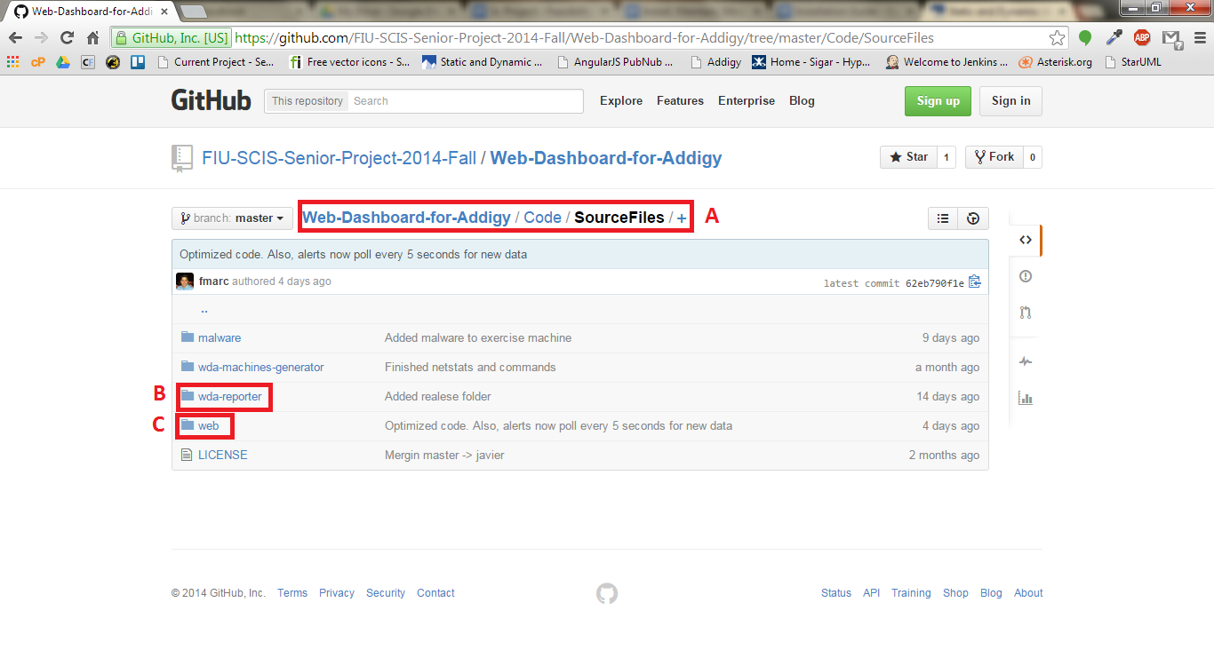

***Image 1***

## 

## Step 2

Enter into the web folder, labeled **C** from **Image 1**. This would bring you to the folder with all the source code as shown in **Image 2**. The content of this folder would have to be copied into the root of the web folder of the LAMP or WAMP server where the website is to be hosted.

**Note**: There are five files of interest in this folder labeled **A** through **E** in **Image 2**. Folder css, labeled **A**, contains all the stylesheets and CSS libraries used for the dashboards.

The folder js, labeled **B**, contains all the javascript source code used in the dashboard, including used libraries. The folder pages, labeled **C**, contains the individual pages such as the main dashboard and the single-machine dashboard. The folder named scripts, labeled **D**, contains all the PHP source code used in the project such as the script for uploading screenshots. Lastly, the index.html file, labeled **F**, contains the entry point to the application.

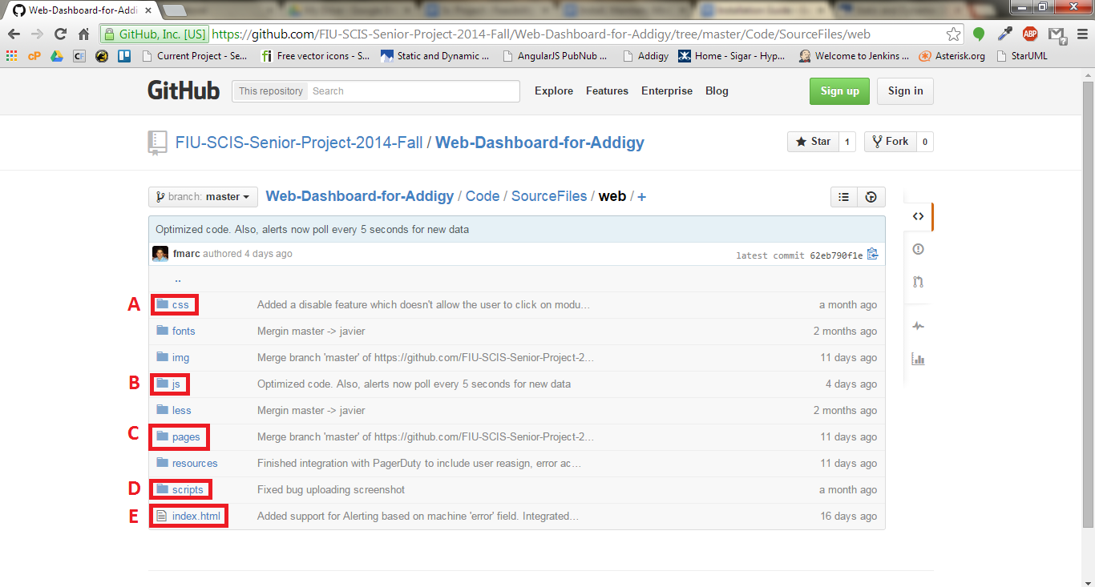

***Image 2***

## 

## 

## 

## Step 3

Navigate two directories up to the Code directory as shown in **Image 3**. Here you will find a file named pubnub-keys, labeled **A** in **Image 3**. This file contains the publish and subscribe keys for the pubnub service. It needs to be created two directories up from directory containing the index.html file of the web dashboard, just like it is in the github repository.

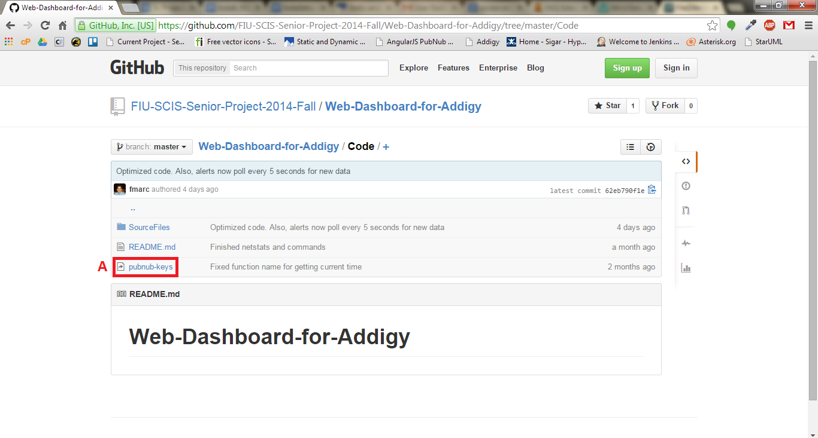

***Image 3***

## 

## Step 4

Open the pubnub-keys file which contains the structure shown in **Image 4**. Set the keys to the values provided by PubNub. The web dashboards should now be fully functional.

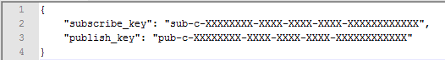

***Image 4***

## Step 5

Open the wda-reporter folder, labeled **C** in **Image 1**. This folder is a Netbeans project that can be imported directly into Netbeans IDE. In here, you will find a directory called Releases, labeled **A** in **Image 5**, that contains ready to deploy zip files.

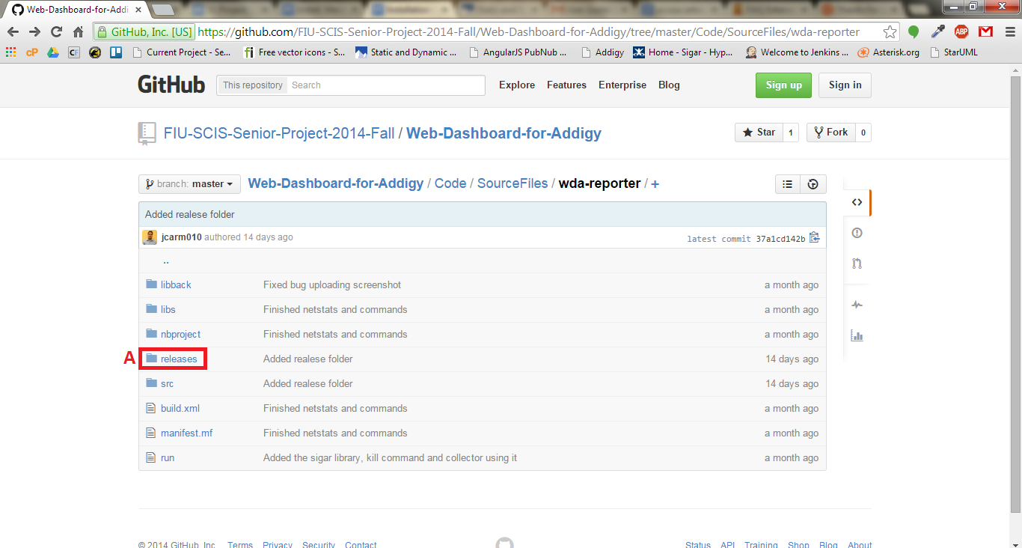

***Image 5***

## Step 6

Download the latest zip file from the releases folder into the machine to be remote controlled and navigate to the directory through a terminal.

## Step 7

Execute the following command to start the agent:

*java -jar wda-reporter.jar channel* ***machine_identifier*** *pubkey* ***pub-c-XXXXXXXX-XXXX-XXXX-XXXX-XXXXXXXXXXXX*** *subkey* ***sub-c-XXXXXXXX-XXXX-XXXX-XXXX-XXXXXXXXXXXX***

***Note:***

The command specifies PubNub’s channel, publish and subscribe keys as key value pairs. Replace the keys by the ones provided by PubNub and set the channel to the channel through which the agent will communicate with the dashboard. The channel name must be the same as the one specified in the single machine dashboard url *http://wda-dev.cis.fiu.edu/#/machine/****machine_identifier.***

The command must run with administrator (root) privileges in order for all the features to work.