CIS 4911 - Senior Project (U01)

Web Dashboard for Addigy

Javier Carmona

Francisco Marcano

December 10, 2014

Jason Dettbarn

**User Manual**

Table of Contents

Abstract

System Requirements

Web Client View

Machine Agent

Users

Software Features

General Features

Navigating to The Application

Logging In

Multiple Machine Features

Locating a Critical Machines on the Map

Managing Machine Errors

Analyzing Machines Based on Thresholds

Single Machine Features

Monitoring Live Machine Information

Chatting with The Worker

Running Terminal Commands

Finding Open Socket Connection in the Machine

Finding the Internet Speed Connection in the Machine

Terminating Processes on the Machine

Conclusion

# 

# 

# 

# 

# 

# 

# 

# 

# Copyright and Trademark Notices

All Addigy specific logos and slogan material is copyright Addigy, Inc. All other materials developed for this project is available open source under MIT License:

<http://opensource.org/licenses/MIT>

# Introduction

This is the User Manual for the Addigy Dashboard, which is a lightweight interface which aims to facilitate IT professionals in managing multiple machines in a corporate environment. This project is part of the Software Engineering Course at Florida International University.

This document will talk about all of the features that are available to each user role. Pictures and diagrams will be used while explaining some of these concepts to facilitate the user with grasping all of the information contained here. Also contained in this document, is the machine specifications which are necessary to run this application.

# 

# System Requirements

There are two components to the Web Dashboard for Addigy, the web client view and the Agent which retrieves information on individual machines. These two modules have different runnable specifications.

## Web Client View

The web client view was built around HTML5 and CCS3 features and for this reason needs a compatible browser which is able to run them. The following is a list of Web Browsers and the corresponding versions that can run the Web Client for Addigy

* **Google Chrome** (version 31 and above)
* **Mozilla Firefox** (version 31 and above)
* **Internet Explorer** (version 10 and above)
* **Apple Safari** (version 5.1 and above)

## Machine Agent

The machine agent was built using the Java language which allows the execution of java programs throughout a wide array of environments. Nevertheless, the following are the minimum requirements necessary to run the agent

* Pentium 233-megahertz (MHz) processor or faster (300 MHz is recommended)
* At least 128 megabytes (MB) of RAM
* At least 100 megabytes (MB) of available space on the hard disk
* An internet connection

# Users

Currently the Web Dashboard for Addigy has features for both Admin and Worker roles.

* An admin is a user that is an IT professional in charge of maintaining and troubleshooting a number of computers in an organization.
* A worker is the person that is physically in charge of one of the computers in an organization.

The features explained in the **Software Features** section will specify the type of user that the feature is targeted to.

# Installation and Setup

To get started, a full installation of the project must be done. To accomplish you must follow the follwing steps:

1. Navigate to the following URL: <https://github.com/FIU-SCIS-Senior-Project-2014-Fall/Web-Dashboard-for-Addigy>
2. Download the project into your machine.
3. Run a local server on the Code->SourceFiles->Web folder of the project.
4. Navigate to the URL that was set up with the server.
5. You should be greeted with the applications login page.

# Software Features

This section will talk about all of the features that are available to each type of user in the application. Along with a description, each features will have images and/or diagrams to help explain the individual features. The features will be split between the Multiple Machine section and the Single Machine section of the project.

## General Features

This section talks about all of the features which do not belong to either the Multiple Machine view or the Single Machine view.

### Navigating to The Application

In order to actually interact with the application, the *Admin* user must first navigate to the URL below. Once the user navigates to the application he/she will be presented with the log in page.

<http://wda-dev.cis.fiu.edu/>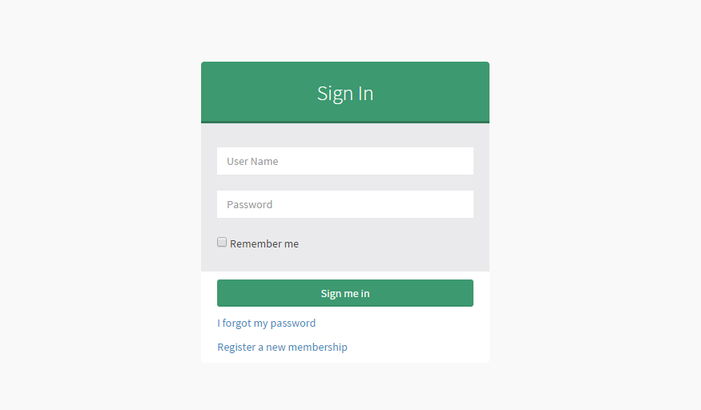

### Logging In

Once the user has navigated to the application, he/she will be greeted with the window on the right. Once in this window, the user only needs to enter his username and password in order to access the application. Currently there are no features to manage a user account, so features like *Forgot Password* and *Register* are not available in this version of the application.

## Multiple Machine Features

The multiple machine dashboard allows the user to quickly look at all of the machines currently connected to a company’s network. This allows for the user to quickly spot machines in critical conditions or make better, educated decisions on asset management.

### Locating a Critical Machines on the Map

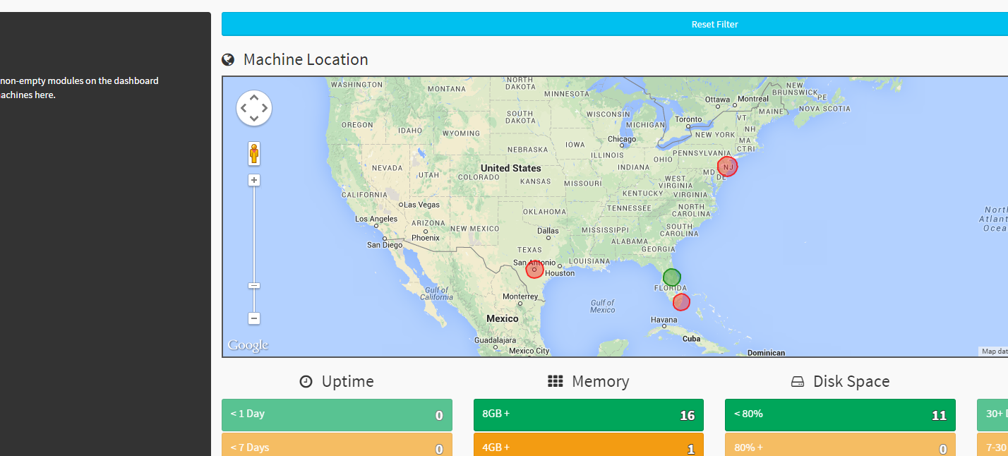The dashboard portion of the application allows *Admin* users to locate critical machines on the map module very easily. While looking at the Multiple Machine view, locate the Map Module which is at the right center of the page.



Once the map module is located, the user can see red and green circles on the map. These circles represent clusters of computers in which red circles contain critical machines.

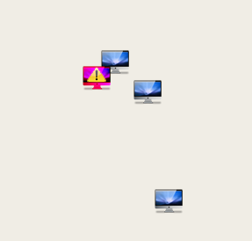

Clicking on a cluster will filter the entire dashboard to only those machines currently in the cluster that was selected. While the application is in this state, the map will now show all of the machines that were in that cluster on the map. Machines that have an exclamation symbol on them are machines that currently have critical errors.

Clicking on the critical machine will provide more information on the *Side Panel Module* (this module is covered in more details later in this document)

### Managing Machine Errors

The dashboard also notifies the *Admin* users of any critical errors that appear in the system through the *Errors Module*. This module allows the management of errors in the following way:

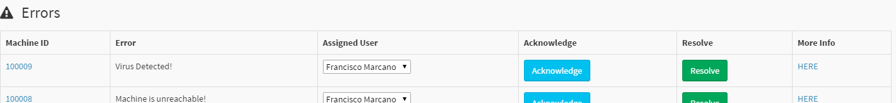

* **Inspect Machine** - Clicking on the machine’s Connector Id will display the machine in the *Side Panel Module* in which more information can be retrieved from the error machine.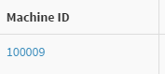

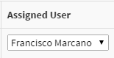

* **Reassign User** - Modifying the assigned user allows the *Admin* to assign the error to another user that will be in charged of handling the error.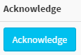
* **Acknowledge Error** - Clicking on the Acknowledge button will dismiss the current error for a determined amount of time. The time currently is 30 minutes by default.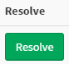
* **Resolve Error** - Clicking on the Resolve button will permanently dismiss the error and mark it as resolved.
* **More Info** - Clicking on the More Info button will display the full information on the current machine that was clicked. In order to view this information, the *Admin* user must be logged into the PagerDuty account that was created for their account.

### Analyzing Machines Based on Thresholds

This section of the Dashboard allows the *Admin* user to look at machines based on certain machine properties. These thresholds modules group machines based on the threshold that they represent. Currently there are 6 modules that each show a different type of information. The modules are:

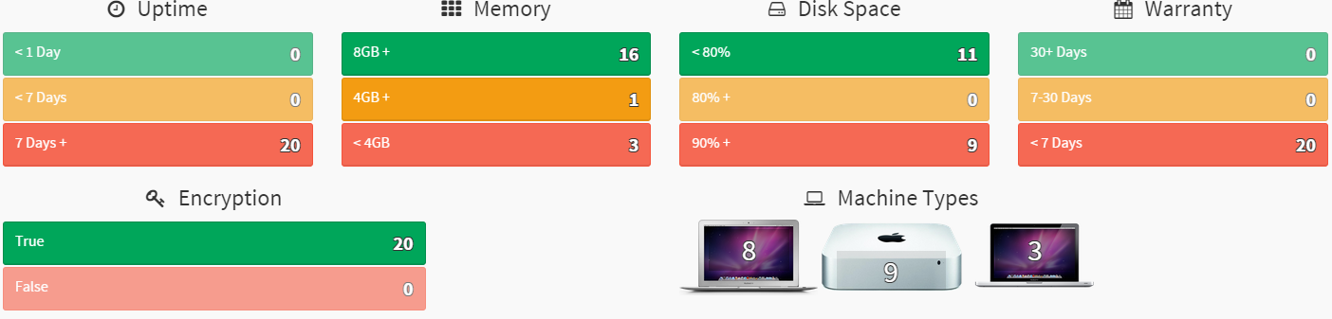

* **Uptime** - Shows how much time a machine has been powered on
* **Memory** - Shows how much RAM memory the machine has installed
* **Disk Space** - Shows how much Disk Space the machine has left.
* **Warranty** - Shows in how many days the machines warranty expires.
* **Encryption** - Shows whether the machine has it’s hard disk encrypted or not.
* **Machine Type** - Shows what type of machine the hardware is.

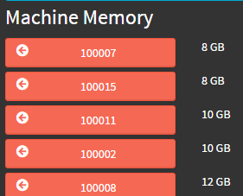

All of the modules described above have the same functionality. When clicking on one of the modules threshold buttons, a list of machines are displayed in the *Side Panel Module*. This list is sorted from worst to best depending on the property that was clicked.

If the module threshold button is clicked while the *control* key is pressed, the application will select the worst machine currently in the group that was selected. The machine details are then displayed on the *Side Panel Module*.

***Interacting With The Side Panel Module***

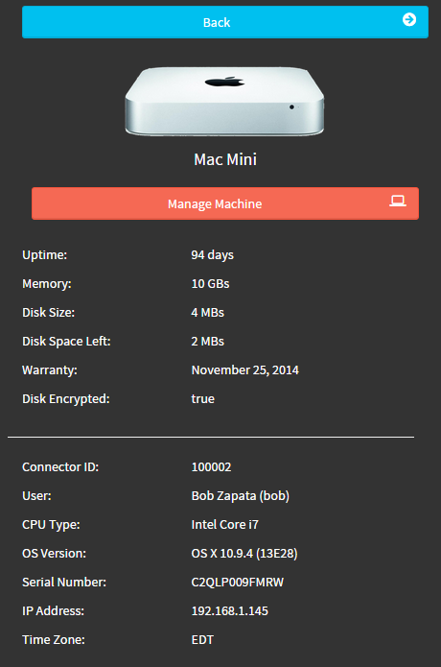

The side panel module is useful for having relevant information when interacting with the application. As described in the earlier features, when an individual machine is selected in some way, the details for that specific machine are displayed in the side panel.

When in this view, the user has the option to go back to the previous information that was displayed in the side panel using the *back* button. The user can also *Manage the Machine*. This will take the user to the **Single Machine View** in which the *Admin* will be able to individually service the machine that was selected.

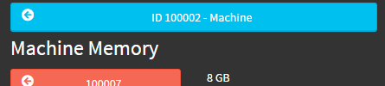

The side panel also remembers the last machine that was viewed. If at any point the *Admin* wish to see the previous machine viewed, clicking on the machine at the top of the Side Panel Module will be enough to display the information for the previous machine

## Single Machine Features

The single machine dashboard allows the Admin user to look at all of the information regarding one specific machine. Using this information the user can determine what is the machine’s condition and service it using any of the features described below.

### Monitoring Live Machine Information

While the machine that the *Admin* is trying to monitor is online, live information for that machine will appear at the top of the Multiple Machine view. There are currently modules that collect machine data. The data collected is the following:

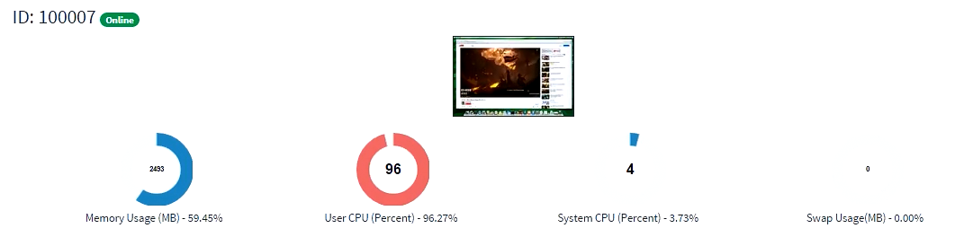

* **Memory Usage** - This shows how much memory the target machine is currently using
* **User CPU** - This shows how much CPU the USER processes on the machine are using.
* **System CPU** - This shows how much CPU the SYSTEM processes on the machine are using.
* **Swap Usage** - This shows how much swap memory is being used.

### Chatting with The Worker

The chat module allows the *Admin* to communicate directly with *Worker*. This is done by expanding the chat module by clicking the arrow button on the top right corner. Once expanded, the *Admin* is able to write a message on the input box and send it using the *Plus* button.

The *Worker* will receive the message on a custom chat box designed to run on the target machine. Once the message is received by the *Worker* and the chat window opened on the target machine, the *Worker* would be able to send a chat message back to the *Admin.* This is currently the only feature available to the *Worker* user.

### Running Terminal Commands

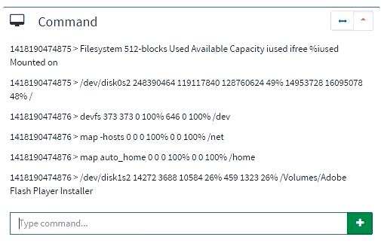

This module allows the *Admin* user to run custom commands on the target machines terminal, and retrieve any output that the command produced.

This is done by expanding the command module (same way as the *Chat Module* explained previously). After expanding, the module should look similar to that of the *Chat Module*. Typing the command on the input box and clicking on the *Plus* button or pressing *Enter* will run the command on the target machine and return the output that was produced by the target machine.

### Finding Open Socket Connection in the Machine

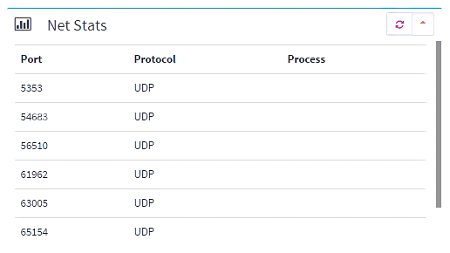

This module allows the *Admin* to quickly see what are the open socket connection currently in the machine. This is generally useful in diagnosing whether there are any malware application currently opening ports and secretly sending information from your machine to another machine.

This is done by expanding the netstats module. After expanding, the *Admin* should see that the module needs to load the information. Once the module has finished loading, all of the open socket connections should be displayed. The *Admin* has the option of refreshing the data by clicking on the *refresh* button located on the upper right corner of the module. Pressing this button will run a new test on the target to look at all of the socket connections currently open in the system.

### Finding the Internet Speed Connection in the Machine

This module allows the *Admin* to quickly run a speed connection test on the target machine and display the information directly on the dashboard.

This is done by expanding the Speed Test module. Once the module has been expanded, the application will automatically run a speed test on the target machine. While this test is in progress, the *Admin* will look at the module in a loading state. Once the test is complete, the results for the test are shown on the module.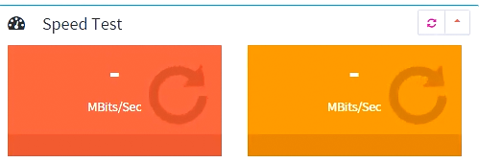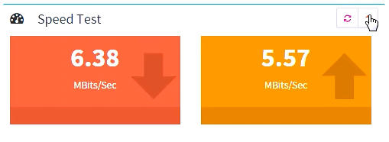

If at any point the *Admin* would like to run another speed test in the machine, he/she may do so by clicking on the refresh button located on the top right corner of the module.

### 

### Terminating Processes on the Machine

This module allows the *Admin* to terminate any of the top 20 processes that are utilizing the most resources on the machine. The processes displayed in the panel have the following information:

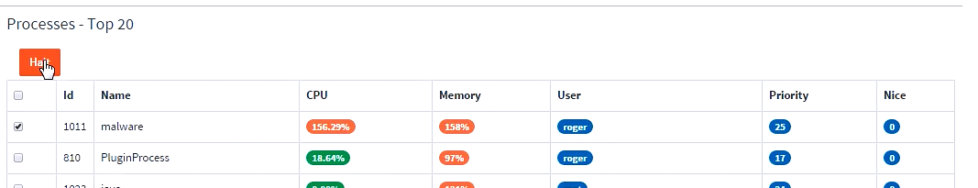

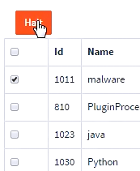

* **ID** - The process id
* **Name** - The name of the process
* **CPU** - Percentage of CPU that this process is using
* **Memory** - Amount of memory that the process is using
* **User** - The user that executed this process
* **Priority** - The priority value for the process
* **Nice** - The nice value for the process

In order to terminate one or multiple processes, the *Admin* only had to click on the check box to the left of each process he/she wishes to terminate. Once all of the processes that need to be terminated are checked, clicking on the *Halt* button on the top left of the processes module will terminate all of the processes that were selected.

# Quick References

These are some simple references that can help you understand the project’s source code in more detail

* AngularJS - <https://angularjs.org/>
* Bootstrap - <http://getbootstrap.com/>
* AdminLTE - <http://almsaeedstudio.com/AdminLTE/>
* Underscore Js - <http://underscorejs.org/>

# 

# Accessing Help Online

If you would like to know more please contact the Computer Science department at Florida International University.

Phone: 305.348.2744

Graduate: [grad-info@cis.fiu.edu](mailto:grad-info@cis.fiu.edu)

Undergraduate: [undergrad_info@cis.fiu.edu](mailto:undergrad_info@cis.fiu.edu)

# 

# Conclusion

This concludes all of the features that are available in the Web Dashboard for Addigy version 1. We hope that this document served to fully explain all of the features available in the system. If you would like to know more please contact the Computer Science department at Florida International University.