*Florida International University*

*School of Computing and Information Sciences*

CIS 4911 Senior Project – **Software Engineering Focus**

**Requirements Document**

|  |  |
| --- | --- |
| Course: | CIS 4911 |
| System: | BOLO Flier Creator |
| Team: | Danae I. Perez Tillan  Icxe Vidal |
| Date: | 01/28/2015 |
| Instructor: | Masoud Sadjadi |
| Mentor: | Samuel Ceballos |

· Copyright and trademark notices, restrictions on copying or distributing the documentation, information for contacting the issuing organization (reader’s comments), warranties, contractual obligations or disclaimers, and general warnings and cautions.

· Abstract – one or two paragraphs giving a brief overview of the document.

· Table of Contents

1. Introduction

The Introduction provides a description about the system that will be built and the need of building such system. It will also provide a description of the expectations about the main system functionalities. Finally, it will provide a brief description of the rest of the document.

1.1. Problem Definition.

The Police Department Of the Pinecrest Village wants to develop an application that will assist first responder officers creating BOLO flyers when they arrive on the crime scene and allows them to upload them to a server; so that when a detective is assigned to the case, he is able to retrieve it from the system

1.2. Scope of system.

1.3. Terminology - Definitions, acronyms, and abbreviations.

|  |  |
| --- | --- |
| **Term** | **Definition** |
| Tier1 | This is a type of user. The (first responders) has access to Create, View, and Edit his/her own Bolo. |
| Tier2 | This is a type of user. This officer (supervisor) will have access to Tier1 permission plus edit, and delete a BOLO. |
| Administrator | Tier1 and Tier2 access, plus create and delete users |
| Registered User | A user that has created an account in the system |
| BOLO | Be on the lookout. The flier created for the officers to capture a suspect. |
|  |  |

1.4. Overview of document – brief explanation of what to expect in chapters 2 through 6.

2. Current System (limitations and problems) – either existing system or manual system that is being automated.

There is no other system that provides this kind of functionality to our customers. Currently our customers use word editing software (like Microsoft Word) to create BOLOs and distribute them via hardcopies or as pdf documents. The limitations of this process are the lack of distribution speed, and the inability of doing searches for BOLO (officers would end up with dozens of BOLOs as pdf and no easy way of searching or browsing them.

There are not previous versions of this system. This project will be the initial code base of the system.

3. Project Plan (**This deliverable only**)

Introduce the project plan section (one or two paragraphs)

3.1. Project organization – assignment of roles for this deliverable.

3.2. Work breakdown – identification of milestones and deliverables (refer to project schedule in Appendix A and the diary in appendix B).

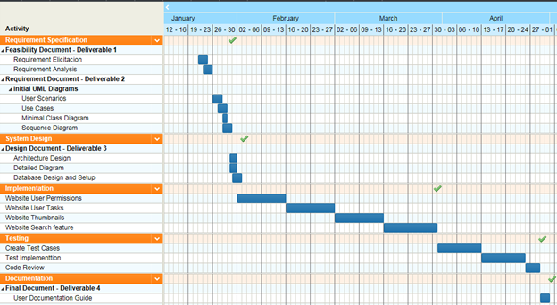

3.3. Cost Estimate – cost to develop the software system.

4. Proposed System Requirements

Introduce the chapter (one or two paragraphs)

4.1. Functional Requirements – describes high-level functionality

Use the following format:

*The system shall …*

For each functional requirement state the associated non-functional requirements, if any, for *Usability, Reliability, Performance,* and *Supportability*.

4.2. Analysis of System Requirements

Analysis models – contains the complete functional specification and is mainly for the designers and programmers. This section describes the diagrams in the Appendices B - D and validates the models against the use cases.

4.2.1. Scenarios

|  |  |
| --- | --- |
| **Scenario Id** | Bolo-001 |
| **Scenario Name** | Log In |
| **Actors** | Tier1, Tier2, Administrator |
| **Flow of Events** | A user log in to the system. The user enters his/her username and password and after correct validation of the information. The user accesses the Bolo Home Page. |

|  |  |
| --- | --- |
| **Scenario Id** | Bolo-002 |
| **Scenario Name** | Log Out |
| **Actors** | Registered User |
| **Flow of Events** | Registered user clicks log out on the User Home page |

|  |  |
| --- | --- |
| **Scenario Id** | Bolo-004 |
| **Scenario Name** | Edit Bolo |
| **Actors** | Registered User |
| **Flow of Events** | A Tier1 user logs in to the system and has the ability to edit their own Bolos.  Tier2 can edit BOLOs created by users in their agency  Administrators can edit any Bolo created in the application. |

|  |  |
| --- | --- |
| **Scenario Id** | Bolo-005 |
| **Scenario Name** | Create Bolo |
| **Actors** | Registered User |
| **Flow of Events** | A user click on the Create Bolo button in order to open the Bolo template. The users will fill out the template with all the information need it. |

|  |  |
| --- | --- |
| **Scenario Id** | Bolo-006 |
| **Scenario Name** | Thumbnails Page |
| **Actors** | Registered User |
| **Flow of Events** | The registered user will see in the home page a representation of all the BOLOs created in the last 24 hours. Users can click on this these thumbnails to view the BOLO details. |

|  |  |
| --- | --- |
| **Scenario Id** | Bolo-007 |
| **Scenario Name** | Save bolo as pdf |
| **Actors** | Registered User |
| **Flow of Events** | In the Create BOLO page the user will have a button that will download the BOLO as a pdf. This BOLO will not be part of the system |

|  |  |
| --- | --- |
| **Scenario Id** | Bolo-008 |
| **Scenario Name** | Search Page |
| **Actors** | Registered User |
| **Flow of Events** | Users must have the ability of search BOLOs by any field. The results are shown sorted by the date they were created |

4.2.2. Use case model

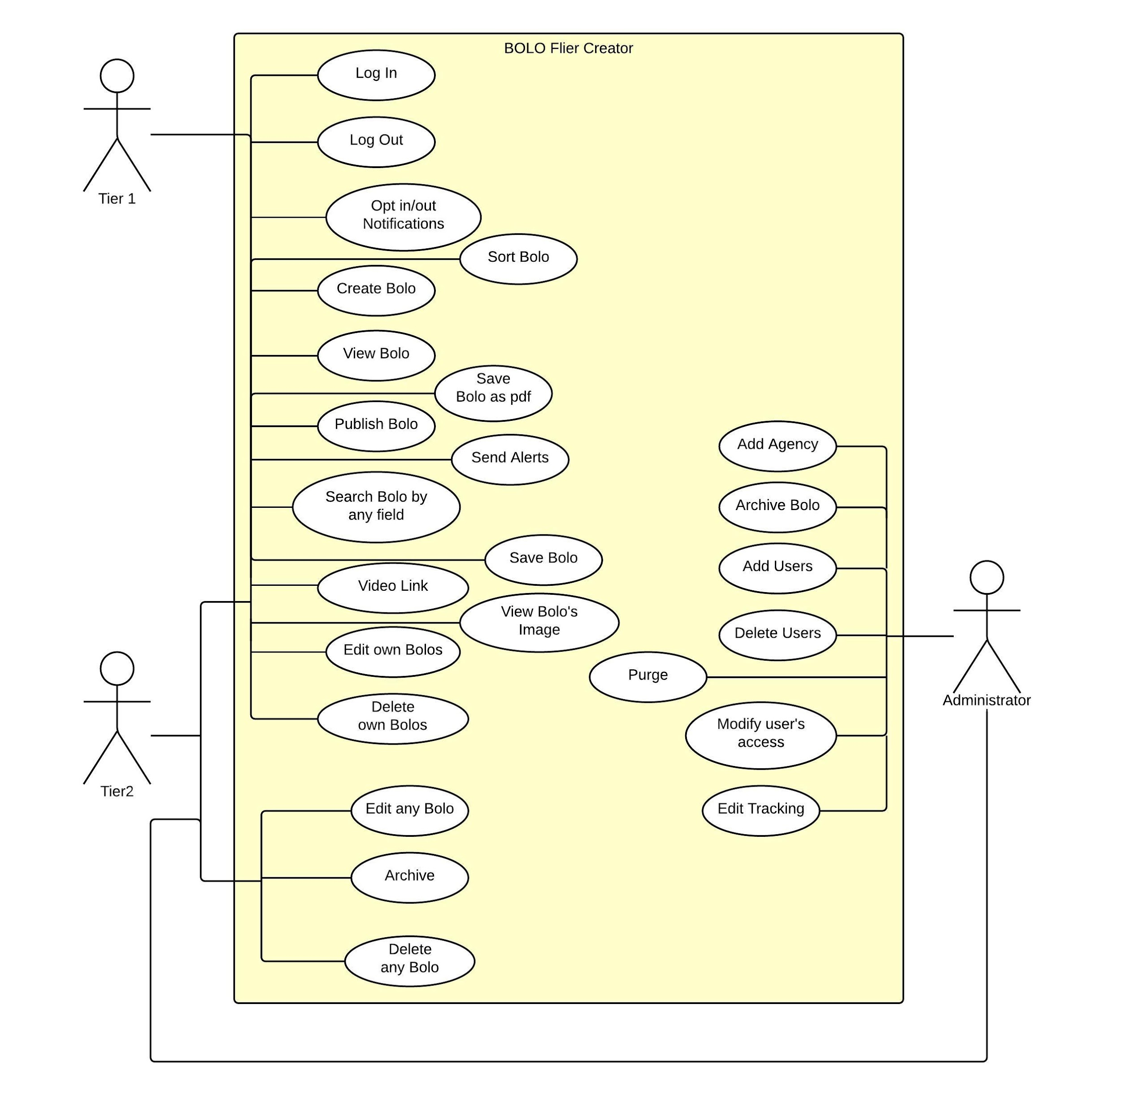

4.2.3. Static model e.g., object diagrams, class diagram

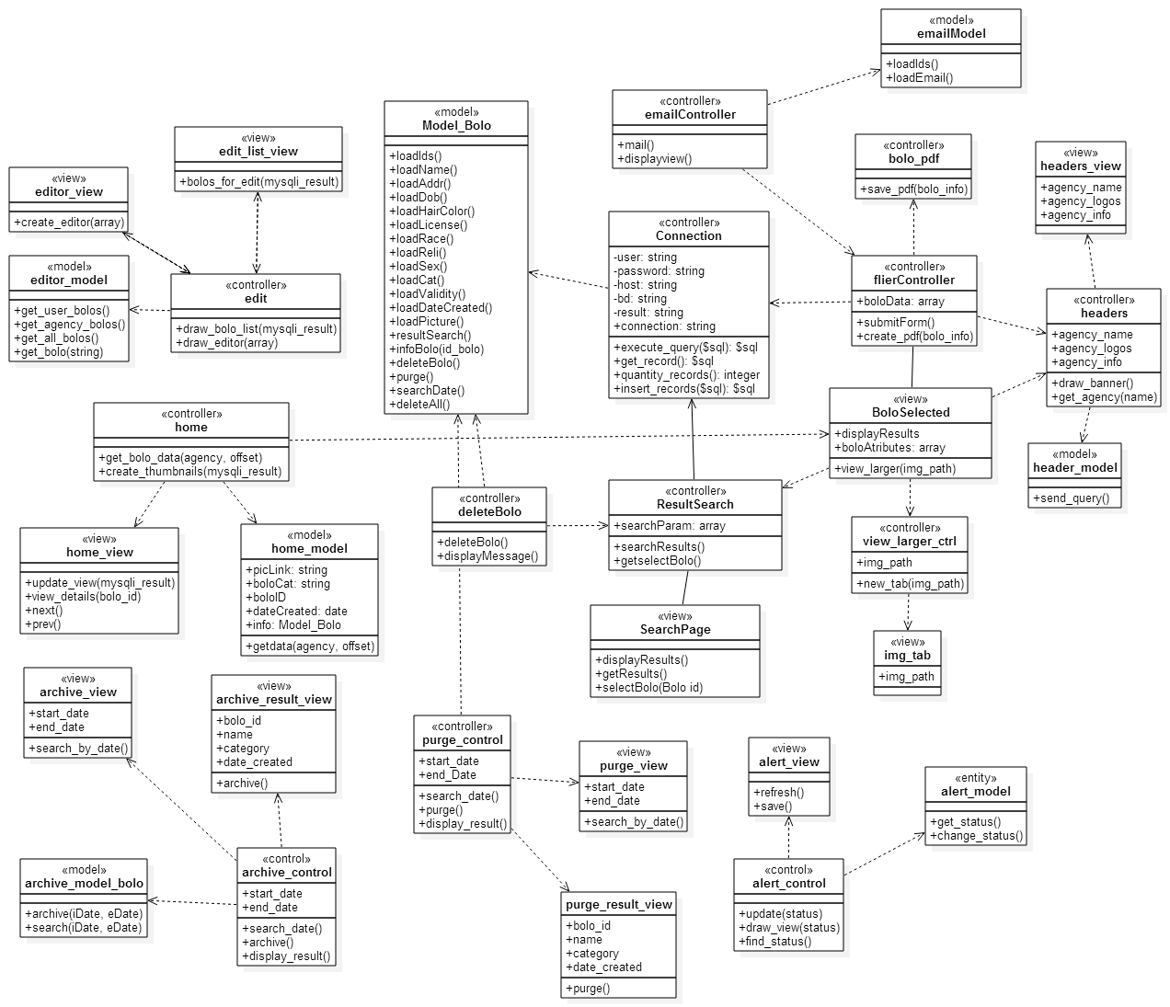

4.2.4. Dynamic model e.g., sequence diagrams or state machines

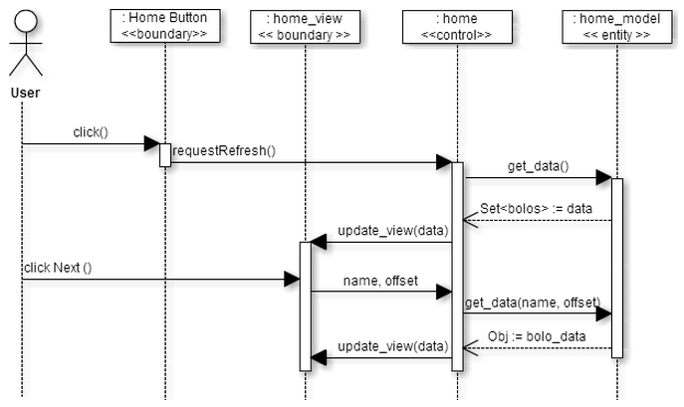homepage next and prev buttons

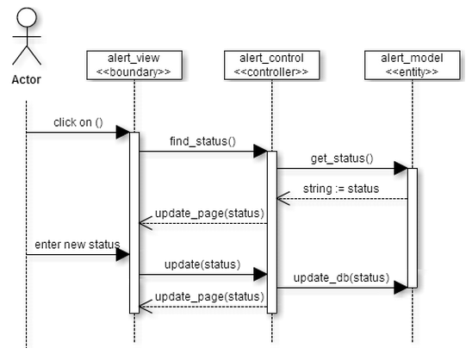

opt out/in of notifications

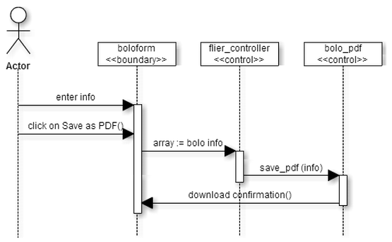

save as pdf

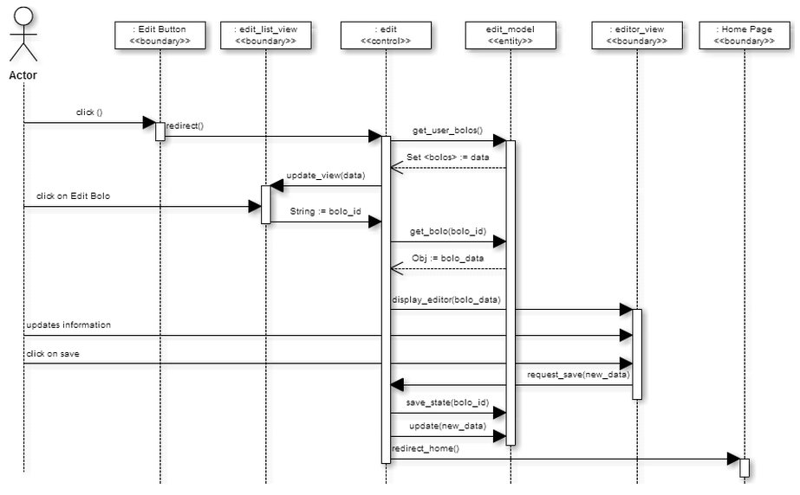edit bolo

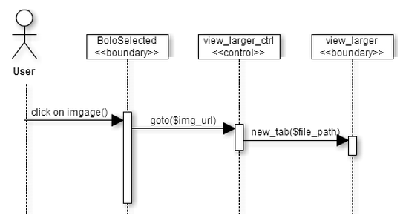

open image full size

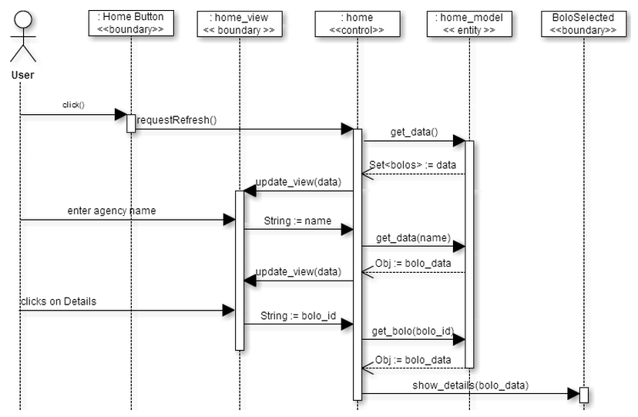

homepage

create new agency(user group)

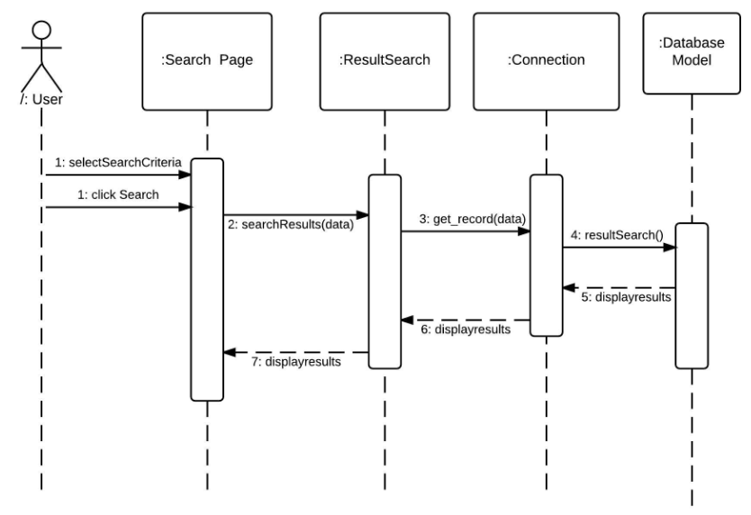

search bolo

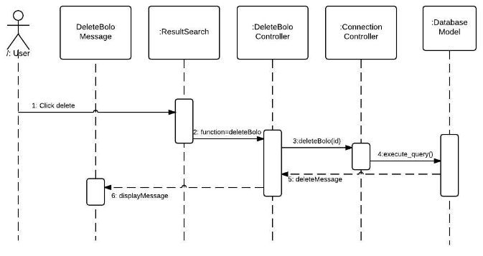delete bolo

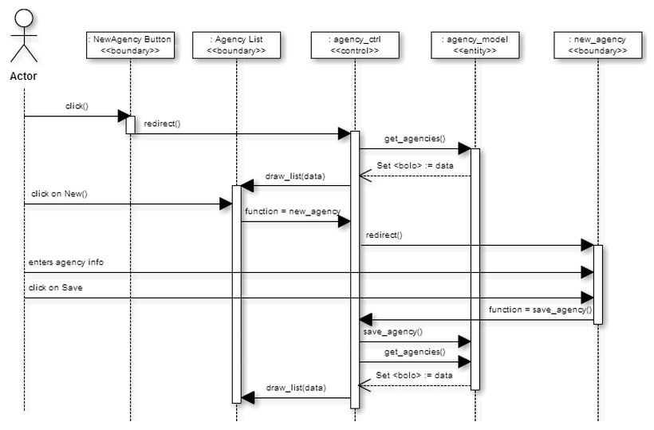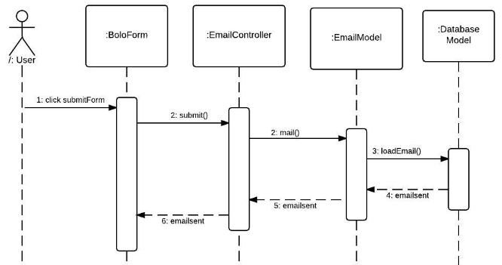email alerts

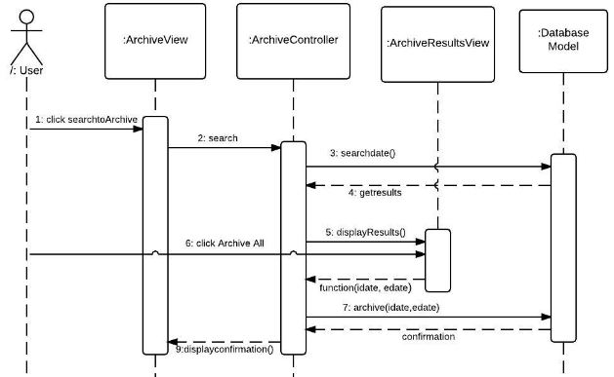archive bolo

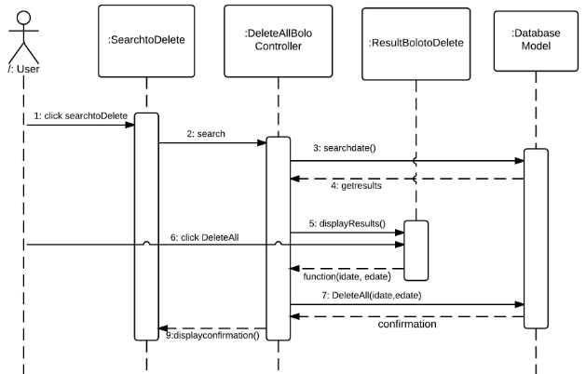purge option

5. Glossary - define terms used in document, especially domain specific terms.

6. Appendix

6.1. Appendix A - Complete use cases

|  |  |
| --- | --- |
| Use Case ID | Bolo-001 |
| Description | Log In |
| Actor | Registered user |
| Pre-conditions | The user is on the Log in page of the system |
| Flow of Events | The user clicks on Log in link  The system will display to the user the new user form  The user will fill in all fields: username, password. |
| Alternate Flow | The user cancels the request by clicking on cancel or closing the browser. |
| Post-Conditions | The user is able to log in |
| Exceptions | The user forgot his/her password, so they will not be able to login in the system. |

|  |  |
| --- | --- |
| Use Case ID | Bolo-002 |
| Description | Log Out |
| Actor | Registered user |
| Pre-conditions | The user is Logged in the system |
| Flow of Events | The user clicks Log Out from the system. The system logs out the user from the application. |
| Alternate Flow |  |
| Post-Conditions | The system will not allowed the user to have access to the application without logging in again |
| Exceptions | The system fails logging out the user |

|  |  |
| --- | --- |
| Use Case ID | Bolo-004 |
| Description | Edit Bolo |
| Actor | Registered user |
| Pre-conditions | The user is Logged in the system  The user has clicked on the Edit link in the header |
| Flow of Events | The user clicks on the Edit option  The user add or change information  The user click on Save button |
| Alternate Flow |  |
| Post-Conditions | The new Bolo information has been saved in the database |
| Exceptions | The user do not change any field in the Bolo form |

|  |  |
| --- | --- |
| Use Case ID | Bolo-005 |
| Description | Create Bolo |
| Actor | Registered user |
| Pre-conditions | The user is Logged in the system  The user is in the Home page |
| Flow of Events | The user clicks on the “Create Bolo” button. The system will display the Bolo form. |
| Alternate Flow | User cancels the request by clicking on the Cancel button at the end of the form. |
| Post-Conditions | The user is able to see the Bolo form to start fill out all the fields needed. |
| Exceptions | The Bolo form is not displayed. |

|  |  |
| --- | --- |
| Use Case ID | Bolo-006 |
| Description | Thumbnails Page |
| Actor | Registered user |
| Pre-conditions | The user is Logged in the system  The user is in the Home page |
| Flow of Events | The system display the most recent BOLOs created  The user click on any of the Bolo to see all description |
| Alternate Flow | The user click on any other link of the page. At that time he will be redirect to another page of the website. |
| Post-Conditions | The user is able to see the thumbnails of the most recent Bolos created in the last 24 hours. |
| Exceptions | The user do not see any Bolo in the Home page because in there are not Bolos created in the last 24 hours. |

|  |  |
| --- | --- |
| Use Case ID | Bolo-007 |
| Description | Save Bolo as pdf |
| Actor | Registered user |
| Pre-conditions | The user is Logged in the system |
| Flow of Events | The user clicks on Create BOLO  the user fills the BOLO information  The user click on the “Save as pdf” button |
| Alternate Flow |  |
| Post-Conditions | The Bolo is saved as a pdf file in the user’s computer. |
| Exceptions |  |

|  |  |
| --- | --- |
| Use Case ID | Bolo-008 |
| Description | Search page |
| Actor | Registered user |
| Pre-conditions | The user is Logged in the system  The user is in the Search page |
| Flow of Events | The user select the filters need it  The user click on the search button  The system display the Bolos requested as thumbnails (same style as the homepage) |
| Alternate Flow | The user click on any other link on the page |
| Post-Conditions | The system display the Bolos requested by the user using the filters selected. |
| Exceptions | The user does not select any filter when doing the search. |

|  |  |
| --- | --- |
| Use Case ID | Bolo-009 |
| Description | Browse BOLO from homepage |
| Actor | Registered user |
| Pre-conditions | The user is Logged in the system  The user is in the homepage |
| Flow of Events | the user clicks on the next button at the end of the page to view the next 24 bolos  the user can either keep clicking next to pull the next 24 or click on prev to view the previous 24 |
| Alternate Flow | The user selects and agency before clicking on next |
| Post-Conditions |  |
| Exceptions |  |

|  |  |
| --- | --- |
| Use Case ID | Bolo-012 |
| Description | Edit BOLO |
| Actor | Tier2, Administrator, and Tier1 who created the BOLO |
| Pre-conditions | The user has clicked on the edit link on the header |
| Flow of Events | The case begins when the user clicks on the “Edit” button link next to the button he wants to edit  The system will display the bolo form prepopulated with the bolo information  The user will edit the bolo information as needed  The user will click on save |
| Alternate Flow |  |
| Post-Conditions | The changes made to the BOLO were saved on the database |

|  |  |
| --- | --- |
| Use Case ID | Bolo-013 |
| Description | User Management |
| Actor | Administrator |
| Pre-conditions | The admin has logged into the system  The admin has accessed the backend side of the website |
| Flow of Events | The use case begins when the admin goes to the user management section  The admin clicks on create user  The admin fills the form with the required data  The use case ends when the admin clicks on the save button |
| Alternate Flow |  |
| Post-Conditions | The new user account has been created and the new user can access the system |

|  |  |
| --- | --- |
| Use Case ID | Bolo-014 |
| Description | View Bolo Flier |
| Actor | All users |
| Pre-conditions | The user is in the homepage |
| Flow of Events | The use case begins when the clicks on the Details link on the thumbnail  The use case ends when system displays the b flier of the bolo |
| Alternate Flow |  |
| Post-Conditions |  |

|  |  |
| --- | --- |
| Use Case ID | Bolo-015 |
| Description | Navigation Menu |
| Actor | All users |
| Pre-conditions | The user has logged into the system |
| Flow of Events | The use case begin when the system displays a navigation bar at the top of the page  The use case ends when the user clicks in the link of the functionality he wants to access |
| Alternate Flow |  |
| Post-Conditions | The system displays the page the user clicked on |

|  |  |
| --- | --- |
| Use Case ID | Bolo-016 |
| Description | Create User Groups |
| Actor | Administrator |
| Pre-conditions | The admin has logged into the system |
| Flow of Events | The use case begins when the admin clicks on the Agencies link in the navigation bar  The admin clicks on the New Agency button  The admin fills the required information  The use case ends when the admin clicks on Save |
| Alternate Flow |  |
| Post-Conditions | The new agency has been added to the system, users can be assigned to it, bolos in the homepage can be sorted by it, and it shows in the list of the agencies enrolled in the system |

|  |  |
| --- | --- |
| Use Case ID | Bolo-017 |
| Description | Send email notifications |
| Actor | System |
| Pre-conditions | The user has filled the bolo form and |
| Flow of Events | The use case begins when the user clicks on the submit button  The system shall pull the email addresses of the users that want to receive email notification  The system shall create an email with a link to the bolo that was created  The use case ends when the system sends the emails to the addresses pulled |
| Alternate Flow |  |
| Post-Conditions | The emails have been sent |

|  |  |
| --- | --- |
| Use Case ID | Bolo-018 |
| Description | Purge Bolos |
| Actor | Administrator |
| Pre-conditions | The administrator has logged into the system |
| Flow of Events | The use case begins when the admin clicks on the Purge Option link in the header  The admin enter the date range he wishes to purge  The admin clicks on the Delete All link at the end of the list  The use case ends when the system displays a confirmation message |
| Alternate Flow |  |
| Post-Conditions | The bolos in the range have been purged from the database |

|  |  |
| --- | --- |
| Use Case ID | Bolo-019 |
| Description | Archive Bolo |
| Actor | Administrator |
| Pre-conditions | The admin has logged in the system  The admin has clicked on the Archive link on the navigation menu |
| Flow of Events | The use case begins when the admin clicks on the Purge Option link in the header  The admin enter the date range he wishes to archive  The admin clicks on the Archive All link at the end of the list  The use case ends when the system displays a confirmation message |
| Alternate Flow |  |
| Post-Conditions | The bolos in the range have been archived and no longer appear in the homepage nor on the search |

|  |  |
| --- | --- |
| Use Case ID | Bolo-020 |
| Description | No image available |
| Actor | All users |
| Pre-conditions | The user has navigated to the Create Bolo form |
| Flow of Events | The use case begins when the user fills the form, but leaves the image field empty (ie uploads no picture)  The systems shall select a default picture of a black silhouette with a “no image available” message  The use case ends when the systems saves the default image in the database |
| Alternate Flow |  |
| Post-Conditions | The bolo is assigned a default image |

|  |  |
| --- | --- |
| Use Case ID | Bolo-021 |
| Description | View image in full size |
| Actor | All users |
| Pre-conditions | The user has pulled the flier of a bolo |
| Flow of Events | The use case begins when the user clicks on the picture in the bolo flier  The use case ends the systems displays the image in full size in a new tab |
| Alternate Flow |  |
| Post-Conditions | A new tab has been opened with the image in full size |

|  |  |
| --- | --- |
| Use Case ID | Bolo-022 |
| Description | Filter the thumbnails in the homepage by agency |
| Actor | All users |
| Pre-conditions | The user has logged into the system and has navigated to the homepage |
| Flow of Events | The use case begins when the user selects and agency from the dropdown menu in the top right corner of the homepage  The user then clicks on the Go button next to the dropdown menu  The system shall filter the bolos shown in the homepage according to the selected agency  The use case ends when the systems refreshes the homepage with the new thumbnails |
| Alternate Flow |  |
| Post-Conditions | The homepage contains only the bolo form the selected agency |

|  |  |
| --- | --- |
| Use Case ID | Bolo-023 |
| Description | Opt in / out of receiving email notifications |
| Actor | All users |
| Pre-conditions | The user has logged into the system |
| Flow of Events | The use case begins when the user clicks on the Alerts link in the navigation menu  The user then chooses whether he wants to receive email notification when a new bolo is created or not  The user clicks on the Save button  The use case ends when the system refreshes the page showing the new option chosen |
| Alternate Flow |  |
| Post-Conditions | This user won't receive emails notification until he changes this setting again |

|  |  |
| --- | --- |
| Use Case ID | Bolo-024 |
| Description | Keep an edit history |
| Actor | System |
| Pre-conditions | The user has made the necessary changes to the bolo he wants to edit |
| Flow of Events | The use case begins when the user clicks on the Submit button on the end of the form  The system shall save the state of the bolo before saving the changes made in the form  The system shall save the changes made on the form  The use case ends when the system has displayed the homepage |
| Alternate Flow |  |
| Post-Conditions | The bolo that was just edited appears first in the thumbnail view of the homepage |

6.2. Appendix B - Use case diagram using UML

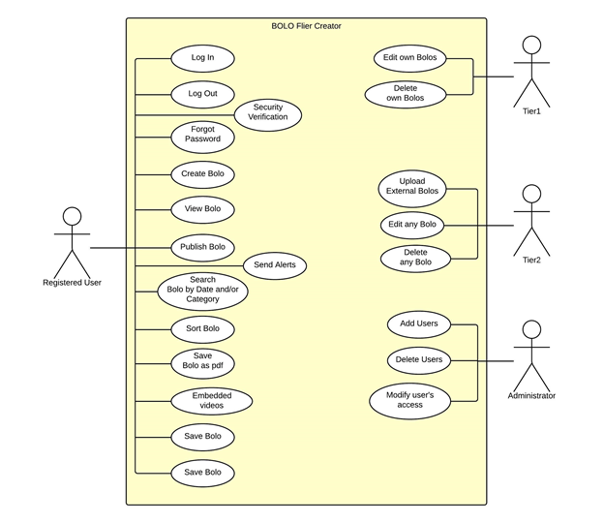

6.3. Appendix C - Static UML diagram

6.4. Appendix D - Dynamic UML diagrams

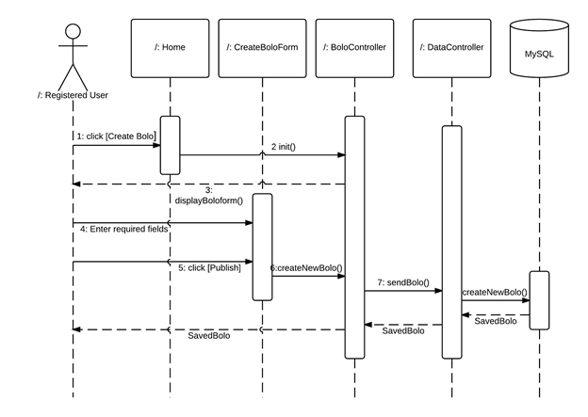

Create BOLO Sequence Diagram

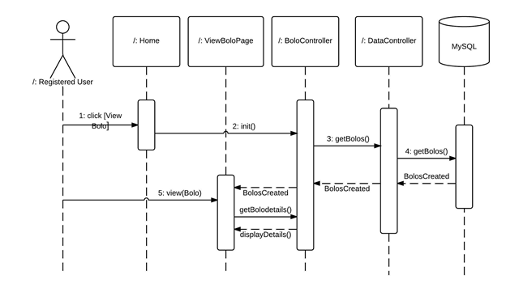

View BOLO Sequence Diagram

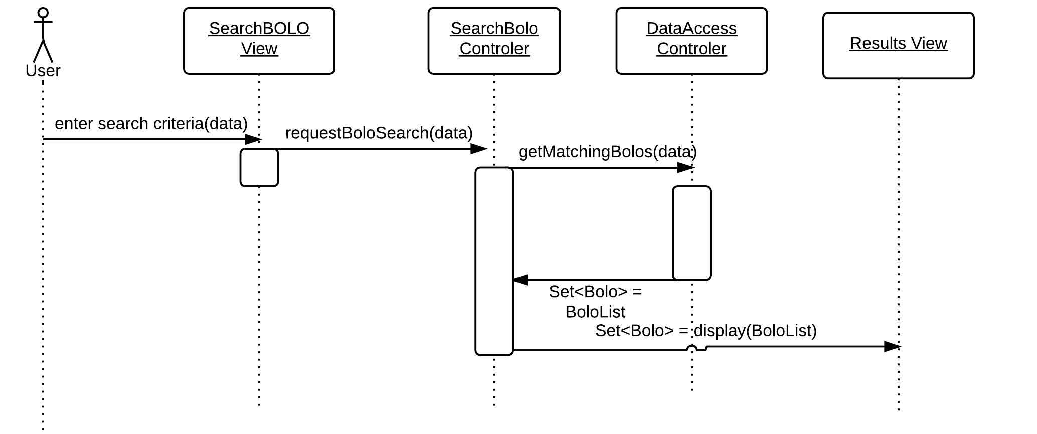Search BOLO Sequence Diagram

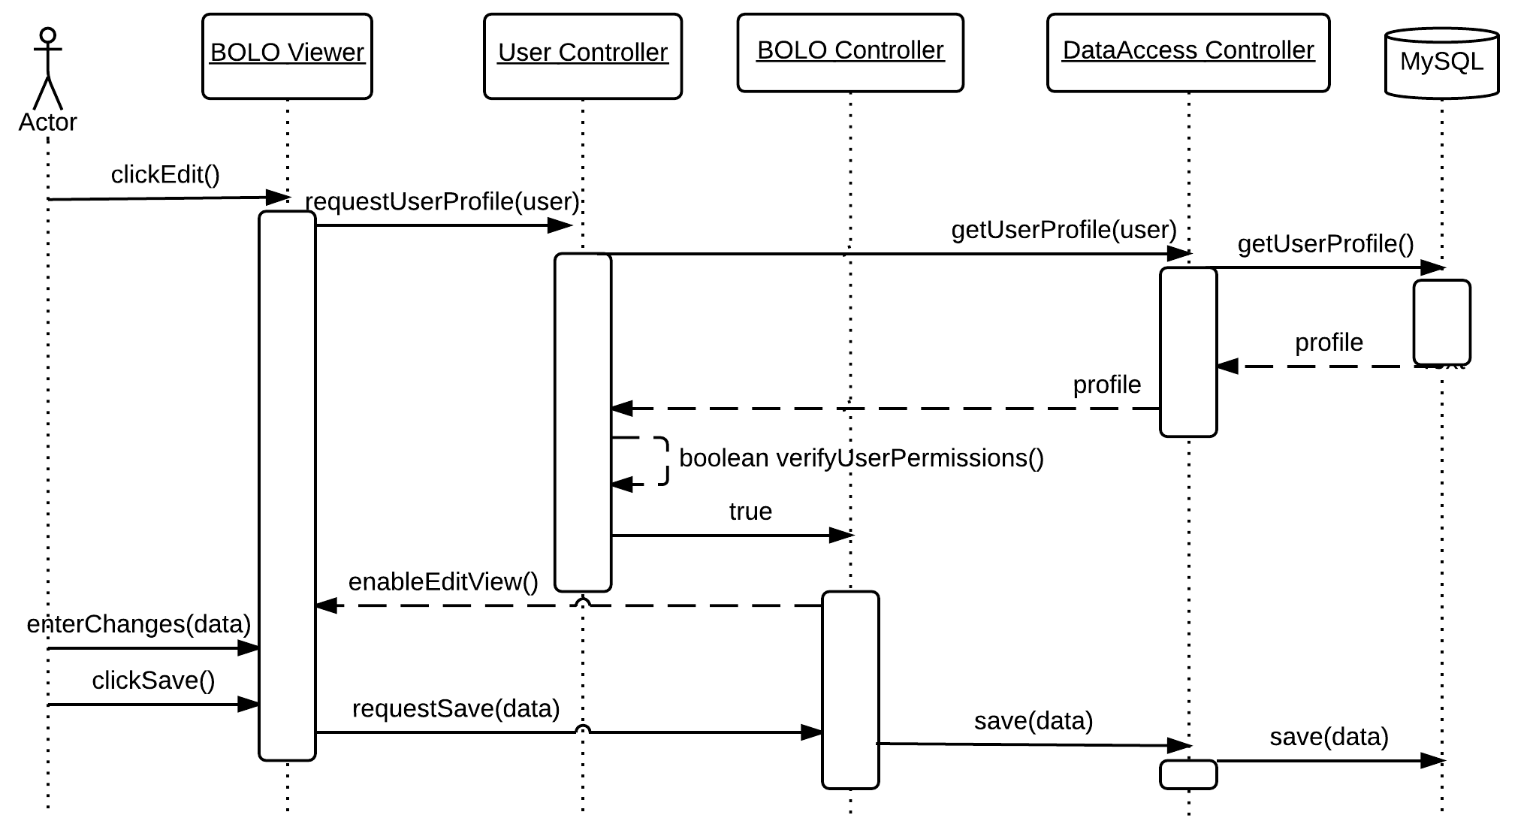Edit BOLO Sequence Diagram

6.5. Appendix E - User Interface designs.

6.6. Appendix F - Diary of meeting and tasks.

7. References

***Please email me the UML diagram in one file before the presentation.***