*Florida International University*

*School of Computing and Information Sciences*

CIS 4911 - Senior Capstone Project

Software Engineering Focus

Final Deliverable

BOLO

**Team Members**

Yamila Fleitas

David Vizcaino

**Product Owner**: Jason Cohen

**Instructor**: Masoud Sadjadi

Copyright and trademark notices, restrictions on copying or distributing the documentation, information for contacting the issuing organization (reader’s comments), warranties, contractual obligations or disclaimers, and general warnings and cautions.

***Abstract***

*The main goal of the project is to build a BOLO Flier Creator web application that will speed the process of creating a BOLO (Be On the Lookout) flier. The application will help officers to serve their communities in a faster, easier, and more efficient way, by replacing the paperless process that is currently in use.*

**Table of Contents**

Introduction........................................................................................................................................ 5

Current System.................................................................................................................................. 5

Purpose of New System..................................................................................................................... 6

User Stories...................................................................................................................................... 7

Implemented User Stories................................................................................................................... 7

Pending User Stories........................................................................................................................ 11

Project Plan..................................................................................................................................... 12

Hardware and Software Resources.................................................................................................... 12

Sprints Plan..................................................................................................................................... 13

Sprint 1........................................................................................................................................... 13

Sprint 2…………………………………………………………………………………………….......................... 16

Sprint 3........................................................................................................................................... 19

Sprint 4…………………………………………………………………………………………….......................... 21

Sprint 5…………………………………………………………………………………………….......................... 23

System Design................................................................................................................................ 26

Architectural Patterns....................................................................................................................... 26

System and Subsystem Decomposition............................................................................................. 26

Deployment Diagram........................................................................................................................ 28

Design Patterns............................................................................................................................... 29

System Validation............................................................................................................................ 30

Glossary.......................................................................................................................................... 55

Appendix......................................................................................................................................... 56

Appendix A - UML Diagrams............................................................................................................. 56

Static UML Diagrams....................................................................................................................... 56

Dynamic UML Diagrams................................................................................................................... 58

Appendix B - User Interface Design................................................................................................... 61

Appendix C - Sprint Review Reports.................................................................................................. 66

Appendix D - Sprint Retrospective Reports........................................................................................ 68

References...................................................................................................................................... 69

# **Introduction**

The Police Department of the Pinecrest Village wants to build a BOLO Flier Creator web application, which will assist the officers in creating BOLO flyers when they arrive at a crime scene and will allow them to upload them to a server; so that when detectives are assigned to a case, they are able to retrieve it from the system.

## Current System

Nowadays, when a police officer is called to a crime scene, a paper report is filled with information pertaining to the crime; the report can end up as a BOLO. Some of the report topics are the probable cause of arrest, if the individual is wanted for questioning, address, and other pieces of information that allow detectives to better identify persons of interest. After the officer finishes the report, a copy is given to the supervisor in charge for review. Upon completion of the review and the report’s approval, the supervisor sends the file to bookkeeping where it is handed to detectives, officers, and even other police agencies.

This process is tedious and expensive because of the time it takes to successfully make a complete BOLO and the number of people working down the chain. If, by any chance, a very serious crime happens on Friday after working hours, all the personnel will receive the notification on monday. Not only that, but after the BOLO being received, it can get lost within information pertaining to many other BOLOs. It is more than likely the older BOLO reports ones will be forgotten.

## 

## Purpose of New System

The purpose of the BOLO Flier Creator is to decrease the amount it takes for an officer to take information from an event, such as a crime scene, and turn such information into a usable report, a BOLO. The new system will allow users to create BOLOs with greater ease than they previously had, view new BOLOs and BOLOs pertaining to other departments faster and easier than the old system, and will automatically send notifications to all relevant users upon the creation of a BOLO, with relevance of certain types of BOLOs being configured on a per-user basis, by the very user. This is a great improvement over the old system, in which an officer would need to send an email to everyone in an emailing list after creating a BOLO, and in which a BOLO would be stored locally on a machine. The new system would keep all BOLOs online and automatically email users without the creator having to specify whom to send it to. The system would also allow supervisors to more efficiently manage the BOLOs pertaining to their agencies as well as approve or remove BOLOs.

The new system will have minimal impact on audience composition, with the largest impact in the form of a third user type, an administrator (or several) that will manage the entire system and will allow users to use the old system by providing them with a format to simply save a BOLO locally for users to do with as they please, allowing smooth transitioning towards the new system while reducing the temporary impact on performance a new system may have on previous users.

**User Stories**

This section will provide details of all the user stories during the life cycle of the application version 2. There will not be any carry user stories since all the functionality requested by the product owner was delivered successfully during this period.

## Implemented User Stories

**User Story # 404 - Add the archive link on each BOLO flier**

As an admin user, I would like to click on an archive link, so that I can archive directly from the homepage.

**User Story # 445 - Redesign archive functionality**

Text of the story.

**User Story # 403 - Allow users to edit previously created BOLOs from homepage**

As a user, I would like to see an “Edit” link on a BOLO, in the homepage, in order to more efficiently and easily update the BOLOs.

**User Story # 441 - Change source email when creating BOLO**

As a user, I would like to be able to receive an email confirmation when a BOLO flier is created, so that all users can receive a notification of any new BOLO.

**User Story # 456 - Modify color schema**

As a user, I would like the system to follow the company design pattern , so I can feel familiar with the visuals of the system.

**User Story # 89 - Preview BOLOs before creation**

Text of the story.

**User Story # 471 - Add ability to destroy Archived BOLO**

As a user, I would like to see a “Delete” link on a BOLO, in the Archive page, in order to easily delete a BOLO from the database.

# **User Story # 486 Add ability to restore a BOLO**

As a user, I would like to see a “Restore” link on a BOLO, in the Archive page, in order to more efficiently and easily activate a BOLO and show it on the homepage.

**User Story # 480 - Create new archive page**

As a user, I would like to view all Archive BOLOs on a page, so I can now see all previously Archive BOLOs.

**User Story # 459 - Ability for administrators to edit agency information**

As an administrator, I would like to be able to edit information on all agencies, so that I may better manager all agencies in the system.

**User Story # 452 - Remove unnecessary details and expand Summary/Additional Info Section**

As a user, I would like to be able to create BOLOs while providing only relevant information in a manner that suits my needs, while having the data still remain readable to users.

**User Story # 494 - Overhaul BOLO preview**

As a user, I would like to be able to create BOLOs while providing only relevant information in a manner that suits my needs, while having the data still remain readable to users.

**User Story # 490 - Attach BOLO flyer to notification Emails**

As a user, I would like the PDF of a BOLO to be attached to any notification emails I receive, so that I can have more choice in how I handle my BOLOs if I choose to use the current system a minimal amount.

## User Story # 519 - Redesign Alerts page

As a user, I would like to see all the agencies in the Alert’s page, so I would be able to choose the agencies that I would like to receive notifications from.

**User Story # 493 - Ability for all users to filter alerts by agency**

As a user, I would like to receive email alerts for BOLO pertaining only to the agencies that I select, so that I can reduce the amount of unnecessary emails I receive.

**User Story # 537 - Create a use case diagram for each actor**

As a user, I would like to have a use case diagram for each type of users, so I can have a better understanding of what are the system functionality for each user.

# **User Story # 123 - Add the 2-step verification of the Archive button**

As a user, I would like to have a 2 step verification of the archive button, so I can manage better the Archive process.

## User Story # 461 - Add the category Recovered to the update drop down

## As a user, I would like to have a category to the update dropdown, so I can see all the recovered BOLOs

# **User Story # 557 - Fix Use Case Diagram**

As a user, I would like to have a use case diagram per tier, so I can have a better understanding of what each type of user can do on the application.

# **User Story # 555 - Refactor Project Documentation**

As a user, I would like to have a document where all the project information is at, so I can have details on what was done on the project during the semester.

## User Story # 548 - Refactor User Guide

## As a user, I would like to have a user guide for each tier of users, so I can have a better understanding of the functionality each user can perform on the application.

## User Story # 491 - Add individual logos to agencies on create

## As a tier 2 user, I would like to be able to add a logo to my agency so that I may have more control over my agency and have my BOLOs contain my agency emblem.

## As an administrator I would like to be able to add a logo to any agency in the system, so that I may have better control over how agencies function.

## User Story # 462 - Ability for Admin to delete Agencies

## As an administrator, I would like to have the ability to delete an agency, so I can better manage the current active Agencies

## User Story # 542 - Create filter to only display BOLOs created by logged in user

## As a user, I would like to filter all BOLOs shown to me with the option of displaying ONLY my created BOLOs, so that I may better manage the BOLOs I create and edit.

## User Story # 541 - Export PDFs of previously created BOLOs

## As a user, I would like to be able to download a PDF copy of any BOLO directly from the website, so that I may not have to rely upon my emails for obtaining the appropriate PDFs.

## Pending User Stories

All user stories requested by the product owner were successfully delivered in the version 2 life cycle of the application.

# 

# 

# 

# 

# 

# **Project Plan**

We will rely heavily on the foundations set by those who worked on the previous version of our project and will continue using their hardware and software setup, mainly WAMP and WordPress. We plan on first modifying existing features as requested by the product owner and then continue with the addition of new features or removal of older features no longer deemed necessary. As they occur, we will also focus on eliminating any bugs encountered, depending on the severity of the bug. If time permits, we may also improve features already implemented in the system at the product owner’s approval/request.

## Hardware and Software Resources

## Hardware:

Laptop, Desktop, or Server running at least Windows Vista (or server equivalent) or new Windows operating systems.

**Software:** Since it is a web application

Wordpress

PHP 5.1.6

HTML

MySQL 3.23.23 or greater

JavaScript

CSS

phpMyAdmin

## 

## Sprints Plan

### Sprint 1

(05/18/2015 - 05/29/2015)

# 

# **User Story #403 - Allow users to Edit previously created BOLOs from the Homepage**

# ***Tasks***

# · Attached an edit link to each BOLO on the homepage based on user qualifications.

# · Fix/Refactor ability to edit previously made BOLOs

# · Test code.

# · Create Documentation

## 

# ***Acceptance Criteria***

# · “Edit” link/button should only appear to Tier 2 users associated with the agency and the Tier 1 user that created the BOLO

# · “Edit” link/button should only appear on pages where multiple BOLOs appear, excluding archives.

# · Upon clicking “Edit”, user should be able to edit and update BOLO.

## 

# ***Modeling***

# Refer to UML diagrams in Appendix A that were created or modified to model the functionality that will be implemented in this sprint.

# **User Story # 445 - Redesign the Archive functionality**

# ***Tasks***

· Implementation of the archive functionality

# · Test the changes in the archive functionality

# · Review code.

· Refactor document

# ***Acceptance Criteria***

# · The administrator user should be able to see all the BOLOs on the homepage.

# · Choose a desired BOLO to archive and click on the link Archive.

# · The user should be able to remain on the homepage and the BOLO should not be visible.

**User Story # 441 - Change the source email when creating a BOLO**

***Tasks***

· Create email address

· Test the changing of the email address

· Review code.

***Acceptance Criteria***

· Individual BOLOs on homepage contain “Archive” link/button.

· User will be able to click on the archive link

· The BOLO will be removed from the homepage

***Modeling***

Refer to UML diagrams in Appendix A that were created or modified to model the functionality that will be implemented in this sprint.

**User Story # 456 - Modify color schema**

***Tasks***

· Change color schema

· Test schema color

***Acceptance Criteria***

· The new color schema will follow the company design pattern.

***Modeling***

Refer to UML diagrams in Appendix A that were created or modified to model the functionality that will be implemented in this sprint.

# **User Story # 404 - Add the Archive link on each BOLO flier**

## *Tasks*

## · Attached each archive link on each BOLO

## · Review code.

## · Test detail link

## · Refactor Final Document

## *Acceptance Criteria*

## · Individual BOLOs on homepage contain “Archive” link/button.

## · User will be able to click on the archive link

## · The BOLO will be removed from the homepage

## 

## 

## *Modeling*

## Refer to UML diagrams in Appendix A that were created or modified to model the functionality that will be implemented in this sprint.

## 

# **User Story # 445 - Redesign the Archive functionality**

# ***Tasks***

## · Implementation of the archive functionality

# · Test the changes in the archive functionality

# · Review code.

## · Refactor document

# ***Acceptance Criteria***

# · The administrator user should be able to see all the BOLOs on the homepage.

# · Choose a desired BOLO to archive and click on the link Archive.

# · The user should be able to remain on the homepage and the BOLO should not be visible.

## 

## User Story # 441 - Change the source email when creating a BOLO

## *Tasks*

## · Create email address

## · Test the changing of the email address

## · Review code.

## *Acceptance Criteria*

## · Individual BOLOs on homepage contain “Archive” link/button.

## · User will be able to click on the archive link

## · The BOLO will be removed from the homepage

## 

## 

## *Modeling*

## Refer to UML diagrams in Appendix A that were created or modified to model the functionality that will be implemented in this sprint.

## 

### Sprint 2

(06/01/2015 - 06/12/2015)

# **User Story # 89 -Preview BOLOs before creation**

***Tasks***

· Add preview button to BOLO creation screen.

· Generate PDF preview when Preview button is clicked.

· Test BOLO preview functionality.

· Create necessary documentation.

***Acceptance Criteria***

· Users should be able to fill out BOLO information as they previously could.

· After filling information users should be able to click on a preview link that will redirect them to a preview of the PDF being created.

· The PDF should display all appropriate information entered by the users.

· System should not bombard database with multiple saved previews for a single user (i.e – if user clicks preview twice, only one preview should be stored in the server).

· Users should be able to save a PDF of, and submit, their BOLO from the preview screen.

· System should not bombard database with multiple saved previews for a single user (i.e – if user clicks preview twice, only one preview should be stored in the server).

***Modeling***

Refer to UML diagrams in Appendix A that were created or modified to model the functionality that will be implemented in this sprint.

# **User Story # 478 -Email upon BOLO creation, debugging**

***Tasks***

· Identify source of issues with emails on BOLO creation.

· Debug issue with emails not being sent upon BOLO creation.

***Acceptance Criteria***

· Upon BOLO creation, user should receive an email notifying them of a new BOLO.

· The email should contain a link to the created BOLO.

**User Story # 471 - Add ability to destroy Archived BOLO**

***Tasks***

[Test the destroy of archive BOLO](https://fiu-scis-seniorproject.mingle.thoughtworks.com/projects/bolo/cards/474)

[Refactor document](https://fiu-scis-seniorproject.mingle.thoughtworks.com/projects/bolo/cards/473)

[Implementation of the deletion process](https://fiu-scis-seniorproject.mingle.thoughtworks.com/projects/bolo/cards/472)

***Acceptance Criteria***

1. If the user logged in is only a tier 1 or tier 2 user, they cannot see the Delete link.
2. If the user logged in is an admin, they can see the Delete link for all BOLOs.
3. Upon clicking “Delete”, the BOLO will be deleted from the database.

**User Story # 486 Add ability to restore a BOLO**

***Tasks***

[Test the ability to restore a BOLO](https://fiu-scis-seniorproject.mingle.thoughtworks.com/projects/bolo/cards/489)

[Refactor Project Documentation](https://fiu-scis-seniorproject.mingle.thoughtworks.com/projects/bolo/cards/488)

[Implementation of the restore button](https://fiu-scis-seniorproject.mingle.thoughtworks.com/projects/bolo/cards/487)

***Acceptance Criteria***

1. If the user logged in is only a tier 1 user, they cannot see the Restore link.
2. If the user logged in is only a tier 2 user, they can see the Restore link for any BOLOs belonging to their agency.
3. If the user logged in is an admin, they can see the Restore link for all BOLOs.
4. Upon clicking “Restore”, the BOLO will be activated again and seeing on the homepage.

# **User Story # 480 Create new Archive page**

***Tasks***

[Implementation of the new archive layout](https://fiu-scis-seniorproject.mingle.thoughtworks.com/projects/bolo/cards/481)

[Test the new archive layout](https://fiu-scis-seniorproject.mingle.thoughtworks.com/projects/bolo/cards/482)

[Refactor Project Documentation](https://fiu-scis-seniorproject.mingle.thoughtworks.com/projects/bolo/cards/483)

***Acceptance Criteria***

1. If the user logged in is only a tier 1 user, they do not have access to the Archive tab.
2. If the user logged in is only a tier 2 user, they can see the Archive tab for any BOLOs belonging to their agency.
3. If the user logged in is an admin, they can see the Archive for all BOLOs.

# 

# **Sprint #3**

# (06/15/2015 - 06/26/2015)

# **User Story #459 Ability for administrators to edit agency information**

***Tasks***

1. Review current implementation and potential solutions
2. Implementation of solution
3. Refactor documentation
4. Testing

***Acceptance Criteria***

1. Admin users should be able to edit all agency information.

# **User Story # 452 Remove unnecessary details and expand Summary/Additional Info Section**

***Tasks***

1. Remove Information Classification
2. Remove Content Validity
3. Remove Source Reliability
4. Expand size of Summary and Additional Info boxes

***Acceptance Criteria***

1. Users should be able to continue creating BOLOs like normal.
2. Source Reliability and all other checkboxes below it should not be visible for any users.
3. Additional Info and Summary boxes should be large for better readability.

# **User Story # 494 Overhaul BOLO preview**

***Tasks***

1. Code new implementation
2. Test

***Acceptance Criteria***

1. Preview should be viewable on mobile devices.
2. Preview should be viewable on desktops.
3. Preview should not be in PDF format.
4. Viewing preview should not reset inputted user information.

# **User Story # 490 Attach BOLO flyer to notification Emails**

***Tasks***

1. Review current system implementation and design solution
2. Implement solution
3. Testing

***Acceptance Criteria***

1. Email system should work as it currently does.
2. When an email is received, a PDF of the created BOLO should be attached.

# **User Story # 519 Redesign the Alerts page**

***Tasks***

1. Implementation of the new alerts page
2. Testing of the new alerts page
3. Refactor project documentation
4. Refactor user guide

***Acceptance Criteria***

1. All users should be able to choose the agencies they would like to receive alerts.
2. Upon user creation, all agencies would be checked by default.

# 

# 

# 

# **Sprint #4**

# (06/26/2015 - 07/10/2015)

# **User Story # 493 Ability for all users to filter alerts by agency**

***Tasks***

1. [Database Redesign](https://fiu-scis-seniorproject.mingle.thoughtworks.com/projects/bolo/cards/525)
2. [Create diagrams](https://fiu-scis-seniorproject.mingle.thoughtworks.com/projects/bolo/cards/506)
3. [Testing](https://fiu-scis-seniorproject.mingle.thoughtworks.com/projects/bolo/cards/505)
4. [Implement solution](https://fiu-scis-seniorproject.mingle.thoughtworks.com/projects/bolo/cards/504)
5. [Review current system implementation and potential solutions](https://fiu-scis-seniorproject.mingle.thoughtworks.com/projects/bolo/cards/503)

***Acceptance Criteria***

1. Users should receive emails as they normally have.
2. A user should be able to selected which agencies to receive alerts from.
3. A user should only receive alerts for BOLOs created by users belonging to their selected agency/agencies.

# **User Story # 537 - Create a use case diagram for each actor**

***Tasks***

1. [Design of the use case for Admin](https://fiu-scis-seniorproject.mingle.thoughtworks.com/projects/bolo/cards/540)
2. [Design of the use case for tier 2](https://fiu-scis-seniorproject.mingle.thoughtworks.com/projects/bolo/cards/539)
3. [Design of the use case for tier 1](https://fiu-scis-seniorproject.mingle.thoughtworks.com/projects/bolo/cards/538)

***Acceptance Criteria***

1. All users can see in a simple diagram what are the allowed functionality that they have in the system.

# **User Story # 491 Add individual logos to agencies on create and edit agency logos**

***Tasks***

1. Design Solution
2. Implement Solution
3. Test

***Acceptance Criteria***

1. Administrators should be able to add any custom logo(s) to any agencies in the system.
2. An agencies logo must properly appear on BOLO created by a member of that agency.
3. Administrators should be able to edit any Logo on a previously created agency.

# **User Story # 531 Add the ability to associate unit/section to each user.**

***Tasks***

1. Add title to each user
2. Add unit/section to each user

***Acceptance Criteria***

1. Users should be able to be created as they previously were.
2. Previous users should face no errors (even though they will lack a section and title).
3. User section and title should be displayed for each appropriate user on the administrative page.
4. User ranking and section should be displayed on created BOLOs.

# **User Story # 463 Display update notification if BOLO has been updated and push to top of homepage**

***Tasks***

1. Design and Implement solution
2. Test solution

***Acceptance Criteria***

1. Homepage works as it previously has.
2. An updated BOLO is pushed to the top of the homepage.
3. An updated BOLO displays the word “UPDATE” along with date in an eye-catching format.
4. An updated BOLO displays the date of the update.

# **User Story # 526 Ensure functionality for awards ceremony**

***Tasks***

1. Fix search functionality errors.

***Acceptance Criteria***

1. All currently implemented systems work flawlessly.
2. All features of the BOLO Flier Creator work flawlessly

# 

### Sprint 5

# (07/10/2015 - 07/24/2015)

# **User Story # 123 - Add the 2-step verification of the Archive button**

***Tasks***

1. Implementation of the 2 step archive verification
2. Testing of the 2 steps archive page

***Acceptance Criteria***

1. User clicks on Archive
2. A confirmation dialog pop ok
3. User can click on OK
4. BOLO is archived

# **User Story # 461 - Add the category Recovered to the update drop down**

***Tasks***

1. A user clicks on the drop-down and select Recovered
2. The, the user click on Go.
3. User will see all the recovered BOLOs

***Acceptance Criteria***

# A user clicks on the drop-down and select Recovered

# The, the user click on Go.

# User will see all the recovered BOLOs

# 

# 

# **User Story # 557 - Fix Use Case Diagram**

***Tasks***

1. Refactor the previous use case diagram

***Acceptance Criteria***

1. Fix use case diagrams

**User Story # 555 - Refactor Project Documentation**

***Tasks***

1. [Refactor Project Documentation](https://fiu-scis-seniorproject.mingle.thoughtworks.com/projects/bolo/cards/556)

**User Story # 548 - Refactor User Guide**

***Tasks***

1. [Refactor User Guide](https://fiu-scis-seniorproject.mingle.thoughtworks.com/projects/bolo/cards/554)

# **User Story # 462 - Ability for Admin to Delete Agencies**

***Tasks***

1. Design solution
2. Implement and Test solution

***Acceptance Criteria***

1. Agency system should work the way it currently does.
2. Administrator should be able to delete an agency from the Agencies menu.

# **User Story # 542 - Create filter to only display BOLOs created by logged in user**

***Tasks***

1. Design solution
2. Implement and Test solution

***Acceptance Criteria***

1. Homepage should maintain current functionality.
2. Drop down menu should have additional option to show “My BOLOs”.
3. Selecting “My BOLOs” should show all BOLOs created by the user.
4. BOLOs shown to user should not be those that are Archived.

# **User Story # 541 - Export PDFs of previously created BOLOs**

***Tasks***

1. Design solution
2. Implement and Test solution

***Acceptance Criteria***

1. BOLOs should remain working as they previously have.
2. Users should be able to download PDF for ANY previously created BOLO.
3. PDF should be identical to the one sent in an email.

# **User Story # 561 - Work on Documentation**

***Tasks***

1. Fix class diagrams
2. Work on general project documentation

***Acceptance Criteria***

1. Class diagrams are fixed and acceptable.
2. Work is done on Project Documentation.
3. Deployment diagram is done.

# 

# **System Design**

This section will provide an overall of the system design implemented on the BOLO Flyer Creator application. It will describe the system design using MVC as architectural pattern and will give a detailed description of the subsystem decomposition for each subsystem.

## Architectural Patterns

The architectural patterns used in this project is the Model-View-Controller (MVC).

## System and Subsystem Decomposition

The application uses a server- client architecture where the implementation will be on the server side using the Model-View-Controller (MVC) architecture.

The Model subsystem handles all the data storage of the application, which is stored in a MySQL database. Every time a user changes some information that is stored in the database, the Controller take care of it by updating it.

The Controller will handle all the logic of the system interactions between the Model and the View subsystems. The way it will work is that the controller receives a request from the View and send it request for the data to the Model. Once the requested information is received, the View will display the information using HTML through the web browser.

The View subsystem will send the user input to the Controller and the response will be presented to the user in a user-friendly manner. The information presented is provided by the Controller.

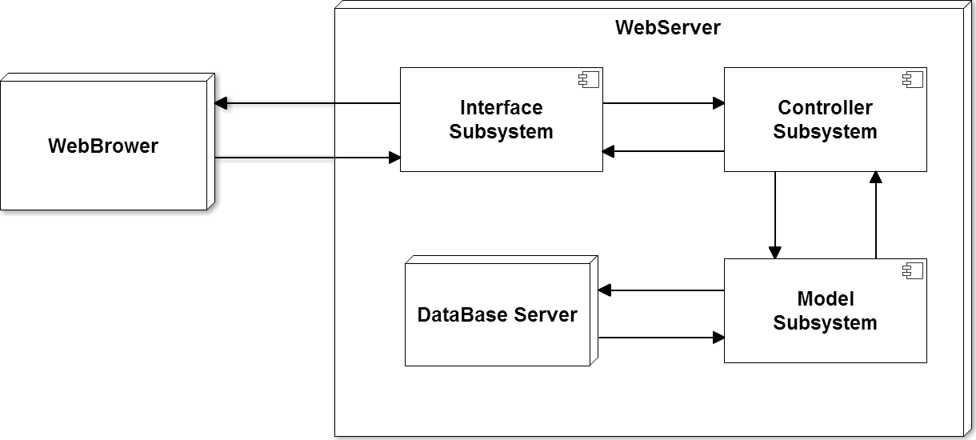

Figure 1 - Subsystem

## 

## 

## 

## 

## 

## 

## Deployment Diagram

Below is our deployment diagram showing how the system is currently implemented using WordPress and MySQL.

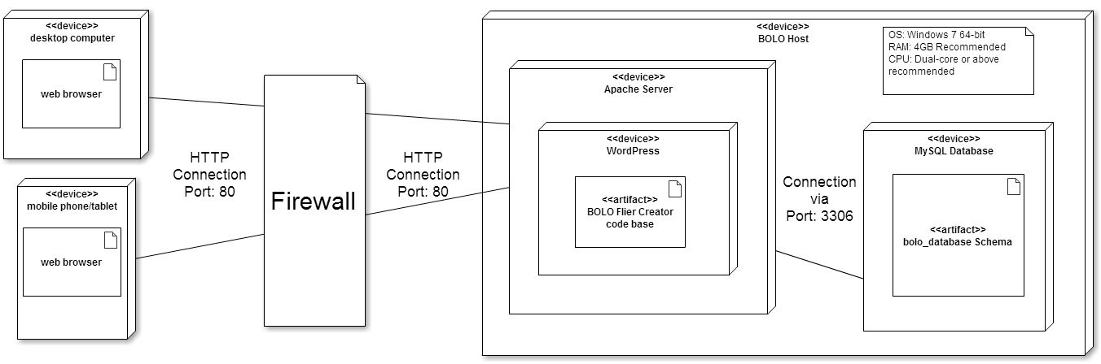

Figure 2 - Deployment Diagram

## 

## 

## 

## 

## 

## Design Patterns

The design pattern chosen for this project was Client-Server. It is a design pattern use to integrate the communication between the client and the servers. The Client requests information which is stored on the server, which will response with the client request by giving the client the requested information.Servers will be waiting for interactions from the clients.The client is not aware of how the server fulfill the request, but rather, the client understands the response based on a well known application protocol.

This pattern allows us to minimize the amount of interaction our users can have with sensitive parts of our application, which will increase security.

# 

# 

# 

# 

# **System Validation**

This section describes all the testing done on the application during its implementation. Dynamic and static test cases were done automated and manual as well on each piece of functionality once its implementation was done. There were independent test cases and integrated test cases with the whole system. The following is a list of the test cases done to the application where each test case has its unique identifier, the purpose, test setup, input and expected output and the script for its automation.

**User Story # 404 - Add the archive link on each BOLO flier**

|  |  |
| --- | --- |
| **Test Case ID** | BOLO 404 - SUNNY |
| **Purpose** | To validate the archive link |
| **Preconditions** | The has to be an admin or tier 2 |
| **Input** | Click on Archive |
| **Expected Result** | Successfully saved BOLO and remove it from the Homepage |

|  |  |
| --- | --- |
| **Test Case ID** | BOLO 404 -1 - SUNNY |
| **Purpose** | To validate the archive link |
| **Preconditions** | The has to be an admin or tier 2 |
| **Input** | Click on Archive |
| **Expected Result** | BOLO was not removed from the homepage |

|  |  |
| --- | --- |
| **Automated Script** | <?xml version="1.0" encoding="UTF-8"?>  <!DOCTYPE html PUBLIC "-//W3C//DTD XHTML 1.0 Strict//EN" "http://www.w3.org/TR/xhtml1/DTD/xhtml1-strict.dtd">  <html xmlns="http://www.w3.org/1999/xhtml" xml:lang="en" lang="en">  <head profile="http://selenium-ide.openqa.org/profiles/test-case">  <meta http-equiv="Content-Type" content="text/html; charset=UTF-8" />  <link rel="selenium.base" href="http://bolo.cs.fiu.edu/" />  <title>New Test</title>  </head>  <body>  <table cellpadding="1" cellspacing="1" border="1">  <thead>  <tr><td rowspan="1" colspan="3">New Test</td></tr>  </thead><tbody>  <tr>  <td>open</td>  <td>/bolofliercreator/</td>  <td></td>  </tr>  <tr>  <td>click</td>  <td>xpath=(//a[contains(text(),'Archive')])[2]</td>  <td></td>  </tr>  </tbody></table>  </body>  </html> |

**User Story # 441 - Change source email when creating BOLO**

|  |  |
| --- | --- |
| **Test Case ID** | BOLO 441 - SUNNY |
| **Purpose** | To validate the change on the source email |
| **Preconditions** | User has to be able to receive an email |
| **Input** | Create a BOLO |
| **Expected Result** | A BOLO is send with the new email address |

|  |  |
| --- | --- |
| **Test Case ID** | BOLO 441 -1 - RAINY |
| **Purpose** | To validate the change on the source email |
| **Preconditions** | User has to be able to receive an email |
| **Input** | Create a BOLO |
| **Expected Result** | BOLO was send with the old email address |

|  |  |
| --- | --- |
| **Automated Script** | <?xml version="1.0" encoding="UTF-8"?>  <!DOCTYPE html PUBLIC "-//W3C//DTD XHTML 1.0 Strict//EN" "http://www.w3.org/TR/xhtml1/DTD/xhtml1-strict.dtd">  <html xmlns="http://www.w3.org/1999/xhtml" xml:lang="en" lang="en">  <head profile="http://selenium-ide.openqa.org/profiles/test-case">  <meta http-equiv="Content-Type" content="text/html; charset=UTF-8" />  <link rel="selenium.base" href="http://bolo.cs.fiu.edu/" />  <title>New Test</title>  </head>  <body>  <table cellpadding="1" cellspacing="1" border="1">  <thead>  <tr><td rowspan="1" colspan="3">New Test</td></tr>  </thead><tbody>  <tr>  <td>open</td>  <td>/bolofliercreator/#</td>  <td></td>  </tr>  <tr>  <td>clickAndWait</td>  <td>link=Create BOLO</td>  <td></td>  </tr>  <tr>  <td>type</td>  <td>id=name</td>  <td>as</td>  </tr>  <tr>  <td>type</td>  <td>id=lastName</td>  <td>as</td>  </tr>  <tr>  <td>clickAndWait</td>  <td>name=save</td>  <td></td>  </tr>  </tbody></table>  </body>  </html> |

**User Story # 471 - Add ability to destroy Archived BOLO**

|  |  |
| --- | --- |
| **Test Case ID** | BOLO 471 - SUNNY |
| **Purpose** | To validate the ability to destroy Archived BOLO |
| **Preconditions** | User has to be logged in as an Admin |
| **Input** | Click on Delete and then click on Ok on the confirmation dialog |
| **Expected Result** | BOLO was successfully deleted from the database |

|  |  |
| --- | --- |
| **Test Case ID** | BOLO 471 -1 - RAINY |
| **Purpose** | To validate the ability to destroy Archived BOLO |
| **Preconditions** | User has to be logged in as an Admin |
| **Input** | Click on Delete and then click on Cancel on the confirmation dialog |
| **Expected Result** | BOLO was not deleted from the database |

|  |  |
| --- | --- |
| **Automated Script** | <?xml version="1.0" encoding="UTF-8"?>  <!DOCTYPE html PUBLIC "-//W3C//DTD XHTML 1.0 Strict//EN" "http://www.w3.org/TR/xhtml1/DTD/xhtml1-strict.dtd">  <html xmlns="http://www.w3.org/1999/xhtml" xml:lang="en" lang="en">  <head profile="http://selenium-ide.openqa.org/profiles/test-case">  <meta http-equiv="Content-Type" content="text/html; charset=UTF-8" />  <link rel="selenium.base" href="http://bolo.cs.fiu.edu/" />  <title>Archive Delete button</title>  </head>  <body>  <table cellpadding="1" cellspacing="1" border="1">  <thead>  <tr><td rowspan="1" colspan="3">Archive Delete button</td></tr>  </thead><tbody>  <tr>  <td>open</td>  <td>/bolofliercreator/</td>  <td></td>  </tr>  <tr>  <td>clickAndWait</td>  <td>link=Archive</td>  <td></td>  </tr>  <tr>  <td>click</td>  <td>link=Delete</td>  <td></td>  </tr>  <tr>  <td>assertConfirmation</td>  <td>Are you sure you want to delete this BOLO?</td>  <td></td>  </tr>  </tbody></table>  </body>  </html> |

**User Story # 486 Add ability to restore a BOLO**

|  |  |
| --- | --- |
| **Test Case ID** | BOLO 486 - SUNNY |
| **Purpose** | To validate the ability to restore Archived BOLO |
| **Preconditions** | User has to be logged in as an Admin |
| **Input** | Click on Restore and then click on Ok on the confirmation dialog |
| **Expected Result** | BOLO was successfully Restore from the database |

|  |  |
| --- | --- |
| **Test Case ID** | BOLO 486 -1 - RAINY |
| **Purpose** | To validate the ability to Restore Archived BOLO |
| **Preconditions** | User has to be logged in as an Admin |
| **Input** | Click on Restore and then click on Cancel on the confirmation dialog |
| **Expected Result** | BOLO was not Restore from the database |

|  |  |
| --- | --- |
| **Automated Script** | <?xml version="1.0" encoding="UTF-8"?>  <!DOCTYPE html PUBLIC "-//W3C//DTD XHTML 1.0 Strict//EN" "http://www.w3.org/TR/xhtml1/DTD/xhtml1-strict.dtd">  <html xmlns="http://www.w3.org/1999/xhtml" xml:lang="en" lang="en">  <head profile="http://selenium-ide.openqa.org/profiles/test-case">  <meta http-equiv="Content-Type" content="text/html; charset=UTF-8" />  <link rel="selenium.base" href="http://bolo.cs.fiu.edu/" />  <title>Restore BOLO from Archive page</title>  </head>  <body>  <table cellpadding="1" cellspacing="1" border="1">  <thead>  <tr><td rowspan="1" colspan="3">Restore BOLO from Archive page</td></tr>  </thead><tbody>  <tr>  <td>open</td>  <td>/bolofliercreator/?page_id=1537#</td>  <td></td>  </tr>  <tr>  <td>click</td>  <td>link=Restore</td>  <td></td>  </tr>  <tr>  <td>assertConfirmation</td>  <td>Are you sure you want to restore this BOLO?</td>  <td></td>  </tr>  <tr>  <td>clickAndWait</td>  <td>link=Home</td>  <td></td>  </tr>  </tbody></table>  </body>  </html> |

**User Story # 459 - Ability for administrators to edit agency information**

|  |  |
| --- | --- |
| **Test Case ID** | BOLO 459 - SUNNY |
| **Purpose** | To validate the Edit Agency Information |
| **Preconditions** | User has to be logged in as an Admin |
| **Input** | Click on Edit button and entered the new information and then click on submit |
| **Expected Result** | The Agency information is changed successfully |

|  |  |
| --- | --- |
| **est Case ID** | BOLO 459 -1 - RAINY |
| **Purpose** | To validate the ability to edit agencies |
| **Preconditions** | User has to be logged in as an Admin |
| **Input** | Click on Edit and enter the new information |
| **Expected Result** | Information is not saved |

|  |  |
| --- | --- |
| **Automated Script** | <?xml version="1.0" encoding="UTF-8"?>  <!DOCTYPE html PUBLIC "-//W3C//DTD XHTML 1.0 Strict//EN" "http://www.w3.org/TR/xhtml1/DTD/xhtml1-strict.dtd">  <html xmlns="http://www.w3.org/1999/xhtml" xml:lang="en" lang="en">  <head profile="http://selenium-ide.openqa.org/profiles/test-case">  <meta http-equiv="Content-Type" content="text/html; charset=UTF-8" />  <link rel="selenium.base" href="http://bolo.cs.fiu.edu/" />  <title>New Test</title>  </head>  <body>  <table cellpadding="1" cellspacing="1" border="1">  <thead>  <tr><td rowspan="1" colspan="3">New Test</td></tr>  </thead><tbody>  <tr>  <td>open</td>  <td>/bolofliercreator/?page_id=1508</td>  <td></td>  </tr>  <tr>  <td>clickAndWait</td>  <td>xpath=(//a[contains(text(),'Edit')])[2]</td>  <td></td>  </tr>  <tr>  <td>type</td>  <td>id=zip</td>  <td>33154</td>  </tr>  <tr>  <td>clickAndWait</td>  <td>name=save</td>  <td></td>  </tr>  </tbody></table>  </body>  </html> |

**User Story # 493 - Ability for all users to filter alerts by agency**

|  |  |
| --- | --- |
| **Test Case ID** | BOLO 493 - SUNNY |
| **Purpose** | To validate the ability to filter alerts by agency |
| **Preconditions** | User needs to have an email account |
| **Input** | Select the desire agencies to receive alerts from and click on Save notifications Preferences |
| **Expected Result** | Each time a BOLO is created from that agency, user will receive the notification |

|  |  |
| --- | --- |
| **Test Case ID** | BOLO 471 -1 - RAINY |
| **Purpose** | To validate the ability to filter alerts by agency |
| **Preconditions** | User needs to have an email account |
| **Input** | Select the none of the desire agencies to receive alerts from and click on Save notifications Preferences |
| **Expected Result** | User will not receive notifications |

|  |  |
| --- | --- |
| **Automated Script** | <?xml version="1.0" encoding="UTF-8"?>  <!DOCTYPE html PUBLIC "-//W3C//DTD XHTML 1.0 Strict//EN" "http://www.w3.org/TR/xhtml1/DTD/xhtml1-strict.dtd">  <html xmlns="http://www.w3.org/1999/xhtml" xml:lang="en" lang="en">  <head profile="http://selenium-ide.openqa.org/profiles/test-case">  <meta http-equiv="Content-Type" content="text/html; charset=UTF-8" />  <link rel="selenium.base" href="http://bolo.cs.fiu.edu/" />  <title>New Test</title>  </head>  <body>  <table cellpadding="1" cellspacing="1" border="1">  <thead>  <tr><td rowspan="1" colspan="3">New Test</td></tr>  </thead><tbody>  <tr>  <td>open</td>  <td>/bolofliercreator/?page_id=1561</td>  <td></td>  </tr>  <tr>  <td>click</td>  <td>name=check-1</td>  <td></td>  </tr>  <tr>  <td>clickAndWait</td>  <td>id=submit</td>  <td></td>  </tr>  </tbody></table>  </body>  </html> |

**User Story # 123 - Add the 2-step verification of the Archive button**

|  |  |
| --- | --- |
| **Test Case ID** | BOLO 123 - SUNNY |
| **Purpose** | To validate the 2-steps verification of the Archive button |
| **Preconditions** | User needs to be logged in as a tier 2 or Admin |
| **Input** | Click on the Archive button and a confirmation dialog will pop up. User will click on OK. |
| **Expected Result** | The BOLO is successfully Archived being removed from the homepage and added to the Archive page. |

|  |  |
| --- | --- |
| **Test Case ID** | BOLO 123 -1 - RAINY |
| **Purpose** | To validate the 2-steps verification of the Archive button |
| **Preconditions** | User needs to be logged in as a tier 2 or Admin |
| **Input** | Click on the Archive button and a confirmation dialog will pop up. User will click on Cancel. |
| **Expected Result** | The BOLO is not Archived and the it remains on the homepage. |

|  |  |
| --- | --- |
| **Automated Script** | <?xml version="1.0" encoding="UTF-8"?>  <!DOCTYPE html PUBLIC "-//W3C//DTD XHTML 1.0 Strict//EN" "http://www.w3.org/TR/xhtml1/DTD/xhtml1-strict.dtd">  <html xmlns="http://www.w3.org/1999/xhtml" xml:lang="en" lang="en">  <head profile="http://selenium-ide.openqa.org/profiles/test-case">  <meta http-equiv="Content-Type" content="text/html; charset=UTF-8" />  <link rel="selenium.base" href="http://bolo.cs.fiu.edu/" />  <title>New Test</title>  </head>  <body>  <table cellpadding="1" cellspacing="1" border="1">  <thead>  <tr><td rowspan="1" colspan="3">New Test</td></tr>  </thead><tbody>  <tr>  <td>open</td>  <td>/bolofliercreator/#</td>  <td></td>  </tr>  <tr>  <td>click</td>  <td>xpath=(//a[contains(text(),'Archive')])[2]</td>  <td></td>  </tr>  <tr>  <td>assertConfirmation</td>  <td>Are you sure you want to delete this BOLO?</td>  <td></td>  </tr>  </tbody></table>  </body>  </html> |

**User Story # 461 - Add the category Recovered to the update drop down**

|  |  |
| --- | --- |
| **Test Case ID** | BOLO 461 - SUNNY |
| **Purpose** | To validate the the Recovered category to the update drop down |
| **Preconditions** | User has to be logged in |
| **Input** | Select Recovered on the Update dropdown and click Save |
| **Expected Result** | BOLO will be moved to the top of the home page and will have in read the update date and time as well as the update reason. |

|  |  |
| --- | --- |
| **Automated Script** | <?xml version="1.0" encoding="UTF-8"?>  <!DOCTYPE html PUBLIC "-//W3C//DTD XHTML 1.0 Strict//EN" "http://www.w3.org/TR/xhtml1/DTD/xhtml1-strict.dtd">  <html xmlns="http://www.w3.org/1999/xhtml" xml:lang="en" lang="en">  <head profile="http://selenium-ide.openqa.org/profiles/test-case">  <meta http-equiv="Content-Type" content="text/html; charset=UTF-8" />  <link rel="selenium.base" href="http://bolo.cs.fiu.edu/" />  <title>New Test</title>  </head>  <body>  <table cellpadding="1" cellspacing="1" border="1">  <thead>  <tr><td rowspan="1" colspan="3">New Test</td></tr>  </thead><tbody>  <tr>  <td>open</td>  <td>/bolofliercreator/#</td>  <td></td>  </tr>  <tr>  <td>clickAndWait</td>  <td>xpath=(//a[contains(text(),'Edit')])[3]</td>  <td></td>  </tr>  <tr>  <td>select</td>  <td>id=update</td>  <td>label=RECOVERED</td>  </tr>  <tr>  <td>clickAndWait</td>  <td>id=submit</td>  <td></td>  </tr>  </tbody></table>  </body>  </html> |

**User Story # 542 - Create filter to only display BOLOs created by logged in user**

## 

|  |  |
| --- | --- |
| Test Case ID | BOLO 542 - SUNNY |
| Purpose | To validate the ability to view BOLOs created by the logged user |
| Preconditions | User has to be logged in |
| Input | On the Homepage select the dropdown Show My BOLOs and click on Go |
| Expected Result | All shown BOLOs were created by the logged user |

## 

## 

## 

|  |  |
| --- | --- |
| Test Case ID | BOLO 542 - RAINY |
| Purpose | To validate the ability to BOLOs created by the logged user |
| Preconditions | User has to be logged in |
| Input | On the Homepage select the dropdown Show My BOLOs and click on Go |
| Expected Result | BOLO were not shown by the logged user |

## 

## 

|  |  |
| --- | --- |
| Automated Script | <?xml version="1.0" encoding="UTF-8"?><!DOCTYPE html PUBLIC "-//W3C//DTD XHTML 1.0 Strict//EN" "http://www.w3.org/TR/xhtml1/DTD/xhtml1-strict.dtd"><html xmlns="http://www.w3.org/1999/xhtml" xml:lang="en" lang="en"><head profile="http://selenium-ide.openqa.org/profiles/test-case"><meta http-equiv="Content-Type" content="text/html; charset=UTF-8" /><link rel="selenium.base" href="http://bolo.cs.fiu.edu/" /><title>New Test</title></head><body><table cellpadding="1" cellspacing="1" border="1"><thead><tr><td rowspan="1" colspan="3">New Test</td></tr></thead><tbody><tr> <td>open</td> <td>/bolofliercreator/</td> <td></td></tr><tr> <td>select</td> <td>id=agency</td> <td>label=Show My BOLOs</td></tr><tr> <td>clickAndWait</td> <td>id=submit</td> <td></td></tr></tbody></table></body></html> |

## 

## 

## 

## User Story # 462 - Ability for Admin to delete Agencies

|  |  |
| --- | --- |
| **Test Case ID** | BOLO 462 - SUNNY |
| **Purpose** | To validate the the ability for admin to delete the agencies |
| **Preconditions** | User needs to be an admin |
| **Input** | Click on the Delete button |
| **Expected Result** | The BOLO is successfully deleted |

|  |  |
| --- | --- |
| **Test Case ID** | BOLO 462 -1 - RAINY |
| **Purpose** | To validate the the ability for admin to delete the agencies |
| **Preconditions** | Logged user is a tier 2 user |
| **Input** | User did not have the access to delete agencies |
| **Expected Result** | Could not delete agencies |

|  |  |
| --- | --- |
| **Automated Script** | <?xml version="1.0" encoding="UTF-8"?>  <!DOCTYPE html PUBLIC "-//W3C//DTD XHTML 1.0 Strict//EN" "http://www.w3.org/TR/xhtml1/DTD/xhtml1-strict.dtd">  <html xmlns="http://www.w3.org/1999/xhtml" xml:lang="en" lang="en">  <head profile="http://selenium-ide.openqa.org/profiles/test-case">  <meta http-equiv="Content-Type" content="text/html; charset=UTF-8" />  <link rel="selenium.base" href="http://bolo.cs.fiu.edu/" />  <title>New Test</title>  </head>  <body>  <table cellpadding="1" cellspacing="1" border="1">  <thead>  <tr><td rowspan="1" colspan="3">New Test</td></tr>  </thead><tbody>  <tr>  <td>open</td>  <td>/bolofliercreator/</td>  <td></td>  </tr>  <tr>  <td>clickAndWait</td>  <td>link=Agencies</td>  <td></td>  </tr>  <tr>  <td>clickAndWait</td>  <td>link=Delete</td>  <td></td>  </tr>  </tbody></table>  </body>  </html> |

## User Story # 541 - Export PDFs of Previously created BOLOs

|  |  |
| --- | --- |
| **Test Case ID** | BOLO 541 - SUNNY |
| **Purpose** | To validate the ability to download PDFs of older BOLOs |
| **Preconditions** | User needs to be logged into system and viewing a BOLO. |
| **Input** | Click on the Download link |
| **Expected Result** | The BOLO is successfully downloaded as a PDF |

## User Story # 89 - Preview BOLOs before creation

|  |  |
| --- | --- |
| **Test Case ID** | BOLO 89 - SUNNY |
| **Purpose** | To validate the ability to preview PDFs of BOLOs being created |
| **Preconditions** | User needs to be logged into system and creating a BOLO. |
| **Input** | Click on the Preview button |
| **Expected Result** | The BOLO PDF is successfully shown in a popup window |

|  |  |
| --- | --- |
| **Test Case ID** | BOLO 89 - RAINY |
| **Purpose** | To validate the ability to preview PDFs of BOLOs being created in a nonstandard screen size (such as mobile screens or ultrawide). |
| **Preconditions** | User needs to be logged into system and creating a BOLO with bad data on a nonstandard sized display. |
| **Input** | Click on the Preview button |
| **Expected Result** | The BOLO PDF is successfully shown in a popup window with bad data being displayed as it would in the PDF and BOLO popup is still viewable in a nonstandard screen size even when resizing windows. |

## User Story # 494 - Overhaul BOLO preview

|  |  |
| --- | --- |
| **Test Case ID** | BOLO 494 - SUNNY |
| **Purpose** | To validate the ability to preview BOLOs being created (after removal of PDF previewing). |
| **Preconditions** | User needs to be logged into system and creating a BOLO. |
| **Input** | Click on the Preview button |
| **Expected Result** | The BOLO is successfully shown in a popup window as it would be displayed on the webpage (not as a PDF). On a mobile device, the BOLO is also shown in a new window after a warning displaying information on the redirect. |

|  |  |
| --- | --- |
| **Test Case ID** | BOLO 494 - RAINY |
| **Purpose** | To validate the ability to preview BOLOs being created (after removal of PDF previewing) in a nonstandard screen size. |
| **Preconditions** | User needs to be logged into system and creating a BOLO with bad data on a nonstandard sized display. |
| **Input** | Click on the Preview button |
| **Expected Result** | The BOLO PDF is successfully shown in a popup window is still viewable in a nonstandard screen size even when resizing windows. On a mobile device, the BOLO is also shown in a new window after a warning displaying information on the redirect. |

# 

# 

# 

# 

# **Glossary**

**BOLO:** Be On the LookOut

**MVC:** Model-View-Controller, an architectural pattern used on this project

# 

# 

# **Appendix**

## Appendix A - UML Diagrams

## Static UML Diagrams

**User Story #403 - Allow users to Edit previously created BOLOs from the Homepage + view BOLO from homepage**

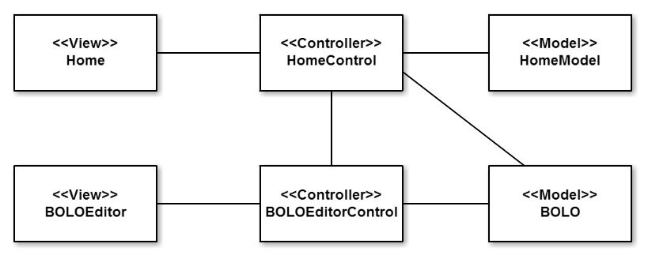

**User Story #89 - Preview BOLOs before creation**

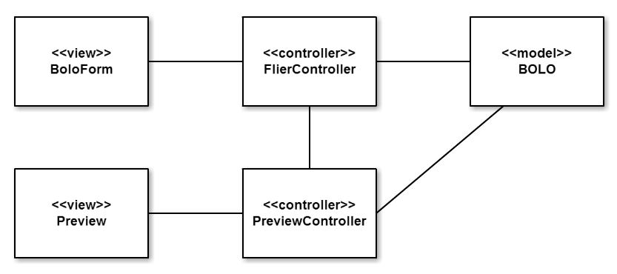

### 

## Dynamic UML Diagrams

# **User Story #403 - Allow users to Edit previously created BOLOs from the Homepage**

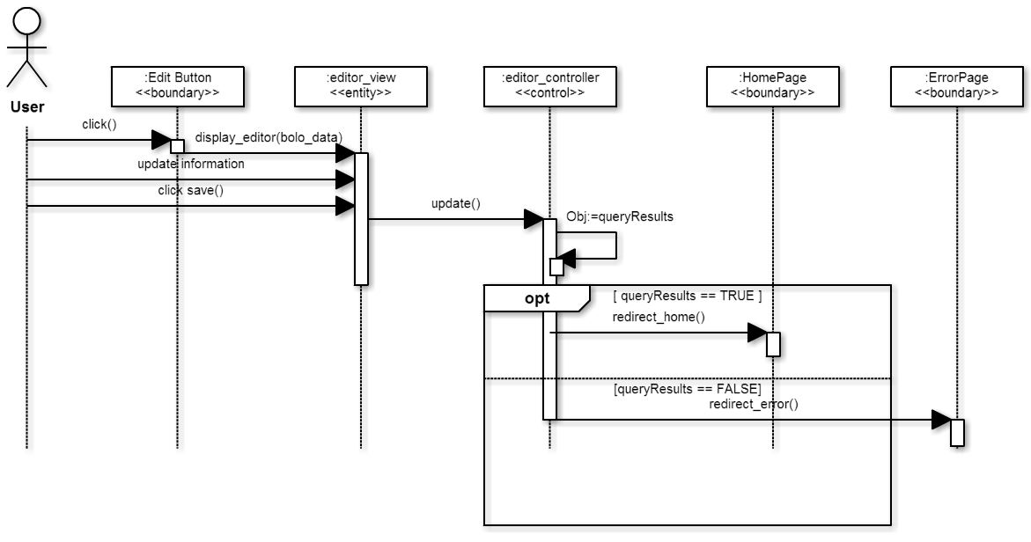

**User Story # 404 - Add the Archive link on each BOLO flier**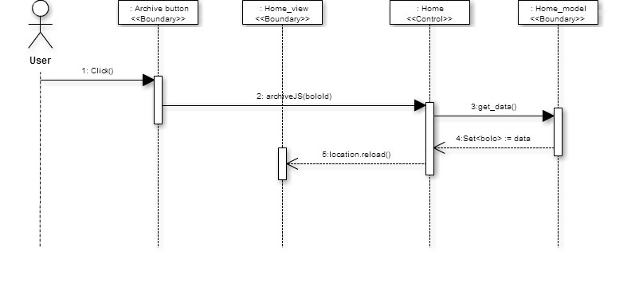

# **User Story #89 - Preview BOLOs before creation**

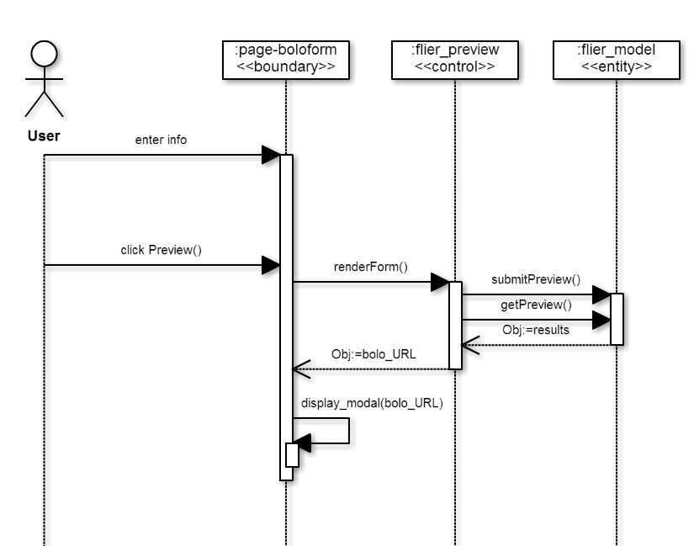

**User Story # 480 - Create new archive page**

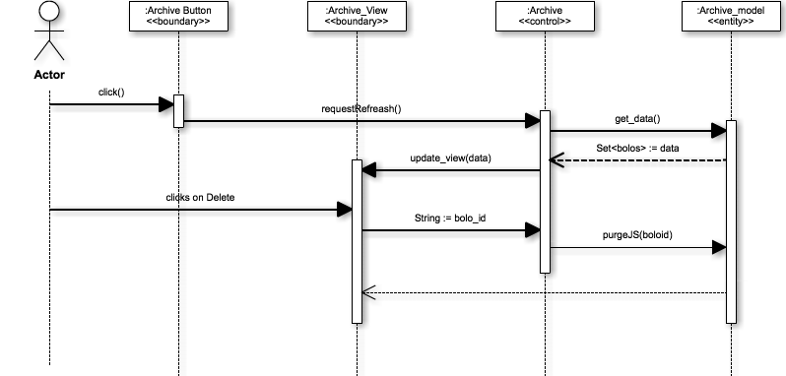

**User Story #459 Ability for administrators to edit agency information**

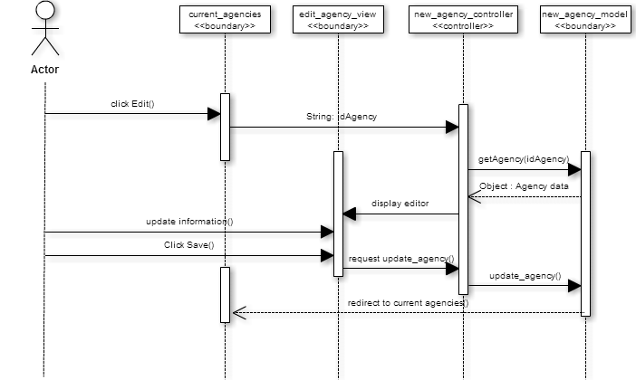

## 

## 

## 

## 

## 

## Appendix B - User Interface Design

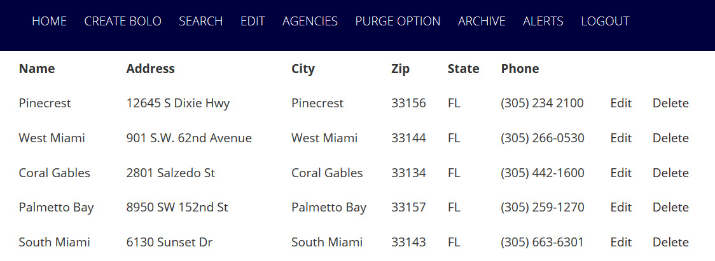

Figure 1 - Agencies Page

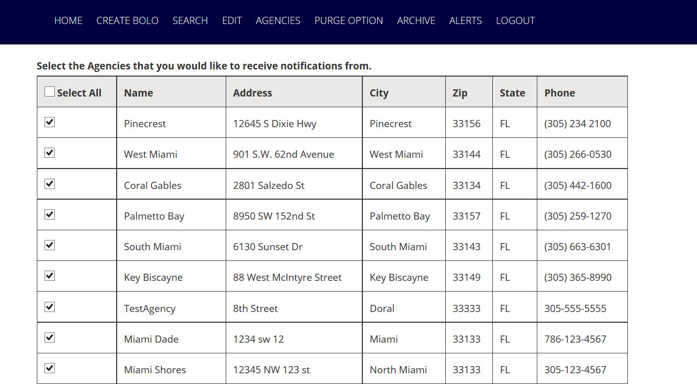

## Figure 2 - Alerts Page

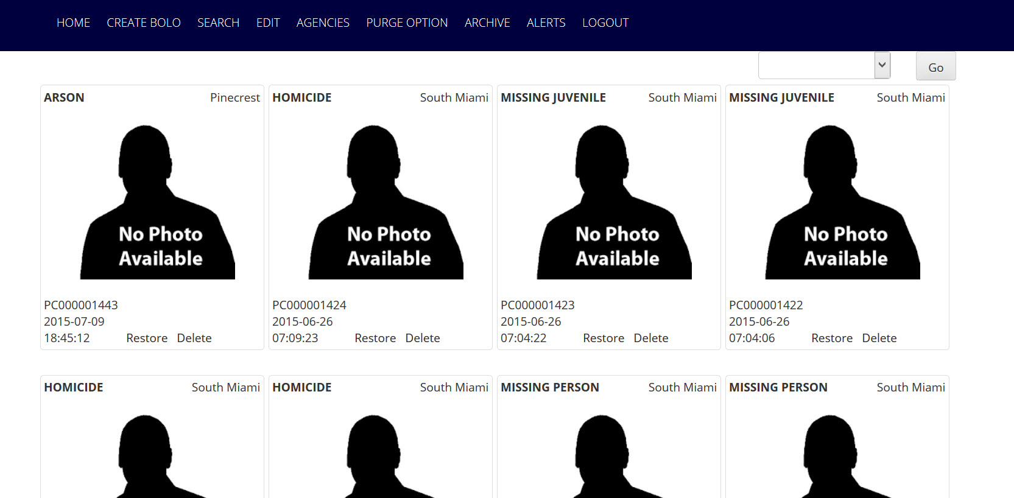

Figure 3 - Archive Page

**Admin Use case diagram**

## Admin (1).png

## 

**Tier 2 Use Case Diagram**

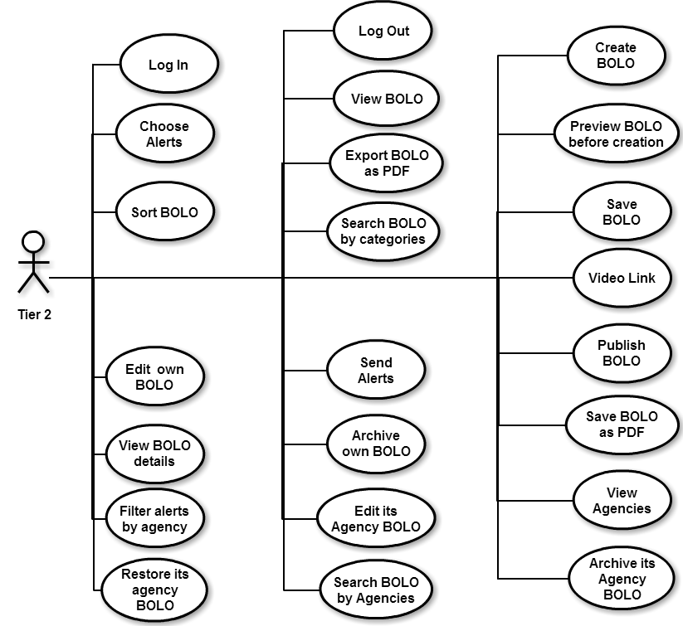

## 

**Tier 1 Use Case Diagram**

## Tier 1.png

## 

## 

## Appendix C - Sprint Review Reports

**Sprint 1 Report**

**Date:** May 29, 2015

**Attendees:** David Vizcaino, Yamila Fleitas

**Discussed Topics:**

Nearly all of the requested tasks were completed on time. Unfortunately, the task involving the previewing of BOLOs was too long for this sprint and was added to the backlog, although some progress was done on it. Other than this task, no other modifications were done to the backlog and in general, things went well.

**Sprint 2 Report**

**Date:** June 12, 2015

**Attendees:** David Vizcaino, Yamila Fleitas

**Discussed Topics:**

For this sprint, David spent the majority of his time working on the BOLO preview. This made our costs go well beyond our estimates, indicating more focus needs to be done on ensuring the accuracy of our estimates. Aside from that, many of the tasks were completed on time, even though the costs for nearly all tasks was above what was expected. Work on redesigning the BOLO creation page was started near the end of the sprint, but was moved towards the backlog for Sprint 3.

**Sprint 3 Report**

**Date:** June 26, 2015

**Attendees:** David Vizcaino, Yamila Fleitas

**Discussed Topics:**

For this sprint, just about everything went as planned. Some tasks took longer than estimated, which is still an issue that should be minimized by next sprint. Nearly all tasks were done on time, with very few tasks moved to the next sprint.

**Sprint 4 Report**

**Date:**

**Attendees:** David Vizcaino, Yamila Fleitas

**Discussed Topics:**

This sprint was another good sprint. Task estimates were more accurate this time and a lot of the tasks were done. Little to no tasks will be carried over to sprint 5.

**Sprint 5 Report**

**Date:**

**Attendees:** David Vizcaino, Yamila Fleitas

**Discussed Topics:**

Considering the initial goals, cost estimates, and acceptance criteria, briefly explain what was achieved and what was not achieved in this sprint. Specify the reasons for not being able to finish all the work that was initially planned for this sprint. Specify if the product backlog was modified as a result of this meeting and if so, how.

## 

## 

## 

## 

## Appendix D - Sprint Retrospective Reports

**Sprint 1 Retrospective**

**Date:** May 29, 2015

**Attendees:** David Vizcaino, Yamila Fleitas

**Discussed Topics:**

There were issues with our user story and task estimation. In some cases, a user story would have no estimate at all, although there would be estimated times for all tasks. In future sprints we must make sure to put in proper estimates and improve our estimation skills for tasks. Our user stories also left much to be desired; they did not follow the general standard for writing a user story. For our next sprint we must make sure to write our user stories in the proper format. Other than these issues, our first sprint went, overall, quite well.

**Sprint 2 Retrospective**

**Date:** June 12, 2015

**Attendees:** David Vizcaino, Yamila Fleitas

**Discussed Topics:**

We did a good job letting Dr. Sadjadi know about any issues we may be having during development, so we should keep that up. Less detail needs to be put into diagrams, so they need to be redone; the diagrams should not overwhelm, but should show enough information to convey what is happening. Lastly, this sprint had an issue with underestimates. Many tasks took longer to complete than estimated and required plenty of overtime to complete within the sprint. For the next sprint, we should focus on increasing our estimate accuracy.

**Sprint 3 Retrospective**

**Date:** June 26, 2015

**Attendees:** David Vizcaino, Yamila Fleitas

**Discussed Topics:**

We need to focus more on the user stories that we are able to do in order to finish them on time. For next sprint, we need to wrap up everything since we are getting close to the last sprint. So, we need to make sure that all user stories are almost done and only leave the ones that will be done in Sprint 5.

**Sprint 4 Retrospective**

**Date:** July 10, 2015

**Attendees:** David Vizcaino, Yamila Fleitas

**Discussed Topics:**

We did a good job completing all our tasks this sprint. The only glaring issue was in the complexity of the class diagrams. It is important to keep our diagrams simple, yet informative; to not bombard the user with irrelevant information that only serves to make the diagram(s) more confusing. Apart from that, everything was done on time and all our estimates were accurate.

**Sprint 5 Retrospective**

**Date:** July 24, 2015

**Attendees:** David Vizcaino, Yamila Fleitas

**Discussed Topics:**

This was another successful sprint. All of our tasks were finished on time or even early. which allowed us more time to focus on our documentation for the final week. Task estimates were, again, pretty accurate and, if they were off, it was typically a case of a task being finished faster than estimated.

# **References**

1. **PHPMailer** by Marcus Bointon; used for sending BOLO emails with attachments. *Source code located at*: <https://github.com/PHPMailer/PHPMailer>
2. Previous development team