**Collaborative Platform**

**Mentor Module: Version 5**

**User Manual**

Senior Project – Section U01

May 1, 2015

**Members:** **Instructor:**

Adrian Alfonso Cardenas Masoud Sadjadi

Jorge Travieso

**Mentor:**

Juan Caraballo

Copyright © Florida International University 2015. All Rights Reserved. No part of the Collaborative Platform Project or documentation may be reproduced or modified without the express consent of Florida International University. Redistribution or commercial use is strictly prohibited.

# Getting Started

In order to access the mentoring module you can be invited by an administrator or you can click the register link located on the home page. If you received an invitation, just click the link at the end of the message.

# Access and Registration

## Registration

The link will redirect you to the Collaborative Platform landing page. Click sign up and this will take you to the Mentor registration page (Figure 1). Once registered you will automatically be logged into your account.

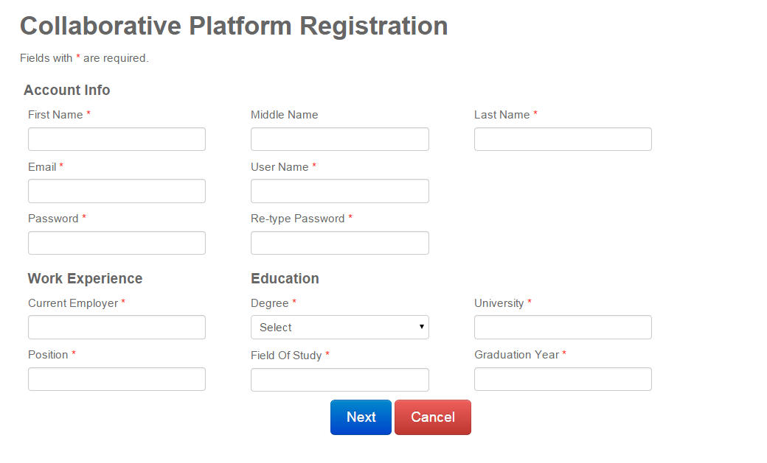

Figure 1 Registration

## Return Login

Once your registration is approved, you will be able to access to the collaborative platform. To login type www.cp.cs.fiu.edu on your browser. This link will redirect you to the Collaborative platform login page as shown on figure 2

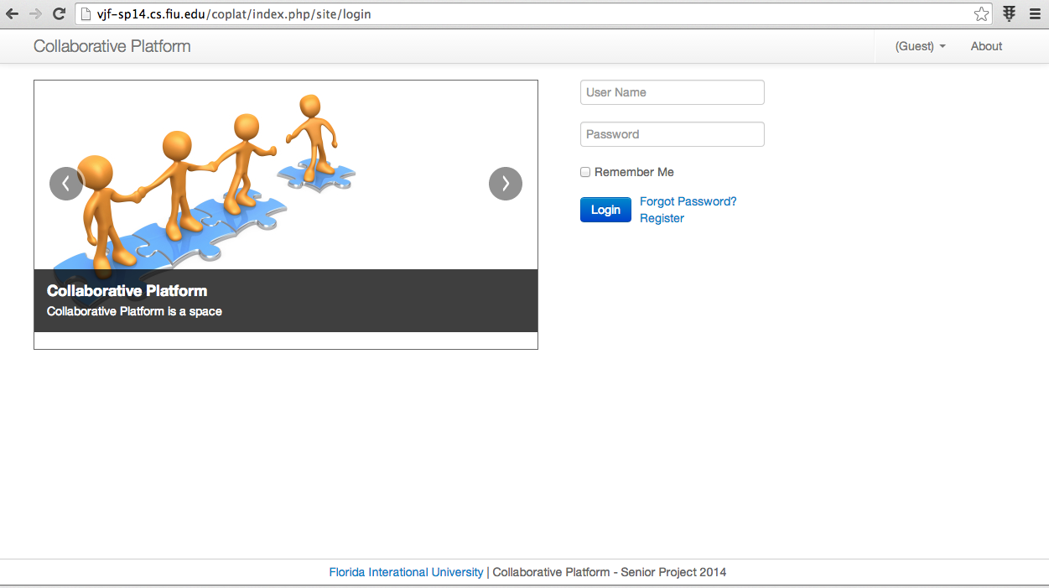

Figure 2 Login Page

In this page provide the credentials username and password.

## Manage Invites

The administrator can manage all the invitations made to mentors, mentees and to other administrators. In order to manage invites, the administrator have the menu Manage and then click on the submenu Invites; refer to figure 3:

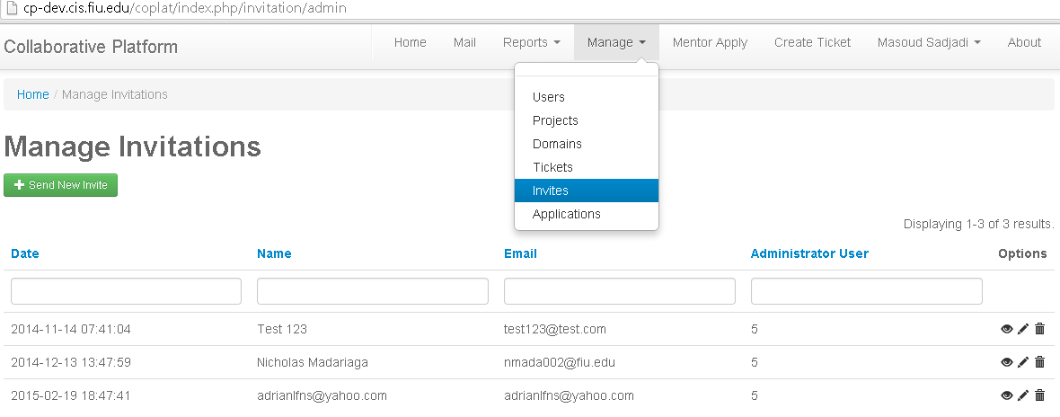  
**Figure 3 Manage Invites**

## Send new Invites

In order to request new mentors and mentees, the administrator should open the invitation manager (refer to Manage Invites). Then, the user should click on the button that says: “Send New Invite” (See figure 3). A new page will open where the user can enter the name, email and the role of the prospective user in the collaborative platform; refer to figure 4.

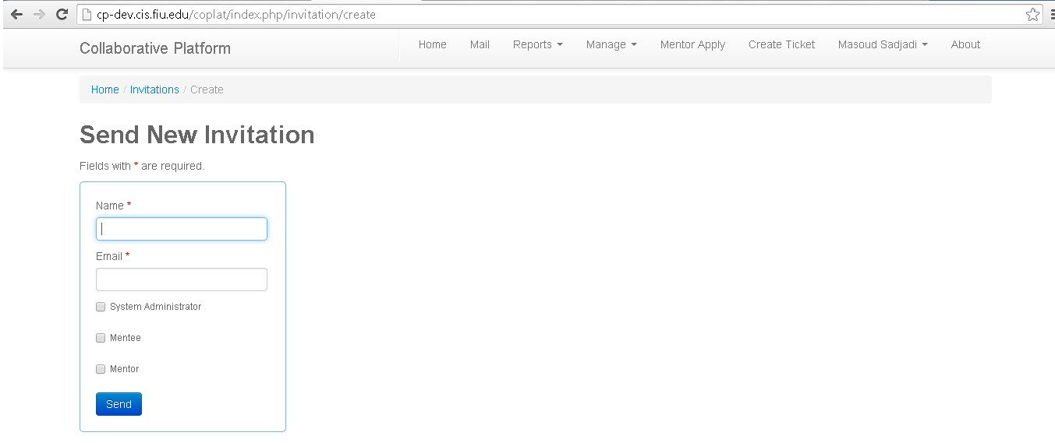

**Figure 4 Send New Invitation.**

Next, if the administrator clicks on Send, the invitee will be registered on the system and a new page will appear in order to format the invitation email See figure 5.

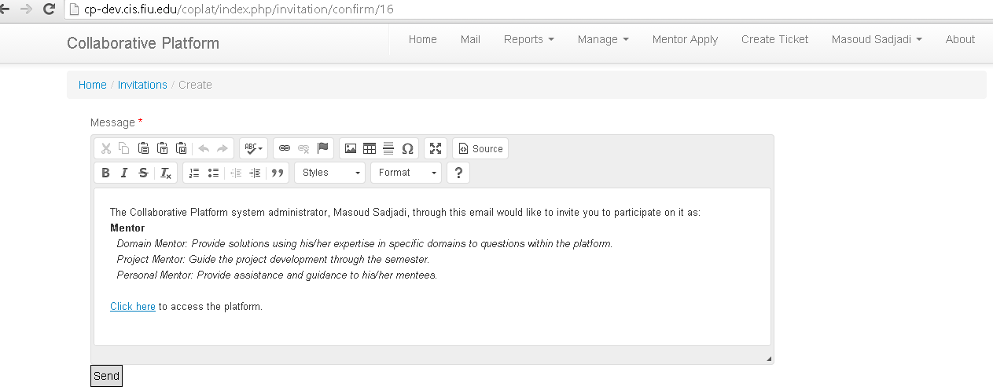

**Figure 5 email invitation formatting.**

Finally if the administrator clicks on Send, the system will email an invitation message to the invitee. Additionally the page for managing the Invites will be shown on the screen.

# Mentor Application Portal

At any time you can access mentorship applications by clicking Mentor Apply from the navbar. Once you click on Mentor Apply, you can see all mentorships available (Figure 6). When an application is currently pending you will be unable to click the corresponding button and apply for a new one until that application has been resolved.

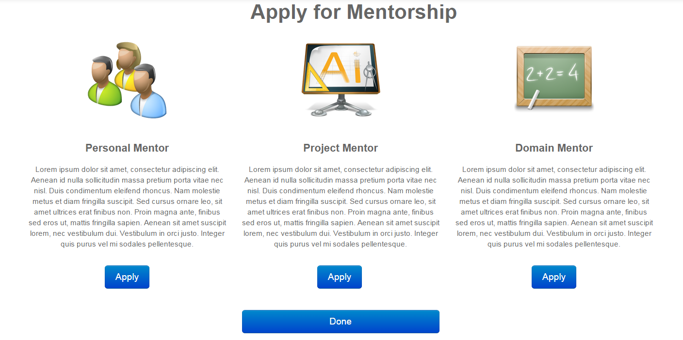

Figure 6 Mentor Application Portal

## Apply for Personal Mentorship

On the Personal Mentor Application (Figure 7), Mentors can select users from a list of available Mentees. Just clicking on the row will move your selection to the next column. To undo a selection just click the row again from the column on the right. You can hover over a row for more information about the Mentee. To defer selection to the system just fill in the number of Mentees you want and provide criteria for which university you want students from. Click next to verify your selections and then submit to have it saved in the system.

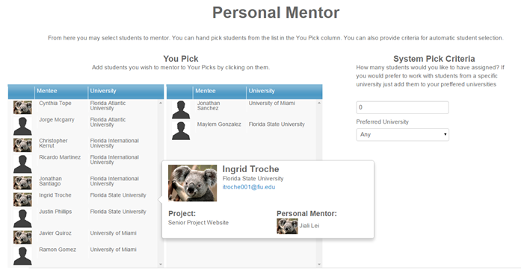

Figure 7 Personal Mentor Application

## Apply for Project Mentorship

The Project Mentor Application (Figure 8) works very similarly to the Personal Mentor Application. Just clicking on the row will move your selection to the next column. To undo a selection just click the row again from the column on the right. You can hover over a row for more information about the project. To defer selection to the system just fill in the number of projects. Click next to verify your selections and then submit to have it saved in the system.

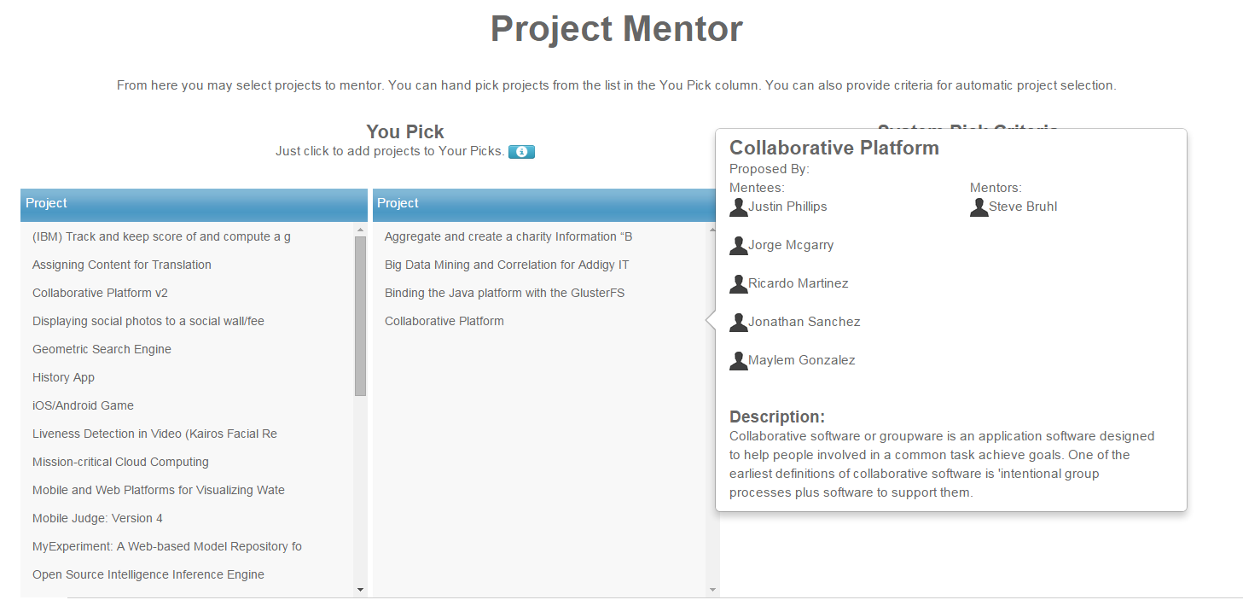

Figure 8 Project Mentor Application

## Apply for Domain Mentorship

The Domain Mentor Application (Figure 9) allows you to select Domain mentorships by providing your proficiency on that topic. Clicking a Domain name will expand the grid and show available Subdomains. Finally enter how many tickets you want to answer per month. Click next, verify and click Submit.

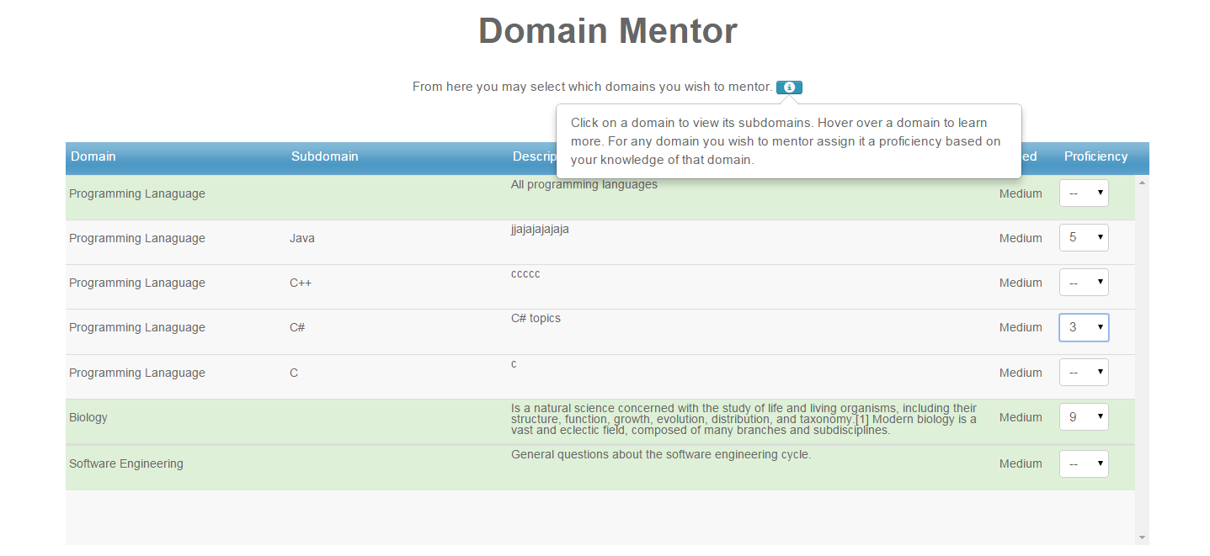

Figure 9 Domain Mentor Application

# Utilization Reports

Only the **Administrator** will have access to utilization reports. The Administrator can access those reports at any time by clicking the menu Reports in the navigation bar. The menu Reports will deploy a submenu with several option: Mentor, Mentee and Ticket (Figure 10). Each one of those submenus represent a report.

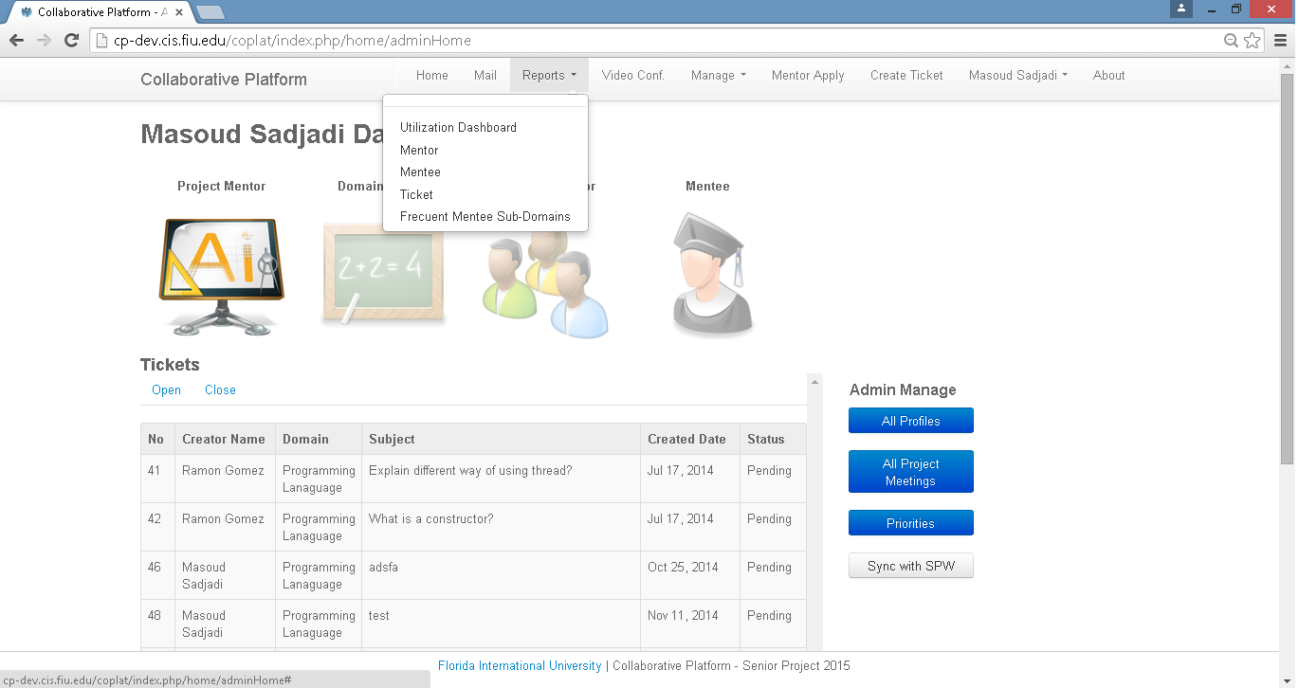

Figure 10 Utilization Report Menu

## Mentor Report

In order to access Mentor Reports, the administrator will have to click on the menu report and then click on the submenu Mentor. The Mentor Report will include all the Mentor related information (Figure 11). Every header of the report can be sorted by clicking on it. Also, right after every column title, the administrator will have a filter that allows him to target specific information. The column on the report can be moved via drag and drop.

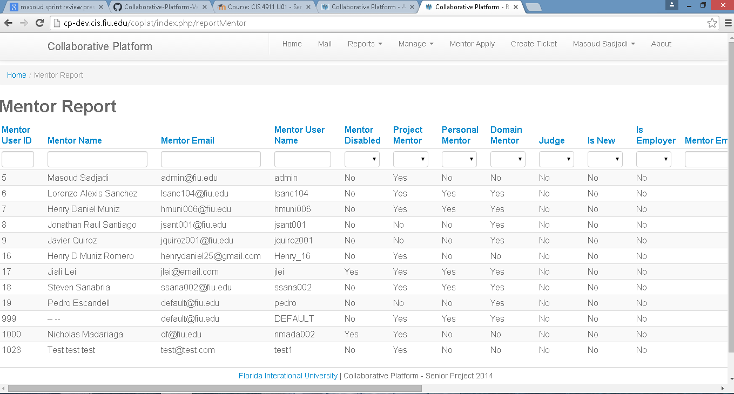

Figure 11 Mentor Report

## Mentee Report

In order to access Mentee Reports, the administrator will have to click on the menu report and then click on the submenu Mentee. The Mentee Report will include all the Mentee related information (Figure 12). Every header of the report can be sorted by clicking on it. Also, right after every column title, the administrator will have a filter that allows him to target specific information. The column on the report can be moved via drag and drop.

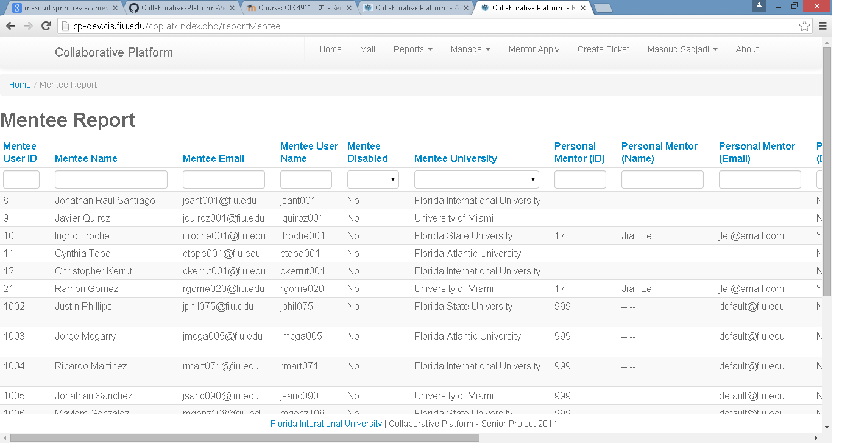

**Figure 12 Mentee Report**

## Ticket Report

In order to access Ticket Reports, the administrator will have to click on the menu report and then click on the submenu Ticket. The Mentee Report will include all the Ticket related information (Figure 10). Every header of the report can be sorted by clicking on it. Also, right after every column title, the administrator will have a filter that allows him to target specific information. The column on the report can be moved via drag and drop.

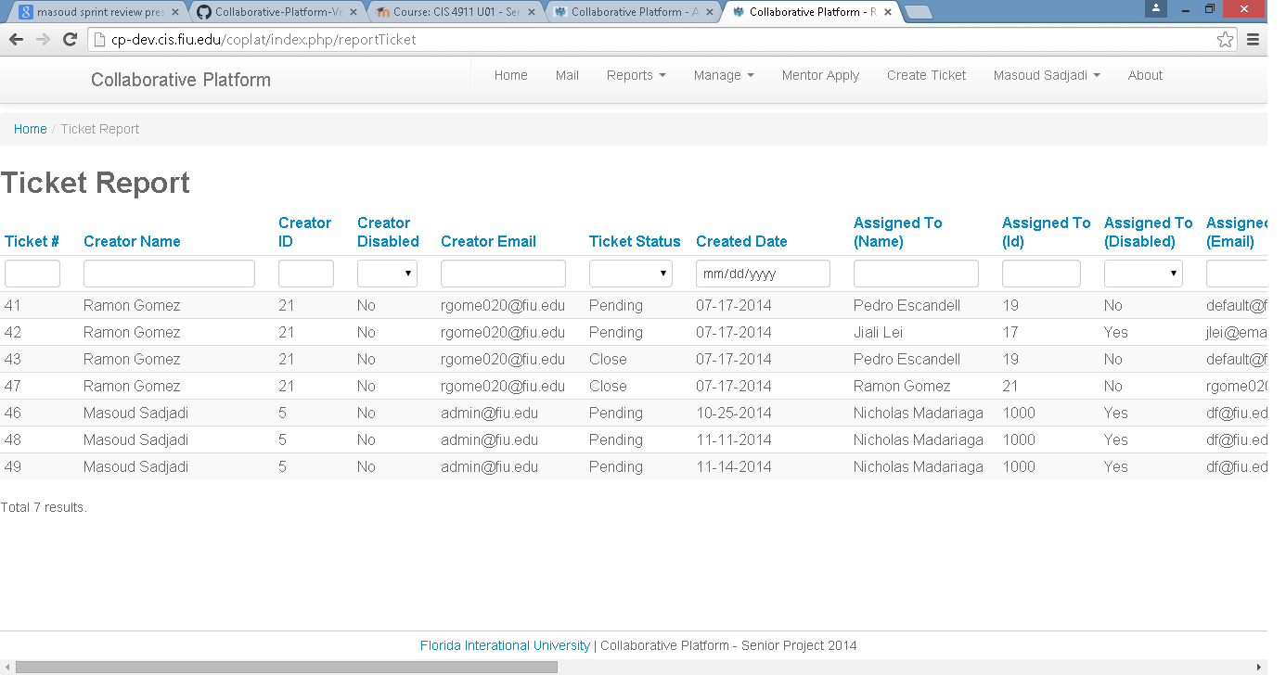

**Figure 10 Ticket Report**

## Utilization Dashboard

In order to pull statistics reports on the Tickets life cycle, the administrator will be able to click on the submenu Utilization Dashboard. Within the Utilization Dashboard screen the administrator will be able to the report type (i.e., Tickets Created). Then the administrator will be able to select the report dimension (i.e. domain, project, etc.). The administrator can also apply filters to the data retrieved in the report (Figure 11).

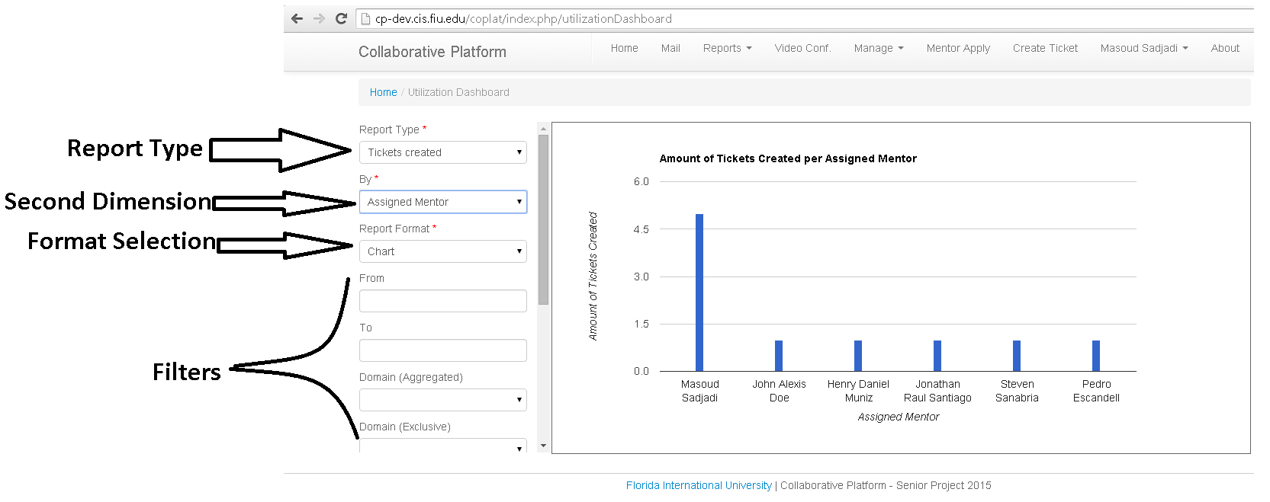

Figure 11 Utilization Dashboard (statistics view)

At any time the Administrator can switch between the statistics report and the detail report. That switch can be performed via dropdown called Report Format field (Figure 12).

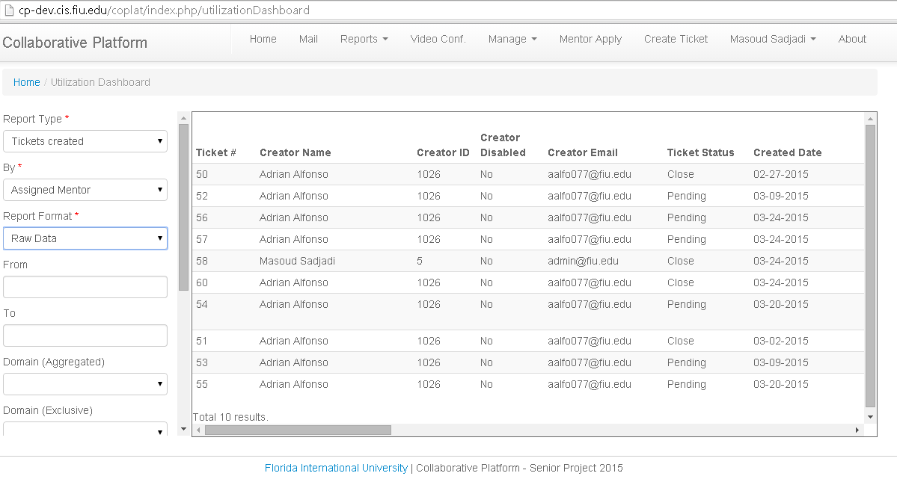

Figure 12 Utilization Dashboard (details view)

## Frequent Mentee Sub-Domains

The Administrator can also pull the most frequent question asked by the mentees. That report can be accessed via the menu Reports, sub-menu **Frequent Mentee Sub-Domains**. That report not only pulls the most frequent sub-domains question; it also pulls questions that are commonly asked together (Figure 13).

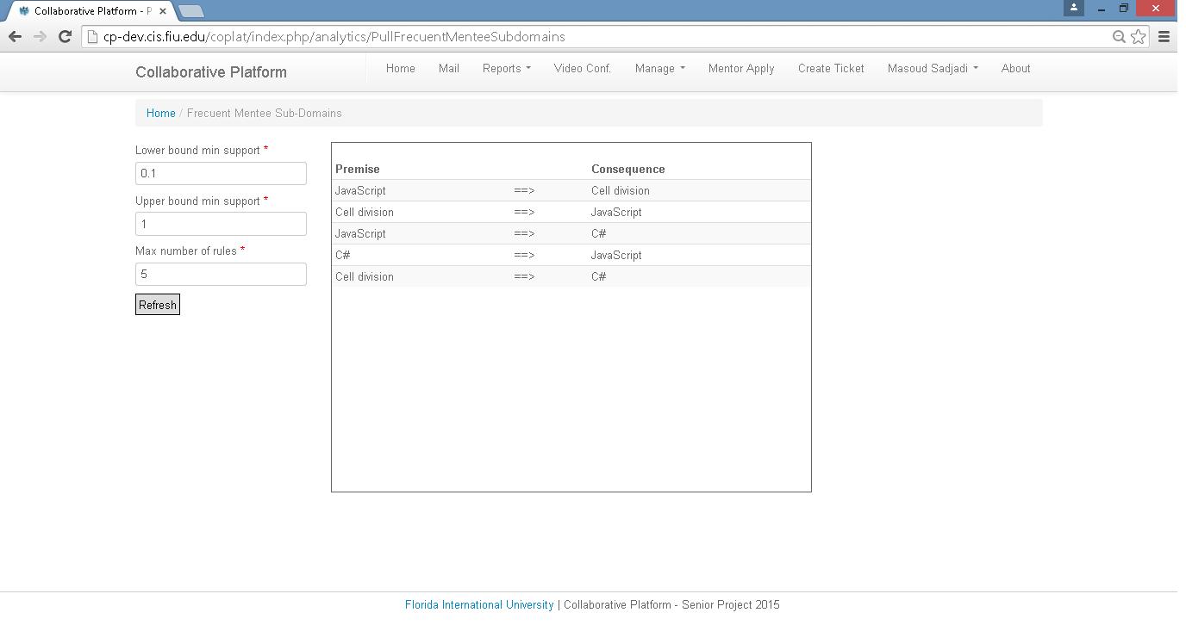

**Figure 13 Frequent Mentee Sub-Domain questions.**

# Collaborative Tools

The collaborative platform lets you create on-demand video conferences and schedule them ahead of time with the aim of improve the interaction between mentors and mentees (Figure 14). During these virtual meetings, users will be able to talk and see each other while they can draw a on a drawing panel and share their screens. The collaborative tools are only known to work on Google Chrome Web Browser for personal desktops and android phones. Regarding necessary hardware and software requirements, a webcam and a microphone are necessary for the meetings while for screen sharing the following Chrome plugin is necessary: <https://chrome.google.com/webstore/detail/screen-capturing/ajhifddimkapgcifgcodmmfdlknahffk>.

To access the Collaborative Tools, please go to:

<https://cp-dev.cis.fiu.edu/coplat/index.php/videoConference/>

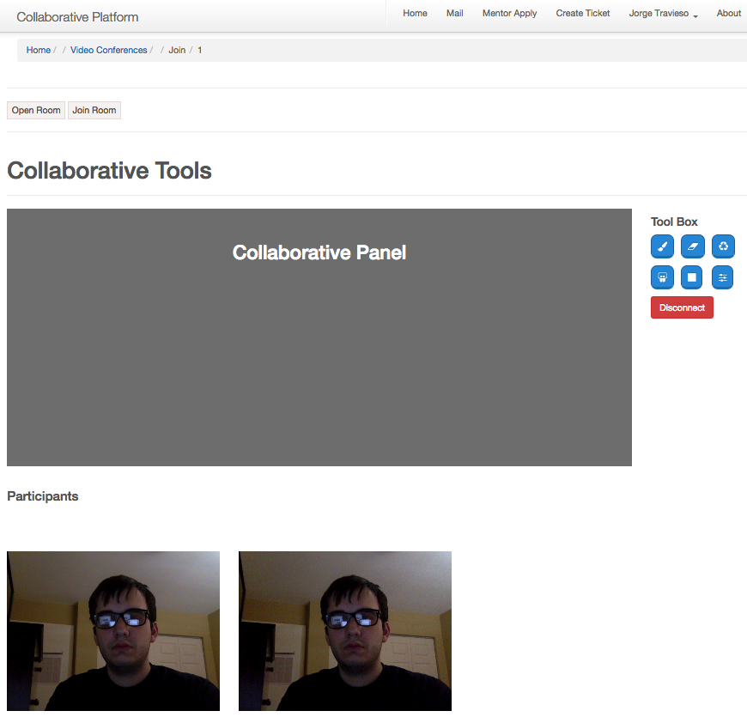

Figure 14 Collaborative Tools