# System Design: Overview

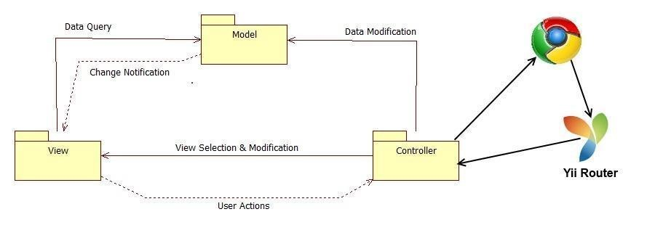

# System Design: Subsystem Decomposition

## Registration and Access Point Subsystem

The registration and access point subsystem will be the main entry point for our platform. This will facilitate the process across the user database. Since there will be one login for each individual module, the access point is simplified into one subsystem. This subsystem will also cover the creation of new users and the retrieval of passwords for current users.

* + Allow register User
  + Allow user Login
  + Allow user Logout
  + Allow reset password

## Mentoring Subsystem

The mentoring subsystem will cover the essentials of the mentoring module. Specifics to the mentoring module are separated into this subsystem. These functionalities include the ability to retrieve information from the senior project website or from LinkedIn. It also covers the essential workflow of the ticketing system for issues created by mentees for the different types of mentors.

* Allow Admin to pull mentee reports.
* Allow Admin to pull mentor reports.
* Allow Admin to pull ticket reports.
* Allow to retrieve project information from the SPW
* Allow to create a question for a specific ticket.
* Allow to add domain.
* Allow to retrieve skill-set/domain expertise from their Linkedln account
* Allow matching tickets with the most relevant domain mentor
* Allow to assign ticket to a domain mentor
* Allow to append comment to a ticket
* Allow to attach file to a ticket
* Allow Administrator to drop a ticket at his discretion
* Allow to close a ticket
* Allow to comment added notification
* Allow mentee to accept answer
* Allow mentee to decline Answer
* Allow a potential mentor to register for an account from a new entry point.
* Allow a Project Mentor to self-register and select projects they like or defer the decision to the system.
* Allow a Personal Mentor to self-register and select students they’d like or defer the decision to the system.
* Allow a Domain Mentor to self-register and select topics they’re proficient in.
* Allow a Domain Mentor to suggest new domains.
* Allow Project Mentor to approve/reject projects suggested by admin.
* Allow Domain Mentor to approve/reject topics suggested by admin.
* Allow Personal Mentor to approve/reject mentee suggested by admin.
* Allow admin to view pending applications
* Allow admin to approve/reject Projects in a Project Mentor Application
* Allow admin to propose Projects in a Project Mentor Application
* Allow admin to approve/reject Mentees in a Personal Mentor Application
* Allow admin to propose Mentees in a Personal Mentor Application
* Allow admin to approve/reject Domains in a Domain Mentor Application
* Allow admin to propose Domains in a Domain Mentor Application
* Allow admin to review domains recommended by mentor
* Allow admin to view open invitations/re-invites
* Allow admin to customize the body of the message while sending an invite
* Allow admin to send a re-invite
* Allow admin to gain insight on site usage through admin dashboard
* Allow admin to gain insight on a particular project
* Allow admin to gain insight on a particular user
* Allow admin to gain insight on a particular domain
* Allow admin to gain insight on a particular subdomain
* Allow admin to view tickets
* Allow admin to manage tickets
* Allow admin to use an advanced search for tickets.

## Remote Judge Subsystem

The remote judge subsystem will cover the fundamentals from the remote judge module. These functionalities are essential to the grading and viewing of projects done within the platform. The subsystem covers main requirements for the necessary two way communication found when giving feedback or grading an individual from certain projects.

* Allow judges to get rubric
* Allow judges to post grades
* Allow head professor to send invitation
* Allow show power point
* Allow judge and mentee to use video conference
* Allow judge and mentee to use the whiteboard

## Communication Subsystem

The communication subsystem is a key subsystem that provides functionality derived from the mentoring module. This communication will be vital to the ticket system as users may frequently send time-sensitive information regarding projects or questions made by mentees.

* + Allow to new Message Notification
  + Allow to send new message to a mentor
  + Allow to read message
  + Allow to delete Message
  + Allow to send ticket due notification

## Virtual Job Fair

The virtual job fair system covers a large amount of functionality. The system plays an essential portion of the collaborative platform as its own module. The system allows a streamlined online interaction system for employers and employees/future employees alike. Document sharing and editing is important within the system as well as screen sharing for interview questions and overall viewpoint on work.

* Allow students and employers to register
* Allow students and employers to view respective profiles
* Allow students and employers to edit their basic profile information
* Allow students and employers to take part in a video interview
* Allow students to upload a resume and video resume
* Allow students and employers to upload an image for their profile
* Allow students to associate skills to their profile
* Allow students to add and delete education information
* Allow students to add and delete experience information
* Allow students to integrate with their LinkedIn account to provide education and experience information (security)
* Allow students to apply to open job postings and provide a cover letter
* Allow students to reply to an employer’s message
* Allow students to search for jobs based on skills
* Allow employers to post jobs
* Allow employers to close a job posting
* Allow employers to associate skills to a job posting
* Allow employers to search for students based on skills
* Allow employers to view student profiles
* Allow employers to send messages to students
* Allow employers to give students a “virtual handshake” to show interest in the student
* Allow an administrator to disable an account (security)
* Allow an administrator to close a job posting
* Allow an administrator to validate an employer registration (security)
* Require a username and password to log into the system (security)
* Encrypt the user password before storing into the database (security)
* Require login before viewing user profiles (security)
* Allow users to create a new shared document.
* Allow users to open a document.
* Allow users to share a document.
* Allow users to delete a document.
* Allow users to import a document.
* Allow users to export a document.
* Allow users to rename document.
* Allow users to save a shared document.
* Maintain access boundaries between non-collaborating temporary accounts (security).
* Allow FIU Computer Science Seniors to login using their FIU SCIS credentials
* Allow users to share their screens
* Allow users to view shared screens
* Allow users to stop sharing their screens
* Allow employers to send SMS to students
* Allow users to receive automatic email and SMS reminders
* Allow users to confirm their phone numbers
* Allow students and employers to start using the whiteboard functionality
* Allow students and employers to upload an image to share during an interview
* Allow students to view images uploaded by the other party in an interview
* Allow students and employers show or restore a whiteboard session
* Allow students and employers to select an image to upload to the server for sharing purposes
* Allow students and employers to draw using the whiteboard
* Allow students and employers to change the color of the drawing pencil tool
* Allow students and employers to type text into the whiteboard
* Allow students and employers to clear the drawings of the whiteboard
* Allow students and employers to partially erase drawings from the whiteboard

# System Design: Persistent Data Managements

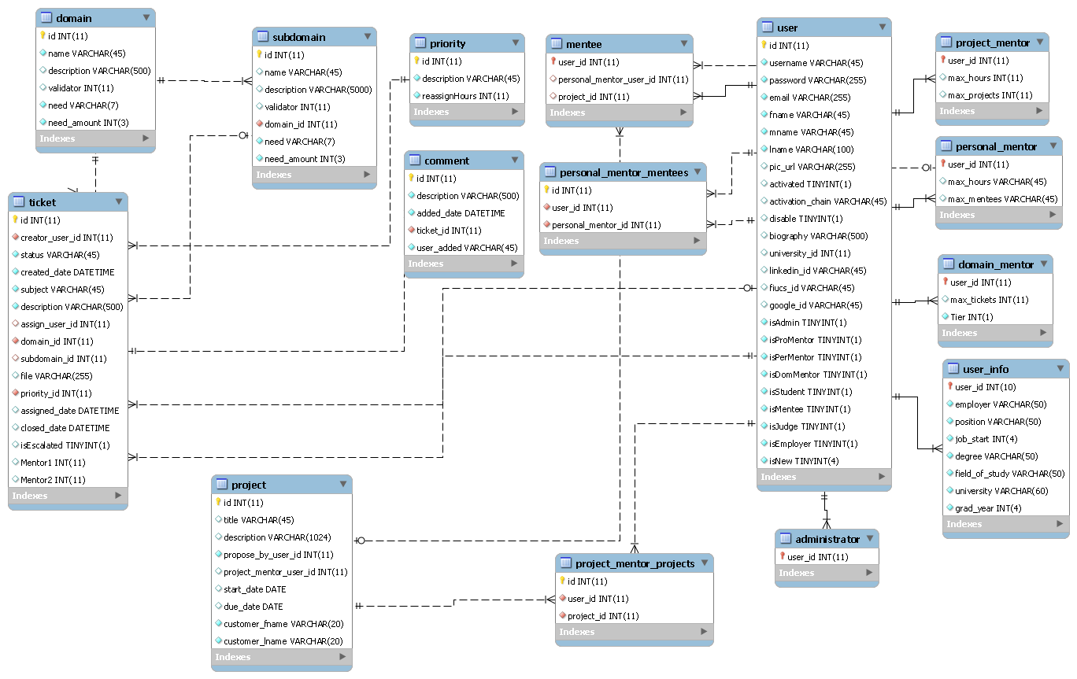

# System Design: Security/Privacy

## Yii access control rules

The Yii framework provides access control with respect to any controller being used.  This access control will reject a subset of users (not logged, students, employers, etc…) from performing certain actions.  For example, users that are not logged in will not have access to profile pages.

## Security Features (password encryption)

User password will be hashed in the database. Upon registration into the system, passwords entered will be hashed right away and will not be saved anywhere on the system.  Upon login, the password entered again will be hashed and the hashed data will be used to query the database.

## Cross-site Scripting Prevention (avoids sql injection)

The Yii framework takes measures against common web exploitations such as cross-site scripting or MySQL injection.  Using Yii, we can be rest assured that such things should not occur.

## Secure registration process

The registration process is not as simple as most sites, especially for employers.  Administrators will have to verify employers after they register in order to ensure they are actual employers and mantain the integrity of the system.  Only those employers registered and verified will be able to post jobs and interact with students.