|  |
| --- |
| DEsigner drug database |
| User Manual Document |
| Senior Project, CIS 4911- U01 |
| **Professor: Seyedmasoud Sadjadi Mentor: Dr. Luis Arroyo** |
| **Carlos** |
|  |

|  |
| --- |
|  |

Copyrights and Trademarks Notices

Nothing yet

Executive Summary

One or two paragraph

Introduction

Features

Login Feature: login feature is for users that are going to be administering this software.

**Step 1:** To login in the system you need to first access the system. The access link is:

<http://designerdrugs-dev.cs.fiu.edu/>

**Step 2:** click in the login menu

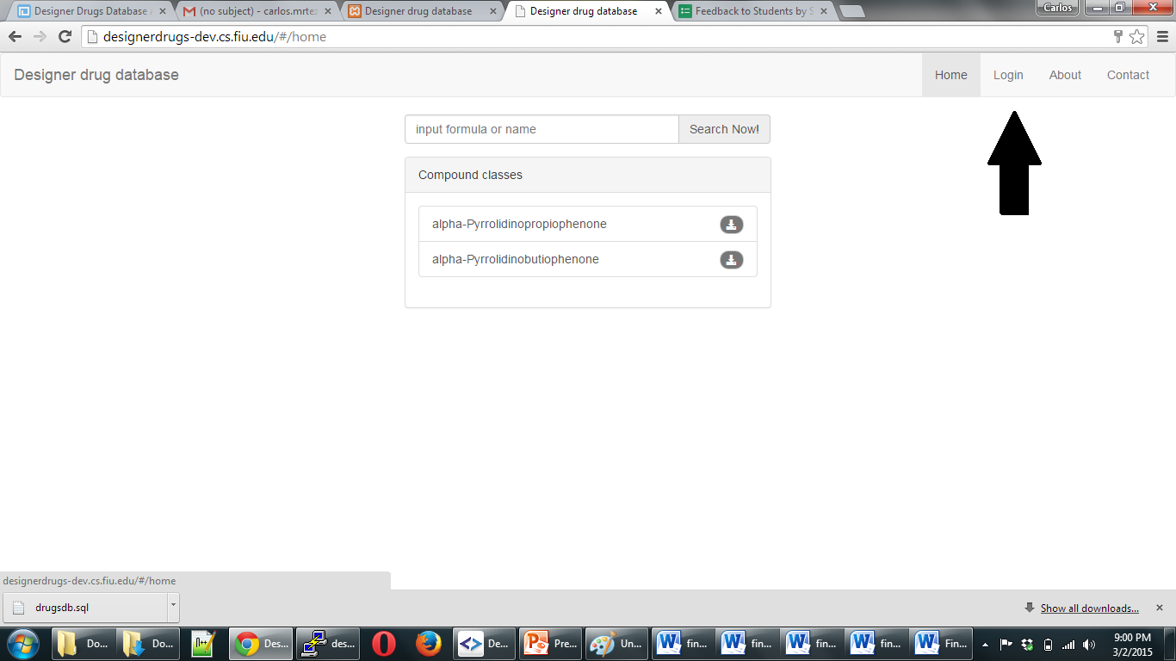

Step 3: type username and password:

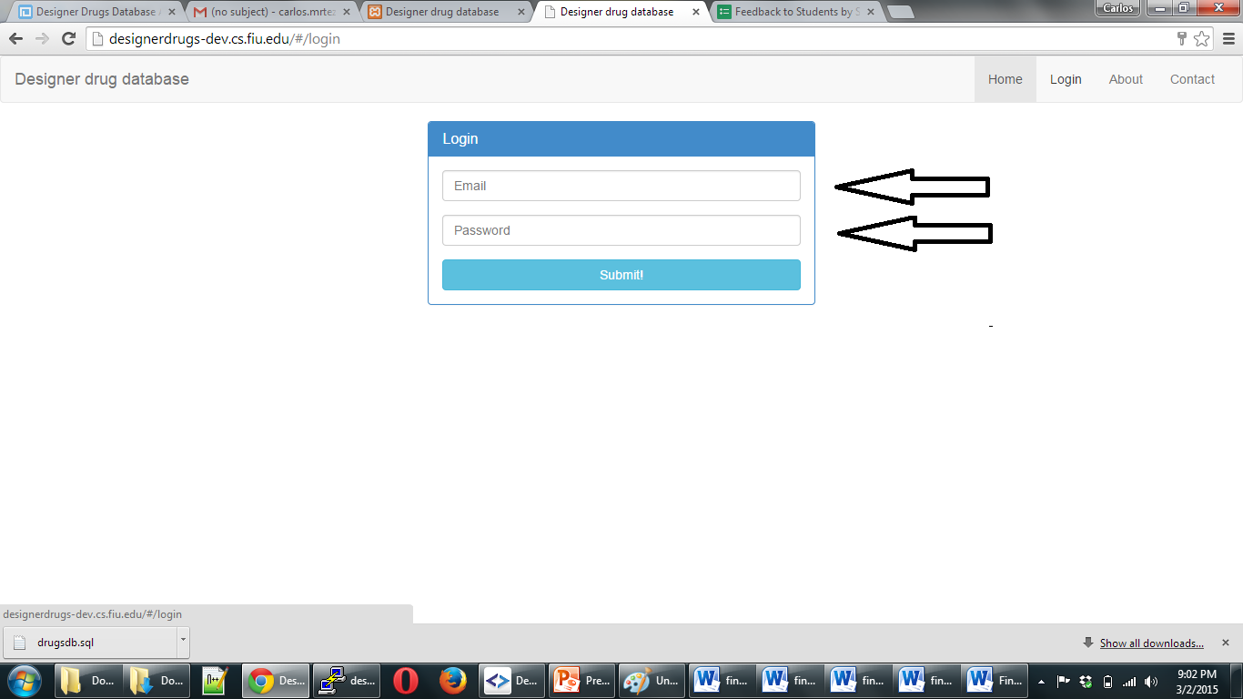

Click login:

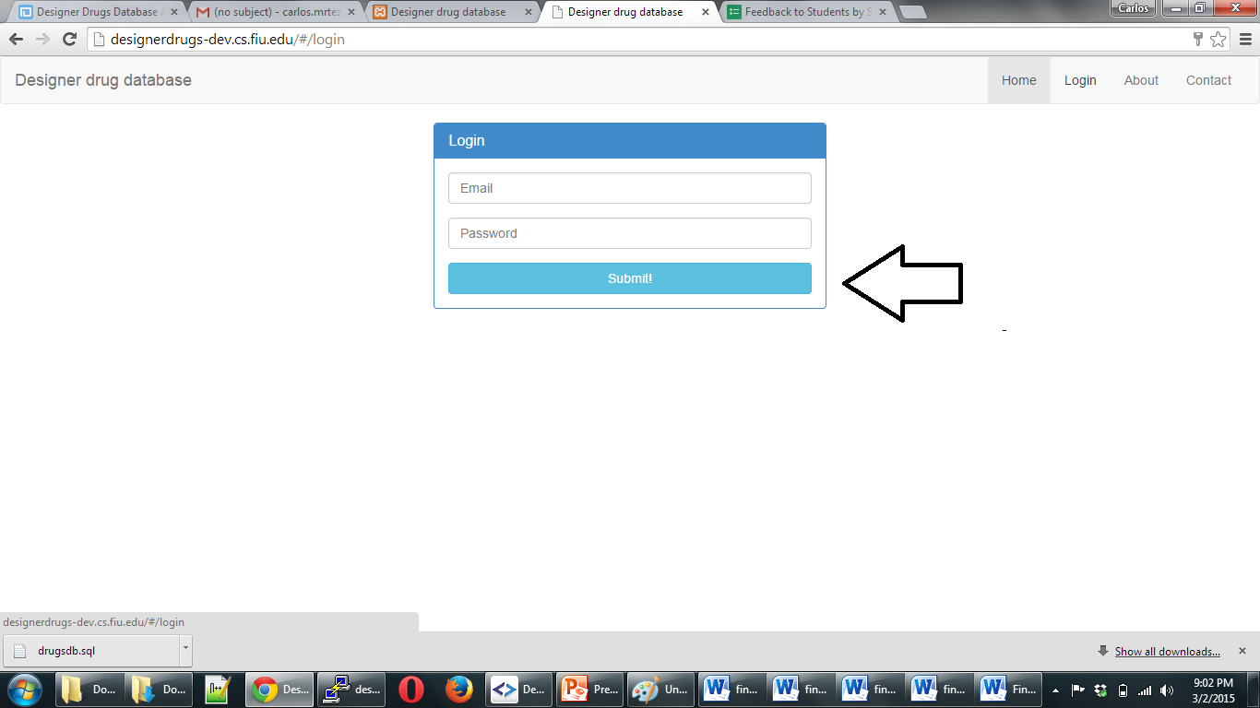

## Modifying your user Information:

After login, click Account Details

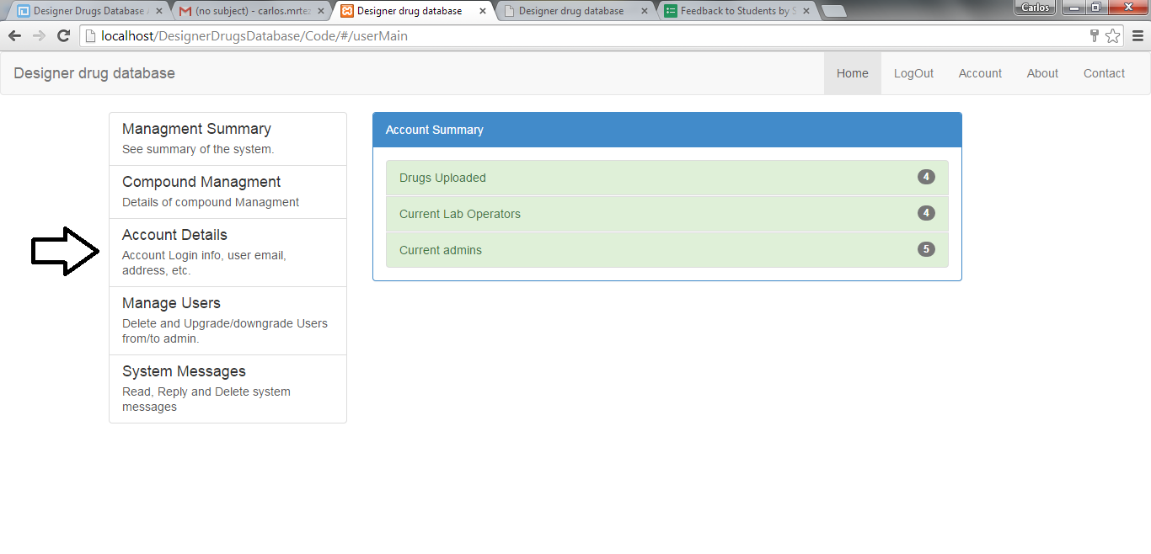

Then click on any of the data you wish to modify:

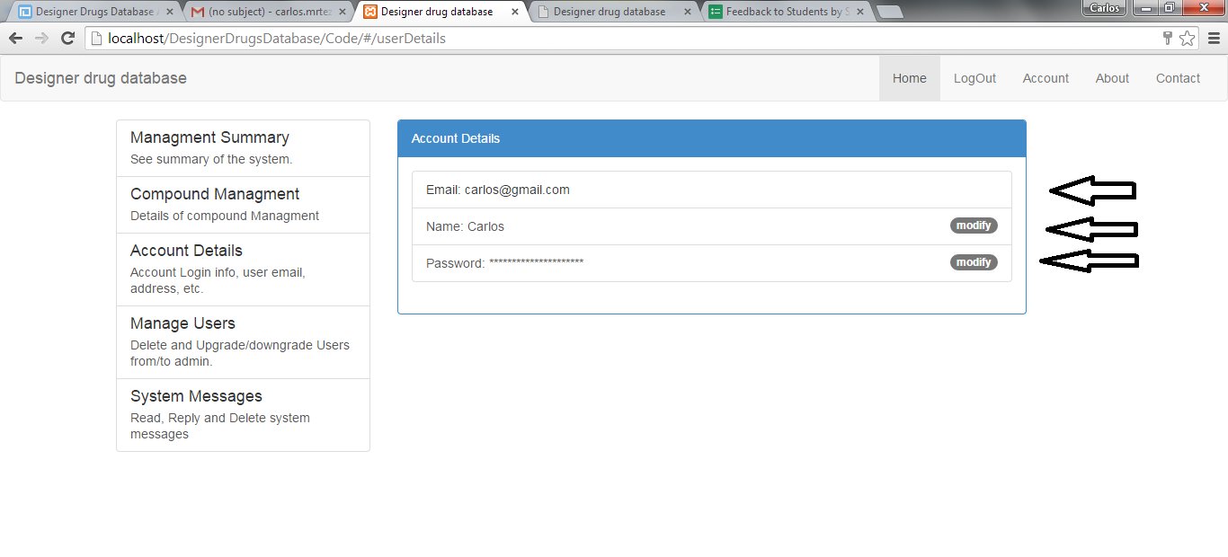

A pop up menu will show asking you to enter the new information : enter require information and click submit

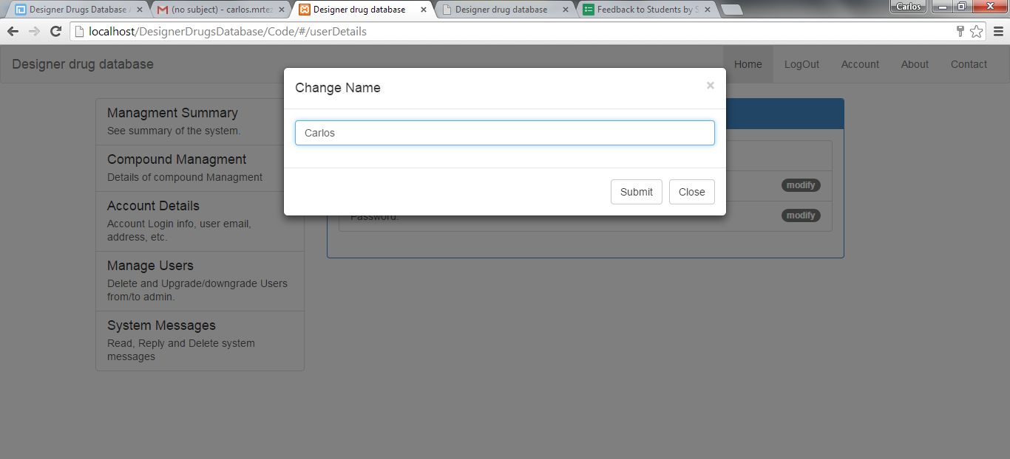

## Admin only: add, delete users:

After logged in click on manage users

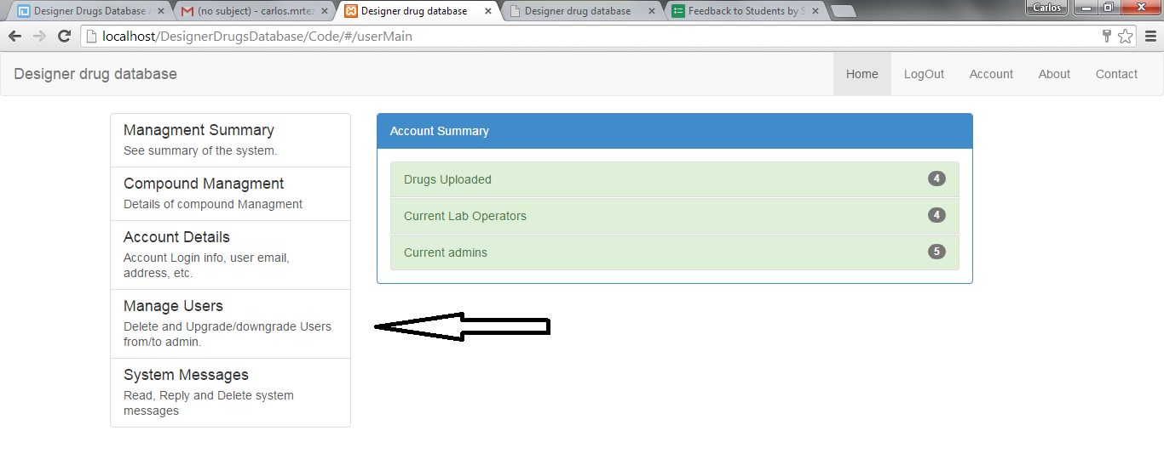

### Add user:

Enter the email in the add user box and click submit

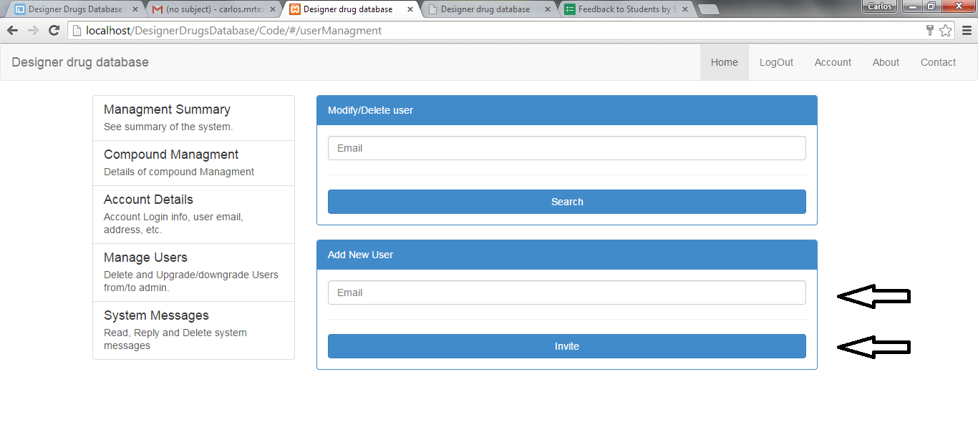

### Edit/ delete users

Enter the user to be edited, deleted email in the modify/delete user box and click search

choo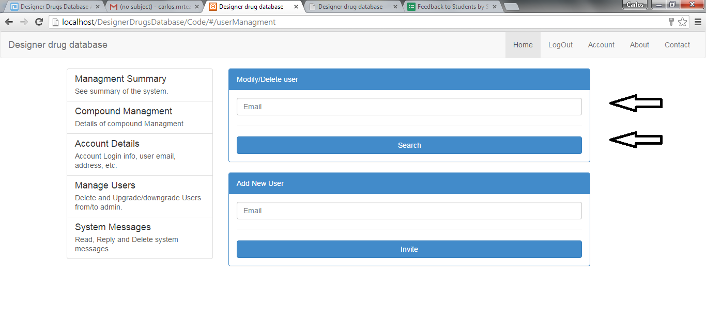

choose the appropriate modification.

