|  |
| --- |
| Designer drug database |
| Feasibility Study and Project Plan |
| Senior Project, CIS 4911- U01 |
| **Professor: Seyedmasoud Sadjadi Mentor: Dr. Luis Arroyo** |
| **Team Member: Carlos Dominguez** |
| **2/2/2015** |

|  |
| --- |
|  |

Copyrights and Trademarks Notices

Nothing yet

Abstract

One or two paragraph

Table of Contents

1. Introduction

This document will be talking about the feasibility study. This feasibility study is done in order to pick the correct technology for the project.

* 1. Problem definition

We need to study the requirements that the client listed and analyze how feasible they are for the time constraint we have, the resources and the overall development. In case they are not feasible we need to come up with several alternatives and pick the one that best fits the description of what is needed.

* 1. Background

The client has requested a native application for ios systems ( Iphone and Ipad)

* 1. Definitions, Acronyms, and Abbreviations

**Single-page application (SPA):** is a web application or web site that fits on a single web page with the goal of providing a more fluid user experience akin to a desktop application.

**Platform independent framework:** is a framework that allows programmers to create one application that can be seen over different platforms.

**Native system:** is a system that can only be seen in its own target devices, such as apple devices or android devices.

* 1. Overview of document

This document will have two main sections, the first one taking about the feasibility study and the second one the project plan.

1. Feasibility Study
   1. Description of Current System (Limitations and Constraints)

In this case there is no current system, the system is to be created from the beginning.

* 1. Purpose of New System

The purpose of this system is to share research knowledge with other institutions and researches in the biological studies field. The system, administrated by FIU research staff, is going to share numbers that will help other doctors identify compounds because the combinations of numbers compose a digital fingerprint of different compounds.

* 1. High-level Definition of User Requirements (must include security/privacy requirements)

The objective is to create a Designer Drugs Database App for native Apple systems. The user requirement for this app are PHP, JavaScript, C#, Css, Html, SQL, Ios, and Objective-c .

**Security:** the system must be secure to administrate. However, the information is free to be seen by other researchers and thus no authentication is required .

* 1. Alternative Solutions

The current options are platform independent framework, hybrid apps crators, and responsive web design application.

* + 1. Description of Alternatives

For platform independent framework there are several different frameworks that can be used. Some of these are:

**Sencha Touch 2**

**Knowledge required:** HTML, CSS, JavaScript, general web development

**Platform support:** iOS, Android, Blackberry

**Cost:** Free [under commercial and open source licenses](http://www.sencha.com/products/touch/license/) (paid OEM license available)

**Documentation:** [Examples, screencasts, and tutorials](http://docs.sencha.com/touch/2-0/#!/guide/getting_started)

**jQuery Mobile Summary**

**Knowledge required:** HTML, CSS, jQuery

**Platform support:** Most mobile browsers

**Cost:** Free (license: [MIT and GPL](http://jquery.org/license/))

**Documentation:** There are [many demos on the site](http://jquerymobile.com/demos/1.1.0/) and [books on jQuery Mobile](http://www.amazon.com/s/ref=nb_sb_noss?url=search-alias%3Daps&field-keywords=jquery+mobile)

The other option is hybrid app creators (HTML/JAVASCRIPT AND HTML/RUBY BASED). The best choices based on support for hybrids are:

[**Appcelerator**](http://www.appcelerator.com/):  This is a solution that allows you to develop native apps with HTML/Javascript (run through a UIWebView on iPhone) . (Free)

[**Phonegap**](http://phonegap.com/): Similar to Appcelerator, I mentioned these two as they seem to have the most vibrant communities, and most extensive support. (Free)

[**Rhomobile**](http://rhomobile.com/) : This is a solution that uses Ruby, especially loved by Ruby on Rails developers. (Free only for noncommercial applications, prices vary)

The last option to create an app like this is to use a responsive web design. Some responsive web design frameworks are:

**Bootstrap:** Sleek, intuitive, and powerful front-end framework for faster and easier web development.   
**Webpage**: getboostrap.com

**Foundation 3:** An advanced responsive front-end framework. Foundation 3 is built with Sass, a powerful CSS preprocessor, which allows us to much more quickly develop Foundation itself — and gives you new tools to quickly customize and build on top of Foundation.  
**WebPage**: foundation.zurb.com

* + 1. Selection Criteria (Briefly describe the feasibility criteria used in the analysis component)

The selection criteria for the recommendation at the end are:

1. Support of the frameworks

2. Documentation availability

3. Overall quality of the solution

* + 1. Analysis of Alternatives (refer to Appendix C – Feasibility Matrix) – you should provide a score so that the alternatives can be compared.

Feasibility Matrix….. Pending

All this choices have pros and cons but every choice that is not platform dependent and uses the web as their main platform has more less the same vision and goal. However, between them the responsive web design is the more appealing choice given it responsiveness, where a web app will look good in any device and adjust to the resolution.

* 1. Recommendations

Given that it have been established that a responsive web design is the best choice, now we are going to analyze the different choices. It is important to say that if we compare bootstrap with Foundation 3 we find that bootstrap has a lot more documentation and example on the web. Moreover, there is support because it is in large use nowadays. Looking deeper, If we look at the applications and framework that integrate with the listed responsive web design frameworks, it is important to say that bootstrap integrates very well with another framework call angularjs, which is developed and maintained by google. Thus it is my recommendation to implement the system using the bootstrap responsive web design framework.

1. Project Plan
   1. Project Organization

The project currently doesn’t have many user stories but there is a lot to be done.

* + 1. Project Personnel Organization

All developing and documentation is assigned to the only team member(me) and the mentor is the product owner that is contacted when question about the product itself are needed.

Moreover, every week on Friday at 1:30pm there is a meeting, whether online or in person, for the developer to report what was done over the course of that week.

Lastly, every weekday the developer will upload and update the project and its status.

* + 1. Hardware and Software Resources

The resources for this project are:

* GitHub repository, for code development.
* Virtual machine, to host the final product
* My computer, to develop test and upload changes
  1. Identification of Tasks, Milestones and Deliverables (work breakdown)

1. Appendix

## Appendix A - Project schedule (Gantt chart or PERT Chart)

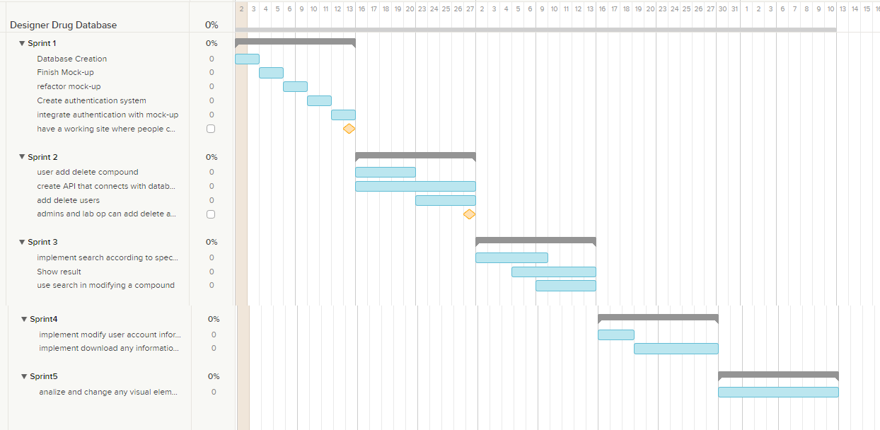

* 1. Appendix B – Feasibility Matrix
  2. Appendix C – Cost Matrix
  3. Appendix D - Diary of Meetings

1. References (you should reference any work that is not your own)

<http://www.vizteams.com/blog/android-ios-top-solutions-for-creating-cross-platform-mobile-apps/#.VM7lbEfF-X0>

<http://www.awwwards.com/what-are-frameworks-22-best-responsive-css-frameworks-for-web-design.html>