|  |
| --- |
| Designer drug database |
| Requirement Document |
| Senior Project, CIS 4911- U01 |
| **Professor: Seyedmasoud Sadjadi Mentor: Dr. Luis Arroyo** |
| **Team Member: Carlos Dominguez** |
| **2/2/2015** |

|  |
| --- |
|  |

Copyrights and Trademarks Notices

Nothing yet

Abstract

One or two paragraph

Table of Contents

ss

1. Introduction

This document will describe the requirements of the system.

* 1. Problem Definition.
  2. Scope of system.
  3. Terminology - Definitions, acronyms, and abbreviations.
  4. Overview of document – brief explanation of what to expect in chapters 2 through 6.

1. Current System (limitations and problems) – either existing system or manual system that is being automated.

In my case there is no current system. The system will be implemented for the first time during this semester

1. Project Plan (**This deliverable only**)

Introduce the project plan section (one or two paragraphs)

* 1. Project organization – assignment of roles for this deliverable.

In this deliverable, and others as well, there is only one team member thus, I am the developer and the scrum master, while Dr Luis Arroyo is the product owner

* 1. Work breakdown – identification of milestones and deliverables (refer to project schedule in Appendix A and the diary in appendix B).
  2. Cost Estimate – cost to develop the software system.

1. Proposed System Requirements

Introduce the chapter (one or two paragraphs)

* 1. Functional Requirements – describes high-level functionality

Use the following format:

*The system shall …*

For each functional requirement state the associated non-functional requirements, if any, for *Usability, Reliability, Performance,* and *Supportability*.

* 1. Analysis of System Requirements

Analysis models – contains the complete functional specification and is mainly for the designers and programmers. This section describes the diagrams in the Appendices B - D and validates the models against the use cases.

* + 1. Scenarios

## Use case model

The use case model looks as follows:

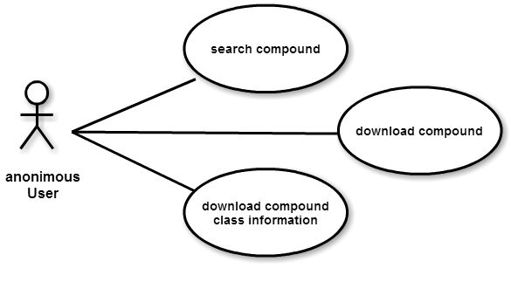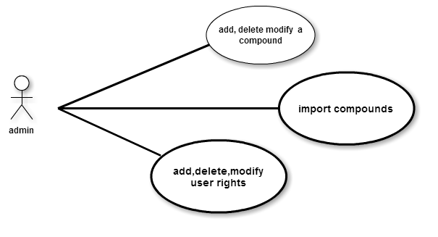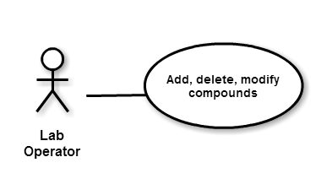

## Static model e.g., object diagrams, class diagram

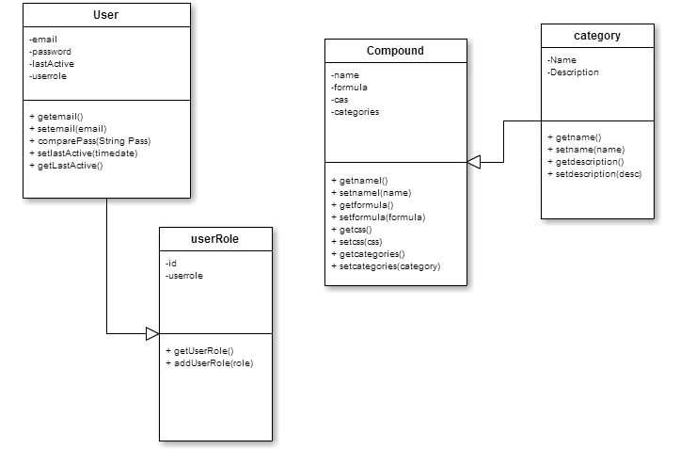

## Dynamic model e.g., sequence diagrams or state machines

Search sequence diagram

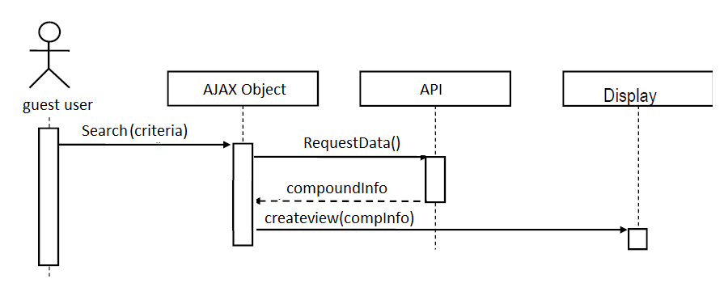

1. Glossary - define terms used in document, especially domain specific terms.
2. Appendix
   1. Appendix A - Complete use cases
   2. Appendix B - Use case diagram using UML
   3. Appendix C - Static UML diagram
   4. Appendix D - Dynamic UML diagrams
   5. Appendix E - User Interface designs.
   6. Appendix F - Diary of meeting and tasks.
3. References