Genomic Sequences

Shortcomings & Wish List

**Yordan Alvarez - Developer**

**Yohan Santos - Developer**

Shortcomings of the Current Software

A shortcoming of the current system is that the images in the About Us page, are not resizing properly when resizing the screen to iPad view. We believe this is happening because the sizes of the uploaded images are greater than the standard 100x100 thumbnail size image.

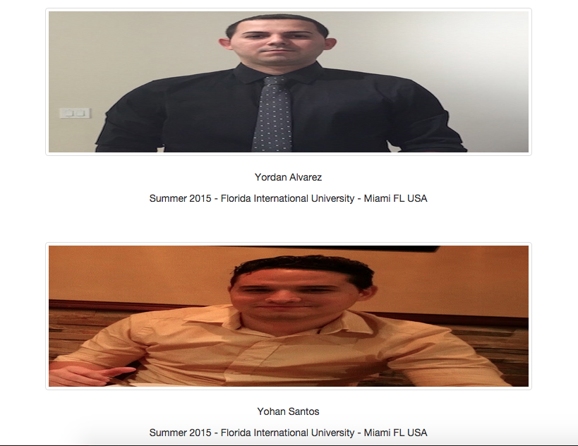

Wish List

* Be able to identify which of the twenty amino acids with their respective RNA codons are present in a genome data file.

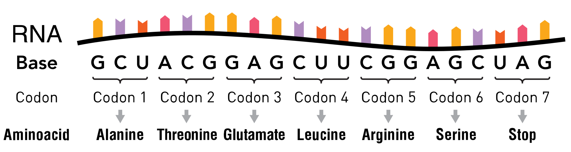

* Be able to expand the find differences among files tool, to compare the genome sequences back to front, and also compare their complements.

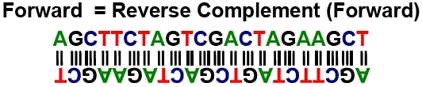

* Be able to check for genes types given a DNA genome data type.

