Genomic Sequences

Installation & Maintenance

Yordan Alvarez- Developer

Yohan Santos – Developer

Application Requirements

* Software to Runs the Application:
  + Windows 7 and up, Mac OS, Ubuntu 14.04 LTS
  + Netbeans and Eclipse
* Development environment:
  + Apache(Linux)
  + PostgreSQL
  + phpPgAdmin
  + PHP

**Install PostgreSQL 9.4**

* Install PostgreSQL
  + sudo apt-get install postgresql postgresql-contrib
* Access PostgreSQL command prompt
  + sudo -u postgres psql postgres
* Set “postgres” user password
  + postgres=# \password postgres
  + Enter new password:
  + Enter it again:
  + postgres=# \q

Install phpPgAdmin

* Install phpPgAdmin:
  + sudo apt-get install phppgadmin
* By default, you can access phppgadmin using:
  + http://localhost/phppgadmin

Access Remote phpPgAdmin

* Edit file /etc/apache2/conf.d/phppgadmin:
  + sudo nano /etc/apache2/conf.d/phppgadmin
* Comment the following line:
  + #allow from 127.0.0.0/255.0.0.0 ::1/128
* Uncomment the following line to make phppgadmin from all systems:
  + allow from all
* Edit /etc/apache2/apache2.conf:
  + sudo vi /etc/apache2/apache2.conf
* Add the following line:
  + Include /etc/apache2/conf.d/phppgadmin
* Then, restart apache service.
  + sudo service apache2 restart

Configure phpPgAdmin

* Edit file /etc/phppgadmin/config.inc.php
  + sudo nano /etc/phppgadmin/config.inc.php
* Find the following line:
  + $conf['servers'][0]['host'] = '';
* Change it as shown below:
  + $conf['servers'][0]['host'] = 'localhost';
* And find the line:
  + $conf['extra_login_security'] = true;
* Change the value to false:
  + $conf['extra_login_security'] = false;
* Find the line:
  + $conf['owned_only'] = false;
* Set the value as true.ru
  + $conf['owned_only'] = true;

Restart postgresql service and Apache services

* Save and close the file.
  + sudo service postgresql restart
  + sudo service apache2 restart
* Important Link.
  + <http://www.unixmen.com/install-postgresql-9-4-phppgadmin-ubuntu-14-10/>

phpPgAdmin Home Page

* Now open your browser and navigate to: <http://genomepro.cis.fiu.edu/phppgadmin/>

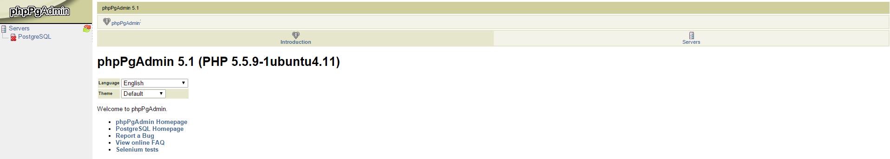

Log In To phpPgAdmin

* Now you can type Your User Name usually “postgres” and Your chosen Password.

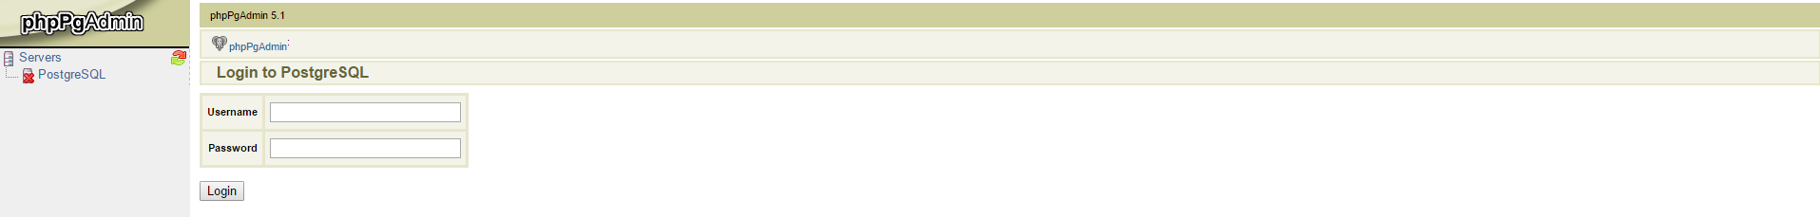

Inside phpPgAdmin

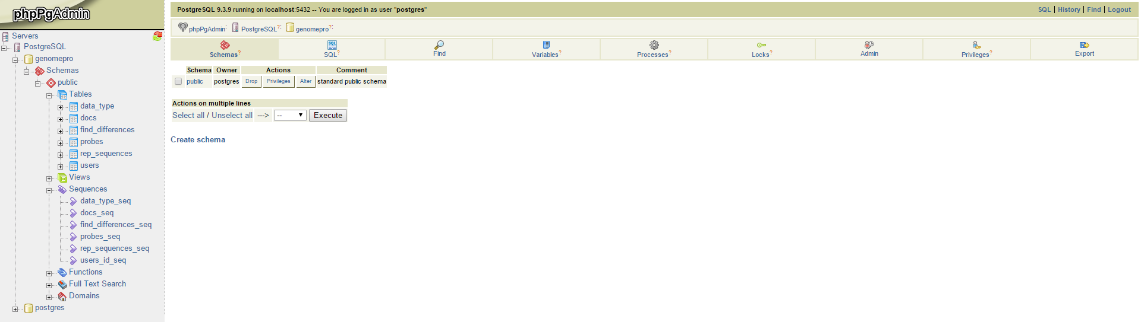

Uploading SQL To phpPgAdmin

* Select SQL
* Choose File
* Click Execute

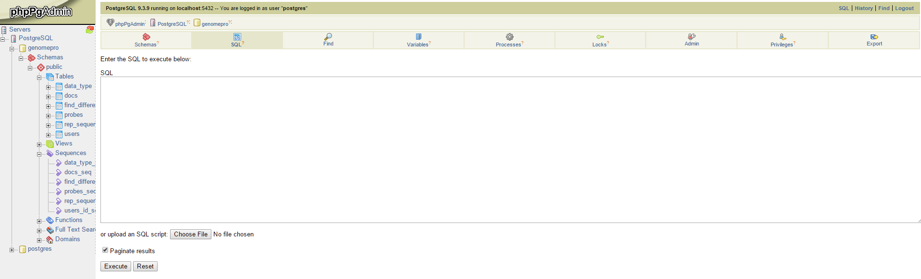

Install Application

* Clone the repository from our Github account: <https://github.com/FIU-SCIS-Senior-Projects/Genomic-Sequences>

Application Folder



Application Running

* Genome Pro Link. [http://genomepro.cis.fiu.edu/#/home](http://genomepro.cis.fiu.edu/)

