Florida International University
School of Computing and Information Sciences
CIS 4911 Senior Project – Software Engineering Focus
Format of Deliverable 2 - Requirements Document (RD)

The bullets represent the sections before chapter 1 “Introduction”, numbers on the left represent the corresponding chapters and sections.
- Cover page – Name of course and section, name of system, project team number, group member names, date, and name of professor.
- Copyright and trademark notices, restrictions on copying or distributing the documentation, information for contacting the issuing organization (reader’s comments), warranties, contractual obligations or disclaimers, and general warnings and cautions.
- Abstract – one or two paragraphs giving a brief overview of the document.
- Table of Contents
- Introduction
Introduce the introduction (one or two paragraphs)
  - Problem Definition.
  - Scope of system.
  - Terminology - Definitions, acronyms, and abbreviations.
  - Overview of document – brief explanation of what to expect in chapters 2 through 6.
- Current System (limitations and problems) – either existing system or manual system that is being automated.
- Project Plan (This deliverable only)
Introduce the project plan section (one or two paragraphs)
  - Project organization – assignment of roles for this deliverable.
  - Work breakdown – identification of milestones and deliverables (refer to project schedule in Appendix A and the diary in appendix B).
  - Cost Estimate – cost to develop the software system.
- Proposed System Requirements
Introduce the chapter (one or two paragraphs)
  - Functional Requirements – describes high-level functionality
Use the following format:
The system shall …
For each functional requirement state the associated non-functional requirements, if any, for Usability, Reliability, Performance, and Supportability.
  - Analysis of System Requirements
Analysis models – contains the complete functional specification and is mainly for the designers and programmers. This section describes the diagrams in the Appendices B - D and validates the models against the use cases.
    - Scenarios
    - Use case model
    - Static model e.g., object diagrams, class diagram
    - Dynamic model e.g., sequence diagrams or state machines
- Glossary - define terms used in document, especially domain specific terms.
- Appendix
  - Appendix A - Complete use cases
  - Appendix B - Use case diagram using UML
  - Appendix C - Static UML diagram
  - Appendix D - Dynamic UML diagrams
  - Appendix E - User Interface designs.
  - Appendix F - Diary of meeting and tasks.
- References
Please email me the UML diagram in one file before the presentation.

1. Introduction
Introduce the introduction (one or two paragraphs)
1.1. Problem Definition.
1.2. Scope of system.
1.3. Terminology - Definitions, acronyms, and abbreviations.
1.4. Overview of document – brief explanation of what to expect in chapters 2 through 6.
2. Current System (limitations and problems) – either existing system or manual system that is being automated.
3. Project Plan (This deliverable only)
Introduce the project plan section (one or two paragraphs)
3.1. Project organization – assignment of roles for this deliverable.
3.2. Work breakdown – identification of milestones and deliverables (refer to project schedule in Appendix A and the diary in appendix B).
3.3. Cost Estimate – cost to develop the software system.
4. Proposed System Requirements
Introduce the chapter (one or two paragraphs)
4.1. Functional Requirements – describes high-level functionality
Use the following format:
The system shall …
For each functional requirement state the associated non-functional requirements, if any, for Usability, Reliability, Performance, and Supportability.
4.2. Analysis of System Requirements
Analysis models – contains the complete functional specification and is mainly for the designers and programmers. This section describes the diagrams in the Appendices B - D and validates the models against the use cases.
4.2.1. Scenarios
4.2.2. Use case model

4.2.2.2. Use case model for Integration Tests

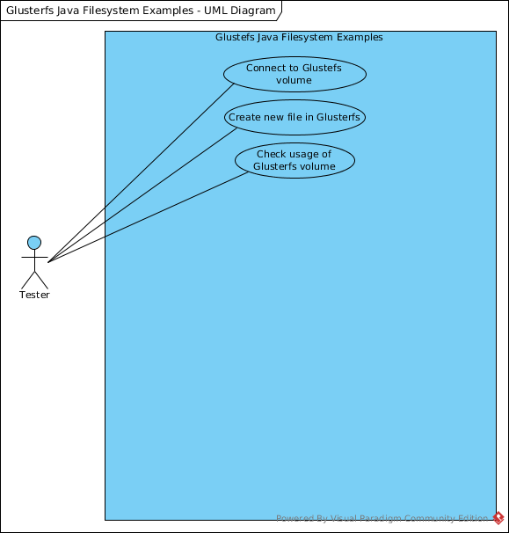

4.2.3. Static model e.g., object diagrams, class diagram

4.2.4. Dynamic model e.g., sequence diagrams or state machines

4.2.4.2. Sequence Diagrams for Integration Tests

5. Glossary - define terms used in document, especially domain specific terms.
6. Appendix
6.1. Appendix A - Complete use cases

6.2. Appendix B - Use case diagram using UML
Figure 1: Use Case Diagram for Integration Tests

6.3. Appendix C - Static UML diagram
6.4. Appendix D - Dynamic UML diagrams

6.4.1. Dynamic UML diagram for Integration Tests

Figure 1: Check Usage of a Glusterfs Volume
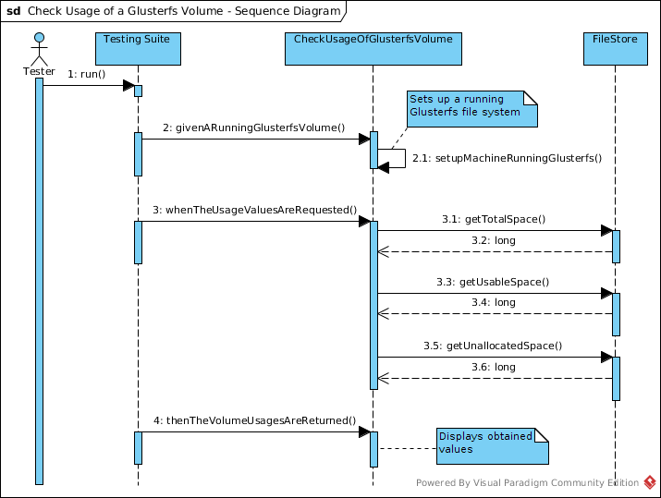

Figure 2: Connect to a Glusterfs Volume
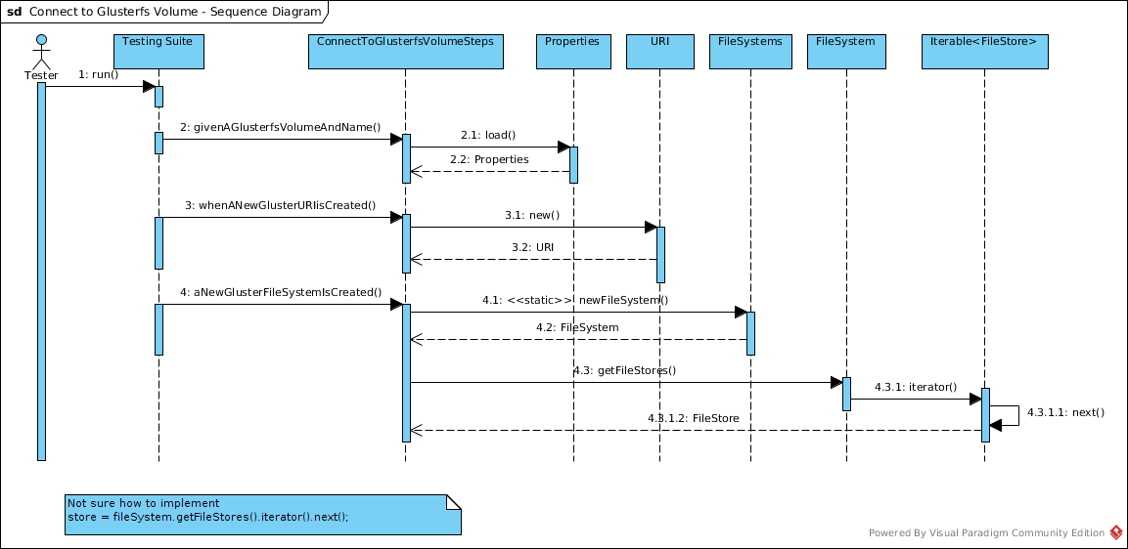

Figure 3: Create New Files in Glusterfs
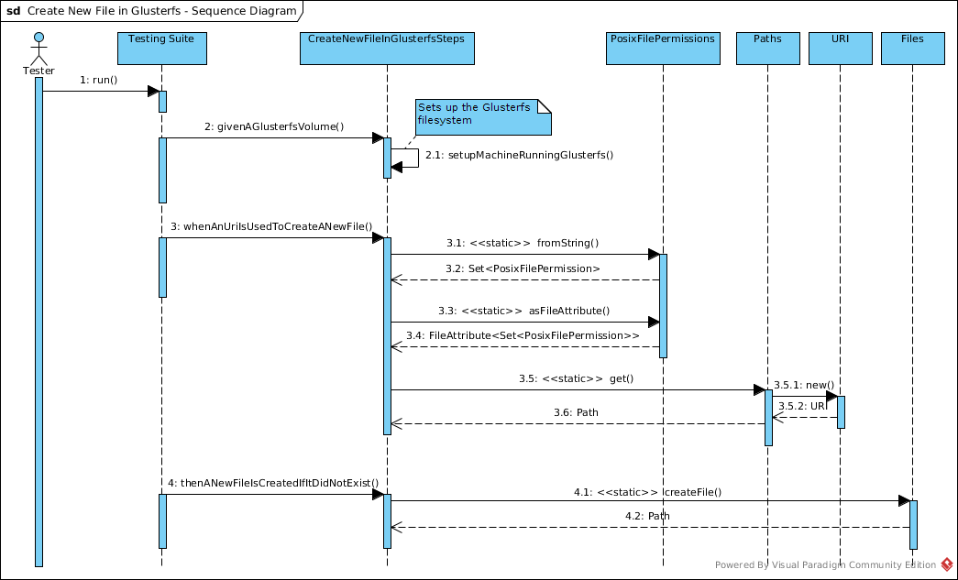

6.5. Appendix E - User Interface designs.
6.6. Appendix F - Diary of meeting and tasks.
7. References

