Installation and Setup Instructions

Introduction

The installation of the development environment of GlusterFS Java Filesystem requires a Linux 64 bit distribution, we use Mint 17 64, and the Instructions in this document are shown for a Debian family system, which includes Ubuntu and Mint amongst others.

Inside this host there must be a guest Linux 64/32 bits virtual machine (Ubuntu 14.04 32).

The virtual machine environment is provided by VirtualBox, and we use Vagrant to automate the setup, usage and management of the virtual machine. GlusterFS runs in the Linux guest virtual machine.

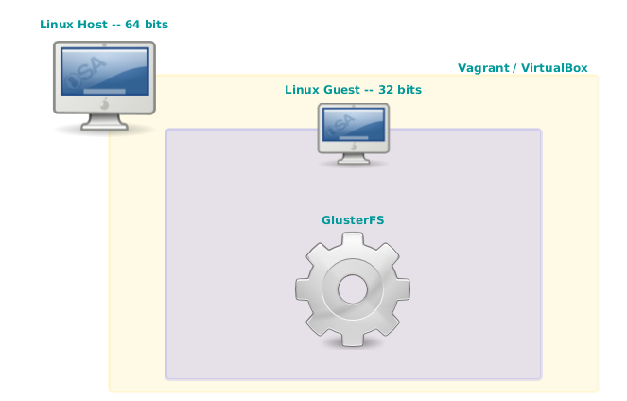

For the demo environment, as before, we need a Linux 64 host, and the guest virtual machine must be a 32 bit version so that the environment is stable. For this project, both the host and guest systems are Ubuntu 14.04.

Required Software Download and Setup Instructions

As stated before, we need a host Linux 64 system, be it a bare metal or a virtual machine, all the instructions there after are to be performed from within such device using the bash console.

Below is the list of software we need to install; when the instructions ask for downloading packages, put them into the same folder, something like ~/JGFS.

1. GlusterFS
2. Java JKD 7 or higher
3. Apache Maven
4. Virtualbox
5. Vagrant
6. Git
7. An Ubuntu image for the demo VM

Install GlusterFS

sudo add-apt-repository ppa:gluster/glusterfs-3.6

apt-get update

sudo apt-get install glusterfs-common

Download and Install Java JDK 7

cd ~/JGFS

wget http://download.oracle.com/otn-pub/java/jdk/7u75-b13/jdk-7u75-linux-x64.tar.gz

#extract it

tar -xvf jdk-7u75-linux-x64.tar.gz

Taking note of the folder where Java was extracted, let's update the ~/.bashrc file to create a path entry for Java:

echo 'export JAVA_HOME=~/JGFS/jdk1.7.0_75' >> ~/.bashrc

echo 'export JDK_HOME=$JAVA_HOME' >> ~/.bashrc

echo 'export JRE_HOME=$JAVA_HOME' >> ~/.bashrc

echo 'export PATH=${PATH}:${JAVA_HOME}/bin' >> ~/.bashrc

Download and extract Maven

cd ~/JGFS

wget ftp://mirror.reverse.net/pub/apache/maven/maven-3/3.2.5/binaries/apache-maven-3.2.5-bin.tar.gz

tar -xvf apache-maven-3.2.5-bin.tar.gz

Now let's add maven alias to the ~/.bashrc file:

echo 'export M2_HOME=~/JGFS/apache-maven-3.2.5' >> ~/.bashrc

echo 'alias mvn="$M2_HOME/bin/mvn"' >> ~/.bashrc

Maven gets installed on first run, which will be done in a step later on, for now let's continue.

Install Virtualbox

sudo apt-get install virtualbox

Download and Install Vagrant

cd ~/JGFS

wget http://files.vagrantup.com/packages/0219bb87725aac28a97c0e924c310cc97831fd9d/vagrant_1.2.4_i686.deb

dpkg -i vagrant_1.2.4_i686.deb

Install Git

sudo apt-get install git

------
clone the github repository
-------
explain that the clone already sets the maven archetypes, even the jBehave one
--------
Download the intelliJ IDE
explain they offer a 1 year trial for students
------

