CEN4010 Section U01

Golden Pages

Team 4

Adam Merille

Shadeh Ferris-Francis

Jorge Travieso

Andy Martinez

Sergio Saucedo

Michael Machin

September 30, 2014

Professor Tariq King

Executive Summary

To provide a simple view of criminal activity for the Miami area, the Miami Crime Statistics web service will be created. The way police reports are written can be hard to understand for the lay person, both the area in which they occurred and the meanings of the comments on the police report require previous knowledge to understand. Thus the hope is to provide a user-friendly representation of the aggregate crime data of the Miami area.

This software requirements document is a description of the Miami Crime Statistics project that is to be developed. The document starts by introducing the purpose of the system, the scope of the system, definitions, acronyms, abbreviations, and an overview of the document. This is followed by a discussion of the current system that exists. The proposed plan, including the project organization, the hardware and software requirements, and the identification of milestones and deliverables, is then presented.

The document continues by going over use cases utilized for requirements elicitation. Some diagrams are displayed in order to better convey the system. The final portion of this document contains a glossary and various appendices pertaining to scheduling, diagrams, user interface, and meeting diaries.

Table of Contents Page

1. Introduction………………………………………………… 4
   1. Purpose of System……………………………………. 4
   2. Scope of System…………………………………….... 4
   3. Definitions, Acronyms, and Abbreviations…………... 4
   4. Overview of Document………………………………. 5
2. Current System……………………………………………... 6
3. Project Plan……………………………………………….... 7
   1. Project Organization………………………………….. 7
   2. Hardware and Software Requirements……………….. 7
   3. Work Breakdown……………………………………... 8
4. Proposed System……………………………………….….. 12
   1. Requirements Elicitation………………………..….... 12
   2. Requirements Analysis………………………………. 75
5. Glossary……………………………………………………. 77
6. Appendix…..………………………………………………. 78
   1. Appendix A - Project Schedule…………………….... 78
   2. Appendix B - Diagrams……………………………… 80
   3. Appendix C - User Interface Designs………………... 85
   4. Appendix D - Diary of Meetings and Tasks…………. 88

# Introduction

This section introduces Miami Crime Statistics. The purpose and the scope of the system are briefly explained, and definitions, acronyms and abbreviations used throughout the document are specified. This section concludes with an overview of the rest of the document explaining what to expect in the following sections.

# 1.1 Purpose of system.

It is important for residents of an area to know what potential dangers are in their area. If there is a recent spree of breaking and entering, home owners that know about this crime spree can better keep themselves and their possessions safe. The issue remains that the way the crime data is recorded is all but unreadable to the lay person. This is why Miami Crime Statistics is being proposed, to better convey this information to an interested audience. The main feature of the service will be to provide a local area map with an overlay representative of the crime data in the constructed database.

# 1.2 Scope of system.

The system will at minimum allow the user to access the website, display a map of the Miami Lakes area with an overlay of crime statistics, and display graphs of certain crime statistics. The information of the crime reported will be stored and maintained on the service providers’ server. The system will also allow the user to filter the information they are being presented on both the graphs and the map. Optimumly the service will provide information on crimes beyond the Miami lakes area.

# 1.3 Definitions, acronyms, and abbreviations.

# Overview of document

This document is laid out to record how the system will be developed, using and updating existing systems to accomplish goals of the system. First we must describe the existing systems in order to understand what further developments need to be made to fully realize our proposed project. Once the missing functionalities are understood, we will discuss the tools we will use to solve the issues facing the current system as well as the roles that each team member will perform in advancing towards our goals. From there we will describe in further detail the system itself. We will accomplish this task using Use Cases, documenting possible scenarios users and outside systems will interact with our system. Concluding this document will be the document’s meta section, which refers to and clarifies subjects found earlier in the document. Glossaries and appendices, where diagrams can be found, are included here.

# Current System

A similar service already exists, <https://www.crimereports.com>. This service places notations, or flags, over its collected crime data. This provides a large quantity of data for the user to page through. While our service could do something similar, our service will differentiate itself by simplifying the data for the user by conducting its own analysis and coloring danger zones to represent high crime areas. We plan to use similar techniques of overlaying data on a existing map such as google maps.

# Project Plan

In this section, the team member roles, hardware and software requirements, and the overall schedule for the project are discussed. The plan for the Miami Crime Statistics project extends over 12 weeks, from February 2nd, 2015 until April 17th, 2015.

3.1 Project Organization

There is one person working on the project. So tasks will be separated by priority and completed by ability.

|  |  |  |  |
| --- | --- | --- | --- |
| Name | Position | Periods required | Key Phases |
| Michael John Machin- | Website Developer & Database Manager | 1/26/15- 4/30/15 | All |

### 

3.2 Hardware and Software Requirements

Hardware resources:

* 1 Laptop
* 1 Server group hosting VM

Software resources:

* Netbeans
* MYSQL
* GitServer
* SmartGit

3.3 Work Breakdown

# 

# 

# 4. Proposed system

Miami Crime Statistics is a web service in current and potential residents of the Miami area will be able to see crime hot spots and statistics for their area. Users will be able to search for information and a list of search results will be displayed for them with all relevant data. Users will be able to view graphs and modify the information displayed on the graph with different filters.. This website is purely a service that provides information to end users, no accounts will be necessary.

The only accounts will be moderator accounts thus allowing them to adjust the database and the service as the need arises

4.1 Requirements Elicitation

***FR-1:***

-The System should allow only the moderator to upload additional crime data to the database

*Usability:* Function should be easy to perform and should notify the user when completed, or when it encounters an error.

*Reliability:* The probability of failure is 1% and 3% over a 48hrs period.

*Performance:* The uploading of a pdf to be scanned should take around 10 seconds

*Supportability*: This should function on all major internet browsers.

***FR-2:***

-The system should allow end users to view a map of the crime data

*Usability:* Function should be automatically performed upon the loading of the website.

*Reliability:* The probability of failure is 1% and 3% over a 48hrs period.

*Performance:* The displaying of the map should happen in under 5 seconds.

*Supportability*: This should function on all major internet browsers.

***FR-3:***

-The system should allow end users search for specific crime data

*Usability:* Function should be easy to perform and should notify the user when completed, or when it encounters an error.

*Reliability:* The probability of failure is 1% and 3% over a 48hrs period.

*Performance:* The displaying of the search results should happen in under 5 seconds.

*Supportability*: This should function on all major internet browsers.

***FR-4:***

-The system should allow end users to view a graph showing trends

*Usability:* Function should be easy to perform and should display the graph upon completion

*Reliability:* The probability of failure is 1% and 3% over a 48hrs period.

*Performance:* The displaying of the graph should happen in under 10 seconds.

*Supportability*: This should function on all major internet browsers.

***FR-5:***

-The system should allow Moderator login in a non hyperlinked page.

*Usability:* Function should be easy to perform and should notify the user upon completion, or notify if an error is encountered

*Reliability:* The probability of failure is 1% and 3% over a 48hrs period.

*Performance:* The displaying of the moderator page should happen in under 5 seconds.

*Supportability*: This should function on all major internet browsers.

***FR-6:***

-The system should allow end users to select filters to change map information

*Usability:* Function should be easy to perform and should display the map upon completion

*Reliability:* The probability of failure is 1% and 3% over a 48hrs period.

*Performance:* The displaying of the updated map should happen in under 10 seconds.

*Supportability*: This should function on all major internet browsers.

***FR-7:***

-The system should allow end users to view a separate map that displays icons for individual crimes

*Usability:* Function should be easy to perform and should display the map upon completion

*Reliability:* The probability of failure is 1% and 3% over a 48hrs period.

*Performance:* The displaying of the search results should happen in under 10 seconds.

*Supportability*: This should function on all major internet browsers.

***FR-8:***

-The system should allow end users to view a bar graphs comparing crimes per day of week

*Usability:* Function should be easy to perform and should display the graph upon completion

*Reliability:* The probability of failure is 1% and 3% over a 48hrs period.

*Performance:* The displaying of the graph should happen in under 10 seconds.

*Supportability*: This should function on all major internet browsers.

***FR-9:***

-The system should allow end users to view a bar graphs comparing crimes per type

*Usability:* Function should be easy to perform and should display the graph upon completion

*Reliability:* The probability of failure is 1% and 3% over a 48hrs period.

*Performance:* The displaying of the graph should happen in under 10 seconds.

*Supportability*: This should function on all major internet browsers.

***FR-10:***

-The system should allow end users to view a bar graphs comparing crimes per hour of day

*Usability:* Function should be easy to perform and should display the graph upon completion

*Reliability:* The probability of failure is 1% and 3% over a 48hrs period.

*Performance:* The displaying of the graph should happen in under 10 seconds.

*Supportability*: This should function on all major internet browsers.

***FR-11:***

-The system should allow end users to view a bar graphs comparing crimes per classification

*Usability:* Function should be easy to perform and should display the graph upon completion

*Reliability:* The probability of failure is 1% and 3% over a 48hrs period.

*Performance:* The displaying of the graph should happen in under 10 seconds.

*Supportability*: This should function on all major internet browsers.

***FR-12:***

-The system should allow end users to view a bar graphs comparing crimes per month

*Usability:* Function should be easy to perform and should display the graph upon completion

*Reliability:* The probability of failure is 1% and 3% over a 48hrs period.

*Performance:* The displaying of the graph should happen in under 10 seconds.

*Supportability*: This should function on all major internet browsers.

***FR-13:***

-The system should allow end users to view a bar graphs comparing crimes per signal group

*Usability:* Function should be easy to perform and should display the graph upon completion

*Reliability:* The probability of failure is 1% and 3% over a 48hrs period.

*Performance:* The displaying of the graph should happen in under 10 seconds.

*Supportability*: This should function on all major internet browsers.

4.2 Analysis of System requirements

4.2.1 Scenarios

4.2.2 Use case Model

The use case Diagram displays the intended actors and what use cases they will be operating on. Refer to appendix B.

4.2.3 Static model (Class diagram)

This diagram will represent the various classes planned for the system. The diagram follows UML notation Refer to appendix C

4.2.4 Dynamic model

For each use case there will be a sequence diagram of the sequence of events initiated by the user. Most of which will be communicated with the database which will be performed by a special class the database controller. The sequence diagrams follows the UML notation. (Refer to Appendix D)

5. Glossery

6. Appendix

6.1 Appendix A: Complete Use cases

**Use Case ID:** FR01 – Update database

**Details:**

*Actor:*Moderator

*Pre-conditions:*

1. Moderator has navigated to hidden moderator page
2. Moderator has logged in using personal credentials
3. Moderator operations page loads

*Description:*

1. Use case begins when the Moderator clicks on update database
2. The system shall provide Moderator user with a template for data entry
3. The Moderator fills in the directory for which the pdf file of the crime data is on their personal computer
4. The moderator clicks the upload button
5. The system shall notify the moderator that the system is scanning
6. The system inform the moderator of the success parsing the data once complete
7. The template for data entry is cleared and displayed allowing for further data entry

*Post-conditions:*

1. The system has stored a record of the new crime data

**Alternative Courses of Action**

1. In step D.4 the user resets the page or goes to a different page. Erasing the entered data
2. In step D.6 the system notifies the moderator that it was unable to parse the file due to user error

**Exceptions:**

No Exceptions

**Use Case ID:** FR02 – User view of Map

**Details:**

*Actor:*End user

*Pre-conditions:*

None

*Description***:**

1. Use case begins when user navigates to front page
2. The system loads a map of the Miami Lakes area with the crime hot spots overlay

*Post-conditions***:**

None

**Alternative Courses of Action**

The user has loaded the map after applying a filter, this will be covered in a separate use case

**Exceptions:**

1. The Front page does not load
2. The database connection has been severed.

**Use Case ID:** FR03 - Search function

**Details:**

*Actor:*User

*Pre-conditions:*

User has navigated to web site

*Description:*

1. Use case begins when the user is viewing the website
2. On all pages of website a entry field will be provided for the user to perform search operation on
3. The User shall their search criteria and hit submit
4. The System shall search the database for crimes that meet the search criteria forming a table of the crimes that match
5. Use case ends when system responds by displaying the matching table

*Post-conditions:*

User is able to perform further searches

**Alternative Courses of Action:**

1. In step D.3 the user hits refresh or navigates to another page deleting the enter data
2. In step D.5 the system responds with a “nothing found” when no crime data meets the search criteria

**Exceptions:**

User cannot access the Website.

6.2 Appendix B – Diagrams for use case model, *sequence diagram\**, *object\** model. These diagrams should be generated in UML.

**Use case Diagram**

**Diagram 1**. Use Cases

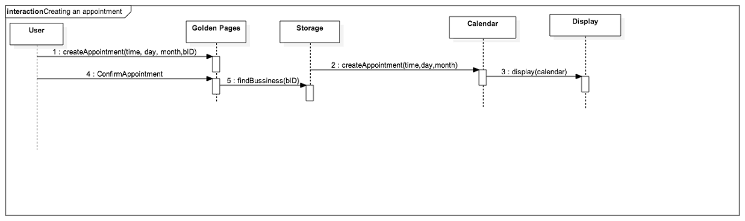

**Diagram 2**. Creating an appointment sequence diagram

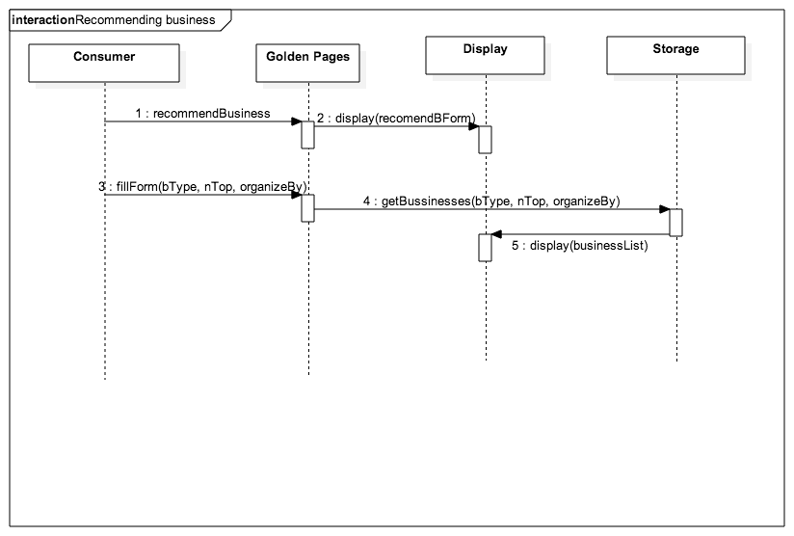

**Diagram 3**. Recommending Business Sequence Diagram

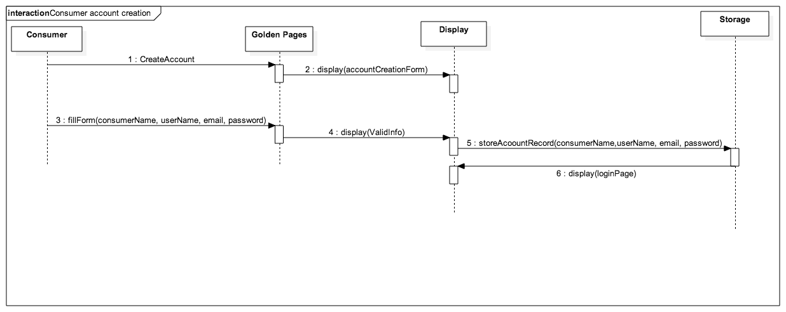

**Diagram 4**. Consumer Account Creation Sequence Diagram

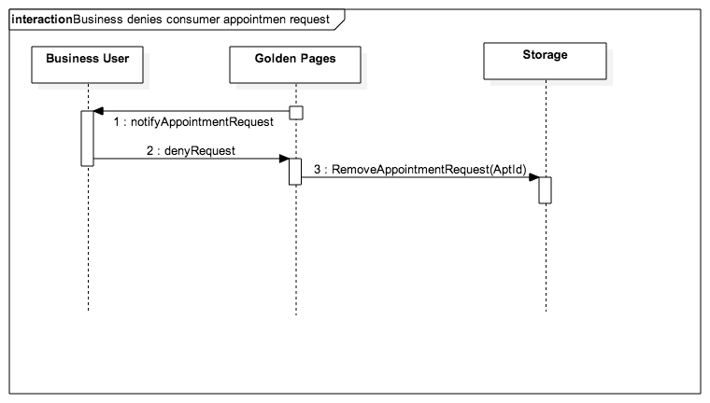

**Diagram 5**. Business Denies Consumer Appointment Request

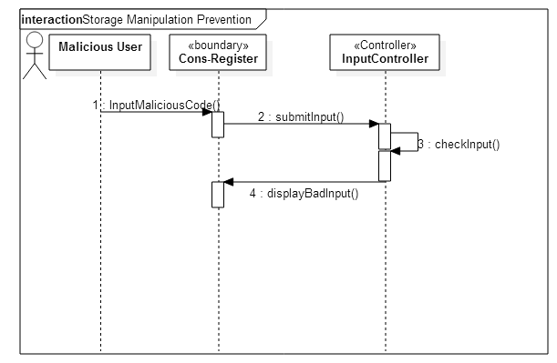

**Diagram 6.** Storage Manipulation Prevention

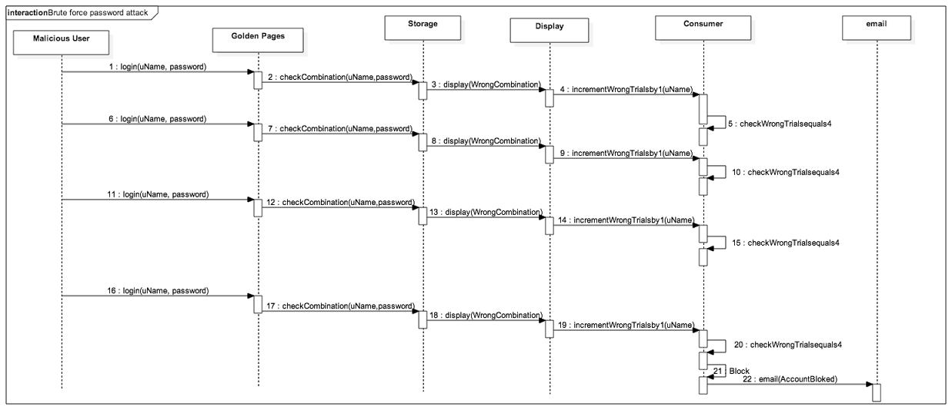

**Diagram 7**. Brute Force Password Attack

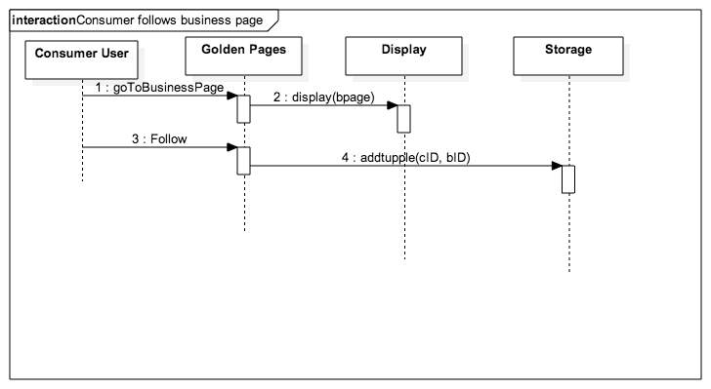

**Diagram 8.** Consumer Follows Business Page

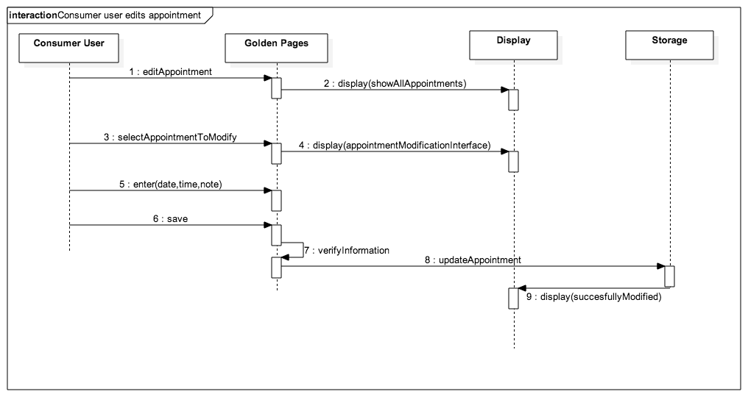

**Diagram 9.** Consumer User Edits Appointment

6.3 Appendix C – User Interface designs

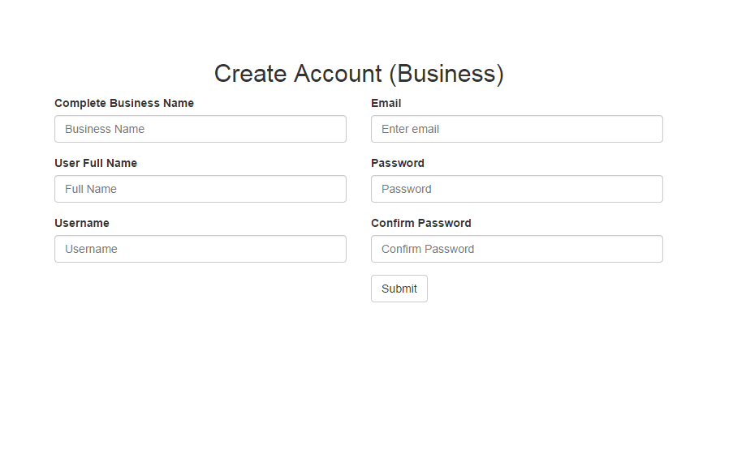

**Template 1.** Business Account Creation

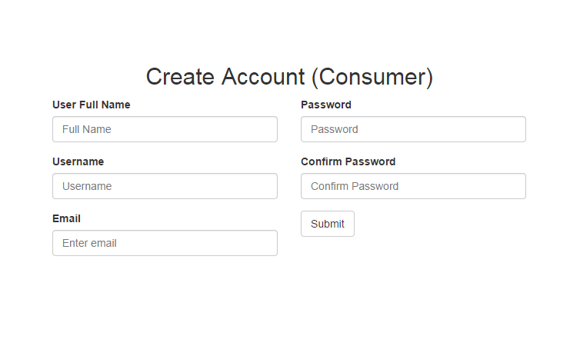

**Template 2.** Consumer Account Creation

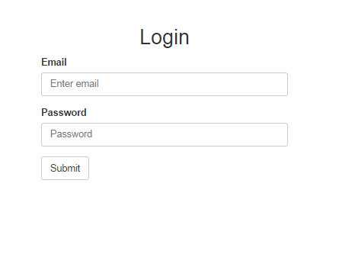

**Template 3.** Login (Both)

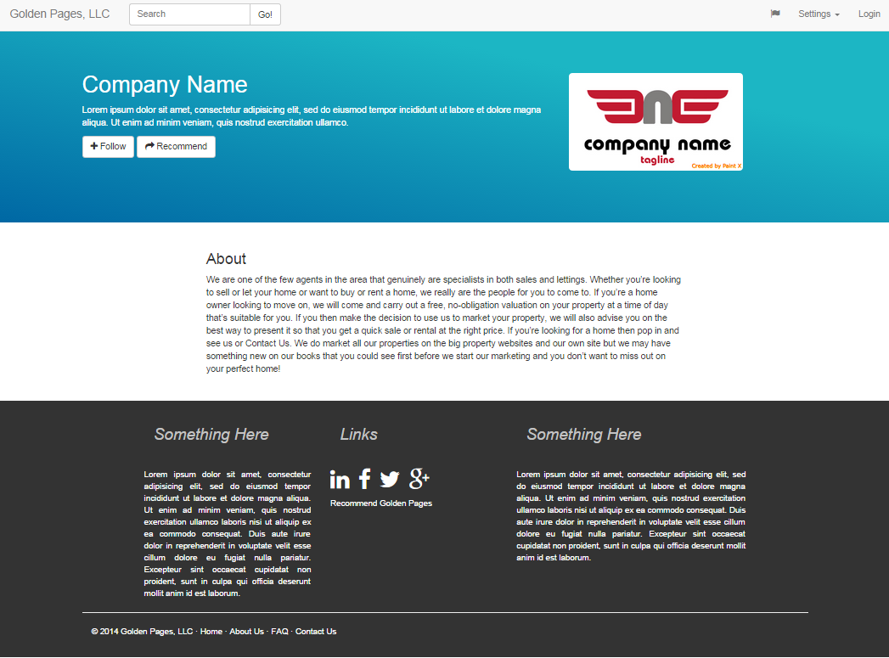

**Template 4.** Business Public View

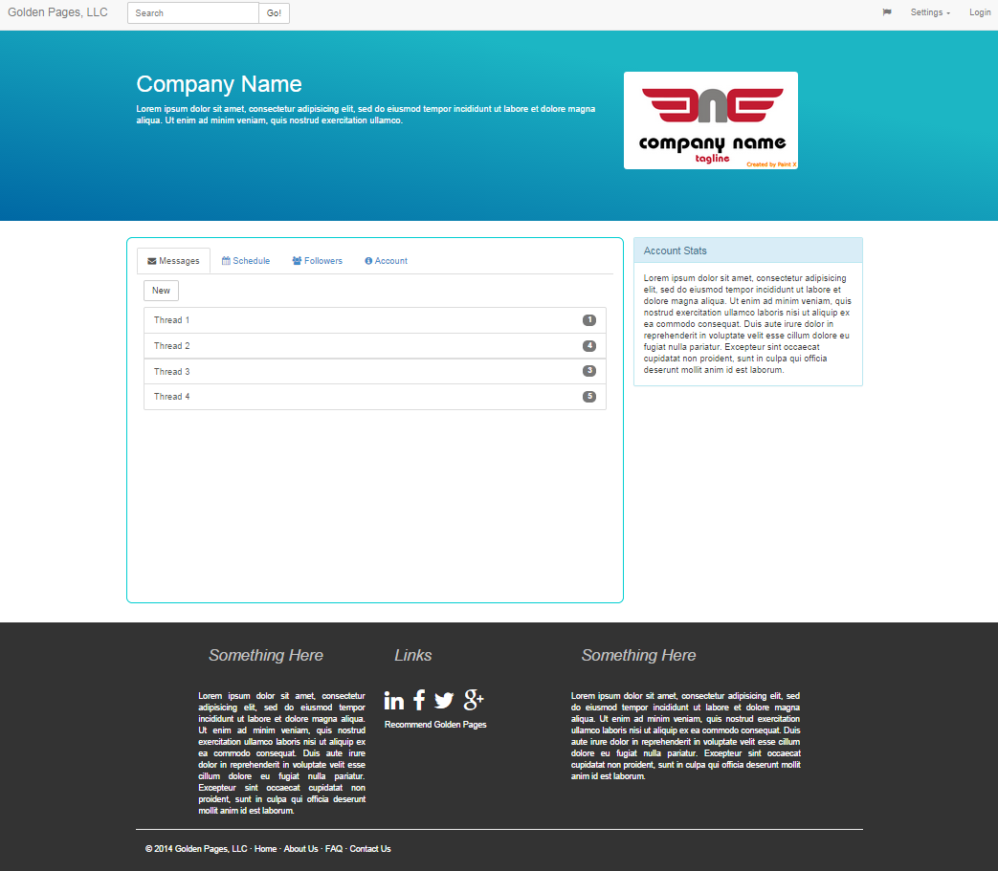

**Template 5.** Business Private View (Dashboard)

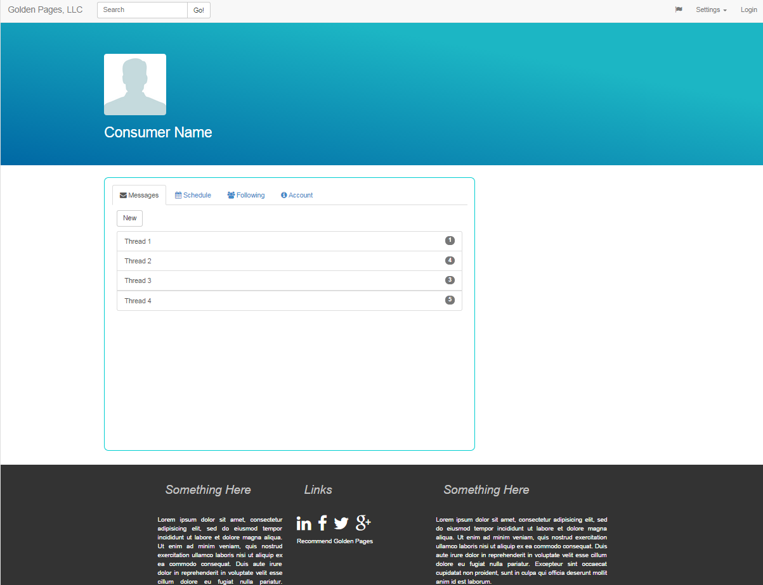

**Template 6.** Consumer Private View (Dashboard)

Note:

For more in depth templates and template code, visit <https://github.com/jtraviesor/golden-pages>

6.4 Appendix D – Diary of Meetings and Tasks

**Diary Entry** - August 28 2014

**Location:** FIU ECS Building

**Start time:** 3:20 pm

**End time:** 4:20 pm

**In attendance:** Sergio, Andy, Shadeh, Adam, Jorge

**Late:** Jorge

**Agenda:** Project Idea discussion

**Summary of discussion:** Came up with book exchange idea, medical app idea, and faculty evaluation app idea.

**Assigned tasks:** Continue to think about possible options and ask Dr. King his thoughts about what we came up with.

**Diary Entry** - August 30, 2014

**Location:** FIU ECS Building

**Start time:** 1:00 pm

**End time:** 3:00 pm

**In attendance:** Sergio, Andy, Shadeh, Adam, Jorge. Michael was out of town and called to discuss meeting notes.

**Late:** Adam, Sergio

**Agenda:** Project Proposal

**Summary of discussion:** Discussed topics from before in light of advice from Dr. King. Eventually came to decide on an application for small business client interactions. Possibly focusing on Appointment coordination.

**Assigned tasks:** Everyone write up at least half page about motivation and solution to splice together for final 1 page Project Proposal.

**Diary Entry** - September 13, 2014

**Location:** FIU ECS Building

**Start time:** 10 am

**End time:** 11:15 am

**In attendance:** Shadeh, Jorge, Adam, Andy, Sergio, Michael

**Late:**

**Agenda:** Discuss use case ideas.

**Summary of discussion:** Came up with a preliminary list of use cases.

**Assigned tasks:** Everyone was to add more use cases to the Google doc list and select ones to be worked on.

**Diary Entry** - September 18, 2014

**Location:** FIU ECS Building

**Start time:** 9:05 pm

**End time:** 9:07 pm

**In attendance:** Shadeh, Adam, Andy

**Late:**

**Agenda:** Unplanned meeting after class

**Summary of discussion:** Discussed possibility of a meeting that weekend.

**Assigned tasks:** Adam sent out email to group asking about meeting time.

**Diary Entry** - September 27, 2014

**Location:** FIU ECS Building, Google Docs

**Start time:** 12 pm

**End time:** 6:30 pm

**In attendance:** Shadeh, Adam, Jorge; Remote - Sergio, Andy

**Late:**

**Agenda:** Finish use cases, discuss splitting up SRD.

**Summary of discussion:** Discussed cohesion of use cases.

**Assigned tasks:** Everyone finish use cases and begin work on sections current systems, proposed plan, Gantt chart, user interface mock ups, use case diagram.

**Diary Entry** - September 28, 2014

**Location:** FIU ECS Building, Google Docs

**Start time:** 12 pm

**End time:** 8 pm

**In attendance:** Jorge, Shadeh, Adam; remote- Andy, Sergio

**Late:**

**Agenda:** Work on and discuss tasks from previous meeting.

**Summary of discussion:** Fleshed out more of the mock ups, finished Gantt chart, proposed plan, use case diagrams.

**Assigned tasks:** Finish combining sections and begin powerpoint slides.

**Diary Entry** - September 29, 2014

**Location:** FIU ECS Building, Google Docs

**Start time:** 3 pm/ 6 pm

**End time:** 2 am

**In attendance:** Jorge, Shadeh, Adam, Michael remote- Andy, Sergio

**Late:**

**Agenda:** Work on and discuss tasks from previous meeting.

**Summary of discussion:** Finished writing up SRD document specifics and cleaned up diagrams.

**Assigned tasks:** Finish combining sections and finish powerpoint slides.