Senior Project CIS 4911-U01

Multi-Touch and Mid-Air Framework

Multi-Touch and Gyroscope Visualizer

Installation Guide

Team Members:

Steven Ignetti (SUMMER 2015)

Alfredo Zellek (SUMMER 2015)

Richard  A. Lopez (SPRING 2015)

Mentor:

Francisco Ortega

Professor:

Masoud Sadjadi

Overview

Input devices have advanced at an outstanding rate in the last few decades. The introduction of the mouse was one of the factors that brought the personal computer out of the technical user niche and into the regular consumer. Now touch input is in almost every cellphone and readily available to the general public. Newer input forms have been developed since such as multi touch screen, 3D mouse, midair tracking, and others. Up until now developers have had to code their respective games and applications for the individual input devices which make it a time consuming task and it limits the utilization of more than one input device in use at a time.

The Touch Air Motion Framework is trying to create a more encompassing input device library such that developers can simply choose their input devices and code their apps without having to deal with the individuality of each device. This document pertains to the visualization interface for the TAM framework.

Requirements

To utilize version 2.0 of the TAM framework you need the following:

* Touch screen computer
* Windows 7 or greater
* 2 GB RAM minimum
* 512 MB video card minimum
* Microsoft Visual Studio 2013
* Qt version 5.4.1
* Qt plugin 1.2.4 for Visual Studio 2013 version 5.4

Installation

1. Download the TamVisualizer Project

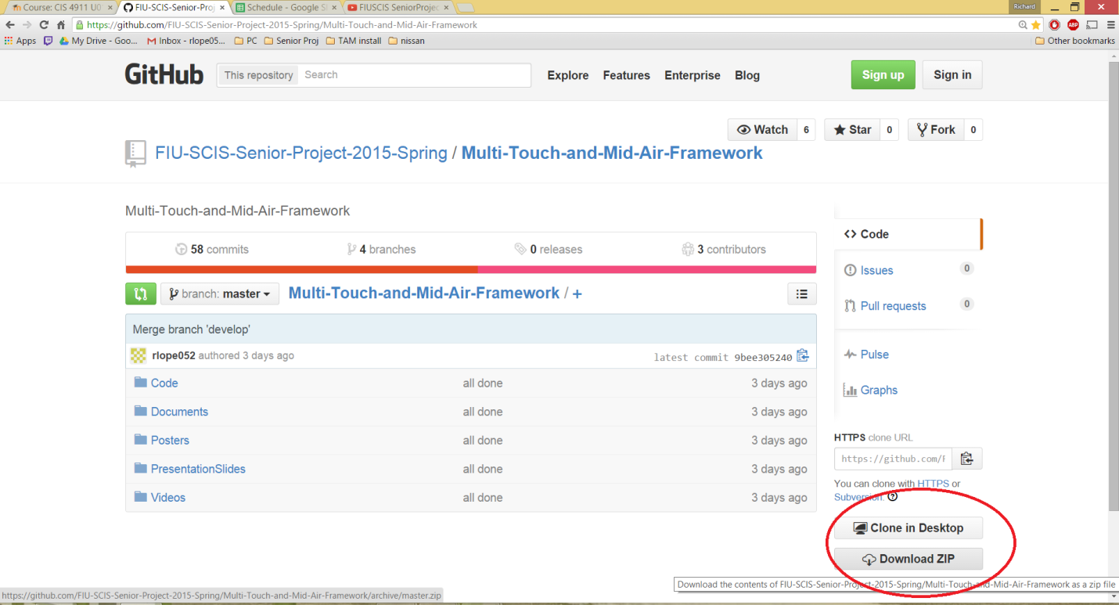

1. Install Visual Studio Community 2013 with Update 4.

<https://www.visualstudio.com/en-us/downloads/download-visual-studio-vs.aspx>

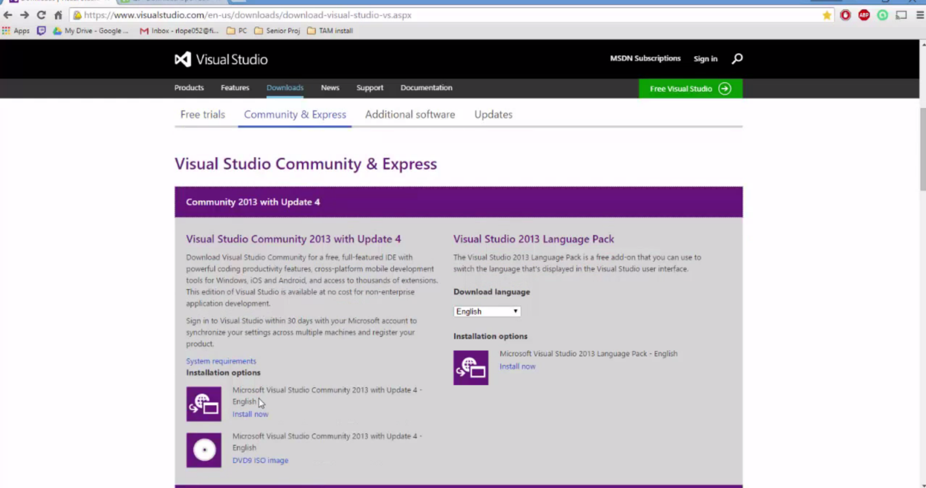

1. Install Qt 5.4.1 with OpenGL

<https://www.qt.io/download/>

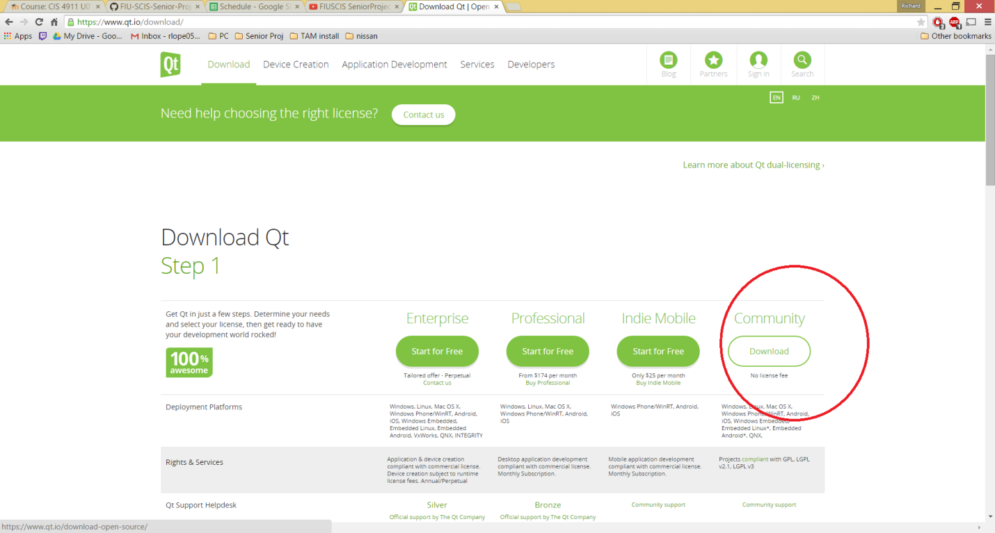

1. Install Qt plugin Version 5.4.1 or greater for visual Studio 2013

<https://www.qt.io/download-open-source/#section-2>

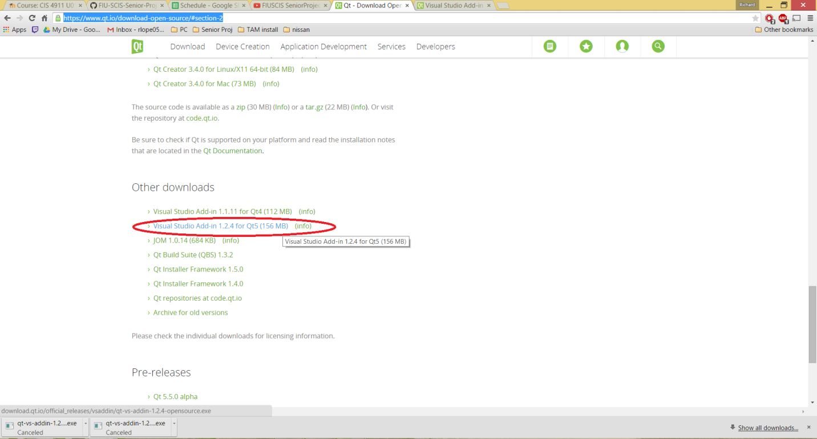

1. Open Visual Studio
2. On the Top left corner Click on the QT5 tab

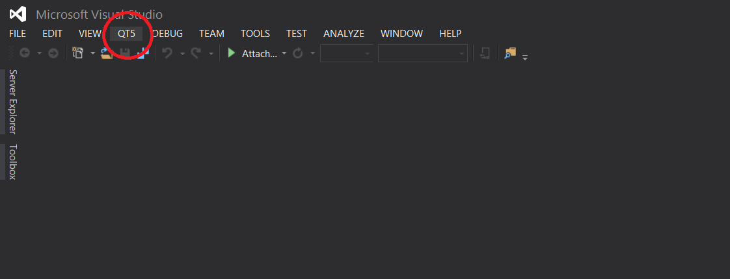

1. Open the Qt Options Menu

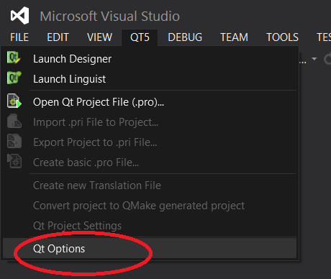

1. Click the Add Button

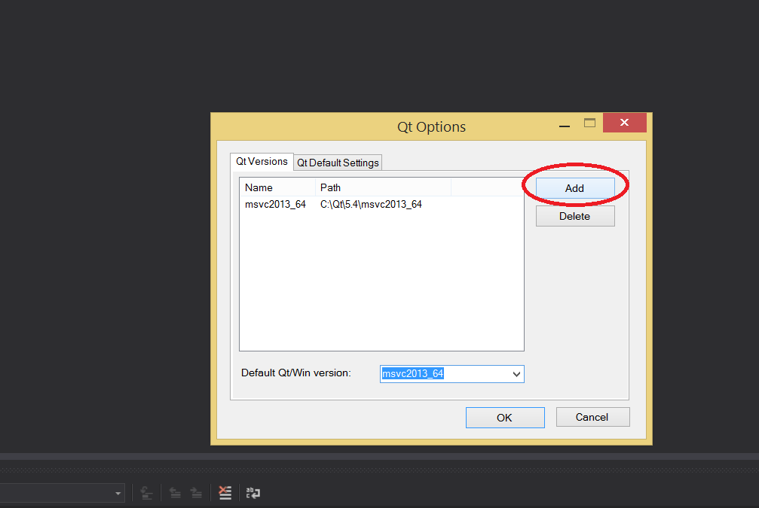

1. Click the Three dots to search for the Path of your Qt installation

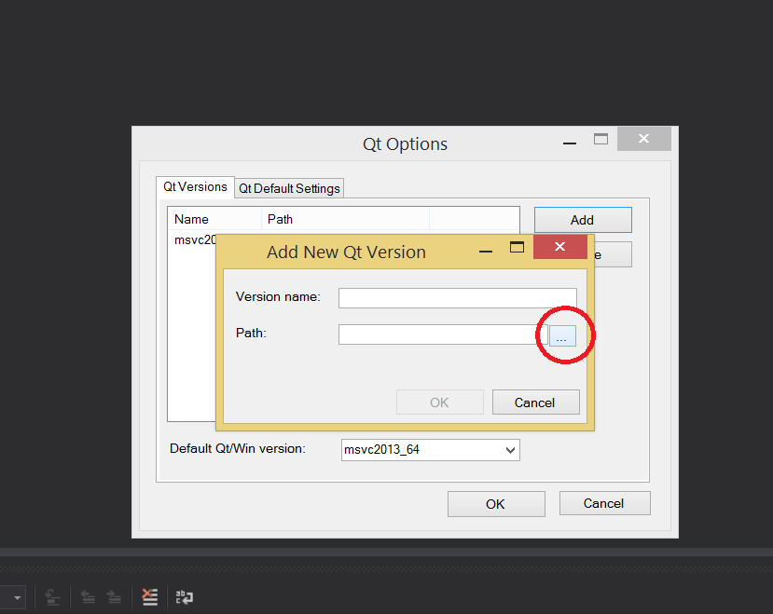

1. The path of your Qt installation is C:/Qt/5.4/msvc2013_64. Select this and hit OK

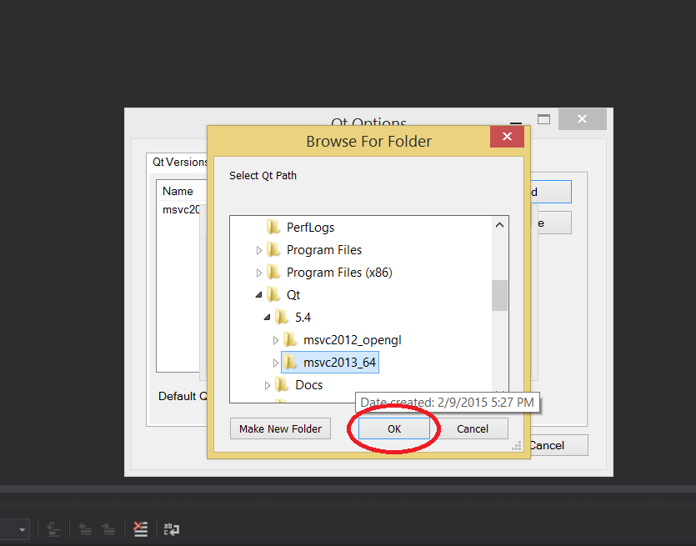

1. Click ok on all the prompts to go back to visual studio.
2. Close visual studio
3. Search for the location of the TAM Framework that you downloaded

**Multi-touch Installation**

1. Go into Code/TamVisualizer and Double click on TamVisualizer.sln

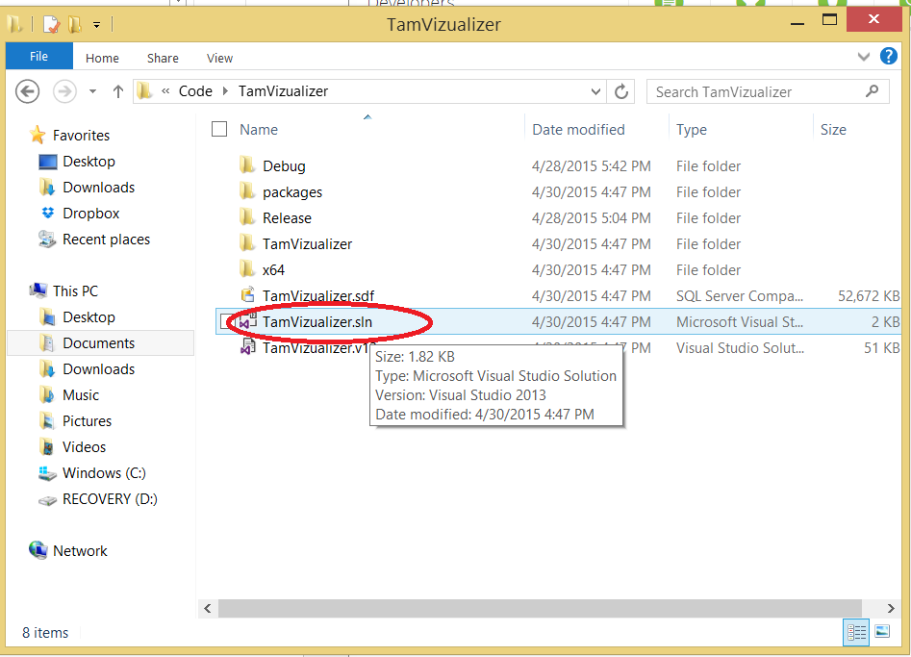

1. Wait for the solution to open, once it is open go back to the top left corner, click on QT5 tab, then click on Qt5 Project Settings

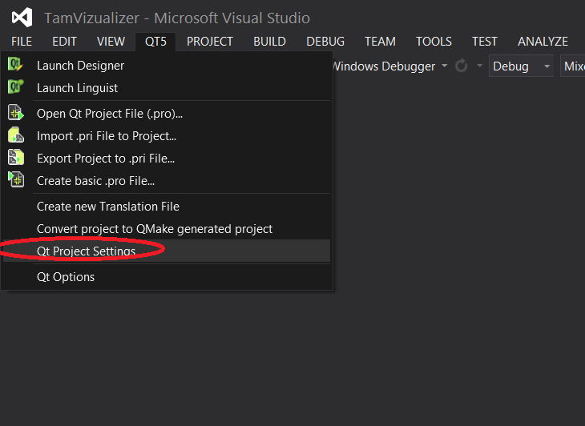

1. Make sure that the version is the one you selected previously msvc2013_64, if not select it from the dropdown

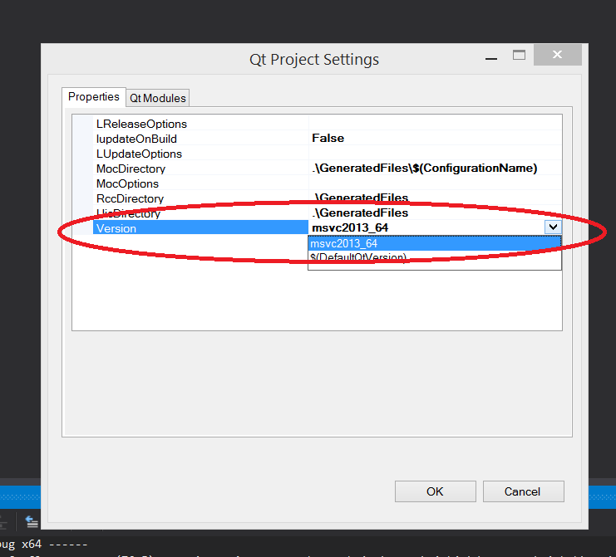

1. Build the solution, Click on Buid->Build Solution.

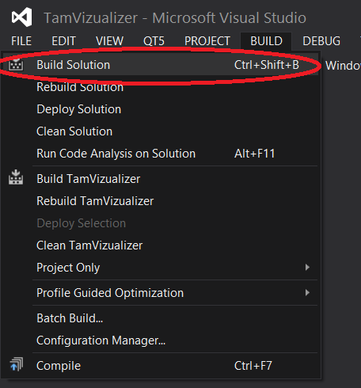

1. Run the solution.

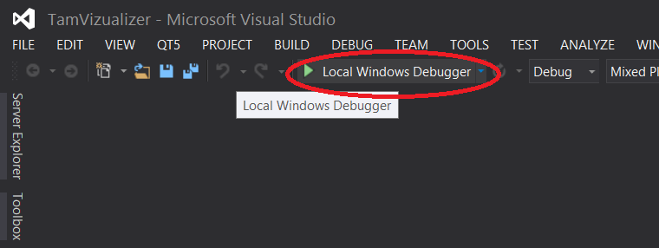

1. You are ready to start using the visualizer

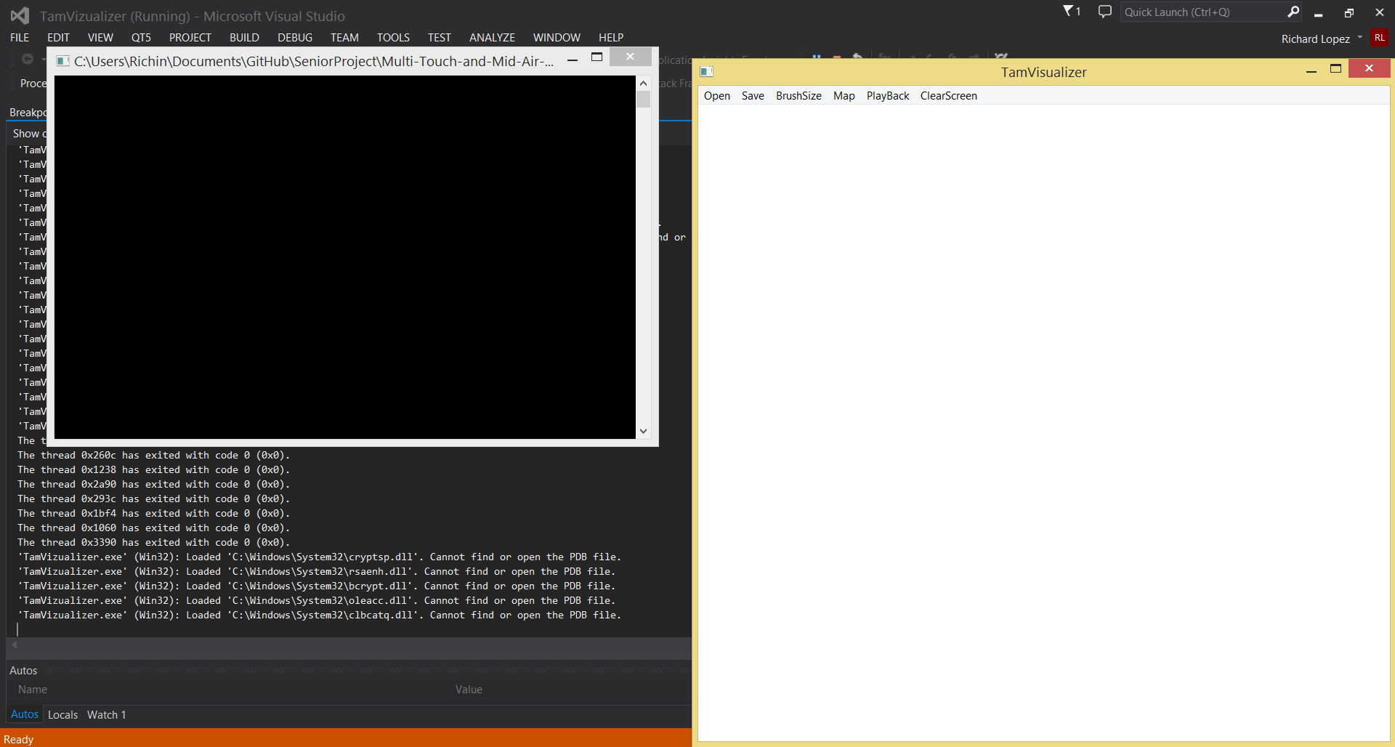

**Gyroscope Installation**

1. Start from step 12
2. Go to [www.yeitechnology.com](http://www.yeitechnology.com) and download the 3-space sensor suite and drivers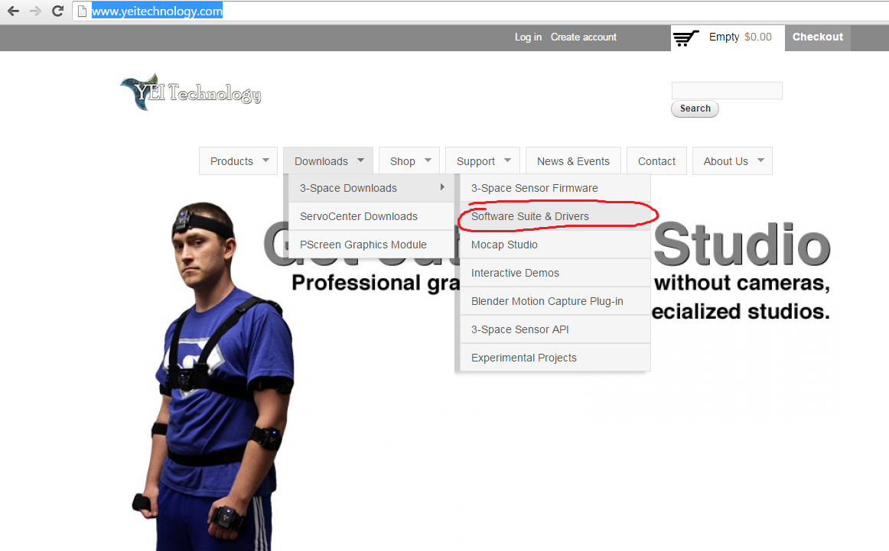
3. Follow the instructions on the download page and install the drivers for the YEI gyroscope
4. Search for the location of the TAM Framework that you downloaded
5. Go into Code\ TAM_GyroscopeVisualizer\ GyroscopeVisualizer
6. Open GyroscopeVisualizer.sln
7. Wait for the solution to open, once it is open go back to the top left corner, click on QT5 tab, then click on Qt5 Project Settings



1. Make sure that the version selected is the msvc2013_opengl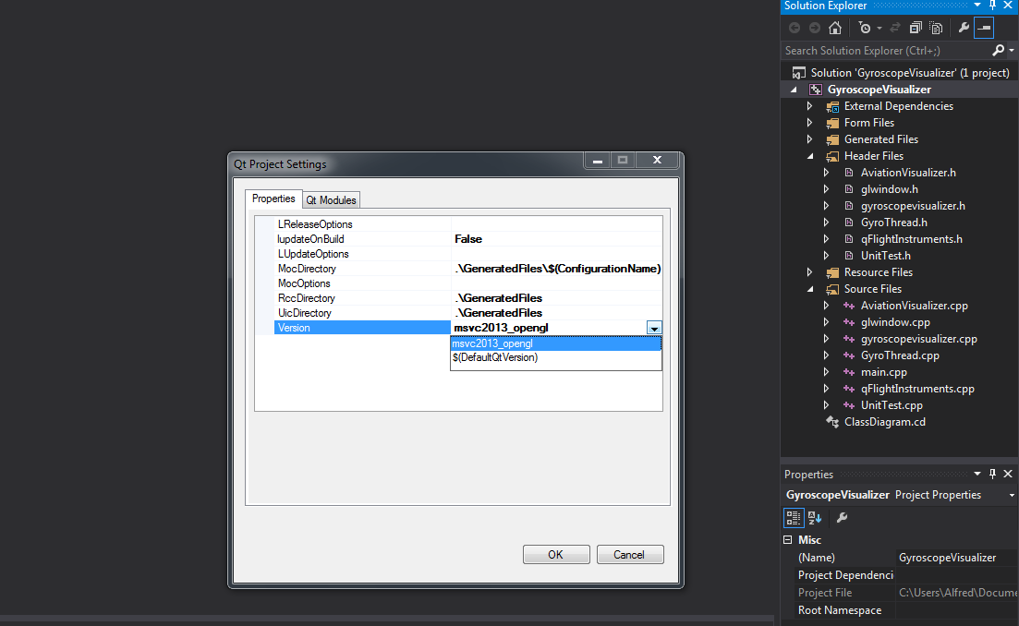
2. Go back to the location of the TAM Framework that you downloaded
3. Go into Code\ TAM_GyroscopeVisualizer\ GyroscopeVisualizer\GyroscopeVisualizer\ ThreeSpace_API_C_2.0.6.1
4. Copy the ThreeSpace_API.dll file found in that folder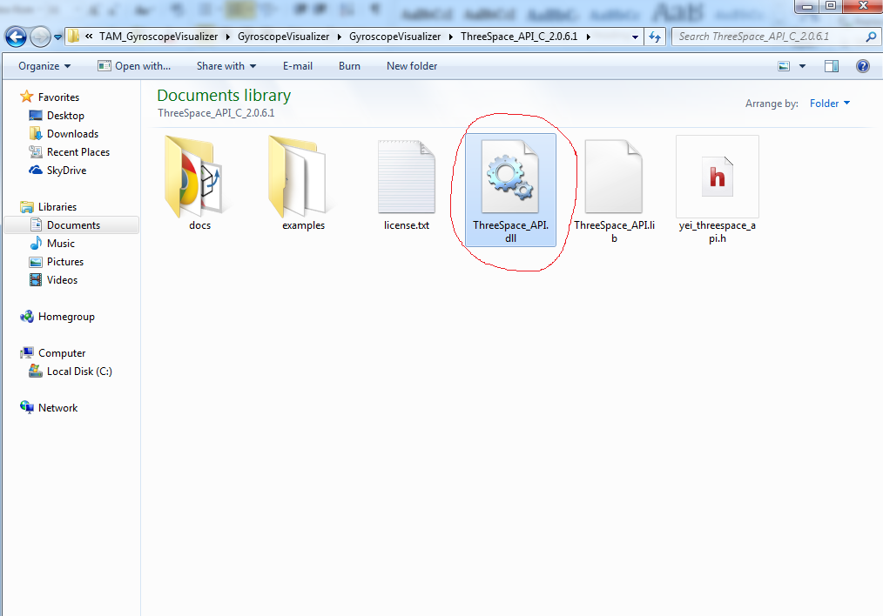
5. Paste the ThreeSpace_API.dll file into C:\Qt\Qt5.4.1\5.4\msvc2013_opengl\bin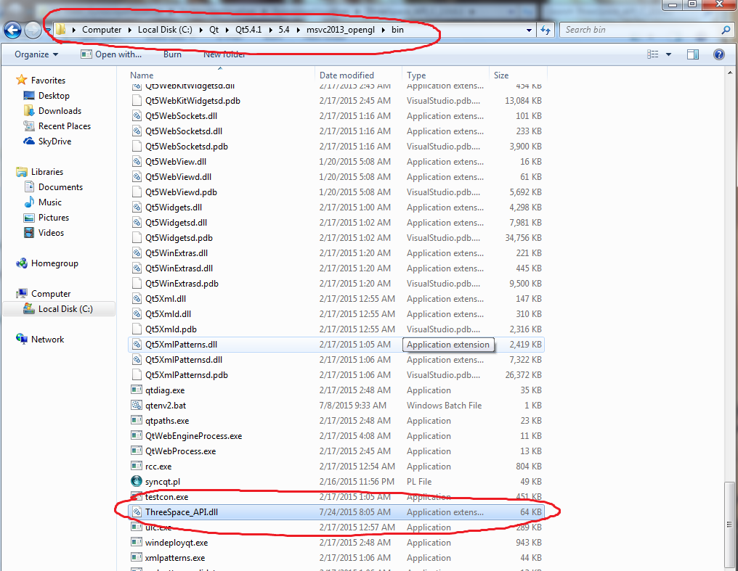
6. Return to Visual Studio and build the solution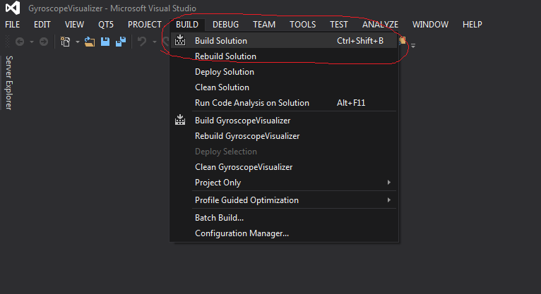
7. Run the program by using the Local Windows Debugger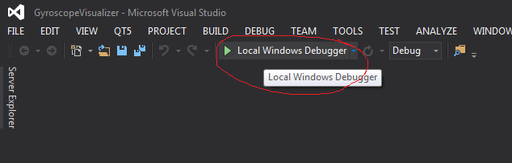
8. The Gyroscope Visualizer is ready for use