Senior Project CIS 4911-U01

Multi-Touch and Mid-Air Framework

Design Document

Team Number #

Team Members:

Anthony M. Amador

Richard  A. Lopez

January 28 2014

Mentor:

Francisco Ortega

Professor:

Masoud Sadjadi

# Abstract

# Table of Contents

Abstract 2

Table of Contents 3

Introduction 3

Problem definition (very similar to RD). 4

Design methodology used 4

Definitions, acronyms, and abbreviations. 4

Overview of document 4

System Design (i.e., overall system design) 5

Overview 5

Subsystem Decomposition 5

Hardware and Software Mapping 5

Persistent Data Management 5

Security/Privacy 5

Detailed Design 6

Overview 6

Static model 6

Dynamic model 6

Code Specification 6

Glossary - define terms used in document, especially domain specific terms. 7

Appendix 8

Appendix A - Use case diagram for use cases being implemented. 8

Appendix B - Use cases being implemented (from the RD). 8

Appendix C – Documented class interfaces (code) for the subsystem(s) you will implement and the constraints. 8

Appendix D - Diary of meeting and tasks. 8

References 9

# Introduction

Introduce the introduction (one or two paragraphs)

## Problem definition (very similar to RD).

## Design methodology used

## Definitions, acronyms, and abbreviations.

## Overview of document

# System Design (i.e., overall system design)

Introduce the system decomposition chapter (one or two paragraphs).

## Overview

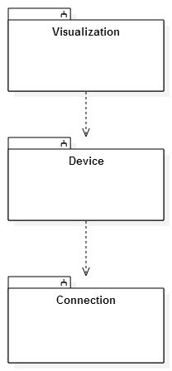

## Subsystem Decomposition

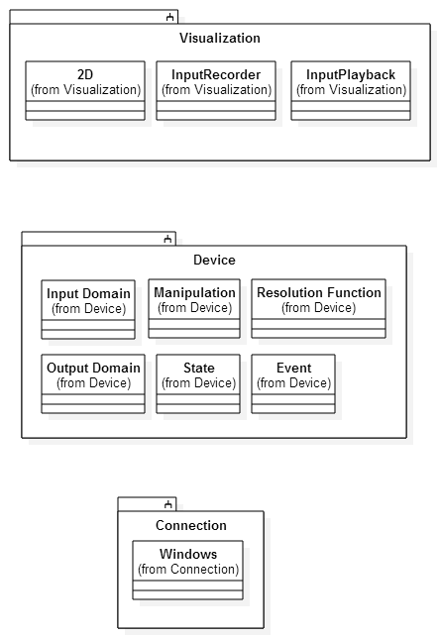

## Hardware and Software Mapping

## Persistent Data Management

## Security/Privacy

# Detailed Design

Introduce the detailed design chapter (one or two paragraphs)

## Overview

## Static model

## Dynamic model

## Code Specification

# Glossary - define terms used in document, especially domain specific terms.

# Appendix

## Appendix A - Use case diagram for use cases being implemented.

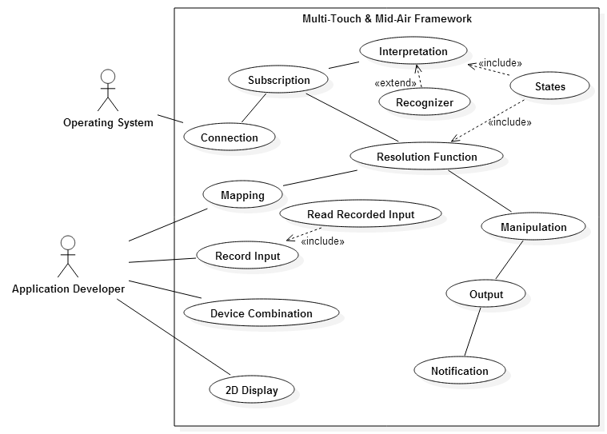

## Appendix B - Use cases being implemented (from the RD).

## Appendix C – Documented class interfaces (code) for the subsystem(s) you will implement and the constraints.

## Appendix D - Diary of meeting and tasks.

# References