Senior Project CIS 4911-U01

Multi-Touch and Mid-Air Framework

Feasibility Study and Project Plan

Team Number #

Team Members:

Anthony M. Amador

Richard  A. Lopez

January 28 2014

Mentor:

Francisco Ortega

Professor:

Masoud Sadjadi

# Abstract

This document outlines the feasibility of creating an API for the use of developers who want to create applications that use any type of input devices, focusing mainly on touch screens and mid-air inputs. Also covered on this document is the plan that we are to follow when developing this API and the necessary objects needed in place be it software or hardware objects.

This document will go over the current systems in place that are not meeting the expectations that our API will meet. It will describe the purpose of our software system and the alternative solutions that could be put in place to generate the expected functionality. The project plan will delineate the organization of the project, the team member that will take part in the development of the API and the hardware and software requirements for the system to be implemented.

# Table of Contents

Abstract 2

Table of Contents 3

Introduction 5

1.1 Problem definition 5

1.2 Background 5

1.3 Definitions, Acronyms and Abbreviations 5

1.4 Overview of document 5

2. Feasibility Study 6

2.1 Description of Current System (Limitations and Constraints) 6

2.2 Purpose of New System 6

2.3 High-level Definition of User Requirements (must include security/privacy) 6

2.4 Alternative Solutions 6

2.4.1 Description of Alternatives 6

2.4.2 Selection Criteria (Briefly describe the feasibility criteria used in the analysis component) 6

2.4.3 Analysis of Alternatives (refer to Appendix C - Feasibility Matrix-) - Score to compare the alternatives 6

2.5 Recommendations 6

3. Project Plan 8

3.1 Project Organization 8

3.1.1 Project Personnel Organization 8

3.1.2 Hardware and Software Resources 8

3.2 Identification of Tasks, Milestones and Deliverables (Work breakdown) 8

4. Appendix 9

4.1 Appendix A - Project Schedule (Gantt or PERT chart) 10

4.2 Appendix B - Feasibility Matrix 11

4.3 Appendix C - Cost Matrix 11

4.4 Appendix D - Diary of Meetings 11

5. References 11

# Introduction

Words go here

## 1.1 Problem definition

Words go here

## 1.2 Background

Words go here

## 1.3 Definitions, Acronyms and Abbreviations

Words go here

## 1.4 Overview of document

Words go here

# 2. Feasibility Study

Words go here

## 2.1 Description of Current System (Limitations and Constraints)

Words go here

## 2.2 Purpose of New System

Words go here

## 2.3 High-level Definition of User Requirements (must include security/privacy)

Words go here

## 2.4 Alternative Solutions

Words go here

### 2.4.1 Description of Alternatives

Words go here

### 2.4.2 Selection Criteria (Briefly describe the feasibility criteria used in the analysis component)

Words go here

### 2.4.3 Analysis of Alternatives (refer to Appendix C - Feasibility Matrix-) - Score to compare the alternatives

Words go here

## 2.5 Recommendations

Words go here

# 3. Project Plan

Words go here

## 3.1 Project Organization

Words go here

### 3.1.1 Project Personnel Organization

Words go here

### 3.1.2 Hardware and Software Resources

Words go here

## 3.2 Identification of Tasks, Milestones and Deliverables (Work breakdown)

Words go here

# 4. Appendix

Words go here

## 4.1 Appendix A - Project Schedule (Gantt or PERT chart)

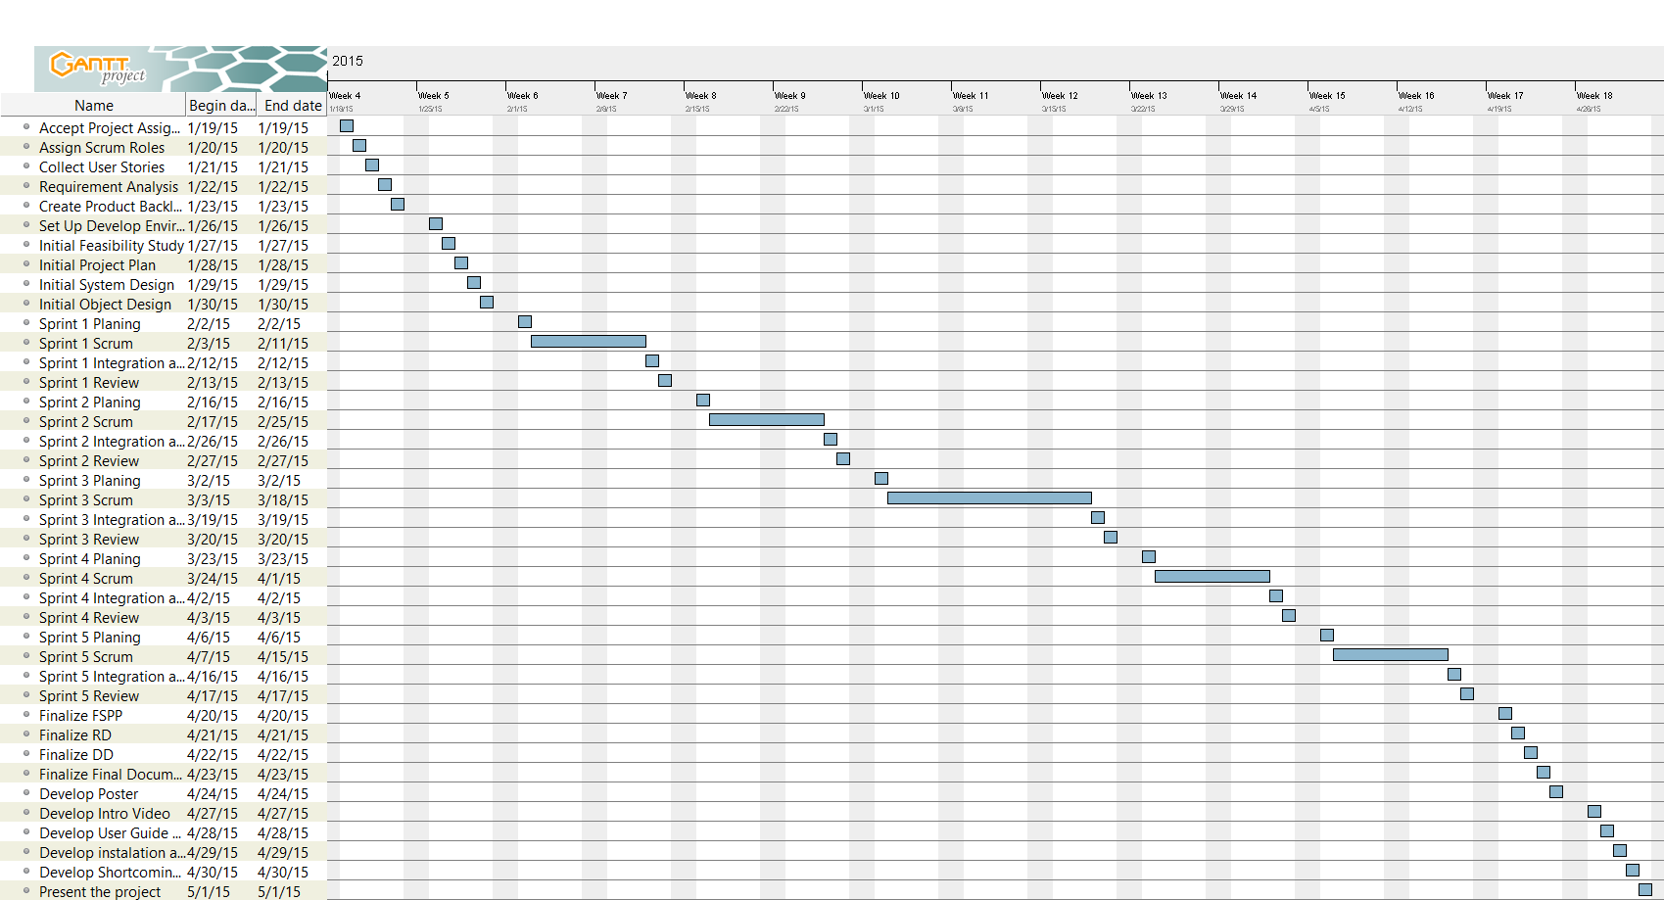

## 4.2 Appendix B - Feasibility Matrix

## 4.3 Appendix C - Cost Matrix

## 4.4 Appendix D - Diary of Meetings

# 5. References