Senior Project CIS 4911-U01

Multi-Touch and Mid-Air Framework

Visualizer

Requirements Document

Team Members:

Richard  A. Lopez

January 28 2014

Mentor:

Francisco Ortega

Professor:

Masoud Sadjadi

# Abstract

# Table of Contents

Abstract 2

Table of Contents 3

1. Introduction 4

1.1. Problem Definition. 4

1.2. Scope of system. 4

1.3. Terminology - Definitions, acronyms, and abbreviations. 4

1.4. Overview of document – brief explanation of what to expect in chapters 2 through 6. 4

2. Current System (limitations and problems) – either existing system or manual system that is being automated. 5

3. Project Plan (This deliverable only) 6

3.1. Project organization – assignment of roles for this deliverable. 6

3.2. Work breakdown – identification of milestones and deliverables (refer to project schedule in Appendix A and the diary in appendix B). 6

3.3. Cost Estimate – cost to develop the software system. 6

4. Proposed System Requirements 7

4.1. Functional Requirements – describes high-level functionality 7

4.2. Analysis of System Requirements 7

4.2.1. Scenarios 7

4.2.2. Use case model 7

4.2.3. Static model e.g., object diagrams, class diagram 7

4.2.4. Dynamic model e.g., sequence diagrams or state machines 7

5. Glossary - define terms used in document, especially domain specific terms. 8

6. Appendix 9

6.1. Appendix A - Complete use cases 9

6.2. Appendix B - Use case diagram using UML 9

6.3. Appendix C - Static UML diagram 9

6.4. Appendix D - Dynamic UML diagrams 9

6.5. Appendix E - User Interface designs. 9

6.6. Appendix F - Diary of meeting and tasks. 9

7. References 10

# Introduction

Introduce the introduction (one or two paragraphs)

## Problem Definition.

## Scope of system.

## Terminology - Definitions, acronyms, and abbreviations.

## Overview of document – brief explanation of what to expect in chapters 2 through 6.

# Current System (limitations and problems) – either existing system or manual system that is being automated.

# Project Plan (This deliverable only)

Introduce the project plan section (one or two paragraphs)

## Project organization – assignment of roles for this deliverable.

## Work breakdown – identification of milestones and deliverables (refer to project schedule in Appendix A and the diary in appendix B).

## Cost Estimate – cost to develop the software system.

# Proposed System Requirements

Introduce the chapter (one or two paragraphs)

## Functional Requirements – describes high-level functionality

For each functional requirement state the associated non-functional requirements, if any, for *Usability, Reliability, Performance,* and *Supportability*.

TAMUC01 The system shall subscribe to a windows service to receive touch events.

TAMUC02 The system shall allow a user to touch the screen with one or more fingers (Max 10) and draw on the screen.

TAMUC03 The system shall define the states of a touch event.

TAMUC04 The system shall use the X and Y coordinates and map them to a function.

TAMUC05 The system shall record input.

TAMUC06 The system shall replay the touch action in the order the action happened.

TAMUC07 The system shall allow for input to be saved to a file.

TAMUC08 The system shall read recorded input files and replay them.

TAMUC09 The system shall allow various sizes of touch visualization.

TAMUC10 The system shall allow the user to clear the screen and replay data at will.

TAMUC11 The system shall display all the information from the program to a debug monitor.

## Analysis of System Requirements

Analysis models – contains the complete functional specification and is mainly for the designers and programmers. This section describes the diagrams in the Appendices B - D and validates the models against the use cases.

### Scenarios

### Use case model

### Static model e.g., object diagrams, class diagram

### Dynamic model e.g., sequence diagrams or state machines

# Glossary - define terms used in document, especially domain specific terms.

# Appendix

## Appendix A - Complete use cases

**Use Case ID:** TAMUC01 – Subscription

**Use Case Level:** High-Level

**Details:**

* **Actors:** Operating System, Developer
* **Pre-conditions:**
  1. The system is capable of multi touch input (Touch Screen)
* **Description:**
  1. Use case begins when the application is started.
  2. The system creates a listener service that subscribes to the touch events in the draw area.
  3. The use case ends when the system receives the subscription ticket.
* **Post-conditions:**
  1. The system is ready to start receiving touch events in the draw area.
* **Alternative Courses of Action:**

n/a

* **Exceptions:**

The system cannot connect to the touch event service.

* **Related Use Cases:**
  1. TAMUC02
  2. TAMUC03
  3. TAMUC04
  4. TAMUC05
  5. TAMUC07

**---------------------------------------------------------------------------------------------------------------------**

**Decision Support**

**Frequency:** On average, 1-10’000 touch events per second.

**Criticality:** High. The Framework cannot be tested if the touch input cannot be received.

**Risk:** Medium. The subscription service depends on the Windows operating system.

**---------------------------------------------------------------------------------------------------------------------**

**Constraints:**

* Usability: No Human User
* Reliability: The system shall recognize 10 inputs maximum and up to 10’000 different touch events per second.
* Performance: The input position should be within ±0.5 mm of the touch screen position.
* Supportability: The screens with multi-touch capabilities cannot exceed 10 fingers at the same time.
* Security: n/a

---------------------------------------------------------------------------------------------------------------------

**---------------------------------------------------------------------------------------------------------------------**

**Use Case ID:** TAMUC02 – Draw Action

**Use Case Level:** High-Level

**Details:**

* **Actors:** Developer
* **Pre-conditions:**
  1. The Application has been launched
  2. The screen is cleared or its started as a new blank canvas
* **Description:**
  1. Use case begins when the user touches the screen with 1-10 fingers inside the “drawing area”
  2. The system shall obtain the X and Y coordinates and use the mapping function selected (TAMUC04-Mapping)
  3. The system shall display a point the size which has been selected (TAMUC09– Resize) at the position designated by the Mapping function.
  4. The user continues the drawing without lifting the finger(s).
  5. The System continues to trace all of the points while simultaneously saving the points (TAMUC07-Record)
  6. The use case ends whenever the user lifts their finger(s) from the screen.
* **Post-conditions:**
  1. The screen allows for another draw gesture.
* **Alternative Courses of Action:**
  1. The user after lifting finger(s) touches the draw area again and continues drawing.
* **Exceptions:**

The user asks another person for them to draw at the same time as him/her; making it more than 10 inputs (the system will only draw original 10).

* **Related Use Cases:**
  1. TAMUC05
  2. TAMUC07
  3. TAMUC09

**---------------------------------------------------------------------------------------------------------------------**

**Decision Support**

**Frequency:** On average, 1-10’000 touch events per second.

**Criticality:** High. The Framework cannot be tested if 2D representation is not available.

**Risk:** Low. The implementation can only fail by not drawing an input.

**---------------------------------------------------------------------------------------------------------------------**

**Constraints:**

* Usability: No previous Training Time
* Reliability: The system shall recognize 10 inputs maximum and up to 10’000 different touch events per second.
* Performance: The displayed points should appear in less than ¼ of a second
* Supportability: The screens with multi-touch capabilities cannot exceed 10 fingers at the same time.
* Security: n/a

---------------------------------------------------------------------------------------------------------------------

**---------------------------------------------------------------------------------------------------------------------**

**Use Case ID:** TAMUC03 – States

**Use Case Level:** High-Level

**Details:**

* **Actors:** Developer
* **Pre-conditions:**
  1. The Application has been launched
  2. The screen is cleared or its started as a new blank canvas
* **Description:**
  1. Use case begins when the user touches the screen with 1-10 fingers inside the “drawing area”
  2. The Operating system flags the touch even and sends the touch signal and information to the application.
  3. The application receives the touch event “Touching” and labels it at such.
  4. The user moves their finger(s) across the draw area.
  5. The Operating system flags the touch event and sends the touch signal information to the application.
  6. The application receives the touch event “Moving” and labels it as such.
  7. The user lifts their finger(s) from the draw area.
  8. The Operating system flags the touch event and sends the touch signal information to the application.
  9. The application receives the touch event “Lifted” and labels it at such.
  10. The use case ends after the event “Lifted” is received.
* **Post-conditions:**
  1. The screen allows for another draw gesture.
* **Alternative Courses of Action:**
  1. The user after lifting finger(s) touches the draw area again and continues drawing.
* **Exceptions:**

The user asks another person for them to draw at the same time as him/her; making it more than 10 inputs (the system will only draw original 10).

* **Related Use Cases:**
  1. TAMUC01
  2. TAMUC02
  3. TAMUC04
  4. TAMUC05
  5. TAMUC07

**---------------------------------------------------------------------------------------------------------------------**

**Decision Support**

**Frequency:** On average, 1-10’000 touch events per second.

**Criticality:** High. The Framework cannot be tested if the touch events cannot be differentiated.

**Risk:** Low. The application does not fail if a touch event is not received.

**---------------------------------------------------------------------------------------------------------------------**

**Constraints:**

* Usability: No previous Training Time
* Reliability: The system shall recognize 10 inputs maximum and up to 10’000 different touch events per second.
* Performance: The touch events should be sent and received in less than 1/10000 of a second.
* Supportability: The screens with multi-touch capabilities cannot exceed 10 fingers at the same time.
* Security: n/a

---------------------------------------------------------------------------------------------------------------------

**---------------------------------------------------------------------------------------------------------------------**

**Use Case ID:** TAMUC04 – Mapping

**Use Case Level:** High-Level

**Details:**

* **Actors:** Developer
* **Pre-conditions:**
  1. The Application has been launched
  2. The screen is cleared or its started as a new blank canvas
  3. TAMUC01 is in step 2 of the description.
* **Description:**
  1. Use case begins when the user selects the mapping menu.
  2. The system displays a selection of all the available mapping functions.
  3. The user selects the desired mapping function.
  4. The system then keeps the selected mapping in memory whenever an input is obtained.
  5. The system shall compute the output coordinates based on the selected mapping function (use 1 to 1 if no function selected).
  6. The System traces all of the points while simultaneously saving the points (TAMUC07-Record)
  7. The use case ends when the last input is mapped to its output, displayed and saved.
* **Post-conditions:**
  1. The screen allows for another draw gesture.
  2. The latest selected mapping function remains active
* **Alternative Courses of Action:**
  1. The user after lifting finger(s) touches the draw area again and continues drawing.
  2. The user selects a different mapping function.
* **Exceptions:**

N/A

* **Related Use Cases:**
  1. TAMUC02

**---------------------------------------------------------------------------------------------------------------------**

**Decision Support**

**Frequency:** On average, 1-10 changes in the mapping function for every input test.

**Criticality:** Medium. Mapping functions can be used or 1 to 1 as crude testing implements.

**Risk:** Low. The default 1 to 1 mapping creates a safe fall.

**---------------------------------------------------------------------------------------------------------------------**

**Constraints:**

* Usability: No previous Training Time
* Reliability: The system shall map the output to two ½ a pixel from the received input.
* Performance: The displayed points should appear in less than ¼ of a second
* Supportability: The screens with multi-touch capabilities cannot exceed 10 fingers at the same time. The mapping function shall not exceed the edges of the drawing area.
* Security: n/a

---------------------------------------------------------------------------------------------------------------------

**---------------------------------------------------------------------------------------------------------------------**

**Use Case ID:** TAMUC05 – Input Recording

**Use Case Level:** High-Level

**Details:**

* **Actors:** Developer
* **Pre-conditions:**
  1. The Application has been launched
  2. The screen is cleared or its started as a new blank canvas
* **Description:**
  1. Use case begins when the user touches the screen.
  2. The system stores the X and Y coordinate, the ID of the finger, and a timestamp of the touch event.
  3. The user continues to touch the screen and move their fingers around the draw area.
  4. The system records each touch even and adds it at the end of a list.
  5. The use case ends when the user lifts all fingers from the draw screen and selects either replay, save, or closes the application.
* **Post-conditions:**
  1. The screen allows for another draw gesture.
  2. The system continues to wait for the user to end the current test.
* **Alternative Courses of Action:**
  1. The user after lifting finger(s) touches the draw area again and continues drawing.
* **Exceptions:**

The maximum number of touch points is reached.

* **Related Use Cases:**
  1. TAMUC02

**---------------------------------------------------------------------------------------------------------------------**

**Decision Support**

**Frequency:** On average, 1-10,000 touch events per second.

**Criticality:** High, It is necessary for the input to be saved so that the replay can happen and the visualizer performs its task.

**Risk:** Medium. The size of the input data may slow down the system while displaying the dots or while playing the recorded data back.

**---------------------------------------------------------------------------------------------------------------------**

**Constraints:**

* Usability: No previous Training Time
* Reliability: The system shall add the input to the list in less than 1/100 of a second.
* Performance: There list should be able to handle 1 Million touch points without noticeable system slowness.
* Supportability: The screens with multi-touch capabilities cannot exceed 10 fingers at the same time.
* Security: n/a

---------------------------------------------------------------------------------------------------------------------

**---------------------------------------------------------------------------------------------------------------------**

**Use Case ID:** TAMUC07 – Saving Input to a file

**Use Case Level:** High-Level

**Details:**

* **Actors:** Developer
* **Pre-conditions:**
  1. The Application has been launched
  2. The screen is cleared or its started as a new blank canvas
  3. The user has drawn on the draw area
* **Description:**
  1. Use case begins when the user selects the “Save” option.
  2. The system prompts the user for a filename and a file type. (CSV is default).
  3. The user selects file path and enters the name of the file (UNTITLED is default).
  4. The user selects the save button.
  5. The system creates the file with the name provided and saves each touch point in the order that the touch action happened.
  6. The use case ends when the system writes the last touch point in the file and closes the file.
* **Post-conditions:**
  1. The screen allows for another draw gesture.
  2. The file is ready to be read from.
* **Alternative Courses of Action:**
  1. The user cancels the save.
* **Exceptions:**

There might not be any touch points (empty file).

* **Related Use Cases:**
  1. TAMUC02
  2. TAMUC05

**---------------------------------------------------------------------------------------------------------------------**

**Decision Support**

**Frequency:** On average 5 saves for every touch test.

**Criticality:** Medium. The ability to save is necessary for replays of older actions, an immediate replay is more important as implemented in TAMUC06 Playback.

**Risk:** Low. If the saving action fails it only cancels the save then the user might save again.

**---------------------------------------------------------------------------------------------------------------------**

**Constraints:**

* Usability: No previous Training Time
* Reliability: The system shall write the input list to the file for every touch event.
* Performance: There file should be able to handle 1 Million touch points without noticeable system slowness.
* Supportability: The screens with multi-touch capabilities cannot exceed 10 fingers at the same time. The file needs to be saved in a Comma Separated Value file to be used by TAMUC08
* Security: n/a

---------------------------------------------------------------------------------------------------------------------

**---------------------------------------------------------------------------------------------------------------------**

**Use Case ID:** TAMUC08 – Playback from a File

**Use Case Level:** High-Level

**Details:**

* **Actors:** Developer
* **Pre-conditions:**
  1. The Application has been launched
  2. The screen is cleared or its started as a new blank canvas
  3. A file with a list of touch points has been created
* **Description:**
  1. Use case begins when the user selects the “Open” option.
  2. The system prompts the user to select the path of the file and the file to be replayed.
  3. The user navigates to the file location, selects the file and selects the “Open” option
  4. The system opens the file, and reads from it while saving the touch points to the replay list.
  5. The system replays the touch points per TAMUC06 Replay.
  6. The use case ends when the last touch point on the file has been replayed.
* **Post-conditions:**
  1. The screen allows for another draw gesture.
  2. The system allows for replay of the file since it has been open once already.
* **Alternative Courses of Action:**
  1. The user might cancel the open action by not selecting a file and selecting the “Cancel Option”
* **Exceptions:**

N/A

* **Related Use Cases:**
  1. TAMUC02
  2. TAMUC06

**---------------------------------------------------------------------------------------------------------------------**

**Decision Support**

**Frequency:** On average, 5 opens per touch test.

**Criticality:** Medium, immediate replay is more necessary than opening files previously saved.

**Risk:** Medium. The size of the input data may slow down the system while displaying the dots or while playing the recorded data back.

**---------------------------------------------------------------------------------------------------------------------**

**Constraints:**

* Usability: No previous Training Time
* Reliability: The system shall add the input to the list in less than 1/100 of a second.
* Performance: There list should be able to handle 1 Million touch points without noticeable system slowness.
* Supportability: The file type has to be a Comma Separated Value type.
* Security: n/a

---------------------------------------------------------------------------------------------------------------------

---------------------------------------------------------------------------------------------------------------------

**Use Case ID:** TAMUC06 – Playback

**Use Case Level:** High-Level

**Details:**

* **Actors:** Developer
* **Pre-conditions:**
  1. The Application has been launched
  2. The screen is cleared or its started as a new blank canvas
* **Description:**
  1. Use case begins when the developer touches the screen with 1-10 fingers
  2. The system shall store the coordinate data from the touch event.(TAMUC04)
  3. The developer stops touching the screen.
  4. The developer chooses the “Playback” button
  5. Use case ends when the system replays the touch events from the stored data
* **Post-conditions:**
  1. The next time a developer causes a touch event the last touch event to be replayed gets replaced by the newest touch event.
* **Alternative Courses of Action:**
  1. The developer may choose to clear the screen and create a new touch event without replaying the previous touch event
* **Exceptions:**

None.

* **Related Use Cases:**
  1. TAMUC04

**---------------------------------------------------------------------------------------------------------------------**

**Decision Support**

**Frequency:** On average, 2-5 playbacks every 10 minutes.

**Criticality:** High. The Framework cannot be tested if a playback is not possible.

**Risk:** Low. The system is independent of the playback until it becomes time to replay, therefore it is not necessary to integrate and can be a module loaded when needed.

**---------------------------------------------------------------------------------------------------------------------**

**Constraints:**

* Usability: No previous Training Time
* Reliability: The system shall replay the touch events up to ½ mm precision.
* Performance: The replay should load in no more than 1 second
* Supportability: The screens with multi-touch capabilities cannot exceed 10 fingers at the same time.
* Security: n/a

---------------------------------------------------------------------------------------------------------------------

**Use Case ID:** TAMUC09 – Resize

**Use Case Level:** High-Level

**Details:**

* **Actors:** Developer
* **Pre-conditions:**
  1. The Application has been launched
  2. The screen is cleared or its started as a new blank canvas
* **Description:**
  1. Use case begins when the user selects the “Size” option.
  2. The system displays a selection of all the available sizes that can be applied to the touch visualization.
  3. The user selects the size wanted.
  4. Use case ends when the system applies the selected size brush to any future touch event.
* **Post-conditions:**
  1. The next time a developer causes a touch event the displayed brush output will be the size selected by the user.
* **Alternative Courses of Action:**
  1. The developer may choose to select a different size after the first selection.
* **Exceptions:**

None.

* **Related Use Cases:**
  1. TAMUC02
  2. TAMUC04

**---------------------------------------------------------------------------------------------------------------------**

**Decision Support**

**Frequency:** On average, 5-10 resize events per minute.

**Criticality:** Medium. Resizing is a secondary need to be able to determine the precision of the touch mapping.

**Risk:** Low. The Resizing event changes the size of the drawing brush and no other aspects.

**--------------------------------------------------------------------------------------------------------------------**

**Constraints:**

* Usability: No previous Training Time
* Reliability: The size selected is to be used every time, no failures are acceptable.
* Performance: The change in the size should be available immediately after selecting it.
* Supportability: Brush sizes 5 - 100.
* Security: n/a

**---------------------------------------------------------------------------------------------------------------------**

**---------------------------------------------------------------------------------------------------------------------**

**Use Case ID:** TAMUC010 – Clear Screen

**Use Case Level:** High-Level

**Details:**

* **Actors:** Developer
* **Pre-conditions:**
  1. The Application has been launched
  2. The screen has been drawn to
* **Description:**
  1. Use case begins when the user selects the “Clear” option.
  2. The system creates a new blank canvas the size of the draw area.
  3. Use case ends when the system replaces the old canvas with the new canvas and displays it to the user.
* **Post-conditions:**
  1. The draw area will be clear allowing for new touch events to happen.
* **Alternative Courses of Action:**
  1. The developer may choose to clear the screen more than once consecutively.
* **Exceptions:**

None.

* **Related Use Cases:**
  1. TAMUC02
  2. TAMUC04

**---------------------------------------------------------------------------------------------------------------------**

**Decision Support**

**Frequency:** On average, 1 – 30 clear events per minute.

**Criticality:** High. For the touch replays and the touch events to be studied there is a need to have a clear canvas.

**Risk:** Low. The new blank canvas can be created in a secondary process to that of the touch actions.

**---------------------------------------------------------------------------------------------------------------------**

**Constraints:**

* Usability: No previous Training Time
* Reliability: For every 1 million clear events the screen should clear 999,999 times.
* Performance: The screen shall appear blank in less than 1/1000 of a second
* Supportability: The new canvas should support screens of all sizes.
* Security: n/a

**---------------------------------------------------------------------------------------------------------------------**

**Use Case ID:** TAMUC011 – Debug

**Use Case Level:** High-Level

**Details:**

* **Actors:** Developer
* **Pre-conditions:**
  1. The Application has been launched
* **Description:**
  1. Use case begins when the application first launches.
  2. The system opens a window displaying a debug terminal.
  3. As the actor uses the program any message resulting form that will be displayed in this debug monitor.
  4. Use case ends when the user closes the application.
* **Post-conditions:**
  1. Closing the debug monitor causes the program to close.
* **Alternative Courses of Action:**
  1. The developer may choose to close the program but not the debug monitor.
* **Exceptions:**

None.

* **Related Use Cases:**

n/a

**---------------------------------------------------------------------------------------------------------------------**

**Decision Support**

**Frequency:** On average, 1 – 10,000 messages per minute.

**Criticality:** Medium. The debug monitor is a secondary instance to the main application.

**Risk:** Low. The debug has no connection to the application the messages only go one way from the application to the debug.

**---------------------------------------------------------------------------------------------------------------------**

**Constraints:**

* Usability: No previous Training Time
* Reliability: For every 1 million messages 1 missed message and 999,999 written.
* Performance: The information being displayed shall do so in less than 1/1000 of a second
* Supportability: The debug monitor is a Windows application and shall only work in Windows Operating Systems.

**---------------------------------------------------------------------------------------------------------------------**

**---------------------------------------------------------------------------------------------------------------------**

## Appendix B - Use case diagram using UML

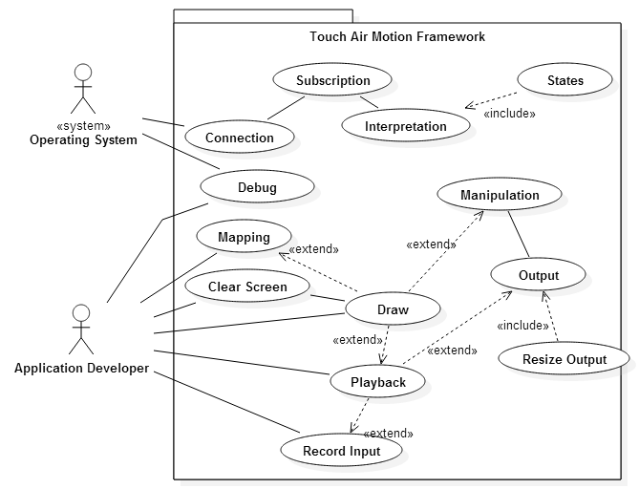

## Appendix C - Static UML diagram

## C:\Users\Richin\Documents\Diagrams\ClassDiagram1.png

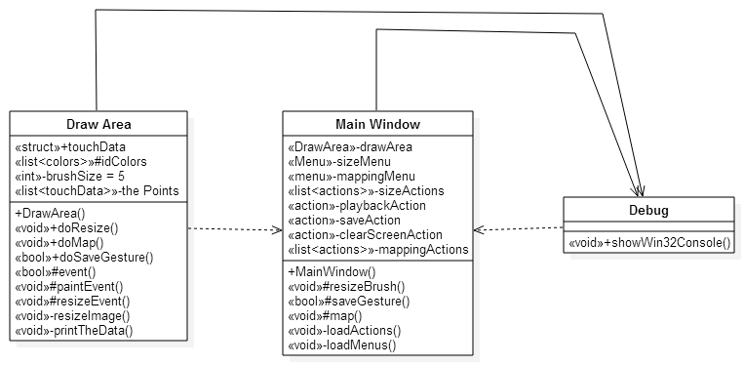

## Appendix D - Dynamic UML diagram

## C:\Users\Richin\Documents\Diagrams\TAMUC01-Subscription.png

Fig.

## C:\Users\Richin\Documents\Diagrams\TAMUC02-Draw.png

## Fig.

## C:\Users\Richin\Documents\Diagrams\TAMUC03-States.png

## Fig

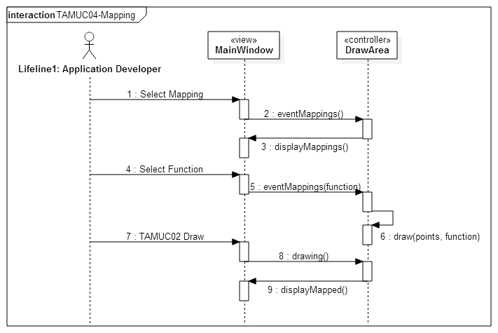Fig

## C:\Users\Richin\Documents\Diagrams\TAMUC07-Playback.pngFig

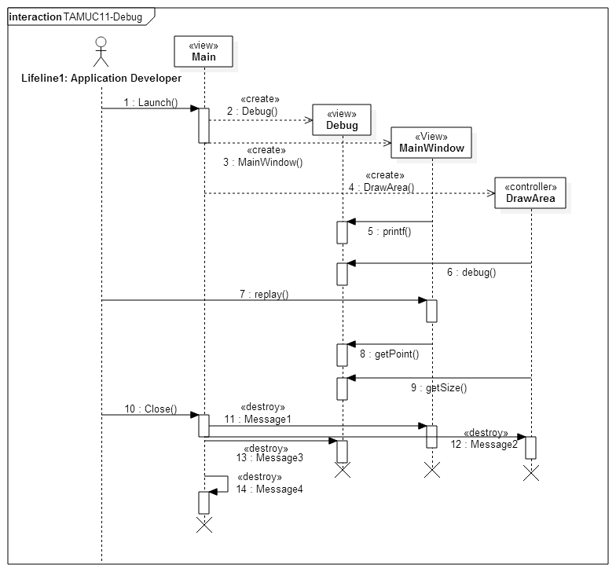Fig.

## 

## Appendix E - User Interface designs.

## Appendix F - Diary of meeting and tasks.

# References