Taken from Senior Project Version 3:

To deploy the current system on an existing server that has been set up:

1. Connect to the existing server using an SFTP tool like FileZilla.
2. Navigate to “/var/html/www/”
3. In the “Local site:” pane:

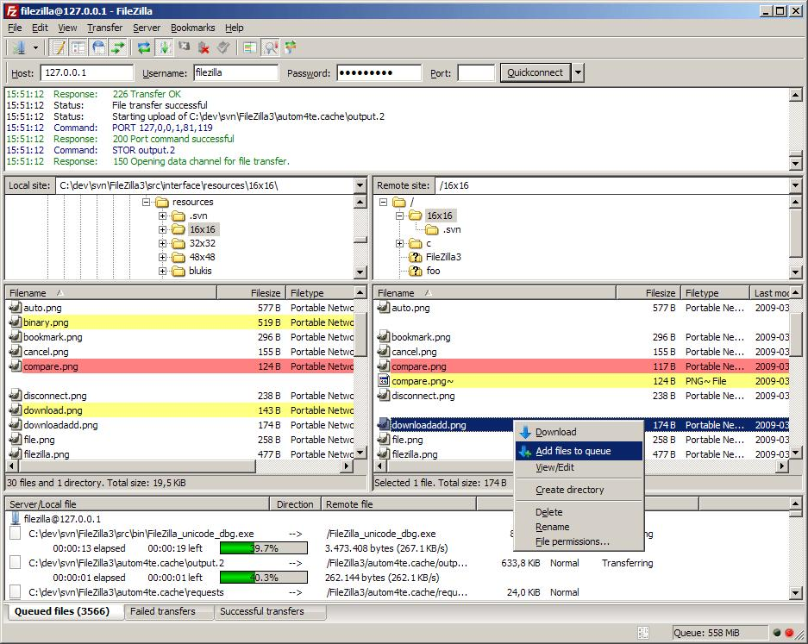

Navigate to the directory containing the “senior-project-devel” folder

1. Now right click that file and click on the upload button
2. Now you should be able to navigate in your browser to: a. http://<hostname URL>/senior-projects/
3. The site will now be available on the server.