

Student User Guide

Senior Project Website

S e n i o r P r o j e c t | Spring 2015 **3**



**Copyright**

*All title, including but not limited to copyrights, in and to the SENIOR PROJECT WEBSITE are owned by School of Computing and Information Sciences Faculty of Florida International University. All title and intellectual property rights in and to the content which may be accessed through use of the SENIOR PROJECT WEBSITE is the property of the respective content owner and may be protected by applicable copyright or other intellectual property laws and treaties. This EULA grants you no rights to use such content. All rights not expressly granted are reserved by School of Computing and Information Sciences Faculty of Florida International University.*

S e n i o r P r o j e c t | Spring 2015 **4**

**Student User Instructions for SPWv5.**

**Student creates a virtual machine request**

1. 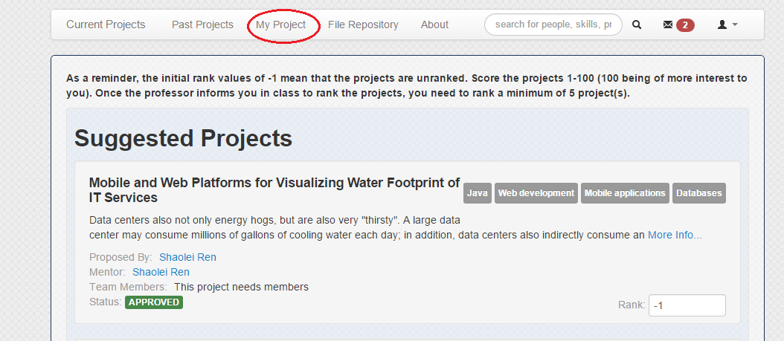After professor notified you choose a project deadline is over, go to My Project page
2. Then you will see a button called Create VM-Request, click on the button to navigate to the page

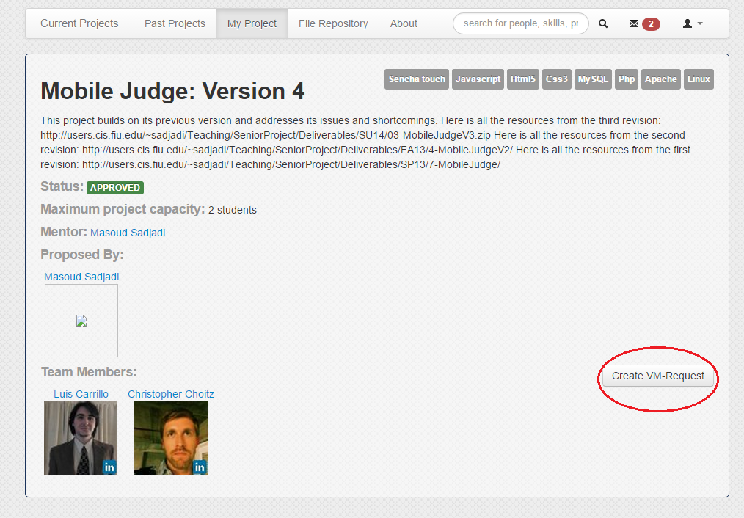

1. Once you are on VM – Request page, select the virtual machine settings from a drop-down list

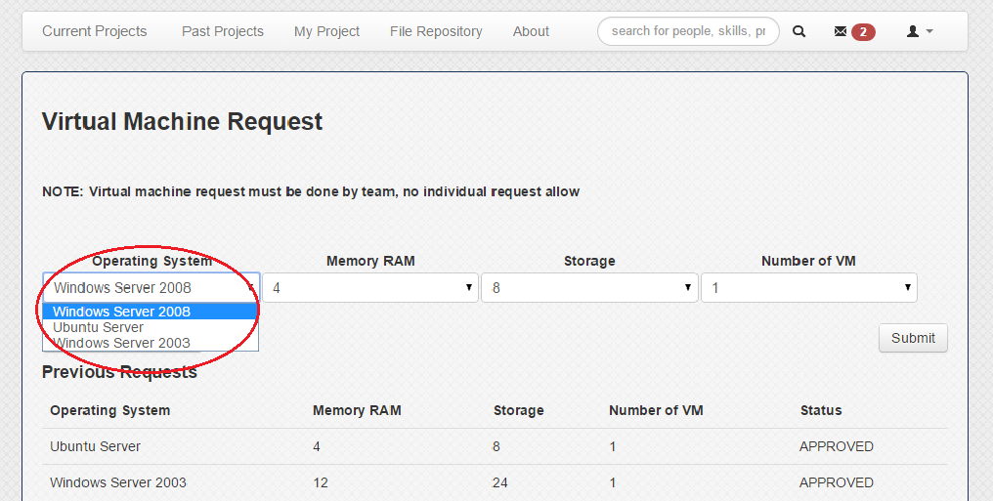

1. 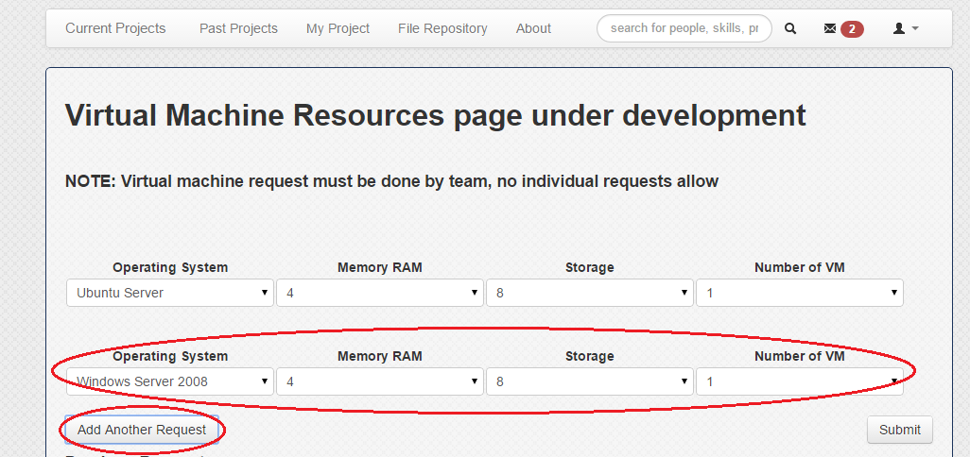To do multiple virtual machine request, click button Add Another Request and a new virtual machine request will show
2. Once you have finished selecting all virtual machine settings, you should then click button Submit to submit your request

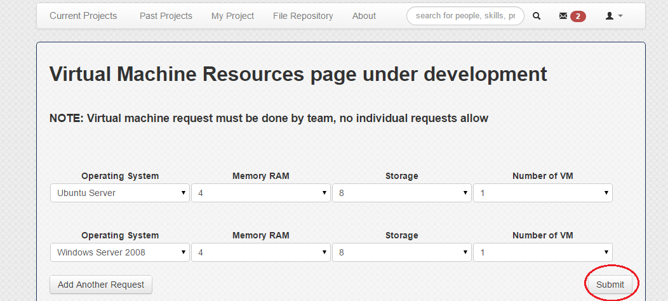

1. 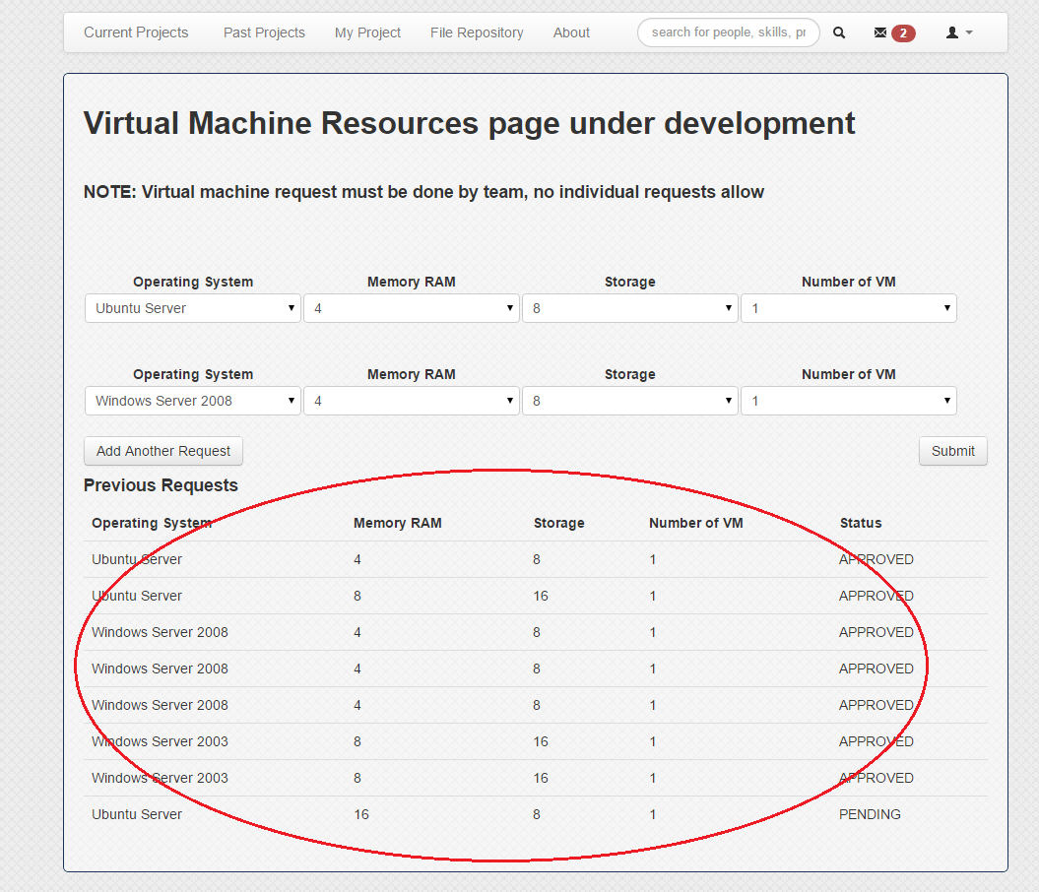After clicking the Submit button, the just submitted requests will show bellow under Previous Request title, informing you of the status of the requests you have submitted

**Student User Instructions for SPWv4.**

**Matching Algorithm Subsystem**

How to Rank

1. After navigating to the respective URL, you should be at a login page.

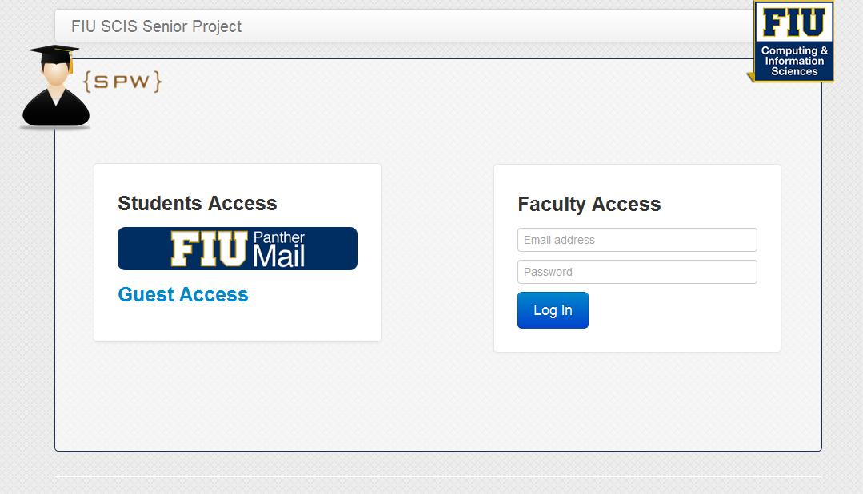

1. Under “Students Access”, you should click the FIU Panther Mail link and login using your FIU credentials at the redirected page shown in Figure 4.1.

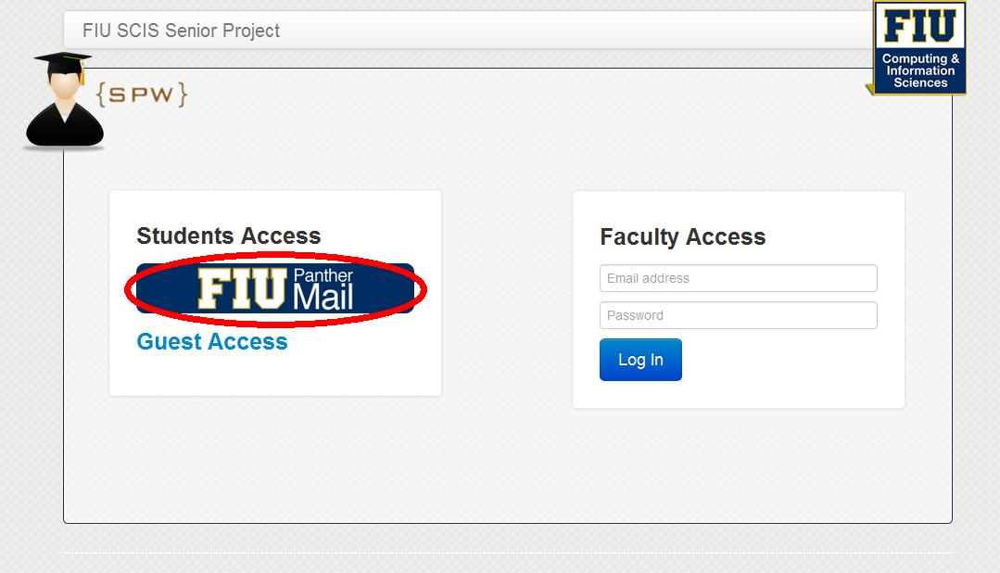

S e n i o r P r o j e c t | Spring 2014 **8**

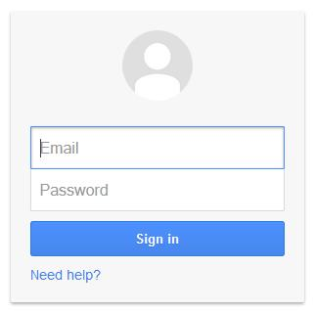

Figure 4.1 – FIU Login

1. After successfully logged in, you should be redirected to a page that shows all the available projects that the professor has approved.

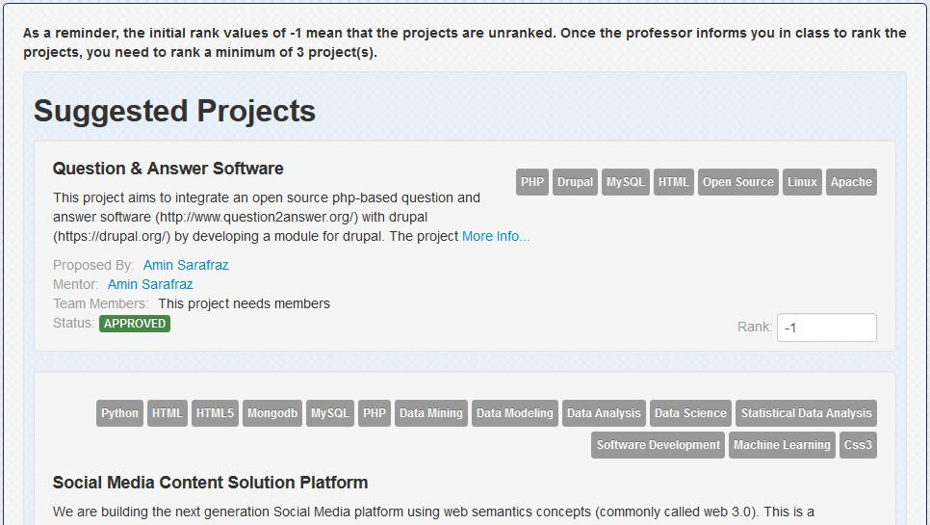

S e n i o r P r o j e c t | Spring 2014 **9**



1. In the “Rank:” textboxes, you should now rank by interest the minimum number of projects that the professor has set, with the knowledge that same rank numbers are weighted as equal interest and as the numbers descend, the interest decrease. The -1 values are set to mean that the project has not been ranked.

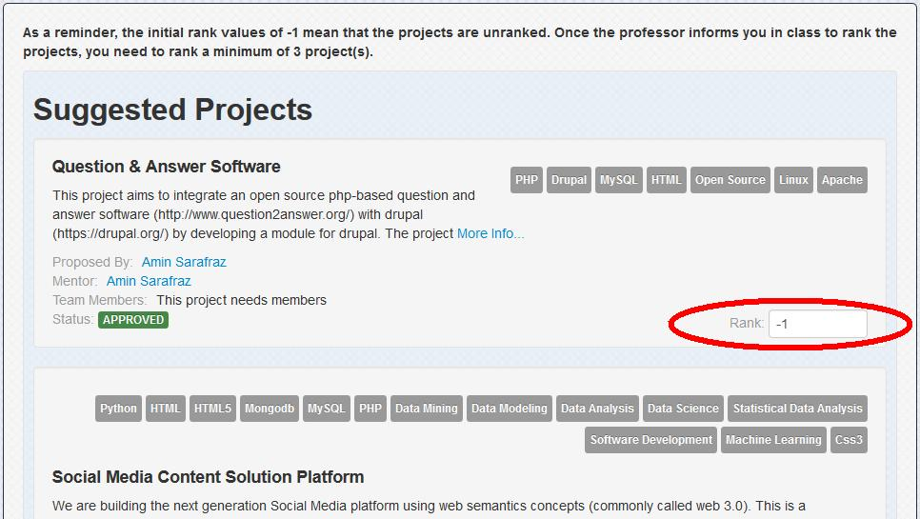

1. Once you have finished ranking, you should then scroll to the bottom and click on the “Save Interest Ranking Scheme” button to save the scheme you have just created.

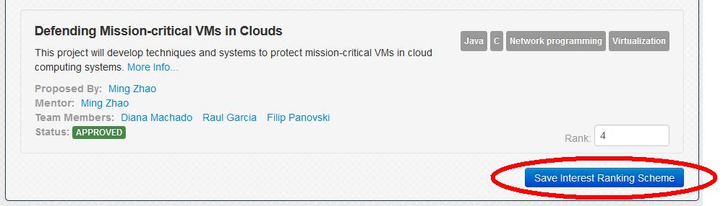

1. Note you can opt not to rank any projects and you will be attempted to be matched to a project that align with your skills

Synchronizing your account with LinkedIn.

1. In your profile page click on “Sync with LinkedIn”.

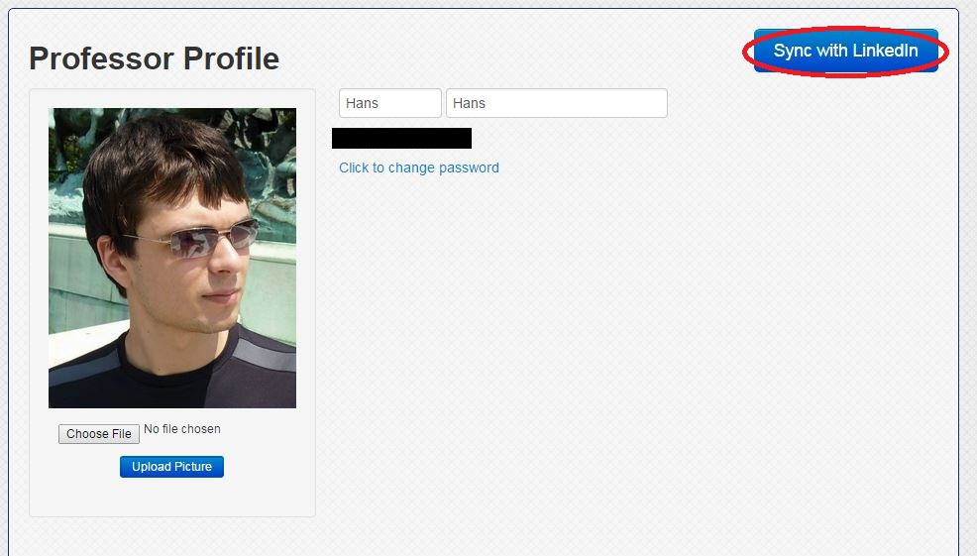

2. If you already have a picture associated with your account, system will ask you if you want to replace it. Click on “Yes”.

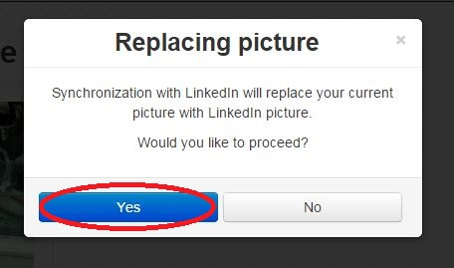

3. You will be asked to use your LinkedIn credentials, and allow access to retrieve information. Click on “Allow access” button.

