Skillcourt Backend

Andy Martinez & Matthew Santiago

Florida International University

Senior Project

## Legal Notices

## Abstract

Table of Contents

Legal Notices i

Abstract ii

Table of Contents iii

1. Introduction 1

1.1 Problem Definition 1

1.2. Background 1

1.3. Definitions, Acronyms, and Abbreviations 1

1.4. Overview of Document 1

2. Feasibility Study 1

2.1. Description of the Current System 1

2.2. Purpose of New System 1

2.3. High Level Definition of User Requirements 2

2.4. Alternative Solutions 2

2.5. Recommendations 2

3. Project Plan 3

3.1. Project Organization 3

3.2. Identification of Tasks, Milestones and Deliverables 5

4. Appendix 6

4.1. Appendix A - Project schedule 6

4.2. Appendix B – Feasibility Matrix 7

4.3. Appendix C – Cost Matrix 8

4.4. Appendix D - Diary of Meetings 9

5. References 10

## **Introduction**

### 1.1 Problem Definition

### Background

Very few platforms that offer a similar experience to what SkillCourt will offer are in existence day. Most of our research for the system comes from our Product Owner who is also a soccer coach.

### Definitions, Acronyms, and Abbreviations

#### 1.3.1 Acronyms

#### 1.3.2 Definitions

### 1.4. Overview of Document

## **Feasibility Study**

### 2.1. Description of the Current System

Currently, soccer training involves a lot of on-field practice, but offers no physical way to track progress. In fact, most sports do not offer a guided methodology for tracking progress or attempts to offer skill specific training. This lack of guidance and visuals for improvement creates an environment which makes it hard to progress without professional help.

### 2.2. Purpose of New System

SkillCourt attempts to overhaul this outdated method by creating an environment which will monitor your progress and offer an arena for furthering your capabilities as a soccer player. By adding features such as personalized progress analysis and specialized skill training along with the ease of access and the portability that SkillCourt pads offer, SkillCourt brings a whole new level of training for Soccer, and possibly even more sports.

SkillCourt saves data from a player’s interaction with the system and analyzes it to present a visual representation of a player’s strengths, weaknesses, and progress throughout their training. These allow a player to be able to focus on what they need to learn conditioning the player to become better overall.

SkillCourt’s specialized skill training will offer users access to routines designed to train specific skills for soccer. Along with the analyzed data, a player can choose skills they feel they need to work on. Ranging from Accuracy to Speed, a player will find a plethora of cognitive skills related to soccer being offered by SkillCourt.

### 2.3. High Level Definition of User Requirements

### 2.4. Alternative Solutions

#### 2.4.1. Description of Alternatives

#### 2.4.2. Selection Criteria

#### 2.4.3. Analysis of Alternatives

### 2.5. Recommendations

This project will consist of creating the back-end for SkillCourt, an activity which uses pressure sensitive pads to help create a measurement and a guide for soccer training. This includes developing an interface for accessing SkillCourt, creating programs that SkillCourt players will use for training, and parsing data from games to create visuals for player review. Also, since the pressure sensitive pads for SkillCourt are still in development, we will need to create a pad-simulator which will simulate the pads for testing and showcasing purposes.

## **Project Plan**

As part of our project’s development process, we have created a detailed plan to organize our work throughout the semester. By following it, we will be able to keep track of both the project’s progress and our performance according to our requirements. This plan includes our individual roles, the personnel organization, and the hardware and software resources needed. It also includes a description of our tasks, milestones and deliverables.

### Project Organization

This section discusses the roles of all team members as well as the technologies that will be used to develop the Skillcourt system.

#### 3.1.1 Project Personnel Organization

This section lists the main role of each of the 2 team members working on the project.

Figure 1. Project Personnel Organization

#### 3.1.2 Hardware and Software Resources

This section describes the hardware and software resources that will be used during this project

Figure 2. Description of Hardware and Software requirements

### Identification of Tasks, Milestones and Deliverables

Table 1. Description of tasks, milestones, and deliverables

|  |  |
| --- | --- |
| Tasks | Task Dependencies |
| 1. Collect User Stories |  |
| 1. Requirement Analysis |  |
| 1. Create Product Backlog |  |
| 1. Setup Development Environment |  |
| 1. Initial Feasibility Study |  |
| 1. Initial Project Plan |  |
| 1. Initial System Design |  |
| 1. Initial Object Design |  |
| Milestone: Feasibility Study and Project Plan Document |  |

(Not complete)

## **Appendix**

### Appendix A - Project schedule

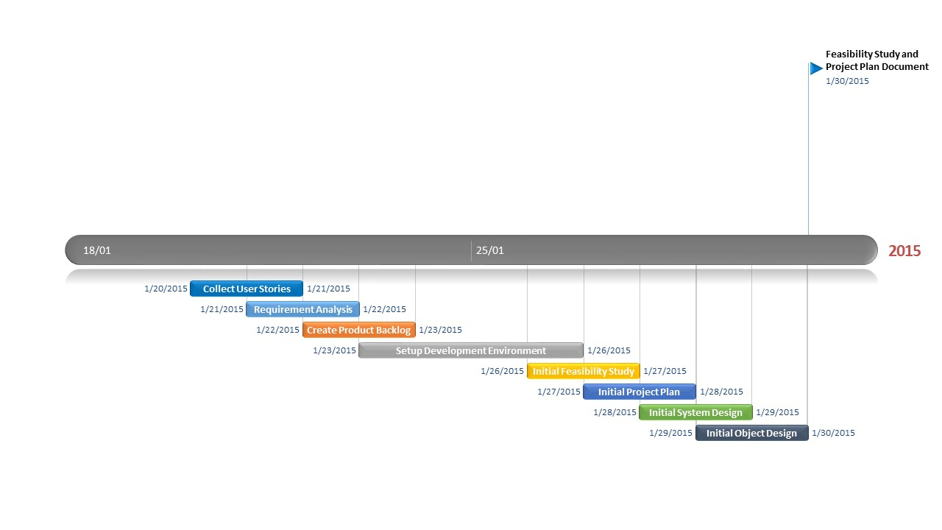

Figure 3. Gantt chart showing project schedule

### Appendix B – Feasibility Matrix

### Appendix C – Cost Matrix

Table 2. Cost Matrix

|  |  |  |  |
| --- | --- | --- | --- |
| Item | Description | Quantity | Cost |
| Human Resources | Team members working on the design, development, and testing processes | 2 | $ 0.00 |
| Hardware Resources | Personal computer | 2 | $ 0.00 |
| Localhost Server to host website | 1 | $ 0.00 |
| Android mobile devices | 1 | $ 0.00 |
| Software Resources | Software (All open source) | - | $ 0.00 |
| Total |  |  | $ 0.00 |

### Appendix D - Diary of Meetings

1. **Meeting 1:**

Monday 1/19/15

@8:57pm

Meeting on Mingle starts

In attendance: Andy Martinez, Matthew Santiago

@9:08pm

Arranging possible meeting times for Requirements Elicitation:

* Tuesday 1/20 9:00 pm
* Wednesday 1/21 before 2:00 pm
* Wednesday 1/21 after 7:30 pm

@9:23pm

Chose for Andy Martinez to be Scrum Master for the first sprint

@9:28pm

Sent message to @Product Owner for their preferred meeting time:

* Awaiting reply…
* **1/20 @10:43am** Reply Received, Meeting Tuesday 1/20 at 9:00 pm confirmed

@9:33pm

Meeting Dismissed

1. **Meeting 2:**

Tuesday 1/20/15

@9:00 pm

Conference Call Started

In attendance: Matthew Santiago, Andy Martinez, Jaime Borras, Gummi

@9:02 pm

Introductions

@9:12 pm

Stories:

1. Skill development (accuracy, speed, intensity)
   1. User chooses skill to train from Android App
   2. Measure pressure, time
   3. 3 colors red blue green
   4. Change to red when underperforming
   5. Ball should take 5 seconds to hit the pad, turn red if user takes too long
2. Tracking and analysis
   1. accuracy, speed, intensity, reaction time
3. Single Player/2 Player
   1. Social Media Connection
4. Mapping a game
   1. Pad light up, hit pad with ball in proper time, another pad lights up, hit with ball in proper time, continue until you make goal (certain number of successful iterations)
   2. Beginner, Intermediate, and advanced levels
5. Simulator (simulate a pad)
   1. Android application?
6. (Backend look at particular game (real game) and simulate a player or play within that game)

@9:32 pm

Set meeting with Gummi on 1/21 at 11:00 am in GL 693

@9:38 pm

Meeting Dismissed

1. **Meeting 3:**

Thursday 1/22/15

@9:00

Conference Call start

In attendance: Andy Martinez, Matthew Santiago, Jaime Borras

@9:07

Review stories

Predetermined Routines:

* Separate Goal Simulation into its own story

Performance Statistics:

* Add statistics about specific game

Competition Mode:

* Separation of social media into a new story is good
* Have different routines for single and multiplayer

Custom User Routine:

Pads Simulator:

Real Game Simulation:

Social Media Sharing:

Website:

* (Differentiate between coach and player?)
* Webpage access

@9:46

Meeting Dismissed

1. **Meeting 4:**

Tuesday 1/27/15

@ 6:30 pm

Meeting starts

In attendance: Jaime Borras, Andy Martinez, Matthew Santiago

**Github upload schedule:**

Matthew upload from 10:00pm - 10:59pm

Andy upload from 11:00pm - 11:59pm

**Weekly in-person meeting:**

Thursday between 2:00pm - 6:00pm to prepare for weekly meetings with project owners

**Coding standards**

Comment Convention:

/**

* Comment goes here

* and here

*/

fun()

{

random code

}

**Indentation:**

1 tab per pair of curly braces

**Variable names:**

private _variableName

public variableName

**Reports:**

**Matthew:** Feasibility report & Initial System Design

**Andy:**  Project Plan & Initial Object Design

**Read up on:**

Android BlueTooth library

Java Databases

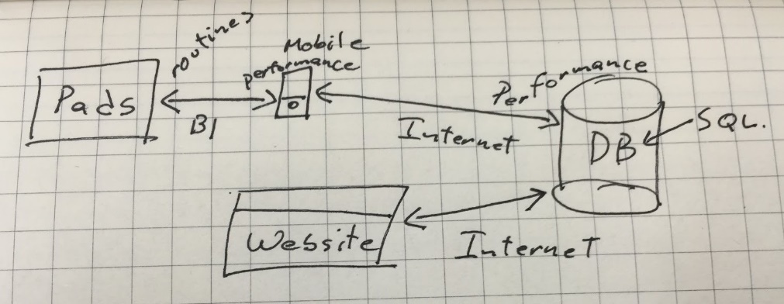

1. **Meeting 5:**

Tuesday 1/30/15

@ 4:00 pm

Conference Call starts

In attendance: Jaime Borras, Andy Martinez, Matthew Santiago, Gummy

## **References**