Skillcourt Backend

Andy Martinez & Matthew Santiago

Florida International University

Senior Project

## Legal Notices

Missing

## Abstract

There is a lot involved with the training of soccer players. The current system for training is primitive usually involving an instructor and a physical field for playing. The primary objective is to produce a new, modern, and system for training soccer players. The system will be a program with features that will assist players for learning the skills required on their own.

Implementing this system is revolutionary to the way avid players train in the sport. With the functionality and portability that SkillCourt offers, the user can create a personalized regimen for improving skills; thus, SkillCourt offers an overall improvement to both the soccer training and playing experience for players.

(Specific to the document?)

Table of Contents

Legal Notices i

Abstract ii

Table of Contents iii

1. Introduction 1

1.1 Problem Definition 1

1.2. Background 1

1.3. Definitions, Acronyms, and Abbreviations 1

1.4. Overview of Document 1

2. Feasibility Study 1

2.1. Description of the Current System 1

2.2. Purpose of New System 1

2.3. High Level Definition of User Requirements 2

2.4. Alternative Solutions 2

2.5. Recommendations 2

3. Project Plan 3

3.1. Project Organization 3

3.2. Identification of Tasks, Milestones and Deliverables 5

4. Appendix 6

4.1. Appendix A - Project schedule 6

4.2. Appendix B – Feasibility Matrix 7

4.3. Appendix C – Cost Matrix 8

4.4. Appendix D - Diary of Meetings 9

5. References 10

## **Introduction**

(missing 1 or 2 paragraphs to introduce the introduction)

### Problem Definition

As it stands, training for soccer can be a very cumbersome feat for the average person to endeavor unaided. Without proper guidance, progression dwindles and a person may not feel obliged to continue.

### Design Methodology

missing

### Terminology

#### 1.3.1 Acronyms

Missing

#### 1.3.2 Definitions

* **Pad Simulator**: An emulated device which will take the place of SkillCourt pads for testing showcasing purposes. This device will offer all of the features a SkillCourt Pad will offer.
* **SkillCourt**: A system which uses SkillCourt Pads and a player interface for training soccer.
* **SkillCourt Arena**: A 20’x40’ room with SkillCourt Pads on the walls used for soccer training.
* **SkillCourt Pad**: A physical device with a flat surface that can measure and transmit when and how much pressure it received.

### 1.4. Overview of Document

Missing

## **System Design**

### Overview

### Subsystem Decomposition

### Hardware and Software Mapping

### Persistent Data Management

### Security and Privacy

## **Detailed Design**

### Overview

### Static Model

### Dynamic Model

### Code Specification

## Glossary

## Appendix

### Appendix A – Use case diagram

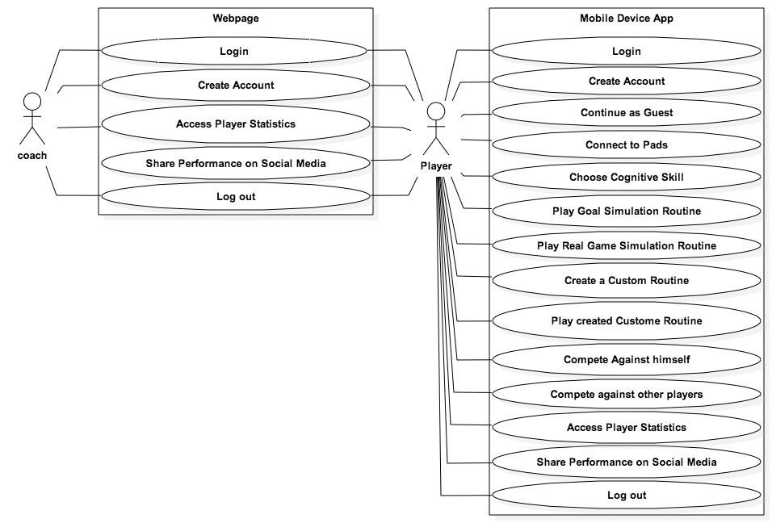

Figure 2. Use Case Diagram

### Appendix B – Implemented Use Cases

### Appendix C – Detailed Class Diagram

### Appendix D - Diary of Meetings and tasks

1. **Meeting 1:**

Monday 1/19/15

@8:57pm

Meeting on Mingle starts

In attendance: Andy Martinez, Matthew Santiago

@9:08pm

Arranging possible meeting times for Requirements Elicitation:

* Tuesday 1/20 9:00 pm
* Wednesday 1/21 before 2:00 pm
* Wednesday 1/21 after 7:30 pm

@9:23pm

Chose for Andy Martinez to be Scrum Master for the first sprint

@9:28pm

Sent message to @Product Owner for their preferred meeting time:

* Awaiting reply…
* **1/20 @10:43am** Reply Received, Meeting Tuesday 1/20 at 9:00 pm confirmed

@9:33pm

Meeting Dismissed

1. **Meeting 2:**

Tuesday 1/20/15

@9:00 pm

Conference Call Started

In attendance: Matthew Santiago, Andy Martinez, Jaime Borras, Gummi

@9:02 pm

Introductions

@9:12 pm

Stories:

1. Skill development (accuracy, speed, intensity)
   1. User chooses skill to train from Android App
   2. Measure pressure, time
   3. 3 colors red blue green
   4. Change to red when underperforming
   5. Ball should take 5 seconds to hit the pad, turn red if user takes too long
2. Tracking and analysis
   1. accuracy, speed, intensity, reaction time
3. Single Player/2 Player
   1. Social Media Connection
4. Mapping a game
   1. Pad light up, hit pad with ball in proper time, another pad lights up, hit with ball in proper time, continue until you make goal (certain number of successful iterations)
   2. Beginner, Intermediate, and advanced levels
5. Simulator (simulate a pad)
   1. Android application?
6. (Backend look at particular game (real game) and simulate a player or play within that game)

@9:32 pm

Set meeting with Gummi on 1/21 at 11:00 am in GL 693

@9:38 pm

Meeting Dismissed

1. **Meeting 3:**

Thursday 1/22/15

@9:00

Conference Call start

In attendance: Andy Martinez, Matthew Santiago, Jaime Borras

@9:07

Review stories

Predetermined Routines:

* Separate Goal Simulation into its own story

Performance Statistics:

* Add statistics about specific game

Competition Mode:

* Separation of social media into a new story is good
* Have different routines for single and multiplayer

Custom User Routine:

Pads Simulator:

Real Game Simulation:

Social Media Sharing:

Website:

* (Differentiate between coach and player?)
* Webpage access

@9:46

Meeting Dismissed

1. **Meeting 4:**

Tuesday 1/27/15

@ 6:30 pm

Meeting starts

In attendance: Jaime Borras, Andy Martinez, Matthew Santiago

**Github upload schedule:**

Matthew upload from 10:00pm - 10:59pm

Andy upload from 11:00pm - 11:59pm

**Weekly in-person meeting:**

Thursday between 2:00pm - 6:00pm to prepare for weekly meetings with project owners

**Coding standards**

Comment Convention:

/**

* Comment goes here

* and here

*/

fun()

{

random code

}

**Indentation:**

1 tab per pair of curly braces

**Variable names:**

private _variableName

public variableName

**Reports:**

**Matthew:** Feasibility report & Initial System Design

**Andy:**  Project Plan & Initial Object Design

**Read up on:**

Android BlueTooth library

Java Databases

1. **Meeting 5:**

Tuesday 1/30/15

@ 4:00 pm

Conference Call starts

In attendance: Jaime Borras, Andy Martinez, Matthew Santiago, Gummy

Complete?

## References