|  |
| --- |
| *FLORIDA INTERNATIONAL UNIVERSITY*  School of Computing and Information Sciences  CIS 4911 Senior Capstone Project |
| **Smart Systems for Occupancy and Building Energy Control (SSOBEC)** |
| Feasibility |
|  |
|  |
| **Instructor**: Dr. Masoud Sadjadi  **Mentor**: Dr. Leonardo Bobadilla  **Mentor:** Dr. Ali Mostafavi    01/23/2015  *Group Member:*  Maria Eugenia Presa Reyes  Dalaidis Hidalgo Arencibia |

Copyright and trademark notices, restrictions on copying or distributing the documentation

* Copyright and trademark notices, restrictions on copying or distributing the documentation, information for contacting the issuing organization (reader’s comments), warranties, contractual obligations or disclaimers, and general warnings and cautions.

Abstract

ENERGYN is an application that provides information on occupancy behavior and energy consumption in buildings. This will include having the occupancy in different zones, artificial lighting information, temperature, plug load, and carbon dioxide. This app will display the information in real time that can help people use electricity in an efficient way.

|  |
| --- |
|  |

Table of Contents

1. Introduction 5

1.1 Problem definition 5

1.2 Background 5

1.3 Definitions, Acronyms, and Abbreviations 6

1.4 Overview of document 6

2. Feasibility Study 7

2.1 Description of Current System 7

2.2 Purpose of New System 7

2.3 High level Definition of User Requirements 7

2.4 Alternative Solutions 8

2.4.1 Description of Alternatives 8

2.4.2 Selection Criteria 8

2.4.3 Analysis of Alternatives 8

2.5 Recommendations 8

3. Project Plan 9

3.1 Project Organization 9

3.1.1 Project Personnel Organization 9

3.1.2 Hardware and Software Resources 9

3.2 Identification of Tasks, Milestones and Deliverables 10

4. Appendix 11

4.1 Appendix A - Project schedule 11

4.2 Appendix B – Feasibility Matrix 11

4.3 Appendix C – Cost Matrix 11

4.4 Appendix D – Diary of Meetings 11

5. References 14

1. Introduction

Currently the use of the electricity is very important for much of our activities. Through the use of the energy we can have a better quality of life. Their use is indispensable and we hardly stop to think about the importance and benefits of using electricity in an effective way.

Learning to use and save electrical energy should be a priority for everyone. When people create good habits and attitudes to save energy, they can achieve a greater efficient use of electricity, rational use of energy resources, a better protection of the family economy and the preservation of our natural environment. In order to support this objective we offer the Smart Systems for Occupancy and Building Energy Control, a software designed to easily manage the use of the energy through a sensor network. This application not only is an easy way to save energy but also it can be a valuable tool to teach you how to save energy.

1.1 Problem definition

United States of America is one of the countries that has the one of the higher energy consumption at homes and in buildings and it should be continue increasing over the time. According to EIA in 2013 (U.S. Energy Information Administration) the 40% of the consume of energy in this country was in residential and commercial building.

Today, many of luxuries that we have require a lot of energy. For example, nowadays we can keep rooms with a comfortable temperature, heat water for bathing and hand washing, provide lighting, and power for TV, computer, appliances, and other technologies. Their use are indispensable for us that is why we need to make possible changes in order save energy. Occupancy behaviors have been identify as a major cause of uncertainty in evaluation of energy performance in building. The ability to save energy in residential and commercial building is considered the top priorities associates with this project.

1.2 Background

This application provides information on occupancy behavior and energy consumption in buildings for the facility manager and can give the user information about energy performance. This include having the occupancy in different zones, natural and artificial lighting information, temperature, and plug load. The information should be displayed in forms of graphs and visualization dashboards. Also, this application can store the data and filter the data and do analysis and then visualize it.

1.3 Definitions, Acronyms, and Abbreviations

Below is a list of definitions, acronyms, and abbreviations.

**DEFINITIONS:**

**Facility Manager**: Person that has elevated privileges in the application.

**Occupant**: Person with limited access, who uses the application to track energy consumption for just his own rooms.

**Android Studio**: Is the official IDE that it is used by Android application development based on IntelliJ IDEA.

**ACRONYMS AND ABBREVIATIONS:**

**SSOBEC**: Is an app which aims to help people learn to reduce the consume of energy.

**EIA:** U.S. Energy Information Administration

**DB**: Database

**FIU**: Florida International University

**SCIS**: School of Computing & Information Sciences

**App**: Application

1.4 Overview of document

The Feasibility Study and the Project Plan cover a lot of details of the Smart Systems for Occupancy and Building Energy Control. Chapter 1 provide general information like problem definition, background information and definitions, acronyms and abbreviation for this project. Chapter 2, provide a feasibility study with covers the system that will be implemented, and the limitations and constraints of the current system. Chapter 3, describe the project and give information about the hardware and software that will be used. Chapter 4, provides Appendix that have the objective to provide information about the Gantt chart, Feasibility Matrix, Cost Matrix and diary of meeting. As a final point, provide the works used as references.

2. Feasibility Study

The feasibility study explores the idea of Smart Systems for Occupancy and Building Energy Control from a practical point of view. At the start, it make a research to make sure that there is no system developed capable of bring to an end the desired tasks. Then, it describe the overall purpose of the Smart Systems for Occupancy and Building Energy Control, and how the features of the SSOBEC system will easily manage the use of the energy through a sensor network in order to save energy. After that, the high-level requirement are described and following the alternatives to certain aspect of SSOBEC system are analyzed. Finally, The recommendation for the project.

2.1 Description of Current System

The current system does not provide a smart approach to compare energy consumption of the building along with occupancy behavior of the people in the different zones of the building. A facility manager and Occupant can measure how much energy is consumed only after he/she reads the utility bills of each month. The facility manager does not know which rooms consume more energy than others, or which rooms waste more energy when they are left empty and electricity is being used. There is no system that notifies a Occupant when his/her room is currently empty and wasting energy. The facility manager and Occupant can see the amount of energy usage there has been for a period of time but cannot identify how much of that energy was not consumed efficiently.

2.2 Purpose of New System

The new system aims to implement a new kind of way of measuring energy by taking into account how much energy is consumed efficiently vs. how much is wasted. It will accomplish this by observing the occupancy behavior of the residents of each zone in the building.

2.3 High level Definition of User Requirements

The use will require to own an Android device (either a smartphone or tablet) with access to the internet. For the user to have access to the application, he/she needs to be either a facility manager or an owner of one or more rooms in the facility.

The new system will allow:

The system shall allow Facility Manager and Occupant to login/out using their account .....

The system shall allow Facility Manager

2.4 Alternative Solutions

Different solutions include a Web Application, Desktop Application and iPhone Application.

2.4.1 Description of Alternatives

2.4.2 Selection Criteria

2.4.3 Analysis of Alternatives

We considered other options to build the application before we decided to use the Android platform. Between those options, we mentioned iPhone application, desktop application and a web application. Since the accessibility to the application is very important for us, we decided to create an Android application because of its increasing popularity and easy accessibility.

2.5 Recommendations

3. Project Plan

3.1 Project Organization

3.1.1 Project Personnel Organization

This section show the assignment of roles during the realization of the project:

|  |  |  |  |  |  |
| --- | --- | --- | --- | --- | --- |
| **GROUP MEMBERS** | | **SOFTWARE** | **TESTING** | **PRESENTATION** | **DOCUMENTATION** |
| Maria Presa | X | | X | X | X |
| Dalaidis Hidalgo | X | | X | X | X |

3.1.2 Hardware and Software Resources

**HARDWARE**

* Computer that has a 1.6 GHz or faster processor
* 1GB(32 Bit) RAM
* 3GB of available hard disk space
* Mobile phone
* Tablet with Android

**SOFTWARE**

* Git
* GitHub
* Google Drive
* Gmail
* Android Studio
* Mingle
* StarUML
* Netbeans
* SQLite
* SQL

3.2 Identification of Tasks, Milestones and Deliverables

|  |  |
| --- | --- |
| **MILESTONE** | **TASK AND DELIVERABLE** |
| Documentation | * Feasibility Study * Project Plan * System Design * Object Design |
| Environment Setup | * Android Studio * JDK 8 * Source Tree * Git * Github * StarUML * Visio 2013 * WampServer |
| UI Design (Project) | * Login * Logout * Zone Details * Occupancy in different zones * Temperature |

4. Appendix

4.1 Appendix A - Project schedule

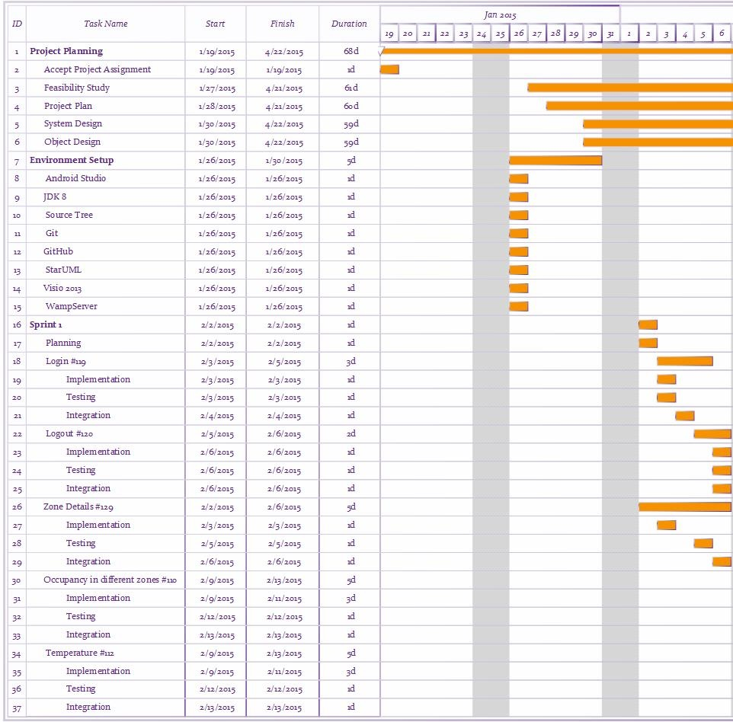

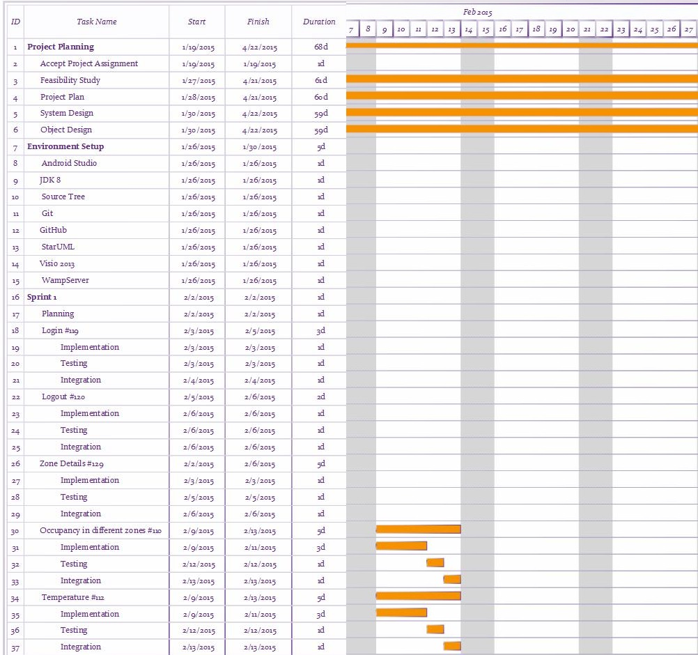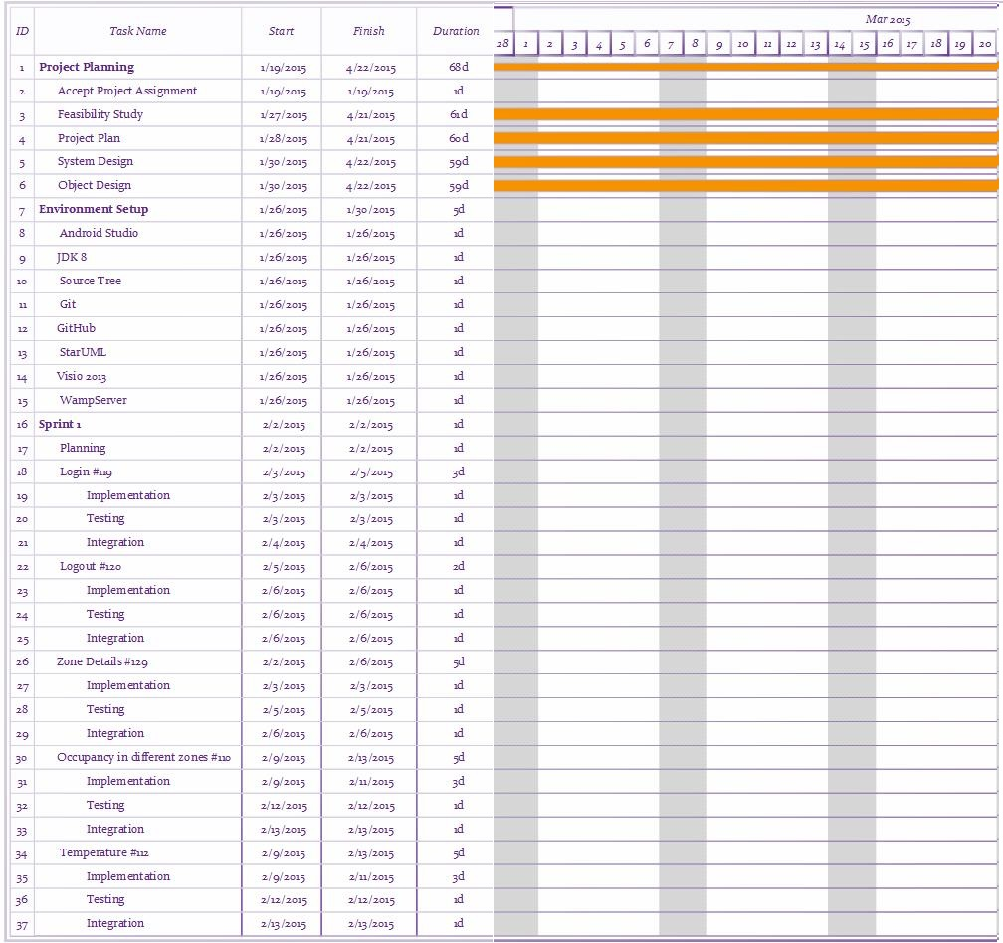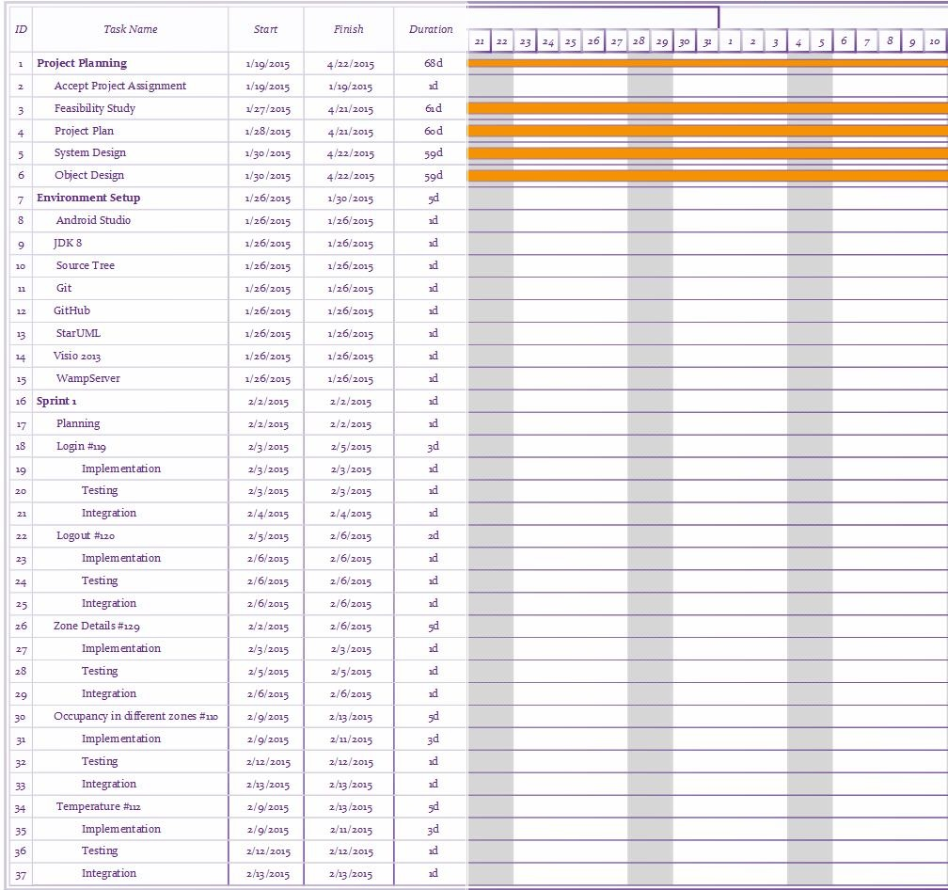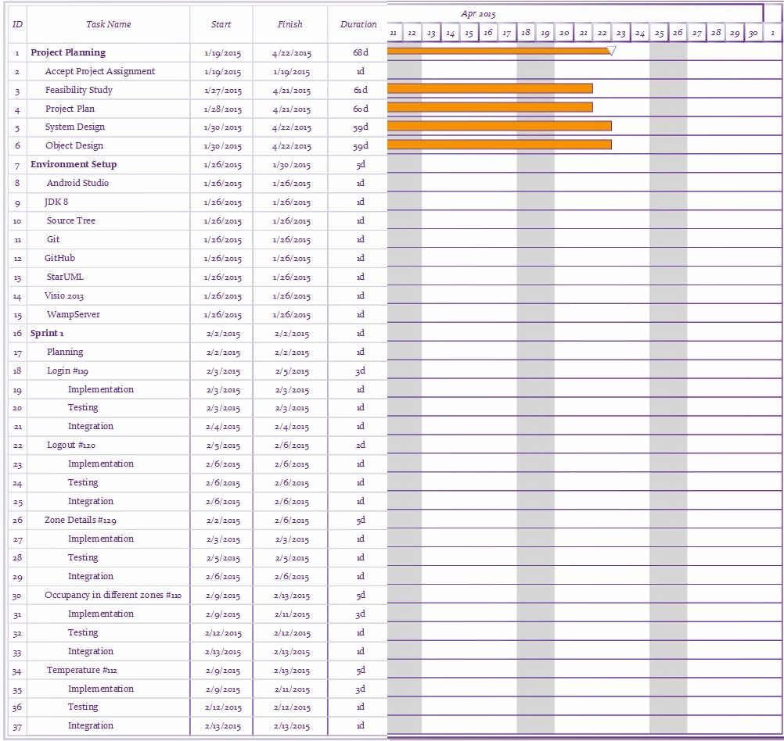

4.2 Appendix B – Feasibility Matrix

4.3 Appendix C – Cost Matrix

|  |  |  |
| --- | --- | --- |
| **RESOURCES** | **QUANTITY** | **COST** |
| PC (Hardware) | 2 | $0.00 |
| Smart Phone Android | 2 | $0.00 |
| Tablet | 1 | $0.00 |
| MySQL | 2 | $0.00 |
| Development |  | $0.00 |
| Testing |  | $0.00 |
| Total Cost |  | $0.00 |

4.4 Appendix D – Diary of Meetings

Following are the diary entries for all of our meetings throughout the semester.

|  |  |
| --- | --- |
| **DATE** | January 21, 2015 |
| **Location** | FIU Modesto A. Maidique Campus ECS 212B |
| **Start** | 5:00 pm |
| **End** | 6:30 pm |
| **In Attendance** | Leonardo Bobadilla  Ali Mostafavi  Maria Presa Reyes  Dalaidis Hidalgo Arencibia |
| **Late** | N/A |
| **Agenda** | - General Background of the project  - Collect User Stories  - Begin to work with Feasibility Study |
| **Summary of Discussion** | -Meeting Time (All  weeks) |
| **Assigned Tasks** | -Create Google Drive to share our document between us.  - Continue working with user stories to improve our work. |

|  |  |
| --- | --- |
| **DATE** | January 26, 2015 |
| **Location** | FIU Modesto A. Maidique Campus ECS 212B |
| **Start** | 4:00 pm |
| **End** | 5:10 pm |
| **In Attendance** | Leonardo Bobadilla  Ali Mostafavi  Maria Presa Reyes  Dalaidis Hidalgo Arencibia |
| **Late** | N/A |
| **Agenda** | - Product Backlog  - Feasibility Study  -Project Plan  -System Design  -Object Design  -Name Android Application |
| **Summary of Discussion** | -Programs and tool to use in our application. |
| **Assigned Tasks** | -Dr. Leonardo Bobadilla and Dr. Ali Mostafavi make the selection of the Name of the Android Application.  -Continue working with the documentation in order to try to do the most that we can.  -Make a selection of the Linux machine for the Database. |

|  |  |
| --- | --- |
| ***DATE*** | *January 30, 2015* |
| ***Location*** | FIU Modesto A. Maidique Campus ECS 212B |
| ***Start*** | 4:00 pm |
| ***End*** | 5:00 pm |
| ***In Attendance*** | Leonardo Bobadilla  Ali Mostafavi  Maria Presa Reyes  Dalaidis Hidalgo Arencibia |
| ***Late*** | N/A |
| ***Agenda*** | - Check the Name of the Android Application  - Check our ideas of the Product Backlog with our mentors  - Check Feasibility Study  - Check Project Plan  - Check System Design  - Check Object Design  - Continue working of the documentation  -Continue thinking on the design of different diagrams  -Prepare the PorwerPoint for the presentation |
| ***Summary of Discussion*** | -The user stories that we are going to implementing in Sprint 1 |
| ***Assigned Tasks*** | Dalaidis: Login, Logout and Temperature  Maria: Zone Details, Occupancy in different zones  Continue improving our documentation |

|  |  |
| --- | --- |
| ***DATE*** | *February 13, 2015* |
| ***Location*** | FIU Modesto A. Maidique Campus ECS 212B |
| ***Start*** | 4:00 pm |
| ***End*** | 5:00 pm |
| ***In Attendance*** | Leonardo Bobadilla  Ali Mostafavi  Maria Presa Reyes  Dalaidis Hidalgo Arencibia |
| ***Late*** | N/A |
| ***Agenda*** | -Explain and show our Code  -Give more ideas for to do in our project during this semester |
| ***Summary of Discussion*** | -New stories point that should be assign  -New ideas for the project  -The user stories that we are going to implementing in Sprint 2 |
| ***Assigned Tasks*** | -Maria: Continue working with Occupancy in different zones and begin to do Artificial Lighting.  Dalaidis: Continue working with Temperature and begin to do Plug Load  Continue improving our documentation |

|  |  |
| --- | --- |
| **DATE** |  |
| **Location** | FIU Modesto A. Maidique Campus ECS 212B |
| **Start** | 4:00 pm |
| **End** | 5:00 pm |
| **In Attendance** | Leonardo Bobadilla  Ali Mostafavi  Maria Presa Reyes  Dalaidis Hidalgo Arencibia |
| **Late** | N/A |
| **Agenda** |  |
| **Summary of Discussion** |  |
| **Assigned Tasks** |  |

|  |  |
| --- | --- |
| **DATE** |  |
| **Location** | FIU Modesto A. Maidique Campus ECS 212B |
| **Start** | 4:00 pm |
| **End** | 5:00 pm |
| **In Attendance** | Leonardo Bobadilla  Ali Mostafavi  Maria Presa Reyes  Dalaidis Hidalgo Arencibia |
| **Late** | N/A |
| **Agenda** |  |
| **Summary of Discussion** |  |
| **Assigned Tasks** |  |

5. References

*Green Building*. (2015). Retrieved from University of the Pacify: http://www.pacific.edu/About-Pacific/Sustaining-Pacific/Campus-Operations/Sustainable-Living/Green-Building.html

*How much energy is consumed in residential and commercial buildings in the United States?* (2014, June 18). Retrieved from Independent Statistic and Analisis U.S Energy Information Administration: http://www.eia.gov/tools/faqs/faq.cfm?id=86&t=1