|  |
| --- |
| *FLORIDA INTERNATIONAL UNIVERSITY*  School of Computing and Information Sciences  CIS 4911 Senior Capstone Project |
| **Smart Systems for Occupancy and Building Energy Control (SSOBEC)** |
| **Final Deliverable** |
|  |
|  |
| **Instructor**: Dr. Masoud Sadjadi  **Mentor**: Dr. Leonardo Bobadilla  **Mentor:** Dr. Ali Mostafavi    01/23/2015  *Group Member:*  Maria Eugenia Presa Reyes  Dalaidis Hidalgo Arencibia |

* Page with copyright and trademark notices, restrictions on copying or distributing the documentation, information for contacting the issuing organization (reader’s comments), warranties, contractual obligations or disclaimers, and general warnings and cautions.

Executive Summary

Table of Contents

1. Introduction 6

1.1 Problem definition. 6

1.2 Scope of system 6

1.3 Over all development methodology. 6

1.4 Definitions, acronyms, and abbreviations 6

1.5 Overview of document 7

2. Feasibility Study 8

2.1 Description of current system. Identify limitations and constraints 8

2.2 Description of alternative solutions considered 8

2.3 Recommendation with explanation of why the solution was selected. 8

3. Project Plan 9

3.1 Project Organization 9

3.1.1 Project Personnel 9

3.1.2 Hardware and Software Resources 9

3.2 Identification of Tasks, Milestones and Deliverables 10

3.3 Cost of the Project 10

4. System Requirements 11

4.1 Functional and Nonfunctional Requirements – similar to RD 11

4.2 Requirements Analysis 11

4.2.1 Use case Model 11

4.2.2 Static Model 12

4.2.4 Dynamic Model 12

5. System Design 12

5.1 Overview 12

5.2 Subsystem Decomposition 13

5.3 Hardware and Software Mapping 14

5.4 Persistent Data Management 14

5.5 Security/Privacy 15

6. Detailed Design 15

6.1 Overview 15

6.2 Static model 15

6.3 Dynamic model 17

6.4 Code Specification 17

7. System Validation 18

7.1 Subsystem Tests 18

7.2 System Tests 18

7.3 Evaluation of Tests 18

8. Glossary 18

9. Appendix 18

9.1 Appendix A - Project schedule (Gantt chart or PERT chart). 18

9.2 Appendix B – All use cases with nonfunctional requirements. 23

9.3 Appendix C – User Interface designs. 35

9.4 Appendix D – Analysis models (static and dynamic) 35

9.5 Appendix E – Design models (static and dynamic) 37

9.6 Appendix F – Documented Class interfaces (code) and constraints. 37

9.7 Appendix G – Documented code for test drivers and stubs. 37

9.8 Appendix H – Diary of meeting and tasks for the **entire semester**. 37

10. References 40

# Introduction

The introductory chapter provides a background information about the Smart Systems for Occupancy and Building Energy Control. In the next section, the problem definition and the scope of the system will be described. After that, the design methodology used to be represented the design. Following, definitions, acronyms, and abbreviations of terms used will be show in this sections. Finally, this sections will conclude with a brief overview of what to be expected from the following chapters.

## 1.1 Problem definition.

1.2 Scope of system.

## 1.3 Over all development methodology.

1.4 Definitions, acronyms, and abbreviations

Below is a list of definitions, acronyms, and abbreviations.

**DEFINITIONS:**

**Facility Manager**: Person that has elevated privileges in the application.

**Occupant**: Person with limited access, who uses the application to track energy consumption for just his own rooms.

**Android Studio**: Is the official IDE that it is used by Android application development based on IntelliJ IDEA.

**ACRONYMS AND ABBREVIATIONS:**

**SSOBEC**: Is an app which aims to help people learn to reduce consume of energy.

**EIA:** U.S. Energy Information Administration

**DB**: Database

**FIU**: Florida International University

**SCIS**: School of Computing & Information Sciences

**App**: Application

## 1.5 Overview of document

The following chapter will explain the information presented in the project. Chapter 2, is about feasibility study and made a description of the current system identifying limitations and constraints, the description of the alternative solution and the explanation of why the solution was selected. Chapter 3, describe the project and give information about the hardware and software that will be used. Chapter 4, introduce the system requirement containing functional and no functional requirements and requirement analysis. Chapter 5, includes the system design, subsystem decomposition, hardware and software mapping, persistent data management, and security and privacy with describe the user authentication processes, encryption of data and another. Chapter 6, present the design chapter with the detailed static model and dynamic model and the code specification that describe the class interface. Chapter 7, introduce the subsystem and system tests. Chapter 8, define terms used in document. Chapter 9, provides Appendix that have the objective to provide information about the Gant chart and another miscellaneous information. As a final point provide the works used as references.

# 2. Feasibility Study

The feasibility study explores the idea of Smart Systems for Occupancy and Building Energy Control from a practical point of view. At the start, it make a research to make sure that there is no system developed capable of bring to an end the desired tasks. Then, it describe the overall purpose of the Smart Systems for Occupancy and Building Energy Control, and how the features of the SSOBEC system will easily manage the use of the energy through a sensor network in order to save energy. After that, the high-level requirement are described and following the alternatives to certain aspect of SSOBEC system are analyzed. Finally, The recommendation for the project.

## 2.1 Description of current system. Identify limitations and constraints

The current system does not provide a smart approach to compare energy consumption of the building along with occupancy behavior of the people in the different zones of the building. A facility manager and Occupant can measure how much energy is consumed only after he/she reads the utility bills of each month. The facility manager does not know which rooms consume more energy than others, or which rooms waste more energy when they are left empty and electricity is being used. There is no system that notifies a Occupant when his/her room is currently empty and wasting energy. The facility manager and Occupant can see the amount of energy usage there has been for a period of time but cannot identify how much of that energy was not consumed efficiently.

2.2 Description of alternative solutions considered.

## 2.3 Recommendation with explanation of why the solution was selected.

# 3. Project Plan

This chapter present the SSOBEC system a project manager. Initially, the organization of the project and its roles will be listed and described. Next, the milestones with all the task and Deliverables will be planned. To conclude, the estimate cost amount will be offered.

## 3.1 Project Organization

|  |  |  |  |  |
| --- | --- | --- | --- | --- |
| **NAME** | **ROLES** | **TASKS** | **PERIOD REQUIRED** | **KEY PHASES** |
| Maria Presa | * Project manager * Document Editor * Developer * Test Engineer |  |  |  |
| Dalaidis Hidalgo | * Project manager * Document Editor * Developer * Test Engineer |  |  |  |

### 3.1.1 Project Personnel

### 3.1.2 Hardware and Software Resources

**HARDWARE**

* Computer that has a 1.6 GHz or faster processor
* 1GB(32 Bit) RAM
* 3GB of available hard disk space
* Mobile phone
* Tablet with Android

**SOFTWARE**

* Git
* GitHub
* Google Drive
* Gmail
* Android Studio
* Mingle
* StarUML
* Netbeans
* SQLite
* SQL

### 3.2 Identification of Tasks, Milestones and Deliverables

|  |  |
| --- | --- |
| **MILESTONE** | **TASK AND DELIVERABLE** |
| Documentation | * Feasibility Study * Project Plan * System Design * Object Design |
| Environment Setup | * Android Studio * JDK 8 * Source Tree * Git * Github * StarUML * Visio 2013 * LAMP * Vertabelo * PHPMyAdmin * SqliteBrowser * Google Drive * Mingle |
| UI Design (Project) | * Login * Logout * Zone Details * Occupancy in different zones * Plug Load * Temperature * Artificial Lighting |

## 3.3 Cost of the Project

# 4. System Requirements

Introduce the proposed system (one or two paragraphs).

## 4.1 Functional and Nonfunctional Requirements – similar to RD

## 4.2 Requirements Analysis

This section consist of different subsections like the use case model of the Smart Systems for Occupancy and Building Energy Control, the static model, and the dynamic model.

### 4.2.1 Use case Model

The use case diagram provide the list of steps that defines the interaction between the two types of users displayed in the diagram: facility manager and occupant. They all have the intention to accomplish the goal of this proposed system.

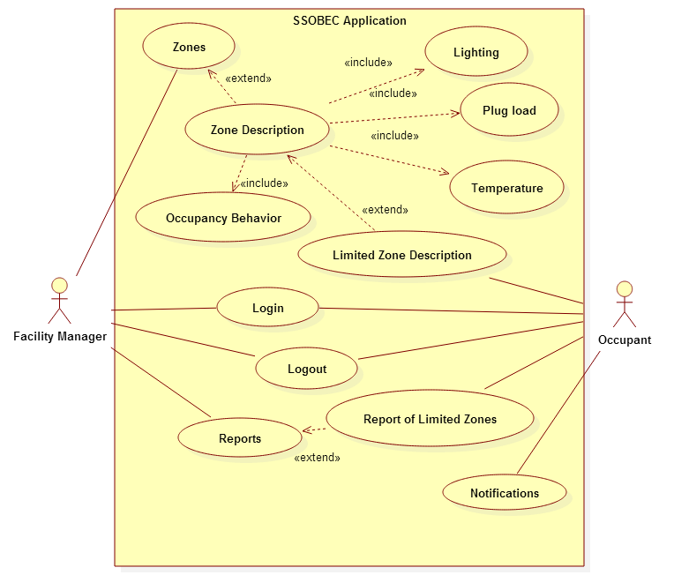

### 4.2.2 Static Model

A static model states the system. The diagram will display the structure of the system by showing the classes, attributes, methods, and also the relationship that can be between these classes. You can go for reference to the Appendix D.

### 4.2.4 Dynamic Model

The dynamic model does account for time. For the Smart Systems for Occupancy and Building Energy Control, sequence diagram will be included. These has objective to show the interaction between object and class in a sequence of event arranged in a time line. In addition, it displays functionality in order to allow the developers and programmers to view how the users should made transition based on these actions.

5. System Design

This chapter give an overall of the system design implemented in the Smart Systems for Occupancy and Building Energy Control. It will made a description of the system design architecture using two architectural patterns. It will be responsible for a detailed description of the subsystem decomposition for each subsystem. It will be cover hardware and software mapping. Following, it will present the persistent Data Management showing the data that need to be stored and also the structure of the data. Finally, it will describe the security and privacy through authentication processes, encryption of data, and use of firewall in order to improve the security of the system.

5.1 Overview

The two architectural are Model View Controller (MVC) and Three-tier architecture.

The three-tier architecture is compose of a interface layer, application layer and storage:

* **Interface layer**: the view of the system, it includes all boundary objects such as: buttons, input text fields and more.
* **Application layer**: is the controller of the system, it includes all the android activities.
* **Storage**: is the model of the system that realizes the storage and retrieval of persistent objects from either our SQLite database or the external MySQL Database.

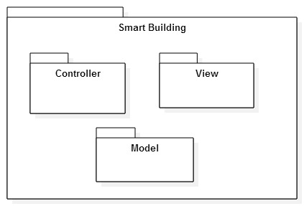

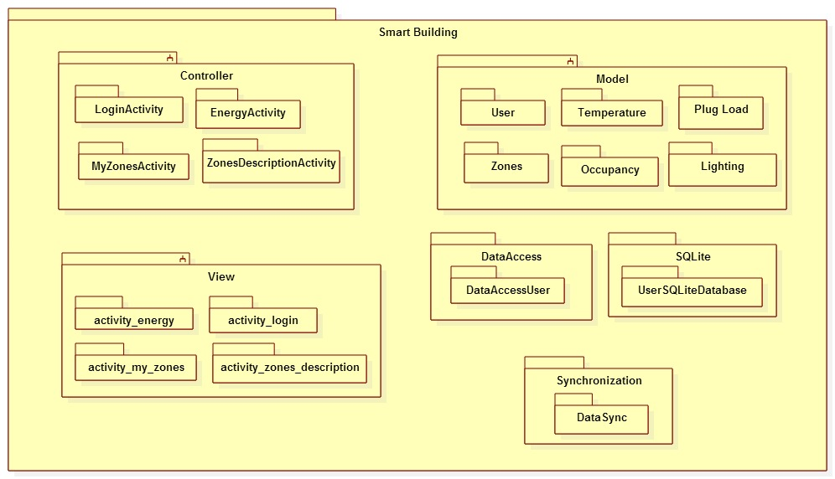

5.2 Subsystem Decomposition

**Activity:** Symbolizes a single user interface class. It is frequently packaged together to form the UI components of the application. That is why, controller has ZoneActivity, ZoneDescription Activity and Login Activity.

**Model:** Permit the access to the database like SQLite and My SQL Database. In brief, the logical sense is to tie the user interface components with the data store components.

**View:** The objective of this pattern is to separate the components of user interface.  View is defined by the XML file.

**Login:** This will welcome the users (Facility Manager or Occupant) when the application started.

**Zone activity:** This will display the zones to the user. At the same time wait for an action.

**Zone description:** This will display the description of all his/her zones for the facility manager and only specify description for occupant that is the responsible of only one room.

**Report:** This will display all the information that user can. Permit manipulate the information that user can have access. Also, they can manipulate the information and show statistic and graph.

**Report of Limited Zones:** The occupant will have a limited report of his/her zone.

**SQLite:** This is an internal Database of the device.

**My SQL Database:** This is an external Database.

5.3 Hardware and Software Mapping

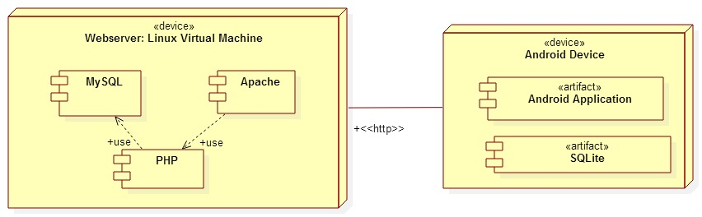

5.4 Persistent Data Management

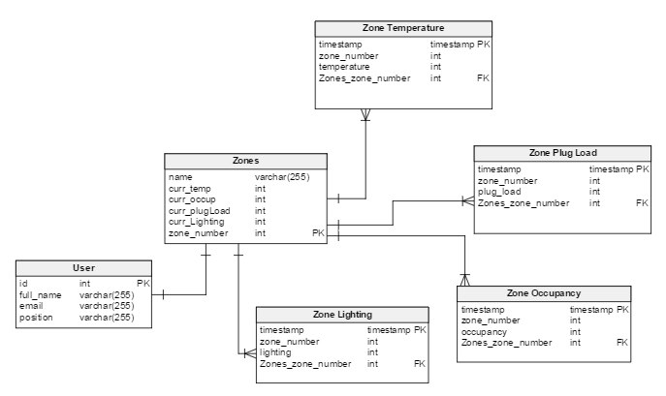

5.5 Security/Privacy

Android applications use an advance hardware and software, and it is designed to be truly open. To guarantee this protection its platform offer an application environment that ensures the security of data, users, applications, the devices, and the network. Android provide protection for all users of the platform. An application’s process is a secure sandbox that permit gain some security. Also the sandbox can isolates apps from each other, so they cannot tamper which each other, except by explicitly declaring the permissions it needs for additional capabilities not provided by the basic sandbox.

# 6. Detailed Design

Introduce the detailed design chapter (one or two paragraphs).

6.1 Overview – briefly describe the behavior and structure of each subsystem. Describe the design patterns used and why they were selected.

6.2 Static model

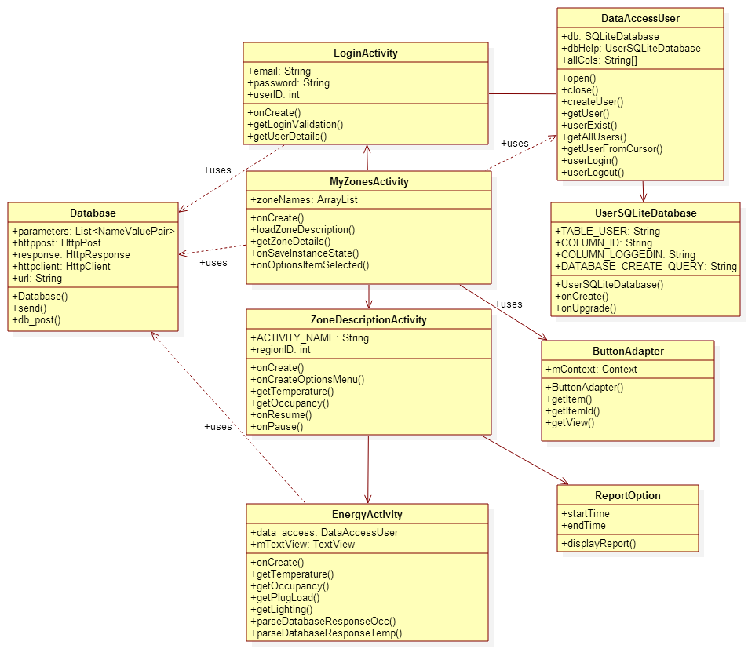

6.3 Dynamic model

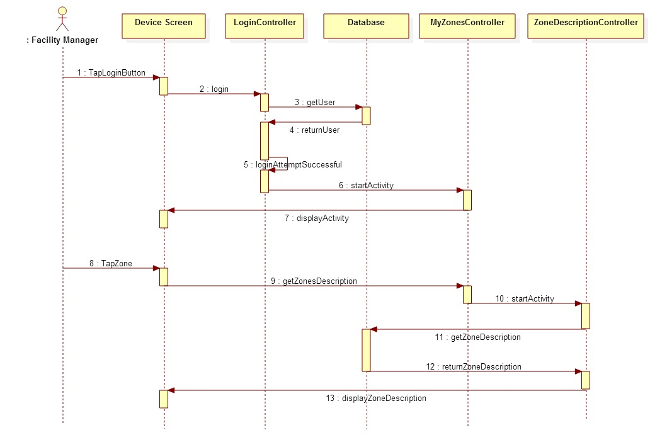

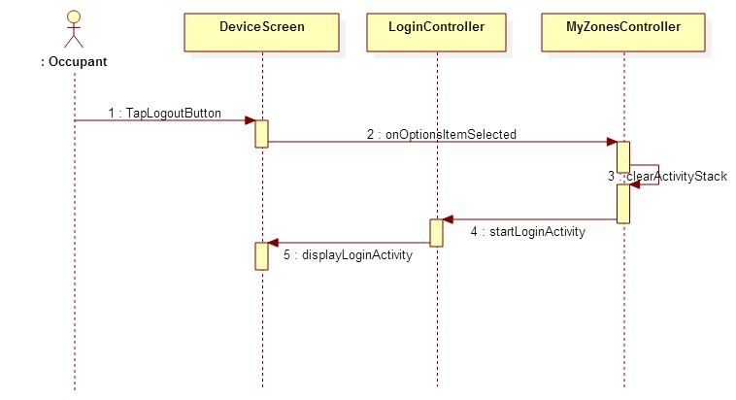

6.4 Code Specification - describe the class interfaces (attributes and method signatures) and constraint (invariants, pre-condition and post-conditions). Code should be in Appendix E.

# 7. System Validation

Introduce the system validation chapter (one or two paragraphs).

7.1 Subsystem Tests – test each of the subsystems. This will involve the creation of a test drivers and stubs. Include the code for the test drivers and stubs in Appendix G.

7.2 System Tests - For each use case create at least 3 test cases, 2 sunny day and one rainy day, should include security test cases. Each test case should include: test case id, purpose, test setup environment, test inputs, and expected outputs.

7.3 Evaluation of Tests – evaluate how successful the tests were. Use a tabular form.

8. Glossary

|  |  |
| --- | --- |
| **TERM** | **MEANING** |
| Class Diagram | An illustration of all the classes in the system. |
| Sequence Diagram | An illustration on how processes operate with one another and the user during the execution of one specific functionality. |
| Use Case | List of steps describing the interaction between a user and a system to achieve one goal. |
| Task | A piece of job that require to be done within a certain time. |
| Functional Requirement | Statements of services the system should provide, how the system should react to particular inputs and how the system should behave in particular situations. |
| Non- Functional Requirement | Constraints on the system e.g., max. response time, min. throughput, reliability, OS platform etc.. |

# 9. Appendix

## 9.1 Appendix A - Project schedule (Gantt chart or PERT chart).

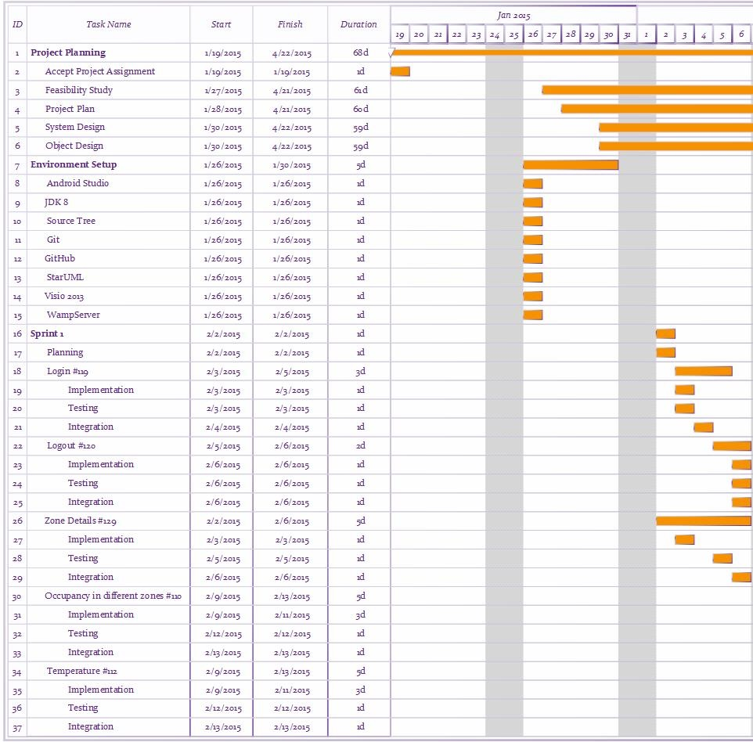

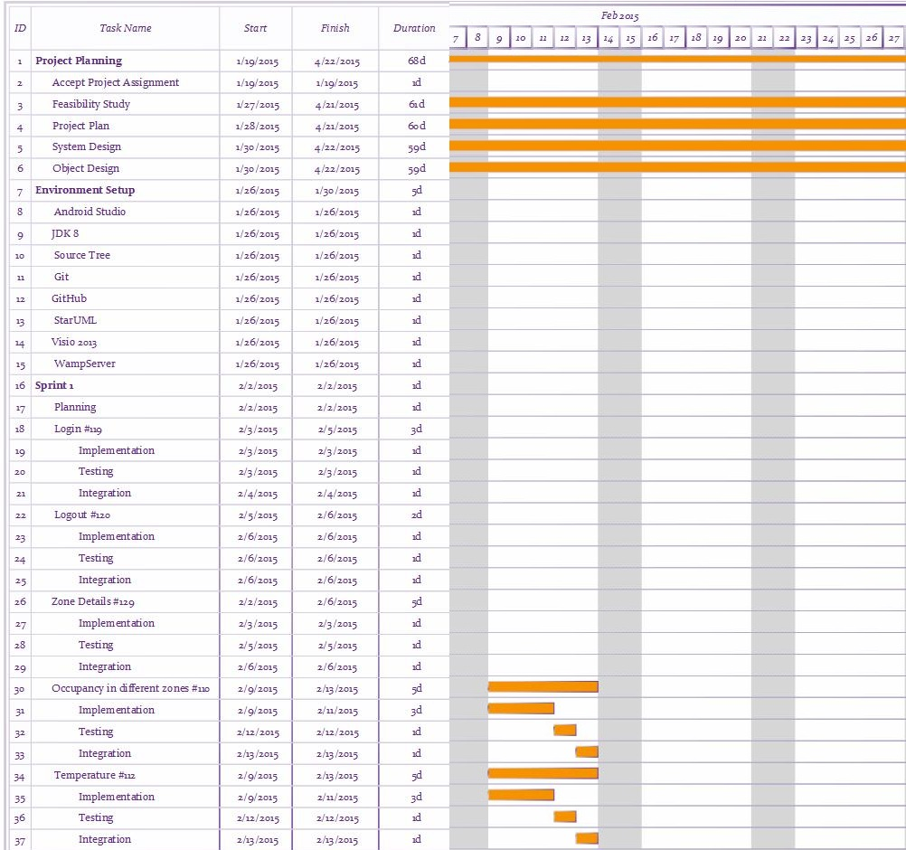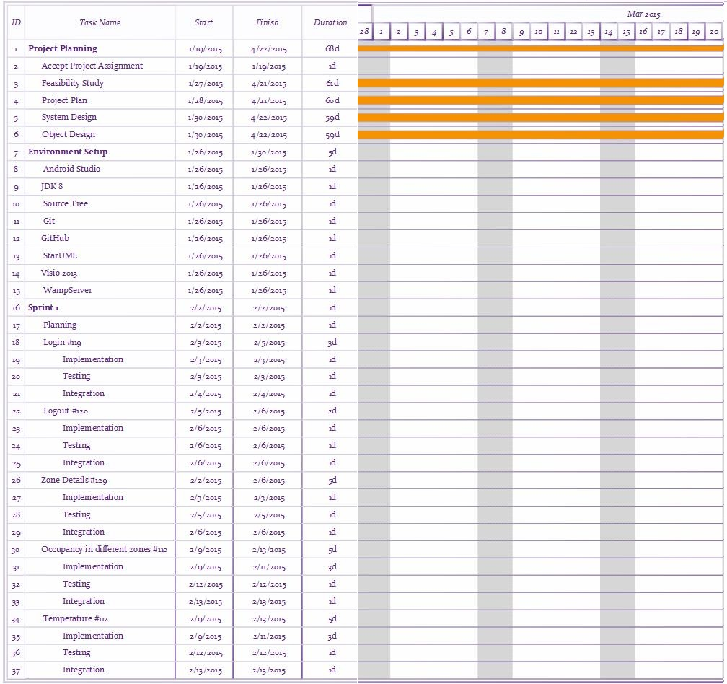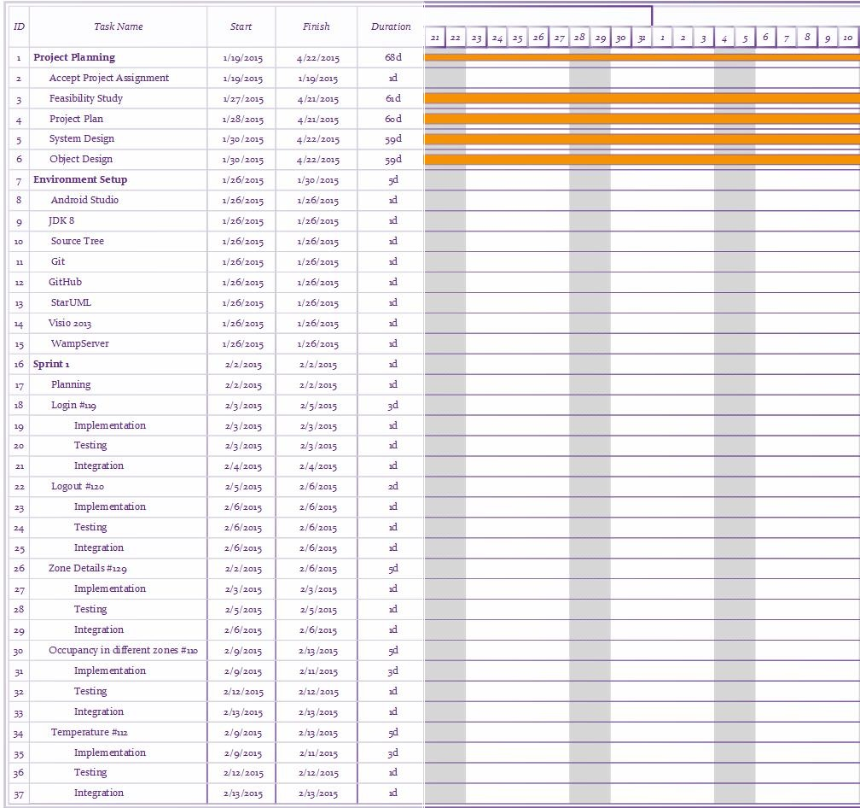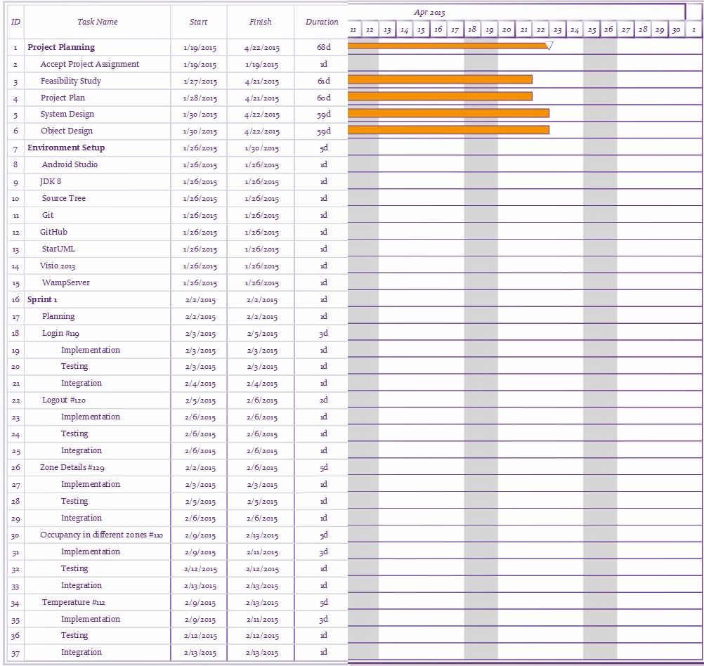

## 9.2 Appendix B – All use cases with nonfunctional requirements.

The following use cases that we are implementing:

USE CASE ID: **SSOBEC01-Login**

USER STORY: Login - Card #119

USER STORY DESCRIPTION: As a user I need to be able to login into the system so that I can see my individual profile.

ACTORS:

User

PRE-CONDITIONS:

1. Download the application.
2. User must be in the LoginView once he/she has either opened the application either for the first time or after he/she has previously logged out.
3. Users must have a username and password created and registered.

DESCRIPTION:

1. Use case begins when the user enters his/her username and password in the provided text fields of the LoginView and clicks the Login button.
2. The system responds by accessing the external database controller to get the user, validates the user, and displays MyZonesView.
3. Use case ends when the user is able to see his/her zones in MyZonesView.

RELEVANT REQUIREMENTS:

A user will only be admitted into the system if he/she has a valid username and password.

POST-CONDITIONS:

1. Login Successful to the system.

ALTERNATIVE COURSES OF ACTION:

1. None

EXCEPTIONS:

1. The database is inactive.
2. The device is not connected to the internet.

RELATED USE CASES:

* Create Account

SPECIAL REQUIREMENTS:

* Usability: No previous training time needed.
* Reliability: The application should perform correctly 99% of the time.
* Performance: The application should be sent and save within 5 seconds.
* Supportability: The application should be easy to maintain and make appropriate changes and be correctly handled by Android v4.0.3 or later.

USE CASE ID: **SSOBEC02-Logout**

USER STORY: Logout - Card #120

USER STORY DESCRIPTION: As a user, I need to be able to logout out of the system so that I can login into another account.

ACTORS:

User

PRE-CONDITIONS:

1. User must have previously logged in.
2. User must be in either MyZonesView, ZonesDescriptionView and EnergyView.

DESCRIPTION:

1. Use case begins when user clicks the menu option from the action bar in MyZonesView.
2. System responds by creating a popup menu, ActionBarPopupMenu, with the Logout option
3. User clicks Logout button in the popup menu
4. Use case ends when the system displays the LoginView.

RELEVANT REQUIREMENTS:

1. A user will only have access to logout if he/she has been previously signed into the system.

POST-CONDITIONS:

1. User gets successfully logged out of the system.

ALTERNATIVE COURSES OF ACTION:

1. In step 1, User can also be in the ZonesDescriptionView and the EnergyView and still have access to the ActionBarPopupMenu.

EXCEPTIONS:

1. The logout option on the application is not active.

RELATED USE CASES:

* Login

SPECIAL REQUIREMENTS:

* Usability: No previous training time needed.
* Reliability: The application should perform correctly 99% of the time.
* Performance: The application should be sent and save within 5 seconds.
* Supportability: The application should be easy to maintain and make appropriate changes and be correctly handled by Android v4.0.3 or later.

USE CASE ID: **SSOBEC03- Create Account**

USER STORY: Create Account- Card #124

USER STORY DESCRIPTION: As a user I need to be able to create my account, so that I can have access to the system.

ACTORS:

User

PRE-CONDITIONS:

1. Download the application.
2. User must be in the LoginView.

DESCRIPTION:

1. Use case begins when the User click the Create Account button.
2. The System respond by displaying the Create Account view.
3. The User fills the required text fields (first name, last name, email and password) and clicks the Submit button.
4. The System responds by validating that the user has filled all the required fields, inserts the user information in the database, then displays the LoginView again along with the message that the account has been successfully created
5. Use case ends when the User is in the LoginView and sees the message that the account has been created successfully.

RELEVANT REQUIREMENTS:

1. N/A

POST-CONDITIONS:

1. User is now register in the database.

ALTERNATIVE COURSES OF ACTION:

1. N/A

EXCEPTIONS:

1. N/A

RELATED USE CASES:

* None

SPECIAL REQUIREMENTS:

* Usability: No previous time because is simple and easy to follow the steps.
* Reliability: The system should perform correctly 99 % of the time.
* Performance: The application should be sent and save within 5 seconds.
* Supportability: Report should be correctly handle by Android.

USE CASE ID: **SSOBEC04-View temperature inside the building**

USER STORY: View temperature inside the building - Card #120

USER STORY DESCRIPTION: As a user I need to have access to information on the temperature in different zones so that I can observe the current energy consumption on temperature.

ACTORS:

User

PRE-CONDITIONS:

1. User is logged in.
2. User is in the ZoneDescriptionView view

DESCRIPTION:

1. Use case begins when the User clicks on the temperature button in my ZoneDescriptionView.
2. The System responds getting the temperature for that zone from the Temperature model and displays the TemperatureView along with the temperature information.
3. Use case ends when the User is able to see the temperature in the TemperatureView

RELEVANT REQUIREMENTS:

1. A Facility Manager can has full access to see the temperature in all zones while the Occupant has only access to one limit zone to see the temperature in with he/she is the responsible to save energy.

POST-CONDITIONS:

1. N/A

ALTERNATIVE COURSES OF ACTION:

1. None

EXCEPTIONS:

1. The database is disconnected.

RELATED USE CASES:

* View Zone

SPECIAL REQUIREMENTS:

* Usability: No previous time because is simple and easy to follow the steps.
* Reliability: The system should perform correctly 99 % of the time.
* Performance: The application should be sent and save within 5 seconds.
* Supportability: Report should be correctly handle by Android.

USE CASE ID: **SSOBEC05-View temperature outside the building**

USER STORY: View temperature outside the building - Card # 227

USER STORY DESCRIPTION: As a user, I need to have access to information on the temperature outside of my building so that I can compare what is the temperature inside the building with the temperature outside.

ACTORS:

User

PRE-CONDITIONS:

1. User is logged in.
2. User is in the ZoneDescriptionView view
3. DESCRIPTION:
4. Use case begins when the User clicks on the temperature button in my ZoneDescriptionView.
5. The System responds getting the temperature outside the building from the Open Weather Database Controller and displays the TemperatureView along with the temperature information.
6. Use case ends when the User is able to see the temperature in the TemperatureView

RELEVANT REQUIREMENTS:

1. A Facility Manager can has full access to see the temperature in all zones while the Occupant has only access to one limit zone to see the temperature in with he/she is the responsible to save energy.

POST-CONDITIONS:

1. N/A

ALTERNATIVE COURSES OF ACTION:

1. None

EXCEPTIONS:

1. The database is disconnected.

RELATED USE CASES:

* View Zone

SPECIAL REQUIREMENTS:

* Usability: No previous time because is simple and easy to follow the steps.
* Reliability: The system should perform correctly 99 % of the time.
* Performance: The application should be sent and save within 5 seconds.
* Supportability: Report should be correctly handle by Android.

USE CASE ID: **SSOBEC06- View Zone**

USER STORY: View Zone - Card #129

USER STORY DESCRIPTION: As a user, I want to identify the important details about a specific zone that affects the energy performance of that zone (e.g. how many windows the zone has, how many appliances) so that I can observe how these details affect the room’s energy performance.

 ACTORS:

User

PRE-CONDITIONS:

1. User is logged in.
2. User is in the MyZonesView view

DESCRIPTION:

1. Use case begins when the User click the zone in the MyZonesView.
2. Use case ends when the System responds by displaying the view ZoneDescriptionsView.

RELEVANT REQUIREMENTS:

1. N/A

POST-CONDITIONS:

1. Access to see the zones is granted.

ALTERNATIVE COURSES OF ACTION FOR VENUE REGISTERED VISITOR:

1. N/A

EXCEPTIONS:

1. The user does not have any zone.

RELATED USE CASES:

* None

SPECIAL REQUIREMENTS:

* Usability: N/A
* Reliability: The use should perform correctly 99% of time.
* Performance: The notification should be sent immediately when the times comes.
* Supportability: Notification should be correctly handle by Android.

USE CASE ID: **SSOBEC07- View Plug Load**

USER STORY: View Plug Load - Card #113

USER STORY DESCRIPTION: As a user I need to have access to information on the plug load in different zones so that I can observe the current energy consumption on plug loads.

ACTORS:

User

PRE-CONDITIONS:

1. User is logged in.
2. User is in the ZonesDescriptionView view.

DESCRIPTION:

1. Use case begins when the User clicks on the plug load button in my ZoneDescriptionView.
2. The System responds getting the plug load for that zone from the Plug Load model and displays the PlugLoadView along with the plug load information.
3. Use case ends when the User is able to see the plug load in the PlugLoadView.

RELEVANT REQUIREMENTS:

1. A Facility Manager can has full access to see the information of plug load in all zones while the Occupant has only access to one limit zone to see the information about plug load in with he/she is the responsible to save energy.

POST-CONDITIONS:

1. Access to see the plug load is granted.

ALTERNATIVE COURSES OF ACTION:

1. N/A

EXCEPTIONS:

1. The database is disconnected.

RELATED USE CASES:

* View Zones

SPECIAL REQUIREMENTS:

* Usability: No previous time because is simple and easy to follow the steps.
* Reliability: The system should perform correctly 99 % of the time.
* Performance: The application should be sent and save within 5 seconds.
* Supportability: Report should be correctly handle by Android.

USE CASE ID: **SSOBEC08- View Occupancy**

USER STORY: View Occupancy - Card #110

USER STORY DESCRIPTION: As a user, I need to have access to information on occupancy in different zones so that I can observe how the zone occupancy affects energy performance.

ACTORS:

Facility Manager

Occupant

PRE-CONDITIONS:

1. User is logged in.
2. User is the ZonesDescriptionView view

DESCRIPTION:

1. Use case begins when the User clicks on the occupancy button in my ZoneDescriptionView.
2. The System responds getting the occupancy for that zone from the Occupancy Model and displays the Occupancy View along with the occupancy information.
3. Use case ends when the User is able to see the occupancy in the Occupancy View.

RELEVANT REQUIREMENTS:

1. A Facility Manager can has full access to see the information of occupancy in all zones while the Occupant has only access to one limit zone to see the information of occupancy in with he/she is the responsible to save energy.

POST-CONDITIONS:

1. Access to see the occupancy is granted.

ALTERNATIVE COURSES OF ACTION:

1. N/A

EXCEPTIONS:

1. The database is disconnected.

RELATED USE CASES:

* View Zones

SPECIAL REQUIREMENTS:

* Usability: No previous time because is simple and easy to follow the steps.
* Reliability: The system should perform correctly 99 % of the time.
* Performance: The application should be sent and save within 5 seconds.
* Supportability: Report should be correctly handle by Android.

USE CASE ID: **SSOBEC09- View Artificial Lighting**

USER STORY: View Artificial Lighting - Card #111

* USER STORY DESCRIPTION: As a user, I need to have access to information on the state of the artificial light of different zones(whether they are ON or OFF) so that I can observe if the light is being used efficiently.

ACTORS:

Facility Manager

Occupant

PRE-CONDITIONS:

1. User is logged in.
2. User is the ZonesDescriptionView view

DESCRIPTION:

1. Use case begins when the User clicks on the Artificial Lighting button in my ZoneDescriptionView.
2. The System responds getting the Artificial Lighting for that zone from the Artificial Lighting Model and displays the Artificial Lighting View along with the Artificial Lighting information.
3. Use case ends when the User is able to see the Artificial Lighting in the Artificial Lighting View.

RELEVANT REQUIREMENTS:

1. A Facility Manager can has full access to see the information regarding Artificial Lighting  in all zones while the Occupant has only access to one limit zone to see the information regarding Artificial Lighting  in with he/she is the responsible to save energy.

POST-CONDITIONS:

1. Access to see the information regarding Artificial Lighting is granted.

ALTERNATIVE COURSES OF ACTION:

1. N/A

EXCEPTIONS:

1. The database is disconnected.

RELATED USE CASES:

* View Zones

SPECIAL REQUIREMENTS:

* Usability: No previous time because is simple and easy to follow the steps.
* Reliability: The system should perform correctly 99 % of the time.
* Performance: The application should be sent and save within 5 seconds.
* Supportability: Report should be correctly handle by Android.

USE CASE ID: **SSOBEC10- View Natural Lighting**

USER STORY: View Natural Lighting - Card #228

USER STORY DESCRIPTION: As a user, I need to have access to information on the level of lighting outside of my building so that I can compare what is the state of lighting inside a zone in the building with the lighting outside.

ACTORS:

User

PRE-CONDITIONS:

1. User is logged in.
2. User is the ZonesDescriptionView view

DESCRIPTION:

1. Use case begins when the User clicks on the Natural Lighting button in my ZoneDescriptionView.
2. The System responds getting the Natural Lighting for that zone from the Natural Lighting Model and displays the Natural Lighting View along with the Natural Lighting information.
3. Use case ends when the User is able to see the Natural Lighting in the Natural Lighting View.

RELEVANT REQUIREMENTS:

1. A Facility Manager can has full access to see the information regarding Natural Lighting  in all zones while the Occupant has only access to one limit zone to see the information regarding Natural Lighting  in with he/she is the responsible to save energy.

POST-CONDITIONS:

1. Access to see the information regarding Natural Lighting is granted.

ALTERNATIVE COURSES OF ACTION:

1. N/A

EXCEPTIONS:

1. The database is disconnected.

RELATED USE CASES:

* View Zones

SPECIAL REQUIREMENTS:

* Usability: No previous time because is simple and easy to follow the steps.
* Reliability: The system should perform correctly 99 % of the time.
* Performance: The application should be sent and save within 5 seconds.
* Supportability: Report should be correctly handle by Android.

USE CASE ID: **SSOBEC11- View statistic information for lighting**

USER STORY: View statistic information for lighting- Card #123

USER STORY DESCRIPTION: As a user, I need to be able to see statistical data of lighting so that I can measure the behavior and energy performance of lighting throughout a given time.

ACTORS:

User

PRE-CONDITIONS:

1. User is logged in.
2. User is the ZonesDescriptionView view
3. User selects a zone.

DESCRIPTION:

1. Use case begins when the User clicks on the Lighting button in my ZoneDescriptionView.
2. The System responds by getting the Statistics for Lighting for that zone from the Statistical Calculation class which access the External Database, makes the statistical calculations and returns it.
3. Use case ends when the User is able to see the Statistic information for lighting View.

RELEVANT REQUIREMENTS:

1. None

POST-CONDITIONS:

1. The user has authority to see the zone information.

ALTERNATIVE COURSES OF ACTION:

1. N/A

EXCEPTIONS:

1. The database is disconnected.

RELATED USE CASES:

* View Zones

SPECIAL REQUIREMENTS:

* Usability: No previous time because is simple and easy to follow the steps.
* Reliability: The system should perform correctly 99 % of the time.
* Performance: The application should be sent and save within 5 seconds.
* Supportability: Report should be correctly handle by Android.

USE CASE ID: **SSOBEC12- View statistic information for occupancy**

USER STORY: View statistic information for occupancy- Card #295

USER STORY DESCRIPTION: As a user, I need to be able to see statistical data of occupant so that I can measure occupancy behavior and energy performance of lighting throughout a given time.

ACTORS:

User

PRE-CONDITIONS:

1. User is logged in.
2. User is the ZonesDescriptionView view
3. User selects a zone.

DESCRIPTION:

1. Use case begins when the User clicks on the occupancy button in my ZoneDescriptionView.
2. The System responds by getting the Statistics for occupancy for that zone from the Statistical Calculation class which access the External Database, makes the statistical calculations and returns it.
3. Use case ends when the User is able to see the Statistic information for occupancy View.

RELEVANT REQUIREMENTS:

1. None

POST-CONDITIONS:

1. The user has authority to see the zone information.

ALTERNATIVE COURSES OF ACTION:

1. N/A

EXCEPTIONS:

1. The database is disconnected.

RELATED USE CASES:

* View Zones

SPECIAL REQUIREMENTS:

* Usability: No previous time because is simple and easy to follow the steps.
* Reliability: The system should perform correctly 99 % of the time.
* Performance: The application should be sent and save within 5 seconds.
* Supportability: Report should be correctly handle by Android.

USE CASE ID: **SSOBEC13- View statistic information for temperature**

USER STORY: View statistic information for temperature- Card #127

USER STORY DESCRIPTION: As a user, I need to be to able to see statistical data of temperature so that the user can measure the behavior of temperature throughout a given time.

ACTORS:

User

PRE-CONDITIONS:

1. User is logged in.
2. User is the ZonesDescriptionView view
3. User selects a zone.

DESCRIPTION:

1. Use case begins when the User clicks on the temperature button in my ZoneDescriptionView.
2. The System responds by getting the Statistics for temperature for that zone from the Statistical Calculation class which access the External Database, makes the statistical calculations and returns it.
3. Use case ends when the User is able to see the Statistic information for temperature View.

RELEVANT REQUIREMENTS:

1. None

POST-CONDITIONS:

1. The user has authority to see the zone information.

ALTERNATIVE COURSES OF ACTION:

1. N/A

EXCEPTIONS:

1. The database is disconnected.

RELATED USE CASES:

* View Zones

SPECIAL REQUIREMENTS:

* Usability: No previous time because is simple and easy to follow the steps.
* Reliability: The system should perform correctly 99 % of the time.
* Performance: The application should be sent and save within 5 seconds.
* Supportability: Report should be correctly handle by Android.

USE CASE ID: **SSOBEC14- View statistic information for plug load**

USER STORY: View statistic information for plug load- Card #113

USER STORY DESCRIPTION: As a user I need to have access to information on the plug load in different zones so that I can observe the current energy consumption on plug loads.

ACTORS:

User

PRE-CONDITIONS:

1. User is logged in.
2. User is the ZonesDescriptionView view
3. User selects a zone.

DESCRIPTION:

1. Use case begins when the User clicks on the plug load button in my ZoneDescriptionView.
2. The System responds by getting the Statistics for plug load for that zone from the Statistical Calculation class which access the External Database, makes the statistical calculations and returns it.
3. Use case ends when the User is able to see the Statistic information for plug load View.

RELEVANT REQUIREMENTS:

1. None

POST-CONDITIONS:

1. The user has authority to see the zone information.

ALTERNATIVE COURSES OF ACTION:

1. N/A

EXCEPTIONS:

1. The database is disconnected.

RELATED USE CASES:

* View Zones

SPECIAL REQUIREMENTS:

* Usability: No previous time because is simple and easy to follow the steps.
* Reliability: The system should perform correctly 99 % of the time.
* Performance: The application should be sent and save within 5 seconds.
* Supportability: Report should be correctly handle by Android.

USE CASE ID: **SSOBEC15- Predict a zone more likely to waste energy**

USER STORY: Predict a zone more likely to waste energy- Card #125

* USER STORY DESCRIPTION: As a user, I need to be able to predict what zone is more likely to waste energy, so that I can make a better decision in order to save energy.

ACTORS:

User

PRE-CONDITIONS:

1. User is logged in.
2. User is in the Temperature View.
3. User selects a zone.

DESCRIPTION:

1. Use case begins when the User clicks on the prediction of air conditioning button in my TemperatureView.
2. The System responds by getting the prediction of the zone more likely to waste energy in air conditioning using the Naïve Bayes algorithm which access the External Database, show the prediction of energy consumption.
3. Use case ends when the User is able to see the prediction of energy consumption of air conditioning in the View.

RELEVANT REQUIREMENTS:

1. None

POST-CONDITIONS:

1. Access to see the prediction of a zone more likely to waste energy is granted.

ALTERNATIVE COURSES OF ACTION:

1. N/A

EXCEPTIONS:

1. The database is disconnected.

RELATED USE CASES:

* View Zones

SPECIAL REQUIREMENTS:

* Usability: No previous time because is simple and easy to follow the steps.
* Reliability: The system should perform correctly 99 % of the time.
* Performance: The application should be sent and save within 5 seconds.
* Supportability: Report should be correctly handle by Android.

USE CASE ID: **SSOBEC16- Predict how energy saving literacy saves energy**

USER STORY: Predict how energy saving literacy saves energy- Card #298

USER STORY DESCRIPTION: As a user I need to be able to know the consumption of some appliances so that he/she can make a decision in order to save energy.

ACTORS:

User

PRE-CONDITIONS:

1. User is logged in.
2. User is in the Plug Load View.
3. User selects a zone.

DESCRIPTION:

1. Use case begins when the User clicks on the appliances consumption button in my ZonezPlugLoad view.
2. The System responds showing the list of appliances for the user make a selection of them, specify the amount of appliances, and the consumption by days.
3. User click the calculate button.
4. The system respond by calculating the monthly consumption of cost and displaying it.
5. Use case ends when the User is able to see the prediction of energy consumption of appliances in the View.

RELEVANT REQUIREMENTS:

1. None

POST-CONDITIONS:

1. Access to see how energy saving literacy saves energy is granted.

ALTERNATIVE COURSES OF ACTION:

1. N/A

EXCEPTIONS:

1. The database is disconnected.

RELATED USE CASES:

* View Zones

SPECIAL REQUIREMENTS:

* Usability: No previous time because is simple and easy to follow the steps.
* Reliability: The system should perform correctly 99 % of the time.
* Performance: The application should be sent and save within 5 seconds.
* Supportability: Report should be correctly handle by Android.

## 9.3 Appendix C – User Interface designs.

## 9.4 Appendix D – Analysis models (static and dynamic)





## 9.5 Appendix E – Design models (static and dynamic)

## 9.6 Appendix F – Documented Class interfaces (code) and constraints.

## 9.7 Appendix G – Documented code for test drivers and stubs.

## 9.8 Appendix H – Diary of meeting and tasks for the **entire semester**.

Following are the diary entries for all of our meetings throughout the semester.

|  |  |
| --- | --- |
| ***DATE*** | *January 21, 2015* |
| ***Location*** | *FIU Modesto A. Maidique Campus ECS 212B* |
| ***Start*** | *5:00 pm* |
| ***End*** | *6:30 pm* |
| ***In Attendance*** | *Leonardo Bobadilla*  *Ali Mostafavi*  *Maria Presa Reyes*  *Dalaidis Hidalgo Arencibia* |
| ***Late*** | *N/A* |
| ***Agenda*** | *- General Background of the project*  *- Collect User Stories*  *- Begin to work with Feasibility Study* |
| ***Summary of Discussion*** | *-Meeting Time (All  weeks)* |
| ***Assigned Tasks*** | *-Create Google Drive to share our document between us.*  *- Continue working with user stories to improve our work.* |

|  |  |
| --- | --- |
| ***DATE*** | *January 26, 2015* |
| ***Location*** | *FIU Modesto A. Maidique Campus ECS 212B* |
| ***Start*** | *4:00 pm* |
| ***End*** | *5:10 pm* |
| ***In Attendance*** | *Leonardo Bobadilla*  *Ali Mostafavi*  *Maria Presa Reyes*  *Dalaidis Hidalgo Arencibia* |
| ***Late*** | *N/A* |
| ***Agenda*** | *- Product Backlog*  *- Feasibility Study*  *-Project Plan*  *-System Design*  *-Object Design*  *-Name Android Application* |
| ***Summary of Discussion*** | *-Programs and tool to use in our application.* |
| ***Assigned Tasks*** | *-Dr. Leonardo Bobadilla and Dr. Ali Mostafavi make the selection of the Name of the Android Application.*  *-Continue working with the documentation in order to try to do the most that we can.*  *-Make a selection of the Linux machine for the Database.* |

|  |  |
| --- | --- |
| ***DATE*** | *January 30, 2015* |
| ***Location*** | *FIU Modesto A. Maidique Campus ECS 212B* |
| ***Start*** | *4:00 pm* |
| ***End*** | *5:00 pm* |
| ***In Attendance*** | *Leonardo Bobadilla*  *Ali Mostafavi*  *Maria Presa Reyes*  *Dalaidis Hidalgo Arencibia* |
| ***Late*** | *N/A* |
| ***Agenda*** | *- Check the Name of the Android Application*  *- Check our ideas of the Product Backlog with our mentors*  *- Check Feasibility Study*  *- Check Project Plan*  *- Check System Design*  *- Check Object Design*  *- Continue working of the documentation*  *-Continue thinking on the design of different diagrams*  *-Prepare the PorwerPoint for the presentation* |
| ***Summary of Discussion*** | *Login, Logout, Temperature, Zone details and Occupancy in different zones.* |
| ***Assigned Tasks*** | *Maria: Work in Zone details and in Occupancy in different zones*  *Dalaidis: Work in Login, Logout and Temperature* |

|  |  |
| --- | --- |
| ***DATE*** | *February 13, 2015* |
| ***Location*** | *FIU Modesto A. Maidique Campus ECS 212B* |
| ***Start*** | *4:00 pm* |
| ***End*** | *5:00 pm* |
| ***In Attendance*** | *Leonardo Bobadilla*  *Ali Mostafavi*  *Maria Presa Reyes*  *Dalaidis Hidalgo Arencibia* |
| ***Late*** | *N/A* |
| ***Agenda*** | *Show the information for:*  *Plug Load*  *Temperature inside the building*  *Temperature outside the building*  *Occupancy*  *Artificial Lighting*  *Natural Lighting* |
| ***Summary of Discussion*** | *Work in the Synchronization* |
| ***Assigned Tasks*** | *Maria: Work in Occupancy, Artificial Lighting and Natural Lighting*  *Dalaidis: Work in: Plug Load, Temperature inside the building and Temperature outside the building* |

|  |  |
| --- | --- |
| ***DATE*** | *February 28, 2015* |
| ***Location*** | *FIU Modesto A. Maidique Campus ECS 212B* |
| ***Start*** | *5:00 pm* |
| ***End*** | *6:00 pm* |
| ***In Attendance*** | *Leonardo Bobadilla*  *Ali Mostafavi*  *Maria Presa Reyes*  *Dalaidis Hidalgo Arencibia* |
| ***Late*** | *N/A* |
| ***Agenda*** | *Check the progress of the project and documentation* |
| ***Summary of Discussion*** | *Algorithms  and Statistic that need to be implemented and programs to use* |
| ***Assigned Tasks*** | ***Using actual Android Devices instead of the emulator to install and test the application.*** *Dalaidis need to work with algorithms and Graphic Design*  *User Stories assigned ()*  *Maria Presa need to work with Statistical and Graphic Design*  *User Stories assigned ()* |

|  |  |
| --- | --- |
| ***DATE*** |  |
| ***Location*** | *FIU Modesto A. Maidique Campus ECS 212B* |
| ***Start*** | *4:00 pm* |
| ***End*** | *5:00 pm* |
| ***In Attendance*** | *Leonardo Bobadilla*  *Ali Mostafavi*  *Maria Presa Reyes*  *Dalaidis Hidalgo Arencibia* |
| ***Late*** | *N/A* |
| ***Agenda*** |  |
| ***Summary of Discussion*** |  |
| ***Assigned Tasks*** |  |

|  |  |
| --- | --- |
| ***DATE*** |  |
| ***Location*** | *FIU Modesto A. Maidique Campus ECS 212B* |
| ***Start*** | *4:00 pm* |
| ***End*** | *5:00 pm* |
| ***In Attendance*** | *Leonardo Bobadilla*  *Ali Mostafavi*  *Maria Presa Reyes*  *Dalaidis Hidalgo Arencibia* |
| ***Late*** | *N/A* |
| ***Agenda*** |  |
| ***Summary of Discussion*** |  |
| ***Assigned Tasks*** |  |

# 10. References