|  |
| --- |
| *FLORIDA INTERNATIONAL UNIVERSITY*  School of Computing and Information Sciences  CIS 4911 Senior Capstone Project |
| **Smart Systems for Occupancy and Building Energy Control (SSOBEC)** |
| Requirements Document (RD) |
|  |
|  |
| **Instructor**: Dr. Masoud Sadjadi  **Mentor**: Dr. Leonardo Bobadilla  **Mentor:** Dr. Ali Mostafavi    01/23/2015  *Group Member:*  Maria Eugenia Presa Reyes  Dalaidis Hidalgo Arencibia |

**ABSTRACT**

The Smart System for Occupancy and Building Energy Control will be design to teach people how to save energy because simple changes in occupants behaviors can quickly lead to significant energy savings. This application provides information on occupancy behavior and energy consumption in buildings. This will include displaying the occupancy in different zones, artificial and natural lighting information, and temperature inside and outside the building, plug load information, predictions for air conditioning, predictions for consumption of some appliances and prediction for the monthly costs associated with energy expenditure. This application will display the information in real time so that it can help to teach people to use the electricity in an efficient way.

The Requirement Document gives basic information about the Smart System for Occupancy and Building Energy Control. Chapter 1, provide an introduction, problem definition, the scope of the system, terminology and one overview of the document. Chapter 2 will include the current system limitation and the problem information. Chapter 3, present the Project Plan that contains a project management concepts, project organization, a list of tasks, milestones, deliverables, and also the estimation cost to development the software system. Chapter 4, introduces the functional requirements of the system, based on usability, reliability, performance, and supportability. Chapter 5 contains a glossary of terms used in the document. Chapter 6, provide all the appendix. Finally, Chapter 7 with the references.

Table of Contents

1. Introduction 5

1.1 Problem Definition. 5

1.2 Scope of system. 5

1.3 Terminology 5

1.4 Overview of document 6

2. Current System 6

3. Project Plan 6

3.1 Project organization 6

3.2 Work breakdown 7

3.3 Cost Estimate 9

4. Proposed System Requirements 9

4.1 Functional Requirements 9

4.2 Analysis of System Requirements 11

4.1.1 Scenarios 11

4.1.2 Use case model 16

4.1.3 Static model 16

4.1.4 Dynamic model 16

5.Glossary 17

6.Appendix 18

6.1 Appendix A - Complete use cases 18

6.2 Appendix B - Use case diagram using UML 38

6.3 Appendix C - Static UML diagram 39

6.4 Appendix D - Dynamic UML diagrams 40

6.5 Appendix E - User Interface designs. 51

6.6 Appendix F - Diary of meeting and tasks 58

7. References 63

# Introduction

This chapter gives some background information about the Smart System for Occupancy and Building Control. In the next sections will be described the problem definition, and the scope of the system. Then, definitions, acronyms, and abbreviations of terms. Finally, a brief explanation of the following chapter that contains this document.

## Problem Definition.

Buildings are the number one energy consumers in the United States, and it is estimated that consumption will continue increasing in future years. Everyone knows that saving energy is a good thing, but most people will only be motivated to curtail their energy consumption when you can demonstrate just how much energy they are wasting, and how much potential there is for them to improve.

## 1.2 Scope of the system.

1.3 Terminology

Below is a list of definitions, acronyms, and abbreviations.

**DEFINITIONS:**

**User**: Person that has privileges in the application.

**Android Studio**: Is the official IDE that it is used by Android application development based on IntelliJ IDEA.

**ACRONYMS AND ABBREVIATIONS:**

**SSOBEC**: Is an app that aims to help people learn to reduce the consume of energy.

**EIA:** U.S. Energy Information Administration

**DB**: Database

**FIU**: Florida International University

**SCIS**: School of Computing & Information Sciences

**App**: Application

1.4 Overview of Document

This project has the objective to explore the requirements for the Smart System Occupancy for Energy Control. Also, the technology that we will be using for the implementation of certain features. During the next chapter, we will begin to explore the current systems, make a project plan, and propose system requirement that need to have a details analysis.

# Current System

Currently, there are no other applications that teach people how to save energy by modifying their behaviors. We proposed a system that can provide information on occupancy behaviors and can give users information about energy performance in a building. Occupant behaviors have been identified as a major cause of uncertainty in the evaluation of energy performance in buildings. The ability to save energy is considered the top priority associated with this project.

# 3. Project Plan

This chapter presents the SSOBEC system a project manager. Initially, the organization of the project and its roles will be listed and described. Next, the milestones with all the task and Deliverables will be planned. To conclude, the estimate cost amount will be offered.

## 3.1 Project organization

|  |  |  |  |  |  |
| --- | --- | --- | --- | --- | --- |
| **NAME** | **ROLES** | **TASKS** | | **PERIOD REQUIRED** | **KEY PHASES** |
| Maria Presa and Dalaidis Hidalgo | * Project manager * Document Editor * Developer * Test Engineer | * Project Status * Schedule/Tasks * Test Result * Implementation Integration * Project Documentation (Deliverables) * Any other additional tasks | 1/12/2015 to  5/1/2015 | | All |

## 3.2 Work breakdown

|  |  |
| --- | --- |
| **MILESTONE** | **TASK AND DELIVERABLE** |
| Documentation | * Feasibility Study * Project Plan * System Design * Object Design * Installation Guide * User Manual |
| Environment Setup | * Git * GitHub * Google Drive * Gmail * Android Studio * Mingle * StarUML * SQL * PHPMyAdmin * Source Tree * Camtasia * Gimp * Notebook++ * SqliteBrowser * Putty * Vertabelo * Visio 2013 * LAMP * Espresso |
| UI Design (Project) | * Login * Logout * View temperature inside the building * View temperature outside the building * View Zone * View Plug Load * View Occupancy * View Artificial Lighting * View Natural Lighting * View statistics information for lighting * View statistics information for occupancy * View statistics information for temperature * View statistics information for plug load * Predict a zone more likely to waste energy * Predict how energy saving literacy saves energy * Create Account * Add a zone * Compare room energy performance. * View reward from people that save energy * View educational tips. |
| Database Design and implementation | * Creates Tables * Create tables relationships and constrains * Create ER diagram |
| Main Activity Functionality | * Connect one activity to the other. * Create main Data Access Object for internal database * Create main Data Access Object for external database |
| Testing | * Automated testing with Espresso |

* 1. Cost Estimate

|  |  |  |
| --- | --- | --- |
| **RESOURCES** | **QUANTITY** | **COST** |
| PC (Hardware) | 2 | $0.00 |
| Smart Phone Android | 2 | $0.00 |
| Tablet | 3 | $0.00 |
| MySQL | 2 | $0.00 |
| Development |  | $0.00 |
| Testing |  | $0.00 |
| Total Cost |  | $0.00 |

# 4. Proposed System Requirements

## 4.1 Functional Requirements

The use will require to own an Android device (either a smartphone or tablet) with access to the internet.

Functional requirements

Android Application:

* The system shall allow legitimate users to login through the application (see use case ID: SSOBEC01-Login in Appendix A and use case diagram in section 4.1.2)
* The system shall allow users to log out through the application (see use case ID: SSOBEC02-Logoutin Appendix A and use case diagram in section 4.1.2)
* The system shall allow users to create account through the application (see use case SSOBEC03- Create Account in Appendix A and use case diagram in section 4.1.2)
* The system shall allow users to view temperature inside the building through the application (see use case ID: SSOBEC04-View temperature inside the buildingin Appendix A and use case diagram in section 4.1.2)
* The system shall allow users to view temperature outside the building through the application (see use case ID: SSOBEC05- View temperature outside the building in Appendix A and use case diagram in section 4.1.2)
* The system shall allow users to view zone through the application (see use case SSOBEC06- View Zonein Appendix A and use case diagram in section 4.1.2)
* The system shall allow users to view plug load through the application (see use case SSOBEC07- View Plug Load in Appendix A and use case diagram in section 4.1.2)
* The system shall allow users to view occupancy through the application (see use case SSOBEC08- View Occupancy in Appendix A and use case diagram in section 4.1.2)
* The system shall allow users to view artificial lighting through the application (see use case SSOBEC09- View Artificial Lighting in Appendix A and use case diagram in section 4.1.2)
* The system shall allow users to view natural lighting through the application (see use case SSOBEC10- View Natural Lighting in Appendix A and use case diagram in section 4.1.2)
* The system shall allow users to view statistic information for lighting through the application (see use case SSOBEC11- View statistic information for lighting in Appendix A and use case diagram in section 4.1.2)
* The system shall allow users to view statistic information for occupancy through the application (see use case SSOBEC12- View statistic information for occupancy in Appendix A and use case diagram in section 4.1.2)
* The system shall allow users to view statistic information for temperature through the application (see use case SSOBEC13- View statistic information for temperature in Appendix A and use case diagram in section 4.1.2)
* The system shall allow users to view statistic information for plug load through the application (see use case SSOBEC14- View statistic information for plug load in Appendix A and use case diagram in section 4.1.2)
* The system shall allow users to predict a zone more likely to waste energy through the application (see use case SSOBEC15- Predict a zone more likely to waste energy in Appendix A and use case diagram in section 4.1.2)
* The system shall allow users to predict how energy saving literacy saves energy through the application (see use case SSOBEC16- Predict a zone more likely to waste energy in Appendix A and use case diagram in section 4.1.2)
* The system shall allow users to add a zone (see use case SSOBEC17- Add a zone in Appendix A and use case diagram in section 4.1.2)
* The system shall allow users to compare room energy performance (see use case SSOBEC18- Compare room energy performance in Appendix A and use case diagram in section 4.1.2)
* The system shall allow users to view reward for people that save energy (see use case SSOBEC19- View reward for people that save energy in Appendix A and use case diagram in section 4.1.2)
* The system shall allow users to view educational tips (see use case SSOBEC20- View educational tips in Appendix A and use case diagram in section 4.1.2)

## 4.2 Analysis of System Requirements

This section contains subsections that show the use case model diagram of the Smart System for Occupancy and Energy Control, the static model, and the dynamic model successively.

### 4.1.1 Scenarios

**Scenario name:** User Login

**Participating actors** Mandy: User

**Flow of events:**

1. Mandy accesses the Login Activity on the SSOBEC application by writing his user name and password.
2. Mandy is prompted for an email and password to check if he is an appropriate user. If it’s wrong, the user is prompted to make this steps again.
3. Mandy is successfully logged into his account, and the next screen is displayedn.

**Scenario name:** User Logout

**Participating actors** Mandy: User

**Flow of events:**

1. Mandy accesses the Setting Activity on the SSOBEC application to make a click in logout button.
2. Mandy is successfully logout to the system.
3. The Login Activity is shown again.

**Scenario name:** User View Zones

**Participating actors** Mandy: User

**Flow of events:**

1. Mandy accesses to the view zones on the SSOBEC application to make a click in the zones where he can have access to the information.
2. Mandy can have access to the zone description and need to make a selections of the specific zone where he can have access to its information.
3. The user can see the information of the zone that he make a selection.

**Scenario name:** User View Temperature Inside the building

**Participating actors** Mandy: User

**Flow of events:**

1. Mandy accesses to view the temperature inside the building on the SSOBEC application to make a click in the zones where he can have access to the information.
2. Mandy can have access to view the temperature inside the building and need to make a selections of the specific zone where he can have access to its information.
3. The user can see the temperature inside the building information of the zone that he make a previous selection.

**Scenario name:** User View Temperature Outside the building

**Participating actors** Mandy: User

**Flow of events:**

1. Mandy accesses to the view temperature outside the building on the SSOBEC application to make a click in the zones where he can have access to the information.
2. Mandy can have access to the view temperature outside the building and need to make a selections of the specific zone where he can have access to its information.
3. The user can see the temperature outside the building information of the zone that he make a previous selection.

**Scenario name:** User View Occupancy

**Participating actors** Mandy: User

**Flow of events:**

1. Mandy accesses to the view occupancy on the SSOBEC application to make a click in the zones where he can have access to the information.
2. Mandy can have access to the view occupancy and need to make a selections of the specific zone where he can have access to its information.
3. The user can see the occupancy information of the zone that he make a previous selection.

**Scenario name:** User View Plug Load

**Participating actors** Mandy: User

**Flow of events:**

1. Mandy accesses to the view plug load on the SSOBEC application to make a click in the zones where he can have access to the information.
2. Mandy can have access to the view plug load and need to make a selections of the specific zone where he can have access to its information.
3. The user can see the plug load information of the zone that he make a previous selection.

**Scenario name:** User View Natural Lighting

**Participating actors** Mandy: User

**Flow of events:**

1. Mandy accesses to the view natural lighting on the SSOBEC application to make a click in the zones where he can have access to the information.
2. Mandy can have access to the view natural lighting and need to make a selections of the specific zone where he can have access to its information.
3. The user can see the natural lighting information of the zone that he make a previous selection.

**Scenario name:** User View Artificial Lighting

**Participating actors** Mandy: User

**Flow of events:**

1. Mandy accesses to the view artificial lighting on the SSOBEC application to make a click in the zones where he can have access to the information.
2. Mandy can have access to the view artificial lighting and need to make a selections of the specific zone where he can have access to its information.
3. The user can see the artificial lighting information of the zone that he make a previous selection.

**Scenario name:** User Predict a zone more likely to waste energy.

**Participating actors** Mandy: User

**Flow of events:**

1. Mandy accesses to the Predict AC Consumption on the SSOBEC application to make a click in the zones where he can have access to the information.
2. Mandy can have access to Predict AC Consumption, and he need to enter the Set Point Temperature for the Air conditioning and make a click in predict button.
3. The user can see the prediction of the Air Conditioning Consumption Low, Medium or High according the result of the algorithm.

**Scenario name:** User Predict Consumption of Appliances.

**Participating actors** Mandy: User

**Flow of events:**

1. Mandy accesses to the Predict Consumption of Appliances on the SSOBEC application to make a click in the zones where he can have access to the information.
2. Mandy can have access to Predict Consumption of Appliances and he need to enter the amount of appliances, hours of use and days of use then he need to make a click in predict monthly consumption button and monthly cost.
3. The user can see the prediction of Monthly Consumption and Monthly Cost.

**Scenario name:** User Create Account

**Participating actors** Mandy: User

**Flow of events:**

1. Mandy accesses the Login Activity on the SSOBEC application and needs to make a click in create an account.
2. Mandy is prompted for enter his personal information like: First Name, Last Name, Email, Password, and Repeat Password and he need to make a click in Submit.
3. Now Mandy can make a successfully logging to the system.

**Scenario name:** User Add a Zone

**Participating actors** Mandy: User

**Flow of events:**

1. Mandy make a click in access button
2. Mandy is prompted for add the zones that he want
3. Now Mandy can see all the zones that he make a previous selection.

**Scenario name:** User View Reward from People that Save Energy

**Participating actors** Mandy: User

**Flow of events:**

1. Mandy is login into the system
2. Mandy is prompted to see the reward for people.

**Scenario name:** User Compare Room Energy performance

**Participating actors** Mandy: User

**Flow of events:**

1. Mandy accesses to the view lighting on the SSOBEC application to view the compare room energy performance.
2. Mandy can have access to the view energy performance of a zone and the average lighting energy perform of the building.

### 4.1.2 Use case model

The use case diagram provides the list of steps that defines the interaction between the users. They all have the intention to accomplish the goal of this proposed system.

### 4.1.3 Static model

A static model states the system. The diagram will display the structure of the system by showing the classes, attributes, methods, and also the relationship that can be between these classes. (See Appendix C by reference)

### 4.1.4 Dynamic model

The dynamic model does account for time. For the Smart Systems for Occupancy and Building Energy Control, sequence diagram will be included. The objective is to show the interaction between the object and the class in a sequence of an event arranged in a time line. In addition, it displays functionality in order to allow the developers and programmers to view how the users should make transition based on these actions. (See Appendix D by reference)

# 5. Glossary

|  |  |
| --- | --- |
| **TERM** | **MEANING** |
| Class Diagram | An illustration of all the classes in the system. |
| Sequence Diagram | An illustration on how processes operate with one another and the user during the execution of one specific functionality. |
| Use Case | List of steps describing the interaction between a user and a system to achieve one goal. |
| Task | A piece of job that require to be done within a certain time. |
| Functional Requirement | Statements of services the system should provide, how the system should react to particular inputs and how the system should behave in particular situations. |
| Non- Functional Requirement | Constraints on the system, e.g., max. Response time, min. Throughput, reliability, OS platform etc.. |

# 6. Appendix

## 6.1 Appendix A - Complete use cases

The following use cases that we are implementing:

USE CASE ID: **SSOBEC01-Login**

USER STORY: Login - Card #119

USER STORY DESCRIPTION: As a user I need to be able to login into the system so that I can see my individual profile.

ACTORS:

User

PRE-CONDITIONS:

1. Download the application.
2. User must be in the LoginView once he/she has either opened the application either for the first time or after he/she has previously logged out.
3. Users must have a username and password created and registered.

DESCRIPTION:

1. Use case begins when the user enters his/her username and password in the provided text fields of the LoginView and clicks the Login button.
2. The system responds by accessing the external database controller to get the user, validates the user, and displays MyZonesView.
3. Use case ends when the user can see his/her zones in MyZonesView.

RELEVANT REQUIREMENTS:

A user will only be admitted into the system if he/she has a valid username and password.

POST-CONDITIONS:

1. Login Successful to the system.

ALTERNATIVE COURSES OF ACTION:

1. None

EXCEPTIONS:

1. The database is inactive.
2. The device is not connected to the internet.

RELATED USE CASES:

* Create Account

SPECIAL REQUIREMENTS:

* Usability: No previous training time needed.
* Reliability: The application should perform correctly 99% of the time.
* Performance: The application should be sent and save within 5 seconds.
* Supportability: The application should be easy to maintain and make appropriate changes and be correctly handled by Android v4.0.3 or later.

USE CASE ID: **SSOBEC02-Logout**

USER STORY: Logout - Card #120

USER STORY DESCRIPTION: As a user, I need to be able to logout out of the system so that I can login into another account.

ACTORS:

User

PRE-CONDITIONS:

1. User must have previously logged in.
2. User must be in either MyZonesView, ZonesDescriptionView and EnergyView.

DESCRIPTION:

1. Use case begins when user clicks the menu option from the action bar in MyZonesView.
2. System responds by creating a popup menu, ActionBarPopupMenu, with the Logout option
3. User clicks Logout button in the popup menu
4. Use case ends when the system displays the LoginView.

RELEVANT REQUIREMENTS:

1. A user will only have access to logout if he/she has been previously signed into the system.

POST-CONDITIONS:

1. User gets successfully logged out of the system.

ALTERNATIVE COURSES OF ACTION:

1. In step 1, User can also be in the ZonesDescriptionView and the EnergyView and still have access to the ActionBarPopupMenu.

EXCEPTIONS:

1. The logout option on the application is not active.

RELATED USE CASES:

* Login

SPECIAL REQUIREMENTS:

* Usability: No previous training time needed.
* Reliability: The application should perform correctly 99% of the time.
* Performance: The application should be sent and save within 5 seconds.
* Supportability: The application should be easy to maintain and make appropriate changes and be correctly handled by Android v4.0.3 or later.

USE CASE ID: **SSOBEC03- Create Account**

USER STORY: Create Account- Card #124

USER STORY DESCRIPTION: As a user I need to be able to create my account, so that I can have access to the system.

ACTORS:

User

PRE-CONDITIONS:

1. Download the application.
2. User must be in the LoginView.

DESCRIPTION:

1. Use case begins when the User clicks the Create Account button.
2. The System respond by displaying the Create Account view.
3. The User fills the required text fields (first name, last name, email and password) and clicks the Submit button.
4. The System responds by validating that the user has filled all the required fields, inserts the user information in the database, then displays the LoginView again along with the message that the account has been successfully created
5. Use case ends when the User is in the LoginView and sees the message that the account has been created successfully.

RELEVANT REQUIREMENTS:

1. N/A

POST-CONDITIONS:

1. User is now registered in the database.

ALTERNATIVE COURSES OF ACTION:

1. N/A

EXCEPTIONS:

1. N/A

RELATED USE CASES:

* None

SPECIAL REQUIREMENTS:

* Usability: No previous time because is simple and easy to follow the steps.
* Reliability: The system should perform correctly 99 % of the time.
* Performance: The application should be sent and save within 5 seconds.
* Supportability: Report should be correctly handle by Android.

USE CASE ID: **SSOBEC04-View temperature inside the building**

USER STORY: View temperature inside the building - Card #120

USER STORY DESCRIPTION: As a user I need to have access to information on the temperature in different zones so that I can observe the current energy consumption on temperature.

ACTORS:

User

PRE-CONDITIONS:

1. User is logged in.
2. User is in the ZoneDescriptionView view

DESCRIPTION:

1. Use case begins when the User clicks on the temperature button in my ZoneDescriptionView.
2. The System responds getting the temperature for that zone from the Temperature model and displays the TemperatureView along with the temperature information.
3. Use case ends when the User is able to see the temperature in the TemperatureView

RELEVANT REQUIREMENTS:

1. The user can have full access to see the temperature in all zones while the Occupant has only access to one limit zone to see the temperature in with he/she is the responsible to save energy.

POST-CONDITIONS:

1. N/A

ALTERNATIVE COURSES OF ACTION:

1. None

EXCEPTIONS:

1. The database is disconnected.

RELATED USE CASES:

* View Zone

SPECIAL REQUIREMENTS:

* Usability: No previous time because is simple and easy to follow the steps.
* Reliability: The system should perform correctly 99 % of the time.
* Performance: The application should be sent and save within 5 seconds.
* Supportability: Report should be correctly handle by Android.

USE CASE ID: **SSOBEC05-View temperature outside the building**

USER STORY: View temperature outside the building - Card # 227

USER STORY DESCRIPTION: As a user, I need to have access to information on the temperature outside of my building so that I can compare what is the temperature inside the building with the temperature outside.

ACTORS:

User

PRE-CONDITIONS:

1. User is logged in.
2. User is in the ZoneDescriptionView view
3. DESCRIPTION:
4. Use case begins when the User clicks on the temperature button in my ZoneDescriptionView.
5. The System responds getting the temperature outside the building from the Open Weather Database Controller and displays the TemperatureView along with the temperature information.
6. Use case ends when the User is able to see the temperature in the TemperatureView

RELEVANT REQUIREMENTS:

1. The user can have full access to see the temperature in all zones while the Occupant has only access to one limit zone to see the temperature in with he/she is the responsible to save energy.

POST-CONDITIONS:

1. N/A

ALTERNATIVE COURSES OF ACTION:

1. None

EXCEPTIONS:

1. The database is disconnected.

RELATED USE CASES:

* View Zone

SPECIAL REQUIREMENTS:

* Usability: No previous time because is simple and easy to follow the steps.
* Reliability: The system should perform correctly 99 % of the time.
* Performance: The application should be sent and save within 5 seconds.
* Supportability: Report should be correctly handle by Android.

USE CASE ID: **SSOBEC06- View Zone**

USER STORY: View Zone - Card #129

USER STORY DESCRIPTION: As a user, I want to identify the important details about a specific zone that affects the energy performance of that zone (e.g. how many windows the zone has, how many appliances) so that I can observe how these details affect the room’s energy performance.

 ACTORS:

User

PRE-CONDITIONS:

1. User is logged in.
2. User is in the MyZonesView view

DESCRIPTION:

1. Use case begins when the User click the zone in the MyZonesView.
2. Use case ends when the System responds by displaying the view ZoneDescriptionsView.

RELEVANT REQUIREMENTS:

1. N/A

POST-CONDITIONS:

1. Access to see the zones is granted.

ALTERNATIVE COURSES OF ACTION FOR VENUE REGISTERED VISITOR:

1. N/A

EXCEPTIONS:

1. The user does not have any zone.

RELATED USE CASES:

* None

SPECIAL REQUIREMENTS:

* Usability: N/A
* Reliability: The use should perform correctly 99% of time.
* Performance: The notification should be sent immediately when the times comes.
* Supportability: Notification should be correctly handle by Android.

USE CASE ID: **SSOBEC07- View Plug Load**

USER STORY: View Plug Load - Card #113

USER STORY DESCRIPTION: As a user I need to have access to information on the plug load in different zones so that I can observe the current energy consumption on plug loads.

ACTORS:

User

PRE-CONDITIONS:

1. User is logged in.
2. User is in the ZonesDescriptionView view.

DESCRIPTION:

1. Use case begins when the User clicks on the plug load button in my ZoneDescriptionView.
2. The System responds getting the plug load for that zone from the Plug Load model and displays the PlugLoadView along with the plug load information.
3. Use case ends when the User is able to see the plug load in the PlugLoadView.

RELEVANT REQUIREMENTS:

1. The user can has full access to see the information of plug load in all zones in with he/she is the responsible to save energy.

POST-CONDITIONS:

1. Access to see the plug load is granted.

ALTERNATIVE COURSES OF ACTION:

1. N/A

EXCEPTIONS:

1. The database is disconnected.

RELATED USE CASES:

* View Zones

SPECIAL REQUIREMENTS:

* Usability: No previous time because is simple and easy to follow the steps.
* Reliability: The system should perform correctly 99 % of the time.
* Performance: The application should be sent and save within 5 seconds.
* Supportability: Report should be correctly handle by Android.

USE CASE ID: **SSOBEC08- View Occupancy**

USER STORY: View Occupancy - Card #110

USER STORY DESCRIPTION: As a user, I need to have access to information on occupancy in different zones so that I can observe how the zone occupancy affects energy performance.

ACTORS:

User

Occupant

PRE-CONDITIONS:

1. User is logged in.
2. User is the ZonesDescriptionView view

DESCRIPTION:

1. Use case begins when the User clicks on the occupancy button in my ZoneDescriptionView.
2. The System responds getting the occupancy for that zone from the Occupancy Model and displays the Occupancy View along with the occupancy information.
3. Use case ends when the User is able to see the occupancy in the Occupancy View.

RELEVANT REQUIREMENTS:

1. The user can has full access to see the information of occupancy in all zones in with he/she is the responsible to save energy.

POST-CONDITIONS:

1. Access to see the occupancy is granted.

ALTERNATIVE COURSES OF ACTION:

1. N/A

EXCEPTIONS:

1. The database is disconnected.

RELATED USE CASES:

* View Zones

SPECIAL REQUIREMENTS:

* Usability: No previous time because is simple and easy to follow the steps.
* Reliability: The system should perform correctly 99 % of the time.
* Performance: The application should be sent and save within 5 seconds.
* Supportability: Report should be correctly handle by Android.

USE CASE ID: **SSOBEC09- View Artificial Lighting**

USER STORY: View Artificial Lighting - Card #111

* USER STORY DESCRIPTION: As a user, I need to have access to information on the state of the artificial light of different zones(whether they are ON or OFF) so that I can observe if the light is being used efficiently.

ACTORS:

User

PRE-CONDITIONS:

1. User is logged in.
2. User is the ZonesDescriptionView view

DESCRIPTION:

1. Use case begins when the User clicks on the Artificial Lighting button in my ZoneDescriptionView.
2. The System responds getting the Artificial Lighting for that zone from the Artificial Lighting Model and displays the Artificial Lighting View along with the Artificial Lighting information.
3. Use case ends when the User is able to see the Artificial Lighting in the Artificial Lighting View.

RELEVANT REQUIREMENTS:

1. The user can have full access to see the information regarding Artificial Lighting  in all zones with he/she is the responsible to save energy.

POST-CONDITIONS:

1. Access to see the information regarding Artificial Lighting is granted.

ALTERNATIVE COURSES OF ACTION:

1. N/A

EXCEPTIONS:

1. The database is disconnected.

RELATED USE CASES:

* View Zones

SPECIAL REQUIREMENTS:

* Usability: No previous time because is simple and easy to follow the steps.
* Reliability: The system should perform correctly 99 % of the time.
* Performance: The application should be sent and save within 5 seconds.
* Supportability: Report should be correctly handle by Android.

USE CASE ID: **SSOBEC10- View Natural Lighting**

USER STORY: View Natural Lighting - Card #228

USER STORY DESCRIPTION: As a user, I need to have access to information on the level of lighting outside of my building so that I can compare what is the state of lighting inside a zone in the building with the lighting outside.

ACTORS:

User

PRE-CONDITIONS:

1. User is logged in.
2. User is the ZonesDescriptionView view

DESCRIPTION:

1. Use case begins when the User clicks on the Natural Lighting button in my ZoneDescriptionView.
2. The System responds getting the Natural Lighting for that zone from the Natural Lighting Model and displays the Natural Lighting View along with the Natural Lighting information.
3. Use case ends when the User is able to see the Natural Lighting in the Natural Lighting View.

RELEVANT REQUIREMENTS:

1. The user can have full access to see the information regarding Natural Lighting

POST-CONDITIONS:

1. Access to see the information regarding Natural Lighting is granted.

ALTERNATIVE COURSES OF ACTION:

1. N/A

EXCEPTIONS:

1. The database is disconnected.

RELATED USE CASES:

* View Zones

SPECIAL REQUIREMENTS:

* Usability: No previous time because is simple and easy to follow the steps.
* Reliability: The system should perform correctly 99 % of the time.
* Performance: The application should be sent and save within 5 seconds.
* Supportability: Report should be correctly handle by Android.

USE CASE ID: **SSOBEC11- View statistic information for lighting**

USER STORY: View statistic information for lighting- Card #123

USER STORY DESCRIPTION: As a user, I need to be able to see statistical data of lighting so that I can measure the behavior and energy performance of lighting throughout a given time.

ACTORS:

User

PRE-CONDITIONS:

1. User is logged in.
2. User is the ZonesDescriptionView view
3. User selects a zone.

DESCRIPTION:

1. Use case begins when the User clicks on the Lighting button in my ZoneDescriptionView.
2. The System responds by getting the Statistics for Lighting for that zone from the Statistical Calculation class that access the External Database, makes the statistical calculations and returns it.
3. Use case ends when the User can to see the Statistic information for lighting View.

RELEVANT REQUIREMENTS:

1. None

POST-CONDITIONS:

1. The user has authority to see the zone information.

ALTERNATIVE COURSES OF ACTION:

1. N/A

EXCEPTIONS:

1. The database is disconnected.

RELATED USE CASES:

* View Zones

SPECIAL REQUIREMENTS:

* Usability: No previous time because is simple and easy to follow the steps.
* Reliability: The system should perform correctly 99 % of the time.
* Performance: The application should be sent and save within 5 seconds.
* Supportability: Report should be correctly handle by Android.

USE CASE ID: **SSOBEC12- View statistic information for occupancy**

USER STORY: View statistic information for occupancy- Card #295

USER STORY DESCRIPTION: As a user, I need to be able to see statistical data of occupant so that I can measure occupancy behavior and energy performance of lighting throughout a given time.

ACTORS:

User

PRE-CONDITIONS:

1. User is logged in.
2. User is the ZonesDescriptionView view
3. User selects a zone.

DESCRIPTION:

1. Use case begins when the User clicks on the occupancy button in my ZoneDescriptionView.
2. The System responds by getting the Statistics for occupancy for that zone from the Statistical Calculation class which access the External Database, makes the statistical calculations and returns it.
3. Use case ends when the User is able to see the Statistic information for occupancy View.

RELEVANT REQUIREMENTS:

1. None

POST-CONDITIONS:

1. The user has authority to see the zone information.

ALTERNATIVE COURSES OF ACTION:

1. N/A

EXCEPTIONS:

1. The database is disconnected.

RELATED USE CASES:

* View Zones

SPECIAL REQUIREMENTS:

* Usability: No previous time because is simple and easy to follow the steps.
* Reliability: The system should perform correctly 99 % of the time.
* Performance: The application should be sent and save within 5 seconds.
* Supportability: Report should be correctly handle by Android.

USE CASE ID: **SSOBEC13- View statistic information for temperature**

USER STORY: View statistic information for temperature- Card #127

USER STORY DESCRIPTION: As a user, I need to be to able to see statistical data of temperature so that the user can measure the behavior of temperature throughout a given time.

ACTORS:

User

PRE-CONDITIONS:

1. User is logged in.
2. User is the ZonesDescriptionView view
3. User selects a zone.

DESCRIPTION:

1. Use case begins when the User clicks on the temperature button in my ZoneDescriptionView.
2. The System responds by getting the Statistics for temperature for that zone from the Statistical Calculation class which access the External Database, makes the statistical calculations and returns it.
3. Use case ends when the User is able to see the Statistic information for temperature View.

RELEVANT REQUIREMENTS:

1. None

POST-CONDITIONS:

1. The user has authority to see the zone information.

ALTERNATIVE COURSES OF ACTION:

1. N/A

EXCEPTIONS:

1. The database is disconnected.

RELATED USE CASES:

* View Zones

SPECIAL REQUIREMENTS:

* Usability: No previous time because is simple and easy to follow the steps.
* Reliability: The system should perform correctly 99 % of the time.
* Performance: The application should be sent and save within 5 seconds.
* Supportability: Report should be correctly handle by Android.

USE CASE ID: **SSOBEC14- View statistic information for plug load**

USER STORY: View statistic information for plug load- Card #113

USER STORY DESCRIPTION: As a user I need to have access to information on the plug load in different zones so that I can observe the current energy consumption on plug loads.

ACTORS:

User

PRE-CONDITIONS:

1. User is logged in.
2. User is the ZonesDescriptionView view
3. User selects a zone.

DESCRIPTION:

1. Use case begins when the User clicks on the plug load button in my ZoneDescriptionView.
2. The System responds by getting the Statistics for plug load for that zone from the Statistical Calculation class that access the External Database, makes the statistical calculations and returns it.
3. Use case ends when the User can to see the Statistic information for plug load View.

RELEVANT REQUIREMENTS:

1. None

POST-CONDITIONS:

1. The user has authority to see the zone information.

ALTERNATIVE COURSES OF ACTION:

1. N/A

EXCEPTIONS:

1. The database is disconnected.

RELATED USE CASES:

* View Zones

SPECIAL REQUIREMENTS:

* Usability: No previous time because is simple and easy to follow the steps.
* Reliability: The system should perform correctly 99 % of the time.
* Performance: The application should be sent and save within 5 seconds.
* Supportability: Report should be correctly handle by Android.

USE CASE ID: **SSOBEC15- Predict a zone more likely to waste energy**

USER STORY: Predict a zone more likely to waste energy- Card #125

* USER STORY DESCRIPTION: As a user, I need to be able to predict what zone is more likely to waste energy so that I can make a better decision in order to save energy.

ACTORS:

User

PRE-CONDITIONS:

1. User is logged in.
2. User is in the Temperature View.
3. User selects a zone.

DESCRIPTION:

1. Use case begins when the User clicks on the prediction of an air conditioning button in my TemperatureView.
2. The System responds by getting the prediction of the zone more likely to waste energy in air conditioning using the Naïve Bayes algorithm that access the External Database, show the prediction of energy consumption.
3. Use case ends when the User can see the prediction of energy consumption of air conditioning in the View.

RELEVANT REQUIREMENTS:

1. None

POST-CONDITIONS:

1. Access to see the prediction of a zone more likely to waste energy is granted.

ALTERNATIVE COURSES OF ACTION:

1. N/A

EXCEPTIONS:

1. The database is disconnected.

RELATED USE CASES:

* View Zones

SPECIAL REQUIREMENTS:

* Usability: No previous time because is simple and easy to follow the steps.
* Reliability: The system should perform correctly 99 % of the time.
* Performance: The application should be sent and save within 5 seconds.
* Supportability: Report should be correctly handle by Android.

USE CASE ID: **SSOBEC16- Predict how energy saving literacy saves energy**

USER STORY: Predict how energy saving literacy saves energy- Card #298

USER STORY DESCRIPTION: As a user I need to be able to know the consumption of some appliances so that he/she can make a decision in order to save energy.

ACTORS:

User

PRE-CONDITIONS:

1. User is logged in.
2. User is in the Plug Load View.
3. User selects a zone.

DESCRIPTION:

1. Use case begins when the User clicks on the appliances consumption button in my ZonezPlugLoad view.
2. The System responds showing the list of appliances for the user make a selection of them, specify the amount of appliances, and the consumption by days.
3. User clicks the calculate button.
4. The system respondx by calculating the monthly consumption of cost and displaying it.
5. Use case ends when the User can see the prediction of energy consumption of appliances in the View.

RELEVANT REQUIREMENTS:

1. None

POST-CONDITIONS:

1. Access to see how energy saving literacy saves energy is granted.

ALTERNATIVE COURSES OF ACTION:

1. N/A

EXCEPTIONS:

1. The database is disconnected.

RELATED USE CASES:

* View Zones

SPECIAL REQUIREMENTS:

* Usability: No previous time because is simple and easy to follow the steps.
* Reliability: The system should perform correctly 99 % of the time.
* Performance: The application should be sent and save within 5 seconds.
* Supportability: Report should be correctly handle by Android.

## 6.2 Appendix B - Use case diagram using UML

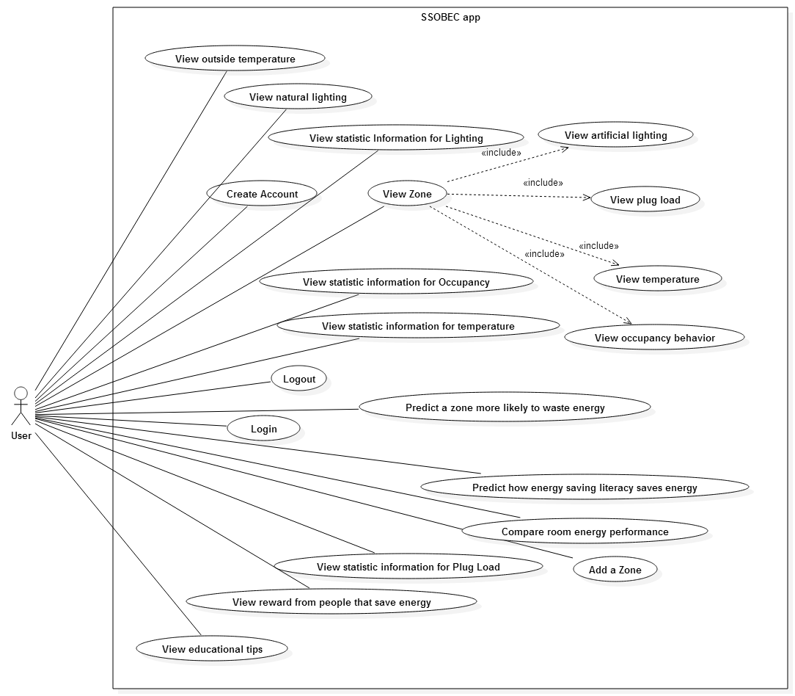

## 6.3 Appendix C - Static UML diagram

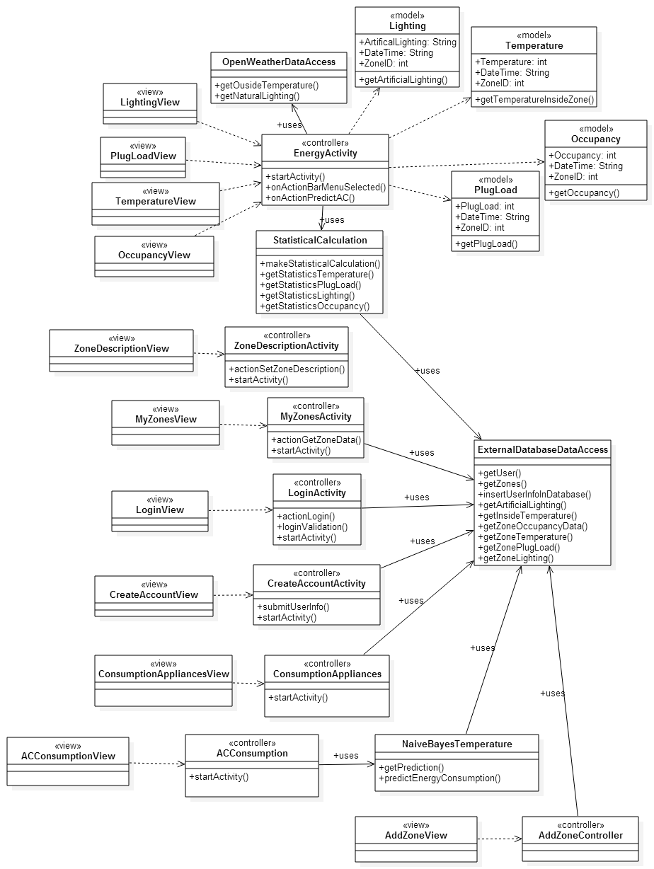

## 6.4 Appendix D - Dynamic UML diagrams

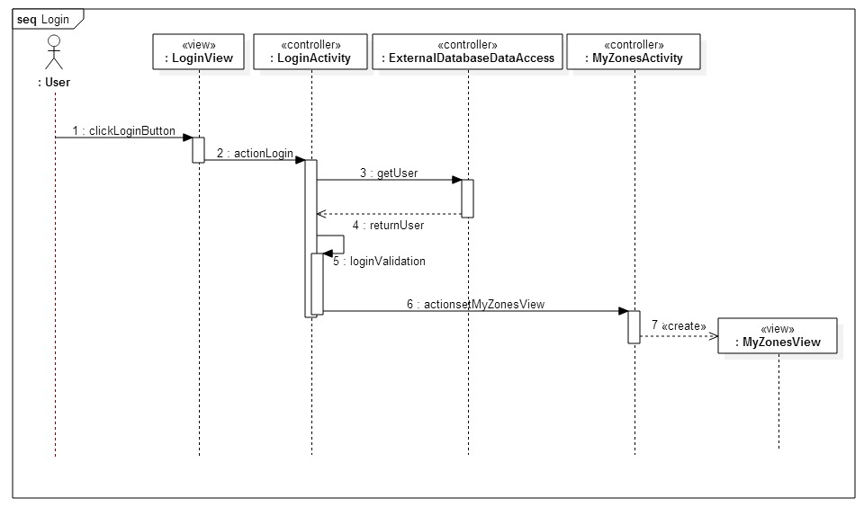

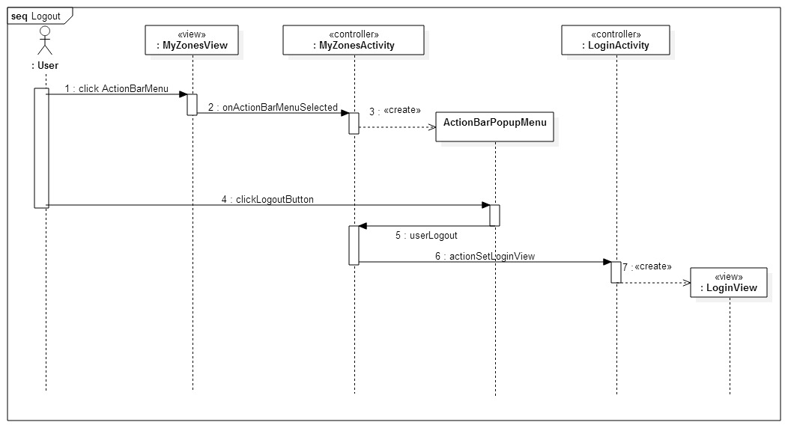

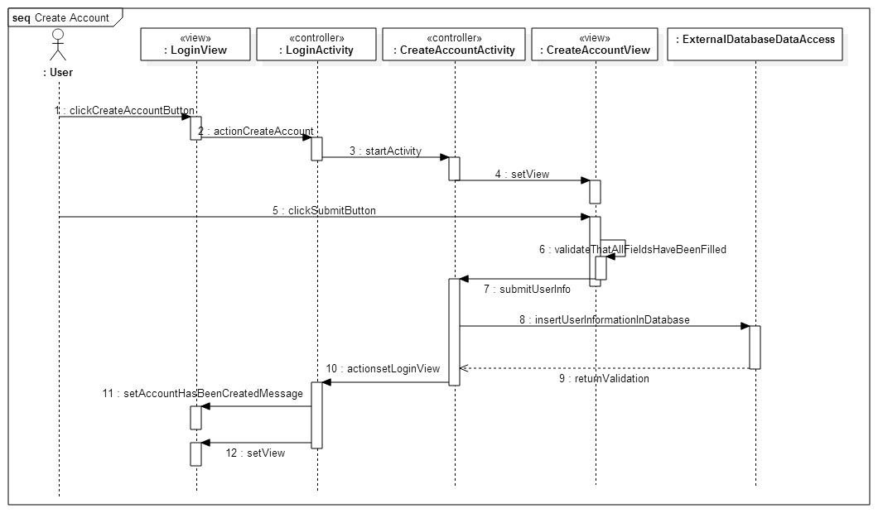

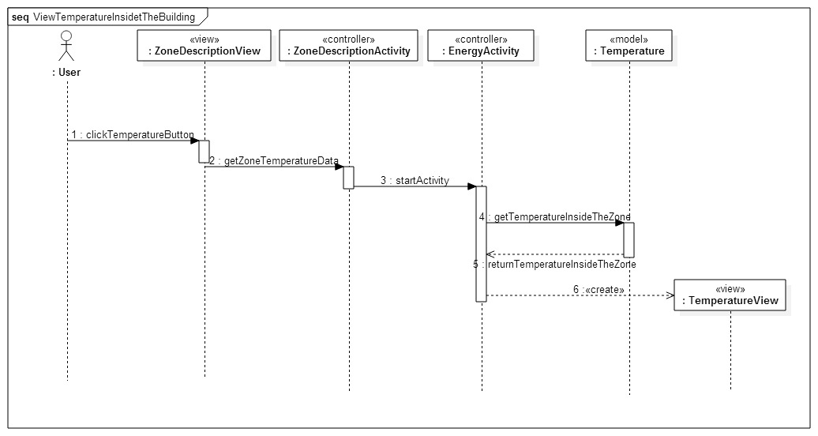

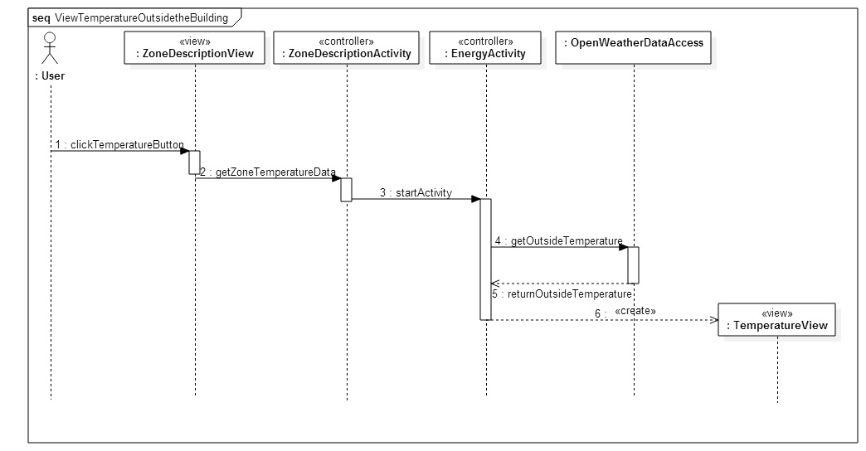

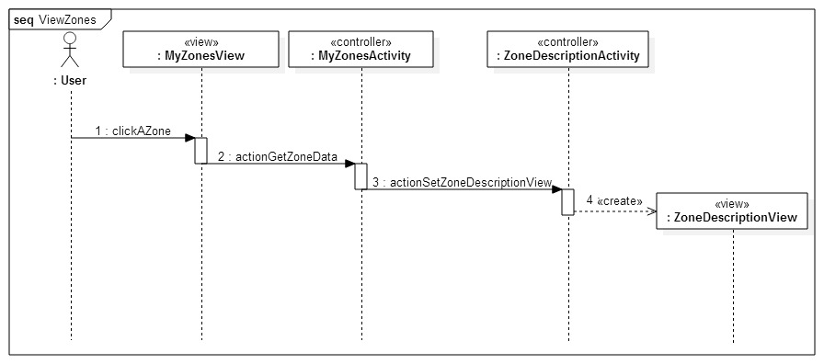

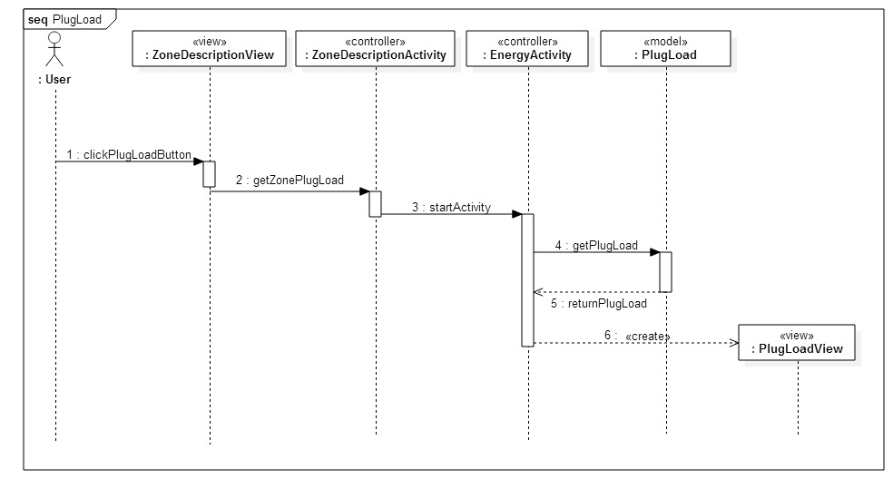

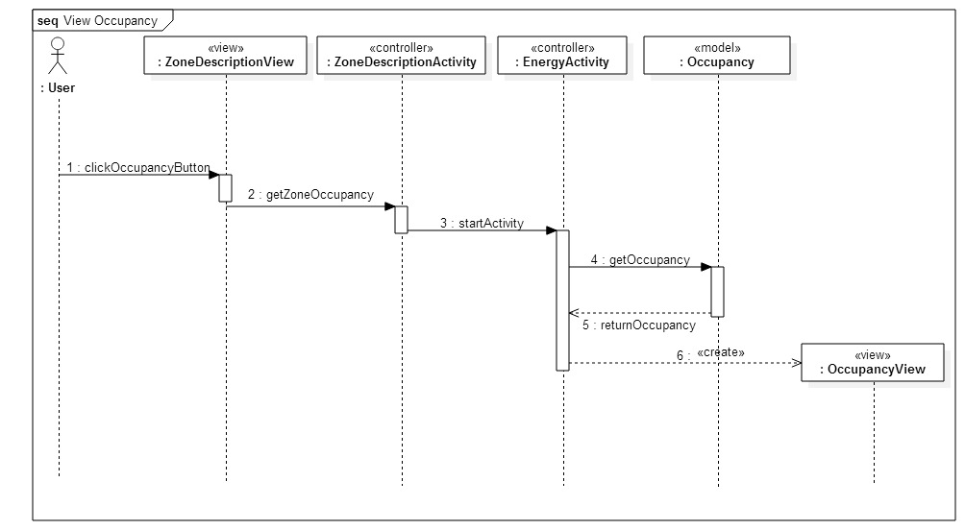

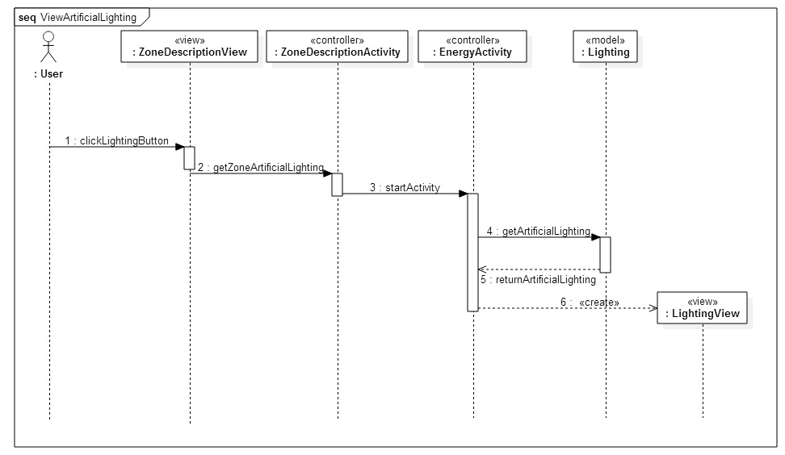

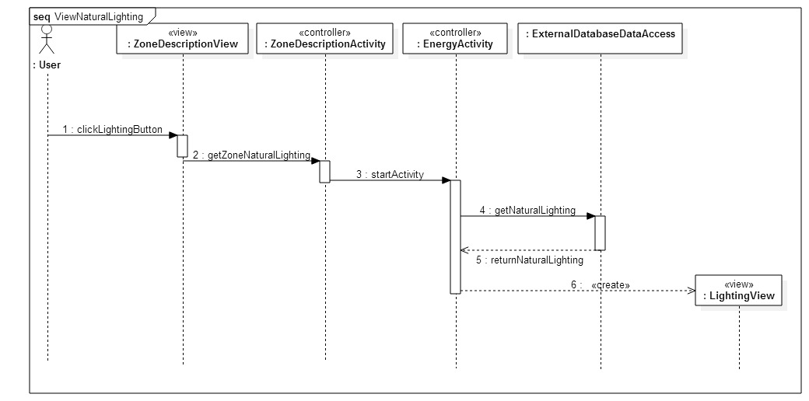

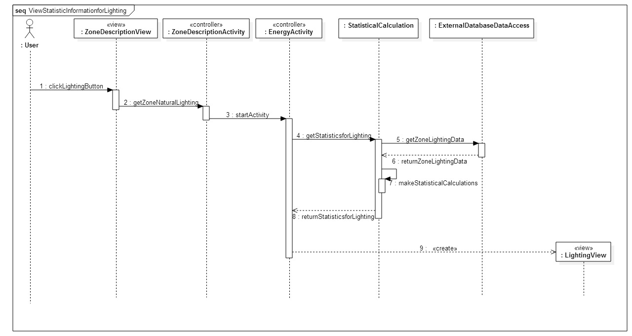

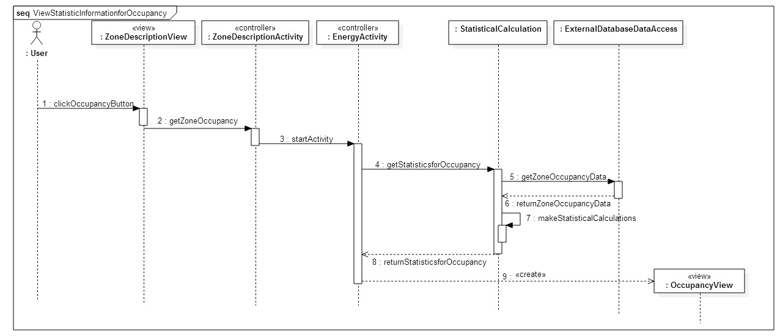

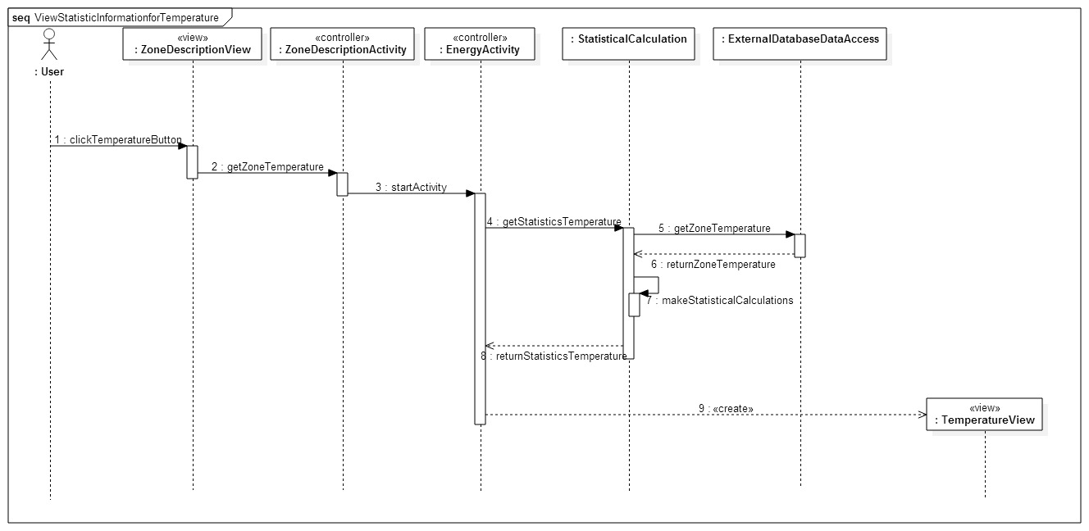

*Seq. Predict a zone more likely to waste energy*

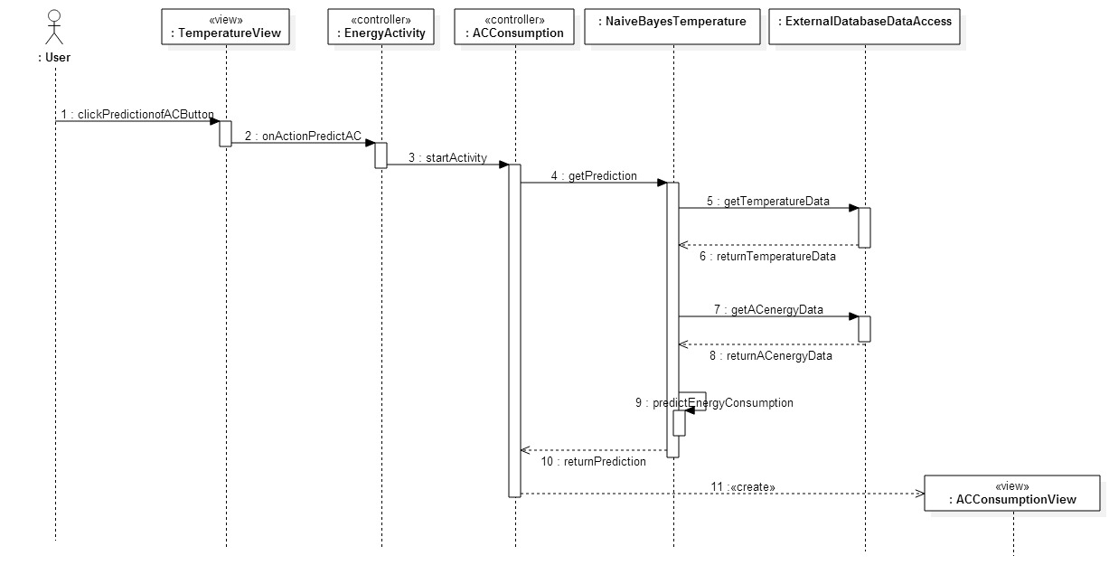

*Seq. Predict how energy-saving literacy saves energy*

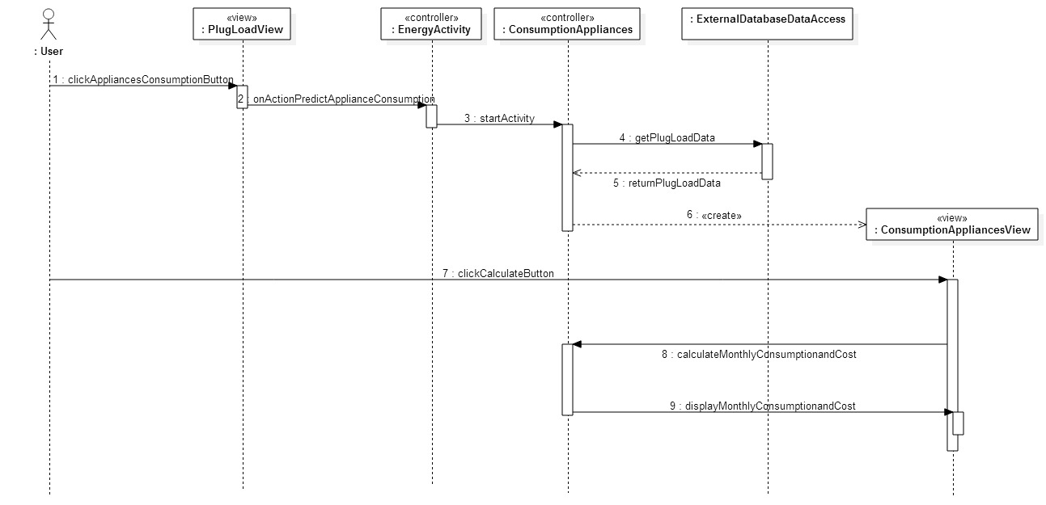

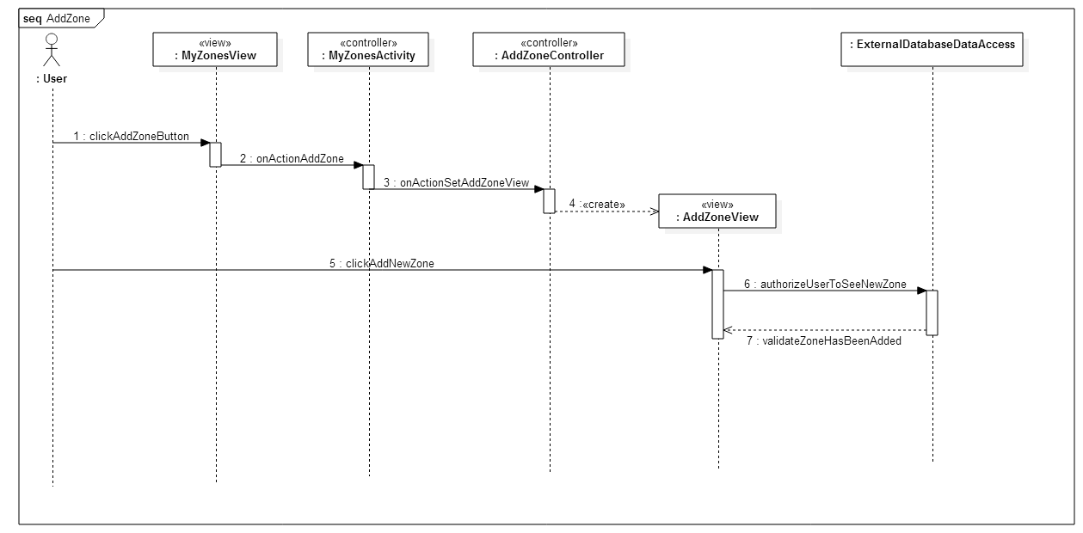

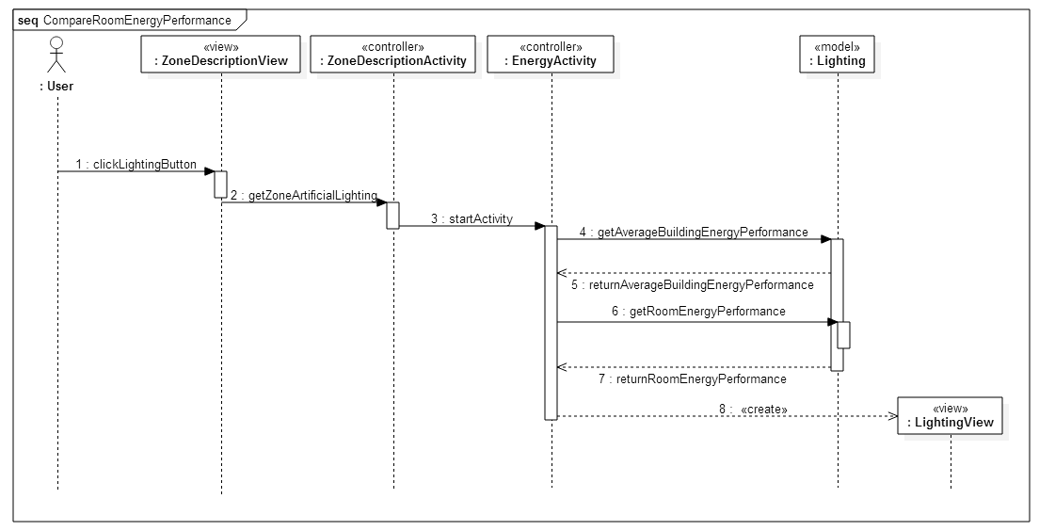

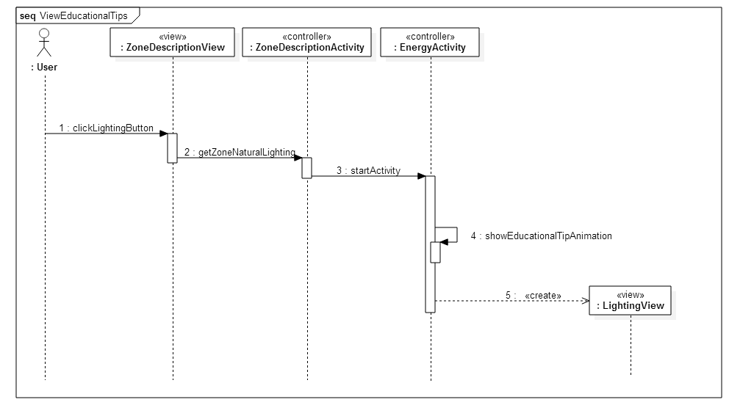

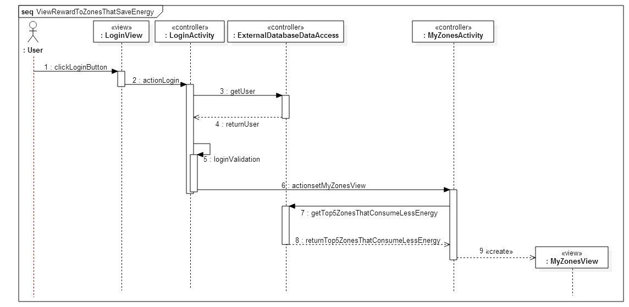

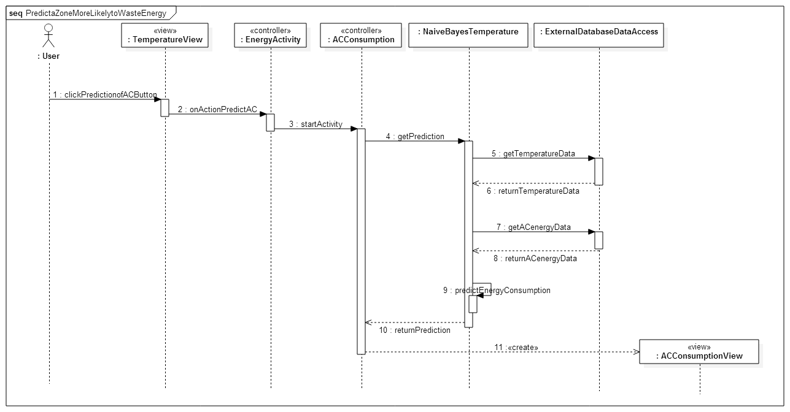

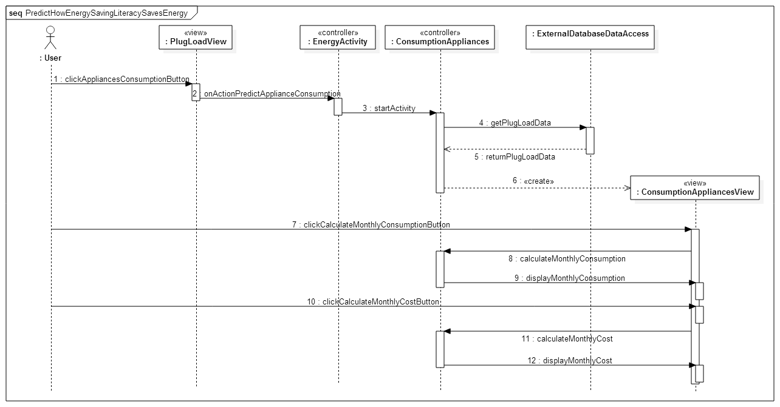

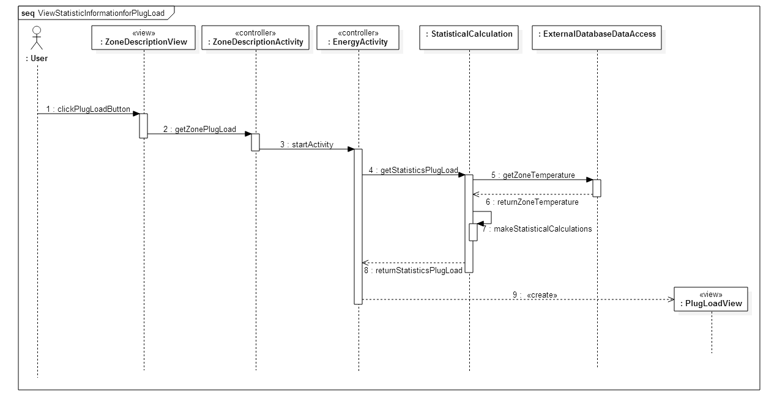

## 6.5 Appendix E - User Interface designs.

These are the different user interfaces that we implemented in our application:

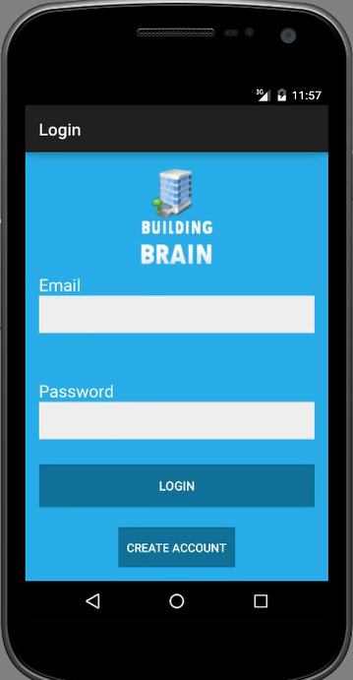

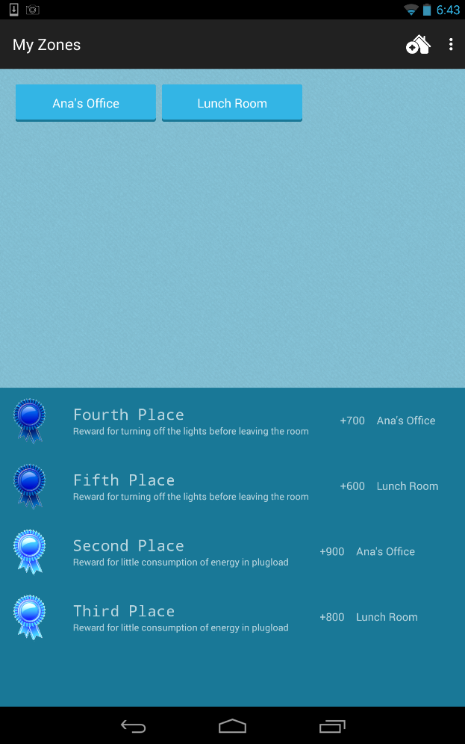

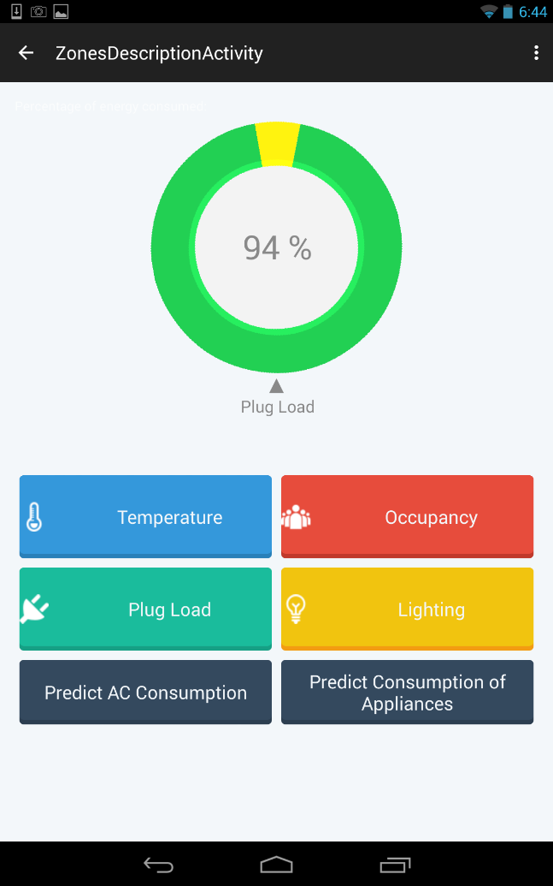

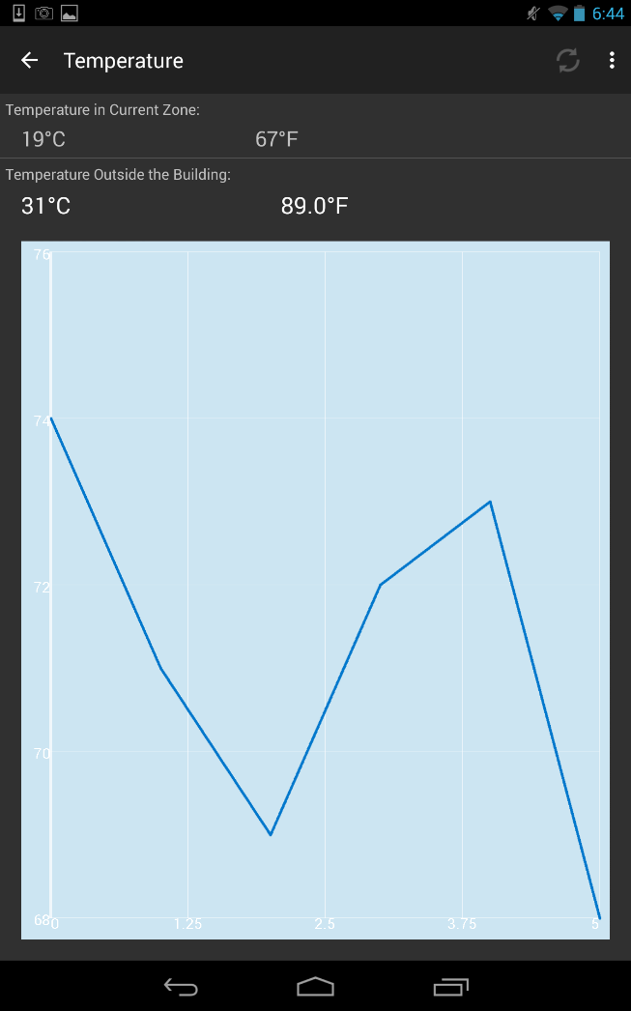

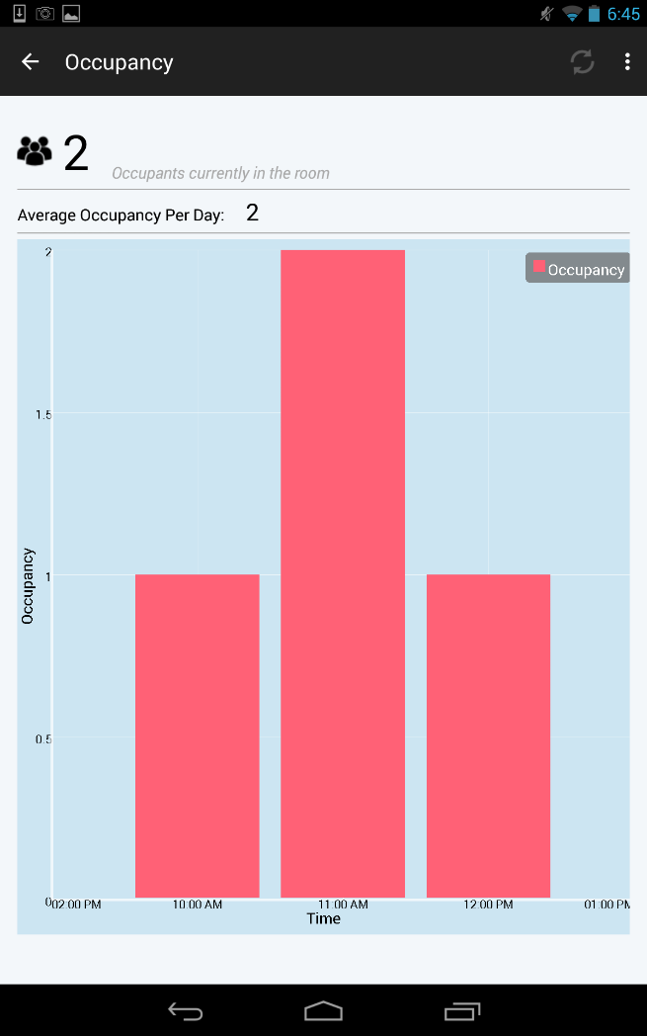

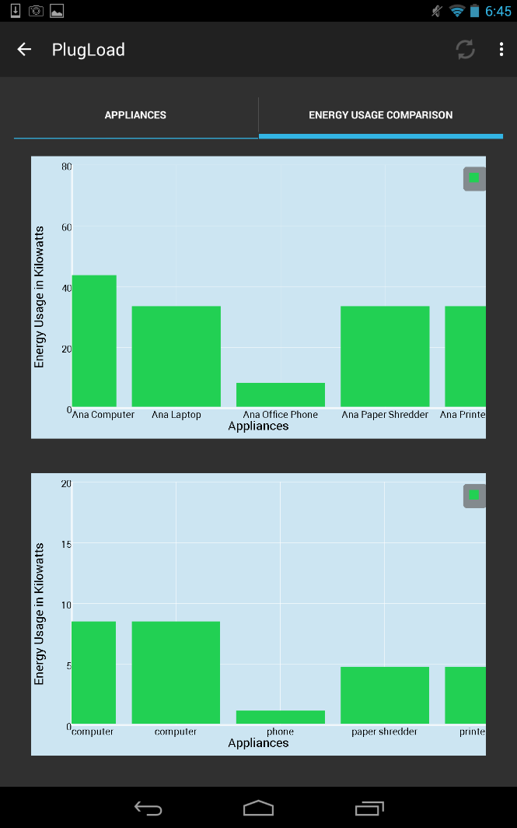

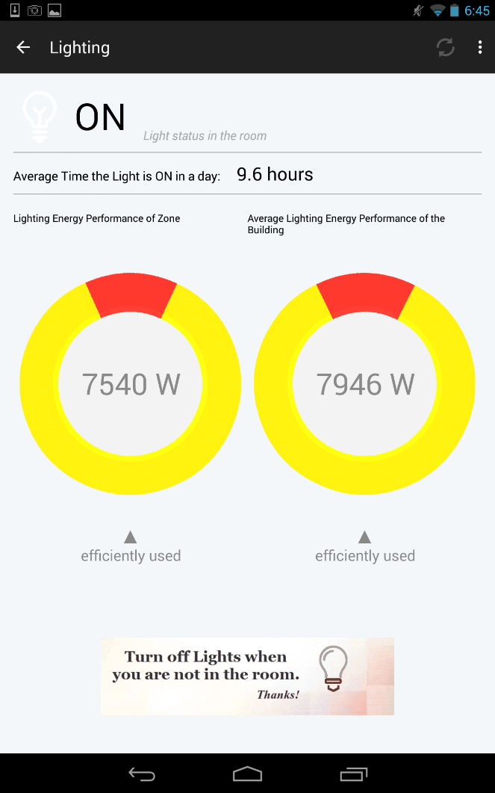

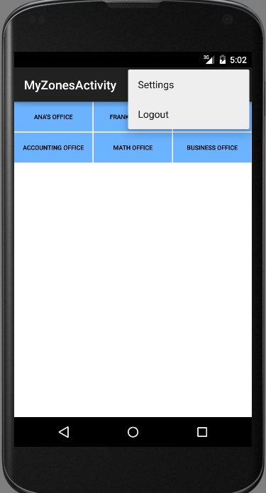

6.6 Appendix F - Diary of meeting and tasks.

Following are the diary entries for all of our meetings throughout the semester.

|  |  |
| --- | --- |
| ***DATE*** | *January 21, 2015* |
| ***Location*** | *FIU Modesto A. Maidique Campus ECS 212B* |
| ***Start*** | *5:00 pm* |
| ***End*** | *6:30 pm* |
| ***In Attendance*** | *Leonardo Bobadilla*  *Ali Mostafavi*  *Maria Presa Reyes*  *Dalaidis Hidalgo Arencibia* |
| ***Late*** | *N/A* |
| ***Agenda*** | *- General Background of the project*  *- Collect User Stories*  *- Begin to work with Feasibility Study* |
| ***Summary of Discussion*** | *-Meeting Time (All  weeks)* |
| ***Assigned Tasks*** | *-Create Google Drive to share our document between us.*  *- Continue working with user stories to improve our work.* |

|  |  |
| --- | --- |
| ***DATE*** | *January 26, 2015* |
| ***Location*** | *FIU Modesto A. Maidique Campus ECS 212B* |
| ***Start*** | *4:00 pm* |
| ***End*** | *5:10 pm* |
| ***In Attendance*** | *Leonardo Bobadilla*  *Ali Mostafavi*  *Maria Presa Reyes*  *Dalaidis Hidalgo Arencibia* |
| ***Late*** | *N/A* |
| ***Agenda*** | *- Product Backlog*  *- Feasibility Study*  *-Project Plan*  *-System Design*  *-Object Design*  *-Name Android Application* |
| ***Summary of Discussion*** | *-Programs and tool to use in our application.* |
| ***Assigned Tasks*** | *-Dr. Leonardo Bobadilla and Dr. Ali Mostafavi make the selection of the Name of the Android Application.*  *-Continue working with the documentation in order to try to do the most that we can.*  *-Make a selection of the Linux machine for the Database.* |

|  |  |
| --- | --- |
| ***DATE*** | *January 30, 2015* |
| ***Location*** | *FIU Modesto A. Maidique Campus ECS 212B* |
| ***Start*** | *4:00 pm* |
| ***End*** | *5:00 pm* |
| ***In Attendance*** | *Leonardo Bobadilla*  *Ali Mostafavi*  *Maria Presa Reyes*  *Dalaidis Hidalgo Arencibia* |
| ***Late*** | *N/A* |
| ***Agenda*** | *- Check the Name of the Android Application*  *- Check our ideas of the Product Backlog with our mentors*  *- Check Feasibility Study*  *- Check Project Plan*  *- Check System Design*  *- Check Object Design*  *- Continue working of the documentation*  *-Continue thinking on the design of different diagrams*  *-Prepare the PorwerPoint for the presentation* |
| ***Summary of Discussion*** | *Login, Logout, Temperature, Zone details and Occupancy in different zones.* |
| ***Assigned Tasks*** | *Maria: Work in Zone details and in Occupancy in different zones*  *Dalaidis: Work in Login, Logout and Temperature* |

|  |  |
| --- | --- |
| ***DATE*** | *February 13, 2015* |
| ***Location*** | *FIU Modesto A. Maidique Campus ECS 212B* |
| ***Start*** | *4:00 pm* |
| ***End*** | *5:00 pm* |
| ***In Attendance*** | *Leonardo Bobadilla*  *Ali Mostafavi*  *Maria Presa Reyes*  *Dalaidis Hidalgo Arencibia* |
| ***Late*** | *N/A* |
| ***Agenda*** | *Show the information for:*  *Plug Load*  *Temperature inside the building*  *Temperature outside the building*  *Occupancy*  *Artificial Lighting*  *Natural Lighting* |
| ***Summary of Discussion*** | *Work in the Synchronization* |
| ***Assigned Tasks*** | *Maria: Works in Occupancy, Artificial Lighting and Natural Lighting*  *Dalaidis: Works in Plug Load, Temperature inside the building and Temperature outside the building* |

|  |  |
| --- | --- |
| ***DATE*** | *February 28, 2015* |
| ***Location*** | *FIU Modesto A. Maidique Campus ECS 212B* |
| ***Start*** | *5:00 pm* |
| ***End*** | *6:00 pm* |
| ***In Attendance*** | *Leonardo Bobadilla*  *Ali Mostafavi*  *Maria Presa Reyes*  *Dalaidis Hidalgo Arencibia* |
| ***Late*** | *N/A* |
| ***Agenda*** | *Check the progress of the project and documentation* |
| ***Summary of Discussion*** | *Algorithms  and Statistic that need to be implemented and programs to use* |
| ***Assigned Tasks*** | *Using actual Android Devices instead of the emulator to install and test the application.*  *Dalaidis needs to work with algorithms and Graphic Design and Create Account.*  *User Stories assigned ()*  *Maria Presa needs to work with Statistical and Graphic Design*  *User Stories assigned ()* |

|  |  |
| --- | --- |
| ***DATE*** | ***March 20, 2015*** |
| ***Location*** | *FIU Modesto A. Maidique Campus ECS 212B* |
| ***Start*** | *4:00 pm* |
| ***End*** | *5:00 pm* |
| ***In Attendance*** | *Leonardo Bobadilla*  *Ali Mostafavi*  *Maria Presa Reyes*  *Dalaidis Hidalgo Arencibia* |
| ***Late*** | *N/A* |
| ***Agenda*** | *Check the progress of the project and make a selection of 2 android phone and 2 android tablet* |
| ***Summary of Discussion*** | *Select with android phone and with android tablet should be better to buy and use in our project.*  *Check the progress of the application so far.* |
| ***Assigned Tasks*** | *Dalaidis should works in prediction and view importance of save energy.*  *Maria needs to continue working with statistic and create a zone.* |

|  |  |
| --- | --- |
| ***DATE*** | April 4, 2015 |
| ***Location*** | *FIU Modesto A. Maidique Campus ECS 212B* |
| ***Start*** | *5:00 pm* |
| ***End*** | *6:00 pm* |
| ***In Attendance*** | *Leonardo Bobadilla*  *Ali Mostafavi*  *Maria Presa Reyes*  *Dalaidis Hidalgo Arencibia* |
| ***Late*** | *N/A* |
| ***Agenda*** | Continue working with prediction and statistics |
| ***Summary of Discussion*** | Showing that our application is running correctly. |
| ***Assigned Tasks*** | Dalaidis continues working with predictions  Maria continues working with |

|  |  |
| --- | --- |
| ***DATE*** | April 18, 2015 |
| ***Location*** | *FIU Modesto A. Maidique Campus ECS 212B* |
| ***Start*** | *5:00 pm* |
| ***End*** | *6:00 pm* |
| ***In Attendance*** | *Leonardo Bobadilla*  *Ali Mostafavi*  *Maria Presa Reyes*  *Dalaidis Hidalgo Arencibia* |
| ***Late*** | *N/A* |
| ***Agenda*** | Talking about the gif animations content and also think about what program we are going to use in order to complete this work |
| ***Summary of Discussion*** | We take the decision to use Camtasia and GYMP 2 in order to achieve our goals. |
| ***Assigned Tasks*** | Dalaidis works with view reward from people that save energy and view educational tips.  Maria continues working with add a zone and compare room energy performance |

7. References