|  |
| --- |
| *FLORIDA INTERNATIONAL UNIVERSITY*  School of Computing and Information Sciences  CIS 4911 Senior Capstone Project |
| **Smart Systems for Occupancy and Building Energy Control (SSOBEC)** |
| Feasibility |
|  |
|  |
| **Instructor**: Dr. Masoud Sadjadi  **Mentor**: Dr. Leonardo Bobadilla  **Mentor:** Dr. Ali Mostafavi    01/23/2015  *Group Member:*  Maria Eugenia Presa Reyes  Dalaidis Hidalgo Arencibia |

Abstract

Smart Systems for Occupancy and Building Energy Control is an application that provides information on occupancy behavior and energy consumption in buildings. The application will report statistics such as the occupancy in different zones, artificial and natural lighting information, and temperature inside and outside the building, plug load information, prediction for air condition, prediction for consumption of some appliances and prediction for the monthly costs. This application will display the information in real time with the goal of helping to teach people how to use the electricity in an efficient manner.

|  |
| --- |
|  |

Table of Contents

1. Introduction 4

1.1 Problem definition 4

1.2 Background 4

1.3 Definitions, Acronyms, and Abbreviations 5

1.4 Overview of document 5

2. Feasibility Study 7

2.1 Description of Current System 7

2.2 Purpose of New System 7

2.3 High level Definition of User Requirements 7

2.4 Alternative Solutions 9

2.4.1 Description of Alternatives 9

2.4.2 Selection Criteria 10

2.4.3 Analysis of Alternatives 10

2.5 Recommendations 11

3. Project Plan 12

3.1 Project Organization 12

3.1.1 Project Personnel Organization 12

3.1.2 Hardware and Software Resources 12

3.2 Identification of Tasks, Milestones and Deliverables 13

4. Appendix 16

4.1 Appendix A - Project schedule 16

4.2 Appendix B – Feasibility Matrix 22

4.3 Appendix C – Cost Matrix 23

4.4 Appendix D – Diary of Meetings 23

5. References 28

1. Introduction

Nowadays, electricity is essential to many of our daily activities. Through the use of the energy, we can have a better quality of life. Electricity has become indispensable and we hardly stop to think about the importance and benefits of using electricity in an efficient way.

Learning how to save energy in our daily consumption should be a priority for everyone. When people create good habits and attitudes to saving energy, they can achieve a more efficient consumption of electricity, prevent the waste of energy resources, improve family economy, and contribute to the preservation of our natural environment. In order to support this objective, we offer the Smart Systems for Occupancy and Building Energy Control, a software designed to easily manage the use of energy easily through a sensor network. This application not only is an easy way to save energy but also it can be a valuable tool to teach people how to save energy.

1.1 Problem definition

The United States of America is one of the countries with higher energy consumption within homes and buildings, and it is estimated that energy consumption in the U.S. will continue to increase over time. According to EIA in 2013 (U.S. Energy Information Administration), 40% of the consumption of energie in this country was in residential and commercial buildings.

Today, many of the luxuries that we have in homes and buildings require a lot of energy. For example, we can keep rooms with a comfortable temperature, heat water for bathing and hand washing, provide lighting, and power for TV, computer, appliances, and other technologies. The use of electricity has become vital for us, and that is why we need to make users aware of their energy consumption so that they can make changes in order to save energy. Occupancy behaviors have been identified as a major cause of uncertainty in the evaluation of energy performance in buildings. The ability to pinpoint ways to save energy in residential and commercial buildings is considered one of the top priorities associated with this project.

1.2 Background

This application provides information on occupancy behavior and energy consumption in buildings for users and gives the user information about energy performance. The information to be presented includes the level of occupancy in different zones, natural and artificial lighting information, temperature, and plug load. The data is displayed in the form of graphs and visualization dashboards. The application can also store the data, filter data, and perform analysis on the data as well as visualize it.

1.3 Definitions, Acronyms, and Abbreviations

Below is a list of definitions, acronyms, and abbreviations.

**DEFINITIONS:**

**Users**: Persons who use the application to track energy consumption for their rooms.

**Android Studio**: Is the official IDE that it is used by Android application development based on IntelliJ IDEA.

**ACRONYMS AND ABBREVIATIONS:**

**SSOBEC**: Smart Systems for Occupancy and Building Energy Control mobile application

**EIA:** United States’ Energy Information Administration

**DB**: Database

**FIU**: Florida International University

**SCIS**: School of Computing & Information Sciences

**App**: Application

1.4 Overview of Document

The Feasibility Study and the Project Plan cover a lot of details of the Smart Systems for Occupancy and Building Energy Control. Chapter 1 provides general information like problem definition, background information and definitions, acronyms and abbreviation for this project. Chapter 2 includes a feasibility study which covers the system that will be implemented, and the limitations and constraints of the current system. Chapter 3 describes the project and gives information about the hardware and software that will be used. Chapter 4 contains the Appendix, which gives information about the Gantt chart, Feasibility Matrix, Cost Matrix and diary of meetings. The last chapter contains the references used in the project.

2. Feasibility Study

The feasibility study explores the idea of Smart Systems for Occupancy and Building Energy Control from a practical point of view. Initially, research was conducted to make sure that there was currently no system developed capable of bringing to an end the desired tasks. Furthermore, we describe the overall purpose of the Smart Systems for Occupancy and Building Energy Control, and how the features of the SSOBEC system will easily manage the use of energy through a sensor network in order to promote energy efficiency. The high-level requirements are also described and the alternatives to certain aspects of the SSOBEC system are analyzed. The recommendations for the project are also described at the end of the study.

2.1 Description of Current System

The current system does not provide a smart approach to compare energy consumption of buildings along with occupancy behavior of the people in the different zones of a building. A user can measure how much energy is consumed only after he/she reads the utility bills of each month. The user does not know which rooms consume more energy than others, or which rooms waste more energy when they are left empty, and electricity is being used. There is no system that notifies a user when his/her room is currently empty and wasting energy. The user can see the amount of energy usage there has been for a period but cannot identify how much of that energy was not consumed efficiently.

2.2 Purpose of New System

The new system aims to implement a new kind of way of measuring energy by taking into account how much energy is consumed efficiently and how much is wasted. It will accomplish this by observing the occupancy behavior of the residents of each zone in the building.

2.3 High-level Definition of User Requirements

The use will require to own an Android device (either a smartphone or tablet) with access to the internet.

Functional requirements

Android Application:

* The system shall allow legitimate users to login through the application (see use case ID: SSOBEC01-Login in Appendix A and use case diagram in section 4.1.2)
* The system shall allow users to logout through the application (see use case ID: SSOBEC02-Logoutin Appendix A and use case diagram in section 4.1.2)
* The system shall allow users to create account through the application (see use case SSOBEC03- Create Account in Appendix A and use case diagram in section 4.1.2)
* The system shall allow users to view temperature inside the building through the application (see use case ID: SSOBEC04-View temperature inside the buildingin Appendix A and use case diagram in section 4.1.2)
* The system shall allow users to view temperature outside the building through the application (see use case ID: SSOBEC05- View temperature outside the building in Appendix A and use case diagram in section 4.1.2)
* The system shall allow users to view zone through the application (see use case SSOBEC06- View Zonein Appendix A and use case diagram in section 4.1.2)
* The system shall allow users to view plug load through the application (see use case SSOBEC07- View Plug Load in Appendix A and use case diagram in section 4.1.2)
* The system shall allow users to view occupancy through the application (see use case SSOBEC08- View Occupancy in Appendix A and use case diagram in section 4.1.2)
* The system shall allow users to view artificial lighting through the application (see use case SSOBEC09- View Artificial Lighting in Appendix A and use case diagram in section 4.1.2)
* The system shall allow users to view natural lighting through the application (see use case SSOBEC10- View Natural Lighting in Appendix A and use case diagram in section 4.1.2)
* The system shall allow users to view statistic information for lighting through the application (see use case SSOBEC11- View statistic information for lighting in Appendix A and use case diagram in section 4.1.2)
* The system shall allow users to view statistic information for occupancy through the application (see use case SSOBEC12- View statistic information for occupancy in Appendix A and use case diagram in section 4.1.2)
* The system shall allow users to view statistic information for temperature through the application (see use case SSOBEC13- View statistic information for temperature in Appendix A and use case diagram in section 4.1.2)
* The system shall allow users to view statistic information for plug load through the application (see use case SSOBEC14- View statistic information for plug load in Appendix A and use case diagram in section 4.1.2)
* The system shall allow users to predict a zone more likely to waste energy through the application (see use case SSOBEC15- Predict a zone more likely to waste energy in Appendix A and use case diagram in section 4.1.2)
* The system shall allow users to predict how energy saving literacy saves energy through the application (see use case SSOBEC16- Predict a zone more likely to waste energy in Appendix A and use case diagram in section 4.1.2)
* The system shall allow users to add a zone (see use case SSOBEC17- Add a zone in Appendix A and use case diagram in section 4.1.2)
* The system shall allow users to compare room energy performance (see use case SSOBEC18- Compare room energy performance in Appendix A and use case diagram in section 4.1.2)
* The system shall allow users to view reward for people that save energy (see use case SSOBEC19- View reward for people that save energy in Appendix A and use case diagram in section 4.1.2)
* The system shall allow users to view educational tips (see use case SSOBEC20- View educational tips in Appendix A and use case diagram in section 4.1.2)

2.4 Alternative Solutions

These sections 2.4.1 throughout 2.5 describe the alternative implementation for this Smart System for Occupancy and Building Energy Control project.

2.4.1 Description of Alternatives

Different solutions include a Web Application and Android Application.

Alternative 1: The first alternative solution was a Web Application. It is easy to update and maintain without distributing and installing a software. Web application helps you to gain information and collect data.

Alternative 2: The second solution was an Android Application. Nowadays Android application has been increasing their popularity. The user has the option to select an Android phone or an Android tablet to show that it has good accessibility.

2.4.2 Selection Criteria

Since selecting a right project is a serious decision for the project to be a success, we focus on the following criteria to make our selection:

1. **Project timeline**: It is important to know that the project should be finished in a reasonable period.
2. **Team availability**: It is necessary to know the amount of time that each team member has to support this project.
3. **Impact on service quality**: It is very important that the product owner is happy with the work of the developer.
4. **Benefits**: It is necessary to have an analysis of cost-benefit that this project should have.
5. **Customer Impact**: It is important to develop a project with the audience in mind.
6. **Solution Clarity**: It is a good idea to identify the true solution. The solution should already be known by the developer.

2.4.3 Analysis of Alternatives

Since the accessibility to the application and the increasing of the popularity it is very important for developers, they decided to create an Android application. Also, the developer is sure that they can manage their time to finish the project in a reasonable period. The cost-benefit was another point that they take into account. But, the most important thing for them was that the developer have a good clarity of the goal that they want to achieve and the impact that an Android application like this should have in the economy. Refer to Appendix B for the Feasibility Matrix.

2.5 Recommendations

The alternative chose consists of developing an Android application. The fact that the Android application has been increasing in their popularity and the easy accessibility make the developers take their decision.

3. Project Plan

This chapter provides a lot of details about how the project will proceed, containing Gantt charts, hardware requirements, and role specification. Also, between the project organizations we specify the role assignments for each member. In addition, the hardware and software requirements specify the necessary requisites to implement and operate the Smart System for occupancy and Building Energy Control, as well as the development environment. Finally, the work breakdown shows the identification of tasks, milestones and deliverables along with their dependencies.

3.1 Project Organization

The following table shows how the roles are broken down for the deliverable of this project.

3.1.1 Project Personnel Organization

This section shows the assignment of roles during the realization of the project:

|  |  |  |  |  |  |
| --- | --- | --- | --- | --- | --- |
| **GROUP MEMBERS** | | **SOFTWARE** | **TESTING** | **PRESENTATION** | **DOCUMENTATION** |
| Maria Presa | X | | X | X | X |
| Dalaidis Hidalgo | X | | X | X | X |

Table 3.1.1.1 Project Organization

3.1.2 Hardware and Software Resources

**HARDWARE**

* Computer that has a 1.6 GHz or faster processor
* 1GB(32 Bit) RAM
* 3GB of available hard disk space
* Mobile phone
* Tablet with Android

**SOFTWARE**

* Git
* GitHub
* Google Drive
* Gmail
* Android Studio
* Mingle
* StarUML
* SQL
* PHPMyAdmin
* Source Tree
* Camtasia
* Gimp
* Notebook++
* SqliteBrowser
* Putty
* Vertabelo
* Visio 2013
* LAMP
* Espresso

3.2 Identification of Tasks, Milestones, and Deliverables

|  |  |
| --- | --- |
| **MILESTONE** | **TASK AND DELIVERABLE** |
| Documentation | * Feasibility Study * Project Plan * System Design * Object Design * Installation Guide * User Manual |
| Environment Setup | * Git * GitHub * Google Drive * Gmail * Android Studio * Mingle * StarUML * SQL * PHPMyAdmin * Source Tree * Camtasia * Gimp * Notebook++ * SqliteBrowser * Putty * Vertabelo * Visio 2013 * LAMP * Espresso |
| UI Design (Project) | * Login * Logout * View temperature inside the building * View temperature outside the building * View Zone * View Plug Load * View Occupancy * View Artificial Lighting * View Natural Lighting * View statistics information for lighting * View statistics information for occupancy * View statistics information for temperature * View statistics information for plug load * Predict a zone more likely to waste energy * Predict how energy saving literacy saves energy * Create Account * Add a zone * Compare room energy performance. * View reward from people that save energy * View educational tips. |
| Database Design and implementation | * Creates Tables * Create tables relationships and constrains * Create ER diagram |
| Main Activity Functionality | * Connect one activity to the other. * Create main Data Access Object for internal database * Create main Data Access Object for external database |
| Testing | * Automated testing with Espresso |

4. Appendix

This chapter provides a Gantt Chart with the scheduled time of work for the whole project, a feasibility matrix, a cost matrix that shows the estimate total cost for the project, and a diary of meetings.

4.1 Appendix A - Project schedule

This appendix displays the project planning schedule for the Smart System for Occupancy and Building Energy Control.

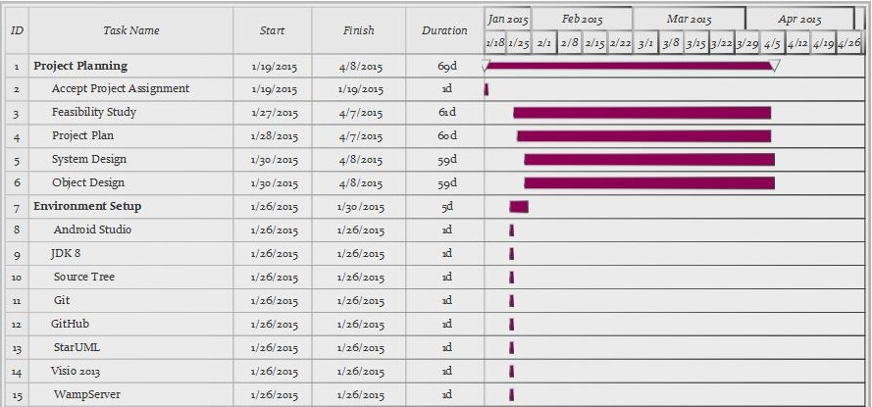

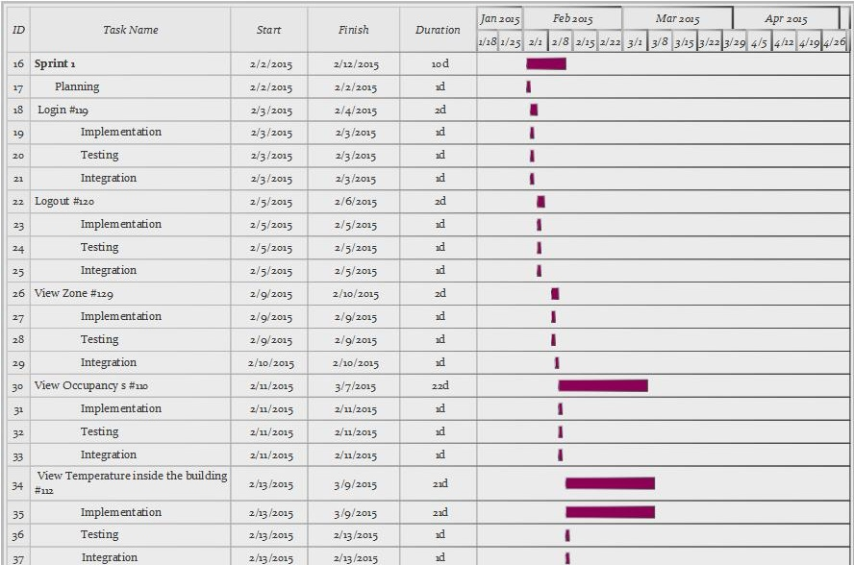

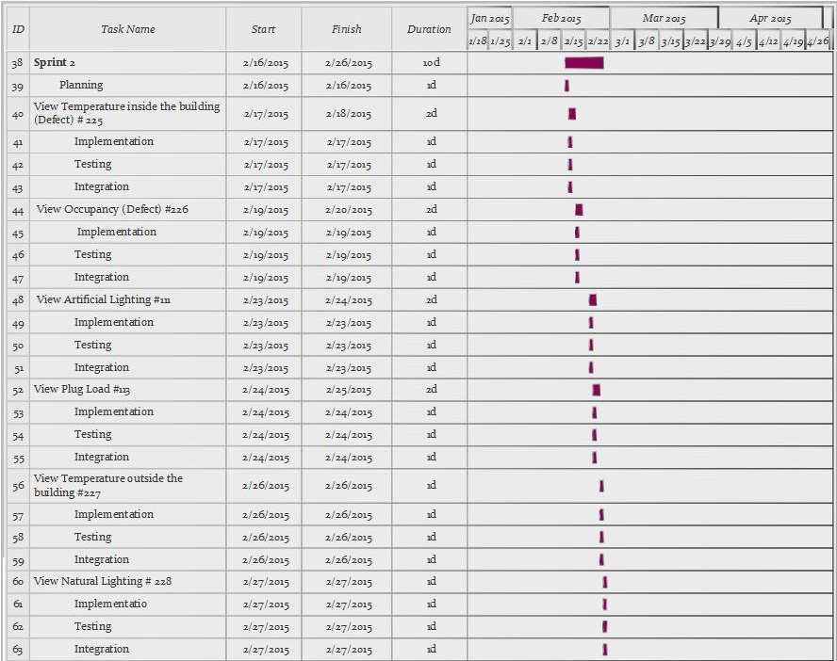

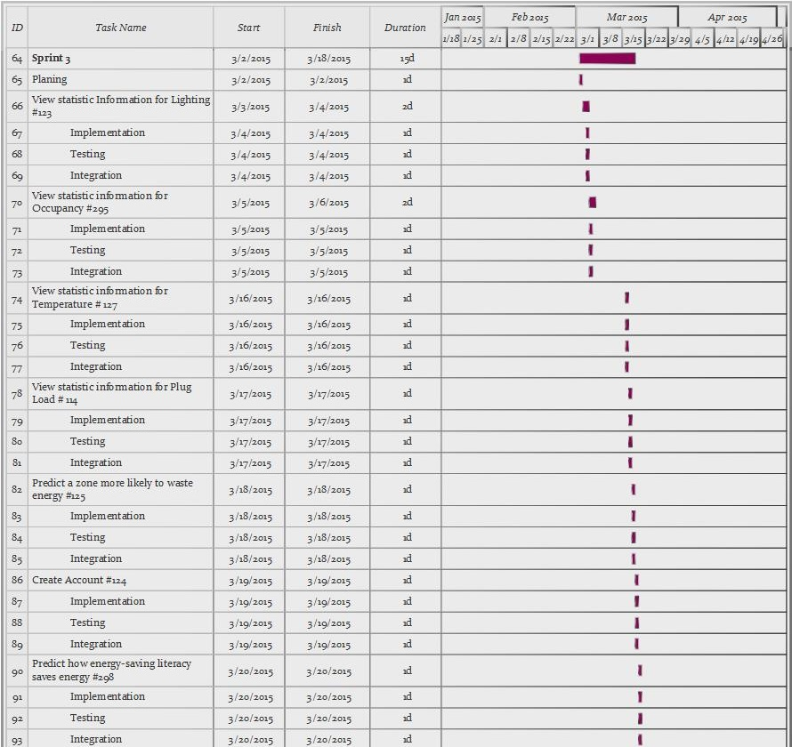

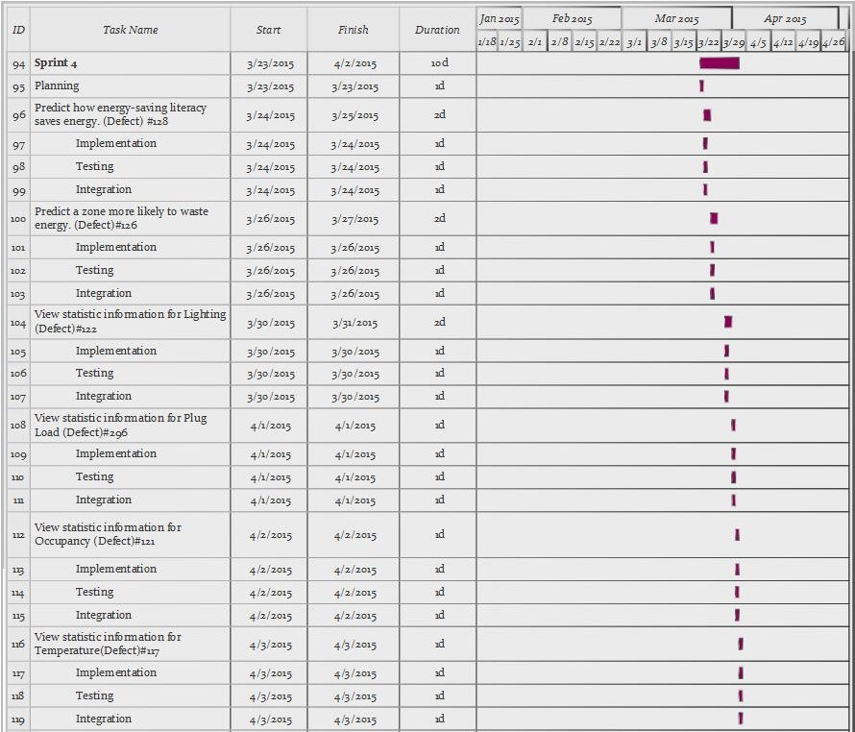

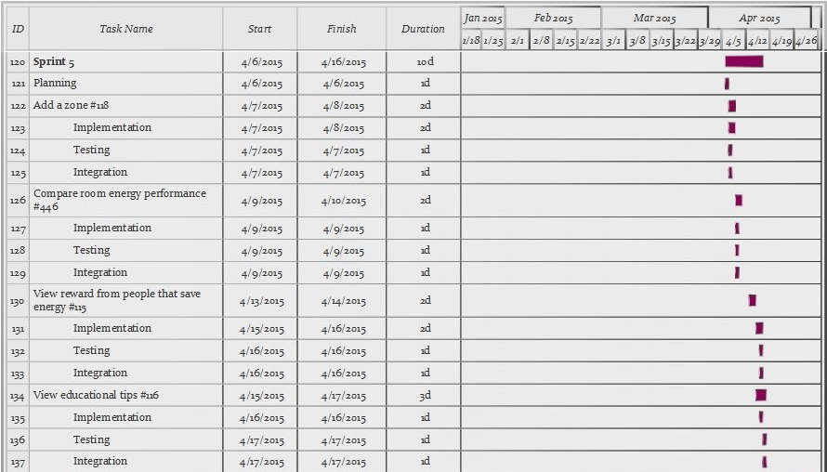

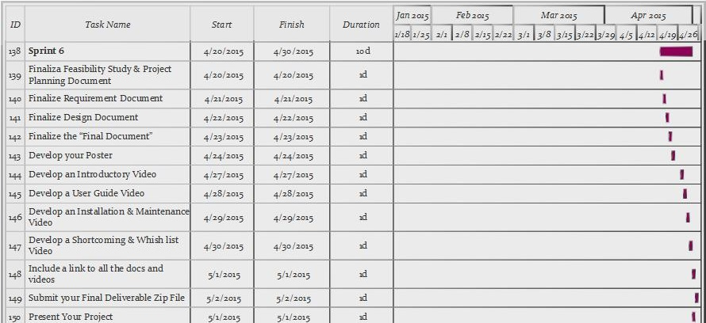

4.2 Appendix B – Feasibility Matrix

|  |  |  |  |
| --- | --- | --- | --- |
| Feasibility Criteria | Wt. | Alternative 1 | Alternative 2 |
| Operational Feasibility    Functionality. A description of to what degree the candidate would benefit the organization and how well the system would work.    Political. A description of how well received this solution would be from both user management, user, and organization perspective. | 30% | Fully supports required functionality                Score:20 | Fully supports required functionality                  Score:30 |
| Technical Feasibility    Technology. An assessment of the maturity, availability (or ability to acquire), and desirability of the computer technology needed to support this candidate.    Expertise. An assessment to the technical expertise needed to develop, operate, and maintain the candidate system. | 30% | Computer supported                  Score:15 | Android supported                      Score:20 |
| Economic Feasibility | 30% | The new platform will make use of open resources, Self-Maintained School Resources. Therefore, the system does not cost anything. There will be no payback.  Score:20 | The new platform will make use of open resources, Self-Maintained School Resources. Therefore, the system does not cost anything. There will be no payback.    Score:25 |
| Schedule Feasibility    An assessment of how long the solution will take to design and implement. | 10% | Two Years    Score:15 | One Year    Score:10 |
| Ranking: | 100% | 70 | 85 |

4.3 Appendix C – Cost Matrix

|  |  |  |
| --- | --- | --- |
| **RESOURCES** | **QUANTITY** | **COST** |
| PC (Hardware) | 2 | $0.00 |
| Smart Phone Android | 2 | $0.00 |
| Tablet | 3 | $0.00 |
| MySQL | 2 | $0.00 |
| Development |  | $0.00 |
| Testing |  | $0.00 |
| Total Cost |  | $0.00 |

4.4 Appendix D – Diary of Meetings

Following are the diary entries for all of our meetings throughout the semester.

|  |  |
| --- | --- |
| ***DATE*** | *January 21, 2015* |
| ***Location*** | *FIU Modesto A. Maidique Campus ECS 212B* |
| ***Start*** | *5:00 pm* |
| ***End*** | *6:30 pm* |
| ***In Attendance*** | *Leonardo Bobadilla*  *Ali Mostafavi*  *Maria Presa Reyes*  *Dalaidis Hidalgo Arencibia* |
| ***Late*** | *N/A* |
| ***Agenda*** | *- General Background of the project*  *- Collect User Stories*  *- Begin to work with Feasibility Study* |
| ***Summary of Discussion*** | *-Meeting Time (All  weeks)* |
| ***Assigned Tasks*** | *-Create Google Drive to share our document between us.*  *- Continue working with user stories to improve our work.* |

|  |  |
| --- | --- |
| ***DATE*** | *January 26, 2015* |
| ***Location*** | *FIU Modesto A. Maidique Campus ECS 212B* |
| ***Start*** | *4:00 pm* |
| ***End*** | *5:10 pm* |
| ***In Attendance*** | *Leonardo Bobadilla*  *Ali Mostafavi*  *Maria Presa Reyes*  *Dalaidis Hidalgo Arencibia* |
| ***Late*** | *N/A* |
| ***Agenda*** | *- Product Backlog*  *- Feasibility Study*  *-Project Plan*  *-System Design*  *-Object Design*  *-Name Android Application* |
| ***Summary of Discussion*** | *-Programs and tool to use in our application.* |
| ***Assigned Tasks*** | *-Dr. Leonardo Bobadilla and Dr. Ali Mostafavi make the selection of the Name of the Android Application.*  *-Continue working with the documentation in order to try to do the most that we can.*  *-Make a selection of the Linux machine for the Database.* |

|  |  |
| --- | --- |
| ***DATE*** | *January 30, 2015* |
| ***Location*** | *FIU Modesto A. Maidique Campus ECS 212B* |
| ***Start*** | *4:00 pm* |
| ***End*** | *5:00 pm* |
| ***In Attendance*** | *Leonardo Bobadilla*  *Ali Mostafavi*  *Maria Presa Reyes*  *Dalaidis Hidalgo Arencibia* |
| ***Late*** | *N/A* |
| ***Agenda*** | *- Check the Name of the Android Application*  *- Check our ideas of the Product Backlog with our mentors*  *- Check Feasibility Study*  *- Check Project Plan*  *- Check System Design*  *- Check Object Design*  *- Continue working of the documentation*  *-Continue thinking on the design of different diagrams*  *-Prepare the PorwerPoint for the presentation* |
| ***Summary of Discussion*** | *Login, Logout, Temperature, Zone details and Occupancy in different zones.* |
| ***Assigned Tasks*** | *Maria: Work in Zone details and in Occupancy in different zones*  *Dalaidis: Work in Login, Logout, and Temperature* |

|  |  |
| --- | --- |
| ***DATE*** | *February 13, 2015* |
| ***Location*** | *FIU Modesto A. Maidique Campus ECS 212B* |
| ***Start*** | *4:00 pm* |
| ***End*** | *5:00 pm* |
| ***In Attendance*** | *Leonardo Bobadilla*  *Ali Mostafavi*  *Maria Presa Reyes*  *Dalaidis Hidalgo Arencibia* |
| ***Late*** | *N/A* |
| ***Agenda*** | *Show the information for:*  *Plug Load*  *Temperature inside the building*  *Temperature outside the building*  *Occupancy*  *Artificial Lighting*  *Natural Lighting* |
| ***Summary of Discussion*** | *Work in the Synchronization* |
| ***Assigned Tasks*** | *Maria: Work in Occupancy, Artificial Lighting, and Natural Lighting*  *Dalaidis: Work in: Plug Load, Temperature inside the building and Temperature outside the building* |

|  |  |
| --- | --- |
| ***DATE*** | *February 28, 2015* |
| ***Location*** | *FIU Modesto A. Maidique Campus ECS 212B* |
| ***Start*** | *5:00 pm* |
| ***End*** | *6:00 pm* |
| ***In Attendance*** | *Leonardo Bobadilla*  *Ali Mostafavi*  *Maria Presa Reyes*  *Dalaidis Hidalgo Arencibia* |
| ***Late*** | *N/A* |
| ***Agenda*** | *Check the progress of the project and documentation* |
| ***Summary of Discussion*** | *Algorithms  and Statistic that need to be implemented and programs to use* |
| ***Assigned Tasks*** | *Using actual Android Devices instead of the emulator to install and test the application.*  *Dalaidis needs to work with algorithms and Graphic Design and Create Account.*  *User Stories assigned ()*  *Maria Presa needs to work with Statistical and Graphic Design*  *User Stories assigned ()* |

|  |  |
| --- | --- |
| ***DATE*** | ***March 20, 2015*** |
| ***Location*** | *FIU Modesto A. Maidique Campus ECS 212B* |
| ***Start*** | *4:00 pm* |
| ***End*** | *5:00 pm* |
| ***In Attendance*** | *Leonardo Bobadilla*  *Ali Mostafavi*  *Maria Presa Reyes*  *Dalaidis Hidalgo Arencibia* |
| ***Late*** | *N/A* |
| ***Agenda*** | *Check the progress of the project and make a selection of 2 android phone and 2 android tablet* |
| ***Summary of Discussion*** | *Select with android phone and with android tablet should be better to buy and use in our project.*  *Check the progress of the application so far.* |
| ***Assigned Tasks*** | *Dalaidis should work in prediction and view importance of save energy.*  *Maria needs to continues work with statistic and create a zone.* |

|  |  |
| --- | --- |
| ***DATE*** | April 4, 2015 |
| ***Location*** | *FIU Modesto A. Maidique Campus ECS 212B* |
| ***Start*** | *5:00 pm* |
| ***End*** | *6:00 pm* |
| ***In Attendance*** | *Leonardo Bobadilla*  *Ali Mostafavi*  *Maria Presa Reyes*  *Dalaidis Hidalgo Arencibia* |
| ***Late*** | *N/A* |
| ***Agenda*** | Continue working with prediction and statistics |
| ***Summary of Discussion*** | Showing that our application is running correctly. |
| ***Assigned Tasks*** | Dalaidis continues working with predictions  Maria continues working with |

|  |  |
| --- | --- |
| ***DATE*** | April 18, 2015 |
| ***Location*** | *FIU Modesto A. Maidique Campus ECS 212B* |
| ***Start*** | *5:00 pm* |
| ***End*** | *6:00 pm* |
| ***In Attendance*** | *Leonardo Bobadilla*  *Ali Mostafavi*  *Maria Presa Reyes*  *Dalaidis Hidalgo Arencibia* |
| ***Late*** | *N/A* |
| ***Agenda*** | Talking about the gif animations content and also think about what program we are going to use in order to complete this work |
| ***Summary of Discussion*** | We take the decision to use Camtasia and GYMP 2 in order to achieve our goals. |
| ***Assigned Tasks*** | Dalaidis works with view reward from people that save energy and view educational tips.  Maria continues working with add a zone and compare room energy performance |

5. References

*Green Building*. (2015). Retrieved from University of the Pacify: http://www.pacific.edu/About-Pacific/Sustaining-Pacific/Campus-Operations/Sustainable-Living/Green-Building.html

*How much energy is consumed in residential and commercial buildings in the United States?* (2014, June 18). Retrieved from Independent Statistic and Analisis U.S Energy Information Administration: http://www.eia.gov/tools/faqs/faq.cfm?id=86&t=1