Setting Up Development Environment for Slideshow App

1) Sencha Touch

Sencha touch was the framework used to develop the Application. It must be used to build the app in order to see your changes. It also works with the native packager cordova or phonegap to package your app as a hybrid app. So you must have sencha touch installed on your development machine to make modifications to the app.

1.1) Sencha Touch 2.x Framework (latest version is 2.4)

There are two major major components of sencha touch. Sencha Cmd and the actual sencha touch framework. Sencha Cmd is a command line tool where you write your build commands on existing applications and the Sencha Framework is used to build new applications.

1.2) Installing the Sencha Framework

1) goto <https://www.sencha.com/products/touch/download/> fill out the survey and download the framework. It should be emailed to the email you specified. You will receive a folder called touch-xxx save this folder on your machine, if something happens you can always create a new app using it.

1.4) Install Java Runtime Environment

version 1.7. Sencha Cmd is written in Java and needs the JRE to run. **Note**: If you are building an Android app using Windows, you must install the [Java SDK](http://www.oracle.com/technetwork/java/javase/downloads/jdk7-downloads-1880260.html). You can build an iOS app under Windows with the JRE, but not an Android app.

1.5) Install Ruby

Ruby is used to create the compiled CSS used by Sencha Touch.

Windows users Download ruby from rubyinstaller.org . Download the RubyInstaller .exe file and run it .Mac users ruby is preinstalled in system.

1.3) Installing Sencha Cmd

1) goto <https://www.sencha.com/products/sencha-cmd/> click the download button and follow the instructions to install it on your system.

2) After installing you should have a global sencha command. Type “sencha” into terminal to make sure the installation was successful you should see something like the image below if not try installing again.

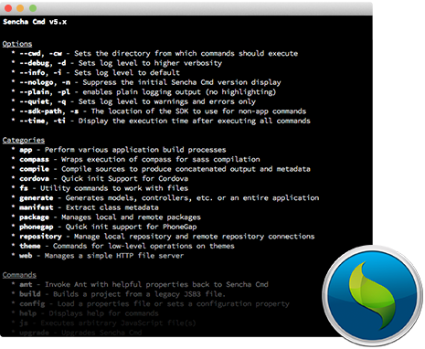

2) Setting Up Cordova

Cordova is the hybrid app packager that converts the sencha app into a hybrid application that can be run on a mobile device. It must be setup inorder to run the app on the device and simulator.

2.1) NodeJs

Nodejs is used to install cordova on your system.

Goto <https://nodejs.org/download/> and download the nodejs installer for your system this will also download npm for you which is crucial.

Follow the instructions on the installer. Type “npm” into terminal to make sure it is installed on your system. Also type “node” into terminal to make sure you have it installed.

2.2) Install Cordova

1) type “npm install -g cordova” into terminal to install cordova globally on your system you may need to type “sudo” first to make the command work. Type cordova in terminal to make sure you have it installed.

3) Downloading the App from the Internet & setting up ios Project

1. Download the projects source code from github at <https://github.com/FIU-SCIS-Senior-Project-2015-Spring/Social-Wall-Ver-2.0> from develop branch.

2. The IOS Xcode project can be found at Code/Mobile Application/seniorProjectApp/cordova/platforms/ios it is the file with the .xcodeproj file extension. The Sencha App is in the seniorProjectApp folder .If the cordova/ folder not present then cd into the seniorProjectApp folder and run “sencha cordova init com.fotozap.socialwall Slideshow” this will create the cordova project and place the cordova/ folder inside the sencha app.

2. Make sure inside the cordova/plugins/ folder you have the plugins we are using org.apache.cordova.splashscreen and com.connectsdk.cordovaplugin. If not cd into cordova/ folder and run “cordova plugin add “ and the name of the plugin for the connectsdk plugin it is [https:*//github.com/ConnectSDK/Connect-SDK-Cordova-Plugin.git#master*](https://github.com/ConnectSDK/Connect-SDK-Cordova-Plugin.git#master)*.* Also make sure to add the ios platform to cordova by typing “cordova platform add ios” into the terminal.

4. Clone the Connect SDK IOS github repository at https://github.com/ConnectSDK/Connect-SDK-iOS.git

5.Set up the submodules by running the following commands in Terminal in the directory of the cloned repository from step 3

git submodule init

git submodule update

6.Open the .xcodeproj ( file from step 2 ) the main xcode project in Xcode.

7.Drag the Connect SDK Xcode project (from step 3) into your main project's Xcode library.

8. Navigate to your project's settings screen, then navigate to the Build Phases tab.

9. Add ConnectSDK as a Target Dependency.

10. add the following in the Link Binary With Libraries section

libConnectSDK.a

libz.dylib

libicucore.dylib

11. Navigate to the Build Settings tab and add -ObjC to your target's Other Linker Flags

12. Build and run the Project if errors occur continue with the next steps.

Setup Connect SDK Chromecast IOS Framework

——————————————————————————————————————————

1.Go to the Google Cast Developer site (https://developers.google.com/cast/docs/downloads ) and download the iOS sender library

2.Extract the GoogleCast.framework bundle from the downloaded ZIP file

3. Move the framework bundle into your google-cast folder of your project under the Connect SDK Xcode project from step 6.

4. Add GoogleCast.framework and MediaAccessibility.framework to Link Binary With Libraries section and drag GoogleCast.framework to the Frameworks folder of your project.

5. Build and Run your Application.

Building the Project

Type “sencha app build native” into terminal inside the seniorProjectApp folder to build the sencha project. Everytime a change is made this setp must be done to show the changes to the app.