**Installation Guide**

CIS 4911 – Senior Project

Virtual Queue

**Member:**

Kenneth Kon

Michael Lazo

**Instructor**

Masoud Sadjadi

**Mentor**

[Bernard Parenteau](http://spws-dev.cis.fiu.edu/senior-project-website-v4/user/231)

**Date**

March 1st 2015

# 1. What you need to install?

## 1.1 Install JDK 7

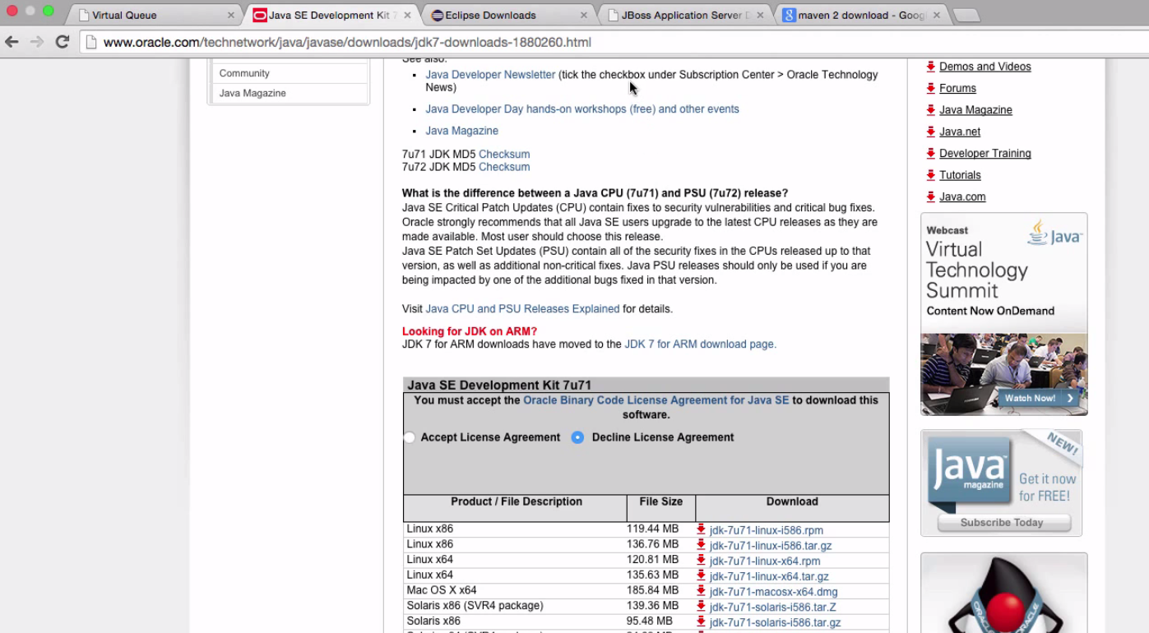

## 1.2 Install Eclipse IDE for Java EE Developers (Any Version)

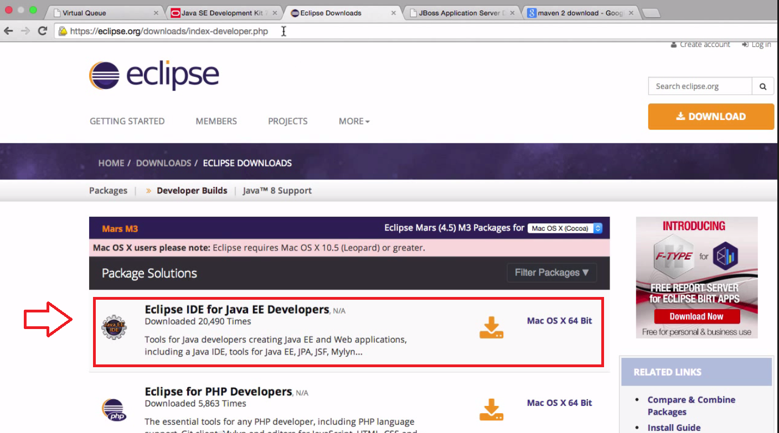

## 1.3 Down load apache-tomee-webprofile-1.7.1

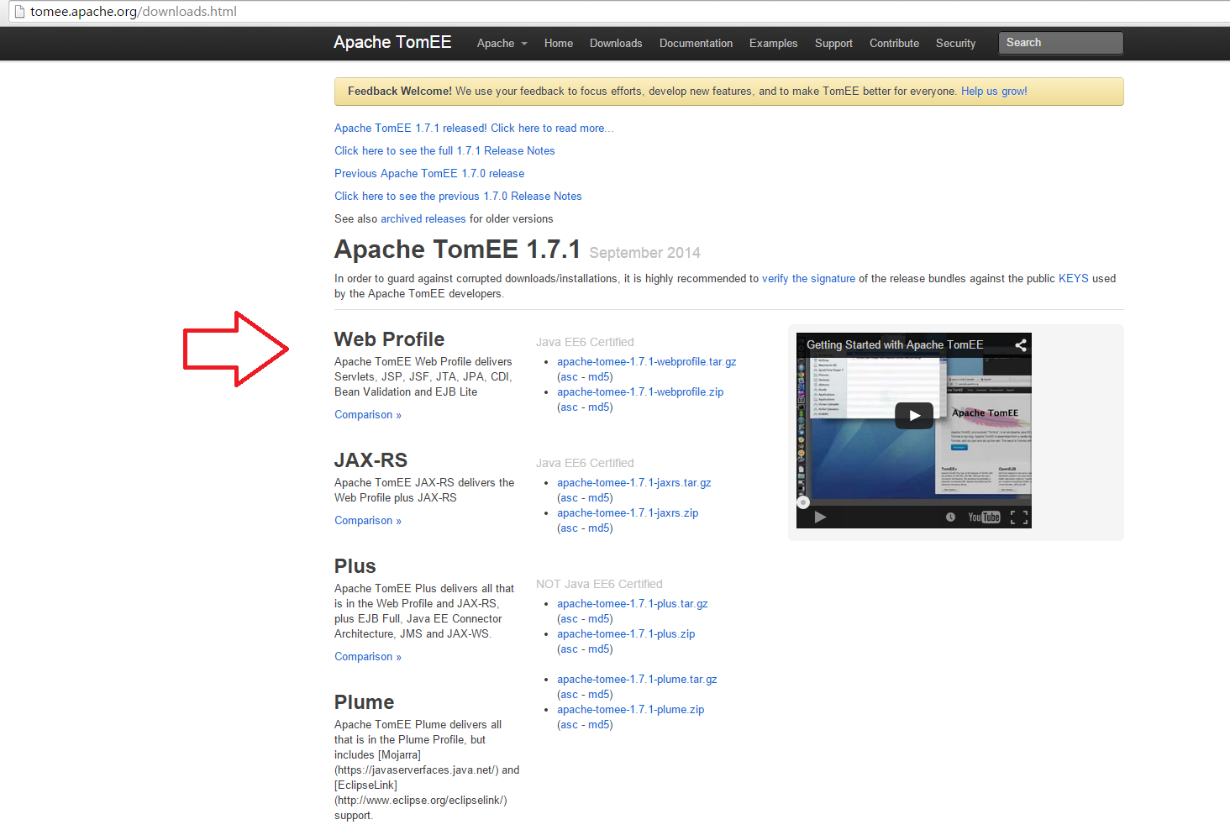

* Download 1.7.1 version from http://tomee.apache.org/downloads.html
* Then create a new server in Server Tab in Eclipse you have downloaded.
* Create Tomecat 7.0 Server version attach 1.7.1 file as Server runtime environment.

