**User Guide**

CIS 4911 – Senior Project

Virtual Queue

**Member:**

Kenneth Kon

Michael Lazo

**Instructor**

Masoud Sadjadi

**Mentor**

[Bernard Parenteau](http://spws-dev.cis.fiu.edu/senior-project-website-v4/user/231)

**Date**

March 1st 2015

# Virtual Queue Homepage:

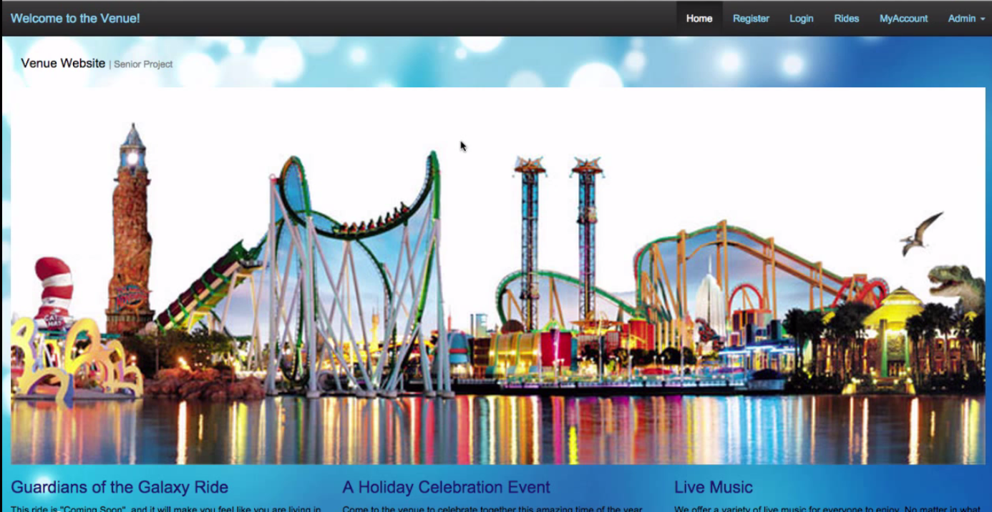

## 1. How to Register?

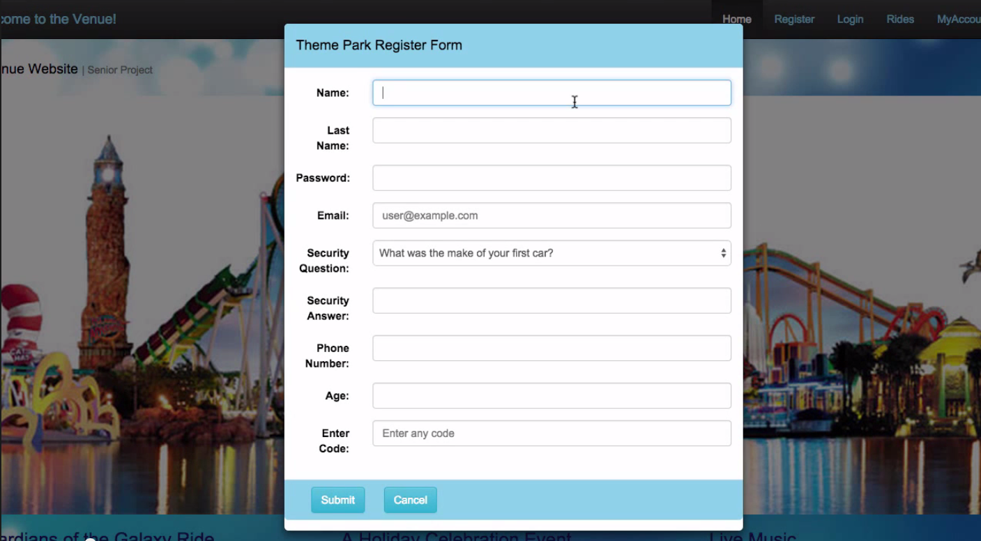

1) Click on Register tab on the top right hand corner of the homepage.

2) Fill in the "Theme Park Register Form"

3) Then press submit.

4) There you are now you are registered!

## 2. How to Login?

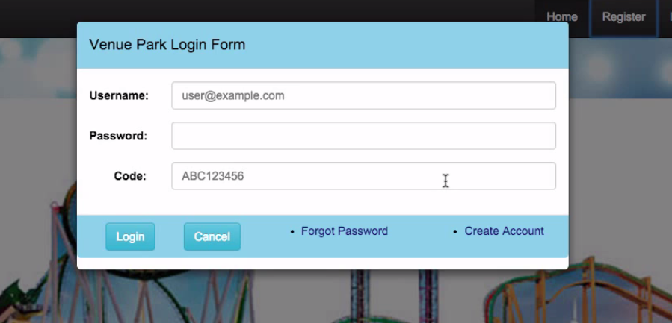

1) Press the Log In tab on top right hand corner of the home page.

2) Fill in the "Veneue Park Login Form", with appropriate Username, Password and Code.

3) Then press "Login"

## 3. How to Reset Password?

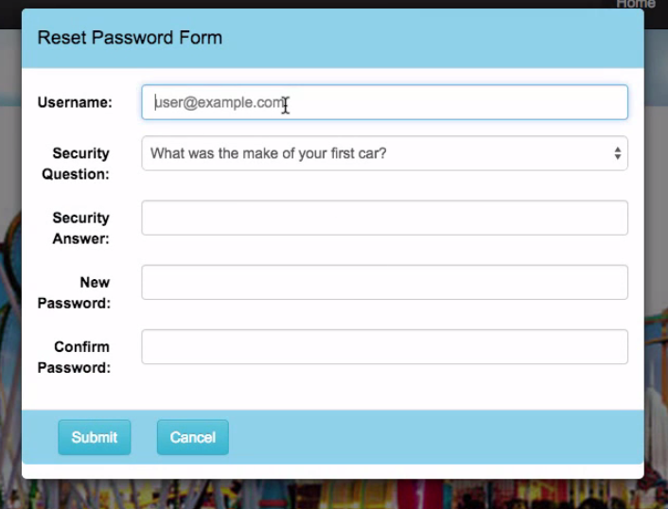

1) Forget your password? Then press the "Forgot Password" link right next to the "Cancel" button in the "Venue Park Login Forum".

2) Then fell out the "Reset Password Form", with appropriate value to change your password.

3) Lastly press Submit then your password is saved to new password.

# 4. How to How to check available Rides & Queue to a Ride?

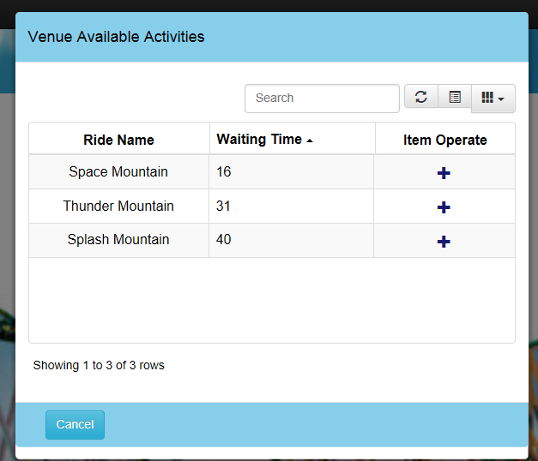

1) Click on "Rides" tab on the home page.

2) "Venue Available Activities" will pop up.

* Ride Name - shows the name of the rides thats available
* Waiting Time - shows how long you have to wait if you queue up to the ride
* Item Operate - the plus button allows you to add yourself to line up to that ride

3) By clicking on the plus button, the user who is logged in can queue themselves to wait in that line.

# 6. How to Login as a Admin?

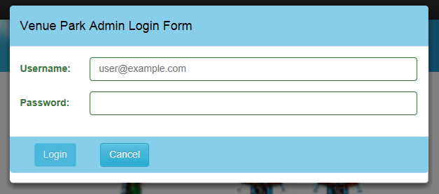

1) Click on "Admin" tab on top right hand corner of the homepage.

2) Then click on Login button.

3) Fill out "Venue Park Admin Login Form"

4) Press "Login" button

# 7. How to How to check available Rides, Queue to a Ride & Dequeue rides?

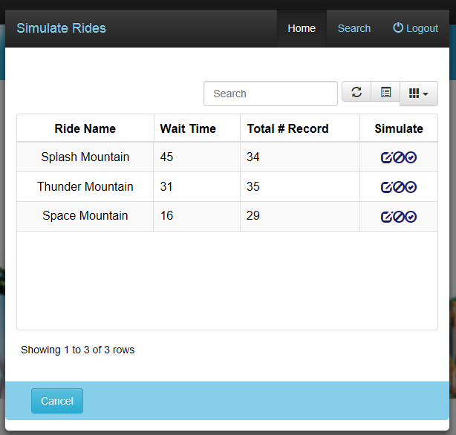

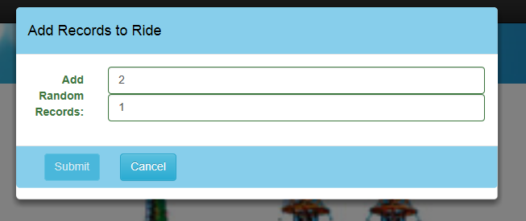

1) Click on "Admin" tab on top right hand corner of the homepage.

2) Then click "Simulate Ride" button.

3) Simulate Ride window will appear, with Simulate Ride table.

* Ride Name - name of the rides in the venue
* Wait Time - total wait time for that current ride
* Total # of records - Total number of records that is currently queued to that ride
* Simulate
  + First button - "Add records" allows Admin to add random visitors to the queue
  + Second button - "Dequeue" allows admin to dequeue max capacity of rides to a ride.

4) When pressing "Add records" button in simulate add records ride will show up.

5) In the first textbox fill in 0-100 number to select how many records you want to add to that ride. The press submit. This should update the # of records and time of the ride you have added too.

6) To simulate dequeue of the ride, click on the "Dequeue" button next to "Add Records" button in the Simulate column of the table. Then it would dequeue the rides by max capacity of the rides.