CIS 4911 – Senior Project
Tractouch's iBLESS
Software Requirements Document

Team Members: Luis Miguel Carrillo
Mentor: Jaime Borras
04/20/2015
COPYRIGHTS AND TRADEMARK INFORMATION

This work is entirely done by Luis Miguel Carrillo unless written otherwise.

Table of Contents
Title | Page Number(s)
1. Introduction | 4-5
1.1. Problem Definition | 4
1.2. Scope of the System | 4
1.3. Definitions | 4-5
2. Current System | 6
3. Project Plan | 7-9
3.1. Project Organization | 7-8
3.2. Work Breakdown | 8
3.3. Cost Estimate | 12
4. Proposed System Requirements | 10-17
4.1. Functional Requirements | 10-11
4.2. Analysis of System Requirements | 11-17
5. Glossary | 18
6. Appendix | 19-45
6.1. Appendix A - Complete Use Cases | 19-32
6.2. Appendix B - Use Case Diagram | 32
6.3. Appendix C - Static UML Diagrams | 33-34
6.4. Appendix D - Dynamic UML Diagrams | 34-36
6.5. Appendix E - UI Designs | 37
6.6. Appendix F - Diary of Meetings | 38-45
7. References | 46

1. Introduction

This is the introductory section of the document. In this section the reader will be familiarized with any keywords needed in the rest of the document. Also, a scope of the system as well as an overview of what is to be expected from section two to six will be provided.

1.1 Problem Definition

Tracktouch Mobile lacks an easy way to display information for themselves and their client about the bluetooth devices that are connected to their phones. Tractouch Mobile is developing a low energy bluetooth vibration device that connects to smart phones using bluetooth. These vibrations devices can capture all kind of information about their surroundings. Right now there exists no platform in which to assess all this information.

1.2 Scope of the System

The project aims to address the need for users to manage their bluetooth devices using a simple to use web interface from their phones or from the website.

1.3 Definitions, Acronyms, and Abbreviations

DS – Dashboard

TM – TractouchMobile

BLE – Bluetooth

JS – Javascript

TBS – Twitter Bootstrap

CSS – Cascading Style Sheets Language

HTML – HyperText Markup Language

VS – Visual Studio

IOS – Iphone Operating System

OS – Operating System

ASP – Active Server Pages

IIS – Internet Information Services

1.4 Overview of Document

This document opens by establishing the project plan, meaning how the project will be scheduled. It also establishes directly the cost for each of the required components, as well as the responsibilities of each of the team members. The tentative due dates of each of the items of the project is also listed in the form of a 2x7 matrix. Great importance will be given to establishing the purpose of the new system, and the state of the current system.

2. Current System (Limitations and Problems)

Currently Tractouch Mobile has no database, neither system for establishing connection between their android application. The information that the android application can capture is extensive but they have no persistence data model. As any company, Tractouch mobile aims to be lucrative; therefore they need a way to charge for their services, but currently there is no such way. Tractouch mobile also aims to be able to efficiently and quickly alert any interested party about certain events that are happening in the environment where the android application is. Finally, tractouch mobile has no way of visualizing in an orderly and neat fashion all the previous information. The new system will accomplish all these tasks.

3. Project Plan

The aim of this section is to describe how the iBLESS project will be conducted throughout the six sprints (considering the documentation part as a sprint). Also, the roles and hardware and software requirements will be listed with their respective costs. An initial schedule for the different components will be developed.

3.1 Project Organization

Members:

Jaime Borras – Mentor
Luis Miguel Carrillo – Developer
Alain Edwards – Tractouch Mobile Developer

Hardware:

- PC with Windows 7
- BLE Device
- Smartphone with Android OS

Software:

- Github
- Mingle
- VS
- Opera
- TBS
- AWS
- Dashbuilder
- Wamp Server
- Visual Paradigm

The project is organized mainly using Mingle. Mingle helps set the milestones for each sprint. The creation of the documentation will be done using LibreOffice in conjunction with Visual Paradigm for the diagrams.

3.2 Work Breakdown

Item | Due Date
Feasibility Document | 02/11/2015
Requirements Document | 02/02/2015
Design Document | 02/10/2015
Final Document | 04/27/2015
User Manual | 04/23/2015
Installation Guide | 04/23/2015

Item | Due Date
Database | 02/13/2015
Website Hosting | 02/13/2015
Guest Management System | 02/13/2015
User Management System | 03/17/2015
Subscription System | 04/17/2015
Phone Services System | 04/17/2015

3.3 Cost Estimate

Device | Price
PC | $600
Android Phone | $300

4. Proposed System Requirements

This section deals with the proposed system. It will talk about the requirements the new system shall meet. In order to explain with detail, UML diagrams will be employed. These diagrams will be of the nature of sequence diagrams, and a unifying use case diagram. The static model will be explained by using a package diagram of the whole system in which subsystems are shown in the form of packages.

4.1 Functional Requirements

1) The system shall allow users to register.

Refer to Appendix A: Register

2) The system shall allow users to recover lost access.

Refer to Appendix A: Retrieve Password

3) The system shall allow users to log in.

Refer to Appendix A: Login

4) The system shall allow users to define an spl range.

Refer to Appendix A: Add SPL Range

5) The system shall allow users to change their information.

Refer to Appendix A: Change Information

6) The system shall allow users to check spl values.

Refer to Appendix A: Check SPL Value and Notify Safety Managers

7) The system shall allow users to create hierarchies.

Refer to Appendix A: Create Table

8) The system shall allow users to create other users.

Refer to Appendix A: Create User

9) The system shall allow users to delete other users.

Refer to Appendix A: Delete User

10) The system shall allow users to delete roles.

Refer to Appendix A: Delete User Type

11) The system shall allow users to modify roles.

Refer to Appendix A: Modify Type

12) The system shall allow users to record spl values.

Refer to Appendix A: Notify SPL Value

13) The system shall allow users (using the android app) to recover password.

Refer to Appendix A: Forgot Password

14) The system shall allow users to subscribe (pay).

Refer to Appendix A: Subscribe

15) The system shall allow users to perform analytics.

Refer to Appendix A: View Data Using Analytics

16) The system shall allow users to modify SPL ranges.

Refer to Appendix A: Modify SPL Range

17) The system shall allow users to delete SPL ranges.

Refer to Appendix A: Delete SPL Range

18) The system shall allow users to notify of BLE disconnection.

Refer to Appendix A: Notify BLE Disconnection

19) The system shall allow users to notify of BLE connections.

Refer to Appendix A: Notify BLE Connection

20) The system shall allow users to notify of staying in the same location.

Refer to Appendix A: Notify Same Location

21) The system shall allow users to notify when excessive sessions occur.

Refer to Appendix A: Notify Excessive Sessions

22) The system shall capture phone's information.

Refer to Appendix A: Set Phone Information

23) The system shall capture BLE device's information.

Refer to Appendix A: Set BLE Information

24) The system shall allow login through web service.

Refer to Appendix A: Login Web Service

25) The system shall allow reset password through web service.

Refer to Appendix A: Reset Password

26) The system shall allow users to register through web service.

Refer to Appendix A: Register User

27) The system shall allow users to modify other users information.

Refer to Appendix A: Modify User Info

4.2 Analysis of System Requirements

4.2.1 Scenarios

iBLESS requires user management functions, as well as web services functions. It allows users to send text messages in an efficient and quick manner. It is totally automatic when properly set up.

4.2.2 Use Case Model
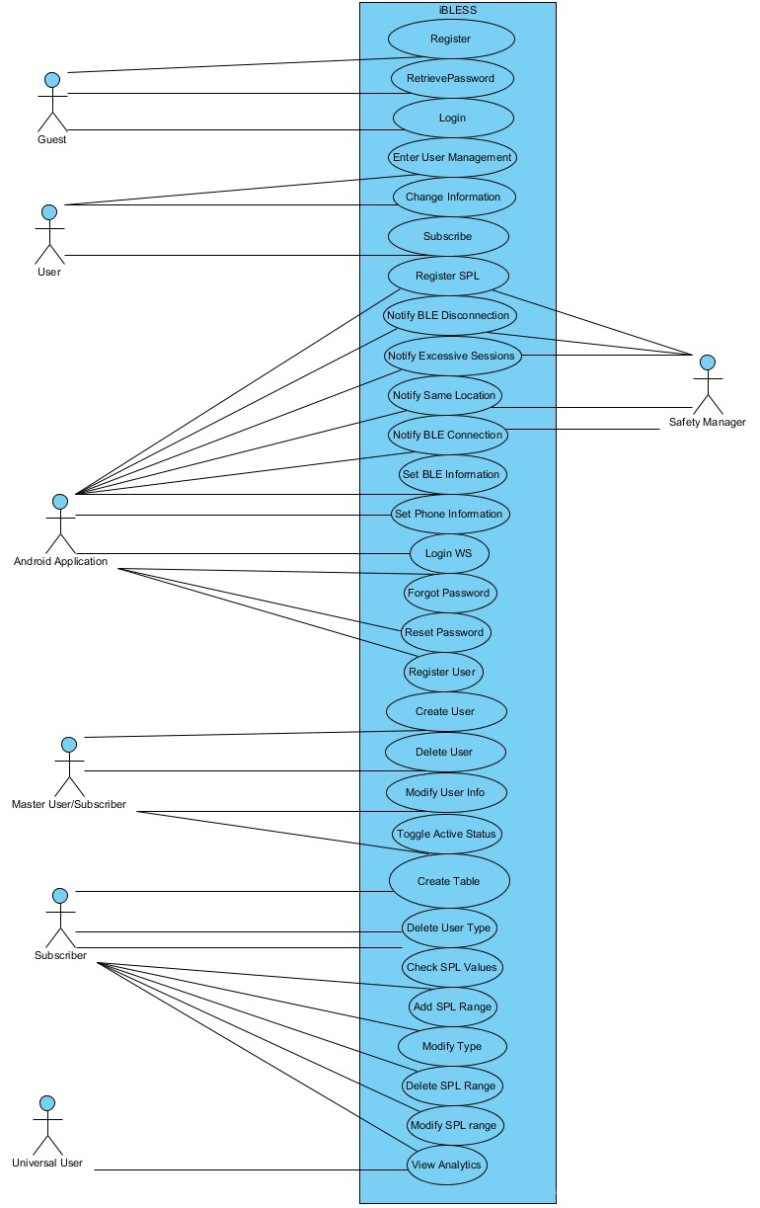

4.2.3 Static Model

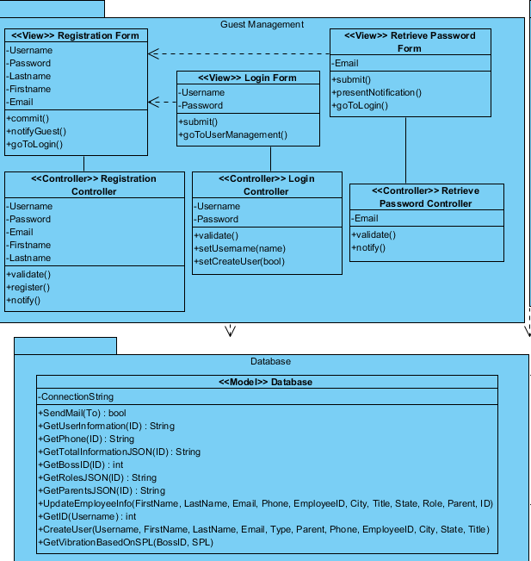

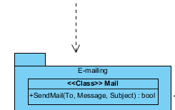

Guest Management Class Diagram

4.2.4 Dynamic Models

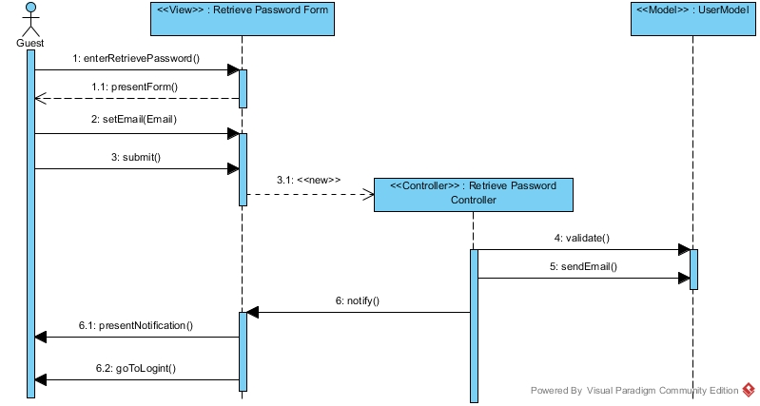
Sequence Diagram for Retrieve Password

For a complete list of sequence diagram refer to the appendix.

5. Glossary

Term | Definition
iBLESS | Intelligent Bluetooth Low Energy Software as a Service
Participating Actors | Users that are participating in the event.
Exit Condition. | Requirements that must have been met in order to exit the event.
Quality Requirements | Requirements that assure the quality of the system.
Entry Condition | Requirements that must be fulfilled prior to the event.

6. Appendix

6.1 Appendix A – Complete Use Cases

Use case name Change Information

Participating actors User

Flow of events 1. The User accesses the “Change Information” function of the website.
2. iBLESS responds by presenting a form to the User.
3. The User fills out the form by typing firstname, lastname, old password,
new password, new password confirmation, or e-mail.
4. iBLESS receives the information, validates it, and submits the changes into the user account. The User is notified that the changes have been replicated successfully.

Entry condition The User is inside the “User Management” function of the website.

Exit condition The User information has been changed.

Quality requirements The User information is changed in less than 2 seconds.

User Story Card: #116

Use case name Create Table

Participating actors Subscriber

Flow of events 1. The Subscriber accesses the “Create Table” function of the website.
2. iBLESS responds by presenting a form to the User with a visual table.
3. The Subscriber clicks the insert button.
4. iBLESS extends the form and shows “User Type” field and “Can Create Users” boolean
5. The Subscriber fills the userType, and canCreate. The Subscriber clicks submit.
6. iBLESS receives the information, validates it, and updates the hierarchy table for the Subscriber with the new information. The visual table is updated so that the user can see the changes.

Entry condition The Subscriber is inside the “Create Table” function of the website.

Exit condition The Subscriber sees the new user type added.

Quality requirements The new user type is created in less than 2 seconds.

User Story Card: #117

Use case name Modify Type

Participating actors Subscriber

Flow of events 1. The Subscriber accesses the “Create Table” function of the website.
2. iBLESS responds by presenting a form to the Subscriber with a visual table.
3. The Subscriber clicks the label representing the type to modify.
4. iBLESS extends the form and shows the modify button.
5. The Subscriber clicks the modify button.
6. iBLESS responds by presenting a form to the Subscriber.
7. The Subscriber fill the new role name and whether it can create users, and clicks submit.
8. iBLESS validates the new role name and updates the hierarchy table.

Entry condition The Subscriber is inside the “Create Table” function of the website.

Exit condition The Subscriber sees the new user type added.

Quality requirements The new user type is created in less than 2 seconds.

User Story Card: #117

Use case name Delete SPL Range

Participating actors Subscriber

Flow of events 1. The Subscriber accesses the “Select Vibration” function of the website.
2. iBLESS responds by presenting a form to the Subscriber with a visual table.
3. The Subscriber clicks the label representing the range to delete.
4. iBLESS extends the form and shows the delete button.
5. The Subscriber clicks the delete button.
6. iBLESS deletes the range from the SPL range table.

Entry condition The Subscriber is inside the “Select Vibration” function of the website.

Exit condition The Subscriber sees the range being deleted.

Quality requirements The range is deleted in less than 2 seconds.

User Story Card: #117

Use case name Modify SPL Range

Participating actors Subscriber

Flow of events 1. The Subscriber accesses the “Select Vibration” function of the website.
2. iBLESS responds by presenting a form to the Subscriber with a visual table.
3. The Subscriber clicks the label representing the type to modify.
4. iBLESS extends the form and shows the modify button.
5. The Subscriber clicks the modify button.
6. iBLESS responds by presenting a form to the Subscriber.
7. The Subscriber fill the new low, high, and vibration setting.
8. iBLESS validates the new information and updates the database.

Entry condition The Subscriber is inside the “Select Vibration” function of the website.

Exit condition The Subscriber sees the changes to the selected range.

Quality requirements The changes are processed in less than 2 seconds.

User Story Card: #117

Use case name Create User

Participating actors Master User/Subscriber

Flow of events 1. The Master User accesses the “Create User” function of the website.
2. iBLESS responds by presenting a form to the User.
3. The Master User fills out the form by typing username, firstname, lastname, e- mail address, address, city, state, zip code, cellphone number, parent, userType, employeeID, and jobTitle. The Master User clicks submit.
4. iBLESS receives the information, validates it, and creates a user account under the Master User table and a user account under the general table. The table is refreshed so that the Master User can see the new user added.

Entry condition The Master User is inside the “Create User” function of the website, and has created a hierarchy in the “Create Table” function of the website.

Exit condition The Master User sees the new user listed in the table.

Quality requirements The new user is created in less than 2 seconds.

User Story Card: #117

Use case name Toggle Active Status

Participating actors Master User/Subscriber

Flow of events 1. The Master User accesses the “Create User” function of the website.
2. iBLESS responds by presenting a form to the User.
3. The Master User clicks on the user's label that needs to be made active/inactive.
4. iBLESS receives the information and updates the user table with the new user status.
5. The Master User is notified by seeing that the status has changed.

Entry condition The Master User is inside the “Create User” function of the website, and has created a hierarchy in the “Create Table” function of the website.

Exit condition The Master User sees the new status.

Quality requirements The new status is updated in less than 2 seconds.

User Story Card: #117

Use case name Delete User Type

Participating actors Subscriber

Flow of events 1. The Subscriber accesses the “Create Table” function of the website.
2. iBLESS responds by presenting a form to the User with a visual table.
3. The Subscriber clicks the delete button.
4. iBLESS deletes the user type and updates the visual table.

Entry condition The Subscriber is inside the “Create Table” function of the website.

Exit condition The Subscriber sees that the type was deleted.

Quality requirements The type is deleted in less than 2 seconds.

User Story Card: #117

Use case name Delete User

Participating actors Master User/Subscriber

Flow of events 1. The Master User accesses the “Create User” function of the website.
2. iBLESS responds by presenting a form to the User.
3. The Master User clicks in the delete button for the corresponding user.
4. iBLESS receives the information and deletes the user from the system. The visual table with the users is updated.

Entry condition The Master User is inside the “Create User” function of the website, and has created a hierarchy in the “Create Table” function of the website.

Exit condition The Master User sees that the user has been deleted in the table.

Quality requirements The user is deleted in less than 2 seconds.

User Story Card: #117

Use case name Login

Participating actors Guest

Flow of events 1. The Guest accesses the “Login” function of the website.
2. iBLESS responds by presenting a form to the Guest.
3. The Guest fills out the form by typing username, and password.
4. iBLESS receives the information, validates it, creates a session for the guest with the username and whether they have the ability to create other users. The user is then moved to the “User Management” function of the website.

Entry condition The Guest is inside the “Login” function of the website.

Exit condition The Guest has a session and has been moved into user management.

Quality requirements The Guest receives a notification whether the credentials were correct or not in less than 2 seconds.

User Story Card: #112

Use case name Modify User Info

Participating actors Master User/Subscriber

Flow of events 1. The Master User accesses the “Create User” function of the website.
2. iBLESS responds by presenting a form to the User.
3. The Master User clicks in the modify info button for the corresponding user.
4. iBLESS moves the user to a new webpage where the user can submit the new information.
5. The Master User submits the new username, firstname, lastname, phone, e- mail, employeeID, city, state, jobTitle, userType, and parent. The Master User clicks submit.
6. iBLESS receives the information, validates it, and updates the user account. The Master User is notified of the status of the update.

Entry condition The Master User is inside the “Create User” function of the website, and has created a hierarchy in the “Create Table” function of the website.

Exit condition The Master User sees that the user information has been modified

Quality requirements The user is deleted in less than 2 seconds.

User Story Card: #209

Use case name Register

Participating actors Guest

Flow of events 1. The Guest accesses the “Register” function of the website.
2. iBLESS responds by presenting a form to the Guest.
3. The Guest fills out the form by typing username, password, e-mail
first name, and last name.
4. iBLESS receives the information, validates it. and creates an account for the Guest. The Guest is brought to the “Login” function of the website.

Entry condition The Guest is inside the “Login” function of the website.

Exit condition The Guest has been notified of his/her registration and has been moved into the “Login” function.

Quality requirements The Guest receives a notification about his/her registration in no more than 2 seconds.

User Story Card: #112

Use case name RetrievePassword

Participating actors Guest

Flow of events 1. The Guest accesses the “RetrievePassword” function of the website.
2. iBLESS responds by presenting a form to the Guest.
3. The Guest fills out the form by typing the e-mail address.
4. iBLESS receives the information, validates it, and sends an e-mail to the address provided. The Guest is notified that the e-mail has been sent and is moved to the “Login” function of the website.

Entry condition The Guest is inside the “Login” function of the website.

Exit condition The Guest has been notified that the e-mail was sent and has been moved into the “Login” function.

Quality requirements The Guest receives a notification about the e-mail status in no more than 3 seconds.

User Story Card: #149

Use case name Subscribe

Participating actors User

Flow of events 1. The User accesses the “Subscribe” function of the website.
2. iBLESS responds by presenting a form to the User.
3. The User fills out the form by typing companyName, companyAddress, companyType, and selecting subscriptionType. The User clicks submit.
4. iBLESS receives the information, validates it, and creates a temporal company account for the User. The User is moved to Chargify to finalize purchase.

Entry condition The User is inside the “Subscribe” function of the website.

Exit condition The User has been moved to Chargify to finalize purchase.

Quality requirements The User's temporal company account is created in less than 2 seconds.

User Story Card: #115

Use case name Notify SPL Value

Participating actors Android Application
Safety Manager

Flow of events 1. The Android Application registers the SPL value, its UserID, windspeed, winddirection, weather, and gps to the RegisterSPL web service of iBLESS.
2. iBLESS validates the UserID, retrieves the BossID, Safety Manager phone, and SPL limit of the Android Application's company. Then it saves the SPL, windspeed, winddirection, weather, and gps in the company table under UserID. Then, iBLESS checks if the SPL value surpassed the SPL limit established by the company, and sends a text message to the Safety Manager. Also, iBLESS checks if the Android Application has reported the SPL from the same position and if yes Notify Same Location is invoked.
3. The Android Application receives the vibration string.

Entry condition The Android Application is capturing SPL, windspeed, winddirection, weather, and gps values.

Exit condition The Android Application has received the vibration string.

Quality requirements No text message is lost.

User Story Card: #221

Use case name Notify BLE Disconnection

Participating actors Android Application
Safety Manager

Flow of events 1. The Android Application submits the UserID in the BLEDisconnection web service.
2. iBLESS validates the UserID, retrieves the BossID, and Safety Manager phone of the Android Application's company. Then it sends an SMS to the Safety Manager's phone number stating that user with id = UserID has disconnected their BLE device for more than 5 minutes.

Entry condition The Android Application is connected with the BLE Device

Exit condition The Safety Manager has received the SMS.

Quality requirements No text message is lost.

User Story Card: #221

Use case name Set BLE Information

Participating actors Android Application

Flow of events 1. The Android Application submits the UserID, IMEI, MSISDN, IMSI, and MAC of the BLE Device
2. iBLESS validates the UserID, retrieves the BossID, and updates the BLE device information with the information received.

Entry condition The Android Application is connected with the BLE Device

Exit condition The table has been updated successfully

Quality requirements Information is updates in less than 2 seconds

User Story Card: #221

Use case name Login Web Seervice

Participating actors Android Application

Flow of events 1. The Android Application submits the Username, and Password.
2. iBLESS validates the username, and password. If everything is correct, then iBLESS sends back all user information associated to the account.
3. The Android Application receives the information as JSON.

Entry condition The Android Application is running.

Exit condition The Android Application receives the JSON.

Quality requirements Information is received in less than 2 seconds.

User Story Card: #221

Use case name Forgot Password Web Service

Participating actors Android Application

Flow of events 1. The Android Application submits the e-mail address.
2. iBLESS sends an e-mail to the e-mail address with instructions.

Entry condition The Android Application is connected with the BLE Device

Exit condition The e-mail has been sent.

Quality requirements The e-mail is sent in less than 2 seconds.

User Story Card: #221

Use case name Reset Password

Participating actors Android Application

Flow of events 1. The Android Application submits the Username, OldPassword, and NewPassword.
2. iBLESS validates the username, and old password. Then it sets the password to the new password.

Entry condition The Android Application is running.

Exit condition The table has been updated successfully

Quality requirements The table is updated in less than 2 seconds.

User Story Card: #221

Use case name Register User

Participating actors Android Application

Flow of events 1. The Android Application submits the username, firstname, lastname, e-mail, and password of the new account.
2. iBLESS checks the username, and e-mail for duplications. Then it creates the new user account with the given information.

Entry condition The Android Application is running.

Exit condition The table has been updated successfully.

Quality requirements The sequence is achieved in less than 2 seconds.

User Story Card: #221

Use case name Set Phone Information

Participating actors Android Application

Flow of events 1. The Android Application submits the UserID, IMEI, MSISDN, IMSI, MAC, BRAND, PhoneNumber, PhoneModel, Carrier, and PhoneIP of the android application.
2. iBLESS validates the UserID, retrieves the BossID, and updates the phone information with the information received.

Entry condition The Android Application is connected with the BLE Device

Exit condition The table has been updates successfully

Quality requirements No text message is lost.

User Story Card: #221
Use case name Notify BLE Connection

Participating actors Android Application
Safety Manager

Flow of events 1. The Android Application submits the UserID in the BLEConnection web service.
2. iBLESS validates the UserID, retrieves the BossID, and Safety Manager phone of the Android Application's company. Then it sends an SMS to the Safety Manager's phone number stating that user with id = UserID has connected their BLE device.

Entry condition The Android Application is connected with the BLE Device

Exit condition The Safety Manager has received the SMS.

Quality requirements No text message is lost.

User Story Card: #221

Use case name Notify Excessive Sessions

Participating actors Android Application
Safety Manager

Flow of events 1. The Android Application submits the UserID in the Excessive Sesions web service.
2. iBLESS validates the UserID, retrieves the BossID, and Safety Manager phone of the Android Application's company. Then it sends an SMS to the Safety Manager's phone number stating that the given user has received more than 5 sessions in the frame of an hour.

Entry condition The Android Application is connected with the BLE Device

Exit condition The Safety Manager has received the SMS.

Quality requirements No text message is lost.

User Story Card: #221

Use case name Notify Same Location

Participating actors Android Application
Safety Manager

Flow of events 1. The Android Application submits the UserID in the Same Location web service.
2. iBLESS validates the UserID, retrieves the BossID, and Safety Manager phone of the Android Application's company. Then it sends an SMS to the Safety Manager's phone number stating that user with id = UserID has remained in the same dangerous location.

Entry condition The Android Application is connected with the BLE Device

Exit condition The Safety Manager has received the SMS.

Quality requirements No text message is lost.

User Story Card: #221
Use case name Add SPL Range

Participating actors Master User

Flow of events 1. The Master User enters the Select Vibration Pattern function of iBLESS.
2. iBLESS respond by presenting the Master User with a form.
3. The Master User fills the form by providing low dB, high dB, and vibration pattern. The Master User clicks submit.
4. iBLESS retrieves the information, validates that the range is unique, and submits the change into the SPL range table of the company. iBLESS updates the GUI with the new range.
5. The Master User sees the added range in the form of a table entry.

Entry condition The Master User has logged on into iBLESS.

Exit condition The Master User sees the new range as an entry.

Quality requirements Adding the range takes less than 2 seconds.

User Story Card: #221

Use case name Check SPL Value and Notify Safety Managers

Participating actors Master User
Safety Manager

Flow of events 1. The Master User enters the Check SPL function of iBLESS.
2. iBLESS respond by presenting the Master User with a form.
3. The Master User checks the last SPL reading for each worker, as well as their location, and names. The Master User clicks Notify Safety Managers.
4. iBLESS loops through all the workers on the table, acquiring their safety manager phone number, and starts sending text messages to the phone number depending on the SPL reading.

Entry condition The Master User has logged on into iBLESS.

Exit condition The Master User has clicked on the Notify Safety Manager button.

Quality requirements The table is populated in less than 2 seconds.

User Story Card: #221

Use case name Enter User Management

Participating actors User

Flow of events 1. The User enters the login Function of the website.
2. iBLESS respond by presenting the User with a form.
3. The user is able to see all his information depending on their user status.

Entry condition The User is in the login function of the website.

Exit condition The User is able to see all their information.

Quality requirements The information is displayed in less than 2 seconds.

Use case name View Data Using Analytics

Participating actors Universal User

Flow of events 1. The Universal User accesses analytics.
2. iBLESS responds by presenting a form to the User.
3. The Universal User provides the username and password.
4. iBLESS responds by validating the information and presengint a form to the User.
5. The Master User clicks in the analytics label that they want to review.
6. iBLESS responds by presenting a form to the User. 7. The Master User types or clicks the filters to use in the query.
8. iBLESS responds by showing all data available that fulfill the criteria provided by the User.

Entry condition The Universal User is inside the “Analytics” section of the system.

Exit condition The Universal User has reviewed all the information based on the filters.

Quality requirements The queries are attractive and responsive.

User Story Card: #118

6.2 Appendix B – Use Case Diagram Using UML

6.3. Appendix C – Static UML Diagram

Guest Management Class Diagram

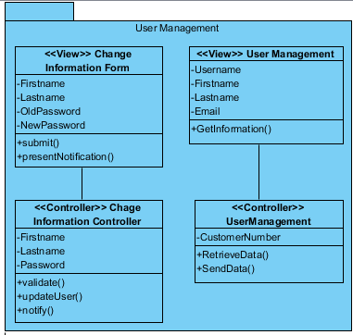

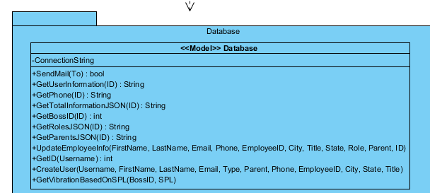

User Management Class Diagram

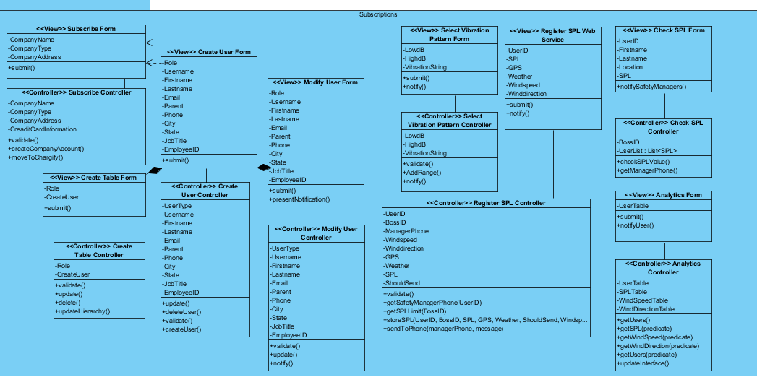

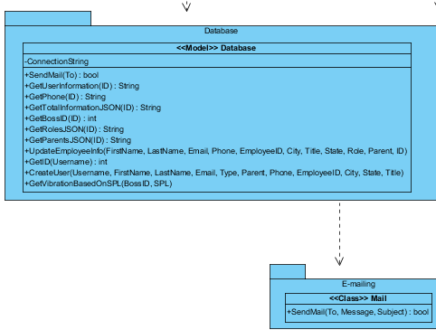

Class Diagram of Subscriptions Subsystem

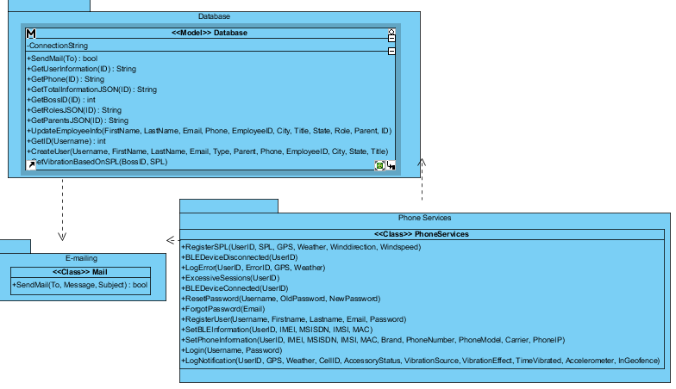
Class Diagram of Phone Services Subsystem

6.4 Appendix D – Dynamic UML Diagrams

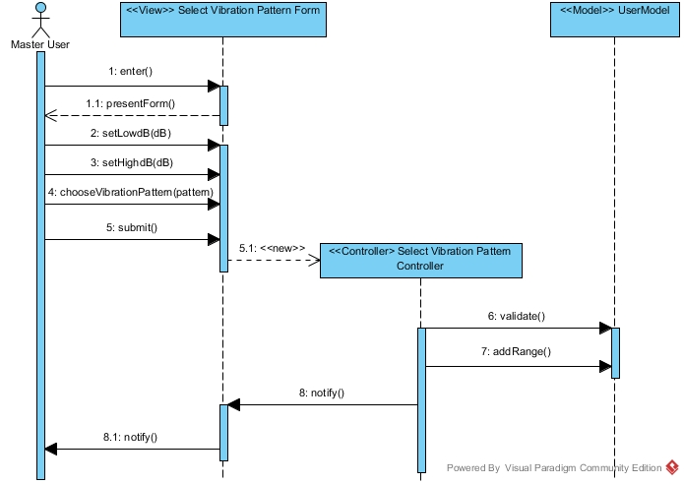
Add SPL Range Sequence Diagram

Change Information Sequence Diagram

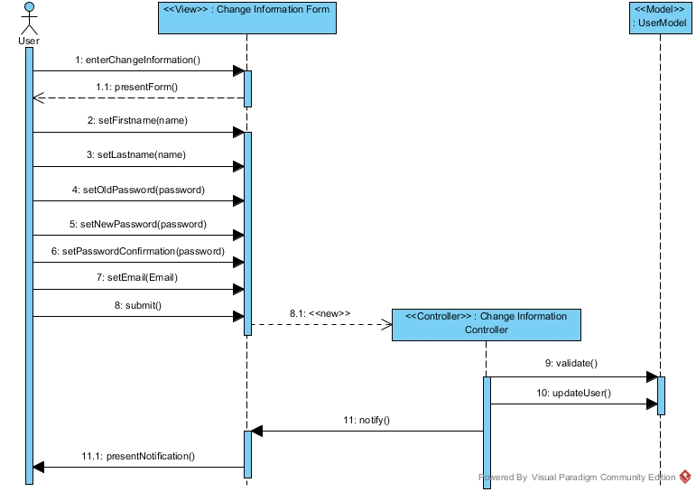

Check SPL Sequence Diagram

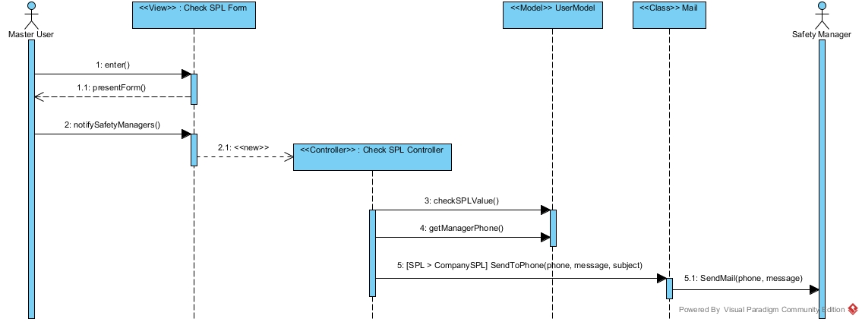

Forgot Password

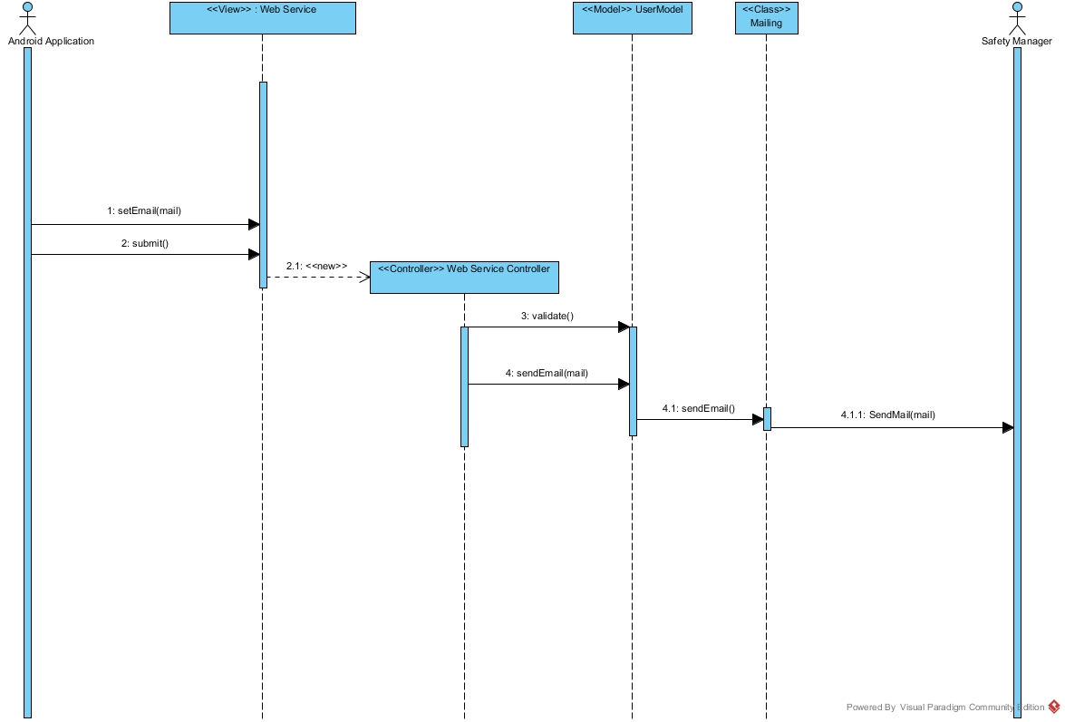

Create Table Sequence Diagram

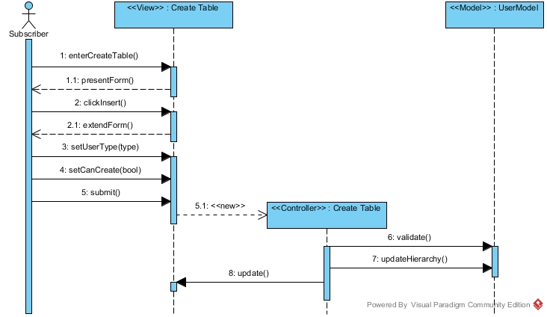
Create User Sequence Diagram
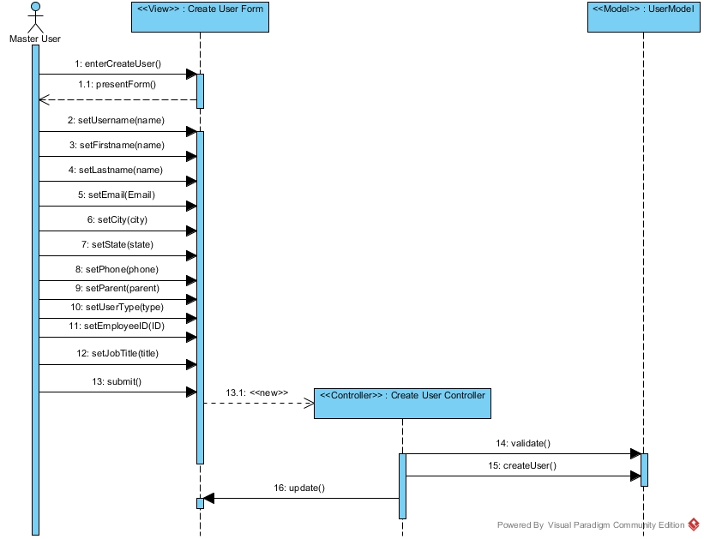
Delete User Sequence Diagram

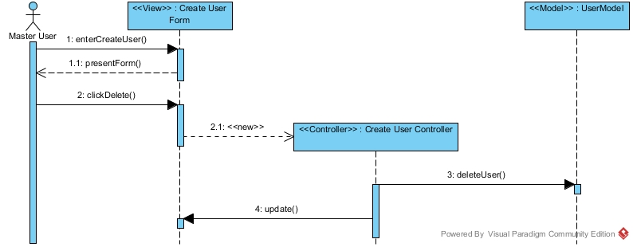
Delete User Type Sequence Diagram

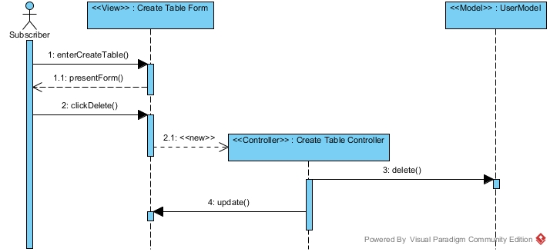

Login Sequence Diagram

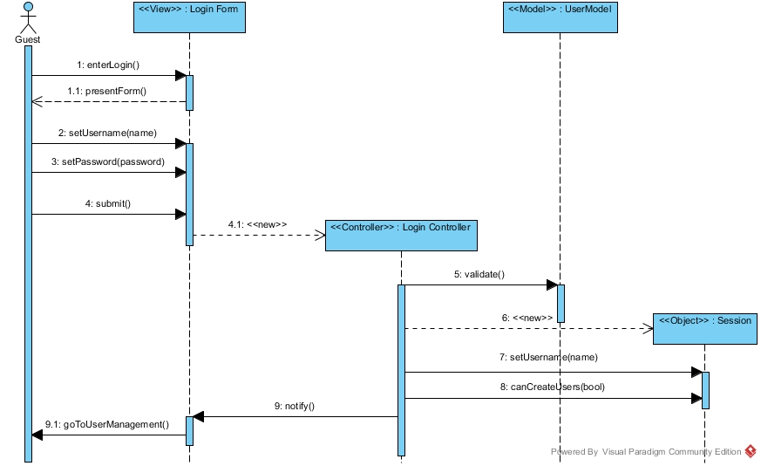
Modify User Sequence Diagram

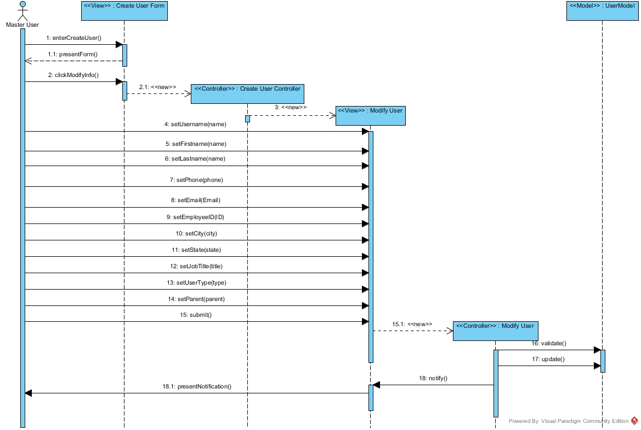

Notify SPL Sequence Diagram

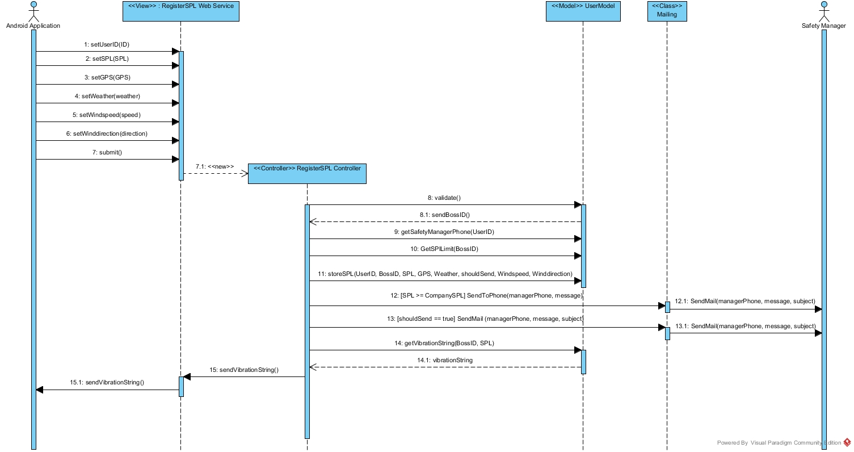
Registration Sequence Diagram

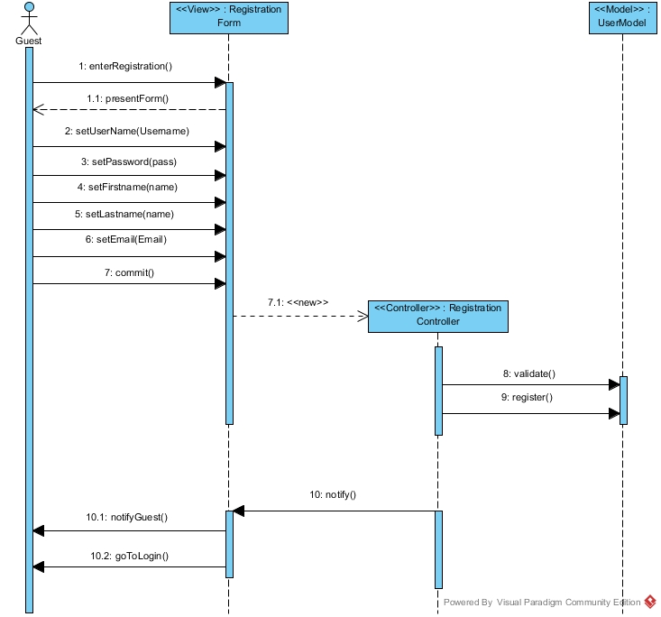

Retrieve Password Sequence Diagram

Subscribe Sequence Diagram

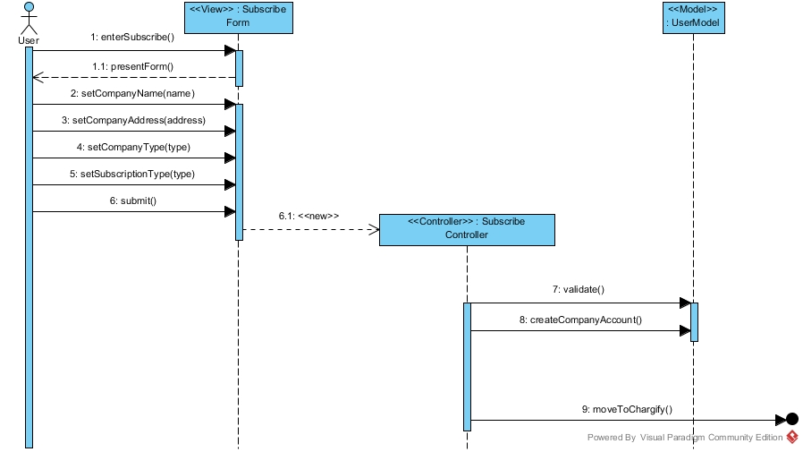

View Analytics Sequence Diagram

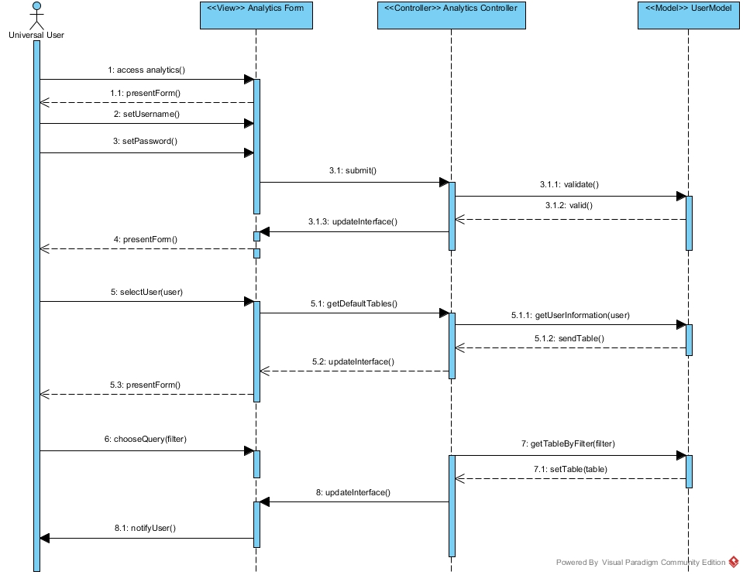

Modify Type

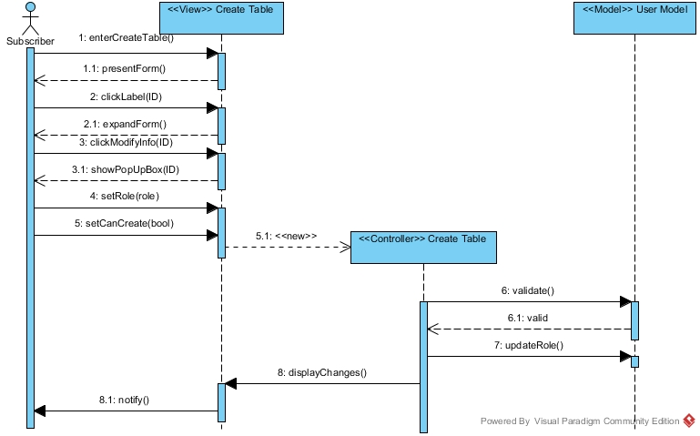

Modify SPL Range

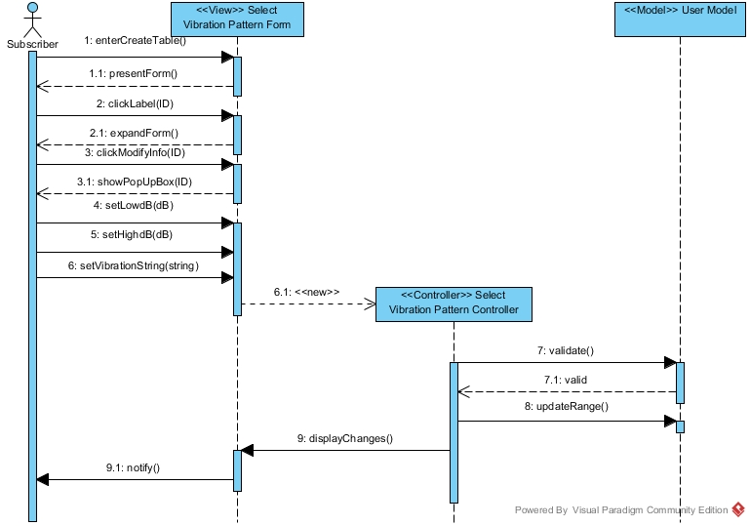

Delete SPL Range

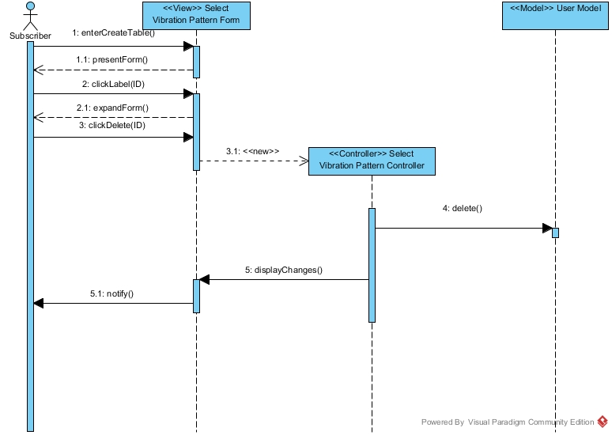

Notify BLE Disconnection

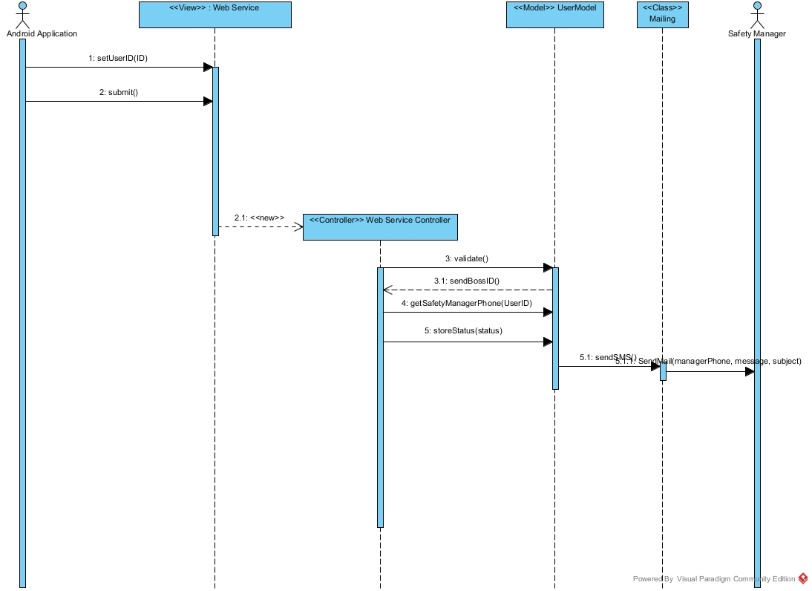

Notify BLE Connection

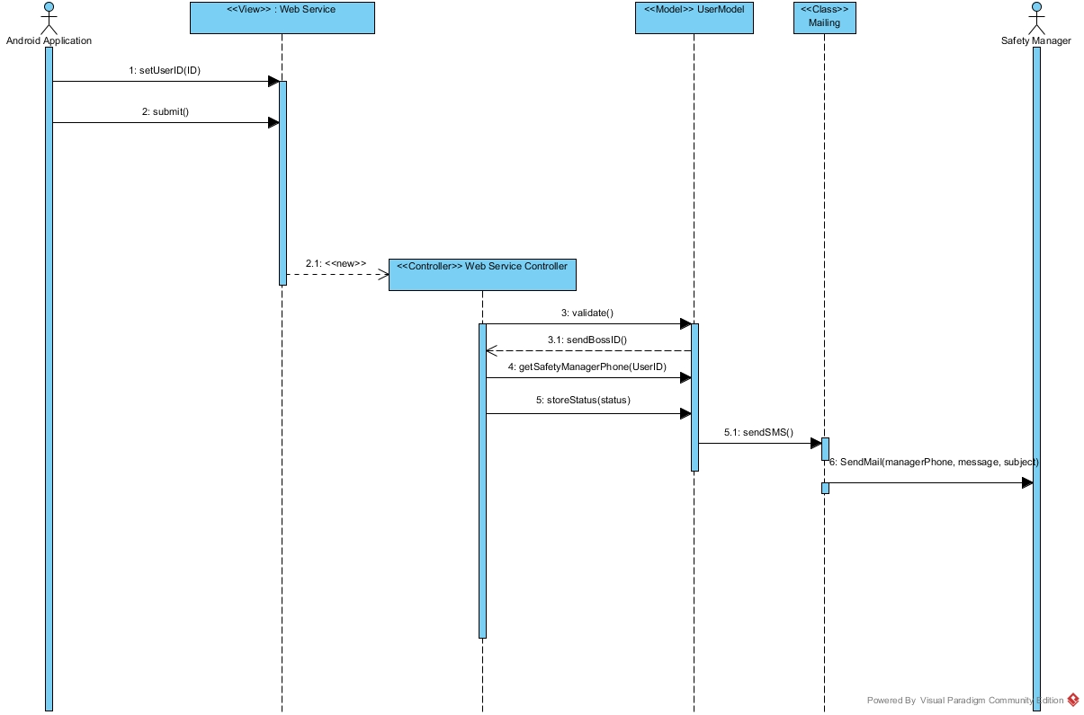

Notify Same Location

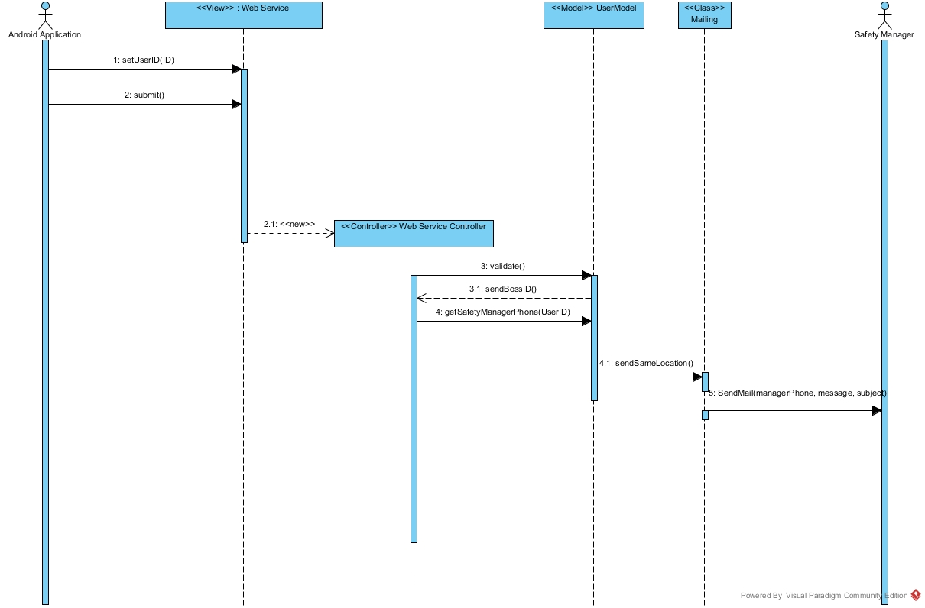

Notify Excessive Sessions

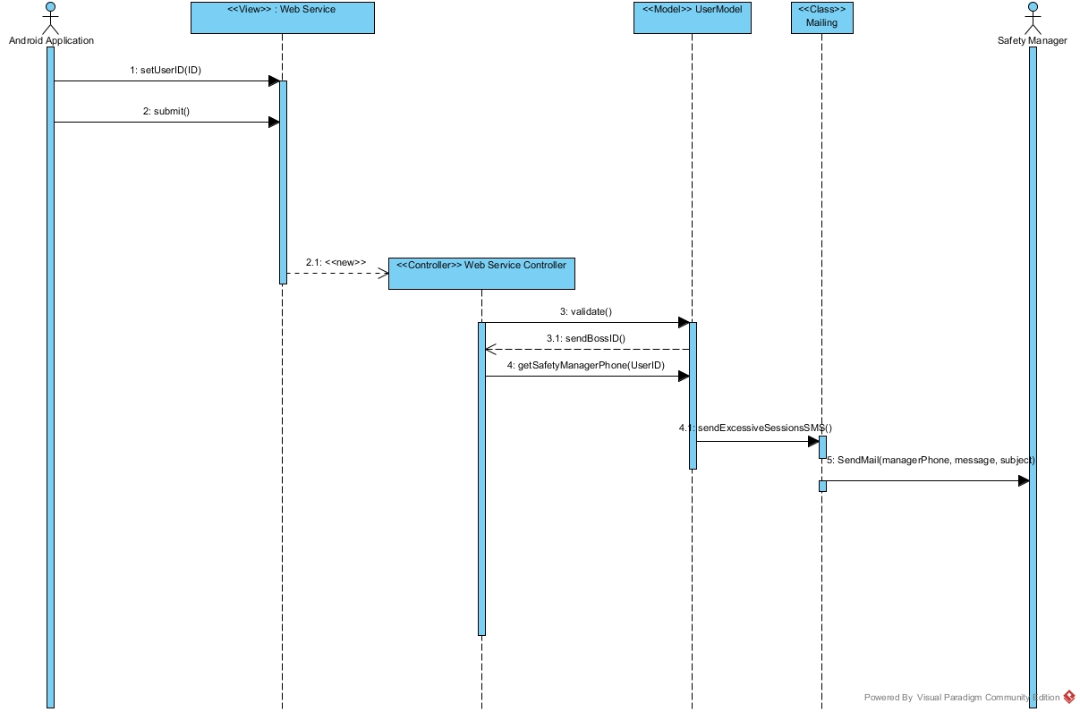

Set Phone Information

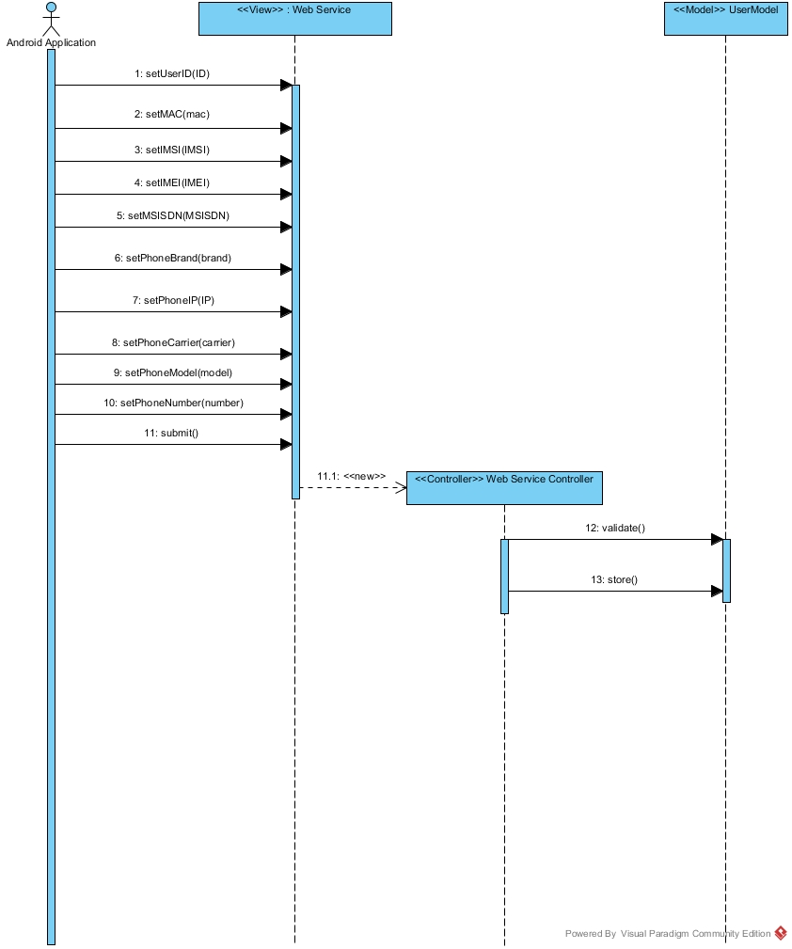

Set BLE Information

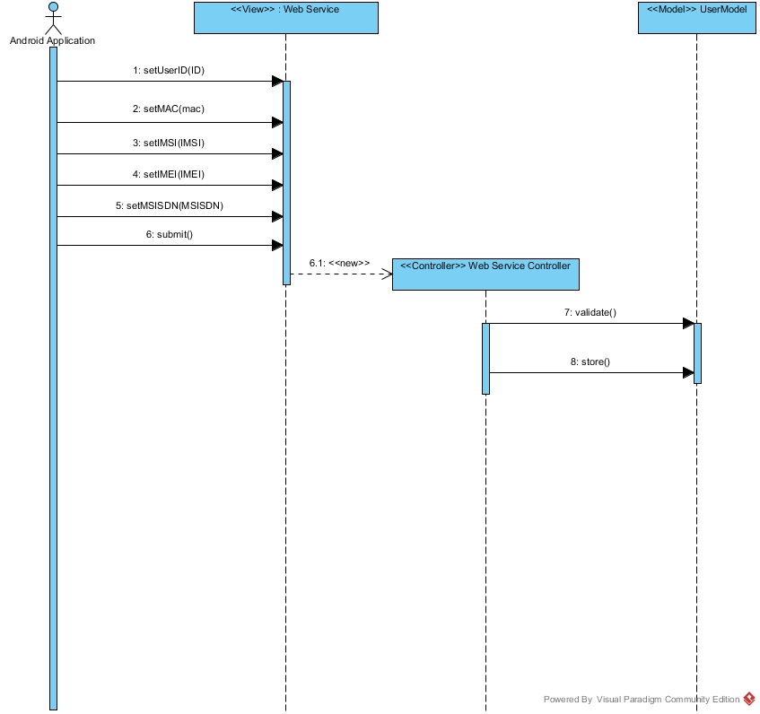

Login Web Services

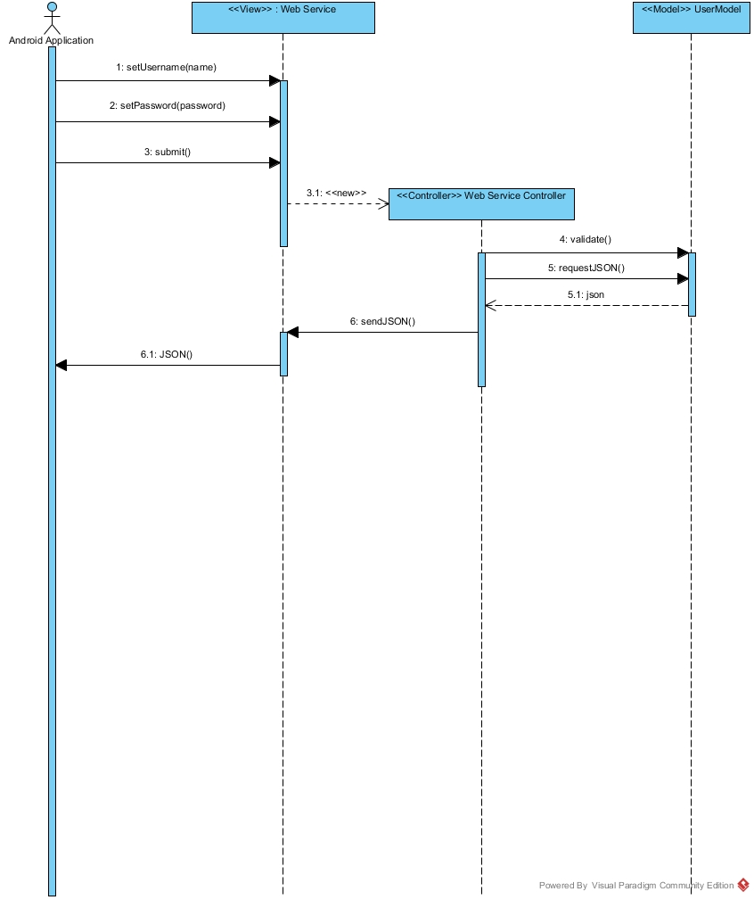

Register User

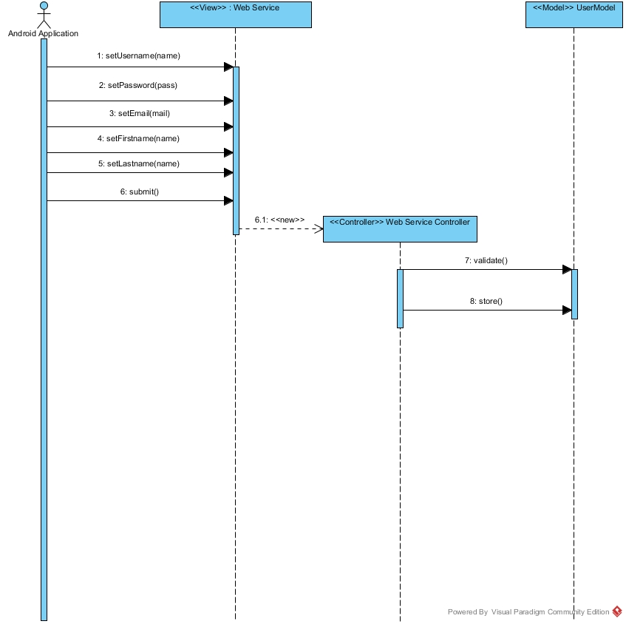

Reset Password

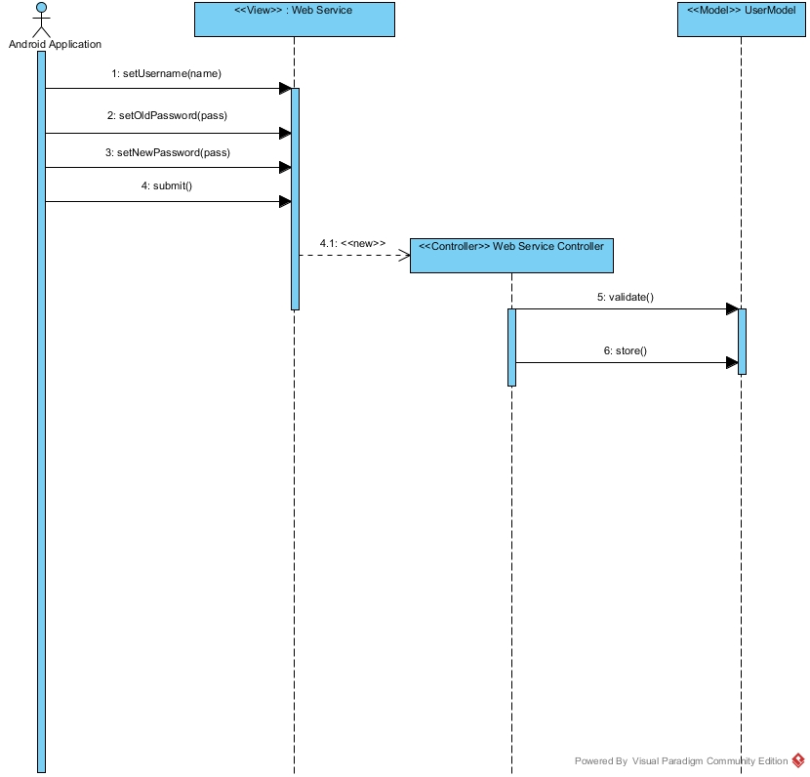

6.5 Appendix E – User Interface Designs
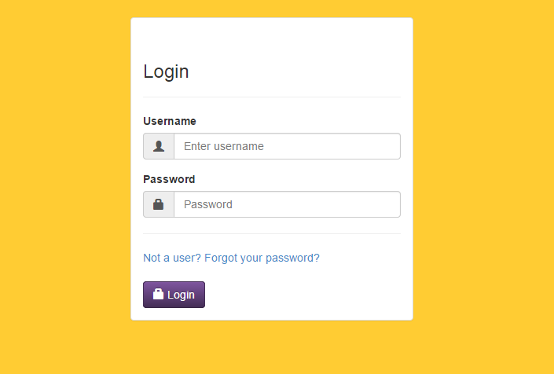

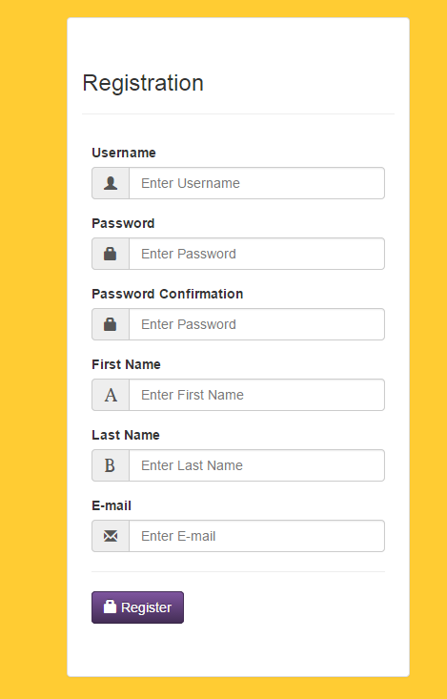

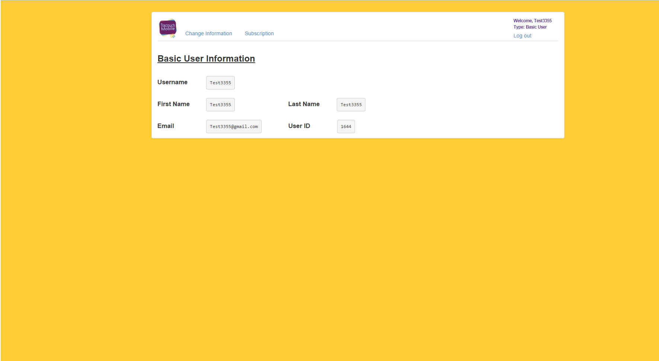

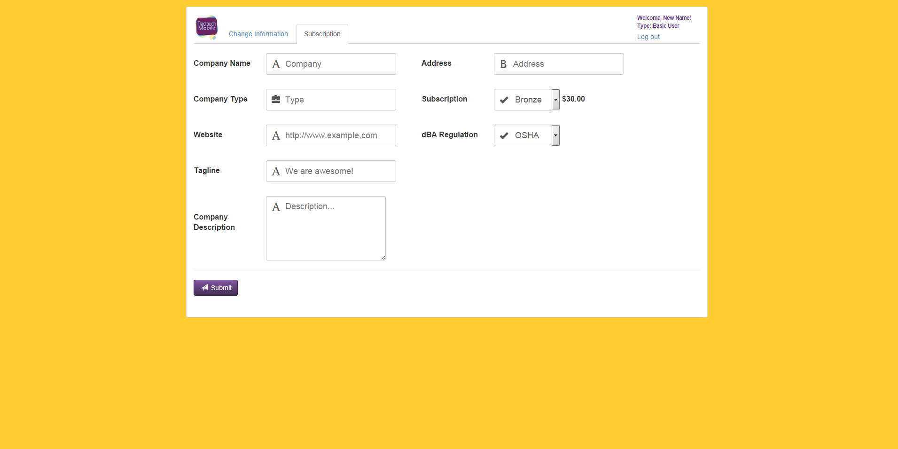

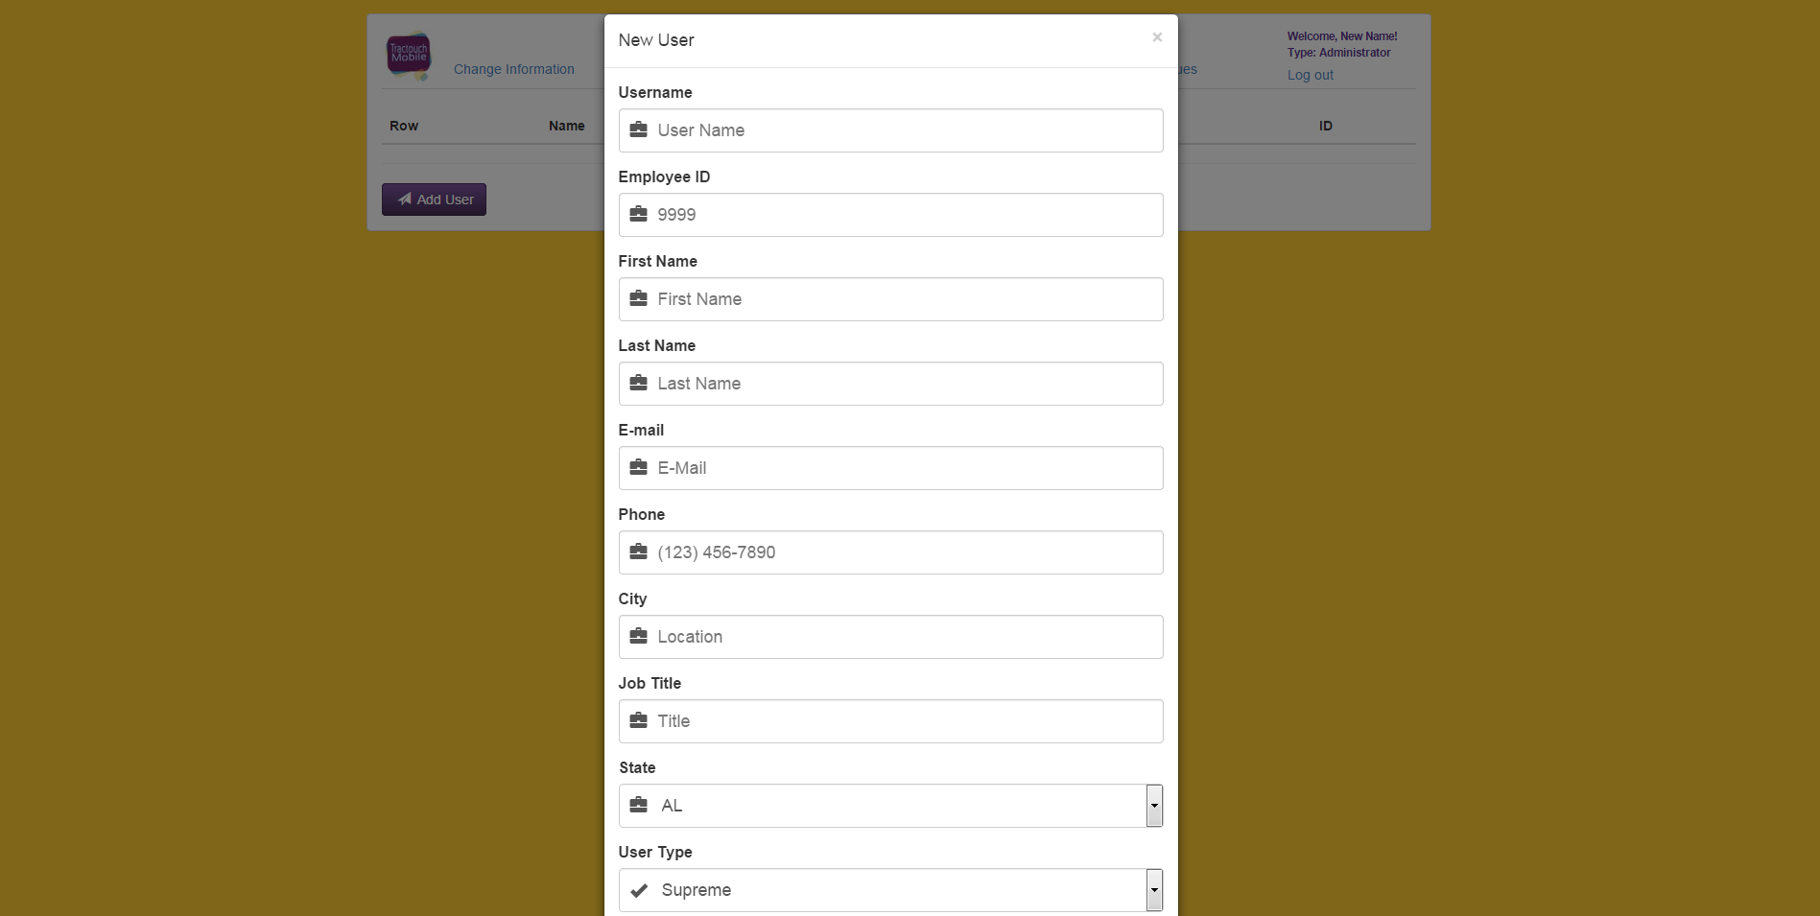

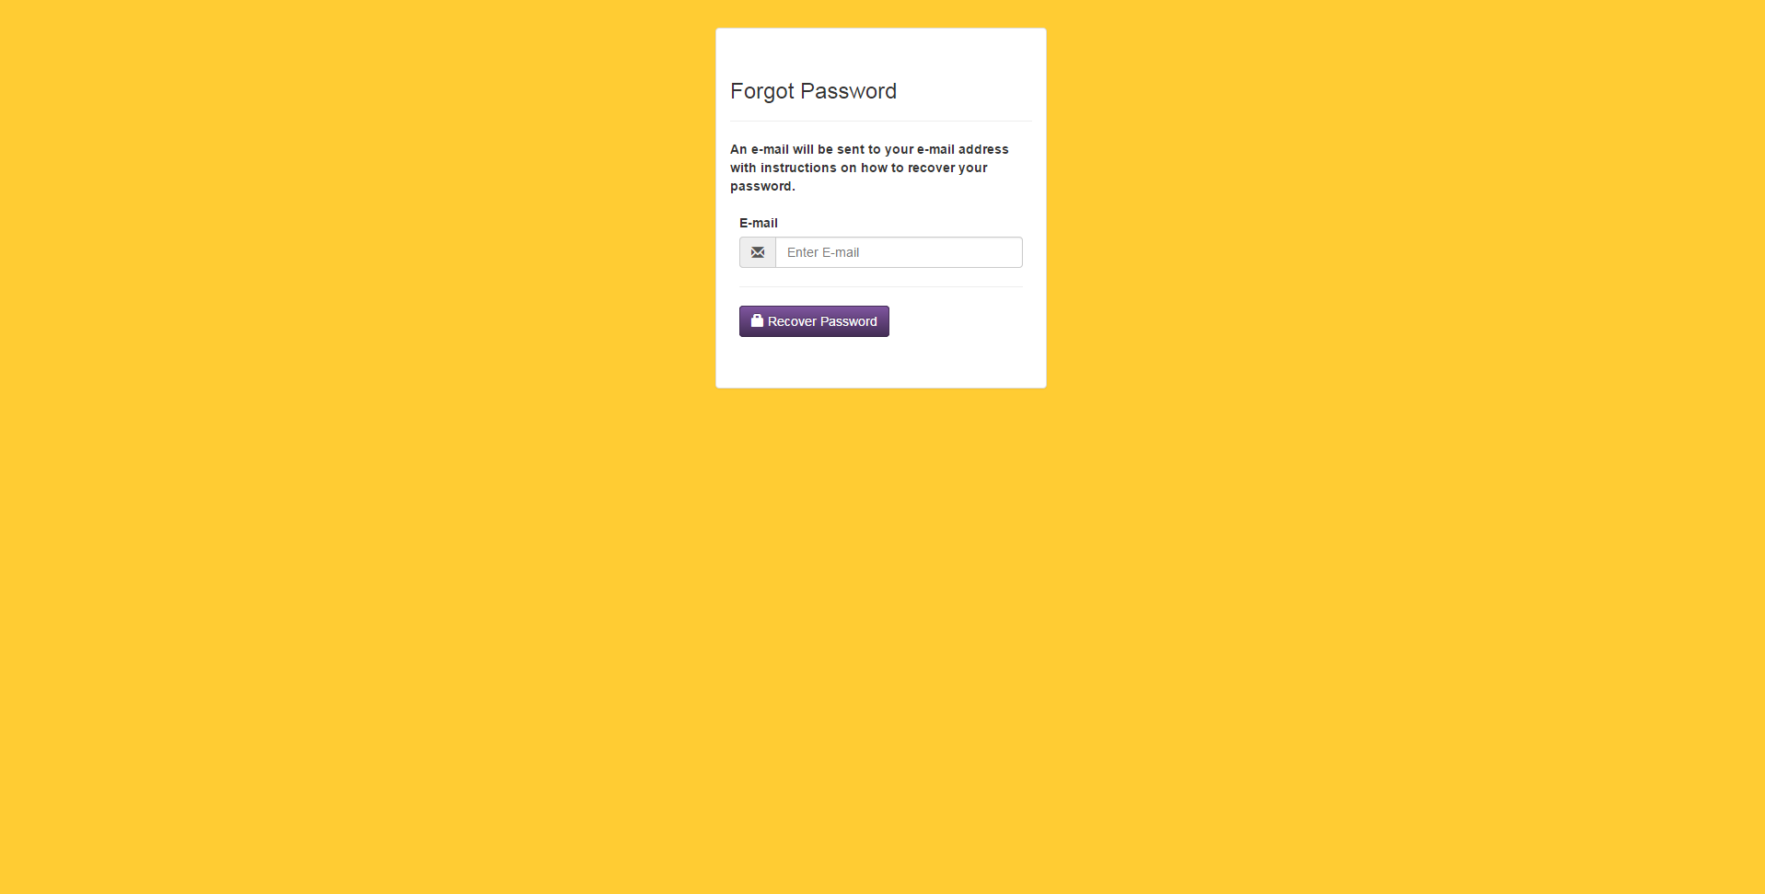

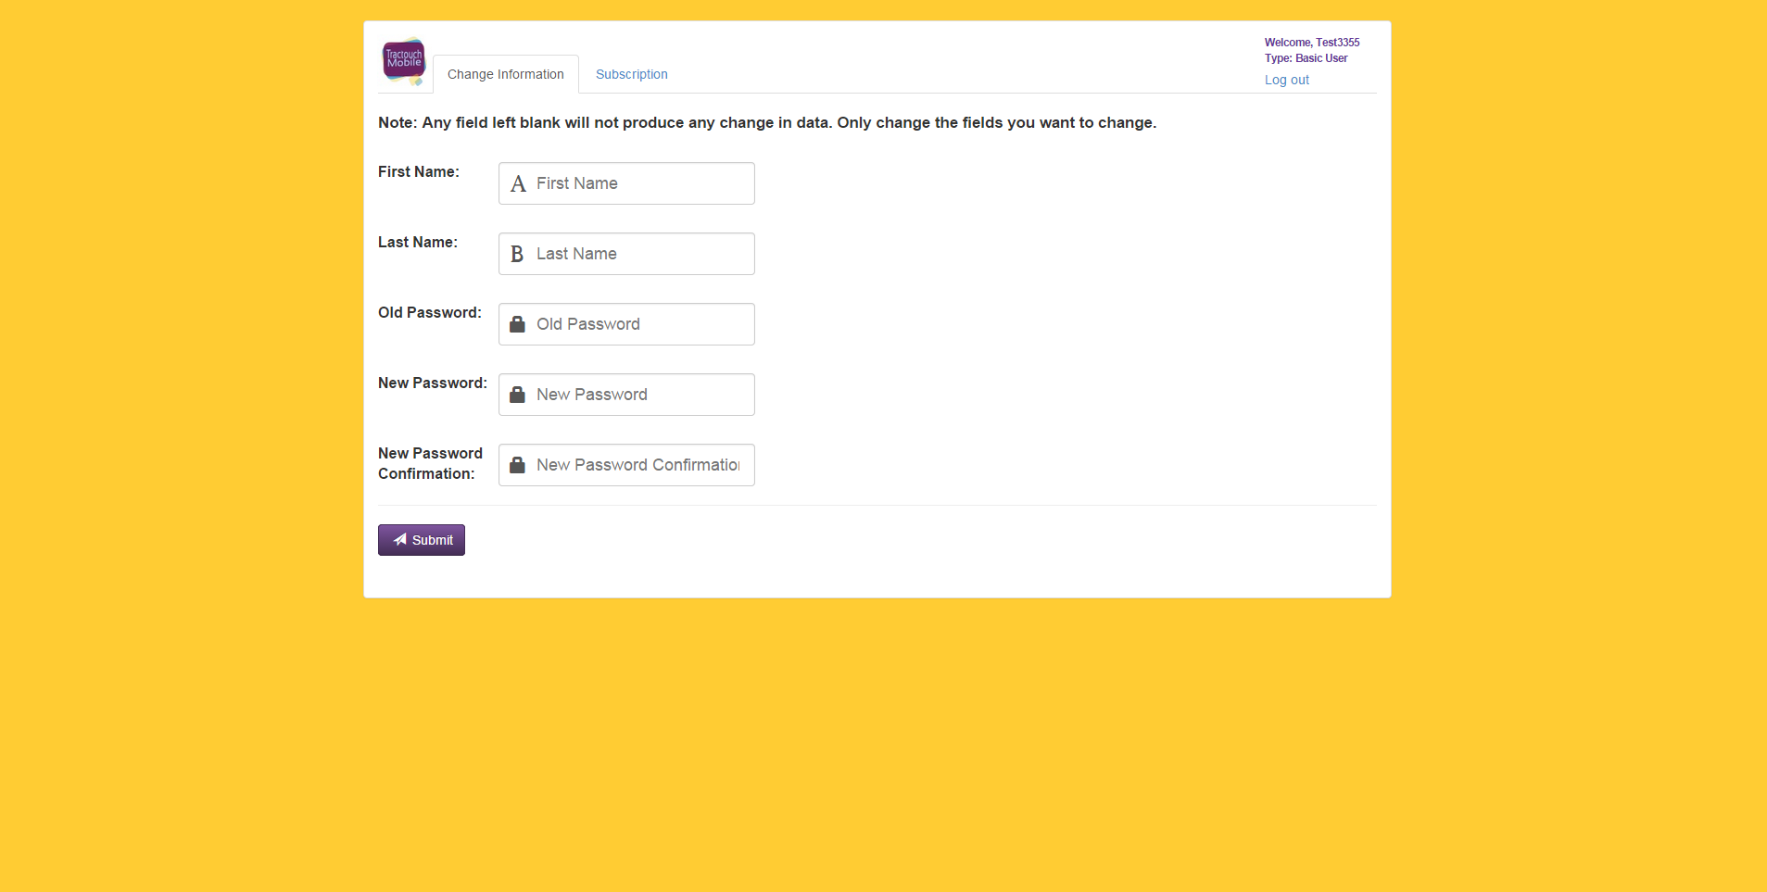

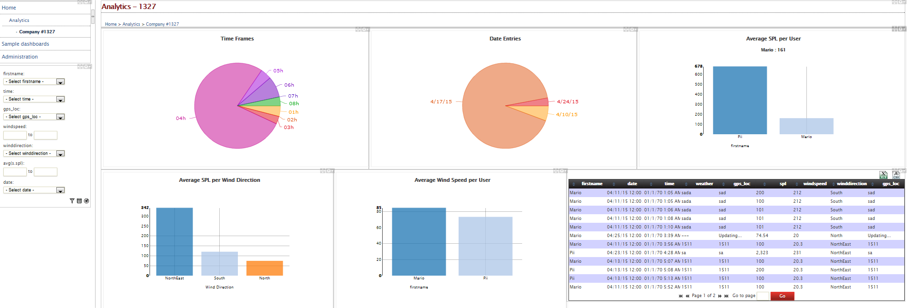

6.6 Appendix F – Diary of Meetings and Tasks

First Entry:

Date: January 20th, 2015
Location: Green Library
Start Time: 12:00 PM
End Time: 4:00 PM
In Attendance: Mauricio Bendeck, and Luis Miguel Carrillo
Late: N/A
Agenda:

- Introduction.
- Learn about project
- Details of project structures

Second Entry:

Date: January 27th, 2015
Location: N/A (Skype Call)
Start Time: 10:00 PM
End Time: 12:30 AM
In Attendance: Mauricio Bendeck, and Luis Miguel Carrillo
Late: N/A
Agenda:

- Go over user stories

Third Entry:

Date: February 13th, 2015
Location: Green Library
Start Time: 1:00 PM
End Time: 2:00 PM
In Attendance: Jaime Borras, Mauricio Bendeck, and Luis Miguel Carrillo
Late: N/A
Agenda:

- Show demo of features developed during Sprint 1.
- Review Sprint 1.
- Select new user stories to develop.

Fourth Entry:

Date: February 27th, 2015
Location: N/A (Skype Call)
Start Time: 3:00 PM
End Time: 5:00 PM
In Attendance: Jaime Borras, Alain Edwards, and Luis Miguel Carrillo
Late: N/A
Agenda:

Show demo of features developed during Sprint 2.
Review Sprint 2.
Select new user stories to develop
Fifth Entry:

Date: March 13th, 2015
Location: N/A (Skype Call)
Start Time: 3:00 PM
End Time: 5:00 PM
In Attendance: Jaime Borras, Alain Edwards, and Luis Miguel Carrillo
Late: N/A
Agenda:

Discuss project progress.

Sixth Entry:

Date: March 20th, 2015
Location: N/A (Skype Call)
Start Time: 3:00 PM
End Time: 5:00 PM
In Attendance: Jaime Borras, Alain Edwards, and Luis Miguel Carrillo
Late: N/A
Agenda:

Show demo of features developed during Sprint 3.
Review Sprint 3.
Select new user stories to develop

Seventh Entry:

Date: March 27th, 2015
Location: N/A (Skype Call)
Start Time: 3:00 PM
End Time: 5:00 PM
In Attendance: Jaime Borras, Alain Edwards, and Luis Miguel Carrillo
Late: N/A
Agenda:

Discuss progress of Sprint 4.

Eight Entry:

Date: April 3rd, 2015
Location: N/A (Skype Call)
Start Time: 3:00 PM
End Time: 5:00 PM
In Attendance: Jaime Borras, Alain Edwards, and Luis Miguel Carrillo
Late: N/A
Agenda:

Show demo of features developed during Sprint 4.
Review Sprint 4.
Select new user stories to develop

Ninth Entry:

Date: April 10, 2015
Location: N/A (Skype Call)
Start Time: 3:00 PM
End Time: 5:00 PM
In Attendance: Jaime Borras, Alain Edwards, and Luis Miguel Carrillo
Late: N/A
Agenda:

Discuss progress of Sprint 5.

Tenth Entry:

Date: April 17th, 2015
Location: N/A (Skype Call)
Start Time: 3:00 PM
End Time: 5:00 PM
In Attendance: Jaime Borras, Alain Edwards, and Luis Miguel Carrillo
Late: N/A
Agenda:

Show demo of features developed during Sprint 5.
Review Sprint 5.

7. References

Twitter Bootstrap: http://getbootstrap.com
ASP.NET: http://www.asp.net
Dashbuilder: http://www.dashbuilder.org
Visual Studio: https://www.visualstudio.com

