*Florida International University*

*School of Computing and Information Sciences*

CIS 4911 - Senior Capstone Project

Software Engineering Focus

Final Deliverable

Virtual Labs 3.0

Quota Store Module

Johann Henao

**Team Members**

Crystal Rivera

Johann Henao

Juan Riano

Trung Ngo

Daniel Gonzalez

**Product Owner**: Masoud Sadjadi

**Instructor**: Masoud Sadjadi

GNU GENERAL PUBLIC LICENSE

Version 3, 29 June 2007

## TERMS AND CONDITIONS

0. Definitions.

“This License” refers to version 3 of the GNU General Public License.

“Copyright” also means copyright-like laws that apply to other kinds of works, such as semiconductor masks.

“The Program” refers to any copyrightable work licensed under this License. Each licensee is addressed as “you”. “Licensees” and “recipients” may be individuals or organizations.

To “modify” a work means to copy from or adapt all or part of the work in a fashion requiring copyright permission, other than the making of an exact copy. The resulting work is called a “modified version” of the earlier work or a work “based on” the earlier work.

A “covered work” means either the unmodified Program or a work based on the Program.

To “propagate” a work means to do anything with it that, without permission, would make you directly or secondarily liable for infringement under applicable copyright law, except executing it on a computer or modifying a private copy. Propagation includes copying, distribution (with or without modification), making available to the public, and in some countries other activities as well.

To “convey” a work means any kind of propagation that enables other parties to make or receive copies. Mere interaction with a user through a computer network, with no transfer of a copy, is not conveying.

An interactive user interface displays “Appropriate Legal Notices” to the extent that it includes a convenient and prominently visible feature that (1) displays an appropriate copyright notice, and (2) tells the user that there is no warranty for the work (except to the extent that warranties are provided), that licensees may convey the work under this License, and how to view a copy of this License. If the interface presents a list of user commands or options, such as a menu, a prominent item in the list meets this criterion.

1. Source Code.

The “source code” for a work means the preferred form of the work for making modifications to it. “Object code” means any non-source form of a work.

A “Standard Interface” means an interface that either is an official standard defined by a recognized standards body, or, in the case of interfaces specified for a particular programming language, one that is widely used among developers working in that language.

The “System Libraries” of an executable work include anything, other than the work as a whole, that (a) is included in the normal form of packaging a Major Component, but which is not part of that Major Component, and (b) serves only to enable use of the work with that Major Component, or to implement a Standard Interface for which an implementation is available to the public in source code form. A “Major Component”, in this context, means a major essential component (kernel, window system, and so on) of the specific operating system (if any) on which the executable work runs, or a compiler used to produce the work, or an object code interpreter used to run it.

The “Corresponding Source” for a work in object code form means all the source code needed to generate, install, and (for an executable work) run the object code and to modify the work, including scripts to control those activities. However, it does not include the work's System Libraries, or general-purpose tools or generally available free programs which are used unmodified in performing those activities but which are not part of the work. For example, Corresponding Source includes interface definition files associated with source files for the work, and the source code for shared libraries and dynamically linked subprograms that the work is specifically designed to require, such as by intimate data communication or control flow between those subprograms and other parts of the work.

The Corresponding Source need not include anything that users can regenerate automatically from other parts of the Corresponding Source.

The Corresponding Source for a work in source code form is that same work.

2. Basic Permissions.

All rights granted under this License are granted for the term of copyright on the Program, and are irrevocable provided the stated conditions are met. This License explicitly affirms your unlimited permission to run the unmodified Program. The output from running a covered work is covered by this License only if the output, given its content, constitutes a covered work. This License acknowledges your rights of fair use or other equivalent, as provided by copyright law.

You may make, run and propagate covered works that you do not convey, without conditions so long as your license otherwise remains in force. You may convey covered works to others for the sole purpose of having them make modifications exclusively for you, or provide you with facilities for running those works, provided that you comply with the terms of this License in conveying all material for which you do not control copyright. Those thus making or running the covered works for you must do so exclusively on your behalf, under your direction and control, on terms that prohibit them from making any copies of your copyrighted material outside their relationship with you.

Conveying under any other circumstances is permitted solely under the conditions stated below. Sublicensing is not allowed; section 10 makes it unnecessary.

3. Protecting Users' Legal Rights From Anti-Circumvention Law.

No covered work shall be deemed part of an effective technological measure under any applicable law fulfilling obligations under article 11 of the WIPO copyright treaty adopted on 20 December 1996, or similar laws prohibiting or restricting circumvention of such measures.

When you convey a covered work, you waive any legal power to forbid circumvention of technological measures to the extent such circumvention is effected by exercising rights under this License with respect to the covered work, and you disclaim any intention to limit operation or modification of the work as a means of enforcing, against the work's users, your or third parties' legal rights to forbid circumvention of technological measures.

4. Conveying Verbatim Copies.

You may convey verbatim copies of the Program's source code as you receive it, in any medium, provided that you conspicuously and appropriately publish on each copy an appropriate copyright notice; keep intact all notices stating that this License and any non-permissive terms added in accord with section 7 apply to the code; keep intact all notices of the absence of any warranty; and give all recipients a copy of this License along with the Program.

You may charge any price or no price for each copy that you convey, and you may offer support or warranty protection for a fee.

5. Conveying Modified Source Versions.

You may convey a work based on the Program, or the modifications to produce it from the Program, in the form of source code under the terms of section 4, provided that you also meet all of these conditions:

* a) The work must carry prominent notices stating that you modified it, and giving a relevant date.
* b) The work must carry prominent notices stating that it is released under this License and any conditions added under section 7. This requirement modifies the requirement in section 4 to “keep intact all notices”.
* c) You must license the entire work, as a whole, under this License to anyone who comes into possession of a copy. This License will therefore apply, along with any applicable section 7 additional terms, to the whole of the work, and all its parts, regardless of how they are packaged. This License gives no permission to license the work in any other way, but it does not invalidate such permission if you have separately received it.
* d) If the work has interactive user interfaces, each must display Appropriate Legal Notices; however, if the Program has interactive interfaces that do not display Appropriate Legal Notices, your work need not make them do so.

A compilation of a covered work with other separate and independent works, which are not by their nature extensions of the covered work, and which are not combined with it such as to form a larger program, in or on a volume of a storage or distribution medium, is called an “aggregate” if the compilation and its resulting copyright are not used to limit the access or legal rights of the compilation's users beyond what the individual works permit. Inclusion of a covered work in an aggregate does not cause this License to apply to the other parts of the aggregate.

6. Conveying Non-Source Forms.

You may convey a covered work in object code form under the terms of sections 4 and 5, provided that you also convey the machine-readable Corresponding Source under the terms of this License, in one of these ways:

* a) Convey the object code in, or embodied in, a physical product (including a physical distribution medium), accompanied by the Corresponding Source fixed on a durable physical medium customarily used for software interchange.
* b) Convey the object code in, or embodied in, a physical product (including a physical distribution medium), accompanied by a written offer, valid for at least three years and valid for as long as you offer spare parts or customer support for that product model, to give anyone who possesses the object code either (1) a copy of the Corresponding Source for all the software in the product that is covered by this License, on a durable physical medium customarily used for software interchange, for a price no more than your reasonable cost of physically performing this conveying of source, or (2) access to copy the Corresponding Source from a network server at no charge.
* c) Convey individual copies of the object code with a copy of the written offer to provide the Corresponding Source. This alternative is allowed only occasionally and noncommercially, and only if you received the object code with such an offer, in accord with subsection 6b.
* d) Convey the object code by offering access from a designated place (gratis or for a charge), and offer equivalent access to the Corresponding Source in the same way through the same place at no further charge. You need not require recipients to copy the Corresponding Source along with the object code. If the place to copy the object code is a network server, the Corresponding Source may be on a different server (operated by you or a third party) that supports equivalent copying facilities, provided you maintain clear directions next to the object code saying where to find the Corresponding Source. Regardless of what server hosts the Corresponding Source, you remain obligated to ensure that it is available for as long as needed to satisfy these requirements.
* e) Convey the object code using peer-to-peer transmission, provided you inform other peers where the object code and Corresponding Source of the work are being offered to the general public at no charge under subsection 6d.

A separable portion of the object code, whose source code is excluded from the Corresponding Source as a System Library, need not be included in conveying the object code work.

A “User Product” is either (1) a “consumer product”, which means any tangible personal property which is normally used for personal, family, or household purposes, or (2) anything designed or sold for incorporation into a dwelling. In determining whether a product is a consumer product, doubtful cases shall be resolved in favor of coverage. For a particular product received by a particular user, “normally used” refers to a typical or common use of that class of product, regardless of the status of the particular user or of the way in which the particular user actually uses, or expects or is expected to use, the product. A product is a consumer product regardless of whether the product has substantial commercial, industrial or non-consumer uses, unless such uses represent the only significant mode of use of the product.

“Installation Information” for a User Product means any methods, procedures, authorization keys, or other information required to install and execute modified versions of a covered work in that User Product from a modified version of its Corresponding Source. The information must suffice to ensure that the continued functioning of the modified object code is in no case prevented or interfered with solely because modification has been made.

If you convey an object code work under this section in, or with, or specifically for use in, a User Product, and the conveying occurs as part of a transaction in which the right of possession and use of the User Product is transferred to the recipient in perpetuity or for a fixed term (regardless of how the transaction is characterized), the Corresponding Source conveyed under this section must be accompanied by the Installation Information. But this requirement does not apply if neither you nor any third party retains the ability to install modified object code on the User Product (for example, the work has been installed in ROM).

The requirement to provide Installation Information does not include a requirement to continue to provide support service, warranty, or updates for a work that has been modified or installed by the recipient, or for the User Product in which it has been modified or installed. Access to a network may be denied when the modification itself materially and adversely affects the operation of the network or violates the rules and protocols for communication across the network.

Corresponding Source conveyed, and Installation Information provided, in accord with this section must be in a format that is publicly documented (and with an implementation available to the public in source code form), and must require no special password or key for unpacking, reading or copying.

7. Additional Terms.

“Additional permissions” are terms that supplement the terms of this License by making exceptions from one or more of its conditions. Additional permissions that are applicable to the entire Program shall be treated as though they were included in this License, to the extent that they are valid under applicable law. If additional permissions apply only to part of the Program, that part may be used separately under those permissions, but the entire Program remains governed by this License without regard to the additional permissions.

When you convey a copy of a covered work, you may at your option remove any additional permissions from that copy, or from any part of it. (Additional permissions may be written to require their own removal in certain cases when you modify the work.) You may place additional permissions on material, added by you to a covered work, for which you have or can give appropriate copyright permission.

Notwithstanding any other provision of this License, for material you add to a covered work, you may (if authorized by the copyright holders of that material) supplement the terms of this License with terms:

* a) Disclaiming warranty or limiting liability differently from the terms of sections 15 and 16 of this License; or
* b) Requiring preservation of specified reasonable legal notices or author attributions in that material or in the Appropriate Legal Notices displayed by works containing it; or
* c) Prohibiting misrepresentation of the origin of that material, or requiring that modified versions of such material be marked in reasonable ways as different from the original version; or
* d) Limiting the use for publicity purposes of names of licensors or authors of the material; or
* e) Declining to grant rights under trademark law for use of some trade names, trademarks, or service marks; or
* f) Requiring indemnification of licensors and authors of that material by anyone who conveys the material (or modified versions of it) with contractual assumptions of liability to the recipient, for any liability that these contractual assumptions directly impose on those licensors and authors.

All other non-permissive additional terms are considered “further restrictions” within the meaning of section 10. If the Program as you received it, or any part of it, contains a notice stating that it is governed by this License along with a term that is a further restriction, you may remove that term. If a license document contains a further restriction but permits relicensing or conveying under this License, you may add to a covered work material governed by the terms of that license document, provided that the further restriction does not survive such relicensing or conveying.

If you add terms to a covered work in accord with this section, you must place, in the relevant source files, a statement of the additional terms that apply to those files, or a notice indicating where to find the applicable terms.

Additional terms, permissive or non-permissive, may be stated in the form of a separately written license, or stated as exceptions; the above requirements apply either way.

8. Termination.

You may not propagate or modify a covered work except as expressly provided under this License. Any attempt otherwise to propagate or modify it is void, and will automatically terminate your rights under this License (including any patent licenses granted under the third paragraph of section 11).

However, if you cease all violation of this License, then your license from a particular copyright holder is reinstated (a) provisionally, unless and until the copyright holder explicitly and finally terminates your license, and (b) permanently, if the copyright holder fails to notify you of the violation by some reasonable means prior to 60 days after the cessation.

Moreover, your license from a particular copyright holder is reinstated permanently if the copyright holder notifies you of the violation by some reasonable means, this is the first time you have received notice of violation of this License (for any work) from that copyright holder, and you cure the violation prior to 30 days after your receipt of the notice.

Termination of your rights under this section does not terminate the licenses of parties who have received copies or rights from you under this License. If your rights have been terminated and not permanently reinstated, you do not qualify to receive new licenses for the same material under section 10.

9. Acceptance Not Required for Having Copies.

You are not required to accept this License in order to receive or run a copy of the Program. Ancillary propagation of a covered work occurring solely as a consequence of using peer-to-peer transmission to receive a copy likewise does not require acceptance. However, nothing other than this License grants you permission to propagate or modify any covered work. These actions infringe copyright if you do not accept this License. Therefore, by modifying or propagating a covered work, you indicate your acceptance of this License to do so.

#### 10. Automatic Licensing of Downstream Recipients.

Each time you convey a covered work, the recipient automatically receives a license from the original licensors, to run, modify and propagate that work, subject to this License. You are not responsible for enforcing compliance by third parties with this License.

An “entity transaction” is a transaction transferring control of an organization, or substantially all assets of one, or subdividing an organization, or merging organizations. If propagation of a covered work results from an entity transaction, each party to that transaction who receives a copy of the work also receives whatever licenses to the work the party's predecessor in interest had or could give under the previous paragraph, plus a right to possession of the Corresponding Source of the work from the predecessor in interest, if the predecessor has it or can get it with reasonable efforts.

You may not impose any further restrictions on the exercise of the rights granted or affirmed under this License. For example, you may not impose a license fee, royalty, or other charge for exercise of rights granted under this License, and you may not initiate litigation (including a cross-claim or counterclaim in a lawsuit) alleging that any patent claim is infringed by making, using, selling, offering for sale, or importing the Program or any portion of it.

11. Patents.

A “contributor” is a copyright holder who authorizes use under this License of the Program or a work on which the Program is based. The work thus licensed is called the contributor's “contributor version”.

A contributor's “essential patent claims” are all patent claims owned or controlled by the contributor, whether already acquired or hereafter acquired, that would be infringed by some manner, permitted by this License, of making, using, or selling its contributor version, but do not include claims that would be infringed only as a consequence of further modification of the contributor version. For purposes of this definition, “control” includes the right to grant patent sublicenses in a manner consistent with the requirements of this License.

Each contributor grants you a non-exclusive, worldwide, royalty-free patent license under the contributor's essential patent claims, to make, use, sell, offer for sale, import and otherwise run, modify and propagate the contents of its contributor version.

In the following three paragraphs, a “patent license” is any express agreement or commitment, however denominated, not to enforce a patent (such as an express permission to practice a patent or covenant not to sue for patent infringement). To “grant” such a patent license to a party means to make such an agreement or commitment not to enforce a patent against the party.

If you convey a covered work, knowingly relying on a patent license, and the Corresponding Source of the work is not available for anyone to copy, free of charge and under the terms of this License, through a publicly available network server or other readily accessible means, then you must either (1) cause the Corresponding Source to be so available, or (2) arrange to deprive yourself of the benefit of the patent license for this particular work, or (3) arrange, in a manner consistent with the requirements of this License, to extend the patent license to downstream recipients. “Knowingly relying” means you have actual knowledge that, but for the patent license, your conveying the covered work in a country, or your recipient's use of the covered work in a country, would infringe one or more identifiable patents in that country that you have reason to believe are valid.

If, pursuant to or in connection with a single transaction or arrangement, you convey, or propagate by procuring conveyance of, a covered work, and grant a patent license to some of the parties receiving the covered work authorizing them to use, propagate, modify or convey a specific copy of the covered work, then the patent license you grant is automatically extended to all recipients of the covered work and works based on it.

A patent license is “discriminatory” if it does not include within the scope of its coverage, prohibits the exercise of, or is conditioned on the non-exercise of one or more of the rights that are specifically granted under this License. You may not convey a covered work if you are a party to an arrangement with a third party that is in the business of distributing software, under which you make payment to the third party based on the extent of your activity of conveying the work, and under which the third party grants, to any of the parties who would receive the covered work from you, a discriminatory patent license (a) in connection with copies of the covered work conveyed by you (or copies made from those copies), or (b) primarily for and in connection with specific products or compilations that contain the covered work, unless you entered into that arrangement, or that patent license was granted, prior to 28 March 2007.

Nothing in this License shall be construed as excluding or limiting any implied license or other defenses to infringement that may otherwise be available to you under applicable patent law.

12. No Surrender of Others' Freedom.

If conditions are imposed on you (whether by court order, agreement or otherwise) that contradict the conditions of this License, they do not excuse you from the conditions of this License. If you cannot convey a covered work so as to satisfy simultaneously your obligations under this License and any other pertinent obligations, then as a consequence you may not convey it at all. For example, if you agree to terms that obligate you to collect a royalty for further conveying from those to whom you convey the Program, the only way you could satisfy both those terms and this License would be to refrain entirely from conveying the Program.

13. Use with the GNU Affero General Public License.

Notwithstanding any other provision of this License, you have permission to link or combine any covered work with a work licensed under version 3 of the GNU Affero General Public License into a single combined work, and to convey the resulting work. The terms of this License will continue to apply to the part which is the covered work, but the special requirements of the GNU Affero General Public License, section 13, concerning interaction through a network will apply to the combination as such.

14. Revised Versions of this License.

The Free Software Foundation may publish revised and/or new versions of the GNU General Public License from time to time. Such new versions will be similar in spirit to the present version, but may differ in detail to address new problems or concerns.

Each version is given a distinguishing version number. If the Program specifies that a certain numbered version of the GNU General Public License “or any later version” applies to it, you have the option of following the terms and conditions either of that numbered version or of any later version published by the Free Software Foundation. If the Program does not specify a version number of the GNU General Public License, you may choose any version ever published by the Free Software Foundation.

If the Program specifies that a proxy can decide which future versions of the GNU General Public License can be used, that proxy's public statement of acceptance of a version permanently authorizes you to choose that version for the Program.

Later license versions may give you additional or different permissions. However, no additional obligations are imposed on any author or copyright holder as a result of your choosing to follow a later version.

15. Disclaimer of Warranty.

THERE IS NO WARRANTY FOR THE PROGRAM, TO THE EXTENT PERMITTED BY APPLICABLE LAW. EXCEPT WHEN OTHERWISE STATED IN WRITING THE COPYRIGHT HOLDERS AND/OR OTHER PARTIES PROVIDE THE PROGRAM “AS IS” WITHOUT WARRANTY OF ANY KIND, EITHER EXPRESSED OR IMPLIED, INCLUDING, BUT NOT LIMITED TO, THE IMPLIED WARRANTIES OF MERCHANTABILITY AND FITNESS FOR A PARTICULAR PURPOSE. THE ENTIRE RISK AS TO THE QUALITY AND PERFORMANCE OF THE PROGRAM IS WITH YOU. SHOULD THE PROGRAM PROVE DEFECTIVE, YOU ASSUME THE COST OF ALL NECESSARY SERVICING, REPAIR OR CORRECTION.

16. Limitation of Liability.

IN NO EVENT UNLESS REQUIRED BY APPLICABLE LAW OR AGREED TO IN WRITING WILL ANY COPYRIGHT HOLDER, OR ANY OTHER PARTY WHO MODIFIES AND/OR CONVEYS THE PROGRAM AS PERMITTED ABOVE, BE LIABLE TO YOU FOR DAMAGES, INCLUDING ANY GENERAL, SPECIAL, INCIDENTAL OR CONSEQUENTIAL DAMAGES ARISING OUT OF THE USE OR INABILITY TO USE THE PROGRAM (INCLUDING BUT NOT LIMITED TO LOSS OF DATA OR DATA BEING RENDERED INACCURATE OR LOSSES SUSTAINED BY YOU OR THIRD PARTIES OR A FAILURE OF THE PROGRAM TO OPERATE WITH ANY OTHER PROGRAMS), EVEN IF SUCH HOLDER OR OTHER PARTY HAS BEEN ADVISED OF THE POSSIBILITY OF SUCH DAMAGES.

17. Interpretation of Sections 15 and 16.

If the disclaimer of warranty and limitation of liability provided above cannot be given local legal effect according to their terms, reviewing courts shall apply local law that most closely approximates an absolute waiver of all civil liability in connection with the Program, unless a warranty or assumption of liability accompanies a copy of the Program in return for a fee.

END OF TERMS AND CONDITIONS

# Abstract

*The following document covers the current Virtual Labs system and how our proposed system changes and improves it. The sprints for this release are described in detail, covering what stories were implemented and which are still pending for future releases. In addition, there is an appendix that covers the user interface, UML diagrams, and other sprint information. A glossary is also included at the end to cover specific terms relevant to our development process and the system.*

Contents

TERMS AND CONDITIONS 2

Abstract 18

1 Introduction 23

2 Current System 23

3 Purpose of New System 25

4 User Stories 26

4.1 Implemented User Stories 26

User Story #119 Learn eFront 26

User Story #120 Learn WebNetwork 26

User Story #122 Learn KVM 26

User Story #154 Learn How a Module in eFront Saves/Uses Data Using a Database 26

User Story #175 Migrate Quota Store database functionality from Moodle to Efront 27

User Story #179 Maintain Quota Store look and feel consistent with eFront and rest of vlabs modules. 27

User Story #202 Migrate Quota Store "Store Manager" tab UI functionality from Moodle to Efront. 27

User Story #207 Automate the process of dumping and importing the data of the db for the Quota Store module. 27

User Story #204 Migrate Quota Store "Pre-assignment" tab UI functionality from moodle to Efront. 27

User Story #203 Migrage Quota Store "Custom Packages" tab UI functionality from moodle to Efront. 27

User Story #206 Implement DB referential constraints for Quota Store tables. 28

Story #178 Migrate Quota Store "Orders Manager" tab UI functionality from Moodle to Efront. 28

Story #212 Replace scripts in Shopping Cart Module with their equivalent online vesions. 28

Story #218 Create tab with database management functionality on Quota Store. 28

Story #241 Migrate Quota Store "Shoppingcart - Store" tab UI functionality from Moodle to Efront. 28

Story #243 Migrate Quota Store "Shoppingcart - Cart" tab UI functionality from Moodle to Efront. 28

Story #249 Change Quota Store to use Quota System user and courses table data instead of efront's. 29

4.2 Pending User Stories 29

Story #238 Create a database management tab in vLabsAdmin. 29

5 Project Plan 30

5.1 Hardware and Software Resources 30

5.2 Sprints Plan 31

Sprint 1 31

User Story #119 Learn eFront 31

User Story #120 Learn WebNetwork 31

User Story #122 Learn KVM 32

Sprint 2 32

User Story #154 Learn How a Module in eFront Saves/Uses Data Using a Database 32

Sprint 3 32

User Story #175 Migrate Quota Store database functionality from Moodle to Efront 33

User Story #179 Maintain Quota Store look and feel consistent with eFront and rest of vlabs modules. 33

Sprint 4 33

User Story #202 Migrate Quota Store "Store Manager" tab UI functionality from Moodle to Efront. 33

User Story #207 Automate the process of dumping and importing the data of the db for the Quota Store module. 34

User Story #204 Migrate Quota Store "Pre-assignment" tab UI functionality from moodle to Efront. 34

User Story #203 Migrage Quota Store "Custom Packages" tab UI functionality from moodle to Efront. 34

User Story #206 Implement DB referential constraints for Quota Store tables. 34

Story #178 Migrate Quota Store "Orders Manager" tab UI functionality from Moodle to Efront. 35

Sprint 5 35

Story #212 Replace scripts in Shopping Cart Module with their equivalent online vesions. 35

Story #218 Create tab with database management functionality on Quota Store. 35

Story #241 Migrate Quota Store "Shoppingcart - Store" tab UI functionality from Moodle to Efront. 36

Story #243 Migrate Quota Store "Shoppingcart - Cart" tab UI functionality from Moodle to Efront. 36

Story #249 Change Quota Store to use Quota System user and courses table data instead of efront's. 37

5.6 Grant Chart 37

6 System Design 38

6.1 Architectural Patterns 38

6.2 System and Subsystem Decomposition 38

7 System Validation 40

7 Appendix 45

Appendix A - UML Diagrams 45

7.1 Static UML Diagrams 45

7.1.1 System and Subsystem decomposition 45

7.1.2 Deployment Diagram 46

7.1.3 Minimal Class Diagram 46

7.1.4 State Machine Diagram 47

7.2 Dynamic UML Diagram 48

7.2.1 Use Case Diagram 48

7.2.2 Sequence Diagrams 49

Appendix B - User Interface Design 52

Appendix C - Sprint Review Reports 54

# 1 Introduction

This section is a brief introduction to the current system and its functionalities, as well as the purpose of building a new system.

# 2 Current System

This document is geared towards the migration of the Quota Store module from Moodle MLS to eFront MLS. Nonetheless, following is a general overview of the system as a whole to provide background context which the reader can use to get a global understanding of all the pieces that make up the whole Virtual Labs solution.

The current system was developed and maintained by Dr. Sadjadi and fellow students. The in production version provides an interface through Moodle that allows students to reserve different types of resources which include virtual labs, mentoring and certificate exams. At the moment the system utilizes Moodle to host the modules but the actual virtual labs interface is hosted in an eFront platform.. This is an unnecessary hop since modules can be built within eFront itself. Also, Java applets are becoming outdated in most major browsers.

*Virtual Labs*: The main interface of Virtual Labs is built with jQueryUI and presents the user with tabs describing networking information as well as RDP sessions. At present the RDP session is established through java applets and the virtual machines are hosted on VMware. Users can tinker with the desktops without leaving the virtual labs module.

*Quota System*: The main interface of the Quota System is built with jQueryUI and smarty. This module allows an administrator to view, create, and modify policies as well as credit types. In addition, a student can view used and available quota.

*Quota Store*: Through the Quota Store, the user requests credit types (virtual labs quota) previously defined in the Quota System. Users then wait for approval of those requests from an administrator. The main interface of the Quota Store is built with jQueryUI.

*Scheduler*: The main interface of the scheduler is a JavaScript calendar, based on FullCalendar jQuery plugin, and with all the desired scheduling functionality added to it. Students can select which resource they want to reserve a time slot and schedule it on the calendar. The calendar will show the users not only their appointments but also the availability of resources to make the scheduling process easier.

*Certificate Test:* The main interface of the Certificate Test module is also built with jQueryUI. This module is very similar to Virtual Labs with an added quiz tab. Upon completion of said quiz and evaluation, specific certificates may be rewarded.

# 3 Purpose of New System

In our proposed system, the aforementioned modules will be made and hosted in eFront, eliminating all Moodle dependencies from the current system. In addition, all applets will be replaced by an HTML5 Remote Desktop Gateway called Guacamole. This will increase response time and overall performance of those tabs. In terms of UI, the proposed system will continue using jQueryUI but the latest and greatest version, updating the look to be clean and modern. Overall, the proposed system is a revamping of the current one, keeping the structure and functionality but giving it a new look and performance upgrade.

In addition to the current services provided by the current system, there will be a new module called vLabsAdmin that allows an administrator to handle the access of vLabs to certain users and to manage the database tables pertaining to the various modules

# 4 User Stories

The following section contains the user stories related to the Quota Store migration from Moodle to eFront.. These user stories were created by the product owner to be implemented in the new version of Virtual Labs and its associated modules.

There are two subsections: Implemented User Stories – which covers what user stories have been implemented, tested, and approved, and Pending User Stories – which covers what user stories have not been implemented or completed during the time allotted for this semester. Pending user stories, though not completed, will eventually be a part of the next version of the system.

## 4.1 Implemented User Stories

### User Story [#119](https://fiu-scis-seniorproject.mingle.thoughtworks.com/projects/virtual_labs/cards/119) Learn eFront

* As a developer, I would need to learn eFront, so that I can add new vLab modules and support single sign on.

### User Story [#120](https://fiu-scis-seniorproject.mingle.thoughtworks.com/projects/virtual_labs/cards/120) Learn WebNetwork

* As a developer, I would need to learn WebNetwork, so that I can integrate it with eFront as an eFront module with single-sign-on support.

### User Story [#122](https://fiu-scis-seniorproject.mingle.thoughtworks.com/projects/virtual_labs/cards/122) Learn KVM

* As a developer, I would need to learn KVM, so that I can programmatically (as opposed to using its GUI-based management tool) manage and manipulate virtual machines in a pool of KVM servers.

### User Story [#154](https://fiu-scis-seniorproject.mingle.thoughtworks.com/projects/virtual_labs/cards/154) Learn How a Module in eFront Saves/Uses Data Using a Database

* As a developer for an eFront module, I would need to know how to work with persistent data in eFront and in my own module, so that I can access the data that I may need in my module and save persistent data related to my module.

### User Story [#175](https://fiu-scis-seniorproject.mingle.thoughtworks.com/projects/virtual_labs/cards/175) Migrate Quota Store database functionality from Moodle to Efront

* As a developer, I would like to migrate and enable the database functionalities found in the Quota Store using Efront DB wrapper functions for backend data interaction.  The scope of the work encompasses the functionality found on the following tabs:  Orders manager, Store Manager, Custom Packages, Pre-assignment.

### User Story [#179](https://fiu-scis-seniorproject.mingle.thoughtworks.com/projects/virtual_labs/cards/179) Maintain Quota Store look and feel consistent with eFront and rest of vlabs modules.

* As a developer, I would like to keep a consistent look and feel with eFront and the rest of the vlabs modules.

### User Story [#202](https://fiu-scis-seniorproject.mingle.thoughtworks.com/projects/virtual_labs/cards/202) Migrate Quota Store "Store Manager" tab UI functionality from Moodle to Efront.

* As a developer, I would like to be able to perform the Quota Store UI  “Store Manager” tab functions in eFront.

### User Story [#207](https://fiu-scis-seniorproject.mingle.thoughtworks.com/projects/virtual_labs/cards/207) Automate the process of dumping and importing the data of the db for the Quota Store module.

* As a developer I would like to automate the process of dumping and importing the data of the db for the Quota Store module:
* When uninstall, all the data is dumped into a dump file before the tables are dropped - this dump file should be kept in the module or a specific location on the target machine
* On module install, if data file exists, all the data is imported after the tables are recreated
* Share results of this with Trung and Crystal

### User Story [#204](https://fiu-scis-seniorproject.mingle.thoughtworks.com/projects/virtual_labs/cards/204) Migrate Quota Store "Pre-assignment" tab UI functionality from moodle to Efront.

* As a developer, I would like to be able to perform the Quota Store UI  “Pre-assignment” tab functions in eFront.

### User Story [#203](https://fiu-scis-seniorproject.mingle.thoughtworks.com/projects/virtual_labs/cards/203) Migrage Quota Store "Custom Packages" tab UI functionality from moodle to Efront.

* As a developer, I would like to be able to perform the Quota Store UI  “Custom Packages” tab functions in eFront.

### User Story [#206](https://fiu-scis-seniorproject.mingle.thoughtworks.com/projects/virtual_labs/cards/206) Implement DB referential constraints for Quota Store tables.

* Ad a developer I would like to configure DB referential constraints from moodle to Efront.

### Story [#178](https://fiu-scis-seniorproject.mingle.thoughtworks.com/projects/virtual_labs/cards/178) Migrate Quota Store "Orders Manager" tab UI functionality from Moodle to Efront.

* As a developer, I would like to be able to perform the Quota Store UI  “Orders Manager” tab functions in eFront.

### Story [#212](https://fiu-scis-seniorproject.mingle.thoughtworks.com/projects/virtual_labs/cards/212) Replace scripts in Shopping Cart Module with their equivalent online vesions.

* As a vLabs developer, I would like to replace some of the local scripts with their online versions so that I can minimize the space taken by my module. These scripts include jquery, jquery ui, and any other scripts that can be swapped out for an online version.

### Story [#218](https://fiu-scis-seniorproject.mingle.thoughtworks.com/projects/virtual_labs/cards/218) Create tab with database management functionality on Quota Store.

* As the admin of eFront, I would like to be presented with an additional Database Management tab in the Quota Store,  so that I can properly install/uninstall this module.

### Story [#241](https://fiu-scis-seniorproject.mingle.thoughtworks.com/projects/virtual_labs/cards/241) Migrate Quota Store "Shoppingcart - Store" tab UI functionality from Moodle to Efront.

* As a developer, I would like to be able to perform the Quota Store UI (User Role)  “Shoppingcart – Store -” tab functions in eFront.

### Story [#243](https://fiu-scis-seniorproject.mingle.thoughtworks.com/projects/virtual_labs/cards/243) Migrate Quota Store "Shoppingcart - Cart" tab UI functionality from Moodle to Efront.

* As a developer, I would like to be able to perform the Quota Store UI (User Role)  “Shoppingcart – Cart -” tab functions in eFront.

### Story [#249](https://fiu-scis-seniorproject.mingle.thoughtworks.com/projects/virtual_labs/cards/249) Change Quota Store to use Quota System user and courses table data instead of efront's.

* As a developer I would like to change the database calls that Quota Store is utilizing to get user and course information so that it pull the information from Quota System instead of efront.

## 4.2 Pending User Stories

### Story [#238](https://fiu-scis-seniorproject.mingle.thoughtworks.com/projects/virtual_labs/cards/238) Create a database management tab in vLabsAdmin.

* As an administrator, I would like to have access to the relevant databases and data pertaining to vLabs and its various counterparts

# 5 Project Plan

The following section has two subsections: Hardware and Software Resources – which covers the software and hardware resources used in development, and Sprints Plan – which outlines each sprint. The user stories completed are listed under the appropriate sprint with the associated tasks and acceptance criteria.

## 5.1 Hardware and Software Resources

**Software:**

* **OS:** Linux
* **Web Server:** Apache 2.4
* **Persistent Data:** MySql 5.x
* **Programming Languages:** PHP, HTML, SQL, jQuery, JavaScript, CSS, Smarty.
* **Frameworks/Libraries:** eFront, jQueryUI.
* **Development/Debugging Tools:** PHPStorm, Firefox Firebug.

**Hardware:**

* **1 GB RAM**
* **40GB HDD**
* **Intel Core 2 Duo**
* **100 Mb/s nic card.**

## 5.2 Sprints Plan

## Sprint 1

(05/18/2015 - 05/29/2015)

### User Story [#119](https://fiu-scis-seniorproject.mingle.thoughtworks.com/projects/virtual_labs/cards/119) Learn eFront

* As a developer, I would need to learn eFront, so that I can add new vLab modules and support single sign on.

**Acceptance Criteria:**

1. I can develop a hello world eFront module that works properly.
2. I can develop an eFront module that users can be automatically signed in it using their eFront credentials.
3. I can support eFront themes in my newly created eFront modules.
4. No plaintext password is required to be saved nor transit cross network to support single-sign-on modules.

### User Story [#120](https://fiu-scis-seniorproject.mingle.thoughtworks.com/projects/virtual_labs/cards/120) Learn WebNetwork

* As a developer, I would need to learn WebNetwork, so that I can integrate it with eFront as an eFront module with single-sign-on support.

**Acceptance Criteria:**

1. I can install a WebNetwork instance that is scalable (target is 100 concurrent users).
2. I can configure the WebNetwork instance to support eFront themes and have the same look and feel.
3. I can adjust the WebNetwork instance so that it allows users to sign in programmatically (as opposed to manually via a login page) using an API (e.g., REST API, Web Services, or simple http get/post).
4. I can adjust the WebNetwork instance to support an API, if not existing already, that allows user management (create new user in WebNetwork, delete, modify, add to a group, etc.).

### User Story [#122](https://fiu-scis-seniorproject.mingle.thoughtworks.com/projects/virtual_labs/cards/122) Learn KVM

* As a developer, I would need to learn KVM, so that I can programmatically (as opposed to using its GUI-based management tool) manage and manipulate virtual machines in a pool of KVM servers.

**Acceptance Criteria:**

1. I can install and configure KVM on a server.
2. I can create a gold image for Windows Server 8 and Windows 7 on KVM.
3. I can use KVM’s API to create new virtual machines from the previously created gold images.
4. I can use KVM’s API to start/pause/stop/restart/etc. virtual machines in a poll of KVM servers.

## Sprint 2

(06/01/2015 - 06/12/2015)

### User Story [#154](https://fiu-scis-seniorproject.mingle.thoughtworks.com/projects/virtual_labs/cards/154) Learn How a Module in eFront Saves/Uses Data Using a Database

* As a developer for an eFront module, I would need to know how to work with persistent data in eFront and in my own module, so that I can access the data that I may need in my module and save persistent data related to my module.

**Acceptance Criteria:**

1. You have read all the eFront documentation related to this topic.
2. You know how to access and modify the data in eFront database.
3. You know how to create tables for your own module.
4. When your module is being installed/updated/uninstalled, the corresponding changes to the eFront database should be created/updated/dropped.

## Sprint 3

(06/15/2015 - 06/26/2015)

### User Story [#175](https://fiu-scis-seniorproject.mingle.thoughtworks.com/projects/virtual_labs/cards/175) Migrate Quota Store database functionality from Moodle to Efront

* As a developer, I would like to migrate and enable the database functionalities found in the Quota Store using Efront DB wrapper functions for backend data interaction.  The scope of the work encompasses the functionality found on the following tabs:  Orders manager, Store Manager, Custom Packages, Pre-assignment.

**Acceptance Criteria:**

1. Record set is properly displayed on the above mentioned tabs within the efront shopping cart module.
2. Efront DB wrapper functions are used for all database interaction.
3. Record set navigation works as expected.

### User Story [#179](https://fiu-scis-seniorproject.mingle.thoughtworks.com/projects/virtual_labs/cards/179) Maintain Quota Store look and feel consistent with eFront and rest of vlabs modules.

* As a developer, I would like to keep a consistent look and feel with eFront and the rest of the vlabs modules.

**Acceptance Criteria:**

1. Quota Store has the same look and feel as eFront and rest of vlabs modules.

## Sprint 4

(06/29/2015 - 07/10/2015)

### User Story [#202](https://fiu-scis-seniorproject.mingle.thoughtworks.com/projects/virtual_labs/cards/202) Migrate Quota Store "Store Manager" tab UI functionality from Moodle to Efront.

* As a developer, I would like to be able to perform the Quota Store UI  “Store Manager” tab functions in eFront.

**Acceptance Criteria:**

1. All “Store Manager” tab functions work as expected

### User Story [#207](https://fiu-scis-seniorproject.mingle.thoughtworks.com/projects/virtual_labs/cards/207) Automate the process of dumping and importing the data of the db for the Quota Store module.

* As a developer I would like to automate the process of dumping and importing the data of the db for the Quota Store module:
* When uninstall, all the data is dumped into a dump file before the tables are dropped - this dump file should be kept in the module or a specific location on the target machine
* On module install, if data file exists, all the data is imported after the tables are recreated
* Share results of this with Trung and Crystal

**Acceptance Criteria:**

1. Data dumping and importing on module deletion and installation respectively, work as expected.

### User Story [#204](https://fiu-scis-seniorproject.mingle.thoughtworks.com/projects/virtual_labs/cards/204) Migrate Quota Store "Pre-assignment" tab UI functionality from moodle to Efront.

* As a developer, I would like to be able to perform the Quota Store UI  “Pre-assignment” tab functions in eFront.

**Acceptance Criteria:**

1. All “Pre-assignment” tab functionalities work as expected.

### User Story [#203](https://fiu-scis-seniorproject.mingle.thoughtworks.com/projects/virtual_labs/cards/203) Migrage Quota Store "Custom Packages" tab UI functionality from moodle to Efront.

* As a developer, I would like to be able to perform the Quota Store UI  “Custom Packages” tab functions in eFront.

**Acceptance Criteria:**

1. All “Custom Packages” tab functionalities work as expected.

### User Story [#206](https://fiu-scis-seniorproject.mingle.thoughtworks.com/projects/virtual_labs/cards/206) Implement DB referential constraints for Quota Store tables.

* Ad a developer I would like to configure DB referential constraints from moodle to Efront.

**Acceptance Criteria:**

1. Referential Constrains work as expected as well as delete on cascade.

### Story [#178](https://fiu-scis-seniorproject.mingle.thoughtworks.com/projects/virtual_labs/cards/178) Migrate Quota Store "Orders Manager" tab UI functionality from Moodle to Efront.

* As a developer, I would like to be able to perform the Quota Store UI  “Orders Manager” tab functions in eFront.

**Acceptance Criteria:**

1. All “Orders Manager” tab Quota Store UI functions work as expected.

## Sprint 5

(06/13/2015 - 07/24/2015)

### Story [#212](https://fiu-scis-seniorproject.mingle.thoughtworks.com/projects/virtual_labs/cards/212) Replace scripts in Shopping Cart Module with their equivalent online vesions.

* As a vLabs developer, I would like to replace some of the local scripts with their online versions so that I can minimize the space taken by my module. These scripts include jquery, jquery ui, and any other scripts that can be swapped out for an online version.

**Acceptance Criteria:**

1. The module should show no visual changes in appearance to the current system.
2. The module shall perform all functions that it has previously been able to do.
3. The module should be smaller than the current module.

### Story [#218](https://fiu-scis-seniorproject.mingle.thoughtworks.com/projects/virtual_labs/cards/218) Create tab with database management functionality on Quota Store.

* As the admin of eFront, I would like to be presented with an additional Database Management tab in the Quota Store,  so that I can properly install/uninstall this module.

**Acceptance Criteria:**

The following functions are available to the admin of eFront

* 1. Import and export the Quota Store module schema.
  2. Import and export the Quota Store module data.
  3. Delete Quota Store module data.
  4. Delete Quota Store schema.

### Story [#241](https://fiu-scis-seniorproject.mingle.thoughtworks.com/projects/virtual_labs/cards/241) Migrate Quota Store "Shoppingcart - Store" tab UI functionality from Moodle to Efront.

* As a developer, I would like to be able to perform the Quota Store UI (User Role)  “Shoppingcart – Store -” tab functions in eFront.

**Acceptance Criteria:**

1. All “Shoppingcart – Store -” tab functions work as expected.

### Story [#243](https://fiu-scis-seniorproject.mingle.thoughtworks.com/projects/virtual_labs/cards/243) Migrate Quota Store "Shoppingcart - Cart" tab UI functionality from Moodle to Efront.

* As a developer, I would like to be able to perform the Quota Store UI (User Role)  “Shoppingcart – Cart -” tab functions in eFront.

**Acceptance Criteria:**

1. All “Shoppingcart – Cart -” tab functions work as expected.

### Story [#249](https://fiu-scis-seniorproject.mingle.thoughtworks.com/projects/virtual_labs/cards/249) Change Quota Store to use Quota System user and courses table data instead of efront's.

* As a developer I would like to change the database calls that Quota Store is utilizing to get user and course information so that it pull the information from Quota System instead of efront.

**Acceptance Criteria:**

1. Quota store pulls user and course information from Quota System instead of efront.
2. Regression test of the complete functionality of Quota Store works as expected.

## 5.6 Grant Chart

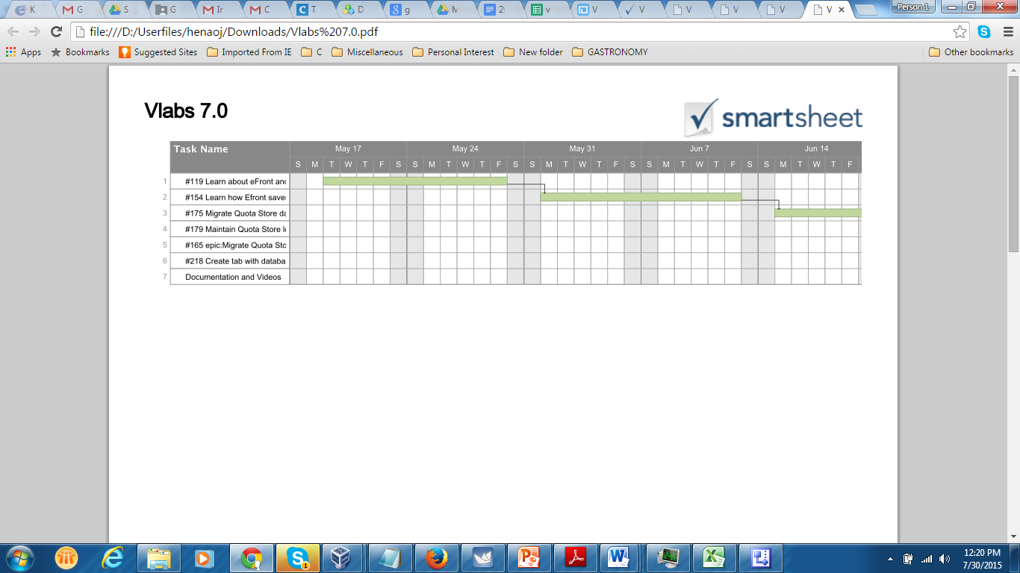Figure 5.6.1 Grant chart for the Quota Store Implementation.

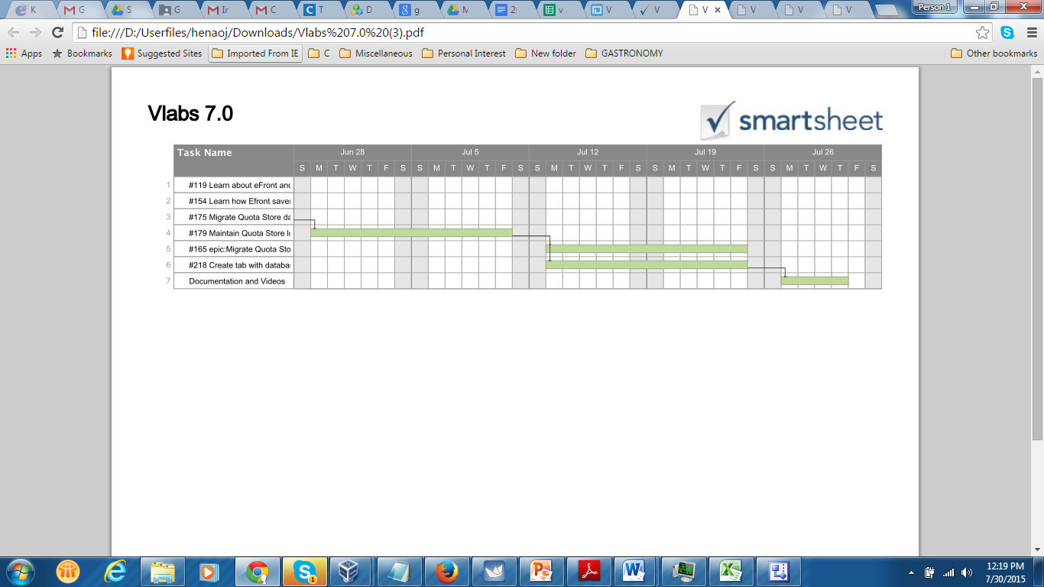

# 6 System Design

This section describes the architecture, system and subsystem decomposition of the Quota Store module.

## 6.1 Architectural Patterns

Quota Store is a web solution based on a classical three tier design architecture.

## 6.2 System and Subsystem Decomposition

The presentation layer which is the client’s browser talks to the business layer via ajax calls. The business layer uses PHP to interact with the database layer and also uses soap calls to fetch credit type information from the quota system.

Figure 6.2.1 System and Subsystem Decomposition.

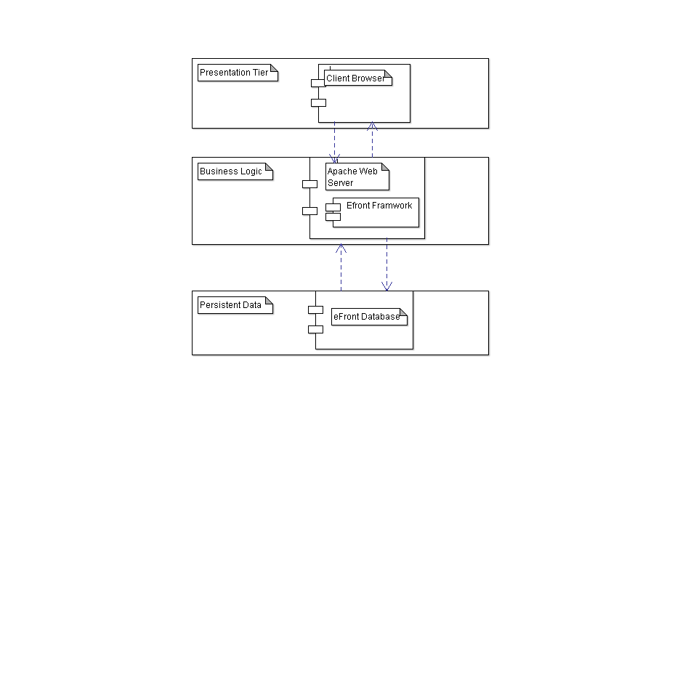

**6.3 Deployment Diagram**

Figure 6.3.1 Quota Store Deployment

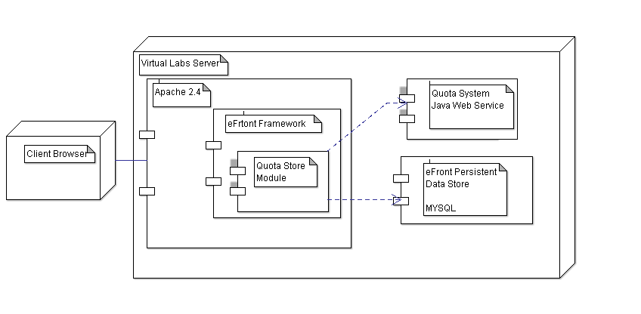

**6.4 Design Patterns**

The main design patter of the Quota Store solution is the use of ajax calls to allow the client to interact with the backend data through the use of eFront DB wrapper functions. PHP is used as the main backend programming language. Also Soap calls are used to fetch credit type information from the Quota System. In addition JQuery data tables is the main look and feel of the Quota Store solution.

# 7 System Validation

* Functional tests were performed for all Use Cases of the Quota Store.
* Regression testing was performed after adding new features to the solution and/or fixing software bugs.

**Glossary**

**Ajax** – (Asynchronous JavaScript and XML) is a group of interrelated web development techniques used on the client-side to create interactive web applications. With Ajax, web applications can retrieve data from the server asynchronously in the background without interfering with the display and behavior of the existing page.

**Credit Type:** A credit type defines how to assign quota and govern the usage of basic units of resources (defined in minutes) for a specific resource (namely, virtual labs, mentors, and

certificate test virtual environment) of a specific course. In other words, a credit type is simply a tuple associating a usage policy to a resource of a course. Different quantities of a credit type can be assigned by an administrator to individual students or to all students enrolled in a course to indicate how much quota they have for using a specific resource of the course and how that quota should be used and expired over time. Note that the quota store system defines each

store item based on only one credit type. A credit type, however, may be used to define many items in the quota store, which may have different pricing types (billable or non-billable) and amounts to be used for creating different packages.

**efront** – a modern learning and training platform or virtual learning environment

**Fixed Policy**: A policy that specifies either an expiration date or a number of days relative to the purchase date of a quota in which the quota will expire.

**Gateway** – A gateway is a network point that acts as an entrance to another network.

**Gradual Policy:** A policy that defines a specific number of periods and days per period, together with the amount of quota that will expire in each of those periods.

**Guacamole** – is a HTML5 client-less remote desktop gateway

**Hypervisor** – or virtual machine monitor (VMM) is a piece of computer software, firmware or hardware that creates and runs virtual machines.

**Kernel** – a computer program that manages I/O requests from software, and translates them into data processing instructions for the CPU and other components of a computer.

**KVM** – Kernel-based Virtual Machines is a virtualization infrastructure for the Linux kernel that converts it into a hypervisor.

**Libvirt** – is a collection of software that provides a convenient way to manage virtual machines and other virtualization functionality, such as storage and network interface management. These software pieces include an API library, a daemon (libvirtd), and a command line utility (virsh).

**Quota**: The limited time (specified in minutes) that is granted to a student to allocate and make use of specific resources. If associated with a usage policy, its usage and expiration must follow the policy.

**URI** – Uniform Resource Identifiers, a string of characters used to identify a name of a resource. Libvirt uses the URI qemu:///system to connect to KVM

**Virsh** – a command line utility provided by libvirt that allows for the management of Virtual Machines

**Virtualization** – the act of making a virtual version of an operating system, computer network, or other hardware or storage devices.

**Virtual Labs** – Different virtual environment configurations designed for students to perform their lab assignments. It is composed of a collection of virtual appliances (also called virtual machines), which are connected by some virtual network components and are deployed on one or more physical machines (also called hosts).

**Virt-manager** – a GUI program offered by libvirt that allows for the management of virtual machines

**VMware** – a virtualization software.

**WSDL**: (Web Services Description Language) is an XML-based language that provides a model for describing Web services.

.

# 7 Appendix

## Appendix A - UML Diagrams

## 7.1 Static UML Diagrams

### 7.1.1 System and Subsystem decomposition



### 7.1.2 Deployment Diagram



### 7.1.3 Minimal Class Diagram

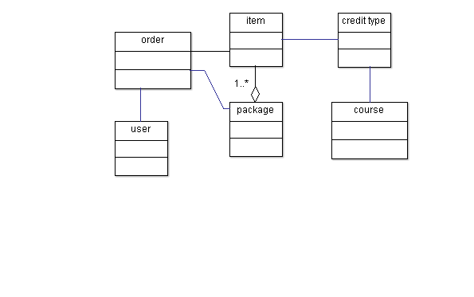

### 7.1.4 State Machine Diagram

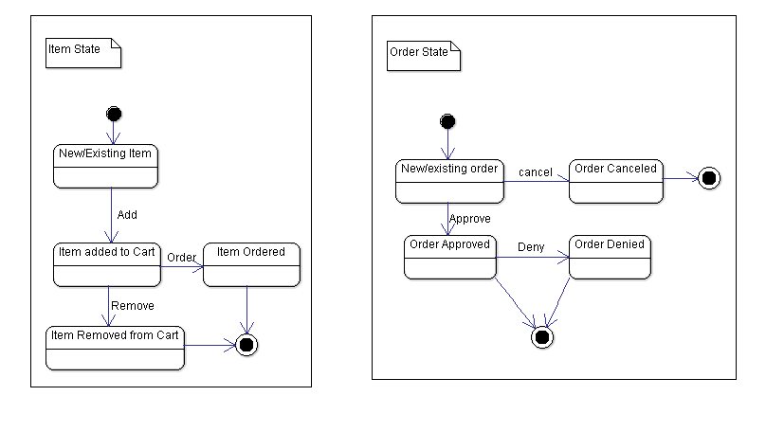

7.77

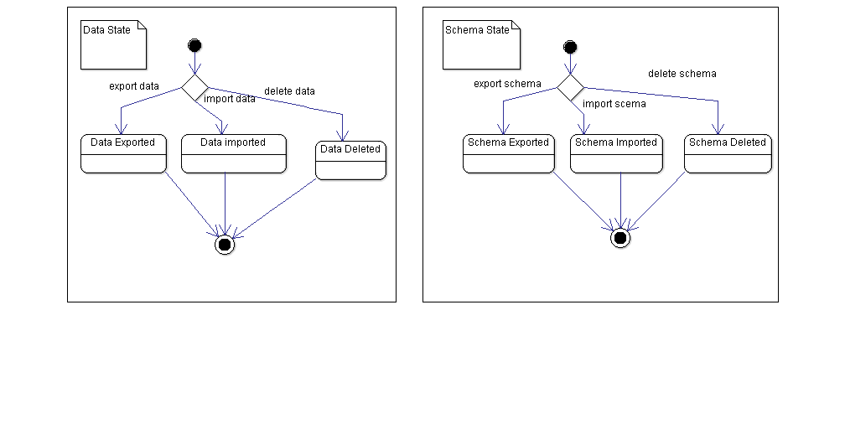

## 7.2 Dynamic UML Diagram

### 7.2.1 Use Case Diagram



### 7.2.2 Sequence Diagrams

7.2.2.1 Quota Store Use Case Diagram



7.2.2.2 Quota Store Sequence Diagram



7.2.2.3 DB Admin Sequence diagram.



# Appendix B - User Interface Design

**Virtual Labs**

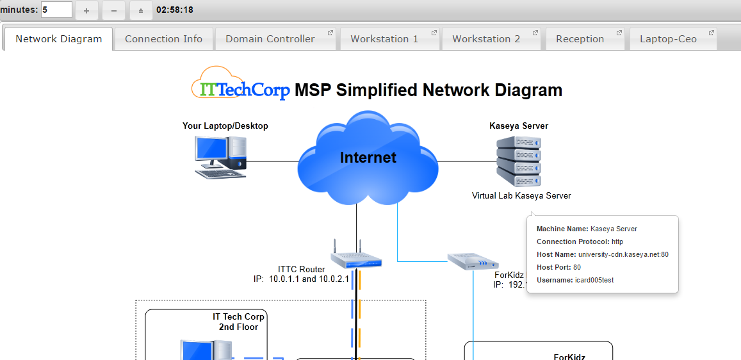

Figure 1 – New tabs layout, tooltips, and new tab icons

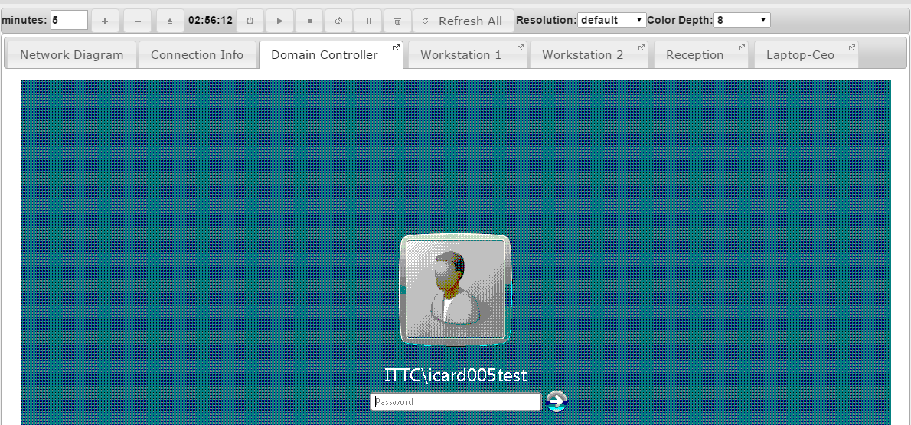

Figure 2 – RDP session is no longer by applet but by Guacamole

# Appendix C - Sprint Review Reports

**Sprint 3 Report**

**Date:** 06/26/15

**Attendees:** Crystal Rivera, Daniel Gonzalez, Johann Henao, Juan Riano, Trung Ngo

**Discussed Topics:**

First student: Crystal Rivera

* What to be done for next sprint:
  + create the user story for migrating the moodle vLabs module into eFront
  + Goal for this sprint: to get the current version of vLabs running correctly in eFront and begin applying the fixes and changes discovered through development of the other module
  + For the jQuery resources: Keep a copy of the specific version under Code/frameworks

Second student: Daniel Gonzalez

* What to be done for next sprint:
  + create the user story for finishing everything in VC12
  + create a user story for the specific conversion schedule
  + make sure all the scripts have comments
  + possibly write a script to convert all the images in vc0-vc11
  + Goal for this sprint: convert vc0-vc11 to KVM
  + Work on documenting all my notes

Third student: Johann Henao

* What to be done for next sprint:
  + Create a user story to automate the process of dumping and importing the content of the db for his module
    - when uninstall, all the data is dumped into a dump file before the tables are dropped - this dump file should be kept in the module or a specific location on the target machine
    - for install, all the data is imported after the tables are recreated
    - Share results of this with Trung and Crystal
  + Create a user story to fix db XML references
  + Create a defect story to fix the theme issue

Fourth student: Juan

* What to be done for next sprint:
  + Focus on REST and Guacamole

Fifth student: Trung Ngo

* What to be done for next sprint:
  + Create defect story for misalignment issue using efront themes.
  + Fully finish quota system and test all functionality of module.  Improve on reports user interface and fix bugs.

**Sprint 4 Report**

**Date:** 07/10/15

**Attendees:** Crystal Rivera, Daniel Gonzalez, Johann Henao, Juan Riano, Trung Ngo

**Discussed Topics:**

First student: Crystal Rivera

* What to be done for next sprint
  + Finalize vLabs Module
    - vm buttons, display parameters in url, other defects
  + Begin working on the CertTest module - should be similar to vLabs

Second student: Daniel Gonzalez

* What to be done for next sprint
  + Work on refresh script
  + Goal is to finish any remaining scripts like is_rdp_ready, run_vm_cmd, refresh_vm

Third student: Johann Henao

* What to be done for next sprint
  + Make sure that the quota store is fully finished and tested
  + The db management tab in vLabsAdmin
    - incorporates the quota store data and the other modules as well

Fourth student: Juan

* What to be done for next sprint
  + fully document and finish the implementation of the guacamole plug in
  + fully deploy the implementation to vlabs-dev and vlabs servers
  + Investigate how we can avoid misuse of guacamole server - security
    - short sessions, timeouts, and a way of using the id so that only our own vms can be serviced by guacamole

Fifth student: Trung Ngo

* What to be done for next sprint
  + Work with Johann and Professor Sadjadi on vLabs admin tabs
  + Finish scheduler
  + Finish testing quota system
  + moving extra tabs to vlabs admin

**References**