Florida International University
School of Computing and Information Sciences

CIS 4911 - Senior Capstone Project
Software Engineering Focus

User Guide KVM

Virtual Labs 3.0

Team Members
Crystal Rivera
Johann Henao
Juan Riano
Trung Ngo
Daniel Gonzalez
Table of Contents
Upgrade an existing virtual lab to KVM…………………………………………………………….3
Applying the network settings ………………………………………………………………………..5
Correcting authentication ……………………………………………………………………………14
Bypassing Sudo ………………………………………………………………………………………..14
Fixing is_rdp_ready …………………………………………………………………………………..15
Fixing pxssh.py ………………………………………………………………………………………..15
Rearming Windows …………………………………………………………………………………...15
Creating a Snapshot …………………………………………………………………………………..17
Installing a Virtual Machine …………………………………………………………………………17
Converting an Image …………………………………………………………………………………17
Information Sheet..……………………………………………………………………………………18

Upgrading an Existing Virtual Lab to KVM:
- John upgrades the server.
- Cleanup the server. Delete all unnecessary files:
- delete exams/routers
- check which templates are needed for conversion and delete the other ones
- delete the "don't care" vLabs under provisioned directory
- Start the convert script.
- Be mindful of the available space.
- Delete the converted VMs as necessary.
- Cleanup exams/assigned.
- Put a copy under ~/backup
- Delete the extra links
- Copy over the golden images
- Copy the routers
- Add link for the other ve_types for routers
- Copy the templates
- Add links for the other ve_types for templates
- Fix the .bashrc
- Make sure VMNAT is properly set
- Make sure PATH is properly set
- Fix sudoer file
- Comment Defaults requiretty
- Add portal ALL=(ALL) NOPASSWD: /home/sadjadi-vmstorage/sadjadi-vms/it-auto-kvm/vmnat.sh
- Fix the iptalbes
- iptables -I FORWARD -m state -d 192.168.122.0/24 --state NEW,RELATED,ESTABLISHED -j ACCEPT
- Fix the IP Address on the converted VMs
- Start each converted vLab and fix the IP Address
- Make sure that it is connected
- Cleanup
- Delete all the VMware images

Applying the Network Settings:
For the correct network settings a new default network must be made with DHCP disabled. Then eight networks need to be created so they can be properly routed. The following steps will go through the process of first deleting and remaking the default network. Then how to set-up each of the networks for routing purposes.
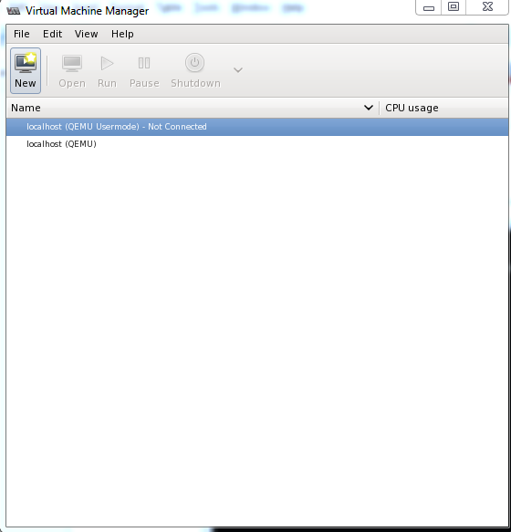
Figure 1- Virtual Machine Manager

- Open virt-manager by typing “virt-manager” in the terminal. A screen such as Figure 1 will appear.
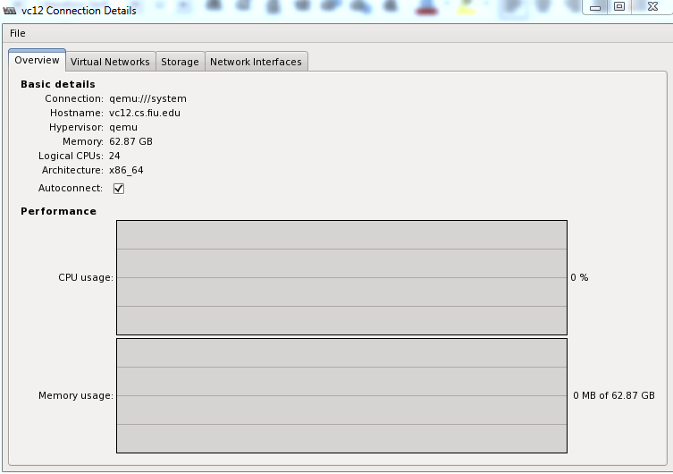
Figure 2 – Connection Details
- Click on Edit>Connection Details, a new window will appear as in Figure 2. Be sure that you are connected to qemu:///system
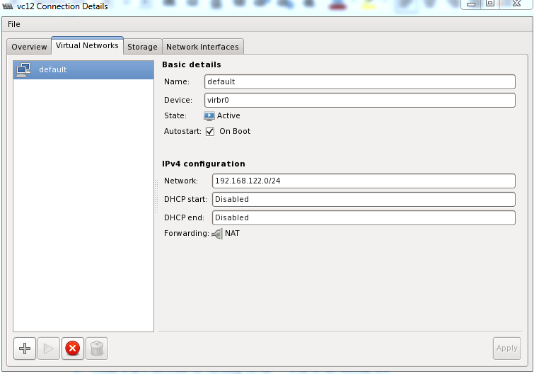

Figure 3 -Virtual Networks
- Click on the “Virtual Networks” tab in the new window, you screen should now display similar to Figure 3.
- In the new window stop the default network by first making sure the default network is selected, then clicking the red circle with the 'X' inside icon.
- Remove the network by selecting it and clicking on the trash can icon to the bottom right. If prompted “Are you sure you want to permanently delete the default network?” click yes.
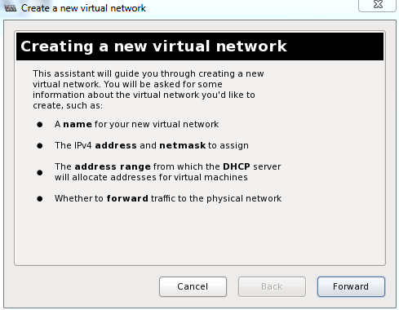

Figure 4 – Creating a new Virtual Network
- Create a new network by first clicking on the '+' icon to the bottom left. A new window should appear, Figure 4.

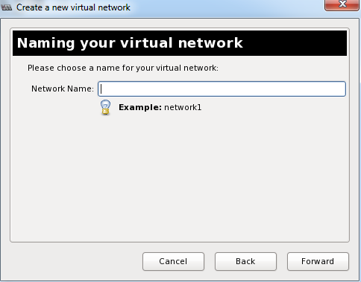

Figure 5 – Enter a Name
- Click on forward the screen will change Figure 5.
- Enter the name “default” and click forward.
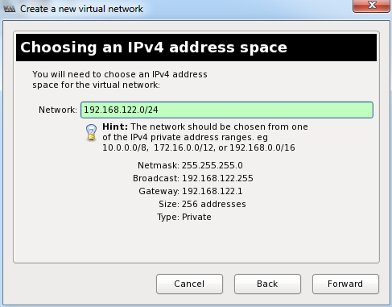

Figure 6 - Ipv4
- For the IPV4 network space the network should be equal to “192.168.122.0 /24” as in Figure 6, click forward.
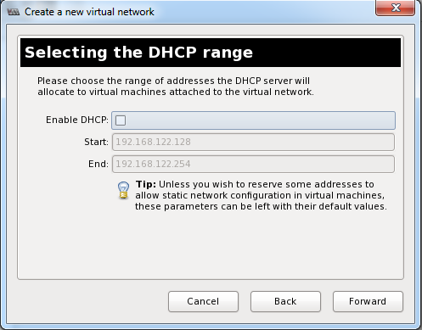

Figure7 – Disable DCHP
- It is important that DCHP remain unchecked as in Figure 7. If it is checked click on the check mark to uncheck it. Then click on forward.

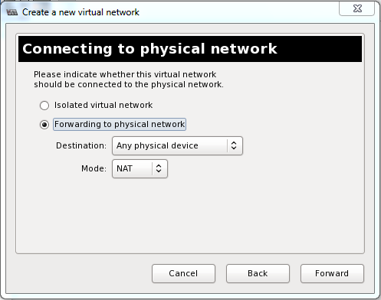

Figure 8 – Forwarding
- Make sure that the radio button for “Forwarding to physical network” is selected. Destination is set to any physical device, and Mode is set to NAT as in Figure 8. Then click forward.

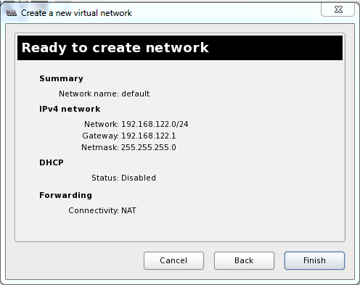

Figure 9 – Confirmation
- Confirm that the settings are correct and similar to Figure 9. Click on finish.
- Create a new network by first clicking on the '+' icon to the bottom left refer back to figure 3.
- Click on forward the screen will change refer to figure 4.
- Enter the name “Router1” and click forward refer to figure 5.
- For the IPV4 network space the network should be equal to “192.168.101.0 /24”, click forward.
- It is important that DCHP remain unchecked, if it is checked click on the check mark to uncheck it. Then click on forward.
- Make sure that the radio button for “Isolated network” is selected.
- Confirm that the settings are correct and click on Finish.
- Repeat steps 13 – 19 making for Router2 – Router 8. Please make sure the names and the IPV4 have been changed for each corresponding Router. For example network name for the second router is “Router2” and the IPV4 network space is “192.168.102.0/24”. For the third Router the name should be “Router3” and the IPV4 network space is “192.168.103.0/24”. This syntax should be followed for all the Networks.
- Exit out of the Virtual Machine Manager.
- In the terminal type the following quote exactly “sudo iptables -I FORWARD -m state -d 192.168.122.0/24 --state NEW,RELATED,ESTABLISHED -j ACCEPT”.
Correcting authentication:
In order for a regular user to access networking, and the other benefits of connecting to the qemu:///system URI, the polkit authentication must be set up. The following steps are a guide on how to apply the polkit authorization.
- Open the Linux terminal.
- Type the following “sudo vim /etc/polkit-1/localauthority/50-local.d/50-org.example-libvirt-remote-access.pkla”, a new file will be created.
- In the new file type the following bold prompt.
[Remote libvirt SSH access]
Identity=unix-user:portal
Action=org.libvirt.unix.manage
ResultAny=yes
ResultInactive=yes
ResultActive=yes
- Save changes and escape from vim. The polkit authorization is now applied for user portal.
Bypassing password for sudo:
In order for the scripts to run properly a sudo call to vmnat.sh must be made by user portal. However this prompts a password. The following steps explain how to bypass the entering of the password.
- In the Linux terminal type “sudo visudo”
- Comment out “Defaults requiretty”
- Add the following line to the bottom of the sudoers template “portal ALL=(ALL:ALL) NOPASSWD: /home/sadjadi-vmstorage/sadjadi-vms/it-auto-kvm/vmnat.sh”.
- Below the previous line add “portal ALL=(ALL:ALL) NOPASSWD: /home/sadjadi-vmstorage/sadjadi-vms/it-auto-kvm/change_owner.sh”
- Save and quit. This allows for the usage of of the shell script vmnat.sh and change_owner.sh without prompting for a sudo password.
Fixing is_rdp_ready:
The python script is_rdp_ready requires nmap to be installed. To do so type “sudo yum install nmap” and enter the password when prompted.
Fixing pxssh.py:
There is an issue in which pxssh.py timeout with every use. To correct this issue the following steps are needed.
- In the Linux terminal type “sudo vim /usr/lib/python.2.6/site-packages/pxssh.py”, enter the password when prompted.
- Travel to line 134 by entering “:134” in vim. This should be the line seen “self.read_nonblocking(size=10000,timeout=1) # GAS: Clear out the cache before getting the prompt”
- Above the previous line type “self.sendline()”
- Below the previous line but above the line before that type “time.sleep(0.5)” the result should look like the following:
  - self.sendline()
  - time.sleep(0.5)
  - self.read_nonblocking(size=10000,timeout=1)
- Save and quit vim.
Rearming Windows:
The product keys for windows are only valid for a limited amount of time. To correct this we can rearm Windows. The following steps will detail the process.
- Run the Windows version you needing the rearm
- Run the command prompt as an administrator
- Type “slmgr /rearm” and press the enter/return key
- If the Windows machine is out of rearms it is necessary to reset the rearm count. Start by opening notepad as an administrator.
- Type the following script in bold:
reg load HKLM\MY_SYSTEM "%~dp0Windows\System32\config\system"
reg delete HKLM\MY_SYSTEM\WPA /f
reg unload HKLM\MY_SYSTEM
- Save the file as “reset.bat” in the “C:\” root drive, ensuring you switch from .txt to all files.
- Reboot Windows
- At boot-up hit F8 on the keyboard, and select the option Repair Your Computer when prompted.
- When Windows has loaded select the keyboard options
- On the next screen enter the administrator login credentials
- On the next screen open command prompt
- Type “C:\reset.bat” and press the enter/return key, if this doesn't work run C might not be recognized so try “D:\reset.bat” instead.
- When the reset.bat file has completed successfully run restart Windows.
- When Windows boots open the command prompt as an administrator.
- Type “slmgr /dlv” to see if the rearm has been reset.
- A message may appear claiming that there is no product key. When this happens type “slmgr /ipk <product_key>”. Where <product_key> is one of the following:
33PXH-7Y6KF-2VJC9-XBBR8-HVTHH for Windows 7 Enterprise
489J6-VHDMP-X63PK-3K798-CPX3Y for Windows Server 2008 R2 Enterprise
- Next type “slmgr /skms kms01.ad.fiu.edu” and press enter.
- Finally type “slmgr /ato”
- Close the command prompt

Creating a Snapshot:
To create a KVM snapshot from an existing image file type the following:
- “qemu-img create -f qcow2 -b <path_to_image_file> <path_to_snapshot>”
where <path_to_image_file> is the location of the original image file and <path_to_snapshot> is the location and name of the snapshot.
Installing a Virtual Machine:
The Virtual Machines can be installed with the libvirt command entitled virt-install.
The following website has in-depth details concerning virt-install. http://www.techotopia.com/index.php/Installing_a_KVM_Guest_OS_from_the_Command-line_%28virt-install%29
Converting an image:
To convert a VMware image to a KVM image simply type the following:
qemu-img convert -f vmdk -O qcow2 <path_to_VMware_image> <path_to_KVM_image>
SSH fixes:
Follow the guide on this website to correct the SSH authentication:
http://www.linuxproblem.org/art_9.html

Information Sheet:
qemu-img convert -f vmdk -O qcow2 xp1-000001.vmdk w7.qcow2
qemu-img convert -f vmdk -O qcow2 w2k3-000001.vmdk w2k8.qcow2

virt-install --connect qemu:///system --ram 1024 -n laptop-ceo2 --os-type=windows --os-variant=win7 --disk path=/lclhome/portal/exams/provisioned/K2_5/1/xp-1/xp1.qcow2,device=disk,format=qcow2 --vcpus=1 --vnc --noautoconsole --import
virt-install --connect qemu:///system --ram 2048 -n dc --os-type=windows --os-variant=win2k8 --disk path=/home/vc12/vm-storage/portal/exams/provisioned/K2_6/1/w2k8-1/w2k8.qcow2,device=disk,format=qcow2 --vcpus=1 --vnc --noautoconsole --import
virt-install --connect qemu:///system --ram 1024 -n ws1 --os-type=windows --os-variant=win7 --disk path=/home/vc12/vm-storage/portal/exams/provisioned/K2_6/1/w7-1/w7.qcow2,device=disk,format=qcow2 --vcpus=1 --vnc --noautoconsole --import
virt-install --connect qemu:///system --ram 1024 -n ws2 --os-type=windows --os-variant=win7 --disk path=/home/vc12/vm-storage/portal/exams/provisioned/K2_6/1/w7-2/w7.qcow2,device=disk,format=qcow2 --vcpus=1 --vnc --noautoconsole --import
virt-install --connect qemu:///system --ram 1024 -n reception --os-type=windows --os-variant=win7 --disk path=/home/vc12/vm-storage/portal/exams/provisioned/K2_6/1/w7-3/w7.qcow2,device=disk,format=qcow2 --vcpus=1 --vnc --noautoconsole --import
virt-install --connect qemu:///system --ram 1024 -n laptop-ceo --os-type=windows --os-variant=win7 --disk path=/home/vc12/vm-storage/portal/exams/provisioned/K2_6/1/w7-4/w7.qcow2,device=disk,format=qcow2 --vcpus=1 --vnc --noautoconsole --import

/home/vc12/vmstorage/portal/exams/provisioned/K2_5/1/

normal user: xauth list ...
in root : xauth add ...

qemu-img create -f qcow2 -b centos-cleaninstall.img snapshot.img

qemu-img create -f qcow2 -b w2k8.qcow2 snapw2k8.qcow2
qemu-img create -f qcow2 -b w7.qcow2 snapw7.qcow2

virt-install --connect qemu:///system --ram 2048 -n dc --os-type=windows --network network:default --network network:default --disk path=/home/vc12/vm-storage/portal/exams/templates/temp-K2_6/w2k8-1/w2k8.qcow2,device=disk,format=qcow2 --vcpus=1 --vnc --noautoconsole --import

virt-install --connect qemu:///system --ram 1024 --name Router1 --os-type=linux --network network:default --network network:default --network network:default --network network:default --disk path=/home/vc12/vm-storage/portal/exams/routers/K2_6/Router1/DSL.qcow2,device=disk,format=qcow2 --vcpus=1 --vnc --noautoconsole --import

virt-install --connect qemu:///system --ram 2048 -n dc --os-type=windows --network network:default --network network:default --disk path=/home/vc12/vm-storage/portal/exams/templates/temp-K2_6/w7-1/w7.qcow2,device=disk,format=qcow2 --vcpus=1 --vnc --noautoconsole --import

changed /etc/sysconfig/network-scripts/ifcfg-em1

Removed BRIDGE=br1
added BRIDGE=br0

#!/usr/bin/python

use --command
--name=NAME Name of the guest instance
--ram=MEMORY
--vcpus=VCPUS Number of vcpus to configure for your guest
--file=DISKFILE
File to use as the disk image
--mac=MAC Fixed MAC address for the guest; if none or RANDOM is
given a random address will be used

--bridge=BRIDGE
Bridge to connect guest NIC to; if none given, will
try to determine the default
--network=NETWORK
Connect the guest to a virtual network, forwarding to
the physical network with NAT

--accelerate Use kernel acceleration capabilities

--connect=CONNECT Connect to hypervisor with URI

--os-type=OS_TYPE The OS type for fully virtualized guests, e.g.
'linux', 'unix', 'windows'

--os-variant=OS_VARIANT
The OS variant for fully virtualized guests, e.g.
'fedora6', 'rhel5', 'solaris10', 'win2k', 'vista'

--force Do not prompt for input. Answers yes where applicable,

Mac must start with 52:54:00:

virt-install --connect qemu:///system --ram 2048 --name dgonz023-K2_7-50496 --os-type=windows --network network:default --disk path=/home/vc12/vm-storage/portal/exams/assigned/dgonz023-K2_7-50496/w2k8-1/snapw2k8.qcow2,device=disk,format=qcow2 --vcpus=1 --vnc --force --accelerate --noautoconsole --import

/home/vc12/vm-storage/portal/exams/templates/temp-K2_7/w2k8-1/snapw2k8.qcow2

start_vm2.py <qcow2_file> <name> <os_type> <ram> <vcpus> <mac_address>

sudo python start_ve.py daniel K2_6 50501 5 112233 6 1 12 0

sudo python start_ve2.py danny K2_6 50506 5 112240 6 2 12 0

sudo python start_ve2.py dan K2_6 50511 5 112250 6 3 12 0

sudo python start_ve2.py dani K2_6 50516 5 112260 6 4 12 0

sudo python start_ve2.py daniel K2_6 50521 5 112270 6 5 12 0

sudo python start_ve2.py danny K2_6 50526 5 112280 6 6 12 0

sudo python start_ve2.py dan K2_6 50531 5 112290 6 7 12 0

sudo python start_ve2.py dani K2_6 50536 5 112220 6 8 12 0

sudo python start_ve.py daniel K2_6 50501 5 112233 6 1 12 2

sudo python start_ve2.py danny K2_6 50506 5 112240 6 2 12 2

sudo python start_ve2.py dan K2_6 50511 5 112250 6 3 12 2

sudo python start_ve2.py dani K2_6 50516 5 112260 6 4 12 2

sudo python start_ve2.py daniel K2_6 50521 5 112270 6 5 12 2

sudo python start_ve2.py danny K2_6 50526 5 112280 6 6 12 2

sudo python start_ve2.py dan K2_6 50531 5 112290 6 7 12 2

sudo python start_ve2.py dani K2_6 50536 5 112220 6 8 12 2

sudo python stop_ve.py daniel K2_6 50501 5 1 12

sudo python stop_ve2.py danny K2_6 50506 5 2 12

sudo python stop_ve2.py dan K2_6 50511 5 3 12

sudo python stop_ve2.py dani K2_6 50516 5 4 12

sudo python stop_ve2.py daniel K2_6 50521 5 5 12

sudo python stop_ve2.py danny K2_6 50526 5 6 12

sudo python stop_ve2.py dan K2_6 50531 5 7 12

sudo python stop_ve2.py dani K2_6 50536 5 8 12

https://dgonz023@github.com/FIU-SCIS-Senior-Projects/vLabs.git

Virtual Lab services change to:
http://vlabs.cis.fiu.edu:6060/axis2/services/VirtualLabs/
restart service

vc9 root:
sudo vmnet.sh

sudo iptables -t nat -L

sudo tcpdump -i br1 | grep 50501

cat /etc/vmnats

mstsc.exe

NEEDED to connect to RDP:
iptables -I FORWARD -m state -d 192.168.122.0/24 --state NEW,RELATED,ESTABLISHED -j ACCEPT

sudo vmnat.sh del 50516 192.168.122.102 1024 5

STATIC IP SETUP:

cat etc/network/interfaces
address 192.168.122.10X
network 192.168.122.0
netmask 255.255.255.0
broadcast 192.168.122.255
gateway 192.168.122.1

cat etc/resolv.conf
search localdomain
nameserver 192.168.122.1

/etc/init.d/networking restart

DC IP1:
IP address 10.0.1.10
subnet mask 255.255.255.0
default gateway 10.0.1.1
Preferred DNS 127.0.0.1

DC IP2:
IP address 10.0.2.10
subnet mask 255.255.255.0
default gateway 10.0.2.1
Preferred DNS 127.0.0.1

WS1 IP:
IP address 10.0.1.100
subnet mask 255.255.255.0
default gateway 10.0.1.1
Preferred DNS 10.0.1.10
Preferred DNS2 131.94.134.129

WS2 IP:
IP address 10.0.2.100
subnet mask 255.255.255.0
default gateway 10.0.2.1
Preferred DNS 10.0.2.10
Preferred DNS2 131.94.134.129

RECEPTION IP:
IP address 192.168.0.100
subnet mask 255.255.255.0
default gateway 192.168.0.1
Preferred DNS 131.94.134.129
Preferred DNS2 131.94.134.130

LAPTOP-CEO:
IP address 192.168.0.200
subnet mask 255.255.255.0
default gateway 192.168.0.1
Preferred DNS 131.94.134.129
Preferred DNS2 131.94.134.130

50491

/home/vc12/vm-storage/portal/exams/templates/temp-K2_6/w2k8-1/w2k8.qcow2
http://libvirt.org/auth.html#ACL_server_polkit

Add to visudo:
portal ALL=(ALL) NOPASSWD: home/vcX/vm-storage/portal/exams/bin/vmnat.sh

run_vm_cmd.py danny K2_6 50506 12 w2k3-1 getstate
refresh_vm.py icard005test K2_6 51486 12 w2k8-1
refresh_vm.py danny K2_6 50506 12 w2k3-1
destroy_ve.py danny K2_6 50506 5 2 12

NEEDED SCRIPTS:
destroy_ve.py
doalarm
is_rdp_ready
provisioner.py
refresh_ve.py

virt-install --connect qemu:///system --ram 2048 --name w2k8-1 --os-type=windows --network network:default --disk path=/home/vc12/vm-storage/portal/exams/templates/temp-K2_6/w2k8-1/w2k8.qcow2,device=disk,format=qcow2 --vcpus=1 --vnc --force --accelerate --noautoconsole --import

virt-install --connect qemu:///system --ram 2048 --name w2k8-1 --os-type=windows --vcpus=1 --vnc --accelerate --network network:default --network network:default --disk path=/home/vc12/vm-storage/portal/clone/w2k8-1.img,device=disk,bus=virtio,size=20 --cdrom=/home/vc12/vm-storage/portal/clone/eng_windows_server_2008_r2_st_ent_dc_web_retail_x64_X15-50365.img

virt-install --connect qemu:///system --ram 1024 --name w7-1 --os-type=windows --vcpus=1 --vnc --accelerate --network network:default --disk path=/home/vc12/vm-storage/portal/clone/w7-1.img,size=20,device=disk,bus=virtio –cdrom=/home/sadjadi-vmstorage/sadjadi-vms/needbackup/images/

virt-install --connect qemu:///system --ram 1024 --name w7-1 --os-type=windows --vcpus=1 --vnc --accelerate --network network:default --disk path=/home/vc12/vm-storage/portal/clone/w7-1.img,size=20,device=disk,bus=virtio –cdrom=/home/sadjadi-vmstorage/sadjadi-vms/needbackup/images/en_windows_7_with_sp1_debug_checked_build_x86_dvd_619602.iso

virt-install --connect qemu:///system --ram 2048 --name w2k8-1 --os-type=windows --vcpus=1 --vnc --accelerate --network network:default --network network:default --disk path=/home/vc12/vm-storage/portal/clone/w2k8-1.qcow2,device=disk,bus=virtio,size=20,format=qcow2 --disk path=/home/sadjadi-vmstorage/sadjadi-vms/needbackup/images/windows_server_2008/eng_windows_server_2008_r2_st_ent_dc_web_retail_x64_X15-50365.img,device=cdrom --disk path=/home/vc12/vm-storage/portal/virtio-win.iso,device=cdrom

virt-install --connect qemu:///system --ram 1024 --name w7-4 --os-type=windows --vcpus=1 --vnc --accelerate --network network:default --disk path=/home/vc12/vm-storage/portal/clone/w7-4.qcow2,device=disk,bus=virtio,size=20 --disk path=/home/sadjadi-vmstorage/sadjadi-vms/nobackup/images/en_windows_7_enterprise_with_sp1_x64_dvd_u_677651.iso,device=cdrom --disk path=/home/vc12/vm-storage/portal/virtio-win.iso,device=cdrom

virt-install --connect qemu:///system --ram 2048 --name w2k8-1 --os-type=windows --vcpus=1 --vnc --accelerate --noautoconsole --network network:Router8 --network network:Router8 --disk path=/home/vc12/vm-storage/portal/clone/w2k8-1.qcow2,device=disk,bus=virtio --import --keymap=en-us

virt-install --connect qemu:///system --ram 1024 --name w7-1 --os-type=windows --vcpus=1 --vnc --accelerate --noautoconsole --network network:Router8 --disk path=/home/vc12/vm-storage/portal/clone/w7-1.qcow2,device=disk,bus=virtio --import --keymap=en-us

virt-install --connect qemu:///system --ram 1024 --name w7-2 --os-type=windows --vcpus=1 --vnc --accelerate --noautoconsole --network network:Router8 --disk path=/home/vc12/vm-storage/portal/clone/w7-2.qcow2,device=disk,bus=virtio --import --keymap=en-us

virt-install --connect qemu:///system --ram 1024 --name w7-3 --os-type=windows --vcpus=1 --vnc --accelerate --noautoconsole --network network:Router8 --disk path=/home/vc12/vm-storage/portal/clone/w7-3.qcow2,device=disk,bus=virtio --import --keymap=en-us

virt-install --connect qemu:///system --ram 1024 --name w7-4 --os-type=windows --vcpus=1 --vnc --accelerate --noautoconsole --network network:Router8 --disk path=/home/vc12/vm-storage/portal/clone/w7-4.qcow2,device=disk,bus=virtio --import --keymap=en-us

virt-install --connect qemu:///system --ram 1024 --name Router2 --os-type=linux --vcpus=1 --vnc --accelerate --noautoconsole --network network=default --network network=Router2 --network network=Router2 --network network=Router2 --disk path=~/exams/routers/K2_6/Router2/DSL.qcow2,device=disk,format=qcow2 --import --keymap=en-us

need to install nmap

sudo vim /usr/lib/python2.6/site-packages/pxssh.py

self.sendline() #Line 134
time.sleep(0.5) #Line 135

References
http://stackoverflow.com/questions/21055943/pxssh-connecting-to-an-ssh-proxy-timeout-exceeded-in-read-nonblocking
http://www.techotopia.com/index.php/Installing_a_KVM_Guest_OS_from_the_Command-line_%28virt-install%29
http://blog.mc-thias.org/?title=keyboard-layout-messed-up-in&more=1&c=1&tb=1&pb=1
http://askubuntu.com/questions/155791/how-do-i-sudo-a-command-in-a-script-without-being-asked-for-a-password
https://niranjanmr.wordpress.com/2013/03/20/auth-libvirt-using-polkit-in-fedora-18/
http://serverfault.com/questions/170079/forwarding-ports-to-guests-in-libvirt-kvm/170641#170641

