*Florida International University*

*School of Computing and Information Sciences*

Software Engineering Focus

Feature Document

User Story ID #687 Add Keyboard/Mouse Controls

**Name:** Nicolette Celli

**Team Member(s):** Lukas Borges, Cristian Cabrera, Hamilton Chevez, Kevin Delamo, Filip Klepsa, Francisco Lozada

**Project:** AR-VR-VE for Computer Science

**Product Owner(s)**: Francisco Ortega

**Mentor(s)**: Francisco Ortega

**Instructor**: Masoud Sadjadi

**User Story Name: Add Keyboard/Mouse Controls**

* Description: As a developer, I would like to add keyboard and mouse controls to the game, so I can test simple features without an HTC Vive.

Acceptance Criteria

* The game can be played with a keyboard and a mouse.

**Use Case**

* Name: Use Keyboard and Mouse Controls
* Actor: Player
* Preconditions: The game is loaded into the first scene.
* Description:
  + The user moves the mouse in any direction.
    - The camera follows the user’s mouse.
  + The user presses or holds the W key.
    - The system moves the camera position forward.
  + The user presses or holds the A key.
    - The system moves the camera position to the left.
  + The user presses or holds the S key.
    - The system moves the camera position backward.
  + The user presses or holds the D key.
    - The system moves the camera position to the right.

**Use Case Diagram**

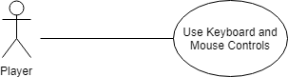

**Sequence Diagram**

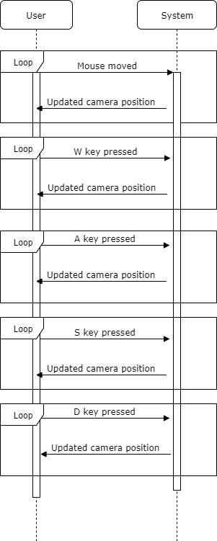

**Class Diagram**

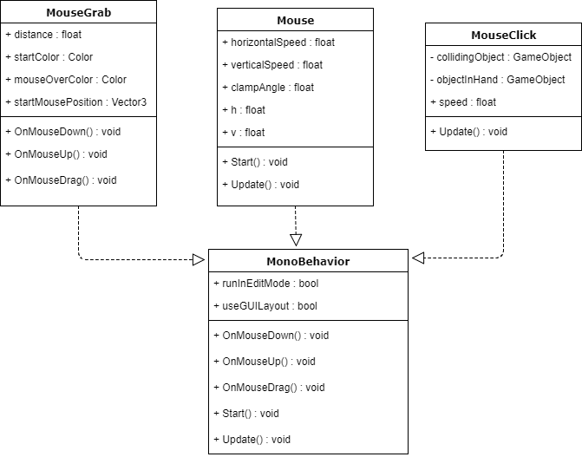

**Unit Test**

* Test case ID: 003
* Description/Summary of Test: Verify that mouse controls are functioning.
* Pre-condition: The game has loaded into the first scene and the user is moving the mouse.
* Expected Results: The camera will follow the user’s mouse.
* Actual Result: The camera follows where the user is pointing the mouse.
* Status (Fail/Pass): Pass
* Test case ID: 004
* Description/Summary of Test: Verify that keyboard controls are functioning.
* Pre-condition: The game has loaded into the first scene and the user is pressing the WASD

keys.

* Expected Results: The camera will move.
* Actual Result: The camera moves.
* Status (Fail/Pass): Pass

**Visual User Guide**

