*Florida International University*

*School of Computing and Information Sciences*

Software Engineering Focus

Feature Document

User Story ID #667 Logical AND Gate in AR

**Name:** Hamilton Chevez

**Team Member(s):** Lukas Borges, Filip Klepsa, Nicolette Celli, Francisco Lozada, Cristian Cabrera

**Project:** AR-VR-VE for Computer Science

**Product Owner(s)**: Francisco Ortega

**Mentor(s)**: Francisco Ortega

**Instructor**: Masoud Sadjadi

**User Story Name: Logical AND Gate in AR**

* Description: As a student I would like to view a logical AND gate in augmented reality so I can see its output value based on different binary inputs.

Acceptance Criteria

* The user can change the input to 00, 01, 10, and 11.
* The model notifies or displays the output.

**Use Case**

* Name: Augment Logical AND Gate
* Actor: Student
* Preconditions: The student is aiming the video camera at the image target.
* Description:
  + User touches virtual reference button.
    - System displays a table data image.
  + User touches Input One virtual button.
  + User touches Input Two virtual button.
    - System displays logic gate output.

**Use Case Diagram**

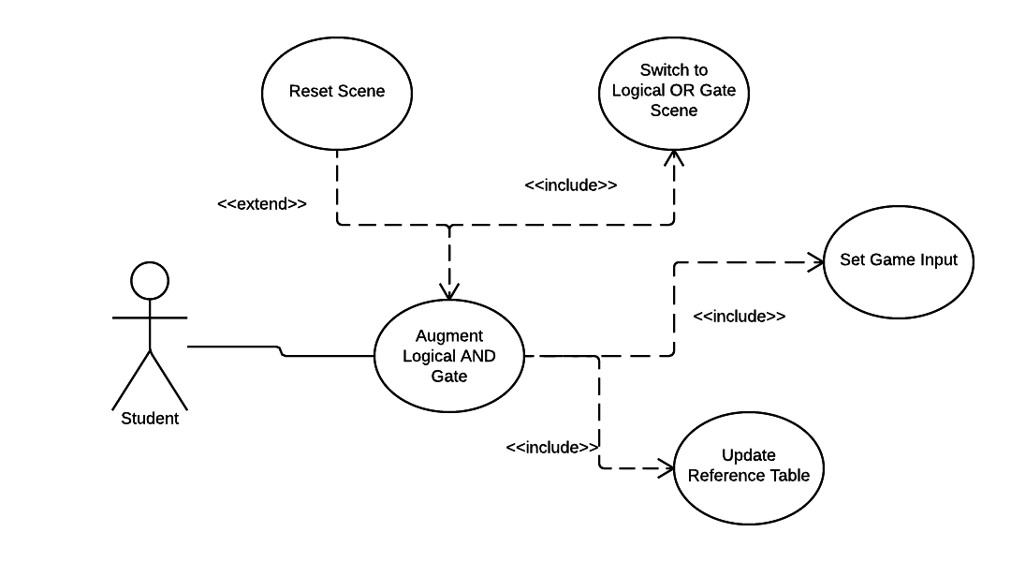

**Sequence Diagram**

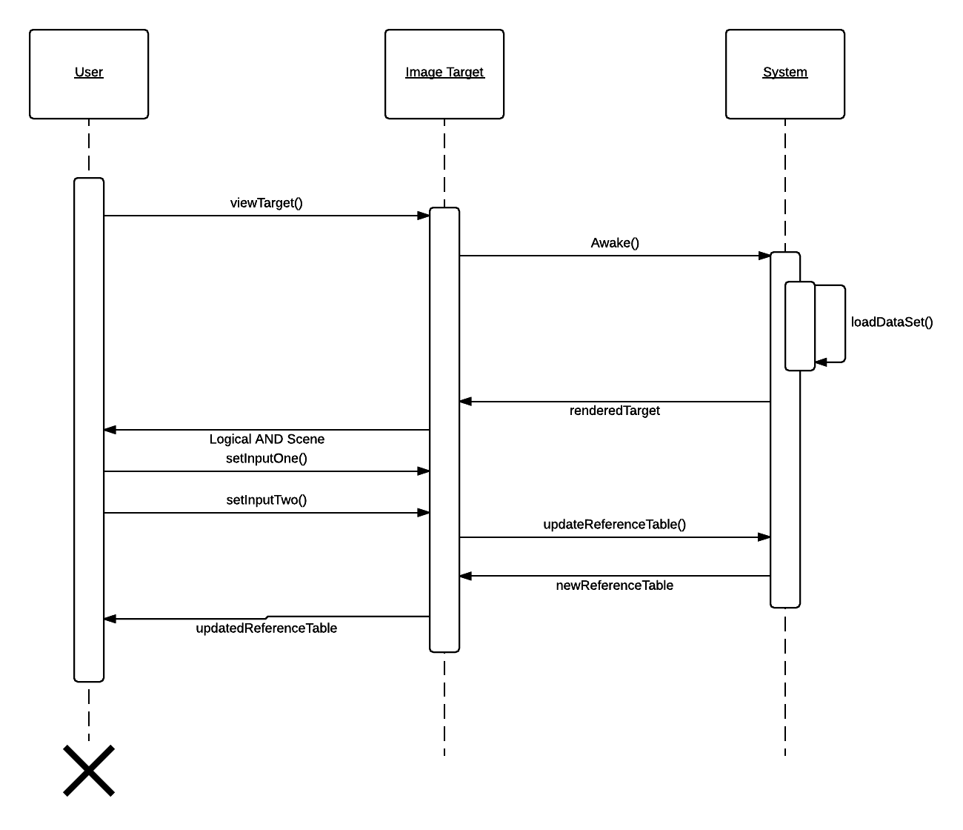

**Class Diagram**

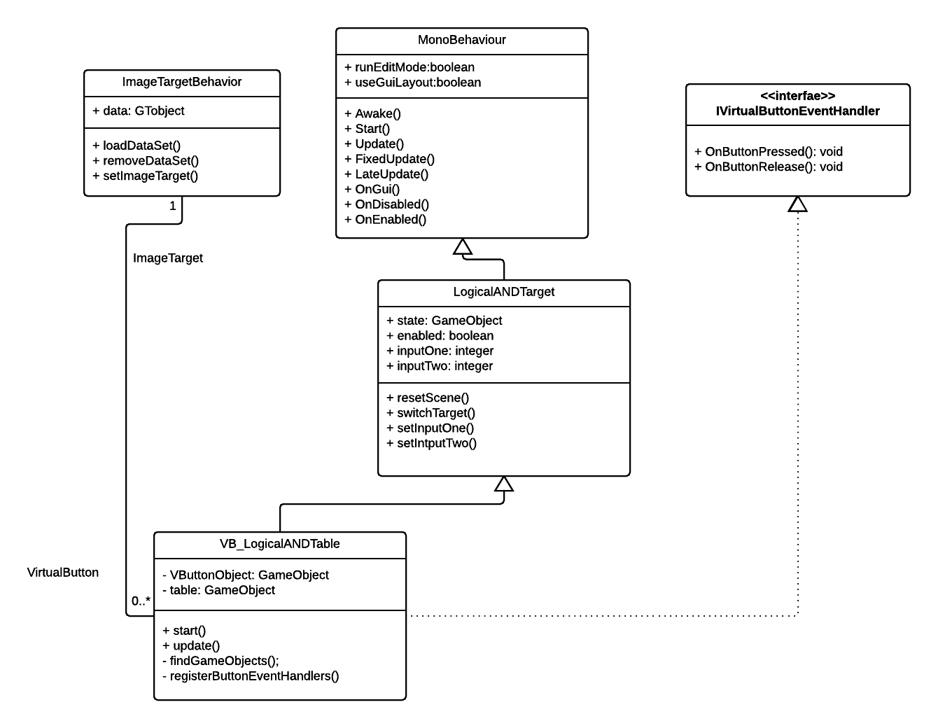

**Unit Test**

|  |  |
| --- | --- |
| Test Case ID | LOG-003 |
| Description/Summary of Test: | Verify that setInputOne() is setting the correct value. |
| Pre-condition: | The user has interacted with the virtual button for input one, as a result setInputOne() has been called. |
| Expected Results: | setIntputOne() returns the integer value 1 |
| Actual Result: | setInputOne() returns 1. |
| Status(Fail/Pass) | Pass |

**Visual User Guide**

