*Florida International University*

*School of Computing and Information Sciences*

Software Engineering Focus

Feature Document

User Story ID #693 Add an Indicator

**Name:** Nicolette Celli

**Team Member(s):** Lukas Borges, Cristian Cabrera, Hamilton Chevez, Kevin Delamo, Filip Klepsa, Francisco Lozada

**Project:** AR-VR-VE for Computer Science

**Product Owner(s)**: Francisco Ortega

**Mentor(s)**: Francisco Ortega

**Instructor**: Masoud Sadjadi

**User Story Name: Add an Indicator**

* Description: As a user, I would like to see an indicator when picking up a box, so it is clear that I have performed this action.

Acceptance Criteria

* The box is red when it is being picked up.
* The box reverts to its starting color when it is dropped.

**Use Case**

* Name: Pick Up and Move Box
* Actor: Player
* Preconditions: The player is looking at the box and the controller is touching it.
* Description:
  + The user presses and holds the grip button on the side of the controller or presses and holds the left mouse button.
    - The system changes the box color to red and it follows the user’s movements.
  + The user releases the grip button or releases the left mouse button.
    - The system changes the box color to its starting color and it falls to the ground.

**Use Case Diagram**

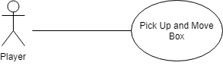

**Sequence Diagram**

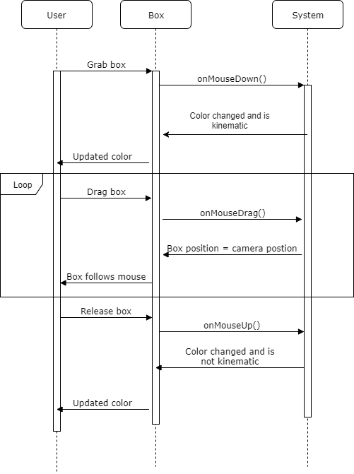

**Class Diagram**

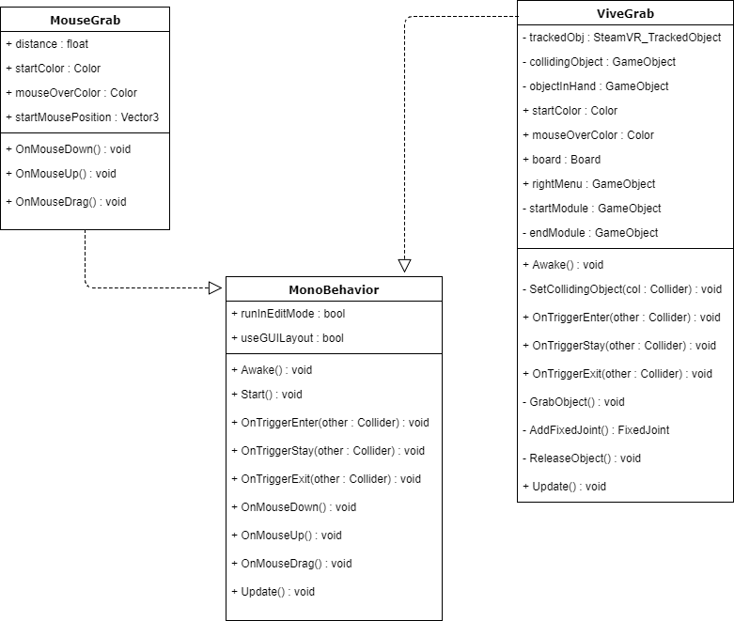

**Unit Test**

* Test case ID: 001
* Description/Summary of Test: Check to see if box color changes when picked up.
* Pre-condition: The user is facing the box.
* Expected Results: User clicks box and it changes to red.
* Actual Result: The box changes to red.
* Status (Fail/Pass): Pass
* Test case ID: 002
* Description/Summary of Test: Check to see if box color changes when released.
* Pre-condition: The user is facing the box.
* Expected Results: The user releases the box and it reverts to its starting color.
* Actual Result: The box reverts to its starting color.
* Status (Fail/Pass): Pass

**Visual User Guide**

